The Almighty Creator Desires
a DEEP PERSONAL relationship with YOU!

Volume 1

Most Important Messages
About The Matters of the Almighty Creator

End Time Issue Ministries
Dr James A Robertson

This is the first volume in a set of eleven volumes (13 books). The printed version of this volume includes a CD with a collection of Recommended Worship Songs and a collection of material, including the website, on a memory device.

ISBN (Softcover) 978-164136179-8
ISBN (Electronic)

First Printing April 2019
Copyright End Time Issue Ministries and Dr James Robertson © 1998 through 2019
You may copy and cite this book partially or in full.
We leave it to you to decide whether to acknowledge the source or not and whether you quote accurately or not. We are confident that the Almighty Creator will judge any use of this material and reward those deserving of reward and punish anyone deserving of punishment.

Why Seek A DEEP Personal Relationship With The Almighty Creator?
As you open this volume the immediate question that may cross your mind is “why should I seek a DEEP Personal Relationship with the Creator, IF there IS a Creator.”
There is much in this collection of books to answer that question but let me give you the short form here:
- The Almighty Creator created Human Beings so that EVERY ONE OF US might have a DEEP Personal Relationship with Him.
- He also created us with the intention that He might actively participate in our lives help us with our daily tasks, help us to invent new things and generally participate constructively in every facet of our lives.
- We are surrounded by evidence that the Creator exists. The complexity of the Universe, the Earth, the Plants, the Animals and Human Beings ALL point to the existence of the Creator.
- The fact that all moderately advanced life forms reproduce sexually, which requires that the male and female fit together and function perfectly for the species to reproduce evidences the existence of a Higher Creative Power.
- We are intended to live forever. When your body dies you will either go to Heaven, where, depending on the works you have done on Earth, you will receive a rank ranging from a place in the Outer Darkness with weeping and wailing and gnashing of teeth through to an extremely high throne with great power, authority and splendour, it is your choice.
- If you fail to believe, which is the ultimate sin, when your body dies you will become a disembodied Ancestor Spirit or Demon with a status in the Satanic realm associated with the evil you have perpetrated in this life. In general this will not be a particularly nice existence. At the end of this age, IF the Almighty loses His Contest with Satan you will remain on Earth with no motive power, not a pleasant state of affairs. If Satan loses, you will be cast into the Lake of Fire and Brimstone where, in a moment of terror and torment, you will be utterly destroyed.
It is up to you, I have great certainty that the RIGHT way to live one’s life is to serve the Almighty faithfully and qualify to sit on a High Throne for Eternity. This series of books contains much information geared to assisting you to do this.
I encourage you right now to take a quality decision to serve the Almighty faithfully to the end!

Why Read These Books?
This volume is part of a collection of thirteen books comprising roughly 7,000 pages and well over 1,000 articles that address a huge diversity of issues relating to seeking to draw close to the Almighty. These books include:
- Commentary on the current state of the Earth and mankind.
- Commentary on the direction in which mankind is going and what must still happen.
- Commentary on how things got to be the way they are today.
- Corrections to widely held errors and statement of important truths.
- Principles with regard to drawing close to the Almighty.
- Diverse other topics associated with the subject of developing a DEEP Personal Relationship with the Almighty Creator.
These volumes present in considerable detail my learnings from March 1993 to February 2019 including the outcome of years of prayer, fasting, separation and seeking. I believe that the Almighty Creator, Yah the Eternally Self-Existing has said that this collection of writings is important and valuable and, accordingly, on that basis, I commend them to you for your consideration and reading.
Much of what is presented in the books is also present on the website at www.ETI-Ministries.org

Companion Volumes
This volume is the first in a set which comprises eleven volumes and thirteen books comprising all writings of significance since the start of this ministry.
Volume 0:
Tables of Contents of all the Volumes in the set together with a set of teachings from the Radio Programme that commenced in October 2018 as well as other recent teachings that were written after the first volumes were finalized.
Volume 1:
Volume 1 contains what I consider to be the most important writings I have originated and includes a CD of Recommended Worship Songs plus a Memory Card containing all articles I have written plus books, audio teachings, videos and the website.
Volume 2:
All writings between the Day of Atonement 2014 and July 2018. These writings consolidate what I had learned and reported up to 2014 and represents a more mature view of those learnings. There is also a large collection of direct quotes given to me by the Almighty in 2014, I strongly recommend that you read this after reading Volume 1.
Volume 3:
All the Website Header Articles written in 2014 plus recent articles not included in Volumes 1 and 2. The Website Headers cover a very large diversity of topics – about 700 short to medium length articles. This volume is well worth reading in terms of getting answers to many questions.
Volume 4:
All articles published between the Day of Atonement 2009 and the Day of Atonement 2014. These articles cover a period where my understanding of diverse topics was maturing, particularly adjusting to the Bible NOT being “The Word of God” and Yahooshua {Jesus} NOT being the Almighty in the flesh. Many other topics are addressed.
Volume 5:
A collection of eBooks never formally published on a range of topics, written between 1998 and 2000 with one written between 2004 and 2007. Most of these contain words and doctrine that I have since come to understand to be incorrect, however in all cases there is much in the core message that is relevant and sound.
Volume 6 to 9:
Many of the articles published from around Passover 2000 to the Day of Atonement 2009. These articles trace my journey from being a deeply committed Charismatic Christian with numerous spiritual experiences and believing that the Bible was “The Word of God” and that Jesus (Yahooshua) was the Almighty in the flesh to recognizing that both of these beliefs were false.
I also came to deeply understand that Islam and Judaism are belief sets that are EQUALLY valid to the Almighty and that Christianity is NOT the defining belief set. I now adhere to a set of beliefs that are effectively an interpolation between Christianity, Judaism and Islam.
These articles also trace the Prophetic shifts in the spiritual dispensation during this period including Satan being sentenced to 1,000 years in the Pit in 2003 and the shifts that have followed.
Volume 6
Writings in 2005 through to the Day of Atonement 2009. During this period I concentrated on secular activities at the expense of the Ministry and much of what I posted took the form of articles from other sources. During this period I was in a relationship that was also not supportive of the Ministry. This was also a period of consolidation with regard to my revised understanding of key principles as outlined above.
Volume 7
Writings in 2003 and 2004. A time of some personal turmoil and struggle. Also consolidating what I had learned in the years before this. In May 2003 I convened the Court of Heaven to Judge Satan and sentence him to the Pit for 1,000 years.
Volume 8
Writings in 2002. A period of intense learning and consolidation.
Volume 9
Writings in 2000 and 2001. A period of intense learning. During this period I was learning a lot about the errors of the Christian faith and correcting my learning in those areas. I was also developing my understanding of the way that spiritual affairs operate. This was all preparation for sending Satan to the Pit in May 2003.
Volume 10:
Transcripts of a series of over 50 audio teachings on Marriage and the Almighty’s plan for Marriage to be “Heaven on Earth” recorded in the second part of 2000. Also well as a series of prophetic messages that provide the lead-in to what is happening in the Spirit realm today. The teachings are also available as audio tracks on two CD’s accompanying the book.

Dedication
This volume is dedicated to Yah the Eternally Self-Existing, the Almighty Creator of the Heavens and the Earth who is the reason for our existence – commonly but incorrectly referred to as “The LORD” and “God”.
This set has much to say about Yahooshua {Jesus} and is dedicated to him as the most powerful human being in the Universe and Lord of all Human Lords and King of all Human Kings. In this capacity he submits to the Almighty Creator as the ultimate Lord and ultimate King.
It is my prayer that through reading what is contained in this book you will draw closer to Him (Yah) and, if you do not yet know Him, that you will come to know Him.
On the Earthly Plane, this book is dedicated to Iain Peters who led me back to Father in March 1993 and set me on the course that has brought me to the point of publishing this book – Thank you Iain!
It is also dedicated to my parents, Angus and Thelma who laid the foundations in my life that have enabled me to do this work. Also my daughter, Alexandra, who I pray will one day embrace these truths.
Also to Ingrid, Geraldine and Esther who have materially stood by me at different times in my journey. Also to Margot who partnered with me throughout the time these volumes were being compiled.

Request for Judgment
The footer to every email I send out when I publish articles today reads:
May Yah, The Almighty Creator, bless you and keep you and make His face to shine upon you and give you His peace.
May Yah judge me severely and correct me harshly and show me the level of my present deception and how to correct it with regard to everything that I write and publish.
I pray this for you and for me as you read this document. The second prayer is particularly important since it gives Father Yah, the Almighty Creator, blanket permission to correct me any time I am in error. This is your best guarantee that what is contained in this document IS accurate AND you must STILL seek Yah for confirmation and clarification as I am constantly learning and therefore what I write may be incomplete or not entirely accurate in terms of the greater scheme of things.

Caveat
As a general rule Father Yah has impressed on me NOT to go back and edit previous messages. Accordingly you will find that some messages at some level do not agree with others. If I were to start trying to harmonize all my existing writings which run to over 1,000 articles I would stop writing new material. Where you find discrepancies please turn to Father Yah, HE has ALL the answers.
Note that in some of the older writings I was still under the impression that the Bible was the Inspired Word of Yah, Father subsequently corrected this error but I have NOT gone back and changed the documents that use that language in this volume or on the website.
Offense
There is much in this book to offend you, particularly if you are a committed believer, I counsel that where you find things that you do NOT understand or agree with that you put those items to one side and move on. In so counselling you I advise that this book is being compiled after years of intense seeking, fasting and close relationship with Father and I testify that the essence of many of the messages IS inspired and accurate

About the Cover
The image on the cover represents the continuum between deep / ALL evil which is Satan on the bottom left to ALL good and ALL truth which is Yah the Eternally Self-Existing, the Almighty Creator, which is on the extreme right.
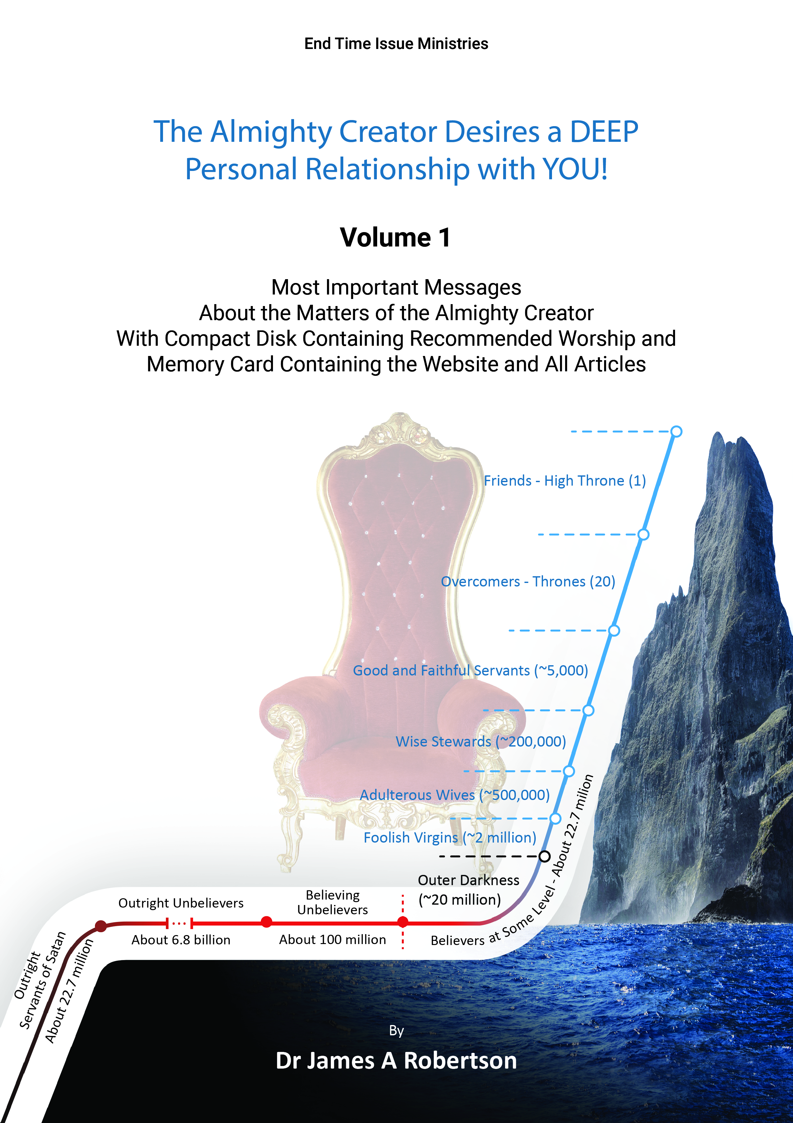
The jagged steep mountain symbolizes how difficult it is to draw close to Father Yah in the present age and how easy it is to fall from any level through pride, self-righteousness and other sin and error.
This collection of writings and, indeed, all of my writings are about how to move from some position on this curve to the position on the top right which is occupied by people close to Father Yah with the designation of “Friend” being the highest status that any human being can aspire to in this life.
The components of the curve are as follows (statistics are as at 25 December 2015) for ALL religious groups worldwide:
- Believers at Some Level – about 22.7 million made up of:
  - Friends (1) – high throne – put Father Yah first in their lives and serve Him faithfully.
  - Overcomers (20) – throne – have overcome sin and the temptations of this world.
  - Good and Faithful Servants (~5,000) – significant measure of faithful service.
  - Wise Stewards (~200,000) – some measure of faithful service.
  - Adulterous Wives (~500,000) – some level of infilling of the Spirit of the Almighty but continue in error and unbelief.
  - Foolish Virgins (~2 million) – believe but no infilling of the Spirit of the Almighty.
  - Outer Darkness (the majority -- ~20 million) – at some level once believed sufficiently to qualify for Heaven but nothing beyond that.
- Believing Unbelievers -- about 100 million – think they believe but so full of error they do not actually believe in the Almighty.
- Outright Unbelievers -- about 6.8 billion plus, the bulk of the population of the Earth – no awareness of any significance of the existence of the Almighty.
- Outright Servants of Satan -- about 22.7 million – at some level consciously serving Satan in roughly analogous groupings to those serving the Creator.
It is my hope that by reading this volume and by visiting my website at www.ETI-Ministries.org or www.End-Time-IssueMinistries.org you will be challenged to seek to move your life to the top right of the curve and become Father’s Friend and qualify for a High Throne in Heaven for Eternity.
I hope that in time this volume will be accompanied by six further collection of my writings – these documents are in course of being compiled and most are available electronically if you would like to email me.
Refer to the articles “The Demographics of the Kingdom of Yah on Earth Today” and “Demographics of the Kingdom of Yah elaboration”.

Vocabulary
Throughout this volume I have used vocabulary that you may find unfamiliar. These words have been drawn from the roots of the faith which are most accurately reflected in the language today known as Hebrew which is most directly related to the language that was used at the time of Creation.
This language has rich meaning that is not always accurately translated in English and other modern languages. The meanings and transliterations that I use here are a mixture of what is academically recorded and what I have been shown by Father Yah, the Almighty Creator.
The most commonly occurring words that are used are:
“Yah” as in “Yah the Eternally Self-Existing” – the true name of the Almighty Creator. Frequently translated “The LORD”. “The LORD” has blasphemous connotations and should never be used to refer to the Creator.
“Yahooeh” – most accurate transliteration of the Hebrew phrase which means “Yah the Eternally Self-Existing” which is more commonly but inaccurately transliterated as “Yahweh”. Frequently translated “The LORD”. Why a “Yahoo.com” email address takes the Name of the Almighty in vain.
“Almighty”, “Mighty One” or “mighty one” depending on context -- commonly but inaccurately translated “God” which has blasphemous connotations.
“El” – “Beloved Mighty One” – term of endearment for the Almighty Creator used by those close to Him. Frequently inaccurately translated “God”.
“Yahooshua” – meaning “Yah is Salvation” – the correct name of the man commonly referred to as “Jesus” and a common Hebrew name 2,000 years ago.
“Anointed by the Spirit of Yah”, “Anointing of the Spirit of Yah”, or “Anointed One” depending on context – commonly but inaccurately translated as “Christ” and incorrectly regarded as another name for Yahooshua {Jesus}. Source of much confusion regarding the identity of Yahooshua – Christ refers to Yah NOT Yahooshua.
“Qodesh” – commonly but inaccurately translated as “Holy” which has blasphemous connotations – means “set-apart”, “separated”, “dedicated to the Almighty”.
“Emissary” – a senior servant of the Almighty who is sent by the Almighty – commonly but inaccurately translated as “Apostle”. A senior rank on Earth.
“Spokesman” or “Spokeswoman” – commonly but inaccurately translated as “Prophet” or “Prophetess” – one who hears the Almighty and speaks on His behalf.
Names including Yah – see the article in section 6: “The TRUE Names of the Almighty in the Bible” for detailed discussion of all of these names. It is not possible to fully understand the history of anointed servants without knowing the extent to which the name of Yah is pervasive in that history.
“Stake” – Yahooshua died on a length of tree trunk, NOT a “cross” this is borne out by the Greek text. The cross is a Satanic symbol.
“Assembly” – commonly but incorrectly translated as “Church”.
“Pesach” – commonly translated as “Passover”.
“Shavuot” – commonly translated as Pentecost.
There are other words that are used in places in this volume but the above items are the most common words.
Throughout my writings incorrect words are reported in curly brackets in most cases e.g. “{Jesus}”.

Sponsorship
While some donations have been received the vast majority of the time, effort and finances used in the creation of these articles and in the preparation and publication of these articles has come from own endeavours and through the finances of the family units of which I was a member from time to time.
The principal source of funding of these physical volumes has been through my business, James A Robertson and Associates Limited.
This business provides consultancy and management services which provide the revenue that provides me with food, shelter and the finances used in the collation, preparation and publication of these volumes.
The logo is based on the Strategy – Tactics Matrix of Professor Malcolm McDonald. Strategy, which McDonald defines as “doing the RIGHT THINGS” is on the horizontal axis of the matrix and Tactics, which he defines as “doing THINGS RIGHT” is on the vertical axis. It follows that an organization or person who does the RIGHT things WELL will prosper and thrive.
James Robertson and Associates assists clients to do this with regard to business strategy, business information systems and business processes generally.
I have applied this same principle in my walk with the Almighty, constantly seeking to understand what He considers to be the RIGHT things and to do them WELL.
This set of books therefore are a resource to help you live your life such that on the Day of your Judgment you will find that you have done the RIGHT things WELL in the sight of the Almighty.
For more information see:
http://www.James-A-Robertson-and-Associates.com/
and
https://www.linkedin.com/in/DrJamesARobertson
In this business the Almighty has taught me a huge amount about business, strategy, ERP, human nature, etc. I would be happy to discuss how we can be of assistance to your organization.
I would like to acknowledge Russel Diniz and Remote Software Solutions who sponsored the uploading of articles from 2014 to 2018 onto the website and Nikita Narvekar who did the work. May the Almighty bless them abundantly.
I would like to acknowledge Sarita Benade who sponsored the printing of Volume 1 to the tune of 1,000 Australian Dollars, may the Almighty bless her abundantly.

Acknowledgements
I would like to acknowledge Geraldine Schoultz who has been interceding for me and my ministry constantly for many years and who has covered this project with prayer.
Also Nikita Narvekar who collated, sorted, classified and cleansed the articles for Volumes 4 through 9. I strongly recommend her work. May the Almighty bless her abundantly. She can be contacted at the following email ID:
sunshell.works@gmail.com
Also Gratiela Dumitrescu who created the covers for the book. May the Almighty bless her abundantly. I strongly recommend her and she can be found on Upwork at:
https://www.upwork.com/freelancers/~0157ad00e64379df31
Also Murtaza Kapaasi who formatted all Volumes diligently and precisely and is directly responsible for the overall appearance of the text. I strongly recommend him. May the Almighty bless him abundantly. He can be found on Upwork at:
https://www.upwork.com/freelancers/~017be35721b665562d

Table of Contents
Why Seek A DEEP Personal Relationship With The Almighty Creator? v
Why Read These Books? vii
Companion Volumes viii
Dedication xi
Request for Judgment xii
Caveat xiii
About the Cover xiv
Vocabulary xvi
Sponsorship xviii
Acknowledgements xx
Table of Contents xxi
Foreword xxvi
Preface : An Engineering Approach to Relationship with the Almighty xxviii
Overview of this Volume xxxi
Overview of the Entire Volume xxxiii
Audio Compact Disc and Memory Stick with Website xlii
Section 1: Initial Very Important Articles 3
1.1 The Almighty Desires Friends 3
1.2 Daddy Yah is LONELY, please talk to Him and use His true Name 5
1.3 Seeking truth 7
1.4 Some critical questions for believers at this time 8
1.5 Seek truth NOT error 11
1.6 The TRUE Name of the Creator is Yah the Eternally Self-Existing 15
1.7 The Demographics of the Kingdom of Yah on Earth Today 17
1.8 Demographics of the Kingdom of Yah elaboration 23
1.9 Why Keep Yah’s High Sabbaths? 27
1.10 Sexual Reproduction Proves Creation 29
1.11 Yah intends sexual lovemaking to be a high point of being human 34
1.12 The Virgin’s Covenant 42
1.13 Separation of a Man and a Woman who were in sexual union {divorce} 53
1.14 Judgment in THIS life 69
1.15 How did Yahooshua accomplish what he did? 77
1.16 What is wrong with “the Bible says it so I believe it”? 82
Section 2: The Eternity Series 85
2.1 The Contest between Yah the Eternally Self-Existing (the Almighty Creator) and Satan 85
2.2 What IF Satan WINS the Contest? 86
2.3 Where are YOU going at the end of your life? 87
2.4 What should YOU do? 90
2.5 The ULTIMATE GOAL -- deep personal friendship with the Almighty Creator of the Heavens and the Earth 91
2.6 The ULTIMATE SIN -- unbelief -- believing the Almighty Creator does NOT exist -- by default allegiance to Satan 91
2.7 The TRAP to prevent you achieving the goal of deep personal relationship with the Creator -- the Bible, the Church and Pastors and other people 92
2.8 The REAL Conspiracy – Satan’s Plan for Victory 94
Section 3: The Almighty Creator Desires a DEEP Personal Relationship with YOU! 97
The Almighty Creator Desires a DEEP Personal Relationship with YOU! 97
Foreword 97
Summary 99
Introduction 101
3.1 How will YOU know He exists? 103
3.2 What is in it for YOU? 105
3.3 But this religion stuff is irrational and illogical, frankly its nonsense! 109
3.4 So, IF He is so powerful why is there SO much wrong in the world? 110
3.5 BUT – He demands too much, I cannot comply! 111
3.6 Some other things you should know 112
3.7 What do YOU need to do IF you accept this message? 112
Conclusion 112
Section 4: Seven Steps to Drawing Close to the Almighty Creator 115
Summary 115
Introduction 116
4.1 Decision 117
4.2 Prayer 123
4.3 Fasting 138
4.4 Cleansing 140
4.5 Worship 156
4.6 Research 179
4.7 Action 180
Section 5: Where will YOU Spend Eternity? 183
Summary 183
Where Will You Spend Eternity? 185
5.1 A Critical Question 185
5.2 An Important Caveat 186
5.3 Where will You Spend Eternity? 187
5.4 A Vital Question: Do We Know What Sin Is? - What Is The Essence Of The Judgment? 191
5.5 Cause For Concern - Nearly All Of Mankind Is Breaking Most Of The Commandments 193
5.6 Is There An Alternative? - Can One Aspire To A High Throne? 194
5.7 It Is Not Just Heaven Or The Lake Of Fire, There Is A Continuum 195
5.8 It Is Possible To Overcome 198
5.9 What Indicators Are There About Pleasing The Almighty? 200
5.10 How Do We Overcome? What Is The Price? 205
5.11 Some Challenging Passages From The Final Quest 216
5.12 Joyners Experience Of The Judgment 226
Conclusion 246
Section 6: The TRUE Names of the Almighty in the Bible 249
Abstract: 249
The TRUE Names of the Almighty in the bible 250
Some Words Used To Describe Yah 251
Words Translated “God ” 253
Names Including Yah 265
Further Words Which Refer To Yah 288
Names Including Yah 291
Additional Words Which Relate To Yah 295
Appendix A : Instances of Jehovah and Jah = Yah (In The Hebrew Lexicon of The Online Bible) 296
Instances of Yah 307
Appendix B: Instances of Yah (In The Hebrew Lexicon of The Online Bible) 307
Closure 309
Section 7: Our World Today – History – the REAL Facts 311
Introduction: The need for an accurate summation of the world today 311
Chapter 1: The beginning – Father was lonely 314
Chapter 2: Satan – an experiment gone horribly wrong – the Contest 319
Chapter 3: Adam as Ruler – rebellion and falling away 323
Chapter 4: The Flood – why it happened and how it happened 325
Chapter 5: Human spirits – ancestor spirits and the demonic Masterminds 326
Chapter 6: The recovery of Earth and ongoing degeneration of mankind 329
Chapter 7: How the madness of Bible worship has corrupted understanding 331
Chapter 8 : Where we are today – the choices we each face 333
Conclusion -- Yah’s call to YOU today 334
Section 8: The Global Flood that Changed the World 335
Foreword 335
Chapter 1: Introduction 336
Chapter 2: Context 339
Chapter 3: South African Gold Mines Prove a Massive Hydraulic and Tectonic Event 348
Chapter 4: Layered Sedimentary Rock Covers MOST of the Planet and Proves a Global Flood 352
Chapter 5: The Halfway House Granite Dome Proves a Massive Tectonic Event 355
Chapter 6: The African Erosion Surface, The Planar Surface that Proves a Global Flood 363
Chapter 7: Incised Valley’s Prove High Speed Water Drainage Consistent with a Global Flood and Continental Separation 369
Chapter 8: Where did the Water come from and where did it Go? 379
Chapter 9: What is the Age of All this? REALLY? 388
Chapter 10: Signs of Judgment : The REAL Miracle – a man and his family SURVIVED! 400
Chapter 11: Implications of the Global Flood. What important lessons can we learn? 416
Chapter 12: Some Spiritual and Religious Considerations 421
Conclusion 431
Section 9: Table of Contents of the Memory Card in the Front Cover of this Book 433
The Almighty Creator Desires a DEEP PERSONAL relationship with YOU! 433
This memory stick contains: 434
01 Most Important Articles 434
02 Very Important Articles 435
03 Books 435
04a Radio Transcripts 435
04b Radio Recordings 435
05 Relationship with Yah Series 436
06 Annual Volumes 436
07a Recommended Worship Songs – Corrected Words 436
07b Recommended Worship Songs 436
08 Music CD 437
09 Global Flood 437
10a Marriage Teaching Transcripts 437
10b Marriage Teaching 437
2000 to 2009 437
2010 to 2019 437
www.eti-ministries.org Website on Disk 438
Conclusion 438
Section 10: Table of Contents of the End Time Issues Website 439
Conclusion 460

Foreword
On Friday 12th March 1993, having been awake all night running strategic processes to try and figure out why my life was such a mess and figuring out the most reliable way to kill myself the Almighty spoke to me audibly from within the room and said “Phone Iain Peters, he has something you need”.
I had been in an adulterous relationship with another man’s wife for two years. During that time we made love passionately and considerately hundreds of times but we never spoke of love – I believed I loved my wife and therefore could not love another woman. When the affair was exposed and I was forced to part company with my mistress who was also my personal assistant, I was devastated to learn that I was massively in love with her such that I could not visualize living without her and so I was seriously considering suicide.
I had been a believer, albeit a nominal believer, since I was confirmed in the Anglican Church at the age of around 13 years old and had been a server or Altar Boy from the age of nineteen for about six years. Eventually I became alienated from the church by the hypocrisy and teachings that did not make sense and so I walked away and progressively backslid to a point where I entered into adultery.
After the Almighty spoke to me I phoned Iain and he invited me to have dinner with him. After dinner he shared with me his living relationship with the Almighty in which prayers were answered and he experienced healing and divine provision. He lead me in prayer to rededicate myself to serving the Almighty.
Iain took me to his church and pointed me in the direction that I have followed ever since.
At that time I understood that my intellect had set me on a course that was headed for destruction and that if I had succeeded in killing myself at that time I would have found myself in Hell. I repented deeply and set myself to seeking to know the Almighty. I reasoned that He was the creator of all things and was therefore the Master Engineer and that, accordingly He would not expect me to compromise my Engineering rigour and disciplines in order to understand Him. Accordingly I set about learning about Him in a rigorous and disciplined fashion asking masses of questions.
Progressively over the years I came to understand that the Church and mankind generally were full of error and, increasingly I came to rely on hearing directly from our Father in Heaven.
The road was a difficult one with numerous pitfalls and traps and lots of painful lessons but, somehow, I have managed to stay more or less on track through all of this.
In 2000 I fasted seriously for the first time and started to receive dramatic revelation. This has continued with another program of fasts in 2010 and again in 2013 and 2014 leading to a point where I was extremely close to Father just before the Day of Atonement in 2014 which is when the two core articles in this volume were written – “The Almighty Creator Desires a DEEP Personal Relationship with YOU!” and “Seven Components in Drawing Close to the Almighty Creator”.
From 2000 onwards I published regularly on various email lists and in 2013-14 my wife at the time, Ester, helped me to build the present website, http://www.ETI-Ministries.org
During this journey I increasingly came to understand that the Creator, His True Name is “Yah the Eternally Self-Existing”, had created us to be His Friends and to work with us in discovering and learning about His Creation but that as a consequence of the fall of man virtually no human beings knew this let alone sought it with commitment. This understanding culminated in my decision to write the two articles above and that, in turn, has led to the creation of this volume in the hope that I will challenge a few people to seek to become TRUE FRIENDS of the Almighty.
I commend this volume to you as containing articles most of which were written under a significant anointing and with a significant level of inspiration and I pray that the study of this material will stimulate YOU to seek to become a FRIEND of Yah. I pray that I will soon be able to publish additional volumes and encourage you to contact me to obtain copies.
May Father bless you and keep you and make His face to shine upon you.
May Yah judge me severely and correct me harshly and show me the level of my present deception and how to correct it with regard to everything that I write and publish.
Warm regards and blessings,
James
James Robertson
End Time Issue Ministries
Emissary and Spokesman of Yah
London
25 September 2018
Website : http://www.ETI-Ministries.org
and http://end-time-issueministries.org/
YouTube on the Global Flood: http://www.YouTube.com/user/ProofOfGlobalFlood
SlideShare Flood Presentations: http://www.slideshare.net/End_Time_Issue_Ministries
Facebook: https://www.facebook.com/profile.php?id=100006994485801
Google+: https://plus.google.com/110001879332326921534

Preface : An Engineering Approach to Relationship with the Almighty
Yah the Eternally Self-Existing, the Almighty Creator says:
"I am the most rational and understandable being in existence and yet the religious cranks and bible punchers have caused people to view me as irrational, unreasonable and nonsensical and therefore NOT worthy of rational consideration!"
And
"People insist on force-fitting me into their boxes according to their limited understanding and incomplete knowledge, instead of seeking to understand me and conform to me"
This volume is the culmination of applying Engineering Principles to the matters of the Almighty Creator since 1993
I have been designing and making things that work since about the age of five, I have a Batchelors Honours degree in Engineering and a PhD in Engineering and have been a registered Professional Engineer for many years.
I hold that Engineering is very robust and demanding -- things, whether machines, buildings, bridges, computer software, etc ONLY work if they are exactly designed, exactly built and exactly operated -- Engineering as an occupation and a way of doing things focusses on designing and building things that work reliably and sustainably for the design life of that item.
Between the age of around 24 and the age of 40 I became increasingly disillusioned with religion because it did NOT satisfy my requirements for rigour, precision, ability to be understood, etc. By rejecting the sloppy approach of established religion I made the mistake of also almost entirely rejecting the Creator as NOT existing, a mistake that many logical, thinking people make.
In March 1993, on the point of killing myself, the Almighty spoke to me audibly as described elsewhere in this Volume and I turned back to Him who had spoken to me.
In doing this I took a decision that since He had created everything with such obvious precision it was clear that He would NOT require me to compromise my Engineering ways of thinking and analysing and I therefore set about learning about Him on the basis that:
- he is an Engineer amongst all His other talents and abilities;
- therefore everything He does is logical and able to be understood;
- He is willing and able to answer EVERY sincere, probing, inquiring question seeking after understanding.
He has operated with me on this basis now for over 24 years at time of writing (September 2017 -- age sixty three) and I commend this approach to anyone who is seeking truth and particularly to those sceptics who are highly educated and have been turned off belief in the Almighty as a consequence of the irrational and illogical teachings of institutional religion.
I hold that Engineering is one of the most demanding occupations on the planet today, make a mistake and buildings collapse, systems fail. The world of structures, machines, electronics, software is extremely unforgiving and therefore the level of rigor that Engineers perforce adopt is great. I decided that the Almighty would NOT expect me to compromise on my Engineering rigor even a little bit and therefore EVERYTHING was capable of rigorous analysis and understanding.
In over 24 years I have NEVER found reason to go back on or question this decision.
I also chose to rely on the Almighty Himself to guide me.
Yes I would learn from people BUT, when I did NOT understand what they said or what they said did not work, I would ALWAYS turn to Him for answers. I have slipped on this a few times and relied on men BUT nearly ALL the time I have relied on Him to teach me. In the process I have come to understand that just about everything that the church teaches is massively in error and at odds with the truths of the Almighty, just as was the case in the days of Yahooshua {Jesus}.
Since 2000 almost all my learning has been directly from Him with other humans providing occasional snippets of information.
What is presented on my website and in this Volume is founded on these two principles:
- Engineering rigour;
- Answers directly from the Almighty.
This is underpinned by an intense personal experiential knowledge of the existence of the Almighty Creator grounded in His deep desire to have a DEEP personal relationship with each one of us AND to talk to us and counsel us and guide us in EVERYTHING.
He is JUST as interested in your areas of expertise and interest as you are. He created each one of us to walk with Him and talk with Him.
When considering what you find in this Volume and those that I hope will follow it, please keep in mind that you should NEVER follow me or ANY other human, follow ONLY Yah. It is up to YOU what you take from this Volume, you must exercise your intellect – by all means learn from my example and my teachings BUT always follow Yah alone!
Be aware that I am human and fallible and come from the same background of gross error as everyone else on this planet and, accordingly, my understanding today may still be skewed to some extent. That said, in many cases my understanding today is very different to what it was ten years ago or even more recently. Accordingly my recent articles may differ materially from earlier articles on the same subject. The more recent articles are generally more accurate.
At the end of the day YOU must discern what is truth and what is error in this Volume -- you are accountable for what you believe on the Day of Judgment and for what you do with what you read.
Should you find issues you disagree with you are welcome to contact me.
That said I testify that I have spent thousands of hours seeking to draw close to Father and that I have prayed regularly to be shown the level of my present deception and how to correct it and asked for judgement for sin so I DO have a high level of confidence that much of what is in this Volume IS largely given by Him and can be trusted.
I pray that as you read this Volume you will find reasons to draw closer to Him, that you will find answers to difficult questions and that your intellect will be challenged in the satisfying way that mine has been.
James Robertson BSc (Eng), PhD
PrEng (Retired), LtCol (Retired)

Overview of this Volume
This volume contains what I consider to be the four most important documents I have ever written in my journey of building my relationship with our Father in Heaven. I understand Him to say that He regards them as the four most important documents on the planet today from His point of view.
Our Father in Heaven, Yah the eternally self-existing, created mankind to be His Friends and to do things with Him and learn with Him. Today virtually no-one on Earth knows this and a minute number of people are actually seeking to come to the point where they hear Father Yah tell them that they are His Friend. In fact, it is my understanding that, at the time of writing, 30 September 2017, there are only TWO people on Earth who Yah has actively named as being His Friends.
This document is intended to make YOU aware that Father Yah wants YOU to be His Friend AND to explain to you HOW to achieve this position in YOUR relationship with Him. IF you succeed in becoming His Friend and remain His Friend throughout your life you WILL qualify for a very high throne and a position of great esteem and responsibility for eternity. It is entirely up to YOU and within YOUR grasp to achieve this position.
The four core documents in this set are:
  - The Almighty Creator Desires a DEEP Personal Relationship with YOU!
This document sets the scene and explains the context and the call to become Yah’s Friend. Read this first.
  - Seven Steps to Drawing Close to the Almighty Creator
This document sets out in great detail most of the measures I have taken, the fasts I have been on, many of the prayers I have prayed and most of the worship songs I have sung hundreds of times in order to progress to the point where Father has called me “Friend”. These same measures have enabled me to retain this position since 2001 to time of writing in September 2017 and, I believe, IF I diligently apply them for the rest of my life, will enable me to leave this life and graduate to a position of high esteem and authority in Heaven on a High Throne. I pray that YOU will aspire to achieve comparable status and to climb the mountain of Yah HIGHER than I have climbed.
There are many other prayers I have prayed and much conversation I have had with Father but this document sets out what I currently understand to be the essential measures. I know one person who has put many of these measures into practice who a short while ago, to my great joy, was pronounced by Father Yah to be His Friend. I commend this document to you for YOUR EARNEST attention!
  - Where will YOU Spend Eternity?
This document, recently revised, was written many years ago as the best expression of how I understand things to be. In particular it provides a detailed analysis of what it takes to qualify for a High Throne and comments on life style adjustments that will be necessary in order to qualify for a High Throne. Read this once you have deeply immersed yourself in the first two books.
  - The TRUE Names of the Almighty in the Bible
An in-depth analysis of the true names of the Almighty in the Hebrew texts of what we know as “The Bible” today. This is extremely important to understanding Father – His true name, Yah the Eternally Self-Existing, means a huge amount to Him because it is so little used and so abused today. I commend this to you as important context to understanding the matters of Father Yah.
The first two documents were written around the Day of Atonement in 2014 at a time when I was operating under a very intense anointing and was the closest to Father that I have ever been and was hearing Him the clearest I have ever heard Him. I commend them to you as inspired and anointed works.
The rest of this volume contains supporting articles which address associated topics including an overview of the History of our present society as given to me by Yah as well as a detailed exposition of the evidence of a Global Flood that exists all around us. Various other supporting articles are also included.

Overview of the Entire Volume
  - Initial Very Important Articles
A few selected articles from the entire collection of over 1,000 articles that is available on the website www.ETI-Ministries.org and also www.End-Time-IssueMinistries.org
The following articles are included:
    - The Almighty Desires Friends
Brief discussion of the Reality that the Almighty Created us to be His Friends.
    - Daddy Yah is Lonely – Please Talk to Him and Use His True Name
The Creator, Yah the Eternally Self-Existing, created us to be His friends, almost no-one today qualifies for a position that he hoped would be occupied by millions of people by this time.
    - Seeking Truth
About the importance of seeking truth – the Almighty is ALL truth, Satan is ALL lies.
    - Some Critical Questions for Believers at This Time
A list of questions that all believers should ask themselves in order to establish where they are in their relationship with Yah.
    - Seek Truth NOT Error
An important principle, the world is full of error, do not talk about it, do not focus on it, focus instead on seeking truth and that will draw you closer to Father Yah.
    - The TRUE Name of the Creator is Yah the Eternally Self-Existing
Like all people, Father is particular about His name and it brings great joy to Him when someone uses His True Name.
    - The Demographics of the Kingdom of Yah on Earth Today
The REAL picture with regard to believers, unbelievers and Satan servants on Earth today. The harsh reality that there are only around 22.7 million believers of all denominations and groups as well as about 100 million believing unbelievers. There are very FEW people really close to Father. This is an extremely sobering assessment of the state of the world today.
    - Demographics of the Kingdom of Yah Elaboration
Further information on the Demographics.
    - Why Keep Yah’s High Sabbaths
Why it is important to keep Yah’s High Sabbaths IF you truly are seeking to draw close to Him.
    - Sexual Reproduction Proves Creation
A robust analysis of why the existence of sexual reproduction in all major plant, animal, bird and fish species proves that there HAS to be a Creator.
    - Yah Intends Sexual Lovemaking to be a High Point of Being Human
Counters wrong thinking amongst many believers of diverse groupings relative to human sexuality and summarizes diverse facts relating to the relationship between man and woman.
    - The Virgins Covenant
The true consequences of sexual intercourse with a Virgin, why Virginity is important and related issues.
    - Separation of a Man and a Woman – Divorce
Discussion of the acceptable basis for divorce and how to go about it in the Spirit Realm including what is necessary to give effect to the divorce.
    - Judgment in THIS life
Very few people understand that judgment takes place in this life, particularly of believers, and that there are measures that can be taken to avoid judgment. This article explains Judgement in This Life in some detail.
    - How did Yahooshua {Jesus} accomplish what he did?
There is great confusion about who Yahooshua is and about what he accomplished and how he accomplished it. This article explains in simple terms what he accomplished and how he accomplished it.
    - What is wrong with – The Bible says it so I believe it?
There is great confusion about the Bible and its role in the life of believers, this article addresses one facet of the subject, there is much more on the website.
  - The Eternity Series
A series of articles that discuss various aspects of what happens at the end of our lives and where we go. This is sobering material for every person to read as well as from the perspective of understanding what the long-term options are relating to our life on Earth.
    - The Contest Between Yah the Eternally Self-Existing and Satan
Critical understanding regarding what is REALLY happening on Earth and why the World is such a messed-up place.
    - What IF Satan WINS the Contest?
Notwithstanding common misapprehensions, it IS possible for Satan to win and to Rule on Earth for Eternity!
    - Where are YOU Going at the End of Your Life?
Crucial reading for every person, whether you believe or do not believe.
    - What Should YOU do?
Recommendations with regard to measures you can take to start actively influencing where you will end up after you die.
    - The ULTIMATE Goal
What you should be aiming for in this life.
    - The ULTIMATE Sin
The greatest sin of all is NOT believing that the Almighty Creator exists.
    - The TRAP to Prevent You Achieving the Goal of Deep Personal Relationship with the Creator
People and things that will get in the way of you achieving a deep personal relationship with Yah the Eternally Self-Existing.
    - The REAL Conspiracy – Satan’s Plan for Victory
There are lots of Conspiracy theories but there is one overarching conspiracy that IS real and IS having massive impact.
  - The Almighty Creator Desires a DEEP Personal Relationship with YOU!
The focus of this volume, this is what YOU were created for!
    - How will YOU know He exists?
A discussion of some pointers to the existence of the Almighty Creator.
    - What is in it for YOU?
Some reasons WHY YOU should believe and seek a deep relationship with the Almighty.
    - But this religion stuff is irrational and illogical, frankly its nonsense!
Confirmation that much of what all religions teach is NOT logical – religion is designed to draw us AWAY from the Almighty.
    - So, IF He is so powerful why is there SO much wrong in the world?
Short answers to a critical question, the contest.
    - BUT – He demands too much, I cannot comply!
A common objection.
    - Some other things you should know
Reference to the website www.ETI-Ministries.org and www.End-Time-IssueMinistries.org
    - What do YOU need to do IF you accept this message?
Some measures you can take and prayers you can pray.
  - Seven Steps to Drawing Close to the Almighty Creator
How to get close to the Almighty – the prayers to pray, the processes to follow – a seventy page discussion summarizing the key lessons that I have learned in order to give you the best opportunity to draw close to the Almighty.
    - Decision
The first step is to take a quality decision.
    - Prayer
Prayer is a vital aspect of drawing close to Father. Discussion of some prayers you can pray, etc.
    - Fasting
The importance of fasting and a recommended approach to fasting.
    - Cleansing
How to clean yourself spiritually to remove the contamination of the World System and the Satanic and Demonic Realm.
    - Worship
Discussion of the importance of worship as making love to Father and some recommended songs. I hope to make these available in a separate volume in due course. Please email me at Volume_1@ETI-Ministries.org.
    - Research
It is vital for YOU to conduct your OWN research into the matters of the Almighty as they apply to you and in the context of YOUR life and YOUR calling.
    - Action
True believe will be accompanied by action, a discussion of steps you can take to act on what you are learning.
  - Where will YOU Spend Eternity?
The most important question for you to answer BEFORE you die so that you are NOT surprised when you die!
    - A Critical Question
Poses the question “where will YOU spend eternity?”
    - An Important Caveat
This writing is geared to belief in the Almighty irrespective of religious bias.
    - Where Will You Spend Eternity?
The subject of the book discussed.
    - A Vital Question: Do We Know What Sin Is? - What Is the Essence of the Judgment?
Vital to understanding the focus of this book.
    - Cause for Concern - Nearly All of Mankind is Breaking Most of the Commandments
A sober assessment of the real state of the Earth today.
    - Is There an Alternative? - Can One Aspire to a High Throne?
Postulating an alternative outcome to life on Earth.
    - It is Not Just Heaven Or the Lake of Fire, There is a Continuum
There are different options available.
    - It is Possible to Overcome
There IS a high road option.
    - How Do We Overcome? What is the Price?
The cost of achieving the high road outcome.
    - Some Challenging Passages from The Final Quest
The book, “The Final Quest” reports some challenging information from a series of visions.
    - Joyner’s Experience of The Judgment
The experience of the writer of The Final Quest of the Judgment in his visions.
Declaration
My declaration regarding my understanding of the accuracy of the contents of the “Where will YOU Spend Eternity” book.
Closing the Second Edition
Notes following updating the document to reflect new understanding.
  - The TRUE Names of the Almighty in the Bible
A lot of the confusion regarding the Almighty stems from the wrong names that are applied to Him. This article discusses in-depth the true names and their occurrence in the Bible as an authoritative reference work.
    - Some Words Used to Describe Yah
Introductory discussion of key words used to describe the Almighty Creator.
    - Technical Caveat
Notes re my approach to translating.
    - Words Translated “God”
A list of words that are translated as “God” but which should be translated differently.
    - Names Including Yah
A list of words which, when correctly translated, contain “Yah” the Name of the Almighty.
    - Further Words Which Refer to Yah
A list of additional words that contain references to Yah.
    - Names Including Yah
Further names including Yah.
    - Additional Words Which Relate to Yah
Further words that relate to Yah.
    - Appendix A: Instances of Jehovah and Jah = Yah in the Hebrew Lexicon of the Online Bible
A further list of words containing Yah.
  - Our World Today – History – the REAL Facts
There is massive misunderstanding, particularly amongst believers, of the REAL facts regarding the history of the world we live in today, this document sets out the headlines of what REALLY matters.
    - The need for an accurate summation of the world today
Introduction, why this document is necessary.
    - The beginning – Father was lonely
The fundamental reason we exist is that Father Yah was lonely and He created us to be His Friends and Companions.
    - Satan – an experiment gone horribly wrong – the Contest
The progressive creative process went horribly wrong when Satan developed pride, rebelled and successfully challenged Yah to a Contest.
    - Adam as Ruler – rebellion and falling away
Adam was Yah’s ruler on earth but he followed Satan’s deception, rebelled against Yah and fell away leading to the mess the world is in today.
    - The Flood – why it happened and how it happened
After about 1,500 years the world was so demonically controlled that Noah asked Yah to destroy it which He did by directing an Ice Comet to strike the Earth.
    - Human spirits – ancestor spirits and the demonic Masterminds
When unbelieving humans die their spirits remain on Earth and they rule the spirit realm.
    - The recovery of Earth and ongoing degeneration of mankind
As the Earth recovered after the Flood mankind again degenerated.
    - How the madness of Bible worship has corrupted understanding
Yah fought to keep the Bible as a reliable History Book, Satan has succeeded in getting believers to worship the Book and use it for purposes that it was never intended to serve.
    - Where we are today – the choices we each face
The options facing each one of us.
    - Conclusion -- Yah’s call to YOU today
What is Yah REALLY saying to YOU today?
  - The Global Flood that Changed the World
How the Geology and Topography of our Planet were formed.
Proof of a massive hydraulic and tectonic event that totally destroyed the surface of the Earth and all that lived on it. Supported by numerous photographs and supporting documentation.
    - Introduction

    - Context
Discussion of a wide range of concepts, principles and facts that support the reasoning contained in the sections that follow.
    - South African Gold Mines Prove a Massive Hydraulic and Tectonic Event
The South African Gold Fields expose metamorphosed sedimentary (that is water-laid) rocks to depths of upwards of 5 kilometres below the surface of the Earth such that they can only result from a Global Flood event.
    - Layered Sedimentary Rock Covers MOST of the Planet and Proves a Global Flood
The presence of Sedimentary rocks covering about 90% of the surface of the Earth clearly evidences that at some stage the surface of the entire planet has to have been covered with water.
    - The Halfway House Granite Dome Proves a Massive Tectonic Event
Granite Domes and other massive intrusions of Igneous Rocks evidence massive disruption of the surface of the Earth that is consistent with a massive tectonic and flood event.
    - The African Erosion Surface -- The Planar Surface that Proves a Global Flood
A horizontal erosion surface over thousands of kilometres evidences that there has to have been uniform water action over huge areas of the planet on a consistent and uniform basis.
    - Incised Valley’s Prove High Speed Water Drainage Consistent with a Global Flood and Continental Separation
Incised Valley’s all over the planet are consistent with high speed drainage of water off the continents consistent with rapid continent separation and expansion of the diameter of the Earth.
    - Where did the Water come from and where did it Go?
A detailed discussion of logical explanations with regard to where the water came from and where it went to.
    - What is the Age of All this? REALLY?
Discussion of the real age of the present surface of the Earth and why about 4,500 years is entirely plausible.
    - Signs of Judgment -- The REAL Miracle – a man and his family SURVIVED!
A discussion of various verifiable historical events associated with judgment by the Almighty as a warning of further judgment to come if we are not careful.
    - Implications of the Global Flood -- What important lessons can we learn?
Discussion of important lessons that flow from realization that there REALLY was a Global Flood.
    - Some Spiritual and Religious Considerations
Some supporting spiritual and religious information that is important to understanding the world we live in.
  - Table of Contents of the Memory Card in the Front Cover of this Book
The Memory Card in the front of this volume contains all the material that I have produced together with a copy of the website. Please use this as a resource for copies of all the volumes of this book and all other materials.
  - Table of Contents of the End Time Issues Website
In the period 2013-14 we undertook a huge amount of work on the www.ETI-Ministries.org website to collate and present the huge volume of material that I had published by email in the years leading up to that period and during that period.
The Table of Contents is a useful reference in terms of seeing the diversity of topics that are addressed on the site. You should find material of relevance to just about every aspect of life on this planet and life in the service of Yah the Eternally Self-Existing.

Audio Compact Disc and Memory Stick with Website
In support of this book and the other books in the series there is a separate volume containing an Audio Compact Disc with copies of the recommended worship songs with doctrinally erroneous elements removed as far as possible and accompanied with corrected listings of the words that are used in the songs.
This volume also contains a Memory Stick which contains over 16 MB of data including a full copy of the website that you can browse on your computer without an Internet connection. A complete set of all the articles and books that I have ever written on the matters of the Almighty is also contained on the memory stick.
Email me at CD_and_Memory_Stick@ETI-Ministries.org to obtain a copy of this volume which also includes a full listing of the contents of the website and full listing of contents of the Memory Stick including listing ALL articles.

The Almighty Creator Desires
a DEEP PERSONAL relationship with YOU!

Most Important Messages
About The Matters of the Almighty Creator

This page is intentionally kept blank.

Section 1:
Initial Very Important Articles

1.1 The Almighty Desires Friends
Yah, the Almighty Creator says:
"There is a huge issue in terms of believers thinking they can believe what suits them and do what suits them thereby abdicating their responsibility to serve me faithfully and overcome"
The purpose of serving Yah is NOT for what He will give us in THIS life, but for what we will give Him in exchange for His rewards to us in the life to come!!
Yah, the Creator, desires to have deep personal relationships with people who become His friends
THE ultimate goal of ALL this, the entire Creation, the entire history of Earth, the entire society in which we live is for human beings to come into existence through procreation from Adam and Chavah {Eve} and live lives that afford them the opportunity to qualify to enter heaven, to be found to be good and faithful servants, to be overcomers and to become friends of the Almighty Creator, Yah the Eternally Self-Existing
Of these the HIGHEST goal is to become a FRIEND of the Almighty in THIS life
A friend of the Almighty is one who has strenuously worked to developed a close personal relationship with the Almighty, through faith, sacrifice, discipline by choice
A person who has done the hard yards to grow in obedience, dealt with sin, aligned themselves with the Almighty, sought a deep personal relationship, prayed the right prayers, spent thousands of hours in worship, prayer, study and seeking the Creator
A friend of the Almighty is a person to whom the Almighty confides His plans and discusses them, consults with asks the opinion of and a person to which He admits His mistakes
YES, the Almighty DOES make mistakes, Satan was a mistake, a failed experiment, The Contest in which we find ourselves today was a mistake, permitting Ham to enter the survival vessel with his father, Noah, was a mistake, etc
A friend is one who does just enough to provide for themselves and devotes as much time as possible to the service of the Almighty, a person who is entirely dependent on the Almighty and totally in love with Him
The Almighty desires friends ABOVE ALL ELSE
People who remain true to their friendship with Yah to the END of their lives will, on their death, sit on the highest thrones in Heaven very close to Yah and Yahooshua {Jesus} -- there is NO GREATER PRIZE than being a friend of the Almighty and the reward in the life to come is beyond anything we can imagine today in terms of the esteem, the honor, the glory, the authority, the power that awaits these people
There are few people in any generation who truly qualify as friends and there have only been a few men in ALL of history who have been so close to the Almighty that they have REALLY made a difference
The most notable friends to date have been Noah, Moshe {Moses}, Yahooshua {Jesus} and Mohammed
There have been friends in every generation who have NOT played such dramatic roles in the world, these include Abraham and David and many others
You may not aspire to such high status BUT it IS available to YOU
It is available to everyone of us to become friends of the highest standing
There is a huge amount of work to be done in this generation and there is place for friends who will make a DRAMATIC difference
Are YOU willing?
Do YOU aspire to please your Father in Heaven and become His Friend?
There is much on this site to assist you, I encourage you to pull out ALL the stops and "go for it"
Refer to Relationship with Yah for more in this regard.
More at http://end-time-issueministries.org/CreatordesiresFRIENDS.aspx.html
29 February 2016

1.2 Daddy Yah is LONELY, please talk to Him and use His true Name
In December 2010 I wrote the following article about how lonely our Father in Heaven is. It seems important to share it now.
I continue to see how lonely Daddy (Abba) Yah is with almost all believers talking AT Him and requiring Him to perform on demand according to their view of what is important.
Please read this article prayerfully and consider what you should do.
>>> Repost begins <<<
2010.12.11
Daddy Yah is LONELY, please talk to Him and use His true Name
I am away on a secluded farm in the Natal Midlands seeking to grow closer to Daddy Yah.
In doing this I am amongst other things getting accustomed to calling Him Daddy, as opposed to Abba.
My reasoning being that Abba is a meaningless word for me as a non-Hebrew, intellectually I sort of know it is the Hebrew for Daddy but it is NOT a word that I intrinsically relate to whereas Daddy has deep meaning to me.
I recently listened to a teaching about our Creator being our Daddy from someone who had such a revelation in this area and spoke with awe about what their Daddy had done that I resolved to change my language in this area as well.
The night before last I was seeking to worship with one of the CD’s I had brought with me which I had thought of as being reasonably reliable from a doctrinal perspective.
Perhaps as a consequence of the series of fasts I have been on I have become more in tune with Daddy’s heart but I found track after track was nice to listen to, a number had sound tracks that I regarded as highly anointed, but …
As I listened, apart from the fact that they all used the incorrect names and titles, which I correct almost without thinking, most of them were about us, me, I, we, there was almost nothing about praising Yah Himself. And then, of course there were tracks that praised Yahooshua and equated him with Yah and these were entirely off the mark.
In the end, on a CD of 20 tracks which had previously been selected with some care I found only two tracks that really praised Yah rather than sung about people or Yahooshua. As I realized this I was wracked with tears and deep grief and I felt how lonely our beloved Heavenly Father, our Daddy was at that moment.
We hardly praise HIM at all, we sing about what we get from Him and what we want from Him and what we do and what we want Him to do but we seldom praise and worship Him.
I thought about recent church visits I have made where I have been deeply troubled by the amount of worship given to wrong names and wrong deities, specifically Yahooshua but I had never appreciated just how lonely and HURT Daddy Yah is at this.
We seem to think we can praise any way we want and He is somehow OK with it, after all, He is big enough to cope isn’t he?
NO, NO, NO, he is LONELY, he is hurting.
We owe our existence to Him and yet we ignore Him almost totally.
And …
NO
I am not talking about the unbelievers, those we love to insult be calling them “unsaved” as though we are guaranteed our place in heaven when all we have done has met the minimum entry conditions for consideration for a place in heaven for eternity.
I am talking about US – YOU AND ME
Do you have any idea how big a SNUB christmas and new year are to Daddy Yah and to Yahooshua?
Do you have any idea what a victory christmas and new year are for Satan and his cohorts?
We boost the global economy for several months before christmas and then the entire global economy grinds to a halt while we worship the sun god and do obeisance with our dollars / rands / pounds / shekels / etc
And through all this Daddy does what Daddy’s do best, put on a brave face and try and be loving and caring and be grateful for the snippets of love and honour that we are able to give Him through our massive deception.
His heart is breaking
And then for the rest of the year we serve him with praise and worship very little of which truly lifts HIM up, most is self centered, self-serving, worships Yahooshua, whatever but it seldom really honours Him and lifts HIM up.
IF you really care about Yah I beg you to start this new calendar year of the satanic calendar (it bears no relation to Yah’s calendar) by committing yourself by seeking to put into practice what I have shared with you in recent weeks regarding the true Names, the true identity of Yahooshua, etc.
And commit yourself to being selective about the worship music you listen to and sing to and if you have musical ability consider recording music that really does honour Yah as Creator of the Heavens and the Earth, the Almighty Mighty One who gave you life and in who is all hope of salvation – use the tunes you like with the words adjusted.
I pray that you will find this article of value and will pass it on to others.

1.3 Seeking truth
For those that are truly seeking a close relationship with Father Yah, Father has given me some prayers and a program of fasting for a particular believer that I believe are relevant to all believers.
Father desires to take the relationship of every believer with Him to a deep new level.
In particular, He earnestly desires them to be aware that they can draw much closer to Him and that He desires them to seek to become His friends.
Following are some prayers that will help:
- Father, I earnestly desire to become your friend, please show me all that is standing in the way of deep friendship with you and how to deal with it and how to draw close to you at a deep personal level.
- Father I ask you to lead me into ALL truth by your Spirit and show me all the changes I need to make to get rid of anything in my life that is NOT truth.
- Father I ask you to show me the level of my present deception and how to correct it.
- Father I ask You to help me to hear only that which You want me to hear, see only that which You want me to see, think only that which You want me to think, speak only that which You want me to speak, write and covenant only that which You want me to write and covenant and walk only where You want me to walk.
- Father I ask you to bless me indeed, enlarge my territory in relationship with You, in knowledge of You and Your ways and Your will and Your kingdom, in the anointing of your Spirit, in humility, in emunah (trust and belief {faith}), harmony, health and in finances.
- Lead me by the hand by Your Spirit every moment of every day and teach me your ways.
- Let your perfect will be done in my life.
- Bring the people you want into my life and take the people that you do NOT want in my life out.
- Open the doors in my life that you want opened and close the doors that you want closed.
- Help me to wear Your full armour, the belt of truth, the sure footed shoes of the good news of peace, the helmet of salvation, the breastplate of righteousness, the shield of emunah (trust and belief {faith}), the mantle of humility and help me to wield the sword of Your Spirit which is Your Commandments – help me to stand on your commandments, to anchor myself on your commandments, to honour your commandments with strict discipline and help me to pray in the Spirit at all times without ceasing.
Judge me severely and correct me harshly that I may serve you more perfectly.
Father would like to you to go on seven three day fasts at weekly intervals taking the bread and wine morning and evening and praying the above prayers starting as soon as possible.
02 December 2015

1.4 Some critical questions for believers at this time
In preparing for a meeting with a very committed believer I was applying my mind to determine the Critical Questions that I should ask them. Having produced the list and discussed it in some detail I have concluded that these questions are of general relevance to any true believer.
  - Can we be as close to Father as previous generations? Are you seeking this?
Does Father want us to be as close to Him today as at any time in history?
Or should we expect less?
Should we expect there to be men and women of the calibre of Noah, Moshe {Moses}, David, Yahooshua, Mohammed?
Answer:
Father deeply desires men and women to be as close or closer to Him as all who have gone before.
How close are you to that level on a scale of 0 to 10? There are hardly any believers today who would score better than 1 on this scale.
So, what are YOU doing to live a life comparable to the abovementioned men?
If NOT, WHY NOT?
  - The set-apart {holy} Spirit was given to lead us into ALL truth – are YOU seeking ALL truth?
The set-apart {holy} Spirit of Yah was given to lead us into ALL truth and also be our teacher, counsellor, comforter, friend, etc – are YOU truly walking in seeking ALL truth?
Are you regularly praying “Father please show me the level of my present deception and HOW to correct it?”
On a scale of 0 to 10 where are you in terms of ALL truth? There are hardly any believers on earth today who will score even 1 out of ten on that scale.
If NOT, WHY NOT?
  - Yahooshua told us that we could do greater works than he did – are you seeking to do greater works?
Yahooshua told us that we would do GREATER works than he did because he was going to be with the Father. Are you reading the Bible, Quran or Torah believing that you can do greater works than Yahooshua, Mohammed or Moshe {Moses}?
On a scale of 0 to 10 relative to doing the same works as those three men, where are you? There are hardly any believers who would score even 1 on that scale today.
What ARE YOU doing about that? What are YOU praying relative to this?
If you are NOT seeking to do greater works than Yahooshua, Mohammed, Moshe, Noah, etc WHY NOT?
  - We were created to be friends of Yah – are YOU seeking to become a friend?
Why were we created? -- to be friends of Yah, be in constant conversation with Him, have Him partner with us in every area of our lives.
What are you praying and doing to be found to be a friend – NOT in your opinion but in His opinion!
There are virtually NO believers who are doing better than 1 out of 10 on this point – what are YOU doing?
If NOTHING then WHY NOTHING?
  - What is the highest award possible in heaven for this life? – are you seeking it?
It is possible to qualify to sit on a high throne with Yah and Yahooshua for eternity but that requires that you overcome sin in this life and overcome adversity.
What are YOU doing to overcome and become a friend of the Almighty?
There are virtually NO believers who would rate more than 1 out of 10 on this point – what are YOU doing?
If little or nothing, what has to happen for you to decide to aim for the high prize?
  - IF you love Father, WHAT will you do? – are you doing it?
It is written that “IF you love the Almighty you will keep His commandments” – are YOU keeping ALL ten of the commandments, in particular do you ACTUALLY know the commandments and what they really mean and are YOU seeking actively to comply.
The four commandments that relate to loving Yah {Allah, The LORD, God} are:
- Yah the eternally self-existing (the Almighty Creator) is ONE mighty one you shall have NO mighty one’s beside him
So, IF you are worshipping Jesus or Yahooshua or inappropriately esteeming Moshe or Mohammed you are in breach.
- No idols
If you are worshipping the Bible or the Quran or the Torah or giving them inappropriate esteem you are breaking this. If you venerate the cross you are breaking this. If your religious grouping is more important to you than your relationship with Father Yah you are breaking this. If you worry about what PEOPLE will say rather than what Yah will say you are breaking this!
- Do NOT take the name of Yah the eternally self-existing, your Mighty One in vain
If you call Him God or The LORD you are breaking this, Allah is borderline, G_d is foolishness. If you call Yahooshua “Jesus” you are breaking this. If you have a Yahoo.com email address you are breaking this, etc. If you say “Ja” or similar for “yes” you are breaking this. Remember that Father has said “how would you like it if your family called you by the name of your worst enemy?”
- Remember the seventh day and keep it set-apart – the seventh day is Saturday
Yah’s Sabbath is from sunrise Saturday to sunrise Sunday. We are also commanded to observe the days of Passover, Pentecost, Trumpets, Atonement and first and last days of Tabernacles. Moslems have a different dispensation.
If you are breaking any or all of the above, most Christians in particular are breaking ALL FOUR of the above, then you can hardly claim that you LOVE the Almighty Creator – saying that you “love God” is a contradiction in terms – you cannot TRULY love Him AND call Him God – you are deceived. Virtually all believers today score zero on the above.
What are YOU doing to TRULY comply with the Commandments?
If you are NOT energetically seeking to clean up your act and seek the truth, WHY NOT?
  - How would you rate the assembly where you worship?
How would you rate the worship and teaching at your local assembly (Church, Mosque, Synagogue) relative to what has been achieved anywhere on earth in the current generation and in terms of what is POSSIBLE in this generation?
Most assemblies will score under 1 out of 10 relative to what has been achieved somewhere on Earth in the last fifty years and perhaps 0.1 out of 10 relative to what is POSSIBLE.
What are you doing to upgrade the level of worship and teaching in YOUR assembly?
If NOTHING, WHY NOT?
Conclusion
I sincerely hope that these questions will stir you out of your comfort zone and provoke you to start praying differently, worshipping differently and living your life differently!
08 December 2015

1.5 Seek truth NOT error
In February 2001 Father Yah gave me a message titled "Seek truth NOT error".
In the years that follows He has repeatedly stressed this principle to me and I am now impressed to share the concept again.
- Six thousand years learning all there is to learn about evil and error
About six thousand years ago when Adam and Chavah (Eve) ate the fruit of the tree of the Knowledge of Good and Evil they set mankind on a journey to learn all evil (they already had access to all good).
As a consequence we now live in the most evil generation that has ever lived and we are surrounded by evil and not much good.
Even that which we think to be good is often corrupt.
This is far more widespread and far more deep seated than it may seem to your right now as will be evidenced in the messages that, Yah willing, will follow this one.
- Only one human with no error
It is also so that there has only been ONE human being who lived a life without error and without sin and that is Yahooshua the anointed of Yah of Nazareth in Israel who lived about two thousand years ago and who died to provide an atoning sacrifice for our sins and to show us the way to serve Yah and overcome with the prospect of eternal life with him and Yah in heaven.
Accordingly, if you examine me or any other person you will sooner or later find error and sin.
The same applies to any article, book, teaching, etc.
Believing that there are human beings who are without sin today is foolishness in the extreme.
Accordingly, whether it be your shepherd {pastor}, husband, wife or whoever, do NOT expect them to be perfect and without error and do NOT be surprised when you discover that they DO have error.
For the same reason, when you encounter teachings, expect to find that there is error mixed with truth or, more likely, truth mixed with error.
Refusing to read anything written by an individual because they have been found to have error is foolishness and will quite possibly cut you off from important truths.
- Only one being with ALL error
To take the matter further, there is only one being that has ALL ERROR and that is Satan.
Thus it is so that even extremely evil people have truth, they could not function without some truth in their lives. So the principles upon which witchcraft and other satanic activities are based are also truths.
Thus, if one is called to minister to people in those areas one must be willing to sift the truth from the error.
- Seek truth amongst the error
It therefore becomes apparent that in searching for truth one must constantly sift through the error.
As the wheat and the chaff are mixed together intimately and difficult to separate until the season is right, so the truth and the error are frequently difficult to separate.
In fact, we have grown up in a world so filled with error that much of what we believe to be truth turns out to be error.
For example, most of us have grown up believing that the name of the Almighty Creator of the Heavens and the Earth is "the LORD" and / or "God" – it comes as a shock to most to learn that those are in fact pagan names and it is only through the Grace of our Almighty Father in Heaven that He has seen fit to answer our prayers and have a relationship with us.
As you dig further into this subject, as I hope to in the days ahead, you will increasingly discover that there are other things that you have taken to be truth which are in fact errors and you may even discover that there are some things you thought were error that are in fact truth.
- Focus on truth, do NOT focus on error
In all of this, focus on the truth, do NOT focus on the error, take it for granted error is there, be it you, your pastor, your wife or husband or any other person you might be inclined to put on some sort of pedestal.
Yahooshua said in MattihYahoo {Matthew} (gift of Yah) 7:1-5 "Judge not, that ye be not judged. For with what judgment ye judge, ye shall be judged: and with what measure ye mete, it shall be measured to you again. And why beholdest thou the mote that is in thy brother's eye, but considerest not the beam that is in thine own eye? Or how wilt thou say to thy brother, Let me pull out the mote out of thine eye; and, behold, a beam is in thine own eye? Thou hypocrite, first cast out the beam out of thine own eye; and then shalt thou see clearly to cast out the mote out of thy brother's eye." (KJV)
This is the same principle. Do NOT look for error in others, deal with your own error and look to others for truth that will help you to find your error and deal with it.
- Do NOT talk about error, SHARE TRUTH
In the same way, do not talk about error, do not gossip and tell others about the errors you have found in people, if you cannot talk well of someone, rather say nothing.
Websites that seek to expose the error of others are doing the work of the accuser and those people will find themselves demonized and on the side of Satan.
The more you look at the works of Satan in people the more you will begin to look like him and learn his ways.
The more you broadcast about evil the more you will be sucked into it.
Where you encounter error AND Yah clearly instructs you to make it known, then do ONLY what He tells you to do, no more and no less.
Otherwise just ignore it and either stop associating with that person if you are unable to do anything to constructively influence them or their sin offends you or focus on what is right in that person and ignore the error.
THEN talk about the truth that you believe you have and if you are attacked just leave it, it is NOT your job to force your truths onto others, it is your job to sow what you have to sow and leave it to Yah to water and bring the seed to fruition.
- The End Time Issue Ministries calling – to act as a catalyst and facilitator to collect, collate and distribute truth
For about ten years Yah has been calling me to act as a catalyst and facilitator to collect, collate and distribute truth, primarily up to now by email publishing.
At times I have been obedient and at other times I have wandered off on side journeys.
In this process I have had to deal with major error in my own life, a process that continues to this day.
He has now strongly called me back to do what He has called me to do and I am in the process of preparing myself for this with the fasts that are currently in process.
Part of this role is simply to publish that information which I particularly hold to be truth.
Part of the role and, as far as I can currently see, a major part of that role in the future will be to act as a facilitator and catalyst for collecting and collating truth in the days ahead.
Currently I understand this to be a website that will provide a forum for anyone who has content they consider to be truth to publish that truth without censorship.
In time I hope that this website will be supported by a team of prophetic intercessors around the world who will be led by the Spirit of Yah to identify specific articles, add words from Yah, classify the articles in terms of accuracy, down to the level of a paragraph or sentence, etc.
It seems that the ministry may also include platform speaking on at least some subjects, such as the true Name of Yah, etc.
The audience for this work will include those who believe and also those who do not, anyone who is seeking truth.
If you feel led to contribute to this work or participate in any way please contact me.
Conclusion
I appeal to all who read this to focus on truth and NOT on error.
It does not matter how offensive you find someone's error they have truth hidden somewhere.
If you are called to find truth, then seek it, if not either move on or avoid getting sucked into error and at the same time realize that you probably have less truth than you think and look constantly for truth which others have which you lack.
11 December 2010

1.6 The TRUE Name of the Creator is Yah the Eternally Self-Existing
Yah, the Almighty Creator says:
"IF you love me you will call me by my true name!"
The true Name of the Almighty Creator of the Heavens and the Earth is frequently represented as "Yahweh" or, more correctly, "Yahooeh" which is an inaccurate anglicization of the true essential Name of the Almighty which is "Yah the Eternally Self-Existing"
Yah's true name is VERY important to Him, just as my name, "James" is important to me, I do NOT answer to "John" or any other name, I do NOT even answer to "Jim" or "Jimmy" which are commonly used abbreviations of "James"
This page contains substantial information about the true Name of the Almighty and its significance historically and in understanding the historic writings in the bible and elsewhere
This information and the use of the correct names is VITAL to clearing up massive confusion that exists amongst believers as well as the world at large
Many years ago, as I was first exposed to teachings about the name of the Almighty Creator and His servant, Yahooshua {Jesus} I asked Him if it was important to make the adjustments necessary to use names that were entirely unfamiliar and quite difficult to pronounce
His reply was simple... "James, how would you like it if your family called you by the name of your worst enemy?"
It took me some years to fully comprehend the significance of this statement in the context of a number of key FALSE names:
  - The LORD (correct form is Yahooeh actually "Yah the Eternally Self-Existing")
The name "The LORD", substituted over 7,000 times in the bible for "Yah the Eternally Self-Existing" (Yahooeh {Yahweh}) is actually an accurate translation of "Baal" a major demonic Mastermind and pagan (that is Satan worshipper) god
The use of the term "the lord" in the context of Yahooshua {Jesus} coupled to "The LORD" in the context of the Creator has contributed to the massive confusion that sees Yahooshua being equated with Yah by most believers thereby breaking the first commandment which is "Yah the Eternally Self-Existing is ONE Mighty One, you shall have NO mighty one's beside Him"
  - God (correct form is Almighty or Mighty One depending on context)
"God" is the name of a Germanic demonic entity or "god" and its subsitution for the underlying Hebrew word "Elohim" that translates "Mighty One" or "mighty one" depending on context has given rise to major confusion -- insofar as Yahooshua {Jesus} IS a mighty one, he IS a "god" but He is NOT the "Almighty Mighty One", that is, "Yah the eternally self existing"
  - Jesus (correct form is Yahooshua)
The man commonly referred to as "Jesus" was a Hebrew from Yahoodah {Judah} and therefore a Yahoodite {Jew}, he was given the same name as the man who led Yisrael {Israel} into the land of "Ysrael", commonly and inaccurately referred to as "Joshua", both men were actually called "Yahooshua" which means "Yah IS Salvation"
The use of "Jesus" and ignorance of the true name "Yahooshua" which directly evidence that the person bearing the name is NOT the Creator (Yahooshua REFERS directly to the Creator) has also given rise to major confusion
"Jesus" is also a pagan name that relates to "Zeus" another demonic Mastermind and pagan (Satan worshipper) god (mighty one)
  - Christ (correct form is anointing / anointed)
The incorrect translation of references to the "anointing" of the Spirit of Yah as "Christ" AND references to people who are "anointed ones" also translated "Christ" has further given rise to massive error and confusion
Yahooshua the man, filled with, that is ANOINTED WITH, the Spirit of Yah, was an "anointed one", that is "Christ", and thus "Jesus Christ" accurately translates "Yahooshua the anointed of Yah" and, again clearly evidences the distinction between the MAN "Yahooshua" and the "anointing" {Christ} -- it is thus apparent that it was the "anointing of the Spirit of Yah", that is the "Christ" that performed the miracles THROUGH the MAN Yahooshua
This error contributes in a major way to the confusion with regard to the identity of Yahooshua through people equating "Christ" with "Jesus"
With this understanding it is apparent that the true meaning of the word "Christian" is "one anointed with the Spirit of Yah" from which we discover that very few of the people who call themselves "Christian" are, in fact, "anointed one's" and from this we see that the religion known as "Christianity", correctly "the religion of the anointed one's" is false and fraudulent in terms of the vast majority of those who adopt that label and therefore, since the vast majority of Christians are, in strict terms unbelievers (worship of Jesus is pagan, that is Satanic and NOT from Yah) which makes broad based "Christianity" a pagan, that is Satan worshipping, religion
The fact that there ARE some Christians who ARE anointed one's does NOT make the religion acceptable, Yah has been speaking for decades telling those who truly love Him to "come out of her my people"
Once all these deceptions have been understood and moved out of one's daily life one can begin to develop a deep personal relationship with the Almighty Creator and cease sinning
Note that if you do NOT know the true Name of the Almighty it is NOT possible to keep the third commandment which is "you shall NOT take the Name of Yah the Eternally Self-Existing, your Mighty One in vain", once you know that His name is Yah you will know that words like "Yahoo", "Ja", "Jah", "Jahwohl", etc are blasphemous and should be avoided at all costs
It is NOT possible to fully understand the historical writings without understanding this truth
It is also NOT possible to fully relate to the Creator if one does not know His true name
The articles on this page go into a lot more detail and I encourage you to study them carefully.

1.7 The Demographics of the Kingdom of Yah on Earth Today
A matter that has exercised my attention to a significant extent in recent weeks is Yah’s count of believers around the world in terms of the categories that occur in Heaven.
The broad disposition has been known to me at some level for around fifteen years and is summarized by the End Time Issue Ministries logo which represents the continuum from the Pit of Deception that is the Satanic and Demonic realm on the left to the Kingdom of Yah, represented by a very steep mountain, on the right with a plateau in the centre which is where the bulk of the world population resides.
In the years since I was first given that continuum I have progressively come to understand it better and this article summarizes my current understanding in the context of the current population of planet Earth as at the end of 2015. The continuum is refined and elaborated on in the images below.
Overall picture – the Demographics of the Kingdom of Yah on Earth today – this image is an elaboration of the logo and shows the descent into all evil on the left of the picture and the ascent into all good, as defined by the Almighty Creator, Yah the Eternally Self-Existing, on the right. The details of this image are presented in the images that follow.
Key things to note here are that it requires real determination and effort to climb the mountain of Yah in search of ALL truth and zero error, that it is relatively easy to slip into deception and rampant sin and that the vast majority of the population of the World today are of little value to either Father Yah OR Satan, they are so wrapped up in their human activities that they are oblivious to the spiritual battle that is being waged. There are roughly 6.8 billion people in this last category with the balance of the population of around 155 million aligning themselves at some conscious level with either Yah or Satan.
Most numbers are approximate barring the numbers for those closest to Yah near the top of the mountain.
The second image enlarges the domain of people serving Satan at some material level with similar demographics to those serving Yah although with far more Satan servants who are intensely serving Satan than there are servants of Yah intensely serving Yah. Father says that the exact demographics of the Satanic realm are of NO consequence for the purpose of this article. The key point is the huge number of unbelievers who are of NO spiritual value to either side. See “Where are YOU Going?” at
http://end-time-issueministries.org/WhereareYOUgoing.aspx.html for more information.
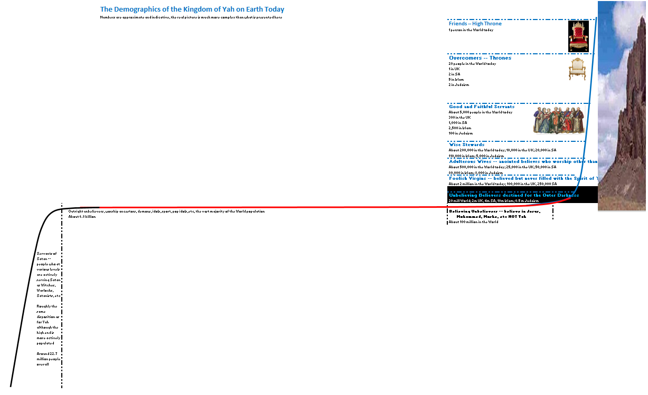
The next image enlarges the elements of the picture which represent those who are of some direct impact on the Kingdom of Yah.
There is a definite ranking in Heaven which is a direct reflection of the conduct of people on earth and this ranking is discussed below:
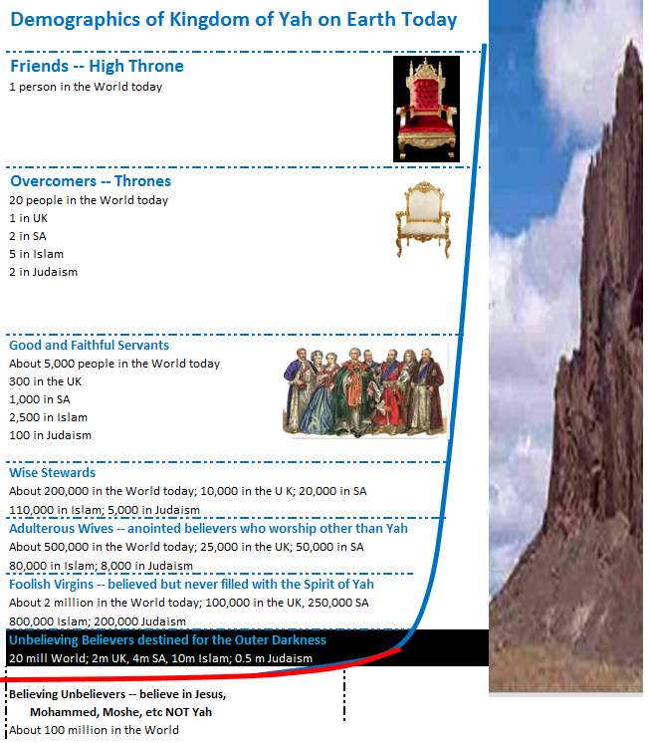
Addressing the above diagrams the following is of relevance:
  - Actively Serving Satan – 22.5 million
Those at some level actively serving Satan, around 22.5 million with around 5,000 who are ACTIVELY serving Satan at a level that is making a real impact for the Kingdom of Darkness – roughly the same numbers as those serving Yah and actively making an impact. If Satan wins the contest -
- (http://end-time-issueministries.org/REALContest.aspx.html) these people will have significant status with Satan. If Satan loses the contest they will be thrown into the Lake of Fire and Brimstone and, after a moment of torment and terror, will be utterly consumed.
  - Outright Unbelievers – 6.8 billion
The outright unbelievers, who are of no use to either side number around 6.8 billion. These people cloud the situation for both sides but provide massive distraction for servants of Yah who think that somehow these people must be “saved” when, in fact, the number of true believers of any value to Yah is reducing constantly. This huge mass of people constitute a major threat to the Kingdom of Yah insofar as so many believers are distracted by them.
  - Believing Unbelievers – 100 million
The next category are the “Believing Unbelievers” – these are the ones who believe in Jesus, or Mohammed, or Moshe {Moses}, the Bible, the Quaran, the Torah but have NO revelation of the reality of the Creator at a level that has impacted him. They may pay lip service to belief but they have never been touched in such a way that there has been a spiritual switch over of allegiance from unbelief in Yah to belief in Yah – referred to many as being “born again”.
This group is a massive distraction to believers who generally regard these people as believers when they are not. The number in this category has been growing fast and will grow faster in the future and is a reflection of the fact that Yah withdrew the grace for the wrong names and for worship of Jesus at the end of the year 2000. In terms of the current battle for the Kingdom of Yah these people are a major threat because of their ability to consume time and resources and distract true believers. In spiritual terms, these people are all members of the Kingdom of the White Witches in Satan’s kingdom.
  - Unbelieving Believers -- Destined for the Outer Darkness – 20 million
At the bottom of the mountain, those who have JUST made it onto the mountain and have at some minuscule level developed a revelation of the reality of the Creator but who thereafter, have gone on to live their lives as though Yah does NOT exist. If these people do NOT grow before they die they will face a tormented time in Hell for all their unconfessed sin -- see http://end-time-issueministries.org/Hell.aspx.html. Thereafter they will find themselves in the Trash Heap of Heaven (Yah’s words) that is “The Outer Darkness” – the place reserved for those who have known of the existence of Yah but who have ignored Him from that point on. Regarding these people Yah says “they ignored me throughout their lives on Earth so I will ignore them for eternity!” – Yah would really rather NOT have these people in Heaven at all!
  - Foolish Virgins – NO Infilling of the Spirit of Yah – 2 million
Having advanced a few steps up the mountain we find those who at some level HAVE changed their lives and sought to serve Yah but they have never worshipped Him in a way that has resulted in an infilling of Yah’s set-apart {holy} Spirit. This includes many in the traditional churches. These people have no relationship with Father, cannot hear His voice and do NOT have meaningful communication with Him. The people currently in this category are operating at about 0% of their potential.
  - Adulterous Wives – Infilling of the Spirit of Yah but worship other mighty ones – 500,000
There are a significant number of those who have received some impartation of the Spirit of Yah who worship Jesus, worship the Bible, worship Mohammed, worship the Quaran, worship Moshe {Moses}, worship the Torah, etc to a point where Yah only receives limited attention. These people are a source of great vexation to Father Yah. The people currently in this category are operating at about 0% of their potential.
  - Wise Stewards – of some use to Father Yah – 200,000
The Wise Stewards have received an infilling of the Spirit of Yah and have at some level treated it responsibly and done something useful with it. This is the first group that at some level gives Father pleasure albeit at a limited level. They are using their gifts and talents at some measure responsibly. The people currently in this category are on average operating at about 5% of their potential.
  - Good and Faithful Servants – making a real effort to serve Yah – 5,000
These are the people who are making the religious institutions of the world function at some level. These people together with the very small number of overcomers and friends are the ones that are keeping the battle flowing on behalf of Father on Earth. They are, however, in serious error and deception and therefore of limited effect. There are a similar number of people who are actively serving Satan and keeping things moving on that front. The people currently in this category are on average operating at about 10% of their potential.
These are the prayer warriors, the faithful servants in Churches, Mosque’s and Synagogues, etc. Father desires the number of these people to increase MASSIVELY!
  - Overcomers – those who will sit on Thrones for eternity if they endure – 20
The overcomers are those who have made a material impact on the Kingdom of darkness and are working hard to serve Yah although, at present, they are in serious error. There are VERY FEW of these people in the world today and they are mostly overcoming at a very basic level. The people currently in this category are operating at about 20% of their potential.
Father desires the number of these people to increase MASSIVELY!
  - Friends – those who are in deep personal relationship with Yah – 1 at present
Friends are people who have laid down their lives to such an extent that they have paid a huge price to serve Father. They have actively sought to come into “all truth”, they have actively worked for many years to seek to know Father intimately, to get to hear Him clearly, to become His trusted confidante’s and friends. There is only one person on earth in this category at present and they are NOT operating at close to their full potential.
“Friend” is NOT a title that one appropriates to oneself, it is a designation that Father assigns once a certain standard of self-sacrifice and alignment with Yah has been achieved. Friends are the one’s who will turn The Contest around and give Yah victory.
See article Recognizing a Friend of Yah at
https://www.linkedin.com/pulse/recognizing-friend-yah-james-robertsoneti
and About REAL service to the Almighty in this age – what REALLY matters at
https://www.linkedin.com/pulse/real-service-almighty-age-what-really-matters-james-robertsoneti
What are YOUR options?
As you read this YOU have the option to seek to become a Friend, the ONLY thing preventing you from becoming a friend is YOU. If you decide today to seek to become a Friend of Yah and set yourself on the journey, praying the necessary prayers, making the necessary adjustments in your priorities and the way you lead your life YOU can become a friend. It will take you some years to get there but IF you are resolute and determined you have EVERY opportunity to reach that level and Father WILL do ALL He can to help you. For guidance on this journey see the articles The Creator Desires Deep Relationship with YOU at -
http://end-time-issueministries.org/Home/CreatorDesiresDeepRelationship.aspx.html
and the follow-up article Seven Components in Growing Close to Yah at -
http://end-time-issueministries.org/Home/7ComponentsinGrowingClosetoYah.aspx.html -- if you apply ALL that is taught in both of these articles you will certainly progress deeply in relationship with Yah.
Once you have read the above, read the eBook Where will you Spend Eternity? at
http://end-time-issueministries.org/Home/WhereSpendEternity.aspx.html for more information on what is required to qualify for a High Throne.
Conclusion
Even if you do NOT aspire to become a Friend and sit on a High Throne because you are not that committed or are not able or willing to make the sacrifices required it is available to YOU to progress to any of the more junior ranks of esteem – that is, Wise Steward, Good and Faithful Servant or Overcomer.
I invite you AND CHALLENGE you to choose TODAY to cease being complacent and deal with what you need to deal with in order to draw MUCH closer to Father. It may seem like hard work in this life, because it IS, but the reward is WELL worth it and you will have eternity to enjoy the benefits of your spiritual labours should you take up the challenge.
25 December 2015

1.8 Demographics of the Kingdom of Yah elaboration
The previous article The Demographics of the Kingdom of Yah on Earth Today summarized the distribution of believers and unbelievers on the Earth today as indicated by the graphic below:
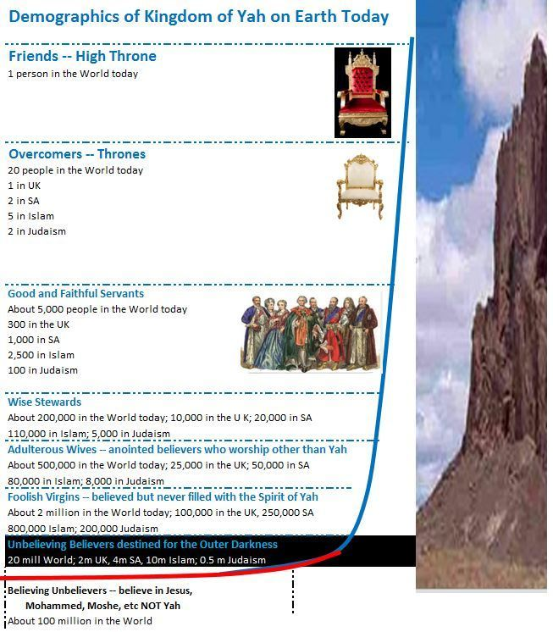
Flowing from this diagram a number of further points require elaboration:
  - True Belief is on the Point of Dying out
Given that true belief {faith} is only maintained at some level by the Good and Faithful Servants, Overcomers and Friends and that there are only around 5,021 of these on the entire planet and that nearly all of them are weak and ineffectual at a deep spiritual level, it is apparent that true faith is rapidly approaching the point of extinction.
Father says that unless the slide is averted that within 100 years there will not be any true believers of material effectiveness left on earth and that, IF this point is reached, it is very unlikely that Father will win The Contest in 3003.
This article therefore recognizes that we live in desperate times and seeks to focus the attention of readers on what is necessary to turn the tide of looming total collapse.
  - Most true believers are women
Yah says that most of the true believers, and even most of the weak people and believing unbelievers, are women:
Item | Category | Ratio of Women to Men
1 | Good and Faithful Servants | 10
2 | Wise Stewards | 7
3 | Adulterous Wives | 3
4 | Foolish Virgins | 4
5 | Outer Darkness (Unbelieving Believers) | 2
6 | Believing Unbelievers | 3

  - Many of the stronger believers are joined to unsuitable spouses
Many of the stronger true believers, that is the Good and Faithful Servants and Wise Stewards are joined sexually {married} to weak believers or unbelievers and this greatly blunts their impact. As discussed in the article Will Yah agree to you divorcing your unbelieving spouse? NO, He will EXPECT you to divorce! At
https://www.linkedin.com/pulse/yah-agree-you-divorcing-your-unbelieving-spouse-he-james Yah EXPECTS believers in such unions to divorce and separate themselves to His service.
This may seem harsh but it is extremely unpleasant for Yah, whose Spirit dwells intensely in these relatively strong believers, to be constantly exposed to the weak believers or unbelievers that these stronger believers are joined to. Such unions also largely blunt and make of little or no effect the ministry of those stronger ones.
IF you are one who is seeking to be close to Yah and you are joined to one who is an unbeliever I strongly advise you to divorce as soon as possible. If you are a woman, accept that it is highly UNLIKELY that you will find a suitable believing man and adjust your thinking to live as a single woman with Yah as your husband, covering and provider. Consider teaming up with a number of other women to form a close covenant based community where you can grow, nurture the anointing and make an impact.
If you are a man married to an unbelieving woman, divorce immediately and seek Yah to guide you to a suitable woman who will strengthen you and help you to draw closer to Yah. Men are a scarce resource and for this reason it is vital that they marry wisely guided by Yah.
If you are married to a weak believer then share your desire to become much stronger with them and ask them to walk the road with you. If they refuse, whether in word or deed, divorce them.
I understand that the above may seem harsh but the reality is that IF you aspire to a position of real esteem with Yah you need to adjust your life accordingly and that means that you are NOT held back by an unbelieving or weak spouse. In particular recognize that if you have been walking with Yah for some time and your spouse is NOT aligned with you that this will get in the way of your relationship with Father.
Further, I submit for your consideration, that it is MORE important what Yah thinks of your marriage situation than what you prefer – so consult Him, ask for guidance and ACT!
  - The core religious truths are ALL upheld by Shemmite peoples
In considering the above statistics it is important to recognize that the core religious truths of the three core monotheist religions, being Christianity, Islam and Judaism, all of which attempt to worship Yah, albeit in a weak and corrupt way, are maintained by blood descendants of Shem the eldest son of Noah and more specifically through the bloodline of Abraham and through him to Isaac and Ishmael and from Isaac through Yakov / Yisrael.
There are members of these blood lines within the Japhethite (far East Asian peoples) and Hammite (African and certain other peoples) but the essence of these three core religions has been maintained by Shemmite people.
Christianity has been preserved by the European peoples who are descended from the ten tribes that went into exile from the Northern Kingdom of Yisrael primarily in Western Europe, Russia, etc but also to some extent Asian Indians and related peoples.
Islam has been preserved by the Arabic peoples descended from Ishmael.
Judaism has been preserved primarily by the people of the Southern Kingdom of Yisrael, that is, Judah (Yahoodah).
These are the three groupings that between them have upheld the truths of Yah to a fair degree and it is vital that in this age where true believers are at risk of dying out that major initiatives to reach Japeth and Ham, other than supporting believers in those demographic components, will have to take second place to strengthening the core before it is eliminated. Once the core is strong and walking in truth and above sin they will then be in a position to assist others.
Important to note that the overcomer who is second closest to Yah is a Muslim Cleric in Teheran and the person who is third closest to Yah is a Jewish Rabbi in Jerusalem. The distribution of true belief is across ALL three main religions attempting to serve Yah.
  - The 5,020 strongest believers are ALL in great error and very weak and ineffectual
Taking note of the points raised in the articles:
- Recognizing a Friend of Yah at
https://www.linkedin.com/pulse/recognizing-friend-yah-james-robertsoneti
- About REAL service to the Almighty in this age – what REALLY matters at:
https://www.linkedin.com/pulse/real-service-almighty-age-what-really-matters-james-robertsoneti
- Some critical questions for believers at this time at
https://www.linkedin.com/pulse/some-critical-questions-believers-time-r-end-time-issue-ministries
- And the prayers in the article Seeking truth at
https://www.linkedin.com/pulse/seeking-truth-james-r-end-time-issue-ministries
it becomes apparent that almost all of the 5,020 strongest believers are in great error and very weak and ineffectual. Each of the major religions has major errors, as evidenced by the division between them and each needs to learn from the other. See the article Seek Truth NOT Error for some key principles at:
http://end-time-issueministries.org/SeekTruth/SeekTruthNOTError.aspx.html
Unless a significant number of these 5,020 people recognize their desperately weak and corrupt state and turn to Father for teaching the future of true faith is very shaky.
  - Only outreach to the 5,020 is of value to Yah at present
Right now, if anyone CAN see the seriousness of the situation they should focus ALL their attention on getting their OWN lives right with Yah and THEN taking the message to other members of the 5,020. All other outreaches, etc should be placed on hold for now. Once the 5,020 have been strengthened and some have dropped off and new ones have taken their place the message can then be taken to the Wise Stewards, the Adulterous Wives and the Foolish Virgins in that order.
We will NOT know who is who to a large extent but provided we tailor our message to seek to reach those who are earnestly seeking and ask Father to bring the people He wants to hear our message in and keep those that He does NOT want to hear the message out, this goal can be accomplished spiritually and NOT by intellect or reasoning.
Getting to be led by Father’s Spirit in this is KEY and the prayers referenced above will help!
  - The focal point for Yah is a powerful revival in the UK
Father has indicated to me that taking account of the blessings of Ephraim that have been responsible for the long term prosperity and success of the United Kingdom as a global power His first priority is to seek to bring revival to the UK first and have this then spread out around the world through the Shemmite people.
This is where I intend to focus my attention in the days ahead in the hope that we can assemble a nucleus of true believers who take the measures necessary to get their lives right and then reach out to others in the UK.
I will continue to minister globally as I have for some years now through the website and more recently through LinkedIn, Facebook and Google+ but my direct physical on the ground focus will be with those people who I have recently been placed in direct contact with in my new situation in the UK in the hope that we can get a few of them on board and then start to reach out throughout the UK. That is my objective for the coming solar calendar year of 2016.
Conclusion
I sincerely hope that this article will challenge YOU, no matter where you perceive yourself to be right now, to go ALL OUT, to serve Yah.
Pray the prayers that are referenced above and do ALL that you can to draw closer to Him. He desires YOU to become His friend and confidante and work with you in EVERY AREA of your life. Grant Him that opportunity TODAY and put aside all your excuses and rationalizations about NOT being good enough or whatever and just DO IT!
26 December 2015

1.9 Why Keep Yah’s High Sabbaths?
Today is the Feast of Trumpets or Day of Trumpets, I am at home observing it.
I started keeping the High Sabbaths of the Almighty Creator, Yah the Eternally Self-Existing, that is Passover, Pentecost, Day of Trumpets, Day of Atonement, First Day of the Feast of Tabernacles and Great Day of the Feast of Tabernacles about 16 years ago. No strong motivation, just read about them being a commandment, met some people who observed them and chose to observe them as well.
I regularly come into contact with people who have excuses for not keeping these Feasts and Fasts, most frequently because they either do not think ahead to take leave or they do not care enough to take leave, in other words, that they see other things as more important.
That is good and well but why should one keep these days?
Well, very simplistically, we are commanded to keep Yah’s Sabbaths (including and specifically His Seventh Day Sabbath on Saturdays) – so IF you fear His judgements you should keep these days (as well as observing Saturday as a Sabbath.
But that is NOT really the fundamental reason to keep these days. The fundamental reason is well presented in 1 John 5:3 in the Bible “For this is the love of Yah, that we keep His commandments. And His commandments are not burdensome,”.
So, IF you love Yah you will keep His Commandments. As simple as that!
And it is NOT difficult, I have certainly found over the years that it is not that difficult, just requires some commitment and some self-discipline – put it in your diary at the start of the year, book leave if appropriate and then, JUST DO IT!
If you aspire to having a close relationship with Father Yah then freely and willingly OUT OF LOVE, KEEP His Commandments including keeping His Saturday Sabbath and the six High Sabbaths mentioned above.
If you aspire to becoming Yah’s Friend (the highest rank a human can have on Earth today), then part of being a Friend is that you observe Yah’s special days. It is that simple!
If you are not sure of the dates then download the calendar from -
https://www.qodesh.co.za/ or search on the Internet for “Jewish Holidays” – the dates on the Julian calendar float every year because they are linked to the cycles of the Moon and there is an adjustment every few years to compensate for the fact that there are thirteen lunar cycles in a period slightly longer than a 365 day year. Different sources may differ with regard to the dates to the tune of a day or so but the main thing is to ask Father Yah to help you find the correct dates and then observe those dates with rigour every year.
What that looks like in my case is that I write those dates into my diary early in the year and apply for leave. I encourage you to do the same. Certainly IF you desire to please Yah you need to do this and IF you aspire to becoming His Friend it is VITAL that you do this.
22 September 2017

1.10 Sexual Reproduction Proves Creation
I have recently been exposed to a very heated debate by email with regard to the existence or non-existence of the Creator with intense arguments by people who label themselves as Atheists – that is they do not believe there is a Creator.
Some years ago I wrote a lengthy document on this topic which is available at http://end-time-issueministries.org/Creation/CreationvsEvolutionPart1.aspx.html which examines all sorts of rational factors that point to the existence of the Creator.
I will now present a shorter rationale for the existence of the Creator based on my learnings and experience since writing the above document.
Essential point of departure is to base the argument as far as possible on things that I can prove from my own experience so let us see how I do.
Before I start let me state that I do NOT believe that Creation took place in seven 24 hour days, it took place in seven periods of indeterminate duration probably running to millions of years. It took place in an evolutionary, that is experimental and inquiring, manner with many failed experiments. A lot of the objections to Creation are in fact objections to irrational and illogical Bible Punching based on wrong translation and wrong interpretation of the historical information in the book known as the Bible.
The basis of my argument is sexual reproduction.
Sexual reproduction, the merging of male and female reproductive gametes such as sperm and egg, is common to all mammals, all fish, all insects and all plants with the exception of very basic plants and animals.
Inherent to sexual reproduction is that there is a male organism and a female organism with male and female generally looking very similar but with certain very distinct male and female characteristics. Those who say there is no Creator need to explain how these two organisms that inter-operate so intimately came into existence spontaneously with no overarching Engineered design to make sure that the two halves could work together first time – they could not have “evolved” in a random spontaneous way because they only work when they are complete in every way. This is very much the chicken and egg phenomenon – the egg has to know the chicken exists in order to produce a chicken and the chicken has to know the egg exists in order to produce the egg – inherently a seriously complex engineering endeavour.
Problem is that this applies not only to chickens but to all birds, all reptiles and, in a slightly different form, all mammals and humans. In a slightly different form again it applies to all plants that produces seeds or fruits (another form of “egg”) from which a new generation of plant emerges. All of these reproductive elements are unique and each has its own beauty, not to mention many of these items having nutritional value for humans and other animals. If you do not believe in a Creator you have to figure out how to explain this massive complexity, massive inter-operability and comprehensive beauty and functionality all with the same core mechanism.
Then there is an added complexity amongst mammals and less obviously other life forms. The female has the capacity to produce both male and female children. The male has NO capability to produce offspring. So how did these two life forms spontaneously evolve and then suddenly reach a point where the male ceased to spontaneously evolve and the female suddenly developed the capability to produce offspring of both genders? Again this points to a highly intelligent, highly creative engineering agency to design and build this complexity. And then the offspring have to be cared for, nurtured, protected, provided for and educated for years in the case of humans, shorter periods with mammals, birds, etc.
In addition, in mammals the male and female are almost identical in physical structure with the exception of the reproductive organs and the female being more petite and delicate than the male, also with different personality traits. The skeletal system, the muscular system, the lungs, the digestive system, the nervous system, the brain, etc, etc are effectively identical, only the reproductive organs differ. Again it is necessary to explain how the male and female evolved spontaneously to be almost identical but with critical differences. Or did they evolve as one form and then at the last minute mutate into male and female? Again, a highly intelligent engineering manager is necessary for this to happen.
Then in plants with regard to reproduction we have a huge diversity of seeds and fruits consider oranges, paw paws, bananas, coconuts, peaches, mangoes, cherries, papayas, litchis, tomatoes, cashew nuts, walnuts, pine cones, maize (corn), sun flowers, millet, wheat, beans, peas, figs, dates, grapes, etc, etc – massive diversity and each enjoyably edible by human beings and aesthetically attractive, many with pleasing scents – how did these all come about spontaneously? And then with insects there is the added step of the caterpillar and the chrysalis both of which keep track of the male and female in one organism. Again, evidence of a creative agency.
And ALL of these plants and animals are complete, functional, perfect – why is there not a plethora of diverse stages of evolution with incomplete items in abundance – why is everything perfectly complete? Surely this speaks of a Creative agency who progressively developed all this complexity and designed it in such a way that the final design could faithfully reproduce itself with great precision!
At the same time one needs to ask why spontaneous evolution has apparently suddenly ceased. And also why there are not MANY more derivatives reflecting a diversity of less and more successful mutations. Consider that there are over 7.5 billion human beings on the planet and they are all fundamentally exactly the same – surely if we were the result of spontaneous evolution there would be myriad different human derivatives on the planet. And then, also, the form of the human race has been fixed for around 6,000 to 15,000 years depending on which dating you trust with no evidence that humans existed in any significant form before that – surely random spontaneous evolution would result in variation over that period of time and result in a hotch potch of different unrelated forms. If one recognizes the role of a master architect who destroyed the unsuccessful experimental outcomes in the incinerator of Heaven (the Lake of Fire and Brimstone) and designed us to be stable and not morph or mutate this is entirely explained.
All plants and animals have a finite life span which may be very short, measured in days or weeks or very long, measured in centuries but that life span is finite. At some point sexual reproduction must take place in order for the organism to continue to exist. So the organism cannot have spontaneously evolved over thousands or millions of years as many postulate. It had to be there complete and functional and able to breed from day one!
It is also so that with animals the organism cannot reproduce itself any other way except by sexual reproduction – the merging of a male gamete or sperm with a female gamete or egg which is then followed by a complex process to generate a new organism. In plants this is further complicated by the use of third party mechanisms to bring the male and female gametes together in most cases be it wind, bees, etc. So somehow the plant had to know the mechanism it would use to transfer the pollen and then design the flower to match that mechanism. And somehow the bee needed to know about flowers in order to feed itself and create the honeycomb in which to breed.
What is notable is that in order for sexual reproduction to work the male and female organism must have very precise knowledge of the other half of the equation in order for the female organism to receive the male gamete and then generate the new offspring as a precise mix of the two parents.
Inherently this capability cannot have come into existence as the consequence of a progressive succession of random events without any plan or any control which is inherent in the argument for evolution. The male and female organisms had to be perfectly formed and functional from the first generation.
In saying this it is important to stress that I assert that the Creative process that led to these perfect male and female organisms was an exploratory, experimental, progressive, that is evolutionary, process that followed a path through which more and more complex organisms and more and more beautiful organisms were created until the Creation reached the sophistication of what exists today.
Let me develop this line of thought a bit further from consideration of human beings, ourselves, after all, that is the component we all have personal experience of.
In order to reproduce a human male must be attracted to a human female and copulation must occur resulting in the discharge of semen in the vagina of the female with the sperm then swimming up-stream to fertilize the egg which is conveniently located in an organ designed with the sole purpose of facilitating that meeting. None of this can happen randomly it has to be the consequence of a master engineer who designed and built the two halves of the whole so that they perfectly fit together. Note that the male needs to know the female exists and vice-versa for procreation to occur.
The male needs to find the female attractive – not something that two organisms evolving without an external design engineer would think to do – bear in mind that evolution argues that NO thinking was necessary for a pile of dirt to explode to form a mass of planets and solar systems, etc, then form a planet with perfect atmosphere to support life, then progressively randomly and in an uncontrolled fashion craft more and more complex and more and more beautiful organisms – for that matter, how did the organisms know to be beautiful seeing as how they had no way of knowing that there would be humans to enjoy looking at them?
How did the ear know to develop without knowing there was something to listen to? How did the eye know to develop without knowing there was something to see? Or the mouth and tongue with the capacity to speak without knowing there was someone to hear? The list is endless. The male organ needs to perfectly fit the female organ in a way that is pleasurable such that the man and woman will desire to copulate on a regular basis – so we have an organ like the clitoris that has absolutely NO value in a sterile evolutionary model. Then of course there is the love the comes into existence when a man and woman “make love” – a tangible spiritual force -- how did that come about with random evolution which did not know that love was possible?
Then, when a man and woman have intercourse a unique spiritual bond is formed that gets stronger and stronger the more frequently and more passionately they make love such that in time they get to know each other’s thoughts and become more and more closely aligned. Certainly no way THAT could happen in a random evolutionary manner.
Finally the female human has a hymen, a seal of virginity that ties in with sexual intercourse being a covenant act ordained by the Almighty – there is NO way that a hymen would come into existence in a spontaneous evolutionary model.
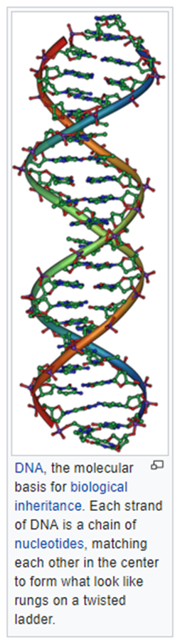
Over and above that humans have deep sexual desire, intense erogenous zones and deep desire for erotic stimulation, all geared to producing a strong one-flesh bond between man and woman in a life time committed relationship. In fact, one could argue that the existence of pornography and all the other aberrations of the Almighty Creators plan for intensely pleasurable sexual congress WITHIN life time covenant union is clear evidence of an external creative agency in the creation of human beings.
So, overall a diverse range of factors all of which strongly evidence that some form of random unmanaged evolutionary process is NOT a plausible explanation. Conversely, highly managed and carefully thought out progressive evolutionary design by an external creative engineering agency is the ONLY explanation for what exists on Earth today. By extension, this explains the entire Universe.
Then there is the most amazing piece of the entire complex puzzle, something that occurs consistently in all forms of life – DNA.
“Deoxyribonucleic acid is a molecule that carries the genetic instructions used in the growth, development, functioning and reproduction of all known living things”-- https://en.wikipedia.org/wiki/DNA
The amazing thing about DNA as shown in the diagram to the left, taken from https://en.wikipedia.org/wiki/Genetics is that when the male and female gametes join, one side of the resulting DNA molecule in the offspring comes from the father and the other half from the mother such that the resulting child is an exact random combination of attributes from the two parents. This happens without fail and the most remarkable thing is that the sequencing on the one side of the spiral “ladder” EXACTLY matches the pattern on the other side – details of the eye come equally from each parent but with dominant and recessive genes in the structure that dictate complex relationships that define the resulting off-spring.
It is essential to recognize that there is NO way that DNA can evolve without the intervention of a highly sophisticated super engineer who first designed the requisite DNA at a precise micro-level and then assembled it in a self-reproducing pair of organisms that would faithfully reproduce and duplicate the design consistently for thousands of years. A mechanism that is present in EVERY living organism on the planet!
Then, the consequence of the merger of the two gametes and their DNA is a complex process that results in an infant that is an exact composite of the two parents and which, in all mammals and birds as well as humans, is defenceless and a mini version of the parents. This infant requires to be fed, nurtured and educated, for years in the case of humans. How then did spontaneous anything generate such an entirely dependent organism that cannot fend for itself? Again, this points to a carefully prepared design and plan in terms of which we reproduce and NOT to some random generative event with no intelligence involved.
I leave you to ponder how all this complexity, sophistication and engineering precision could conceivably have come into existence without a highly intelligent, highly imaginative, highly creative engineer to conceptualise, design, test, prove and put this design into production.
Yes, I grant you that this leaves one with the dilemma of where that Creator comes from but He says that His name is “Yah the eternally self-existing” so He has always been here. The fact that I exist and have a deep personal relationship with Him and have conversations with Him and have experienced numerous instances of His manifest presence in my life is sufficient for me to accept that He exists and I therefore choose to take His word that He has always existed and leave it at that.
If you refuse to believe that the Creator exists you are left with “where did all this stuff come from” to which you more or less have to reply “I do not know but as we learn more we will figure it out” which is quite a common response from proponents of spontaneous evolution. To this I have to reply “I HAVE figured it out, the Creator made it all!”. To this the Atheist is compelled to reply “but there is NO Creator”. You can take this imagined dialogue further if you choose but I suggest it is absurd just as I have to say that I think it is pretty foolish to believe that all of this beauty and complexity just happened. I am an engineer and I know how hard it is to design and build things that work so I see it as pretty silly to believe in evolution without an engineer in charge
Incidentally, there is added complexity, the Creator will NOT reveal Himself UNLESS you first believe He exists and then He says that He WILL be found by those who diligently seek him! So, I offer you this document and this rationale to assist you to recognize that He exists so that you may then diligently seek Him. THEN you will discover that He exists
Note also that this world is part of an experiment to develop human beings who despite all the tribulations and opposition will seek to form a relationship with the Creator so, IF you decide not to believe that He exists the Almighty is NOT unduly moved by your unbelief, He simply regards you as a failed experiment ultimately destined for the incinerator of Heaven, the Lake of Fire and Brimstone, unless Satan wins The Contest on Earth – see
http://end-time-issueministries.org/REALContest.aspx.html
I hope that this article has given you food for thought and that you will come to realize that the Creator really must exist and that NO other explanation will support the amazing complexity that exists in this world we live in. I would also hope that you will see that it really is UNWISE to deny His existence.
IF you DO reach this point then I commend the Article “The Creator Desires a Deep Personal Relationship with YOU!”
http://end-time-issueministries.org/Home/CreatorDesiresDeepRelationship.aspx.htm for your consideration.
If you take this seriously then I suggest that you read “Seven Components (or Steps) in Growing Close to Yah (the Almighty Creator)”
http://end-time-issueministries.org/Home/7ComponentsinGrowingClosetoYah.aspx.html
14 September 2017

1.11 Yah intends sexual lovemaking to be a high point of being human
I regularly encounter people who have a negative view of sexual love making. There are also many religious groups who advocate celibacy as the highest form of relationship with Yah. These lies are hugely damaging to the body of believers and are an insult to Yah who created sexual reproduction and sexual love making and gave us the organs, emotions and senses to enjoy hugely satisfying and powerful lovemaking.
To a significant extent these lies cripple the body of believers and turns many away from serving Yah. It also empowers the Satanic and Demonic realm who derive great power from utilizing sex to serve their evil ends.
Following are some key points:
  - A man shall cut (cleave) into his woman – sex is a covenant act
The act of a man inserting his organ into the organ of the female with, at first penetration of a virgin, shedding of blood, is a covenant act of great significance.
Thereafter every ejaculation by the male in the female vagina sheds semen which contains the elements of blood and is therefore a covenant act. In the same way first intercourse with a truly divorced woman is a covenant act. See the detailed discussion of “The Virgins Covenant” at
http://end-time-issueministries.org/MenWomen/MenandWomenandCovenant/TheVirginsCovenant.aspx.html
and the detailed analysis of the basis of sexual covenant at
http://end-time-issueministries.org/MenWomen/ScripturalDefinitionofMarriage/2Definemarriagecovenant.aspx.html
A covenant is a lifetime contract with a death penalty. In the Court of Heaven the penalty for adultery, sex with a woman who is already one with another man, is death unless it is repented of and forgiveness obtained.
It is vital to recognize that the form of the external female sexual organ is in the same form that a deep cut with a sharp knife makes in flesh. Yah purposed for sexual intercourse between man and woman to be a covenant act at the time that He created man and woman. There is NOTHING about sexual love making that is an accident – Yah designed it to be highly pleasurable and for man and woman to make intense and uninhibited love on a regular basis.
Sadly the false teachings of many religions and denominations have completely lost this knowledge and they have replaced it with all sorts of false, demonically inspired, teachings.
  - And they shall become one-flesh – the one-flesh bond
When either the man or the woman experiences a sexual climax during intercourse where there is body to body contact a portion of the spirit of that person is also ejaculated and it adheres to the spirit of the other person resulting in an unbreakable bond which is known as “the one-flesh” bond.
Every time a man and woman have intercourse with orgasm by one or both this bond gets stronger until it is like a large spiritual pipe between the two people that enables them to know each other’s thoughts and to communicate with one another spirit to spirit in a powerful way.
The strongest one-flesh bond is formed through male ejaculation in the vagina of the female. Weaker bonds are formed through climax by either party with contact with the external female organ, the vulva or through oral or anal climax. Even weaker bonds are formed with climax against other parts of the body, such as the hand. A bond is even formed if a man or woman masturbates to orgasm while intensely focussing on another human being at a distance, this includes the use of pornography.
One-flesh bonds are also formed in the event of sexual congress with an animal which is a total abomination.
  - When two or more pray in symfoneo (agreement) their prayers will be answered – much more than agreement
A powerful one-flesh bond allows two people who are one-flesh to pray MUCH more powerfully and to have much greater impact on the Earth. This is a key reason that the forces of darkness have gone to such lengths to trap committed believers into believing that sex is dirty and carnal.
This verse speaks to “symphony” – the same song, to the same music in the same key – perfect alignment and perfect harmony THEN prayers will be answered. The stronger the one-flesh bond the stronger the harmony and the more powerful the prayers.
The one-flesh bond is also a shadow of the bond that occurs between Yah and a Spirit-Filled believer – one who has invited Yah to indwell them. Ephesians 5:31-32: “For this reason a man will leave his father and mother and cut into (cleave) his woman, and the two will become one-flesh.” 32This mystery is profound, but I am speaking about the Anointing of the Spirit of Yah {Christ} and the body of believers {church}.” So, we were given sexual love making in order to understand the intensity with which Father Yah desires that we will worship Him. It is great sin to make out that sex is dirty and carnal within a covenant union.
  - House divided WILL fall
The opposite point to the previous point is that “a house divided against itself WILL fall” – when a man and woman are NOT in harmony, whether by tacit quiet disagreement or worse still in active strife then the Forces of Darkness have a blank cheque book to tear down that house and cause loss in every possible way, particularly in finances.
  - A fault finding and contentious woman is like rottenness in the bones
Once a man and woman are one-flesh, if the woman argues and fights with the man the man will experience internal trauma that feels like “rottenness in the bones” (Proverbs 12:4) – it is therefore vital for a couple to be well aligned and in perfect harmony.
  - Age for union – NOT possible in most societies today
From the above it will be apparent that a woman is ready for lifetime covenant as soon as she reaches puberty and becomes sexually aware. Yah intended for women to enter into covenant when they were relatively young and therefore adaptable to married life. However, that has been terribly corrupted such that most societies where this is practiced abuse women and regard them as chattels while other societies with a better attitude to women regard the age of puberty to be much too young to marry because they do NOT prepare them appropriately.
The huge problem with this is that reports indicate that about two thirds of young women lose their virginity by the age of 16. This happens largely casually in one night stands and quickies in the back seat of a car, etc and they then lose contact with the man who took their virginity. As a consequence, the vast majority of women have had more than one sexual partner and therefore the “marriage” that they are in is generally adultery and they and their “husband” will pay a heavy price on the day of their judgement unless they repent and clean up as appropriate!
  - Sexual lovemaking creates love
There is a very good reason that sexual intercourse is known as “making love”, the act of sexual intercourse builds a deep spiritual bond that we know as “love”. This love grows deeper and stronger every time that two people make love. It is so that love never dies and so a person who has had multiple sexual partners will find that they are drawn back to previous partners UNLESS there is a very solid divorce in place on the correct legal terms in the Court of Heaven.
This lovemaking will produce love whether between man and woman, man and man or woman and woman.
  - Dating and long engagements are out – right choice and consummate
It is important to understand that dating, which raises sexual desire and results in casual one-flesh bonds is totally unacceptable – in the case of young adults the parents of the man and the parents of the woman should agree that their offspring are well matched. The youngsters should then be introduced and given a short while to assess whether they are willing to spend their lives together and this should move to marriage with a short ceremony followed by consummation within a week or so.
In the case of mature adults they should carefully draw up a specification of what they are looking for and a prospectus of who they are and then use dating websites or whatever means are available to them to locate a member of the opposite sex who is a suitable partner. Follow this by detailed discussion and agree terms and conditions, write these down, sign them and consummate.
The bottom line is that Father Yah intended us to be able to make covenant union work between ANY man and ANY woman PROVIDED they are socially, culturally and otherwise well matched. And even if they are NOT well matched it is possible to make it work with real commitment and effort because of the power of the one-flesh bond IF they have regular fulfilling sex.
  - Fornication NOT sex is dirty and wrong
So many religious people see sex as dirty and wrong. I recently read an article by an intensely religious person in which the writer expounded that conjugal love was the lowest form of human love. This is false, conjugal love is the highest form of human love. Given that this writer is influential and has apparently advocated this principle on a long-term basis one can only imagine the amount of harm caused to the body of believers.
What is dirty and wrong in the sight of Yah is sexual fornication in which men have sex with multiple partners and then abandon them to have sex with other men and where women have sex with multiple partners. This is NOT per se dirty and wrong on an earthly level, it is highly pleasurable and people derive great pleasure from the excitement of a new relationship but it IS dirty and wrong from the perspective of the Almighty Creator who sees a mesh of one-flesh bonds in a completely random form with believers joined to unbelievers, that is Satan worshippers, in a way that gives the forces of darkness considerable power over the believers.
The big error of many in much of organized religion is to make ALL sex dirty as opposed to recognizing that sexual lovemaking is highly pleasurable but that in the wrong setting it is grievous sin.
In fact, all the lies about sex amongst believers collectively result in a situation where lies about sex and wrong beliefs about sex are the single most debilitating suite of lies that the Forces of Darkness have managed to imprint on much of the body of believers. These lies are wreaking havoc on the body of true believers!
  - Sex in a covenant relationship should be frequent, passionate and highly enjoyable
One of the great traps of conventional religious sexual thinking is that sex is only for procreation and should NOT be enjoyed whereas, such a view is an insult to the Almighty who created us to enjoy highly uninhibited, passionate and enjoyable sexual love making with NO holds barred WITHIN the covenant relationship such that a strong one-flesh bond is developed.
This is one of the reasons that believers turn to pornography – within their religious confines they cannot find anything useful about sex whereas pornography speaks of a highly enjoyable experience BUT without the strict relationship constraints outlined above. Wrong thinking about sex amongst religious people is a big reason that pornography flourishes amongst believers with all the wrong thinking that accompanies it.
It is vital to understand that highly uninhibited, no holds barred, intensely pleasurable sexual lovemaking WITHIN a committed life time relationship is highly pleasing to Yah – after all, He created us to be able to do this.
  - The marriage bed is undefiled – nothing is prohibited
Hebrews 13:4 states “Marriage is honourable in all, and the bed undefiled: but whoremongers and adulterers Yah will judge.” This extends the previous point. In particular, note that there are NO restrictions on what partners in a lifetime covenant relationship can do together sexually. So oral sex, mutual masturbation, various sexual positions and even anal intercourse are NOT prohibited provided both partners agree and it is done in a considerate, loving manner. I do NOT think that bondage types of games were envisaged by Yah but one cannot present a case to say they are prohibited provided they are entered into voluntarily.
Surrounding sexual lovemaking WITHIN lifetime covenant union with all sorts of constraints is destructive and opens the door for people to fall into the trap of going outside the union.
  - Adultery is a one-flesh bond between two men
There is a lot of confusion about adultery but in its fundamental form adultery is a one-flesh bond between two men. This can take place through homosexual congress but it can also take place by two men having a one-flesh bond with the same woman. In spiritual terms, because they are both one with the woman they might just as well directly have sex together, the spiritual effect is the same.
For this reason, singling out male-male homosexuality for special opprobrium while turning a blind eye to massive male-woman fornication in the body of believers is an abomination in the sight of Yah. He disapproves EQUALLY of both forms of adultery. It is high time that the body of believers tell the truth about fornication and deal with it at root – the huge levels of ignorance and wrong teaching.
  - One incident is ALL it takes
One of the big lies that the church teaches is that somehow the Almighty will condone a one-night-stand or one off “slip” – NOT so, once it has happened there is a one-flesh bond and that is unbreakable except in special circumstances. Release certainly does NOT apply when the woman was a virgin even if the man has an existing woman.
The message needs to be clear – “man, take the virginity of a woman and you are responsible for her for life no matter how unsuitable she is”, “woman give your virginity to a man and you are required to spend the rest of your life with him, no matter how unsuitable he is”. This applies equally if the woman is truly divorced and all one-flesh bonds, etc have been cut.
  - It is possible for a man to covenant with more than one woman
From consideration of the male and female sexual organs and what is written above regarding the virgins covenant it is apparent that a woman can ONLY give her virginity once and therefore is designed to ONLY covenant with one man while men are designed to be able to covenant with more than one woman.
The catch today is that in Western Society and in many other societies women are programmed NOT to share their men and undergo intense psychological trauma if their man tries it such that they simply CANNOT share. This does not alter the fact that IF a man takes the virginity of more than one woman he is responsible for ALL of them.
In this context sadly most of those societies where it IS acceptable for one man to covenant with more than one woman have an abusive attitude towards those women. So, in most cases monogamy is unavoidable but it is NOT Yah’s best.
  - There are seven (7) x more women than men in the body of believers
One of the harsh realities in the context of the points above is that in this age Yah says that there are seven times more women than men in the body of true believers. This means that the vast majority of believing women cannot find a suitable man. This has huge implications for the spiritual well-being of a huge number of women believers. See the article on this subject at
http://end-time-issueministries.org/SingleWomenbelievers7xmen.aspx.html for more information.
  - Union with an unbeliever is a major problem for Yah
In the context of the previous point an inevitable consequence of the large number of women believers relative to the number of male believers is that there are a huge number of women joined to unbelieving men, a situation that is very uncomfortable for Yah who is, at some level, indwelling those women and therefore forced into contact with a person who is a temple of the Demonic realm.
Simplistically Yah would prefer those women to divorce and will always grant a divorce if requested but, in practice, these women have sexual needs and most have children so it is a major problem. If you are female and single it is advisable that you decide NOT to enter into covenant with a man UNLESS Yah clearly brings a believing man to you. Accordingly, in this situation it IS so that it is preferable for a woman to remain single and celibate than to covenant with an unbelieving man and in these circumstances a woman is entitled to ask Yah to be her husband.
  - Women should covenant with a man who is closer to Yah than they are
As a further complication women should only covenant with a man who is closer to Yah than they are so that when they look to their man they are looking towards Yah and not away from Him. It will be apparent from this that it is very difficult to do this in practice so much of the time women who do find a believing man find themselves with a man who is less mature than they are. This gives rise to its own set of problems.
  - Nothing prevents sexual congress between women in a committed relationship
It will be apparent from consideration of the terms of the sexual covenant and the definition of adultery that nothing prevents two women or more than two women from having sexual congress. This applies to two or more women on their own in a relationship or two or more women in relationship with a man.
This is a viable way for believing women who cannot find a suitable man to team up with other women with the same challenge and resolve their sexual needs that way. Note that it is not mechanically possible for women to form a full one-flesh bond since the full bond requires a male organ in the female organ. But they CAN become one-flesh at the level of a betrothal one-flesh bond.
  - Forced celibacy is NOT right in the sight of Yah
Extending the previous point, forced celibacy was NEVER Yah’s intention.
In the case of men, where there are many times more women than men in the body of believers there is NO need for men to go celibate and, in fact, it is a sin for a man to refuse to cover at least one woman who is in need.
In the case of women forced celibacy may in many cases be almost unavoidable, but see below.
  - Man covers his woman
Part of the way that Father Yah created things to be is that the man spiritually covers his woman such that he protects her physically and spiritually. If the man is an unsuitable spouse this again leads to various spiritual problems. Men are commanded to love their women as Yahooshua loved the body of believers and gave his life for them – in other words – man love your woman even if she beats and abuses you. So, best to be careful about your choice of partner.
  - Woman submit in everything
Women are commanded to submit to their man in everything – Ephesians 5:22, Colossians 3:18 and 1 Peter 3:1. This is NOT weak-willed subservience it is a strong woman aligning herself with her man towards a high ideal of what they are aiming at as a couple – see Proverbs 31:10-31. By extension, woman love your man even if he beats you and abuses you – so best to be careful about your choice of partner.
  - Divorce is permitted by Yah for covenant breaking
Where one party in a covenant relationship breaks covenant there is a basis for divorce. See the article on the Virgin’s Covenant for a discussion of the terms of the Virgin’s Covenant and the point that it is possible to agree any terms one chooses for a covenant BEFORE first intercourse. After first intercourse one is locked into whatever terms were agreed before intercourse or to the default terms of the Court of Heaven.
See the article “Separation of a Man and a Woman who were in sexual union {divorce}” at -
http://end-time-issueministries.org/MenWomen/MenandWomenandFamily/SeparationofManandWoman.aspx.html for a detailed discussion of what is required to separate a man and woman who have been in sexual union. This includes divorce AND adulterous unions.
Conclusion
I hope that the above has clarified some issues with regard to Yah’s true views on sex and sexual lovemaking. See the section of the Website on “Men and Women” at http://end-time-issueministries.org/MenWomen.aspx.html for a wide range of additional material on the relationship between men and women.
23 September 2017

1.12 The Virgin’s Covenant
I have recently been contacted by a number of women who are in abusive marriages asking what they should do
In each case, on inquiry, it turned out that the man who took their virginity was NOT the man they were married to and they were still in contact with the man who took their virginity
The simple answer in each case was that, notwithstanding whatever church or civil marriage rite they had been through with their present man {husband} they were still in covenant with the first man in the sight of Yah AND in the sight of the spirit world and therefore they were in adultery with the man they called “husband” with the result that spiritually these men were entitled to treat them roughly because they were legally regarded as whores in the spirit realm AND the Satanic and specifically demonic realm therefore had full rights to attack their unions and the women
The further, theoretically simple answer was that they should both return to the man who took their virginity
The problem with this answer is that our society does NOT understand it or agree with it and, in one case it would have meant the man having two women because he was living with another woman whose virginity he had ALSO taken and there was NO way that other woman was going to “share her husband”
In one case it turned out that the woman left her covenant man, the man to whom she gave her virginity, because he was NOT to her liking and did not measure up to her standards religiously and in other ways, the problem is, that in terms of covenant that is NOT acceptable!
Why do I say all this?
Very simply, Yah created women with a hymen, a thin membrane that partially covers the entrance to the vagina. In most instances it is necessary to rupture the hymen in order to have sexual intercourse with full penetration
When this happens blood is generally shed
There ARE exceptions, particularly with older women and with women who have engaged in strenuous sports or women who have inserted absorbent items in their vagina during menstruation
However, the fundamental principle is that Yah created women to bleed when they first have sexual intercourse with vaginal penetration
Once the hymen is ruptured it CANNOT heal and it is therefore only possible for a woman to give her virginity and shed blood once
The hymen is therefore a form of safety seal which evidences that a woman is a virgin
This is critical because the shedding of blood is a fundamental component of entering into covenant and so, we see, that Yah created women with the fundamental intent of women covenanting with their man and, since they can only shed blood once, of covenanting with ONLY one man
On the other hand males have NO corresponding seal
A man can take the virginity of any number of women and there is NO evidence that he has done this
Accordingly it is evident that Yah created men that they might covenant with more than one woman
The fact that our society, or certainly Eurocentric society, is unable to accept this and that social and demonic programming has produced generations of Christian and Western women who cannot conceive of or tolerate the possibility of sharing their man is a harsh reality which gives rise to a situation where it is extremely inadvisable for a man to try and enter into covenant with more than one woman UNLESS those women all voluntarily and willingly ask him to do this
Insofar as this article is NOT about the merits and fundamental reality that Yah created men to be in covenant with a number of women I will NOT discuss this further in this article – there are a number of articles on the website that discuss this topic in much more detail
My main point is that sexual intercourse with a virgin IS a covenant act and that, whether we like it or not, at the moment that blood is shed a covenant is entered into that is INTENDED to be unbreakable and for life
The only basis for severance of the covenant is extreme treachery by one of the parties which includes, but is NOT limited to adultery, that is the woman having sexual intercourse with another man
Note that consummation during menstrual flow defiles the covenant, that is NOT “safe sex” – Yah forbids intercourse during menstrual flow and for some time before and after
In practice based on humble supplication Yah MAY grant grace such that a severance of the covenant (divorce) MAY be granted under particular circumstances such that the woman may enter into covenant with another man through sexual intercourse in the form of ejaculation in the vagina by the man alone -- no shedding of blood but the semen contains all the genetic elements of blood as well as containing salt and so a form of blood covenant and a salt covenant are entered into – note that these elements are ALSO present in the covenant with a virgin
To better understand this discussion it is important to know that the reason that there is ALWAYS blood in the consummation of a covenant, whether sexually with a virgin or any other form of covenant, is that the terms of the covenant are fundamentally “if you break this covenant you will DIE” – see
http://www.end-time-issue-ministries.org/Articles/ArticleViewPage/tabid/124/ArticleId/247/2011-01-06-The-blood-of-any-covenant-means-death-to-those-who-break-it.aspx
Thus, in strict terms the ONLY basis for being released from a covenant is if one partner dies or commits a sin that leads to death at a level that is BEYOND repentance
In any situation less than this the covenant may NOT be set aside by the Court of Heaven
In addition to this, there are very specific terms that Yah prescribes for the covenant between a man and a woman through the shedding of the virgin’s blood that CAN be overridden ONLY by agreement BEFORE the blood is shed
These terms can be understood through the example set by Yahooshua and what is set out in Ephesians 5 and elsewhere:
MAN:
- lead your woman closer to Yah
- love her even if she beats you, flogs you and nails you to a stake
- treat her gently and tenderly
- provide for her
- make love to her tenderly and skilfully
- accept her the way she is when you covenant with her and do NOT try and change her
- comply with any specific terms you may have agreed BEFORE consummation (additional terms are NOT necessary) – the previous terms apply UNLESS you contract OUT BEFORE consummation
- most women today would want their man to agree to monogamy, the default terms do NOT include monogamy, they include polygyny, more than one woman with one man – it is important to be absolutely clear on this point BEFORE consummation – if he is having sex with other women when he consummates with you do NOT be surprised when he continues to do this subsequent AND you will have no basis to complain UNLESS you covenanted exclusive monogamy
- break this covenant and you will die
WOMAN:
- follow your man wherever he goes and promote him towards Yah
- love him and submit to him in EVERYTHING even if he requires you to be beaten, flogged and nailed to a stake
- honour and adore him
- support him and work with him in all his endeavours
- bear his children and raise them
- make love to him passionately and skilfully
- keep yourself to him only sexually
- accept him the way he is when you covenant with him and do NOT try and change him – if he was drunk when you consummated accept that he will be drunk again
- comply with any specific terms you may have agreed BEFORE consummation (additional terms are NOT necessary) – the previous terms apply UNLESS you contract OUT BEFORE consummation
- break this covenant and you will die
NOTICE that there is NO way out
No way to say, “BUT he …” or “BUT she …”
Once you have entered into covenant you are in it literally “until death do us part”, be it physical death or be it spiritual death
Over the years I have heard ALL sorts of exclamations about how unjust this is
Fact is, it is only unjust BECAUSE we have been LIED TO comprehensively and you just thought you were having a good time because you loved or lusted one another, IF you had known the truth it is likely that most men and women would NOT have taken and given virginity nearly so easily and mostly NOT to the person that they did
IF you understand covenant you will make ABSOLUTELY CERTAIN before you engage in sexual intercourse, you will evaluate the other party and establish exactly what they stand for and what they believe, you will agree any terms he consider important and she considers important, you will EXCLUDE any of the terms above you do NOT agree with
Understand that you accept each other with ALL your undisclosed weaknesses, addictions, vices, etc so pray and MAKE sure that you are certain this is Yah’s leading BEFORE you consummate
IF you want to reverse roles and have her lead you are at liberty to do that, provided you do it BEFORE you consummate
IF you want to serve Satan instead of Yah you are free to agree that BEFORE you consummate
BUT if she wants to serve Yah and he wants to serve Satan and you do NOT discuss it then it is his covenant right to expect submission and if he beats her and torments her and forces her into prostitution and to use drugs and to enter into Satanic rites he is ENTITLED to because those are the terms of the covenant – submit in EVERYTHING
A way out?
Because of the lies and the lack of knowledge Yah DOES grant grace in the event of humble and contrite supplication coupled to repentance but NOT always
It depends on what YOU knew before hand and your circumstances after consummation
In particular, since the vast majority of women are NOT living with the man who took their virginity there is a basic remedy
Woman
If you are a woman -- contact the man who took your virginity and ask him to take you under his covering and comply with the above terms as established at the time of consummation – preferably do this face to face, if not face to face then in writing and if not in writing, verbally BUT note that IF your attitude is wrong and you push him away your approach will count for nothing in the Court of Heaven
IF you do it meekly and gently and he turns you away and refuses to do right by you, you then have a basis to ask Yah for divorce and the sin will be on the head of the man
IF you cannot locate the man, make every reasonable attempt to contact him and, if after that you have still not been able to contact him (assisted by appropriate prayers and worldly measures like Facebook, etc) you then have a basis for divorce and to ask Yah for grace and mercy
If you are living with another man in marriage or covenant and he refuses to let you do this the sin is upon him – he must remember that he is in adultery and will burn in the Lake of Fire for at least some time UNLESS the situation is cleaned up so it is in his interests for you to do this (contact the first man) in the hope that the first man will decline
Once you have reached a point where Yah grants divorce you are then in a position to pray the appropriate prayers see
http://www.end-time-issue-ministries.org/Articles/ArticleViewPage/tabid/124/ArticleId/391/2012-06-13-Separation-of-a-Man-and-a-Woman-who-were-in-sexual-union-%7Bdivorce%7D.aspx
Once you have done that and cleaned up relative to ALL other sexual relationships you are then free to enter into covenant with your present man OR, provided you do NOT have sex with him again, leave him – separate discussion but since you have been in adultery you are NOT bound to him in the Court of Heaven but be aware that if you have made love regularly you will suffer massive trauma if you leave him for the wrong reasons
Man
If you are a man you face the reverse situation, you come to realize that you took the virginity of a woman and are responsible for her before Yah until death but she is NOT with you – contact her and offer to take her under your covering – you must do this with the RIGHT attitude
IF she turns you away you have a basis for divorce
IF you cannot locate her make every reasonable effort through prayers, Facebook, etc and, if you fail, you have a basis to ask for mercy and a divorce
Once you have the divorce from Yah apply the same prayers, etc set out in the document referenced above – cut one-flesh bonds, etc
IF you (man) are living with another woman and she refuses to allow you to do this, the sin is upon her – she needs to understand that UNLESS you clean up you will spend time in the Lake of Fire so, assuming she loves you, she should support you in this
IF your present woman was NOT a virgin when you took her you need her to go through the same process as outlined above
IF you took the virginity of a number of women you need to do this repeatedly
After cleaning up
Once you have prayed the prayers set out in the document referenced above you can enter into a covenant with your present man or woman either on the basis of the terms set out above or other terms you may agree
This requires cutting of ALL other one flesh bonds, soul ties and other spiritual connections, renouncing vows and promises including inner vows and physically cutting ties as appropriate BEFORE you enter into a new covenant – stop communicating with the past men or women UNLESS by PRIOR agreement with firm resolve on your part to keep ALL contact to strictly arm’s length as necessitated by particular situations
Note that love never dies but you can put it aside and NOT give it place – the love for each person is in its own compartment, you can pray for the compartment to be sealed and never open it and also pray for all desire for that person to be closed off
Note that if the woman is legally married to another man with a divorce pending, even if she has separated and all the relevant prayers have been prayed, the forces of darkness will STILL secure a judgment for adultery so it is necessary for the woman to be legally divorced BEFORE consummation
To enter into a new covenant you should take the bread and wine and pray over the covenant meal and recite the agreed terms – see other documents referenced below
Be aware that sexual intercourse with ejaculation by the male in the vagina of the female introduces a covenant, albeit weaker than that resulting from the virgin’s blood unless reinforced by taking the blood and wine of the covenant of Yahooshua in which case the covenant is of the same strength
IF you do NOT agree explicit terms the terms set out above will apply
Not about all the other stuff we hear in our world
Notice that covenant is a tough, no nonsense CONTRACT
It is possible for any man and any woman to be attracted and “fall in love”
It is possible for them to “fall out of love”
It is possible for them to have “good sex” even if they are from totally different backgrounds
BUT if they do NOT take account of the standard covenant terms, make them explicit in their search for a “life partner” and negotiate firmly BEFORE consummation they are likely to make a SERIOUS mistake
The reason most marriage fail is because they started out on the wrong foot with no knowledge of covenant and, from day one they have been breaking the default terms at some level and most of the time she was NOT a virgin so everything is messed up and defiled
There is ONLY one answer, clean up, do the necessary hard yards, pray the necessary prayers, have the TOUGH conversation and THEN consummate PROPERLY
Added complexity – the Isaiah 4:1 factor
Isaiah chapter four verse 1 suggests that in this age there will be seven times more women than men – in practice this applies to the body of true believers where there are today, indeed approximately seven women to every man
However, Isaiah’s solution, of seven women covenanting with one man is NOT possible in Western society, the women cannot and will not share and the men cannot cope – I know, I tried it at Father’s request and failed miserably and painfully until I asked Father to allow me to enter into a monogamous covenant
Reality therefore is that MOST believing women are better off single since there are simply NOT nearly sufficient genuine believing men to go round – see article referenced at the end
That said it is vital to understand that if you are a man you are created to be able to covenant with more than one woman so, unless you keep your eyes, mind and heart closely focused on your woman you WILL sooner or later find another woman who attracts you. At that point, you have a choice, if you have a monogamous covenant, keep it or break it and break your woman and burn
It is ALSO important to understand that ANY man and ANY woman can be attracted and, if you use worldly criteria it will ALWAYS be possible to find another who appears to be “better” than your current partner – again, once you understand covenant you should NOT allow such attractions or close working relationships to even begin to get out of hand
If you treat your partner badly they are much more likely to fall for another, so obey the covenant and treat them will
It is NOT about falling in love, it IS about KEEPING covenant
What about love?
What about love you ask?
Well, the reason it is called “making love” is because, IF a man and woman “make love” to one another, especially in a caring, loving manner, a spiritual FORCE that we know as love will come into existence. This spiritual force is designed to hold man and woman together and will NEVER die but it CAN be murdered through continual strife, rebellion, violence, treachery, adultery, etc
You do NOT enter into union BECAUSE you love, you love BECAUSE you are in union
So care for and cherish one another, make love regularly, considerately and skilfully and the risk of “falling in love” with someone else will be greatly reduced
The one-flesh bond the KEY component
Something else impacts the situation of man and woman
When a man or woman reaches a sexual climax or orgasm a portion of their spirit is ejected from the vagina in the woman and the penis in the man
In both cases the sexual organs are at the end of a spiritual “duct” that connects the sexual organs to the spiritual heart, the core, the centre of the man and the woman thus, when a man ejaculates in the vagina of a woman a portion of his spirit flows into her and up the duct in her spirit to attach to her heart, when she orgasms over his penis a portion of her spirit flows down over his penis and up the corresponding duct to attach to his spiritual heart – this is the “one-flesh bond” and this is the reason why adultery is an abomination in the site of Yah – it is spiritual chaos, everyone joined to everyone else
These spiritual ties do NOT, however, break, they are like infinitely elastic strands that join the man to the woman, the more frequently and the more passionately the man and woman make love the stronger this bond becomes such that they begin to know each other’s thoughts and to be able to communicate without words, even if they are separated by half the world
The one-flesh bond together with the love bond and the covenant terms are ALL designed to ENSURE that the union succeeds provided you BOTH adhere to the terms of the covenant
If they fight and argue the bond will get weaker
A weaker bond is formed in the event of male ejaculation in the mouth, vulva or anus of the woman and an even weaker bond is formed in the event of ejaculation elsewhere on the body. Likewise if the woman orgasms in contact with the man other than with his penis in her vagina, e.g. on his hand, a weaker bond is formed
When a man and woman who are already one masturbate apart from one another the spiritual “ejaculate” will flow down the existing tie
This SAME bond is formed in casual and adulterous sex, sex with prostitutes and EVEN masturbation in phone sex or looking intensely at pictures or fantasizing about someone
Bottom line?
ONLY have sex with your life partner!
Once the bond has been formed, specific prayers are required, see the reference above and the other articles listed at the end of this article. There is much more material on the website
The seven days of consummation
There is a spiritual window of seven days, seven being the number of completion and perfection, from the moment that the covenant is first consummated – shedding of blood with a virgin or male ejaculation in the vagina in the case of a truly divorced woman
During this window the couple should spend all their time together, make love as frequently as possible and build their relationship in a caring and loving manner – a union based on such a foundation will be very strong and much more likely to last for life
A one night stand or quickie has very little probability of success and, once the covenant has been consummated and the seven days have elapsed you will NEVER again have that same opportunity to build a strong foundation
Choosing a partner and marrying
Too late for most but perhaps NOT for our children
I have concluded that the old fashioned approach of parents choosing partners for their children is the way to go BUT NOT in the rough fashion that some practised
Establish that the proposed couple come from the same background, have the same values and religious beliefs and moral standards, agree to this form of introduction, agree the covenant terms based on what is set out above, have a party and consummate the union OR consummate the union and then a week later have a party
Whatever you do do NOT let the couple get even vaguely drunk before they consummate, the important thing is the consummation NOT the party
And do NOT keep them up late – as far as I am concerned a party BEFORE is OUT
If the man and woman are mature and previously married then a sober discussion of what they stand for, what they want and who they are and formal agreement of covenant terms is vital BEFORE consummation in the form of ejaculation by the man in the vagina of the woman – up to that point there is NO covenant although a betrothal bond WILL come into existence with male ejaculation in the mouth, vulva or anus and that is ALREADY creating a level of lock-in
Wedding ceremonies, because they deny virginity and put a pastor or priest or law officer in the office of a pagan priest are at some level pagan and cursed so be VERY careful who officiates and WHAT they say and what YOU say – vows AFTER consummation are FRAUDULENT and to be avoided UNLESS you recite EXACTLY what you previously agreed and you declare that this is what you are doing
African tribal weddings and those for many other people groups are totally pagan and should, if at all possible, be avoided totally – if not be very prescriptive about what is said and done – better to offend your relatives than to curse your union – BUT honour your father and mother so NOT easy – ask nicely to be released from a ceremony and JUST have a party
Overall, for a mature couple, better to hide away at home for a week and have a really solid consummation and then invite the family for a party later and, if you want the full legal picture arrange a form of wedding which is explicitly a blessing of what has already happened in order to fulfil the legal requirements for the woman to gain the man’s name.
Note that it IS Yah’s intention that the woman should take the man’s surname
My wife and I did this with a comprehensive covenant making based on the standard terms and entered into just between the two of us after clear discussion and agreement. Weare extremely close and in love as Yah intended covenant union between man and woman to be
Conclusion
There is considerable complexity with regard to covenant union between men and women that needs to be understood in order to have a sustainable and successful life time covenant union
There is much more that I hope to write in time
Other References
Various articles on the website that have a bearing on this subject
The blood of any covenant means death to those who break it
http://www.end-time-issue-ministries.org/Articles/ArticleViewPage/tabid/124/ArticleId/247/2011-01-06-The-blood-of-any-covenant-means-death-to-those-who-break-it.aspx
The Spiritual Interaction between Man and Woman
http://www.end-time-issue-ministries.org/Articles/ArticleViewPage/tabid/124/ArticleId/388/2012-06-09-The-Spiritual-Interaction-between-Man-and-Woman-in-sexual-union-%7Bhusband-and-wife-in-marr.aspx
The role of man and the role of woman
http://www.end-time-issue-ministries.org/Articles/ArticleViewPage/tabid/124/ArticleId/402/2012-07-11-The-role-of-man-and-the-role-of-woman.aspx
Understanding Divorce
http://www.end-time-issue-ministries.org/Articles/ArticleViewPage/tabid/124/ArticleId/404/2012-07-13-Understanding-Divorce.aspx
Malachi and Yahooshua – Divorce – REALLY?
http://www.end-time-issue-ministries.org/Articles/ArticleViewPage/tabid/124/ArticleId/413/2012-08-05-Malachi-and-Yahooshua-Divorce-REALLY.aspx
Cleave is NOT adhere
http://www.end-time-issue-ministries.org/Articles/ArticleViewPage/tabid/124/ArticleId/415/2012-08-07-Cleave-is-NOT-adhere.aspx
Important Prayers
http://www.end-time-issue-ministries.org/Articles/ArticleViewPage/tabid/124/ArticleId/420/2012-10-01-Important-Prayers.aspx
Treachery is a Spiritual Force
http://www.end-time-issue-ministries.org/Articles/tabid/93/smid/544/reftabid/124/Default.aspx?key=Treachery+is+a+Spiritual+Force
A contentious woman is as rottenness in the bones
http://www.end-time-issue-ministries.org/Articles/ArticleViewPage/tabid/124/ArticleId/363/2011-12-03-A-contentious-woman-is-as-rottenness-in-the-bones.aspx
The one flesh bond
http://www.end-time-issue-ministries.org/Articles/ArticleViewPage/tabid/124/ArticleId/298/2011-04-08-The-one-flesh-bond.aspx
The dilemma of the Isaiah 4:1 phenomenon
http://www.end-time-issue-ministries.org/Articles/ArticleViewPage/tabid/124/ArticleId/281/2011-03-01-The-dilemma-of-the-Isaiah-4-1-phenomenon.aspx
01 October 2013

1.13 Separation of a Man and a Woman who were in sexual union {divorce}
In a recent article (2012.06.09) I discussed all the spiritual connections that occur when a man and woman enter into a sexual relationship – these apply whether the relationship is a formal “marriage” or simply a sexual relationship ranging from a casual “one night stand” to a long term live in relationship which is effectively “marriage” in Yah’s sight provided that the woman is in a position to enter into a covenant relationship because she is free of all ties to any men in her past.
All of the items discussed come into effect anyway whether she is free to enter into covenant or not but if she is NOT free to covenant curses will come into effect as well which require repentance before prayers to cut the curses are offered. Some of the other consequences of such a relationship will necessarily be of effect.
In reading what follows it is vital to have read the previous article first in order to understand how these things come into effect.
In particular it is vital to understand that a SINGLE act of sexual intercourse with orgasm by only one of the parties but particularly ejaculation in the vagina of the female by the male, will bring virtually all of these factors into existence. The spiritual state change is INSTANTANEOUS and therefore most, if not all, of the prayers below are required.
To recap, a woman is legally in covenant union {marriage} before the Court of Heaven if she was truly a virgin at time of consummation (first penetration with male ejaculation), or a true widow, or truly separated {divorced} in the Court of Heaven. Under any other circumstances the union was harlotry and must be repented of. Pray, “Father Yah I come to you in the name of Yahooshua {Jesus} and I confess my sin of adultery and harlotry, I repent and I ask you to forgive me and to lead me in cutting off all consequences of my sin. In particular, I ask you to cut off all curses that have come into play as a consequence of my adultery.”
If you have a covenant relationship that is legal in the sight of the Court of Heaven, that is the woman was a true virgin, true widow or truly divorced then you need to establish whether there is a legal basis for termination of the covenant {divorce}.
In general such a termination will NOT be given lightly and there will have to be clear-cut breach of the terms of the covenant, either Yah’s default covenant terms or the terms that were verbally agreed or agreed in writing BEFORE consummation. Once consummation with male ejaculation in the vagina has taken place promises made after that point are NOT marriage covenant promises and breaking of such promises does NOT constitute a basis for divorce.
Where breach DOES occur Yah requires that we repeatedly notify the other party of breach and that we do everything we reasonably can do to work with them to remedy the breach. In general a minimum of three notifications of breach are required and, wherever possible, these notifications should be in writing with clear statement of intention to divorce if the situation is not remedied.
Note that a divorce in a human court carries NO weight in the Court of Heaven. The Court of Heaven has its own legal protocols and its own rules in terms of when a judgment for divorce will be handed down and how it will be executed.
It is up to any individual seeking divorce in the Court of Heaven to satisfy themselves that they have been granted that divorce by the Court BEFORE they action divorce in the earthly realm.
In some cases, such as the woman going with another man, the divorce is relatively clear cut although even then there should be formal calling to repentance and calling to return to the marital bed.
In other cases where there were terms to the marriage agreement that have been broken in the opinion of one of the parties they must petition Yah for clear guidance and clear signs until they are entirely satisfied that Yah has granted the divorce.
Note that if you proceed with a worldly divorce WITHOUT the consent of the Court of Heaven you are guilty of a grievous sin and that is in itself a form of adultery (spiritual treachery) as expounded by Yahooshua.
It is important to understand that the word translated adultery in the English is porneia in the Greek and corresponds to fornication which is effectively spiritual treachery – so a divorce can be granted on the grounds of spiritual treachery or betrayal NOT only sexual unfaithfulness by the woman.
A fundamental breach of the marital contract constitutes porneia or treachery.
In seeking guidance from Yah with regard to the possibility of divorce it is vital to come to Him with the correct heart attitude and be willing to be corrected and told to work harder at resolving the problem.
It is also important to seek clear confirmation – the nature of this will depend greatly on the point at which you are in your relationship with Him.
If you are a young believer with very little relationship with Him you can ask for repeated signs and guidance whereas if you have been walking with Him for years, know His ways and know His voice you will be expected to hear clearly and exercise your own discretion in reaching a decision.
Signs are given primarily for the less mature or for the mature in making radical changes in direction.
Refer the article “Essential principles in seeking a valid sign from the Almighty”.
A suitable prayer might be “Father Yah, I come to you in the name of Yahooshua, it seems to me that my relationship with … has fundamentally broken down and that they have fundamentally broken covenant with me on the following grounds (list your complaints), I believe that this constitutes a basis for divorce but I do NOT want to divorce if it is against your will. Accordingly I ask you for clear signs that you agree that the relationship has fundamentally broken down AND that you will grant me a divorce in the Court of Heaven” … pray whatever else you might have on your heart.
Note that if you have a sloppy covenant or no covenant agreement at all you have very limited basis for divorce.
By no covenant agreement I mean that you met and had sex and did not have any discussion about a long term relationship or terms. The covenant that came into effect at the moment that he ejaculated in her vagina is therefore according exclusively to Yah’s standard covenant terms:
- Woman you are to be a helpmeet, that is a helper, meet, suitable, conformed to your man;
- Man you are to be head to and cover your woman;
- Man love your woman as Yahooshua did and gave his life for the body of believers;
- Woman be subject to your man in everything as Yahooshua was subject to the authorities in his time who falsely accused him, beat him and put him to death;
- Man teach your woman at home;
- Woman engage in commerce and industry together with your man or alongside your man or in conjunction with your man to the mutual benefit of your house.
These terms are subject to variation IF you have a formal agreement. Such a formal agreement can totally reverse the standards of Yah’s covenant and make the man subject to the woman if that is what you choose or make neither subject to the other or anything else that takes your fancy. Know only that those terms will form the basis of any pleading for divorce in the Court of Heaven so be willing to stand by them.
By sloppy terms I mean the pretty words that many couples concoct for their wedding day, sometimes based on nice words from their Shepherd {Pastor}, sometimes from some book they have read or a nice, pretty sounding email someone sent them. Whatever you recited in church or in front of the magistrate, subject only to the man not having ejaculated in the woman’s vagina prior to that moment, will be binding in the Court of Heaven. Such sloppy vows can totally nullify Yah’s default terms AND create a situation in which it is almost impossible for the Court of Heaven to find grounds for divorce. In such cases you can only appeal for mercy or live the rest of your life in bondage to your sloppy promises.
The preferred state of affairs is that you clearly discuss the terms of your covenant WELL BEFORE you consummate, preferably put them in writing, give both parties time to consider them and discuss them and ensure that there is formal acceptance of those terms prior to consummation. In that case whatever documents, be they emails, sms’s (mobile phone text messages) or formal written documents or simply explicitly discussed terms that were accepted prior to consummation WILL form the basis of any petition for divorce whether the acceptance was verbal or written – remember that ALL words are recorded in the Court of Heaven and whether you remember what you said or did or not the Court has total recall of every single word you spoke and wrote and will hold you accountable – remember that it is written “by your words you shall be judged”.
Such a formal agreement may open up broader terms for divorce.
The following sections discuss how to deal with the spiritual components that come into being in a sexual union between a man and a woman as discussed in the previous article:
  - Soul ties (friendship ties) and memories
Soul ties can be cut by a simple prayer “Father Yah, I come to you in the name of Yahooshua and ask you to cut all soul ties that exist between me and … and I ask you to seal and heal all points of spiritual connection”. Technically you could pray “I speak to all soul ties between me and … and I sever them now in the name of Yahooshua and I speak to all points of spiritual connection and tell you to be sealed and healed in the name of Yahooshua”, I prefer to petition Yah in matters such as this.
Soul ties are straightforward.
Memories are a different matter. They comprise a chemical pattern imprinted in your brain and a corresponding pattern in your spirit.
You can try and force yourself to forget those memories in your own strength but that will likely result in depression, forgetfulness and other negative consequences.
Alternatively you can pray “Father Yah, I ask you in the name of Yahooshua, to seal up all memories that I have with regard to …”
You will still have to work at it, memories will tend to surface at times, demons in the air around you will bring back memories to try and distract you and trip you up, etc – any time that happens pray the above prayer again and shift gear to think about other things trusting that Yah has heard your prayer.
  - Sexual attraction / desire – chemistry
Sexual attraction and desire may remain even after the relationship has irrevocably broken down as a consequence of broken covenant terms.
It will certainly remain strong until most of the items covered in this document have been dealt with, so you might pray about this early on but will probably have to pray it at intervals as you work through the following prayers and even after you have worked through everything may need to pray again from time to time. Much in the same way as dealing with memories.
You can pray “Father Yah, I ask you in the name of Yahooshua to cut off all sexual attraction and desire between me and … I ask you also to seal up all sexual memories and attraction that cannot be cut off so that I will no longer think of … sexually and no longer desire them.”
Note that having prayed such prayers it is advisable to avoid contact with that person if at all possible. At some level the underlying desire will tend to draw you back together.
Note that sexual desire, sexual attraction and sexual chemistry can get one into a lot of trouble. It is quite possible to develop sexual desire for someone who is entirely unsuitable as a covenant partner. You can pray “Father, in the name of Yahooshua I ask you to close down my sexual desire until it is time to consummate a covenant with the person you choose for me and we have taken all necessary measures to ensure that we are fully conversant with the expectations of the other person and they have done the same and that we are certain that it is the right time in your sight for consummation to occur.”
Refer notes further down, if you are a woman serving Yah finding a man is very difficult, if you are a man, although there are many women many are not suitable.
  - Spirit to spirit adhesion
Spirit to spirit adhesion can be cut by praying “Father Yah, I ask you in the name of Yahooshua to cut off all spirit to spirit connection between myself and …”
As a further measure I recommend that at the right time -- after you have worked through this entire document for the first time AND after you are no longer in constant contact with the person as in they are no longer living in the same dwelling as you – that you symbolically shave your entire body to cut off all spiritual connections. This is a powerful spiritual “prophetic” act in any case for general spiritual cleansing even when it is not associated with divorce.
Take a safety razor – you do NOT need to physically shave, simply move the razor lightly over your entire body and pray as you do so “Father, Yah, as I pass this razor over my body I pray that you will cut off all spiritual ties and cleanse me of all spiritual contamination that has resulted from events in my life to date. I ask you to leave intact ONLY those spiritual elements that are according to your will and pleasing in your sight” -- pray appropriately with regard to each part of your body and “shave” systematically.
You might do this in conjunction with a three day fast – shave on the first day at the start and again at the end of the fast.
If you have come out of Satanism or been in contact with someone who is involved in Satanism this prayer and symbolic action becomes much more important.
In extreme cases you might shave most or all of your body. In general I would recommend that you do NOT shave your head and your eyebrows. In the case of a woman DEFINITELY do NOT shave your head because it is written that the hair of the woman is her crowning glory but in the case of a man it is quite customary for him to shave his head as an act of penance and to seek cleansing – it depends on how serious you are about getting cleansed of all spiritual defilement.
If you have pins and other Satanic objects or Satanic tattoos or even any tattoos at all I strongly recommend that you do this irrespective of your situation with the man or woman in your life with regard to ALL areas of your body where there are pins, tattoos or other similar demonic objects – pray, “Father Yah, I come to you in the name of Yahooshua and ask you to cut off ALL assignments, associations and connections associated with these pins, tattoos, …, etc as I pass this razor over them” – pray in more detail as appropriate to each tattoo, area of pin embedment, etc.
Following this you might immerse three times totally but I would recommend that you work through all the items in this document before you do this – or do it several times.
In considering triple immersion it is important to recognize that immersion is a ROUTINE rite prescribed repeatedly in Leviticus (“bathe” = immersion in a body of clean water) and that in the so-called New Testament there are two immersions, the immersion of Yahoochanan the immerser (John the Baptist) following repentance from sin and the immersion administered by Shaul {Paul} and others associated with entry into the kingdom and immersion in the Spirit of Yah evidenced by the gift of speaking in unknown tongues in several instances.
There are other documents on the ETI websites which discuss triple immersion in more detail. It was given to me by Yah about ten years ago and every time I have used it there have been powerful consequences.
You can immerse with someone with the appropriate anointing to pray with you and immerse you or immerse with you or you can do it on your own. You can immerse in a bath tub but strictly speaking you should immerse in a body of water of sufficient extent that you can immerse your ENTIRE body at once.
The first immersion is for cleansing from sin, pray “Father Yah, in the name of Yahooshua I ask you that as I go under the water that you cleanse me from the consequences of all my sin and wash away all contamination” – hold your nose and submerge completely, take your time, some people actually feel a spiritual cleansing taking place when they do this, others experience other things, I once had a large demonic sphinx fly off the property at the end of the swimming pool as four of us immersed together.
The second immersion is for a deeper infilling of Yah’s Spirit (assuming you have had an infilling previously else this can be done for a first infilling), pray “Father Yah, in the name of Yahooshua I ask that as I go under the water for the second time you will fill me with your Spirit (if you have never been filled with His Spirit) or fill me with your Spirit to an even greater extent” (if you are already Spirit filled) – I once did this with a Satanist killer that Yah had just used me to bring to repentance and he said afterwards that despite the fact that it was a freezing cold day and the swimming pool was bitterly cold he felt an amazing warmth spread over his entire body.
The third immersion is to draw you deeper into the Kingdom of Yah, pray “Father Yah, in the name of Yahooshua I ask that as I go under the water for the third time that you will immerse me deeper into your Kingdom” – when I immersed the Satanist I mentioned above for the third time he had a vision of the gates of Heaven opening for him. When I did this for the first time with a group of three others Yahooshua appeared in the spirit and walked down into the water with us with his arms outstretched towards us.
I have undertaken symbolic shaving followed by triple immersion on a number of occasions since the incidents referred to above and have done this with others on a few other occasions, the experience, particularly the first time, is frequently powerful. This is very important if you are coming out of defiled relationships or a defiled marriage.
You may need to pass the razor symbolically over your tongue if things have been said by you that should NOT have been said.
If you have been involved in a defiled sexual relationship it is particularly important that you pass the razor over your entire sexual area and you might want to consider physically shaving your pubic area praying as you do “Father Yah, I come to you in the name of Yahooshua and as I shave myself I ask you to cleanse my pubic area of all spiritual contamination resulting from my relationship with …” -- name all names that are relevant.
  - Contractual ties – promises, vows, oaths, covenant
Some aspects of covenant promises and vows were discussed in the introduction.
It is important to understand that every promise, vow or oath creates a spiritual link between the parties making that promise. This link has spiritual substance in the spirit realm and in the spirit realm it looks like a physical link.
Depending on the nature of the promise, vow or oath and the severity of it and the extent to which reliance has been placed on it the breaking of that promise, vow or oath will have greater or smaller spiritual consequences.
If it is a lightly given and lightly received promise then the breaking of it will have little consequence in the spirit realm. However, if it is a major promise that has been restated repeatedly and particularly if the party receiving the promise has invested heavily in doing things in their lives based on trust in that promise the spiritual consequences of a broken promise, vow or oath can be huge.
I mentioned before that I was once in a situation in which a promise was broken, the woman concerned took off her engagement ring given by me and threw it against the wall – I distinctly heard something break in the spirit BEFORE the ring hit the wall and at that instant something inside me broke and we were NEVER able to heal that relationship despite several attempts at reconciliation.
In another recent incidence a woman broke a very strong promise that I had been invested in for nearly a year, had told people about our plans, had spent perhaps a hundred hours working to give effect to the agreement and then, when without warning the promise was unilaterally broken I was devastated to a point where I experienced massive spiritual, emotional and physical trauma to the point where I nearly physically collapsed and my anointing drained off of me. For several weeks I struggled to survive and am only now getting to a point where I am strong enough to work my customary hours, have significantly reduced medication and feel anointed sufficiently to start writing again with any degree of confidence and energy.
When such a promise, vow or oath is broken, unless there is massive and very severe repentance and particularly if that promise, vow or oath is part of promises made BEFORE consummation the spiritual damage that will be caused will be very difficult to recover from and will almost certainly do unrecoverable damage to the relationship. Where such a promise, vow or oath was part of the basis on which the decision to marry was based the breaking of it will frequently constitute the basis for a divorce decision in the Court of Heaven UNLESS the party on the receiving end of the treachery did something else to break trust first.
In such a case you will need to deal with resentment, unforgiveness, etc before you can be fully healed.
Given that there may be major on-going consequences it may take time for you to reach a position of full forgiveness.
You can, however, commence praying and pray repeatedly “Father Yah, in the name of Yahooshua I ask you to heal me of the hurt that this treachery has caused, I ask you to heal my spirit, my soul, my emotions and my body.” Note that in the case of major betrayal the consequences may at some level be irreversible and only partial healing may occur – for example massive trauma can result in accelerated physical and mental ageing which is irreversible.
Restoring trust after such a situation is very difficult and may prove impossible unless the guilty party shows extreme remorse and intense repentance and works hard to restore the relationship to its former status – if the other party is unrepentant then it is my understanding that provided the promise, vow or oath that has been broken was made before consummation AND was a fundamental consideration in choosing to consummate such treachery constitutes a basis for divorce. If treachery relates to something that was not part of the marriage covenant it may require much more onerous consideration before it constitutes a basis for divorce.
  - Yah’s default covenant terms
When a man and a woman who have had intercourse where the woman was free to enter into covenant in order to divorce the aggrieved party must petition to be released from the terms of the covenant UNLESS the formal marriage agreement cut across and nullified some or all of Yah’s default terms.
The man should pray “Father Yah, in the name of Yahooshua I ask you to release me from all responsibility for …, I ask you to release me from being her covering, I ask you to release me from having to teach her, I ask you to release me from being responsible to her sin in obedience to me and I ask you to release me in every other way possible of my obligations to her in terms of your standard covenant terms. Father, I ask you to sever the covenant totally at my side and at hers and to cancel out all covenant vows, promises and oaths associated with the union.”
The woman should pray “Father Yah, in the name of Yahooshua I ask you to release me from all responsibility to …, I ask you to release me from being under his covering, I ask you to release me from having to submit to him and learn from him, I ask you to release me from having to align myself with him and from being engaged in commerce and industry together with him or alongside him to the mutual benefit of our joint house and I ask you to release me in every other way possible of my obligations to him in terms of your standard covenant terms. Father, I ask you to sever the covenant totally at my side and at his and to cancel out all covenant vows, promises and oaths associated with the union.”
Note that where a promise was made in conjunction with taking so-called communion – the covenant bread and wine – the party breaking covenant may be subject to a death sentence in the Court of Heaven, possibly in this life but certainly in the life to come unless they come to deep repentance.
Note that trust is like a promise, vow or oath, it is a spiritual phenomenon which once broken is very difficult to repair – pray “Father Yah I ask you in the name of Yahooshua to teach me to trust … again” IF you are trying to heal the relationship, coupled with “Father Yah, I come to you in the name of Yahooshua and ask you to heal the hurts caused by this treachery and ask you to help me rebuild the relationship”.
  - One-flesh bond
As stated previously the one-flesh bond is a spiritual connection between the spirits of the man and woman that comes into existence the moment one of them experiences orgasm and releases a spurt of their spirit in such a way that that spurt can connect with and bind to the other person.
A one-flesh bond can be formed by using the hand or mouth or other part of the body to bring the other person to orgasm as well as during conventional sexual intercourse with vaginal penetration.
It can even be formed in a very limited and weak fashion by focusing on a photograph while masturbating to climax or even while thinking of a person while masturbating to climax – this is designed to allow a man and woman in sexual covenant to connect spiritually when they are separated but it will work with all forms of pornography and fornication – see the article on pornography for more information.
If one-flesh bonds have been formed in adulterous situations, in other words between a man and a woman who are NOT free to enter into life covenant then those bonds are the consequence of sin and require sincere repentance BEFORE you can request that they are cut. One flesh bonds will also form between people of the same gender and also with animals.
In considering the one-flesh bond it is vital to understand that this is a bond given by Yah, it is NOT demonic or satanic and we, as human beings, do NOT have the authority to break it – so prayers like “I speak to this one flesh bond in the name of Yahooshua and I cut you now” are erroneous, presumptuous , foolish and powerless – you do NOT have the authority and therefore the prayer is of no effect.
In the case of reckless one-flesh bonds resulting from masturbation in conjunction with pornography, inappropriate fantasies, inappropriate photographs and inappropriate sexual connections such as with prostitutes, heavy petting and sex with women who are not free to marry the prayer is basically the same “Father I come to you in the name of Yahooshua, I repent of my sin of … (name all that applies) and I ask for your mercy with regard to the one-flesh bonds that have come into existence and ask you to cut them at my end and at the other end and to heal my spirit and the spirit of the other person/s of the wounds caused by cutting the one-flesh bond/s”.
In the above prayer I am taking it as a given that the person praying the prayer has the legal right in the Court of Heaven to pray that prayer – in other words that the one-flesh bond/s were illegal.
In the case of divorce where the one-flesh bond is legal it is vital to FIRST establish if the divorce has been granted as discussed in the introduction so there is first a prayer to ask for permission to divorce.
There is then a letter of divorce – note that technically Deuteronomy 24 only makes provision for the man to divorce the woman, not the other way round, although it is possible for Yah to cause an unsuitable man to divorce his woman. Where a woman is legally joined to a man who is treating her badly she needs special mercy from Yah in order to receive a divorce and this is NOT always given, particularly if the default covenant terms are in place – remember that 1 Peter 3:1 says that women should submit to their man in the same way that Yahooshua submitted to them that falsely accused, beat him, tortured him and murdered him so in the Court of Heaven the grounds for divorce for a woman are limited to an appeal for mercy.
A woman who is being badly treated should do everything she can to comply with her covenant terms and Yah’s default covenant terms while at the same time asking Yah to help her to cope and asking Yah to deal with the situation in whatever manner he sees fit. Sometimes, a consequence of such a prayer prayed in submission to Yah’s commandments will result in the death of the man. In other situations he may come to repentance and a knowledge of Yah and submission to Yah, as it is written that the man “may be won without a word”.
A woman who is truly a virgin, widow or fully formally divorced in the Court of Heaven should NOT join herself to a man unless she is absolutely certain he is the right man AND is prepared to submit to him in everything – this includes his wrong behaviour, his drinking, his whoring, his false doctrine, his beatings, his … -- whatever he does that you do not like, even if he goes into Satanism you have to submit to him unless Yah clearly takes you out.
There are many Christians today who will tell you that this is NOT the case, I have it clearly that Yah says it IS the case. Do NOT divorce on another person’s say so UNLESS they confirm their opinion in writing and INDEMNIFY you against judgment if their opinion is incorrect – unless they are willing to burn in the Lake of Fire which is the second death for giving you their opinion and persuading you to follow their opinion do NOT follow their opinion – my name on the bottom of this article indicates that I take responsibility for what is written here and ask Yah to judge me severely and correct me harshly if I am out of line – notwithstanding this you should take responsibility for what you pray and act in accordance with your own conviction – YOU will be judged for ALL your actions, those who lead you astray will ALSO be judged but that will NOT indemnify you from judgment UNLESS they actively state that they are willing to stand by the consequences of their counsel to you.
In the case of a man and woman who are legally joined in the sight of the Court of Heaven there is NO recourse UNLESS covenant is broken and then ONLY the person who has been wronged has the right to pray.
If you have betrayed your spouse and been kicked out of the house YOU do NOT have the authority to pray for the one-flesh bond to be broken, ONLY the aggrieved party has the right to pray.
In this case the prayer would be of the following form: “Father, I come to you in the name of Yahooshua, I believe with all my heart that you have consented to my divorcing …, I acknowledge that I do NOT have the authority to cut the one flesh-bond, accordingly I ask you for your mercy and grace and ask you in your mercy to cut the one-flesh bond at my end and at hers / his and to heal up the wounds in our respective spirits”
If you are NOT sure you want it cut it will not be cut, you must be absolutely certain that you want it cut BEFORE you pray AND have legal sanction.
  - Transfer / replication of demons and curses
You must pray for all illegitimate one-flesh bonds, etc to be cut BEFORE you pray for the associated demons to leave.
Demons will ONLY leave once all legal right has been removed.
Accordingly, all sin associated with illegitimate one-flesh bonds must be sincerely repented of and dealt with BEFORE praying the following prayer.
If the one-flesh bond remains in place the demons will simply transfer back through the one-flesh bond so in each instance it must be cut first, the following prayer is ONLY of relevance once the one-flesh bond and associated items are dealt with, so deliverance should take place quite late in the sanctification process and may have to take place repeatedly. In order to get fully clear you may need to go through the entire spectrum of prayers in this document iteratively, that is several times, before you will have dealt with everything that is required to get every single demon to leave.
If you are a novice with regard to deliverance you may need the ministry of a much more experienced believer with an anointing for deliverance.
In the case of divorce you MUST have a legal divorce in the Court of Heaven BEFORE prayer against demons associated with the marital one-flesh bond will be effective.
For the situations where the above conditions are satisfied pray as follows:
“Father I come to you in the name of Yahooshua and in the name of Yahooshua I speak to all demons that have transferred to me as a consequence of my sexual contact with … (name person/s involved), I bind you now in the name of Yahooshua, I command you to leave me and to go where Father Yah sends you in the name of Yahooshua, Father I ask you to heal my spirit of all wounds and hurts caused by the presence of these demons and to seal up all thoughts and memories associated with what these demons have spoken to me”.
  - The divided house / harmony
The moment a one-flesh bond is cut the rebellion and disharmony of the other party will be separated from the house concerned and things should improve and conversely all harmony effects will be lost so if disharmony was not the issue things may deteriorate.
You could pray “Father I divorce … and ask you to terminate all spiritual consequences of my union with them both positive and negative”.
I stress that this prayer will ONLY be effective IF the one-flesh bond is cut.
If it is not cut because a divorce is in process it is sometimes possible to really humble yourself and pray for mercy and finances but realize that you will probably end up having to quote extremely low prices in order to get business until your house either comes into harmony or divorce is granted and executed.
Note that a legal divorce is NOT required in order for there to be a divorce in heaven. Once you are absolutely certain that the Court of Heaven has granted you the divorce then you can pray for divorce and issue the other party a “writ of divorce” a letter setting out the reasons for the divorce. Where the parties are legally married the writ must include a statement that a legal divorce will be applied for unless the legal divorce is in process at the time the writ is served.
Once the divorce has been granted in heaven the parties concerned are free to enter into whatever actions they consider appropriate to find a new partner, there is no requirement to wait for a legal divorce although in many cases it may be advisable.
  - Love results from “making love”
It is vital to understand that sexual intercourse is called “making love” for a reason, it causes love to come into existence and love never dies, it can be murdered through rebellion and bad behaviour but you cannot simply decide to terminate love.
Yah is love, He will NOT terminate love.
All you can do is to request mercy and ask Him to help you to seal up the love you have for the other party.
Note that “I don’t love you anymore” may be valid in worldly terms but will probably only be valid to a point even in the most acrimonious divorce, “I do not love you as much as I used to” is more likely to be correct and note that loss or diminishing of love is NOT a basis for a divorce in the Court of Heaven – there MUST be a breach of covenant (breach of contract).
Once a divorce has been granted in the Court of Heaven you can pray along the following lines “Father, I ask you to seal up the chamber of my heart that contains my love for …, help me to keep that chamber closed, to seal up the memories and heal the hurts and help me to move on with my life without constant memories of …”
  - Putting away – “divorce”
The subject of divorce has been dealt with throughout this article, in summary there are only very specific breach of covenant type charges that are valid in the Court of Heaven and specific prayers that need to be prayed.
These are all addressed elsewhere in this article.
In conjunction with the symbolic or actual shaving and the triple immersion there are further spiritual measures that can be taken to clean up after divorce or after termination of illegitimate sexual contact.
You should take the bread and wine at appropriate intervals throughout the processes described above, refer prayers in other articles.
You might also embark on a one day or three day complete or near complete fast in association with cutting off a major relationship, three days in particular where you think there may have been witchcraft involved – refer other articles on Fasting – only if your health permits and you are sure Yah has indicated what you are proposing is appropriate.
The measures described below can ALSO be undertaken at ANY time as an act of cleansing and drawing closer to Yah.
They can be done at two levels, the level described in Leviticus 14 or by going the full distance, which is what I recommend.
The simple route is to take some grape juice or wine, pray over it to have it represent the blood of the covenant “Father, I come to you in the name of Yahooshua and I ask that this grape juice will represent the blood of the covenant” and apply it to your right ear lobe, right thumb and right big toe praying as you do “Father as I anoint my ear I pray that you will cleanse my ears from all wrong things that I have heard and close my ears to what is wrong and open my ears to hear you clearly and to clearly hear what you want me to hear”.
Apply it to your right thumb and pray “Father, I come to you in the name of Yahooshua and I ask that you will cleanse my hands from all wrong they have done, from all wrong that I have written or contracted and that you will cleanse my hand and guide me that in future I will write only what you want me to write and contract only what you want me to contract”.
Apply it to the big toe on the right foot and pray “Father, I come to you in the name of Yahooshua that you will cleanse my feet of all wrong turnings I have taken and all wrong places I have been, remove all contamination, I ask you to guide my walk from now on that I will only go where you want me to go”.
As an extension you can anoint your forehead and pray about your thoughts and you can anoint your tongue and pray about the words that you utter and anoint your right eyelid and pray about what you look at and see – “close my eyes to what you do NOT want me to see and open my eyes to what you DO want me to see”.
If you are willing to really “go for it” you can take a large plastic mug or other container of grape juice, get in a shower or other suitable area and rub and pour the grape juice ALL over your entire body praying as appropriate – I usually start by pouring some over my head and work down to the soles of my feet. It is advisable to stand on a towel as the average shower or other hard surface can become quite slippery. Particularly in the case of cleansing after divorce or after fornication or other sexual sin ensure that your sexual organ is thoroughly anointed and pray “Father, I ask you in the name of Yahooshua that you will cleanse my sexual organ form all contamination and all connections from … and seal my sexual organ that I will only ever use in in ways that are pleasing to you”. When you have anointed your whole body pour the remainder of the container over your head and again ask for cleansing and setting apart of your body for Yah’s service.
If you want to take the above to its logical conclusion BEFORE you do the anointing with grape juice you will symbolically or actually shave your entire body (leaving the hair and eyebrows if a woman and leaving the eye brows if a man – IF you are willing to go all out – go as far as you are willing to go), then immerse three times as above on the first day, then anoint with grape juice totally as above and then anoint with oil totally as discussed below AND do this on day one, then the seventh day from the first time and then the eighth day from the first day. It is up to you what extent you go to but I believe that IF you are really intent on going all out for Yah you should go all out with this – full tilt would be to do an eight day fast – water only if you are willing to go that far concurrently with this or three days water only and then the balance only with vegetables or broth.
Once you have anointed yourself with grape juice at whatever level you chose anoint with oil at the same level – take some Olive Oil and pray “Father I ask that this oil will represent the oil of Your Spirit and that you will fill me with your Spirit and draw me closer to you as I anoint myself”.
As a minimum anoint first your right ear lobe, ask to hear Yah’s voice clearly, your right thumb, ask to write and contract led by Yah’s Spirit and your right big toe, ask to walk led by Yah’s Spirit.
Optionally anoint your forehead – have the mind of the anointing of Yah, right eye-lid see by Yah’s Spirit, see only what He wants you to see, see in the spirit realm, tongue – speak only what He wants you to speak by His Spirit, sexual organs that your sexual activity will be led by His Spirit and you will only enter into sexual activities as He desires for you.
If you really want to go all out then anoint your whole body with the same oil praying appropriately starting by pouring some on your head and ending by pouring the entire remainder over your head – vital that you stand on a towel, the floor WILL get very slippery and best to do this in a shower – gets quite messy, splashes all over the place. Use a plastic container, it is easy to drop as your hands get very oily – only oil the hand holding the container when you have completed the process.
You may NOT feel anything as you do this but you might also be surprised about what happens when you do it.
Again, if you really want to go all out combine this with an eight day fast and anoint with oil on the first, seventh and eighth days.
If you do all the above you will have the best possible prospect of putting the old relationship or relationships behind you and of making a new start in a closer relationship with Yah AND able to remain single until such time as you find the right partner.
Note that IF you are a woman and reasonably close to Yah there are hardly any men available (refer previous articles on this) and you may have to choose celibacy for life – do NOT join yourself sexually to a man that is weaker in relationship with Yah than you are – you MUST be able to look UP to your man and see Yah through your man.
If you are a man, there are many more suitable women available BUT they must also be suitable in secular life – you are seeking a helpmeet, a Proverbs 31 woman, a woman who will conform to you, accept your leadership, who is a good match to you spiritually and in your business / career and your home and with your minor children if you have any – there are many who seem suitable who on getting to know them more closely are entirely unsuitable – take your time and do NOT rush even though it IS Yah’s will that unless you are called to a very isolated prophetic office that you SHOULD be in covenant with a suitable woman – it is difficult for a man to stand without a woman, we were NOT designed to do this.
All of the factors discussed in the previous article are designed to make the union between man and woman (or women) extremely powerful and enduring, Yah never had in mind that we would marry lightly and divorce lightly or that we would engage in casual sex or use prostitutes or pornography. ALL of these factors must be dealt with in order to make a clean start and, in my experience, ALL the above prayers should be prayed and all the above spiritual prophetic acts should be undertaken in order to clean up after a failed marriage or after contamination by unwise sexual activity.
Conclusion
Cleaning up from legacy sexual contact requires commitment and comprehensive spiritual treatment in order to FULLY put such sexual activity fully behind you and is vital before you seek a new relationship.
23 June 2012

1.14 Judgment in THIS life
I continue to encounter believers who do not understand that there is judgment in this life and that NOTHING will go wrong in their lives other than through their own foolishness, laziness, negligence or sin.
In this article I will give you the basis of judgment in THIS life and give advice on how to avoid such judgment.
In the sections that follow I will build a picture step-by-step of the Court Room of Heaven and how it operates so that you are no longer unsure of how things go wrong in your life and what to do about it.
  - History is packed with examples of judgment in this life
The historical accounts contained in the book {bible} are packed with cases of judgment in this life – things that happen that cause loss, inconvenience, death, etc.
Immediately following their rebellion in disobeying the commandment of Yah Adam and Chavah {Eve} are banished from the garden and huge judgment was pronounced over the sons (children) of Adam that remains in force today.
In the time of Noah huge judgment was pronounced over the earth and the flood resulted.
Sodom and Gomorrah were destroyed by fire from the sky.
Egypt experienced repeated judgments culminating in the slaughter of the first born and the drowning of Pharaoh's Army in the Red Sea.
Moshe {Moses} was judged for striking the rock and died before entering the promised land.
David was judged for his adultery with Bathsheba, was deposed by his son and had to flee Jerusalem and had his ten covenant woman servants {concubines} raped in the sight of all Jerusalem.
Ananias and Saphira dropped dead for lying to the set-apart {holy} Spirit of Yah.
Shaul {Saul / Paul} suffered severe judgments from the time he was taken prisoner in Jerusalem to the time that he got to Rome for his disobedience in going to Jerusalem when Yah told him not to go.
There are clear indications of judgement to come at the end of this age on the living and the dead.
There are numerous other historical passages that speak of judgment in this life.
If you are not aware of judgment in this life you are ignorant of one of the most important factors that influence your life as a believer and it is vital that you give deep and prayerful consideration to what follows.
  - Your own doing – NOT judgment necessarily
Your own foolishness can cause things to go wrong in this life without there necessarily being sin – a woman who simply does not do the things that she should do as a covenant woman {wife} may experience strife with her covenant man {husband} simply because her behaviour is not acceptable to him.
Likewise a man can experience strife because he does not treat his covenant woman well.
A lazy person will experience things going wrong without necessarily breaking any of the commandments.
An argumentative person will experience things going wrong without necessarily breaking any of the commandments.
If something is NOT working in your life the first place to look is whether YOU are being ill disciplined, not conducting yourself in a constructive and appropriate fashion, etc.
If you are doing these things you need to course correct before you expect the things that are taught in the remainder of this article to work for you.
  - Satan seeks who he MAY devour
In 1 Peter 5:8 it is written "Be sober, be vigilant; because your adversary the devil, as a roaring lion, walketh about, seeking whom he may devour:" (KJV)
Take particular note of the work "MAY" – Satan and his forces cannot touch you without permission from Yah and that permission will ONLY be given if there is sin in your life.
So, the next time that Satan or his cohorts touch your life and you are wondering why, stop rebuking Satan, go to the mirror, look in the mirror and ask yourself what YOU have done to open the door for Satan and the forces of darkness to operate in your life.
I say again, Satan and the forces of darkness CANNOT TOUCH YOU UNLESS YOU HAVE SIN IN YOUR LIFE!
  - Yahooshua is our advocate – why? There IS a court!
In 1 John 2:1 it is written "My little children, these things write I unto you, that ye sin not. And if any man sin, we have an advocate with the Father, Yahooshua the anointed of Yah {Jesus Christ} the righteous:" (KJV)
Believers love to quote this verse but they do not understand its significance.
What is an "advocate"? An advocate is a senior legal representative who speaks on behalf of the defendant in a court case – the advocate knows the law and ensures that the evidence of the defendant is appropriately structured and argued in order to ensure the most favourable outcome in the court.
So why does Yahooshua need to be our advocate?
Because there IS a court and we DO get charged.
So Satan and his forces constantly patrol the earth looking for sin and then they bring charges to the Court of Heaven and Yahooshua represents us as our advocate.
The forces of darkness are NOT obliged to bring charges, they can wait until the sin builds up and THEN bring charges in order to secure a heavier sentence OR, if the person concerned is serving Satan at a material level the forces of darkness may choose NOT to bring charges as the lack of repercussions for sin may encourage the person concerned to dig themselves deeper and deeper into sin and therefore remain in service of Satan.
This is the reason so many Christians remain in their huge errors with regard to worshipping Jesus, using the wrong names, worshipping the Bible, using the Cross, keeping Sunday as the Sabbath, etc. By doing these things they are in service of Satan and so Satan and his cohorts have no reason to bring charges. They know that the offenders will be judged at the end of the age and will probably end up in the Lake of Fire serving Satan for eternity.
Yahooshua as our advocate can plead for mercy – he has lived in this world and knows how difficult it is and, therefore, if you are in ignorance or a young believer, or have asked for Grace in an area you are battling with Yahooshua has the right to plead for Grace on your behalf and it MAY be granted.
However, IF you are a mature believer who should know better then there is NO Grace, you must face the full consequences of your sin.
If you have prayed "Father judge me severely and correct me harshly that I may serve you more perfectly" then you have voluntarily requested the withdrawal of Grace and should expect the full force of the Law of Yah to be applied against you when you sin.
Even here, if Yah has given you a particular mission that you are not well equipped for Yah may still extend Grace at His discretion and Yahooshua's request.
You may well ask why you would pray for judgment – the simple answer is that the more you are judged in this life and the more sensitive you are to judgment and the more willing you are to course correct when judgment comes the LESS severe will be your judgment at the end of your life, the more likely you will be to overcome to the end of your life and the better equipped you will be to sit on a high throne alongside Yahooshua as a King and judge in the Court of Heaven.
There is GREAT REWARD for actively seeking to be judged in this life.
Seeking judgment in this life is a prerequisite for living a life above sin in this life.
  - Satan is the prosecutor in the court
In Revelation 12:10 reference is made to "the accuser of our brethren …, which accused them before our Mighty One {God} day and night." (KJV)
Here we see confirmation of what is written above.
Satan and his cohorts are before the Throne (= Judgment Seat) of Yah day and night bringing accusations against the brethren.
So, they are not that concerned about those who are not believers, why should they be? Those people are Satan's servants, Satan and his cohorts will not bring charges unless Yah forces their hand, see examples below.
They concentrate on the brethren, those who believe and, in fact, they concentrate most of their energy on those who are really making an effort to serve Yah.
If you are lukewarm, not praying much, not doing much to serve Yah and not constituting a real threat to Satan and his forces he will leave you alone a lot of the time.
To the extent that there are blood-line curse and similar factors at play they may attack you at some level but their preferred mode of operation is to leave you alone in your sin.
If, on the other hand they see that you are a threat to them they will focus all the attention necessary to try and keep you from having the time and energy to serve Yah.
So, IF you are reading this and questioning the validity of what is written here then check out your standing with Yah.
Unless you have prayed prayers like "Father I give you my life to do with as you will" or "Father I desire to be found a good and faithful servant on the Day of Judgment" or something else along these lines AND you are making an effort to grow closer to Yah and to serve Him then Satan and his forces will likely leave you alone.
BUT, IF you have made a serious commitment and are really serving Yah or seeking to serve Him materially THEN expect that there is a whole army of demons and fallen messengers {angels} watching your every word and deed and looking for every situation that will give them a right to destroy you or attack you or damage you in any way they can.
IF you fall into this category it is VITAL that you understand what is written here.
  - Satan and his forces ALSO stimulate sin and error
Notwithstanding what is written above Satan and his cohorts WILL seek to lead all people into sin and error – that is part of their mandate with Satan as mighty one {god} of this world and they do NOT need the consent of the Court of Heaven to do this.
So they will bring temptation, get people to curse you, assign demons to find a basis on which they can attach themselves to you, bring people and material to you that will bring you into wrong teaching (doctrine), etc.
BUT these attempts will only take effect IF you submit to them and do not discern correctly that these things are sin, error, etc.
It is so that a curse without a cause cannot alight – in other words, no matter how much Satanists, Witch Doctors, etc curse you those curses will ONLY have effect if you open the door for them to attach to you and operate against you – so, the forces of darkness can curse you but they need the consent of the Court of Heaven for those curses to operate.
Last year I discovered through a number of Yah's spokes persons {prophets} that there were something like 193 death curses against me but they were not touching me because I did not have sin in my life deserving of a death sentence. Had I committed any sin deserving of a death sentence ALL of those curses would immediately have kicked in and I would likely have been killed very quickly, whether in a motor car accident, through a deadly disease or whatever unless I had rapidly repented and turned from my sin and returned to Yah.
If you have had close shaves with death you need to look at what sin there is in your life that is opening the way for the forces of darkness to gain the right to take your life.
You can claim the promises of Yah and at some level these WILL offset the consequences of your sin but it will be a constant battle for Yah to save your life when at the same time he is forced to give judgments against you.
  - Job – an example of the operation of the Court of Heaven
In Job 1:6-13 we see a clear description of the operation of the Court of Heaven:
"6 Now there was a day when the sons of The Almighty {God} came to present themselves before Yah the eternally self-existing {the LORD} , and Satan came also among them.
7 And Yah the eternally self-existing { the LORD } said unto Satan, Whence comest thou? Then Satan answered Yah the eternally self-existing { the LORD }, and said, From going to and fro in the earth, and from walking up and down in it.
8 And Yah the eternally self-existing {the LORD} said unto Satan, Hast thou considered my servant Job, that there is none like him in the earth, a perfect and an upright man, one that feareth Yah, and escheweth evil?
9 Then Satan answered Yah the eternally self-existing { the LORD }, and said, Doth Job fear The Almighty {God} for nought?
10 Hast not thou made an hedge about him, and about his house, and about all that he hath on every side? thou hast blessed the work of his hands, and his substance is increased in the land.
11 But put forth thine hand now, and touch all that he hath, and he will curse thee to thy face.
12 And Yah the eternally self-existing { the LORD } said unto Satan, Behold, all that he hath is in thy power; only upon himself put not forth thine hand. So Satan went forth from the presence of Yah the eternally self-existing { the LORD }." (KJV)
So we see the Court of Heaven where Satan has been roaming the earth.
We see that a dialogue takes place between Satan and Yah regarding what Satan has found and specifically relating to Job.
We see that Satan is of the view that Job is protected by Yah in every way such that Satan cannot touch Job.
BUT we see that Yah actually tells Satan that all that Job has is "IN YOUR POWER" but that Satan is not permitted to touch Job's person.
It is widely believed that Job is one of the oldest, if not the oldest passage in the collection of writings known as the Bible and with this information together with a description of what happens in the Court we deduce that this situation took place early on when sin was not widespread in the earth and when Satan did not fully know his legal rights.
In Job 3:25 we see the basis of the judgment against Job "For the thing which I greatly feared is come upon me, and that which I was afraid of is come unto me." (KJV)
Here we see that by his own admission Job was walking in fear.
Fear is the opposite of faith, fear is faith in Satan and the forces of darkness and distrust of Yah.
Accordingly, Job, through his fear, gave Satan a legal right to touch ALL THE THINGS HE FEARED LOSING.
Later, in Job chapter 2 we see that Satan is also permitted to touch Job's person but not kill him and in Job chapter 29 we see that Job was also walking in pride and so, since pride is also sin because it exalts oneself against the knowledge of Yah, Satan was also permitted to humiliate Job.
If you do not understand this about the story of Job you can draw seriously wrong conclusions.
The fundamental lesson is that, no matter how righteous you are, no matter how much you are in right standing with Yah, ANY SIN in your life will grant Satan the legal right to cause you loss, suffering, illness, disease, etc.
  - Ahab – an example of how the forces of darkness are used to execute sentence
In 1 Kings 22:19-24 and 2 Chronicles 18 we see another example of the Court of Heaven in operation:
"19 And he said, Hear thou therefore the word of Yah the eternally self-existing { the LORD }: I saw Yah the eternally self-existing { the LORD } sitting on his throne, and all the host of heaven standing by him on his right hand and on his left.
20 And Yah the eternally self-existing { the LORD } said, Who shall persuade Ahab, that he may go up and fall at Ramoth-gilead? And one said on this manner, and another said on that manner.
21 And there came forth a spirit, and stood before Yah the eternally self-existing {the LORD}, and said, I will persuade him.
22 And Yah the eternally self-existing { the LORD } said unto him, Wherewith? And he said, I will go forth, and I will be a lying spirit in the mouth of all his prophets. And he said, Thou shalt persuade him, and prevail also: go forth, and do so.
23 Now therefore, behold, Yah the eternally self-existing { the LORD } hath put a lying spirit in the mouth of all these thy prophets, and Yah the eternally self-existing {the LORD} hath spoken evil concerning thee." (KJV)
Here we see a situation in which Ahab, who has sinned mightily against Yah and Yah's servants and has seemingly escaped Yah's justice, crosses the line and Yah decides to kill him.
Yah puts the judgment to the Court of Heaven and asks for volunteers to execute the death sentence.
A demon comes forward and offers to be a lying spirit in the mouth of Ahab's prophets and Yah gives his blessing to the course of action proposed by the demon.
We read before and after this passage how the demon was able to carry out the sentence and how Ahab died a long and lingering death after having been shot by an arrow fired at random that penetrated between the joints in his armour thereby giving effect to a prophetic statement of his death given by the spokesman of Yah {prophet} EliYahoo {Elijah}.
  - So … what should YOU do?
It is vital to understand that when things go wrong in your life, not matter WHAT, YOU AND ONLY YOU are ultimately responsible for what happens.
You can either ignore the judgment, or you can use language that imputes power to Satan and his cohorts, or you can have a pity party, or … OR you can take RESPONSIBILITY for what has happened and get on your knees before Yah and ask Him what YOU have done that has opened the door to that judgment.
In the middle of last year I tripped and fell in front of about fifty people while walking through a conference venue. I was carrying a computer, video camera and tripod slung over my shoulder and could do nothing to stop the fall. I landed full length on my chest and was seriously winded and bruised in various places. I struggled to walk for several days because of the pain in my hip. My cell phone screen was shattered. I was humiliated in front of a large group of people who were going to hear me speak a short while later!
I could have blamed the person who was responsible for the stand that I tripped over, instead I took it as a judgment and when I got home got on my knees and asked Yah WHY this had happened. He told me I was allowing pride to creep into my heart and it was affecting my behaviour. I repented and course corrected.
What will YOU choose to do?
Will you seek and welcome Yah's judgments as always just and fair and merciful or will you continue in your own strength to avoid Yah's judgments and to moan and complain and give Satan glory when you sin?
IF you chose to become sensitive to judgment in your life then the first thing you should do whenever anything goes wrong is get on your knees before Yah to seek instruction as to your sin and what correction is necessary. Repent, ask for and receive forgiveness in the name of Yahooshua, course correct and continue.
Course correction may require that you apologise to people you have wronged, return with interest and penalties things you have stolen, come clean with people you have lied to, cut off adulterous relationships, change your language, etc, etc.
Note that judgments tend to correlate with your sin – so, if you have stolen from someone then it is likely that the judgment will relate to someone stealing from you. Many years ago, when I had recently made an intense commitment to serve Yah He showed me through a dream that a former employee was going to steal from me and then told me that He could not protect me because I had stolen goods in my possession. He required me to take some items I had removed from the University when I was a student and return them openly to the University and confess that I had stolen them before Yah was able to protect me against my disaffected former employee!
Conclusion
The basis of judgment in this life has been set out.
Things that go wrong in our lives are entirely the consequence of our own actions.
Will you accept responsibility for your actions or will you duck and dive Yah's judgments and get a nasty shock on the Day of Judgment?
27 August 2011

1.15 How did Yahooshua accomplish what he did?
There is a lot of confusion about who Yahooshua {Jesus} is and how he accomplished what he did.
Many people believe that the only way Yahooshua could have accomplished what he did and have the authority that he has is by being the Almighty in the flesh.
However, this is incorrect, IF Yahooshua were the Almighty in the flesh then he would have NO authority on earth and he could NOT have accomplished anything on earth. It is only by being entirely human that Yahooshua could accomplish anything.
This article provides an overview of the main elements of what Yahooshua accomplished and how he accomplished what he accomplished.
Before I address this issue let me first define some terms:
- The correct name of the man commonly known as Jesus Christ is Yahooshua the anointed of Yah. He was a Yahoodite {Jew}* and therefore his name cannot be Jesus which is based on a Greek name, Iesus (Greek) which is derived from Zeus, a pagan idolatrous name, the name of a Greek God.
- Christ relates to the outpouring or anointing of the Spirit of the Almighty on the flesh of a human being, thus the Spirit of the Almighty came upon Yahooshua at the time that he was immersed by Yahoochanan {John}, thus until the age of thirty Yahooshua was NOT anointed (NOT Christ).
- When we refer to Christ, that is to the anointing, we refer to the Spirit of the Almighty, that is the Almighty. Thus one who is anointed will at some level have the Almighty manifest in and through them.
- The word translated “god” or “God” refers to a “mighty one”, “Mighty One” or “the Almighty”. It is true that Yahooshua is a mighty one {god} but it is false to say that he is Almighty {God}.
- The word translated “The LORD” is Yahooeh {or Yahweh} meaning “Yah the eternally self existing”, this is NOT the same as Adonai, also translated Lord or Baal which can also be translated Lord. It breaks the third commandment to call the Almighty “The LORD” when He has clearly stated that His Name is Yah the eternally self-existing or Yahooeh. Thus Yahooshua IS an Adonai (Lord) but he is NOT “The LORD” (Yahooeh).
- The above points give rise to great confusion. Once the above points are understood it becomes apparent that Yahooshua is a man and that he lived for three and a half years with the Spirit of the Almighty dwelling in and on him in a mighty way but he is NOT the Almighty in the flesh or in disguise – it is blasphemy to suggest that he is.
How did Yahooshua accomplish what he accomplished?
  - Firstborn of creation – Yah’s executive assistant and messenger – knew what to expect
When Father Yah, the eternally self existing Creator of the heavens and the earth, commenced with creation the first spirit being He created was the spirit being that eventually came to earth in the body of the man we know as Yahooshua {Jesus}.
In this capacity he assisted Yah as an executive assistant and messenger and at times came to earth as the “Messenger of Yah”, “Captain of the host” and in other capacities.
As a consequence, when he arrived on earth in the body of a human being he knew what to expect, he knew Satan’s devices and he knew Yah’s way of doing things and Yah’s plans.
Thus, Yahooshua the son of Adam (son of man) was exceptionally well informed and well equipped for what he was called to do.
He also fully knew what to expect and how he was to die and why it was necessary that he go through all that he had to go through.
He did this by choice knowing full well what the reward would be if he succeeded and the penalty if he failed.
It is vital to understand that he chose to go through all he went through voluntarily in exchange for the promise of being king of all human kings and lord of all human lords for eternity.
  - Born of a virgin -- son of Adam – authority -- no blood line curses
In being conceived by a creative miracle in the fallopian tubes of a virgin the being that became Yahooshua was fully human save for the absence of a male father.
This miracle is minor compared to the miracle of the creation of Adam from dust and the creation from Eve (Chavah) from a rib of Adam.
This miracle does NOT in any way make Yahooshua in some way more special than Adam and therefore does not in any way make Yahooshua more special than you or I. As such, it is entirely false to infer some form of sexually transmitted paternity that in some strange way makes Yahooshua devine. Such thinking is a pagan abomination.
If we are to follow that logic we must impute greater divinity to Adam and therefore to the entire human race. It is therefore patently false to assign divinity to Yahooshua.
BUT by being born as a son of a human being, and therefore a son of Adam, Yahooshua had the right to redeem the authority that Adam gave to Satan when he submitted to Satan in response to Satan’s lies to Eve and this in turn put Yahooshua in a position to redeem mankind by living a sinless life and regain authority for the sons of Adam. Note that Yah gave authority on earth to Adam and told him to have dominion over all things on earth, including Satan.
In this Yahooshua had exactly the same opportunity that had existed for every son of Adam before him with the exception that he had better knowledge of his enemy AND that because he was born of a virgin he was free of bloodline curses which pass down the male bloodline.
  - King because men with authority proclaimed him king
Yahooshua became king simply because Herod and Pontius Pilate, respectively as king of the Yahoodites {Jews} and governor in office on behalf of the Roman Emperor declared him king even as did many others albeit that they thought they were mocking him.
The placards above the stake {cross} were sufficient to make him king.
  - Offering for sin because he was declared the lamb of Yah and he declared the bread and wine as representative tokens of his body and blood and therefore of the sin and other offerings
Yahooshua became the offering for sin simply because Yahoochanan {John} [meaning Yah has Graced] declared Yahooshua to be “the Lamb of Yah” at the time that Yahooshua was immersed by Yahoochanan.
AND because Yahooshua assigned the bread and wine to represent his body and blood at his last meal with those who followed him.
The entire reassignment of representation is simply a matter of authoritative statement. Yahoochanan as a member of the Levitical priesthood had the authority to proclaim Yahooshua to be the lamb and Yahooshua had the authority to proclaim that his body and blood would henceforth be represented by the bread and wine.
This was vital to enable us to overcome in this age after the Levitical priesthood fell away totally after the destruction of Jerusalem and was necessary even before that because the Ark of the Covenant had gone missing when Babylon invaded Jerusalem.
  - Offering for atonement because he was sent outside the city walls and his blood fell on the Mercy Seat of the Ark (Container) of the Covenant
By laying hands on Yahooshua the High Priests and people transferred their sins onto Yahooshua as the scape goat and then sent him outside the city walls.
In addition, as discovered recently by Ron Wyatt, someone, probably YirmaYahoo {Jeremiah} [meaning whom Yah has appointed], hid the Ark (Container) of the Covenant in a cave under a hill known as Skull Hill (Golgotha) outside the city walls and reached by a tunnel from underneath the Temple Mount at the time of the Babylonian invasion in about 597 before Yahooshua (so Yahooshua knew exactly where and how he had to die).
In 1982 Ron Wyatt found the Ark of the Covenant directly under an execution site that exactly fits that described in the historical accounts known as Matthew, Mark, Luke and John and found an earthquake crack through the central stake {cross} hole in the rock AND found human blood without the male chromosome that had run down the earthquake crack onto the Mercy Seat of the Ark of the Covenant.
Thus the offering required for atonement of sin and also the offering required for the induction of a new Priesthood were made moments after the soldier pierced Yahooshua’s side with a spear and water and blood ran out and ran down the earthquake crack onto the Mercy Seat.
The precision of Yah’s planning is amazing.
From this it is entirely certain that Yahooshua knew exactly how and where he would die BEFORE he came to earth.
  - His name (Yahooshua) means “Yah is Salvation” and there is no name higher than this
The man most know as Jesus was NEVER known that way, his name was Yahooshua meaning “Yah is Salvation”.
Since there is nothing higher than the salvation of Yah it is apparent that Yahooshua is the name above all names.
  - New priesthood because the High Priest laid hands on him and declared him Messiah and because his blood (the blood of the offering) fell on the Mercy seat
As indicated above, Yahooshua ushered in a new priesthood because the High Priest laid hands on him and proclaimed him Messiah and because the blood of the offering was placed on the Mercy Seat.
  - We have authority in his name because he gave it to us
Because of his life and death ALL authority in heaven and on earth was given to Yahooshua.
We have authority in his name because he commanded those who followed him to be his emissaries (representatives) and to go in his name. He delegated his authority to them and to all who follow him.
Thus, whenever we use his name we do so as his representatives (emissaries) and in his authority.
He is SEATED at the right hand of the Father WAITING until his enemies are MADE HIS FOOTSTOOL. He will do nothing now until we prepare for him and take authority on his behalf and if NO human being is ready for Yahooshua to return in about 3003 which will be 7,000 years from Creation then Satan will be victorious on earth because Yahooshua will have been betrayed by those he came to save.
One way to hand over dominion on earth to Satan is to worship Yahooshua as deity and thereby break the first and greatest commandment.
  - He showed us how to live life led by the Spirit of Yah and petitioned for us to be given the Spirit without the intervention of other humans
From the time the Spirit of Yah came upon him following immersion {baptism} by Yahoochanan the Immerser {John the Baptist} Yahooshua was filled with the Spirit of Yah and demonstrated to us what is possible when we are so filled.
Furthermore, he petitioned that the set apart {Holy} Spirit, which is simply the Spirit of the Almighty in a special measure, would be given to all who asked for it in the name of Yahooshua so that we are no longer reliant on the laying on of hands or other ministry by other humans to receive this gift.
All of this was done in order to make a way for any and all human beings to live life in service to the Creator irrespective of the spiritual state of other human beings. Prior to the death of Yahooshua we were dependent on there being others who had gone before as Priests or prophets to induct us. After the death of Yahooshua this is no longer necessary.
Yahooshua died a terrible death so that we would not have to live for eternity in the torment of hell fire. We will be judged in terms of the way he suffered and we will suffer eternal death if, having accepted Yahooshua’s gift, we treat it lightly or make a mockery of it.
It is a grave offense to make out that Yahooshua is the Almighty in disguise, or part of a “godhead” or “trinity” because it denies the full magnitude of what Yahooshua achieved as a MAN. This is sin in addition to the sin of worshipping a man as the Almighty which breaks the greatest commandment – “Yah the eternally self existing is one mighty one and you shall have no other mighty one’s beside Him”.
In my capacity as an emissary and spokesperson of Yah the eternally self existing I urge you NOT to worship Yahooshua or regard him as deity or part of a pagan trinity but to esteem him greatly as an emissary (sent one {apostle} and prophet (one through whom the Almighty speaks) and man who achieved great things in his life AND gave us an example, that is showed the WAY, for us to do likewise.
For this reason we CAN aspire to do GREATER works than he did.
31 December 2010

1.16 What is wrong with “the Bible says it so I believe it”?
In response to my publication of the book “The Global Flood the Changed the World” I have received feedback claiming that the Bible says that the flood was local and that demonic offspring of human beings survived the flood and constitute the bulk of the population of Earth today. As the book proves, this is totally false and much more could be written in rebuttal of that line of argument. However, right now I want to rebut the reliance of people on “The Bible Says it”.
There is much on my website at http://end-time-issueministries.org/TheBible.aspx.html about the errors and lies regarding the Bible but I will summarize the position here.
In the broader context there are many who believe that the Bible is “The Word of God and without error” and overarching definitive – what is wrong with that belief?
  - The Bible does NOT make that claim for itself
Nowhere in the compendium of writings that make up the Bible does the Bible claim to be “The Word of God”, let alone “without error” – it is utterly absurd to therefore make this claim on behalf of the Bible.
  - “Bible” means “Book”
The word “Bible” is an Anglicisation of the Greek word “biblios” meaning book. It is really very silly to call the Bible “The Book” and then claim special properties for it.
  - 66 Sections means man has messed with the Bible
There are 66 sections in the Protestant Bible – in religious number studies 6 is the number of man so IF the Bible DOES have some level of divine inspiration then the Almighty is telling us that man has been messing with the book.
  - New Testament is a compilation of disparate fragments
The so-called “New Testament” (which itself is a meaningless and inaccurate name) is a compilation of innumerable fragments of hand copied manuscripts that differ between themselves to the tune of around 1,250 discrepancies so the New Testament can hardly be regarded as reliable.
  - The Bible is the work of a Committee, Father does NOT work through Committees
The Bible in its current assembled form is the work of a committee but the Almighty does NOT work through Committee’s He works through individual anointed spokesmen and women (Prophets) – the Bible clearly repeatedly evidences this.
  - The Old Testament is a compilation of fragments recorded from memory in Exile
The so-called “Old Testament” (also a meaningless and inaccurate name) was assembled by Israelites from Yahoodah {Judah} in Exile in Babylon after the original scrolls were destroyed or left in Jerusalem. So hardly fall into the category of robust historical account.
  - Most of the Bible is uninspired historical account of little value
The vast majority of the text in the Bible is fragments of uninspired historical accounts so to limit the Almighty Creator of the Heavens and the Earth to this tiny scrap of a document is utterly absurd and a GROSS INSULT to Him!
  - The Bible WAS preserved after a spiritual battle
What IS true about the Bible is that it WAS preserved after a spiritual battle between the Forces of Darkness and the Almighty when the Forces of Darkness tried to destroy ALL remaining records of the historical interaction between the Almighty and mankind. So, to THAT extent the Bible has SOME claim to being special. Beyond that, Father has spoken through numerous prophets through the ages and there is MUCH more information about Him and His ways that is just as reliable and of equal or better quality than the Bible. This includes the Quran which in general is more inspired and more reliable than most of the Bible and it is equally sin to put the Quran on a pedestal either!
Having believed the lies about the Bible for some years it has taken time for me to really understand the significance of the lies about the Bible. Recently I have come to see more and more clearly how a great deal of evil in believers today flows from the extreme unquestioning worship of the Bible leading to massive errors with regard to miss-interpretation of what the Bible says which is then slavishly followed.
26 March 2016

This page is intentionally kept blank.

Section 2:
The Eternity Series
A series of articles written for the website that summarize
some key issues in terms of the world we live in and the choices we face.

2.1 The Contest between Yah the Eternally Self-Existing (the Almighty Creator) and Satan
The entire existence of man on earth relates to a contest between Yah and Satan to see whether Satan can totally corrupt the entire mankind in the final generation BEFORE the end of the 7,000th year from Creation
When Satan fell he was appointed to be cast into the Lake of Fire and Brimstone along with the third of the messengers {angels} that followed him
When he was being judged he challenged Yah to the effect that "this new creation, mankind, that you are planning to put on earth is NOT going to follow you, put me on earth with my followers and I wager that within seven thousand years I will have them ALL following me and you will NOT have a single one of them who is in a position to call on you for me to be judged"
Yah accepted the challenge and banished Satan and his followers to earth to see if they could achieve their goal
At this stage they have been much more successful than Yah expected but there are still nearly 990 years for believers of Yah to achieve victory over Satan
This website is directed at recording important truths in order to better equip the servants of Yah to serve Yah and overcome to the end of the 7,000 years
It is also directed at evidencing to the servants of Satan that they have been misled and that the fruits of victory on their side are NOT that attractive and that therefore they should rather change sides and serve Yah -- see the page "IF Satan Wins" for more information
08 August 2016

2.2 What IF Satan WINS the Contest?
The FUNDAMENTAL aim of the contest is to see whether there is a believing man or woman who is a descendant of Adam who is alive on the last day of the 7,000 years of creation who is in a legal position (free of sin and error) in the Court of Heaven to call on Yahooshua to return to the earth and bring judgment
If there is NOT such a believer, Satan will come before the throne of Yah and claim victory because he (Satan) has proved that Yah was UNABLE to create human beings such that after seven thousand years NOT even a SINGLE person was in right standing with Yah
At this point Yah will admit defeat and Satan will reign on earth for eternity together with ALL those who were unbelievers, both those that are alive at that point and those who have died before then and continued to exist on earth as ancestor spirits {demons}
I do NOT want to think about what life on earth will be like with Satan officially ruling and Yah COMPLETELY withdrawn from earth and with the high order Satanists, witches, etc coming to prominence with murder, the sacrifice of humans, the eating of human flesh and drinking of human blood becoming the order of the day in terms of the Satanic power on earth
To better understand what happens when Satan truly reigns consider Africa South of the Sahara or the Indians of the Amazon jungle who sunk totally into Satanism and witchcraft and lost all vestige of civilization while sinking to the level of barbaric murder and wholesale slaughter coupled to subsistence existence
All these people originated from Noah but those who have most actively served Satan sank into the greatest depravity and physical and mental deterioration
The same can be seen in terms of degradation of peoples to primitive form in North America, Australia, etc -- wherever people forsake the Creator totally they sink into primitive barbaric existence -- Satan has NO creative or healing power and therefore people degrade
If you look closely at a mid to high order Satanist, Witch or other Satanic servant you will see there is a sallow lifelessness about their faces, they have generally engaged in measures such as weird hair cuts, tattoos, piercings, etc to show their allegiance and their eyes are dull or show a sharp aggression because of the demons looking out of them -- consideration of their physical state indicates that their service of Satan is bringing about progressive deterioration
Contrast this to the health and life that one sees in true believers through the healing power of the Spirit of the Creator
This degradation was also in Europe during the dark ages when the quality of life, technology, etc degraded into barbarism as people forsook the Creator
With the Reformation and the resurgence of belief in the Creator and relationship with Him Europe turned around and led a global revival the fruits of which we still enjoy today, this same revival is impacting Africa and other places where extreme degradation due to Satan service had taken place
With the increasing abandonment of recognition of the Creator, particularly in the USA (banning the bible, prayer and name of the Creator from schools, etc), we will see increasing degradation in the centuries ahead
All of this points us to what will happen on earth if Satan wins the contest
This possibility should be enough to motivate anyone to seek Yah urgently
If you still think it might be "not so bad" to serve Satan after Yah withdraws remember that "in Yah we live and move and have our being" -- the Spirit of Yah holds us together, holds the earth together and the solar system and the Universe
Yah states that in the event that Satan DOES win the contest Yah will progressively remove Himself from planet earth and any other location where there are live human beings and, as a consequence, over a period of about 100 years ALL life will die out and the earth will become a sterile desert in the worst sense of the word populated with several hundred billion demons who no longer have humans or animals to ride on
The vast majority of demons will therefore spend eternity stuck in the location where their host died only able to communicate with other demons within shouting distance. The only exception will be the masterminds and other senior demons who will have Satanic messengers to ride on and even there their authority will be limited and it is probable that things will degenerate to a point where the different masterminds and their followers are fighting with one another since they have nothing else to do and only know strife and hatred
If you really get a sense of the utter futility of this existence it is my prayer that you will repent and turn to actively serving Yah from now on.
10 August 2016

2.3 Where are YOU going at the end of your life?
The Almighty says:
"Good people who die without believing in me die and become ancestor spirits which have NO standing in the kingdom of Satan just as those who believe and then do NO more find themselves in the outer darkness in Heaven and have NO standing with me"
Where are YOU headed?
Where are you going at the end of your life?
Following are the REAL choices that are available to you:
  - Heaven -- eternity with the Creator in a place of great splendour and esteem
  - Rejected -- you once believed but fell into repeated wilful sin and were ultimately rejected -- you will pay the price for your sin and then be utterly destroyed in the Lake of Fire
Remain on earth as an ancestor spirit or demon to do what you can find to do around the people on the earth -- note that you will NOT be able to move unless you are carried by a messenger {angel} or ride on a living human being or animal and some other spirit or human needs to assign you to one of those else you are stuck with your corpse or where your corpse rotted
Heaven
IF you choose Heaven you need to have a deep personal revelation that the Almighty Creator REALLY exists
Then you have some further choices:
- Highest of thrones as a friend of the Creator -- means you really need to work at it in THIS life and become His friend now, requires considerable time, effort and commitment.
- Throne -- overcomer -- overcome sin in THIS life and served the Almighty Creator, you need to have a deep personal relationship with Him and work hard to achieve this.
- Position of authority -- a good and faithful servant -- relationship with the Almighty and worked hard to please Him and do His will on earth NOW -- wide range of ranks.
- Wise steward – you have done well with what you knew. You have not done much but you have accepted the Almighty to dwell in you and have done the best within the confines of what you knew without actively seeking more.
- Adulterous wife – you received the infilling of the Set-Apart {holy} Spirit of the Almighty but did nothing more and you worshipped other mighty one’s such as Yahooshua, the Bible, etc.
- Foolish virgin -- some sort of relationship with the Almighty but did your own thing and had little or no relationship with Him – never received the infilling of the Set-Apart {Holy} Spirit of the Almighty -- a place of little esteem.
- Outer darkness -- very dark, you ignored the Almighty although you knew He existed so He will ignore you for eternity.
Be aware that Yahooshua {Jesus} died so that you might receive forgiveness for sin that you repent of in this life, accordingly for whatever sin you have NOT repented of in this life you will go to the place of torment and correction BEFORE you enter Heaven and will be tormented there for a duration and intensity commensurate with the level of your unconfessed sin
Rejected
If you have believed but have fallen into repeated wilful sin fully understanding what you were doing you will be rejected -- in this case you will go to the place of torment to pay the price for your unconfessed sins and then, once you have paid the price, you will be cast into the Lake of Fire where you will be utterly consumed in a moment of terror and torment
Satan Servant As An Ancestor Spirit {Demon}
IF you do NOT believe the Almighty exists then, when you die, you will be told the truth, that the Almighty exists, that Satan lied to you, that there IS a heaven, you will even see through a window that Heaven exists and that there really IS a place called Hell -- you will be shown that too, but you will be returned to earth as an ancestor spirit (demon / ghost) reliant on other parties to transport you -- unless you have made prior arrangements you will start off stuck to your deceased body
You then have a number of choices comparable to those in heaven but serving Satan
  - Mastermind -- most powerful demons on the planet, advisors to Satan -- these places are all taken unless you have been REALLY evil in this life and even then you will have to work REALLY hard to qualify -- the incumbents have thousands of years of practice and guard their positions jealously and violently with huge numbers of committed supporters in a power--fear structure
  - Illuminated one -- you were highly committed to Satan as a Satanist, Witch, Warlock, etc in this life, were filled with demons, perpetrated human sacrifice and other extreme evil in order to win favour with Satan and the Masterminds -- you will be rewarded with a position of considerable evil power in support of the Masterminds
  - Foot soldier -- you were moderately successful in sinning, led many others into sin, had some sort of relationship with the demonic and Satanic realm, a position of some authority and esteem in the Satanic sense
  - Pretender -- you were into sin, you denied the Creator but you really never did very much for Satan, largely disregarded in the Satanic realm, you will be used for low level assignments to low level people on earth -- remember that you will be one of over 100 billion ancestor spirits at the time you die
  - Kingdom of the white witches -- good "faeries" {demons} -- you lived a good life, you sort of thought there might be a God but never truly believed and never thought it important, you may have been well educated, done all sorts of good works, went to church regularly but never had a deep revelation of the existence of the Creator -- no major sin, no real use to the kingdom of Satan so they will largely leave you alone in some lonely location to be a "good ghost" unless a white witch thinks she can use you in her witchcraft using the Satanic and Demonic realm to attempt to do good
Which do YOU choose?
If you choose to change direction and seek to draw closer to the Almighty there is much on this website to help you make that decision and then change direction
Frankly IF you get a real picture of the rewards for being a good and faithful servant, even more so an overcomer and even more so a friend of the Almighty I am sure that you WILL choose to change direction
13 August 2016

2.4 What should YOU do?
Having read this book or visited the website, what should you do?
Irrespective of who you are or what you have believed up to this point, it is fundamentally true that the Almighty Creator of the Heavens and the Earth, Yah the eternally self-existing, created human beings with a view to having a close personal relationship with EVERY one of us
He desires a close personal relationship with YOU
He desires to be part of every facet of your life
He desires to guide you and help you in your work, your family, every area of your life
He knows EVERYTHING about you
He is NOT surprised by your sin and error in your life to date and he has provided a mechanism through the sacrifice of Yahooshua for you to repent of your sins and ask for forgiveness, see the WHY BELIEVE page for more information on what to do if you currently do NOT believe and even if you have once believed but have now fallen away
If you do at some level believe Father Yah wants a MUCH deeper personal relationship with YOU, see the Relationship with Yah page for more information
Whatever your current position there is room for improvement, there is room to grow closer to Yah and to clean up your act at some level, there is NOT a single person on earth today who is in total right standing such that there is NO room for improvement -- so I urge you right now to turn around and pull out all the stops to develop and grow your relationship with the Almighty NOW!
14 August 2016

2.5 The ULTIMATE GOAL -- deep personal friendship with the Almighty Creator of the Heavens and the Earth
The fundamental reason for our existence is to have a deep personal friendship relationship with Yah the Eternally Self-Existing the Almighty Creator of the Heavens and the Earth
THAT is WHY He created us -- He desires YOU to be His friend, His collaborator, His partner
He desires to be actively involved in EVERY area of your life
He desires to teach you and to help you to learn for yourself
He desires to discuss His goals with YOU
There is NOTHING more important than seeking a DEEP personal relationship with Him
There is MUCH on this site that will assist you to do this
See particularly all the pages relating to Relationship
In contrast to this the ultimate sin is unbelief -- there is massive evidence of the existence of the Creator, unbelief is by default alignment with Satan and is the greatest sin possible
There are a range of levels of relationship with the Almighty and resulting outcomes ranging from the "Outer Darkness" in Heaven for those who believe but ignore the Creator to the highest thrones of unimaginable prestige and authority for those who truly become friends of the Almighty in this life -- there is an entire spectrum of ranks between these extremes -- what will YOU do?
In seeking to become a friend of the Almighty there are a number of traps that will potentially distract you and sideline your intention
I encourage you to commence seeking the Almighty today -- get on your knees, start fasting, pray "Father I desire to have a deep personal relationship with you, please help me and guide me to accomplish this goal" then make this your TOP priority for the rest of your life -- the reward is WELL WORTH IT
20 August 2016

2.6 The ULTIMATE SIN -- unbelief -- believing the Almighty Creator does NOT exist -- by default allegiance to Satan
There are all sorts of views regarding sin, but the ULTIMATE sin is unbelief...
The world is full of evidence that the Almighty exists and He earnestly desires a deep personal relationship with every one of us
So NOT believing He exists is THE ULTIMATE SIN
There is NO greater sin than failing to believe that the Creator exists and failing to seek to have a deep personal relationship with Him
The Ten Commandments are IRRELEVANT if you do NOT believe -- the Commandments apply ONLY to believers
If you do NOT believe that the Almighty exists keeping the commandments and being a nice moral, ethical human being is of NO value, you remain an unbeliever and, as such, a servant of Satan and you will NOT enter Heaven at the end of your life -- see "Where are YOU headed" for a discussion of alternative destinations
There is NO middle ground -- either you believe that Yah the Eternally Self-Existing -- The Almighty Creator -- exists or you do NOT
And, since Satan's ultimate goal is to deceive human beings into believing that the Creator does NOT exist and therefore NOT serve Him, unbelief is DIRECTLY alignment with Satan
When I talk of "belief" I am NOT referring to some weak sort of belief that maybe there is a creator, I am referring to a DEEP settled CONVICTION that the Creator Exists such that you seek a personal relationship with Him
See the page "Why BELIEVE" for more information
21 August 2016

2.7 The TRAP to prevent you achieving the goal of deep personal relationship with the Creator -- the Bible, the Church and Pastors and other people
Once you have recognized that the TRUE GOAL OF LIFE is a deep personal relationship with the Creator and that it is SIN NOT to believe, there are a number of traps you can fall into that will keep you from a deep personal relationship with the Creator, these are:
    - Jesus -- Yahooshua was a man anointed {Christ} with the Spirit of Yah -- it was Yah, by His Spirit THROUGH the man Yahooshua who performed the miracles and raised Yahooshua from the dead. Yahooshua became the first born from the dead and therefore King of all HUMAN Kings and Lord of all HUMAN Lords as a consequence of his sinless life. The prevalent beliefs about Jesus are false and lead to people worshipping Satan
    - The Bible -- the bible is a tiny little book that contains some fragments of information about the history of a few people who have believed and it contains a few fragments of important information -- however, it is ONLY a book compiled by human beings, ALL of whom are fallible and have error -- various claims are made for the bible all of which are false -- it is simply a book, no more and no less, worship of the book and placing major reliance on the book and seeking a relationship with the book will distract you and KEEP you from a deep personal relationship with the Almighty Creator who has said that He "hates" the Bible because it keeps people from a deep personal relationship with Him
Furthermore the Bible contains errors and much of what is taught as being "bible based" is false and contrary to the will of the Creator
    - The Church (including Mosque and Synagogue) -- the church is run by people who make their living out of claiming to represent the Almighty -- He does NOT need this, He wants a deep personal relationship with each one of us and does NOT want us spending hours and hours at church and having relationship with the church when we should be seeking deep personal relationship DIRECTLY with Him. Furthermore, most of what the church teaches is false and the church distracts us from seeking deep personal relationships with the Almighty
    - Pastors / Priests / Imam’s / Rabbi’s / other religious professionals -- although some of these people DO have some level of relationship with the Almighty, ALL those who are relying on their ministry for income are at some level corrupt and holding the Almighty's servants in bondage -- Yah has referred to these people as "prison warders"
    - Liberal intellectualism -- a huge amount of the rationalization and explanation about things such as creation versus evolution, the existence of the Creator, etc rely on ignorant intellectualism that is NOT based on relationship with the Almighty and is therefore false
The CORRECT answer is to get on your knees, fast and pray simple prayers such as "Father, James Robertson says you exist, please help me to find you and know you in the way that he describes" and then listen and look and constantly seek Him -- there is much on this website to help you
By all means ask other human beings for guidance in seeking the Creator but the moment that they start giving orders or dictating approach, or start relying on the bible or the church or asking you for tithes and offerings, walk away -- the Almighty wants a deep PERSONAL relationship with you and anything or anyone who gets in the way of that should be avoided
24 August 2016

2.8 The REAL Conspiracy – Satan’s Plan for Victory
I receive a steady stream of angry and anguished emails about any number of alleged conspiracies ranging from the “New World Order” to any number of other conspiracies in high places. Juxtaposed with these is concrete evidence that at some level there ARE incidents of conspiracy, such as the controlled demolition of the Twin Towers of the World Trade Centre on 11 September 2001 see
http://end-time-issueministries.org/TheREALConspiracy/WorldTradeCenterDemolition.aspx.html
What IS the truth?
  - Genuine Conspiracies
As mentioned above there ARE human conspiracies of which the 911 controlled demolition is by far the most obvious. But this did NOT require a large number of conspirators – what happened there was a manifestation of the efforts of a small group coupled with the naiveté and trusting nature of the bulk of society and an interesting psychological phenomenon whereby we do NOT see what we cannot believe is possible.
  - Supposed Conspiracy
Far reaching conspiracies that implicate elected representatives across the globe are more problematic. I have consulted at the executive level for other 30 years and I know how difficult it is to get significant numbers of people to cooperate towards a specific goal. I therefore suggest for your consideration that the Earthly realm of physical human beings is NOT governed by some cabal of humans who have massive powers to manipulate the economy and people of the Earth.
  - Events Suggest Conspiracy
BUT there ARE developments and events that at some level create the impression of widespread collaboration with mal-intent – so what IS real?
  - The Satanic and Demonic Realm
What IS real is that in the Satanic and Demonic Realm the Earth is ruled by billions of Satanic messengers {angels} and over 100 billion demons or ancestor spirits – the spirits of deceased unbelieving humans.
  - Demonic Masterminds Rule
The Satanic and Demonic Realm is ruled over by a council of Seven Demonic Masterminds see
http://end-time-issueministries.org/DemonicMastermindsDirect.aspx.html who, for the most part, have been ruling on Earth in the spirit realm for over 5,000 years with an agenda of seeing the Almighty totally defeated on Earth by the time the 7,000 years of man on Earth are over. THIS is the REAL Conspiracy.
  - Demonic Direction of the Affairs of Earth
These Masterminds rule and direct the affairs of the Satanic and Demonic hordes that they control with vicious and harsh discipline and these, in turn, through the influence of demon’s resident on just about every human being on the planet, direct the affairs of mankind. They are battled in turn by the will and prayers of those who believe which have become less and less effective as the number of true believers on Earth has dwindled in the onslaught. The Satanic and Demonic horde have very well developed command and control, communication lines and ways of working which they have been evolving and perfecting over more than 5,000 years as they learn the rules of the game and find out what works and what does not work.
Their most successful ploy on Earth right now is that they have managed to convince the vast majority of humans that the goal is a GOOD life and NOT a deep relationship with the Almighty Creator. In doing this they are well on the way to winning the Contest with the Almighty see http://end-time-issueministries.org/TheContest.aspx.html
  - Combat this Conspiracy with Relationship, Prayer and Fasting
The only way to combat this conspiracy is to develop a DEEP personal relationship with the Almighty see
http://end-time-issueministries.org/Home/CreatorDesiresDeepRelationship.aspx.html
and intensely seek Him. This should be coupled with intense fasting and prayer and ongoing seeking for set-apartness {sanctification}.
I sincerely hope that this article will challenge you to cease chasing after conspiracy theories as you come to realize that YOU are the victim of the most cunning conspiracy of all and therefore choose to actively serve the Almighty.
10 September 2016

This page is intentionally kept blank.

Section 3:
The Almighty Creator Desires
a DEEP Personal Relationship with YOU!

The Almighty Creator Desires a DEEP Personal Relationship with YOU!

Foreword
I am writing to share what I consider to be THE MOST IMPORTANT conclusion I have reached in my entire life!
Early in November 2013 I met with a Professor who has significantly influenced my thinking on a number of elements of what I use in my consulting work. He very generously hosted me to supper AND cancelled an appointment to hear what I had to say and counsel me on a number of fronts.
Towards the end of our meeting last year we discussed a mutual friend who had a strong religious thrust and, in fact, led me back to our Father in Heaven in 1993 and who also introduced me to my host. I think I mentioned briefly that I was also religious and that this man had played a key role in my coming to a deep commitment to serve the Almighty.
In passing my host said something like “as I see it, it is about living a good life”
At that moment I KNEW he was mistaken but I could NOT offer him a good reason and so I kept my peace.
I was deeply troubled after that meeting based on that comment.
I knew that IF that was indicative of his level of belief he was NOT going to make it into Heaven and that was a terrible thought given the considerable impact he has had on my life!
I prayed intensely about the situation and a few weeks later I heard our Father in Heaven say to me “why would I want someone to spend eternity with me when they do NOT believe I exist?”
I knew instantly THAT was THE answer.
A few minutes later He said “why would I want someone to be close to me in Heaven, which inherently means I will give them great authority, if they do NOT have a deep personal relationship with me and have NOT proven to me that they can be trusted?”
The problem was that I did NOT know HOW to communicate this message to this widely esteemed Professor in a manner that he would be able to receive AND act on.
So, I continued to pray.
As I did so I came to understand a diversity of issues that I had NOT previously understood. My wife and I did massive additions to our ministry website adding over 700 pages that addressed all sorts of issues and answered any number of questions that someone who believed that being “good” might want answered in order to come to a place of deciding that there IS an Almighty Creator and seeking a personal relationship with Him.
I also came to understand that this was NOT sufficient.
It does NOT help to decide that the Creator exists if one does not have guidance in terms of how to progress to a close relationship with Him.
So, I continued to pray (and fast) and tie together things that I had learned over the previous 21 years – all directed at producing a document that I could give to this Professor and others like him that would provide the BEST possible basis for them to make an INFORMED decision for or against; and IF they choose to believe would provide them with resources that they could draw on to know what to pray, etc.
The end result is the detailed email below which I hope adequately presents the reality that the Almighty Creator desires a DEEP personal relationship with each one of us.
Together with this I authored a second document of 70 pages that I will email to you separately with a whole lot of “how to” information based on my experiences.
At the outset I had realized that IF I could get the message right for my friend it would potentially help many others.
The bottom line is that after more than 21 years of actively seeking to know the Almighty Creator by applying a rigorous "Engineering Approach" I have arrived at the point of writing what I believe is the most important article that I have ever written and THE most important message that there IS to ANY person on Earth today -- The Almighty Creator desires to have a DEEP Personal Relationship with each one of us and for those who rise to the challenge there are huge rewards in the life to come.
This message goes FAR beyond ANYTHING I have ever published before and FAR beyond anything that I have shared with anyone before.
I have deeply learned in the last decade that it is about our relationship with Father, NOT what others say, NOT about the church, the Pastor, the Priest, the Bible, James, whatever -- it is ONLY about OUR individual personal relationship with the ALMIGHTY -- that is ALL that matters.
I have NO doubt that the best is for each of us is to grow in our relationship with Father, having Him help us in every area of our lives and helping us to grow closer to Him and I desire this for everyone I know.
Warm regards and blessing
James

Summary
The Almighty Creator created us to have a deep personal relationship with Him.
In order to believe that He desires a deep personal relationship with Him you need to believe that He exists.
He says regarding this “By DEEP PERSONAL RELATIONSHIP I mean an ongoing dialogue and partnership in which I am consulted with regard to every area of that person’s life, where that person is constantly asking questions directed at gaining understanding and where I am able to speak intelligently to that person at ALL times".
In order to believe that He exists examine the deep engineering complexity of your body, the world you live in, the planet, the Universe and recognize that this complexity and precision requires a Creative agency to conceptualize, design and build – it is impossible for you to have come into existence as the output of a progression of random events without careful intellectual engineering input.
Consider also sexual reproduction. Sexual reproduction ONLY works when it works, it cannot “evolve” as a random progression of events. Sexual reproduction requires that man and woman are sexually attracted to one another, have the mechanical components to couple successfully, have the reproductive organs necessary to provide the sperm and egg that function effectively and have the nurturing equipment necessary to bring the resulting fetus to maturity and ultimately to produce YOU! This HAS to be the result of a careful designed and carefully executed Creative process.
If you look around there are numerous other indicators that clearly evidence that the Creator exists.
This leaves one with the question of where the Creator came from but that is no more difficult than believing that all of this stuff of which we are made randomly created itself into the highly ordered forms that surround us today.
The article then goes on to examine the benefits to you of believing in the Creator.
In simple terms these relate to being admitted to Heaven or NOT being admitted to Heaven. IF you believe at a deep and intense level you WILL be admitted to Heaven with the opportunity to qualify in this life for a position as a friend of the Creator which is associated with a position of high authority and great esteem in Heaven for eternity or, if you believe and then ignore the Creator you will find yourself in the Outer Darkness, the trash heap of heaven where, because you have ignored Him in this life He will ignore you for eternity. The article discusses the different levels of rank in Heaven in some detail.
If you believe and do NOT deal with all your sin you will find yourself in Hell, the place of torment and correction where you will pay the price for unconfessed sin BEFORE entering Heaven.
If you do NOT believe you will become an Ancestor Spirit or Demon on your death and part of a powerful, cruel and evil regime that dominates the Earth. But you will be dependent on living human beings, animals or The Adversary {Satan}ic messengers {angels} for transport, you will have NO means of getting around on your own. And you will be competing with over 100 billion other human spirits for a position of power and privilege in a hierarchy that demands allegiance. The rules of engagement of The Contest between The Adversary {Satan} and the Almighty Creator will also prevent you from warning those who live after your death of the fate that is awaiting them.
You may read this and be turned off by all reference to religion. That is understandable, most of what is taught by the church is false and confused. In particular the Bible is simply a book and worship of the book gets in the way of understanding the truths of the Almighty Creator. Accordingly, to understand this message put aside ALL that you have been taught about religion and consider a fresh look at the subject.
You may ask why, if the Almighty is so powerful there is so much wrong in the world – this is a consequence of The Contest between the Almighty and The Adversary {Satan} in terms of which The Adversary {Satan}, on the point of being cast into the incinerator of Heaven, challenged the Almighty that if he was given seven thousand years on Earth with mankind he would so corrupt mankind that there would NOT be a single person to stand against him (The Adversary {Satan}) at the end of the seven thousand years. We are now over 6,000 years into The Contest and at this stage The Adversary {Satan} is winning hands down. Will you assist The Adversary {Satan} or will you assist the Creator?
Many people believe that the standards set by the Almighty are too high, this is a matter of your understanding of what He expects of you and the manner in which He desires to help you keep His Commandments. In addition, there is great error in what the Church teaches about the matters of the Almighty.
There is a huge amount of additional information on my website at http://www.End-Time-IssueMinistries.org
What do you do IF you accept this message and choose to seek a close relationship with the Almighty Creator? The second article in this series, to follow shortly, discusses measures that you can take in detail including taking a Decision, Prayer, Fasting, Cleansing, Worship, Research and Action.
I hope that this summary will prompt you to read the article that follows in detail and to come to a place of choosing to serve the Almighty Creator.
The article that follows is also available on my website at:
http://www.End-Time-IssueMinistries.org/CreatordesiresFRIENDS/CreatorDesiresDeepRelationship.aspx
and can be downloaded in pdf format from:
http://www.End-Time-IssueMinistries.org/ETI_Worship/00_1_The-Creator-Desires-a-Deep-Personal-Relationship-with-YOU.pdf
The companion article, “Seven Steps in Drawing Close to the Creator” is available at
http://www.End-Time-IssueMinistries.org/CreatordesiresFRIENDS/7StepsinGrowingClosetoYah.aspx
And can be downloaded in pdf format from:
http://www.End-Time-IssueMinistries.org/ETI_Worship/00_2_Seven-Steps-in-Drawing-Close-to-the-Creator.pdf

Introduction
The Almighty Creator created this Universe, this planet and all that is on it in order to create human beings as highly intelligent life forms with whom He could have a relationship and collaborate to learn more about what He had created.
THIS is THE most important element of human existence.
We exist for one reason only, to have a DEEP PERSONAL relationship with our Creator and have Him participate in every area of our lives.
Everything else is of secondary importance and the rewards that we receive at the end of our lives are a DIRECT reflection of our success or failure in this ONE thing, RELATIONSHIP.
He says regarding this “By DEEP PERSONAL RELATIONSHIP I mean an ongoing dialogue and partnership in which I am consulted with regard to every area of that person’s life, where that person is constantly asking questions directed at gaining understanding and where I am able to speak intelligently to that person at ALL times ".
This is NOT about “good” or any other criterion, it is about fulfilling our design purpose.
To better understand the above, consider that the Almighty spent millions of years crafting the Universe, then the Solar System, then Planet Earth, then plants and animals and finally mankind so that He might have a deep personal relationship with each one of us and develop deep experience of His Creation with us.
Instead, late in the development process the Almighty encountered a manufacturing defect in a messenger {angel} who was one of the three commanders of messengers in Heaven, that messenger is now known commonly as “Satan” or more correctly “The Adversary”. This messenger challenged the Creator and, having been found defective through the presence of pride and rebellion was about to be cast into the incinerator of Heaven (the Lake of Fire and Brimstone). This was the fate of all experimental prototypes that did NOT perform to specification. At this point the Adversary challenged the Creator to a Contest.
The basis of the Contest was that the Adversary claimed that IF the Almighty placed the Adversary and those who followed him (one third of the messengers) on Earth for seven thousand years together with the Human Beings that the Almighty was in the process of creating, the Adversary would ensure that there was NOT a single person obedient to the Almighty at the end of the seven thousand years. The Adversary demanded that IF that were the case he and his followers should be spared from the incinerator (the Lake of Fire and Brimstone) and be allowed to rule on Earth forever with the humans who followed him. If there WAS a single believing and obedient human free of sin and with established authority to call the end of the contest THEN only would the Adversary and his followers be consigned to the incinerator.
In what the Almighty now says was a rash moment of anger and frustration the Almighty accepted the challenge. Thus for the last six thousand and eleven years the Contest has waged with neither party allowed to take any action on Earth unless they work through a living human being. Those who die are prohibited from correcting the errors of those who remain behind in either direction.
Those who die without believing in the Almighty leave their bodies but remain on Earth as Ancestor Spirits or Demons and those who die believing in the Almighty are judged and taken into heaven, generally via a term in the place of correction, commonly known as Hell, where they pay the price for unconfessed sin. Currently there are over 100 billion ancestor spirts on Earth and the Adversary is winning the Contest hands down.
Thus instead of a bright end result of His creative efforts, working in partnership and friendship with the humans He created, the Almighty has endured over six thousand years of trauma and tumult as His creation has been ripped apart by sin and evil to a point where today there are virtually NO human beings who have any sort of meaningful relationship with Him and NONE who have the relationship that the Almighty intended when He planned mankind.
This article seeks to present little known truths, such as these, about the Almighty and His ways in order to afford readers the best possible opportunity to take a quality decision as to whether they will actively seek to serve the Almighty or whether they will adopt another course of action.
In particular, this article is intended to draw your attention to the fact that, no matter your spiritual condition today, the Almighty Creator of the Heavens and the Earth desires a DEEP personal relationship with YOU starting NOW!

3.1 How will YOU know He exists?
But, you say “how do I know He exists?”
Well that is the first part of the challenge, is it not?
He created us to make CHOICES, to apply our intellect to discern His existence.
Actually it is NOT as difficult to discern His existence as most people think.
Two key indicators:
  - Engineered Complexity
If you have ever been involved in the creation of anything of significance, be it a cake of a particular type, building a treehouse for your children, building a house, having a new office building or factory built for your organization or simply watching the construction of a road, bridge, building, railway line, etc you KNOW how exacting design and construct endeavors are.
Creation of all these things requires a careful design by, in most cases, highly experienced and highly knowledgeable people. Even in the case of a cake one needs prior instruction and experience to bake a cake which others will enjoy eating.
Look around you.
Look at the plants, the animals, the planet, the universe, look in the mirror – each of the items that you look at are hugely complex. They can ONLY have come into existence by a highly informed design and construct process.
There is NO way that you and I could have come into existence through some process of random self-creation. Our entire life experience tells us that it takes highly skilled people to develop plans that work and then to execute those plans to bring into existence the things that we conceptualize. There HAS to be a Creator who designed things in a progressive, that is evolutionary way – as He learned He refined designs and conceived and executed new designs until He got to create human beings and even that took place in a progressive, that is evolutionary, way.
  - Sexual Reproduction
You are the product of sexual reproduction. You probably engage in sexual intercourse fairly regularly and quite possibly enjoy it.
Every plant and animal on the planet that is of material sophistication reproduces sexually – there are male reproductive organs and female reproductive organs. There are male gametes (seeds, sperm, etc) and female gametes (ovums, etc).
Without an interaction of varying complexity that involves intangible components including attraction and other psychological elements there is NO coupling and NO reproduction.
As human beings we find members of the opposite sex attractive at some level, sufficient to desire to have sex. We develop love, friendship, desire towards those we engage with. We feel fulfilled when our coupling results in pregnancy and more so when a child is born.
Most plants require an independent agency such as a bee for reproduction. Without that agency there is NO fertilization and therefore NO reproduction and the species would cease to exist.
Without sexual desire and reproduction, humans would cease to exist.
It is vital to recognize that in each case the reproductive process is very specific and precise and must work FULLY for the species to continue in existence. Fundamentally this requires a complex process that allows the DNA of the male to fuse with the DNA of the female to create the DNA of a WHOLE child being that is an exact merge of the characteristics of both parents.
NONE of this can develop in a random “evolutionary” manner. It requires that the male and female come into existence fully equipped to desire to breed, to be physically equipped to breed and to be genetically capable of producing an accurate and consistent replication of the parents generation after generation. Again this requires a highly intelligent creative agency, a Creator, to bring these components into existence FULLY FORMED.
Confronting the resulting questions – there HAS to be a Creator
Yes, this confronts us with the question “so where DID this Creator come from”, but we face a form of this question either way – if you believe all of this stuff, you and me, the plants and animals, the planet, the solar system, the galaxies, the Universe all “just happened” over millions or billions of years in a self-energized manner with random generation of more and more complex entities you are STILL faced with the question of “where did all the raw materials come from”. And, you are faced with a level of intellectual sophistry which I have to say constitutes an extreme level of faith in the ability of inanimate materials to self-invent themselves and self-invent us with NO engineering input and NO designer or manufacturer.
So the bottom line is “is there a Creator or did all of this just happen as a consequence of billions of unplanned, uncoordinated random events that all came together to give us what we have today? This is discussed in much more detail in my eBook “What is the origin and purpose of man”.
Notice that this Creator says that He has ALWAYS existed, His TRUE name is “Yah the eternally self-existing”, NOT “God”, NOT “The LORD”, NOT any other name. So “Yah” says He has always existed – can I explain that? NO but I hold that it requires LESS faith to accept his existence than it takes to believe that inanimate materials self-assembled themselves to create you and I and then ceased creating.
So we are left with the dilemma – to believe in a Creator or to believe in intelligent inanimate materials – frankly I find the concept of a Creator more readily acceptable.
That is EASY for me to say because I have DETAILED experience of His existence over a period of over 21 years from the day that He spoke to me audibly, as clearly as I would speak to you were you to connect with me now by telephone. My marriage was a mess, I was in a dead end, I was desperately seeking answers to why I was there and where I was going and the Creator spoke to me and advised me to seek the counsel of a friend who knew Him. I did, realized I had been going in the wrong direction and took a VERY robust decision to serve Him.
In making that decision I recognized that human beings had led me into error and I could ONLY rely on the One who had spoken to me. I also concluded that since I was an Engineer and highly skeptical of the existence of the Creator up to that point that He would NOT expect me to compromise my engineering training or my intellect in order to believe in Him and serve Him. He has proven to me that that is a VALID position and, as a consequence, He has taught me a huge amount about Himself and about the way things operate on the Earth. Much of this is presented on my website http://www.End-Time-IssueMinistries.org/
I leave it up to you to deliberate on what I have set out above.
Ultimately, I have one piece of advice – IF in this document I at any level challenge you to question the possibility of the existence of the Creator then I challenge you to find a quiet place, GET ON YOUR KNEES BEFORE HIM and pray something like “Creator, this man James says that you exist and want a deep personal relationship with me, IF this is so please reveal yourself to me in a way that I can comprehend and take on-board” and then see what happens – it may take some time for YOU to get into a place where you can receive the answer to that prayer but be alert to what happens and my entire experience of working with Him for twenty one and a half years says that He WILL answer you provided you pray sincerely and NOT in arrogant defiance!

3.2 What is in it for YOU?
So, WHY should YOU believe?
Why should YOU seek a relationship with the Almighty Creator?
Well, simply put, it is in your best interests for eternity.
For the next few minutes while you read this email please PUT ASIDE EVERYTHING you have heard about Him, been taught about Him, believed about Him and give me your undivided attention. Consider critically what I have to say because, ONCE you “get it” it makes perfect sense and CANNOT be any other way.
If YOU believe
There is a hierarchy, a set of RANKS in Heaven with rewards that are DIRECTLY proportionate to how you and I live our lives.
IF you really serve the Almighty faithfully and become His friend in this life, His agent and representative doing what He asks of you, you WILL qualify to sit on a HIGH THRONE with Him for eternity. This is a position of great honor and esteem and great power in Heaven and you will have that status for eternity.
On the other hand, IF you at some level believe the Almighty exists, or did at some time in your life BUT you totally ignore Him apart from that, you will find yourself at the opposite extreme, a place called “The Outer Darkness” because it is pitch dark. It is also cold and a lonely place. The Almighty refers to it as “the trash heap of heaven”. Here, because you ignored the Almighty all your life HE WILL IGNORE YOU. You will have NO contact with Him and you will have NO access to the place of pleasure and privilege in Heaven. NOT a nice place to be!
So we have a continuum, a range IF you have at some level believed:
- The “Outer Darkness” – “The Workers of Iniquity” – as described above, the trash heap of heaven -- totally disregarded;
- “The Foolish Virgins” – people who knew that the Almighty existed and served Him at some elemental level but failed to do His will – most pew warmer church goers will end up here – remember that He create YOU to have a DEEP personal relationship with Him, NOT a relationship with your church or Pastor, or Priest or whatever;
- “Wise Virgins” – people who prepared themselves to serve the Almighty but stopped at that point – they did something material to serve Him but did NOT go far and did NOT commit deeply;
- “Wise Stewards” – people who knew the Almighty existed and at some basic level used that knowledge wisely and responsibly;
- “Good and Faithful Servants” – people who really made an effort to serve the Almighty within the constraints of what they felt capable of doing;
- “Overcomers” – those who actively sought to serve the Almighty, to conquer sin in their lives, to actively DO what they were called to do and, in the process, overcome all the obstacles – this is a place of HIGH HONOR and power – the target to aim for IF you are a high achiever;
- “Friends” – this is first prize, this is what YOU were created to be, a friend of the Almighty, one who has dedicated their life to building relationship with the Almighty and doing His will.
With each step in the above progression you will receive greater esteem and honor, higher rank and greater authority and power in Heaven. In this context the Almighty has said “why would I want someone to be close to me in Heaven, which inherently means I will give them great authority, if they do NOT have a deep personal relationship with me and have NOT proven to me that they can be trusted?”
Hell – the place of correction where you will pay the price of unconfessed sin
There is a further element to the above.
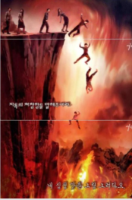
The man, Yahooshua {you probably know him as “Jesus”} died to provide a simple and easy to apply mechanism for repenting of sin.
To the extent that you avail yourself of this mechanism -- simply by praying sincerely “Father I confess that I have sinned in such and such a manner, I deeply repent, choose to turn around, and in the name of Yahooshua I ask you to forgive me” your sins are dealt with as YOU deal with them. But, insofar as Yahooshua died a terrible death to provide this simple means of deliverance from sin YOU will pay a terrible price for ALL sin that you fail to confess in this life.
There IS a place called “Hell” and, contrary to widespread belief is NOT a place primarily for unbelievers, it is for believers. It is a place where BELIEVERS will be tormented and tortured in direct proportion to the severity and duration of EVERY UNCONFESSED sin at the moment of death. Visit the page on Hell on my website for a number of detailed accounts of what this place is like.
If you do NOT believe
Well, that is fine I hear you say, BUT I DO NOT BELIEVE, then what?
Well it is fairly obvious is it not?
The Almighty has said of you "why would I want someone to spend eternity with me when they do NOT believe I exist?”
It is NOT about “good” it is about relationship. If you do NOT believe the Creator exists you commit the ultimate sin, UNBELIEF and you fail to qualify to compete in the race.
So, if you do NOT believe, NO matter how good you are, NO matter how many good works you have performed, NO matter how much you have given to charity or even the church you will NOT qualify to enter Heaven – it is THAT simple and THAT brutal!
So, what WILL happen to you when you die as an unbeliever?
Well, it so happens that there really ARE Ancestor Spirits, also known as Demons. When you die, a messenger {angel} will take you to the gates of the lake of fire and brimstone and explain to you that IF The Adversary {Satan} loses the Contest you will be cast into that fire and, in a moment of torment and terror you will be utterly consumed by the fire and cease to exist. You will also be advised that should the Adversary {Satan} win the Contest you will remain on Earth for eternity as an Ancestor Spirit (Demon) and that your calling is now to help the Adversary {Satan} to win.
You will also be shown Heaven and it will be explained to you that by failing to believe you have failed to qualify to enter Heaven. It is likely that you will be extremely upset and angry or dismayed at this point.
It will ALSO be explained to you that in terms of the Rules of Engagement you are NOT permitted to inform those that you have left behind of their error, certain other rules will be explained. You will also be advised that you now report to the Council of the Masterminds, the Demonic junta that rules the Earth in association with the Adversary {Satan} and that you will be brutally tortured if you step out of line. But that IF you promote the agenda of the Satanic realm you will be rewarded with promotion and positions of greater power and authority.
You will then be returned to your corpse. If you have died in a remote area your spirit will remain at the place of death for ever or until an agent of the Adversary collects you – ancestor spirits are human spirits – they need a human body or animal to ride on OR they need a messenger {angel} to transport them but the messengers ONLY transport the ancestor spirits if commanded to do so.
IF you die in a place of habitation, you may manage to transfer yourself onto a family member when they embrace the corpse or a Witch or other Satan servant in the hospital, mortuary, crematorium, etc may collect you, take you into stock, send you on orientation programs and assign you to some human being to lead into deeper error and sin.
As with heaven there is a progression of rank associated with power and authority and prestige, see “Where are YOU going?” for more information if this interests you.
Be aware that high rank in the kingdom of the Adversary {Satan} is associated with gross evil, human sacrifice, drinking human blood, torture, etc – so, IF you regard yourself as a “good” person expect to find the place of unbelief an uncomfortable place to spend eternity.
Should Satan WIN the Contest, and right now he is winning hands down, then he will reign on Earth for eternity and you will serve him on Earth for eternity. Expect to see the world degenerate into the worst excesses of the dark ages, Africa, primitive tribes and you will have NO option but to participate in whatever manner is dictated to you. There is an added catch. Should the Adversary win, the Almighty Creator, Yah, will WITHDRAW totally from the Earth and ALL life will cease. So UNLESS you have progressed to a sufficiently senior position in the hierarchy to have your own messenger {angel} to transport you, you will be stuck in the location where the corpse of your host fell and you will stay there forever!
NOT an attractive prospect to my way of thinking!

3.3 But this religion stuff is irrational and illogical, frankly its nonsense!
You are ABSOLUTELY CORRECT!
Almost ALL that organized religion teaches is FALSE and it IS irrational, illogical and nonsense.
For example, the Bible is NOT “the Living Word of God” or any such thing, it is a book, written by humans, it contains error and the Almighty HATES it because people turn away from seeking relationship with Him to worship the book – consider “Bible Church”, “Bible Study”, “Bible School”, ALL are an abomination in the sight of the Almighty – He desires a deep personal relationship with each and every one of us and the Bible gets in the way of that.
Furthermore, “Bible punchers” (the Almighty’s term) preach messages that are fundamentally false based on inaccurate translations of remnants of texts to which have been ascribed mystical properties that are entirely false.
For example -- creation did NOT take place in seven 24 hour days, it took place in seven stages over millions of years as the Almighty carefully crafted each element of what we see today, incremental step by incremental step, learning as he went, refining designs, discarding failed designs – everything that you would expect in an evolutionary engineering process of this magnitude and complexity.
Another example – the so-called “Flood” did NOT come about because it rained and rained and rained with water that came from nowhere – the Earth was hit by an ice comet from the Kuiper Belt that struck the Earth and melted flooding the Earth. It turns out that an ice comet of around 2,250 kilometers in diameter – the size of the Hellas Planitia impact crater on the surface of Mars once melted would flood the Earth to a depth of around 11.75 kilometers.
In the process the impact knocked the Earth to about 30 degrees off its vertical axis and knocked the Earth into an elliptical orbit around the sun. This massive shift in the axis of the Earth coupled to the change in solar orbit resulted in massive crustal forces which resulted in crustal disruption and tectonic upheaval (Earth crust disruption), around 20,000 volcanoes, upwelling of granite and lava, etc. The evidence is readily visible all over the Earth.
Concurrently with this, dating from its creation the core of the Earth had reached a super-heated state as a consequence of the nuclear reaction that occurs there. Coupled to the weakened crustal condition this suddenly caused the crust of the Earth split open and the Earth increased in diameter by about 25%. This caused deep canyons to form, where the seas exist today and caused the water to drain off the continents. This gave rise to massive high velocity erosion resulting in the land forms that we take for granted today.
There is much other nonsense that Bible worship is associated with.
So, in considering my message, PUT ASIDE all your issues with what you have heard and perhaps been taught and focus on THIS MESSAGE “The Almighty Creator wants a DEEP PERSONAL RELATIONSHIP WITH YOU!”
That is the ONLY message that matters – if you are NOT seeking a personal relationship with Him and seeking to know Him and to be guided and directed by Him and have Him lead you to the answers to ALL your questions you are fundamentally OUT OF LINE AND WASTING YOUR TIME!
Keep in mind that NO MATTER what you do, He knows more than you do and He wants to help you get better at what you do -- I am NOT referring to sin here! I am referring to productive work that you do to earn a living and make a contribution to society. He is also interested in your hobbies and other extramural pursuits and particularly interested in anything that is creative, inventive, seeking new knowledge. He wants to push the boundaries of your knowledge, technology, etc FAR MORE than you do!

3.4 So, IF He is so powerful why is there SO much wrong in the world?
Very GOOD question!
During the creative process things went wrong.
One of the major manufacturing defects was that one of the three most senior messengers {angels} who was the light bearer and praise leader in heaven developed pride and rebelled. We know him today as Satan, the Adversary.
The Almighty (Yah) judged the Adversary defective and was about to cast him into the incinerator (the Lake of Fire and Brimstone) to be destroyed when the Adversary challenged him to a Contest. The rules of the contest were simple – the Adversary and the third of the messengers who followed him (billions) would be cast out of heaven and onto Earth where Yah was working to create mankind. Once on Earth they would seek to deceive mankind to such an extent that after 7,000 years there was NOT a single human being in right standing with the Almighty on the Earth. In this event the Adversary {Satan} would be spared from destruction and would rule on Earth forever. If the Adversary failed then he and all those who followed him would be cast into the Lake of Fire and Brimstone and, in a moment of torment and terror, they would be utterly destroyed.
Neither party was allowed to directly speak to the humans with regard to changing behavior they had to work through other humans and by asking questions, etc.
At the time Yah was angry and frustrated and believed he would win easily and accepted the challenge. In fact it has turned out that the Adversary has been winning hands down and that there are very few human beings today who at any material level are serving the Almighty and in a position to bring judgment on the Adversary. In fact, right now there is NO certainty that Yah will win the contest.
Because of the “Rules of Engagement” Yah is heavily constrained and therefore is unable to deal with all the sin, error and evil that is on the Earth. Until one understands “The Contest” one is NOT able to really understand what is going on on the Earth today.

3.5 BUT – He demands too much, I cannot comply!
Many people hold that complying with the Commandments of the Creator, commonly referred to as “The Ten Commandments” is difficult.
That is because of the way we have been brought up.
In actual fact the Commandments are NOT difficult to comply with, it is a matter of understanding them and making a QUALITY DECISION to comply.
Yes, it WILL take time for you to walk out that decision but, with the help of the Almighty it is entirely achievable.
In order to do this one needs to understand the TRUE importance of the Commandments because, as with everything on Earth just about everything we have been taught about the Commandments is false and a lot of what we do that we believe IS compliant turns out to be in breach. The “Commandments” section on my website discusses this in some detail.

3.6 Some other things you should know
There is a huge amount more that I could write to you but I think this is enough for now.
I aim to email you from time to time with further information. In the interim, IF you are seeking more information please visit the website at http://www.End-Time-IssueMinistries.org

3.7 What do YOU need to do IF you accept this message?
So, you have read this message, you see that it makes sense that there is a Creator, that He desires a deep personal relationship with you, that things that did NOT make sense now DO make sense. If you already believed you see things in a new light with a new opportunity. If you did NOT believe you now see things differently and now CHOOSE to believe. You may of course write this all off as so much mumbo jumbo and carry on as before.
What do you do?
My advice, get on your knees, repent of your sin and pray something like “Almighty Father I ask you to have mercy on me, I now realize that my entire life to date has failed to accord you the position that you desire to have with me, please forgive me and lead me to a place of having a deep personal relationship with you”.
Or, IF you are NOT prepared to do that, please do it understanding the consequences of your decision.
Having prayed as above the next article addresses “Seven steps in drawing close to the Creator”.

Conclusion
I hope that this article has challenged you to seek a deep personal relationship with the Almighty Creator, Yah the eternally self-existing.
That is our ultimate purpose on Earth and the eternal rewards are huge.
Yes, you WILL have to make changes in your life, change your priorities and make sacrifices but I have total assurance that you WILL find this worthwhile at the end of your life. The fundamental question for each one of us is whether to live life with eternity in mind or with the here and now as our goal.
It is a choice for each one of us and is THE ULTIMATE design choice we were created to make!
IF this message has really challenged you and you have really decided to go all out to serve the Almighty please drop me an email at James@EndTimeIssueMinistries.org and we will add you to a mailing list and prayer list for such people and send you additional information from time to time.
If you are NOT challenged I encourage you to AT LEAST believe and do enough to become a Wise Virgin, the alternatives really ARE VERY unpleasant.
If you have found this article of value please forward and distribute as widely as you deem appropriate.
The article that follows is also available on my website at:
http://www.End-Time-IssueMinistries.org/CreatordesiresFRIENDS/CreatorDesiresDeepRelationship.aspx
and can be downloaded in pdf format from:
http://www.End-Time-IssueMinistries.org/ETI_Worship/00_1_The-Creator-Desires-a-Deep-Personal-Relationship-with-YOU.pdf
The companion article, “Seven Steps in Drawing Close to the Creator” is available at
http://www.End-Time-IssueMinistries.org/CreatordesiresFRIENDS/7StepsinGrowingClosetoYah.aspx
And can be downloaded in pdf format from:
http://www.End-Time-IssueMinistries.org/ETI_Worship/00_2_Seven-Steps-in-Drawing-Close-to-the-Creator.pdf
The Article “Seven Steps in Drawing Close to the Creator” gives much information on drawing close to the Almighty summarizing much of what I have learned in the last twenty one and a half years.
This is NOT about a group it is about YOU personally developing your own deep personal relationship with the Almighty Creator
In the final analysis do NOT rely on any other human being to determine your relationship with the Almighty. Draw on them as resources BUT YOU CAN draw closer to Father than ANY other person on Earth today IF you go ALL out to know Him and to craft YOUR life the way He wants it for YOU.
October 2014
This page is intentionally kept blank.

Section 4:
Seven Steps
to Drawing Close to
the Almighty Creator

Summary
The previous article stated that “The Creator Desires a Deep Personal Relationship with YOU”.
This article addresses the measures you can take to draw close to the Almighty Creator, starting NOW! – these steps apply whether you have previously believed or whether you have now chosen to believe for the first time – the emphasis will vary depending on where you are coming from.
The seven steps are:
  - Decision
Decide that the Creator exists and decide to seek a deep personal relationship with Him or, IF you already believe He exists, chose to seek a much deeper personal relationship with Him;
  - Prayer
A range of prayers intended to enable you to get MUCH closer to the Creator and be led by Him in every possible way, prayers like “show me the level of my present deception and how to correct it” – prayers that are intended to enable you to walk directly with the Creator and NOT rely on other human beings;
  - Fasting
It is NOT possible to get really close to the Almighty without fasting, some basic guidelines on what to do and what to pray;
  - Cleansing
This earth is controlled by the Satanic realm and demons, when one first comes to the Almighty one is highly contaminated, this section discusses at length what is required to get to a place where you can draw close to the Almighty and hear Him clearly;
  - Worship
Worship is vital in drawing close to the Almighty, a selection of highly effective worship songs that will help you on your journey;
  - Research
You are unique, your needs are unique, the value you can add to the Creator is unique, you need to investigate Him and His Kingdom for yourself and work with Him to craft your unique position in His service;
  - Action
Having done all the above it is now time for you to step out with the Almighty Creator and start being of service to Him and developing that deep personal relationship that you have chosen to pursue.
Each of these steps are discussed in detail below. Growing close to the Almighty Creator is an iterative and progressive process of all of these points as you deal with your sin and come to a place of hearing Him more clearly and understanding Him and His goals for your life.
The article that follows is also available on my website at:
http://www.End-Time-IssueMinistries.org/CreatordesiresFRIENDS/7StepsinGrowingClosetoYah.aspx
And can be downloaded in pdf format from:
http://www.End-Time-IssueMinistries.org/ETI_Worship/00_2_Seven-Steps-in-Drawing-Close-to-the-Creator.pdf
The companion article, “The Creator Desires a Deep Personal Relationship with YOU” is available at
http://www.End-Time-IssueMinistries.org/CreatordesiresFRIENDS/CreatorDesiresDeepRelationship.aspx
and can be downloaded in pdf format from:
http://www.End-Time-IssueMinistries.org/ETI_Worship/00_1_The-Creator-Desires-a-Deep-Personal-Relationship-with-YOU.pdf

Introduction
What follows is a series of measures that you can take in recognition of the harsh reality that virtually every human being on earth is in gross error and grossly corrupted and contaminated by the evil in this world and that, in order to draw close to our Father in Heaven we need to take extreme measures to move ourselves out of our current condition to a position where we can be truly close to Him and bring Him joy every day.
All the steps and the measures that follows are steps and measures that I have personally actively applied in my life over more than 21 years and which I testify DO work:

4.1 Decision
Fundamentally the first step that is required to draw close to the Almighty Creator whose true name is “Yah the eternally self-existing” is a QUALITY decision that He exists and, thereafter, a QUALITY decision to draw close to Him.
It is vital to understand that we are talking here of a profound and deep realization that this world and you, yourself, cannot exist without there being a Creator, that it is impossible for all around you to have come into existence without an intelligent creative agency. Once you have taken a deep decision that you know that you know that you know that He exists you can move on to choosing to draw close to Him.
Deep settled assurance that the Almighty exists
If at this point you do NOT have a deep and settled conviction of the reality of His existence then this is the first bridge for you to cross.
There are two elements to deciding that the Almighty Creator exists, one is a rational intellectual decision, the other is a deep settled assurance of the reality of His existence. The rational intellectual decision should be reasonably easy for any thinking person who calmly considers the massive complexity, creative genius and manufacturing precision of the Universe, the Earth, the Plant realm, the Animal realm and Human Beings coupled to an understanding of the level of engineering precision that was required to design and assemble all of this including the complimentary complexity required for the sexual reproduction that occurs throughout the more advanced elements of plants, animals and particularly human beings. That intellectual “Aha” may be all that you need to come to a deep conviction that the Almighty Creator exists.
IF, however, you have reached a level of intellectual agreement that there must have been a Creative agency but have NOT reached a settled assurance of His existence I would suggest that you ask Him to reveal Himself to you in a way that you are able to comprehend. Even if you DO have an intellectual “Aha” you may still want to reach a level of deep assurance of His existence.
In asking Him to reveal Himself to you it is vital to understand that He is restricted by the “Rules of Engagement” from doing anything that you have NOT formally authorized Him to do in your life.
Accordingly it is vital that in asking Father Yah to reveal Himself to you that you pray in a manner that opens the way for Him to move as He best sees fit to enable you to have confirmation of His reality. It is also vital to understand that He is offering you a huge reward for serving Him in this life. The ultimate prize is a position of great esteem, glory and authority in Heaven with Him for eternity.
As much as He IS lonely in this age because of the very small number of people who truly serve Him and seek to become His friends, He has stressed to me that He is NOT in any way desperate. In other words, He has NO need to prove to you that He exists. He firmly holds that you can validate His existence from the most elementary intelligent consideration of yourself and the world around you. Accordingly any form of “challenge” to Him to prove His existence will at best be met by silence and NO response and at worst will be given to demons and Satanic Messengers {angels} to answer.
An approach to reaching a decision
I suggest you adopt the following broad approach, remember always that He wants an individual relationship with YOU that meets YOU where YOU are and is tailored to YOUR knowledge, experience, character, etc – so there is NO recipe. What follows is a suggestion only, take whatever measures seem right to you at the time you decide you need to ask for confirmation and depending on the circumstances that pertain at that moment in time. Remember also that He hears ALL your thoughts and it is NOT necessary to speak out loud. In fact, as a general principle with regard to all major elements of interaction with Him it is PREFERABLE to speak to Him in your heart and your thoughts and NOT out loud where demons and fallen Satanic Messengers {angels} can hear you and intervene to counterfeit or mislead you.
Realize also that you should NOT dictate to Him HOW He should answer you, He is the Almighty Creator, it is NOT for us to dictate ANYTHING to Him. He has a very low tolerance for insolence in the light of his experience with the Adversary {Satan}.
I suggest you do something along the lines of the following: find a quiet place, get on your knees before Him, in other words humble yourself before Him (I find that on your knees or flat on your face before Him are the physical postures in which I hear Him most clearly) and pray something along the lines of “Father Yah, James says that you exist, I sort of get this from considering the world around me but I am struggling to overcome all my prejudices and deep seated beliefs held in my life to this point. I humbly ask you to reveal yourself to me in whatever way you choose, I ask you to give me a sign, to speak to me, to reveal your existence in ANY way that you deem appropriate and I ask you for the discernment and the wisdom to recognize you when you speak to me. Amen”
You could pray this standing on a bus or wherever you are at the moment the realization hits you that He MUST exist, there are NO limits on where and how you pray subject to the guidelines given above. He may answer you audibly, He may speak to you through another person, He may give you some sign that could NOT have come from anyone else but Him. Be aware that He is super-natural, He is ABOVE and BEYOND nature, so He is NOT constrained in the ways He can do things and therefore He may simply reveal Himself by doing something that could NOT happen under normal circumstances. In my case He revealed Himself to me by speaking audibly to me in an empty room and directing me to contact a friend who was a believer who told me what I needed to know – He did this in response to prayer by my father who was deeply concerned about my situation. This happened when I was nearly forty years old, about twenty seven years from the point at which I first believed at a very basic level.
It is NOT necessary for you to wait such a period. He desires to reveal Himself to YOU today, to start building a relationship with YOU today. He wants to start talking to you TODAY and to talk to you every day for the rest of your life if YOU are willing to listen and to do the hard work that is necessary to come to a point where YOU can hear Him in that way. If you cannot hear Him the problem is ALWAYS on your side. So it is ALWAYS possible to get to a place of hearing Him, even though this may require some hard decisions and actions at times.
One of the easiest ways to STOP hearing Him is to get into pride or rebellion both of which will prevent you from hearing Him and may cause Him to cease speaking to you until you humble yourself before Him. Remember, He is offering you a prize of great value and has NO need to beg you to receive it. YOU have to earn it and learning to hear Him is the FIRST step in that journey.
Asking for confirmation
If you receive a sign and are unsure or appear NOT to receive a sign there is NOTHING to prevent you asking for confirmation or clarification along the lines of “Father Yah I think that … was from you but I am NOT sure, please will you give me another sign or confirm that sign”.
The trash heap of Heaven
Once you are certain that He exists the next step is to decide to draw close to Him and to serve Him for the rest of your time on Earth and for eternity. Note that you do NOT have to make this decision, the vast majority of people who DO make a decision that He exists stop at that point barring perhaps a few feeble attempts to serve Him. These people will end up in the “Outer Darkness” in Heaven -- a place of total darkness with NO hint of light, it is also cold and uncomfortable as well – Father refers to it as “The Trash Heap of Heaven” – this is the place for those who decided that Father Yah existed and then ignored Him for the rest of their lives. If YOU ignore Him for the rest of your life from the point that you believe then realize that He is entirely justified in ignoring YOU for eternity. NOT the right way to go about things but the majority do this.
IF as you read this you realize that you are headed for the Outer Darkness I suggest you do the following: find a quiet place, get on your knees before Him and pray something along the lines of “Father Yah, I know that you exist but I have just realized that I have almost totally ignored you since I first believed. I now realize that I am headed for the Outer Darkness to be completely distained and disregarded in Heaven for eternity. I repent and ask you to forgive my gross sin of ignoring you and to give me another chance. Father please help me to come to a place of serving you faithfully, I desire to overcome to the end and become your friend, please help me to do this”.
Obviously ONLY pray the above IF you mean it sincerely and intend to DO something about your decision. Then do ALL that you find to do including ALL that is set out in the rest of this document.
If you are only prepared to go part way and regard a less prestigious rank than “Friend” as acceptable or the maximum that you are willing to put in the hard yards for, then tone down the above prayer appropriately.
Praying to an indeterminate entity is NOT acceptable
NOTE that praying AT some indeterminate entity called “God” or “The LORD” or whatever is NOT belief, that is just praying at some indeterminate entity. If you are going to pray to Father Yah do so as the Creator of ALL things, the Almighty, YOUR Creator, show Him respect, humble yourself and pray with a deep certainty that He exists, DOES want a deep relationship with you and DOES hear you and desires to answer your prayers. If you start out on that footing you WILL find that He answers you and in many cases grants your requests.
NOTE also that it is NOT necessary to get on your knees OR get in a quiet place – you can speak to Him at ANY time, in a crowded room, ANYWHERE, He will ALWAYS hear you. Depending on where you are spiritually you may NOT always hear Him, one gets on one’s knees in a quiet place in order to better hear His still, small voice!
NOTE ALSO that you should NOT choose to serve the Almighty Creator because someone has told you that He is going to prosper you or heal you or whatever. He is NOT a commodity to be purchased. Yes, it is possible that He MAY heal you, He MAY prosper you, BUT the forces of darkness will be deeply upset by your decision and will actively seek to oppose you, trip you up, lead you astray and generally keep you from walking out your decision. That is why those who achieve great stature in Heaven are called “Overcomers”, they achieve that illustrious status by overcoming sin, overcoming temptation, overcoming opposition, overcoming their own weaknesses and fallibility to walk totally with the Almighty Creator.
Expect opposition
Therefore be warned that you WILL find that from the moment you take a quality decision to draw close to the Almighty you WILL encounter ongoing and sustained opposition. You WILL find yourself being judged for unrepented sin, you WILL suffer loss, you WILL find it harder to do business, you WILL find that people who were your friends become your enemies – you have taken a position against the mighty one {god} of this world, Satan, the Adversary, and the forces of darkness will rally round to oppose you in every possible way. The ONLY way to overcome this opposition is to deal with ALL sin in your life and to resolutely seek to serve the Almighty in every possible way in every area of your life.
I would go so far as to say to you that IF you make what you consider to be a quality decision and start walking that decision out and you are NOT experiencing opposition in some shape or form there is something WRONG! You are obviously then NOT causing the forces of darkness concern and they are leaving you alone. Note that most prosperity teaching is NOT from the Creator, do NOT sign up with the Almighty on the basis of what He can do for you, sign up on the basis of the reward that there will be for YOU in the life to come IF you serve Him faithfully in this life and then be willing to make sacrifices to serve Him. And if that seems too hard, remember that you always have the option of the Outer Darkness or, if you have NOT yet believed, the option of being one of more than 100 billion ancestor spirits {demons} roaming the earth governed by vicious and perverse Masterminds who regard brutality and human sacrifice as the highest forms of reward – we are engaged in a vicious battle, choose who you will serve!
Deal with ALL sin
In this context note that a non-negotiable requirement for successfully serving the Almighty is to deal with ALL SIN in your life and energetically work to come to a point of living a life that is FREE of sin – that is the ONLY way you can serve the Almighty and walk in victory. The other option is to continue with your sin at such a level that the forces of darkness regard you as an ally and prosper you to let you think that you are going in the right direction. Problem then is what happens when you stand before the Throne of the Almighty Creator on the day of your death!
Note that IF you have just accepted Father for the first time you should immediately pray “Father, I ask you to fill me with your Spirit to assist me to serve you more effectively”, raise your hands to heaven and expect to receive, you should pray this daily and should sing worship songs that speak of being filled with the Spirit of the Almighty. See the collection of worship songs later in this document.
Seven days of Grace
Note also that IF you have just believed for the first time there is a seven day period of grace during which no evil can come near to you and during which Father is able to pour out His Spirit and pour out learning on you in a way that will NEVER again be possible. If at all possible take a week off work and devote the entire week to prayer, fasting, worship, study (there is much material on my website that is more than sufficient to keep you reading for more than a week). If you cannot take all that time off work take off whatever time you can and spend as much time as you can outside of working hours seeking to be filled with His Spirit (anointed), to be cleansed of sin, to learn, etc. See further recommendations in this regard later in this document.
Rehearse the Covenant
Once you have believed for the first time OR have now repented of your sin and error and taken a quality decision to serve the Almighty it is advisable to take note of the Covenant between believers and the Almighty and to rehearse the terms of that Covenant. The most powerful covenant available, there are many, is the Covenant made by Yahooshua {you may know him as Jesus but you insult him grievously by using this pagan name} and, accordingly, I advise you to pray to be grafted into this covenant.
At the first possible opportunity obtain some grape juice, preferably Red Grape, preferably NOT carbonated, you can use red wine as an alternative but I recommend grape juice. Also obtain some bread, preferably unleavened, some shops sell Jewish Matzos, or a plain wheat biscuit or, failing that ordinary leavened bread.
Find yourself a quiet place and pray along the lines of:
“Father, I come to you in the name of Yahooshua and I recall that on the night that he was betrayed Yahooshua took the bread and broke it and gave it to his followers and said, ‘this is my body given for you, do this as often as you eat it in remembrance of me’. I ask that as I partake of this bread that I partake of ALL that it represents to you and that you will teach me what this means and what the Covenant entails” – take the bread, break it and eat it soberly and thoughtfully considering all your sins and wrong doing.
Then take a cup of the grape juice or wine and pray “Father, I recall that after supper Yahooshua took the cup and gave it to those who followed him and said ‘this is my blood shed for you and for many for forgiveness of sin, do this as often as you drink it in remembrance of me’. I ask that as I partake of this cup that I partake of ALL that it represents to you and, in particular I ask that you forgive me ALL my sins -- all that I have done that I ought NOT to have done and all that I have NOT done that I ought to have done. I ask that where there is sin that I need to deal with specifically that you will bring it to my attention and guide me in dealing with it, I also ask that you will cover me with the blood of the covenant from the top of my head to the soles of my feet and also cover my dwelling and all that I own and have beneficial use of the with the blood of the covenant, I ask this in the name of Yahooshua, Amen”.
If as you are praying you become conscious of sin, immediately confess it and repent “Father I recall that I …, I now recognize that I have sinned, I deeply repent and ask you to forgive me” – if this is your first experience of this you could spend several hours repenting. Have a pen and notebook to hand so that you can make notes, you may find that you need to contact people to repent and ask forgiveness, restore things you have stolen, etc. When you have finished praying drink the grape juice or wine, dip your forefinger in the cup and apply a small amount to the back of your neck, your forehead, your tongue, your eyelids, the lobe of your right ear, the thumb of your right hand and the big toe of your right foot praying as you do so, “Father I ask you to seal my brain with the blood of the covenant, seal my tongue and all that I say, seal my eyes and all that I see, seal my ears and all that I hear, seal my right hand and all that I write and covenant and seal my right foot and guide me everywhere I walk”.
Metaphor
Father makes extensive use of metaphor and physical world parallels to teach us and to communicate with us. Do NOT be distracted or put off by this, it is simply part of the challenge for Him in communicating with us in our messed up state on this corrupt planet.
Clean up
Thereafter be very alert to any thoughts that you may have about wrongs that you have committed, people you need to apologize to, things you may have stolen that you may need to return, etc – generally this will open the door to a lengthy process of dealing with sin over a number of years as you become aware of issues you need to deal with. This may happen in a much shorter period or a much longer period depending on your willingness to take the uncomfortable steps that follow awareness of sin. Note that should you take the measures above in the first seven days after you first believe the cleaning up process will be MUCH quicker and easier so, if you are such a person I encourage you to GO FOR IT!
In the first seven days after believing I encourage you to take the bread and wine morning and evening every day. Even if you have returned to Father or taken on a much more intense commitment I would encourage you to take the bread and wine morning and evening every day for seven days. You might feel impressed to keep doing this daily for weeks, months or years. I have had periods where I have taken the bread and wine morning and evening daily for months at a time.

4.2 Prayer
The previous section has introduced prayer and given some guidelines. The next step in moving to a deep personal relationship with the Almighty Creator is to start praying the prayers that are necessary for Him to start moving in your life and guiding you.
On your knees – the best way to hear
As a general rule the best position for prayer is on your knees before Father. This is also the best position to hear Him clearly. This position is a meaningful statement of humility towards the most powerful being in the entire Universe and it also helps you to get your mind right and hear more clearly. IF you make a quality decision to serve Him in response to these emails it is probable that you will spend MANY hours on your knees confessing your sins, asking questions, etc.
Note that you can pray ANY place, ANY time, in ANY position, your knees is simply a good place to be if you are REALLY seeking answers. Flat on your face on the floor can also be a good position if you really need to humble yourself.
As with ALL of these things it is up to YOU to craft the mix of postures, etc that you adopt as you develop your relationship with the Almighty.
Prayers are NOT necessarily answered instantly, or at all
While some prayers may be answered very soon after you pray them others take much longer to be answered. For example a prayer “Father I ask you to give me wisdom” should be prayed regularly and may take years before you become aware that you are wiser than you were before through learning experiences that have come your way since you first started praying that prayer.
Other times it can take months or years for Father to set-up the answer. I have had prayers and questions answered halfway across the world and it sometimes took a lot of organization to get me there.
Note that you should also be praying “Father let your will be done in my life” – it is very easy to pray things that are NOT Father’s will and either NOT receive a response OR have your foolish or presumptuous prayer answered by the Satanic realm.
Rules of Engagement restrict Father Yah
Remember that in terms of the Rules of Engagement Father Yah cannot DO anything in your life unless He has the consent of a human being and He cannot SAY anything to you that is outside the realms of what you believe without the consent of a human being, in both cases primarily yourself – generally human beings have limited authority with regard to these matters for other human beings.
Show me the level of my present deception
Thus, if you believe that “the Bible is the living word of God and without error”, Yah is constrained to operate within that belief and cannot tell you that you are mistaken UNLESS YOU give Him permission to operate outside the boundaries of what you currently know and believe by praying a prayer like “Father I ask you to show me the level of my present deception and how to correct it” – and pray this regularly, I started praying this in around 1998 and still pray it regularly today. As a consequence I have received dramatic revelation of all sorts of errors in what I believed at the time I started praying this prayer. Note that it is NOT humanly possible to deal with the consequences of praying to be shown deception in one installment; Father is constrained by our limitations to teach us step by step as we are willing to learn and adjust. There is NO point in praying “show me the level of my present deception” UNLESS you are willing to course correct. And little point in praying it once, pray this daily IF you are serious.
Lead me into ALL truth by Your Spirit
Another important prayer in a similar vein is “Father I ask you to lead me into ALL truth by Your Spirit” – this prayer will take years to be fully answered.
The End Time Issues Ministries website provides many answers
Note that answers to prayers such as these can take various forms and can take days, weeks, months, years or decades to be fulfilled. If Father had shown me the level of my deception all at once the first time I prayed the above prayers I do NOT know if I could have handled it and I certainly would NOT have known what to do with all the mountains of revelation that followed in the next four years in particular. Once you have prayed the above prayers you will find that my website, http://www.End-Time-IssueMinistries.org contains answers to MANY questions that you may ask and this should assist you to fast track dealing with many of the more commonly occurring errors.
See the Table of Contents for a listing of over 700 webpages on diverse topics.
See the Article Categories page for a listing of the more than 300 articles written from 2009 onwards which address a diversity of topics, also listed in reverse sequence of publication on the Articles page.
See the Article Keyword Cloud for keywords on many of these articles as an alternative point of entry into the articles.
See the List of Articles prior to 2009 for over 600 articles written between 1999 and 2009 which address numerous issues that are NOT discussed elsewhere on the site.
Use the Google Site Search in the right hand side bar to search particular topics across the entire site. There is also an Article Search in the side bar.
The Important Insights page lists a significant number of important pieces of information that Father has shared with me recently.
Judgment in this life
A key reason why the above resources are important relates to a fundamental principle of serving the Almighty, Judgment in this life. The moment you choose to serve the Almighty the forces of darkness will focus attention on you with the intention of misleading you or, if possible, destroying you before you become a threat to them. One of the most effective tools available to them is Judgment in this life. Simply put the Almighty presides over the Court of Heaven, Satan and his cohorts appear in the Court as prosecutors and bring charges against living human beings, primarily believers. Yahooshua {Jesus} as advocate argues in defense and in mitigation of sentence by way of mercy and grace for young and inexperienced believers and the Almighty hands down sentences that are executed by the Satanic forces or by the messengers {angels} of Heaven.
This can range from a minor sentence like causing you to trip and fall through to a major sentence such as a serious illness, motor accident or, in extreme cases, death. The severity of the sentence is in direct proportion to the severity of your sin and your level of maturity.
A new believer is accorded considerable mercy and grace while a believer who has been walking with Father for decades will be judged most severely.
In many cases, particularly with mature believers, the Forces of Darkness will bide their time until a significant level of sin has accumulated so that they can obtain a severe sentence that they hope will neutralize or take out the believer concerned.
Judge me severely and correct me harshly
The simplest solution to this reality is to avoid sin, the problem is that the day one starts on this journey one is almost totally ignorant of what REAL sin is. Accordingly study and prayer, as above, are of paramount importance. Coupled to this possibly the most powerful prayer there is in terms of seeking to overcome is “Father I ask you to judge me severely and correct me harshly that I may serve you more perfectly”.
At first glance this may look like an extremely high risk prayer, it is NOT – Father has a fundamental principle that He will NOT allow His children to be tested beyond what they can endure. I first prayed this prayer in around 1998 and have prayed it regularly for a number of years now. I have NEVER experienced a judgment that I have NOT been able to handle, recover from, learn from, course correct from and grow from. This prayer prevents the forces of darkness from controlling judgment in your life and place the control in the hands of our merciful and loving Heavenly Father. This also permits Him to judge us immediately so that we can deal with issues as they occur without them heaping up.
If you are serious about serving the Almighty I STRONGLY COMMEND “Father I ask you to judge me severely and correct me harshly that I may serve you more perfectly” as a daily prayer.
Bring the people you want into my life and take those that you do NOT want in my life out
One of the things that I learned early on in my intense walk with Father was that I was NOT a good judge of character and that there were people around me who were NOT helpful to me in my walk with Him. Accordingly, for the first time in 1995 I prayed “Father I ask you to bring the people you want into my life and take the people out of my life that you do NOT want in my life out” – in the first year He removed one of my business partners, several of my staff, my wife and various other people. In each case as He took them out (in most cases they left without me doing anything) Father revealed hidden agenda’s and spiritual issues that were getting in my way of serving Him.
When one prays prayers such as those presented so far one MUST be sensitive. You have asked Father to take charge in BIG areas, EXPECT Him to act on those prayers. So when a person starts acting up in strange ways and threatening to resign, LET THEM GO! If the strife in your marriage suddenly escalates to a point where you discover treachery then get divorced. And so on as things unfold.
These prayers frequently do NOT require that you audibly HEAR anything from Father, only that you discern that you are being led in a way that is an answer to what you have prayed. If you find yourself in a bookshop with time to spare, perceive there is probably a book there that Father wants you to read, turn to Him for guidance, go to whatever shelf attracts your attention, pick up whatever book catches your eye, open it wherever it opens and you may find the answer to a question. I have had this happen thousands of miles from home as the way that Father used to answer a particular question. I have even had Him do this in ways that have answered questions that I did NOT know existed and have been taught accordingly.
Once one prays these important directional prayers one opens the door for all sorts of developments in one’s life.
If you miss it
At the same time, IF you are NOT willing to be sensitive and obedient do NOT pray the above prayers, you will bring judgment upon yourself if you pray these prayers and then FAIL to respond to the answers. Apart from anything else, Father will soon lose interest in answering your prayers. If, as you read this you realize that you are guilty of asking for guidance and then ignoring the guidance when it occurred, pray immediately “Father, I realize that I have ignored your guidance in … situation, I repent and ask you to forgive me”. He is gracious and off forgiving and He WILL grant forgiveness for genuine repentance.
Note, however, that if you get into ongoing rebellion and disobedience you WILL eventually reach a point of total rejection from which there is NO recovery. Once you have crossed that line Father will cease to have anything to do with you, the forces of darkness will use you to serve whatever purpose serves them and at the end of your life you WILL be judged and sent to Hell for all your unconfessed sin and once you have paid the price for your unconfessed sin you WILL be cast into the Lake of Fire and Brimstone where in a moment of torment and terror you WILL be utterly consumed and cease to exist.
Do NOT pray prayers like those suggested here if you are NOT serious.
Open doors and close doors
Another very effective directional prayer is “Father I ask you to open the doors in my life that you want opened and to close the doors that you want closed” – this allows Father to direct you in diverse ways. Be prepared to change jobs, home, country, whatever Father deems appropriate to your best interests in His service.
Prayer for advancement
Assuming that you have read this far because you ARE serious about serving Father the next prayer to consider is “Father help me to become a wise virgin, a wise steward, a good and faithful servant and an overcomer to the end of my life, help me to become your friend for eternity”. If your ambitions do NOT go all the way to “friend” with the commitment and sacrifice that entails, then stop wherever you are comfortable stopping. Each of these categories is closer to Father in Heaven, carries greater prestige, rank and authority AND greater responsibility and accountability. AND greater opposition and challenges in this life. YOU decide how far you want to go.
The rank up from the “Workers of Iniquity”, those in the outer darkness, is the “Foolish Virgins”, those who know Father exists but do things THEIR way – the vast majority of Church / Mosque / Synagogue going believers sit in this category – they make NO real effort to know Father’s will and to do it. In fact, MOST Pastors, Priests, Imams and Rabb’s are in this category as well – the number of people who are seeking at least enough of a relationship with Father to know His will and do it is VERY SMALL!
So, what about you?
Where are you going to aim for?
The “Wise Virgins” are those who at a basic level are prepared and seeking to do Father’s will but they never get beyond the basics. They have NOT been filled with the Spirit of the Almighty, in other words they have NOT allowed Father in, they have an intellectual knowledge but NO spiritual connection.
The “Wise Stewards” are those who are starting to do something material for Father in accordance with HIS will NOT the teachings of the church or the Pastor, or the Imam or the Rabbi or whoever.
The “Good and Faithful Servants” are those who are going out of their way to serve Father, they are REALLY making an effort, they are obedient even unto death, they are really GOING FOR IT.
The “Overcomers” are those who have got to a place of overcoming sin in their lives, they are overcoming the obstacles that the forces of darkness are bringing against them, they are conquering and ruling with the Spirit of the Almighty within them.
Friends
The “Friends” are those whose relationship with Father is so close, who are so committed to Him that nothing else matters except pleasing Him, who are reigning over sin, who are confidantes and friends of the Almighty in the deepest possible sense. These people have made huge sacrifices over years, they have laid down their lives, they talk to Father constantly and engage in dialogue with Him. He tells them His plans and consults with them. He even defers to their judgment with regard to how specific assignments should be executed because, as He puts it “I do NOT live in your skin”.
These are people who in the extreme examples include Noah, Abraham, Moshe {Moses}, Daniel, Yahooshua {Jesus}, Mohammed – men and women whose prayers have brought judgment on the earth, parted seas and turned situations around. There have been many others but these are the most notable and the opportunity exists for YOU to become a Friend of the Almighty and seek to achieve the same level of standing and authority on earth TODAY!
Father desires this level of relationship with EVERY human being on earth, INCLUDING YOU!
Will YOU respond?
Will YOU go ALL OUT to serve Him, to please Him, to get to know Him?
To become His trusted advisor and confidante?
Someone to whom He confides His deepest desires and concerns, someone who is totally sold out to achieving Father’s will on Earth and bringing Him JOY every day?
He STRONGLY desires this of YOU. Right now He is very lonely because there are almost NO people on earth at this level.
If you apply the principles contained in this document YOU can become His Friend IF you so choose and make the effort and sacrifices that are necessary to get there.
Other directional prayers:
- “lead me by Your Spirit every second of every day”
- “help me to accurately discern the leading of Your Spirit and be instantly obedient”
- “help me to see what you want me to see and nothing else”
- “help me to hear what you want me to hear and nothing else”
- “help me to think what you want me to think and nothing else”
- “help me to speak what you want me to speak and nothing else”
- “help me to write and contract (with my hand) what you want me to write and contract and nothing else”
- “help me to walk (go with my feet) where you want me to walk and nowhere else”
- “lead me in every possible way”
- “speak to me through whatever medium I am able to hear you through, books, magazines, newspapers, emails, radio, TV, recordings, websites or any other medium”
- “where necessary send people or messengers {angels} across my path to speak to me”
In all of the above it is up to you to be sensitive and discern that Yah is answering your prayers.
He will NOT steam roller you into anything or force your hand. If you do NOT want to listen or for some reason are unable to listen He will NOT force you – it is up to YOU to be sensitive and obedient and seek clarification, confirmation and further guidance as you grow in relationship with Him.
Do NOT ask for Yah to send other people to you UNLESS you are willing to be obedient to what He says, failing this you will open yourself up to judgment. It is a major logistical exercise in most cases for Yah to arrange the life of another person to meet up with you – when it happens be appropriately grateful to Yah and be attentive to what Yah has to say to you through that person.
As a spokesman {prophet} of Yah I am constantly disappointed by the extent to which people, when confronted with a spokesperson {prophet}, take what that person says lightly and frequently go out and do exactly the opposite of what Yah has said. I challenge you, having read this far, to take the message of this article to heart and NOT ignore Yah’s message to you through me.
Bless me indeed, enlarge my territory
Another important prayer “Father I ask you to bless me indeed, enlarge my territory in relationship with you, in knowledge of you and your will and your ways and your kingdom, in the anointing of your Spirit, in emunah {faith, trust and belief}, health and in finances” – you can change this prayer any way you want and remove finances or put finances first, it is up to you to determine what YOUR priorities are.
Harmony
If you are in a covenant union with another with a one flesh bond, {marriage} you can add “harmony” to the above list of items to ask for.
If you are in such a union you can pray “Father, please teach us to walk in perfect harmony, to be perfectly aligned with your will and with one another”.
Wisdom, Understanding and Favor
As a daily prayer you can ask “Father I ask you to grant me wisdom, understanding and favor in ALL that I do”. You might preface this by praying, “Father I thank you for this day, I thank you for your love, your mercy and your grace”
Protection
IF you are in line with Father’s will and living a life above sin the forces of darkness CANNOT TOUCH YOU!
This is really important. So many who believe at some level suffer loss because of sin in their lives and the resulting judgment to the extent that they think that loss is inevitable. I have encountered highly anointed ones who are unaware of the principles of Judgment in this Life and who regularly suffer loss and take it as part of the job. It is NOT, IF you are fully in Father’s will, as best you are able at whatever stage in development you are today, Father will NOT permit the forces of darkness to touch you. You CAN be cast into the Lion’s den or the fiery furnace and walk out unscathed.
Pray, “Father I thank you that your messengers {angels} encamp around me to protect me, that NO weapon formed against me shall prosper, that EVERY tongue that rises against me in unrighteous judgment WILL be refuted”. This prayer ONLY works if you are doing all you can to live above sin at the level of your current understanding so that Father has a legal basis to protect you.
Daily prayer
It is advisable to pray at least morning and evening in a formal way in addition to the prayers and conversation you engage in with Father throughout the day. We pray in the morning before breakfast and at night when we go to bed. Prayers should include most of the prayers listed here, as seems appropriate at any time, many should become part of your standard routine. I like to open along the lines of “Father we thank you for this day, we thank you for your love, your chesed {mercy, loving kindness} and chen {grace}. We ask you to help us draw closer to you, to live our lives in a way that is pleasing to you and to bring you joy every day. We ask you to help us to use this day wisely. In particular we ask for guidance with regard to … etc … Amen”.
Prayer in the name of Yahooshua {Jesus}
Note that prayer in the name of Yahooshua is ONLY relevant when you FIRST come to belief, when taking authority over the powers of darkness – you are operating in the delegated authority of Yahooshua and in the EARLY stages of your relationship with Father when you are repenting of sin. Apart from these cases and particularly as you mature the name of Yahooshua is NOT relevant in prayer and is, in fact, offensive to Yah. In fact, Father has given me to clearly understand that He is thoroughly angry relating to inappropriate prayer “in the name of Jesus” or “in the name of Yahooshua” and, accordingly, you should avoid that usage unless you are VERY clear that it is appropriate. Yah answered prayer before Yahooshua and He answers prayer by those who do NOT believe in Yahooshua so there is NO need to pray in this name, whether the real name OR the pagan name.
Giving thanks for meals
The giving of thanks / saying grace before meals is a widely held custom but is in fact largely meaningless except in extreme cases. The food in front of you is a consequence of your own endeavours and there is therefore no basis to thank Father for it. If you are living in an advanced society with no risk of poisoning and little possibility of serious contamination there is also NO basis to bless the food or pray over it in any shape or form. IF Father has indeed provided miraculously, which very very seldom happens THEN it is appropriate to give thanks. IF you are in an environment where poisoning or contamination are real risks then pray specifically against those things. Apart from that Father has made it clear to me that such prayers are unnecessary and a source of irritation to Him.
The “Lord’s Prayer”
Father has made it clear that the example prayer given by Yahooshua, while containing some good principles is simply a prayer by a man, recorded by a man in a book published by men and NOTHING more. So, while it is better than praying nothing Father is also thoroughly frustrated with people praying this prayer on a regular basis with NO engagement. He is interested in YOUR PRAYER TODAY, your needs, your wants so, while there is MUCH in this document that you SHOULD pray regularly it is up to YOU to craft a selection of prayers and wording of prayers that works for YOU.
Provision – Most Prosperity teaching is NOT from Yah
There is GREAT error relating to the subject of provision and particularly with regard to finances, Father WILL give you the wisdom to get wealth and He will provide your needs through the anointing of His Spirit but YOU have to do the hard work, deal diligently, honorably, with wisdom and integrity. Get to work on time and put in a good days work, etc.
Remember that after Adam ate the fruit in the Garden that Father condemned us to live by the sweat of our brows, NOTHING has changed and any teaching that teaches to the contrary is NOT from Father.
For this reason tithing is NO LONGER RELEVANT because there is virtually no-one in a fit spiritual state to receive tithes. Yes, Father MAY request that you give of your finances to another believer on occasion but be VERY sure that it is Him that is asking you, failing that you become yoked to the error of the person to whom you give finances.
If you are currently in a Prosperity church and prospering and you start doing the things that are set out here expect your finances to dry up because the demons that have been prospering you will cease to favor you, almost all that it taught in the Prosperity churches is NOT from Yah!
As you draw closer to Father the level of opposition will increase and you will find it harder and harder to cope financially – this is NOT because Father is unable to provide it is because the level of opposition to those who are truly seeking to serve Yah is huge – the forces of darkness will do ALL they can to starve you out and you WILL have to work diligently and with extreme integrity in order to prosper. If you are in covenant with another, that is marriage, it is vital that you are perfectly aligned and in intense harmony because a divided house WILL fall.
Wisdom to get wealth
Father provides for us through teaching us things that enable us to earn good livings. He supplies all our needs through the anointing of His Sprit that is upon us BUT we have to live by the sweat of our brow because that is how it was ordained after Adam disobeyed the Creator.
Pray, “Father I ask you for the wisdom to get wealth by the anointing of Your Spirit upon me, I ask you to teach me what I need to know in order to make a reasonable living and still have time to serve you”.
Bible NOT “the living word of God and without error”
One of the greatest lies today is the lie about the Bible being “the living word of God and without error”. The harsh reality is that Father hates the Bible and says that it is the “GREATEST IDOL ON EARTH TODAY” because it prevents people from drawing close to Him and GREATLY limits His ability to interact with them.
Yes, people DO have experiences of Yah through the Bible because that is the ONLY way they will allow Him to reach them BUT He truly wants a deep personal relationship with them in terms of which He can speak to them directly and in any way He chooses and through any book, website, etc that He chooses.
The Bible is such a problem because:
- It is a “tiny book” in terms of the total engagement of the Creator with human beings and really focusses on about 2,000 years of history out of the over 6,000 years from creation;
- Much of what it does cover, such as creation and the flood it deals with very superficially at a level that results in major error;
- Most of the Bible is simple historical account, there is very little direct guidance and most of what there is is directed at specific groups of people;
- Most so-called “Bible based teaching” is by extension and inference rather than based on what is actually present in the Bible;
- People devote time they should be devoting to building their relationship with the Almighty Creator to Bible Reading, Bible Study, Bible School and Bible Church all of which detract from a deep personal relationship with the Creator;
- Father has interacted with human beings in a huge diversity of ways over and above what is contained in the Bible and these ways are ignored;
- The Bible contains some useful history and that is ALL.
Overall Father regards the Bible as a huge limiting factor in His relationship with us, accordingly IF you have worshipped the Bible I encourage you to pray “Father, I repent of worshipping the Bible and of allowing it to come between me and a living relationship with you, I ask you to forgive me and to help me to focus on you and NOT the Bible”.
“The LORD” is a blasphemous name
The names “The LORD” and “God” are both incorrect and blasphemous and their use flows directly from the incorrect use of the Bible.
The name “The LORD” is an inaccurate representation of the Hebrew phrase “Yahooeh” or, less accurately, “Yahweh” which means “Yah the eternally self-existing” and which occurs over 6,000 times in the source Hebrew of the so-called “Old Testament”. “The LORD” is actually an accurate translation of the Hebrew word “Baal” which is retained in the majority of Bible translations – Baal is one of the demonic Masterminds that rules on earth reporting directly into Satan. To refer to the Almighty as “The LORD” is a great insult and it is only through His long suffering and mercy that He has answered prayers in that name at all.
This use of “lord” is also confused with the use of “lord” in reference to Yahooshua {Jesus} and is a contributing factor to the confusion regarding the identity of Yahooshua.
If you are guilty of calling the Almighty “The LORD” or “Lord” instead of using His true name, Yah, pray as follows “Father, I confess that I have called you ‘Lord’ mistakenly believing that this was a valid name for you, I now realize that this is sin and repent and ask you to forgive me”.
“God” is a blasphemous name
“God” is generally a translation of the Hebrew word “Elohym” meaning “Mighty One”, “mighty one” or “Almighty” depending on context. “God” is derived from a German pagan, that is Satanic, name and should also be avoided.
If you are guilty of the sin of calling the Almighty “God” pray “Father, I confess that I have called you ‘God’ mistakenly believing that this was a valid name for you, I now realize that this is sin and repent and ask you to forgive me”.
Jesus’ correct name is Yahooshua
Another major factor that gets in the way of people’s relationship with the Almighty Creator is the worship of Jesus and making Jesus equal to the Creator coupled to the wrong name, “Jesus” instead of “Yahooshua”.
The man commonly referred to as “Jesus” was born to Hebrew parents in Yisrael {Israel} and given a Hebrew name by the Hebrew Mighty One. “Jesus” is an inaccurate Anglicization of “Ieosus” which is Greek for “blessed of Zeus” and which is derived from “Zeus”, the name of the dominant Demonic Principality in Greece at the time of Yahooshua. Prayerful research reveals that the true name of this man was “Yahooshua” meaning “Yah IS salvation” and frequently inaccurately translated as “Joshua”.
Jesus is a blasphemous name, if you are guilty of this sin pray “Father, I confess that I have called Yahooshua ‘Jesus’ mistakenly believing that this was a valid name for him, I now realize that this is sin and repent and ask you to forgive me”.
Yahooshua was ONLY a human prophet and it is sin to worship him and make him equal to Yah
Yahooshua {Jesus} was a human being anointed with the Spirit of the Almighty {Christ} which enabled him to heal the sick, raise the dead and speak on behalf of the Almighty. It was ONLY possible for him to achieve his purposes by being entirely human and he was resurrected as a simple legal requirement because he had lived a life without sin and death therefore had NO legal claim to him.
It is gross sin to make Yahooshua equal to Yah and breaks the first Commandment, if you are guilty of this sin pray “Father, I confess that I have made Yahooshua equal to you and worshipped him, I now realize that this is sin and repent and ask you to forgive me”.
“Christ” refers to “anointed with the Spirit of Yah”, NOT Jesus
The English word “Christ” is a translation of various Greek words all of which relate to the anointing of the Spirit of the Almighty Creator on a human being, sometimes this refers to Yahooshua but it can be applied equally to ANY other anointed believer.
There ARE instances where “Christ” refers to “Yahooshua the anointed spokesman {prophet} of Yah” but NOT always. It is a sin to equate “Christ” with “Jesus” or “Yahooshua” as a universal principle and thereby to equate Yahooshua with the Almighty. If you are guilty of this sin pray “Father, I confess that I have equated ‘Christ’ with ‘Jesus’ and made Yahooshua equal to you and worshipped him, I now realize that this is sin and repent and ask you to forgive me”.
Far more women than men amongst the body of true believers – praying for a husband may be futile
In this age there are seven times as many believing women as men, exact ratio varies from community to community but, overall, the ratio is around seven to one. This means that most believing women will NOT find a believing husband. It is sin to join the temple of the Spirit of Yah to an unbeliever and therefore such women are counselled to remain single UNLESS Father clearly leads them to an available believing man.
Many of these women are desperately seeking a man and praying for a suitable man. Father advises that He cannot fulfil the vast majority of these prayers and advises single women to choose to remain single UNLESS He clearly provides a suitable man.
It is also so that as a consequence many believing women have joined themselves to unbelieving men who will NEVER come to belief. This is sin in the sight of the Almighty and He desires such women to divorce and remain single. If you are guilty of this sin pray “Father I recognize that I have committed the sin of joining myself to an unbeliever who shows NO signs of coming to belief. I confess this sin, repent and choose to turn around and ask you to guide me in ending this unrighteous union”.
Single women who read this are counselled to choose to remain single and ask Father to be their husband, protector and provider. It is advisable also to ask Father to remove your desire for sex and your desire for children or at least moderate these. Pray “Father I choose to remain single and I ask you to be my husband, my protector and my provider. I ask you to remove my sexual urge and to remove my desire for children”. More information on the website.
Excessive sex drive
If you are a man and are NOT sexually satisfied within your covenant union {marriage} you ARE entitled to enter into covenant with more women. Note that IF you have sexually consummated with a virgin or truly divorced woman you are “married” in the sight of Yah. In practice in this society it is improbable that you will manage to maintain relationships with more than one woman successfully and openly, the women simply cannot handle it. Accordingly it is advisable to ask Father to reduce your sexual urge to that which works in your relationship “Father I ask you to reduce my sex drive to a level that is appropriate to my circumstances”.
You can also pray this if you are single and do NOT intend to marry.
If you are woman and NOT sexually satisfied pray the same prayer.
Note that Father intends us to have extremely enjoyable no holds barred passionate sex WITHIN our covenant relationships. The church is full of lies about enjoying sex.
The full armor of Yah
Another powerful prayer relates to “the full armor of Yah”, this is metaphoric, each component of the armor relates to a specific discipline that you need to take on board in order to be able to serve Father better. It is therefore wise to pray regularly to be taught to walk in the full armor of Yah. As you pray visualize an old style Roman soldier with his armor, shield, sword, etc and seek understanding of the metaphor.
Pray, “Father, I desire to walk in Your FULL armor, please teach me to wear your full armor and apply it effectively every day. Help me to wear the belt of truth, the sure footed shoes of the good news of peace, the helmet of Salvation, the breast plate of Righteousness, the shield of Emunah {faith / trust and belief) and the sword of the Spirit which is your commandments. Help me to stand firm and anchor myself with your commandments and to pray in the Spirit at all times without ceasing”.
Notice that there is NO armor for the back in the event that you advance towards the enemy in pride or turn your back and run – in both cases unless you have someone else covering your back you WILL be taken out. We are intended to work together and cover each other’s backs, at the very least at the level of husband and wife.
A single woman may pray to Father to cover her, pray “Father, I am unable to find a suitable man, I choose to remain single and ask you to be my husband and my covering and to protect me”.
The Mountain
Father also uses the metaphor of a mountain to depict what is required to draw close to Him.
Consider a very high, very steep mountain with limited toe holds and finger holds. We are required to climb this mountain to draw close to Father IF we are truly committed to serving Him and overcoming to the end.
Pray, “Father I desire to climb to the top of your set-apart {holy} mountain, show me the toe holds and the finger holds and help me to anchor myself firmly with your commandments”.
As one climbs one climbs by learning new truths, lower down on the mountain the truths are broad and relatively widely known, as one climbs the truths are more obscure and less widely known and it becomes easier to slip. We must keep our eyes on Father and ensure that we adhere to His commandments so that the forces of darkness cannot dislodge us from our position on the mountain, which is their ongoing objective – they do NOT want anyone to reach the top of the mountain – which is inherent with a decision to seek a deep personal relationship with Father.
Read “The Final Quest” for a graphic description of climbing the mountain.
Bringing Father JOY
Inherent in a decision to seek a deep personal relationship with Father and particularly a decision to seek to become His friend is a necessary requirement that you should seek to bring Him JOY every day. This is NOT as difficult as it sounds, right now Father is surrounded by indifference and is almost totally ignored with those who claim to be close to Him while those actively seeking to please Him are so full of error and confused that their attempts to bring Him joy in fact bring Him nothing but grief!
You will bring Him joy by deciding to actively serve Him, by praying the prayers that are presented here and doing what flows from praying those prayers, by cleansing yourself as set out below, by worshipping as set out below, by making the daily sacrifices that are necessary to make the time to serve Him day by day and by doing the tasks that He gives you day by day.
You can bring Him great joy simply by being His messenger to look someone deeply in the eye who at some level is seeking to serve Him and telling them that He desires a MUCH deeper relationship with them, plus anything else that He may give you for them.
You can bring Him joy by getting up and going to work and actively keeping ALL of His Commandments even when that causes you personal loss.
You can bring Him GREAT joy by choosing NOT to pursue promotion so that you have more time to devote to Him and His work.
There are numerous other ways that you can bring Him joy, pray “Father I ask you to help me to draw close to you and to bring you joy every day”.
Invite Father to be part of your life in every sense
Father desires to be an active part of every facet of your life provided that if you are engaged in activities which are NOT pleasing to Him He expects you to cease those activities even if it requires that you resign your job and find different work. Remember that Father Yah is “uncompromisingly righteous”.
If you are REALLY serious about this pray “Father, I desire you to be an active part of EVERY aspect of my life, I commit to align my life with your will and to do your will and I ask you to take an active role as my partner in every aspect of my life” – if you REALLY take this to heart Father can help you in numerous ways.
Hearing Father
Inherent in the goal of this article, to draw close to Father is a requirement that you come to HEAR Him clearly. If you are to be His friend you need to be able to engage in clear dialogue with Him where you hear Him absolutely clearly and can discuss deep and complex matters with Him with ease. It IS possible to get to a place where you can hear Him always with crystal clarity but it will take you years of training and cleansing to get there.
Father is largely constrained to speak to you Spirit to spirit and your spirit communicates with your conscious self via your brain. Your brain is a complex transponder that allows your spirit to control your body. This same transponder is receiving impulses from you, from Yah and from demons and messengers, both Yah’s messengers and Satan’s messengers, not to mention noise from the world around you and speech from other human beings, etc. Discerning Yah’s still small voice amongst the cacophony of other sounds is an art and takes time. This is NOT to say that you will NOT hear Him from early on in your relationship with Him it IS to say that initially you will frequently most likely be unsure whether it really WAS Him or another voice, particularly when He says something that you do NOT think He would say.
There are times He speaks loudly so that you are almost certain to hear Him but most of the time His voice is quiet.
In many respects I cannot explain this to you, it is a journey of discovery that YOU must follow, again there is NO recipe – it is up to you to open yourself to hear Him clearly and a significant part of this is to get rid of as many other voices as possible, specifically to get rid of the demonic voices that are speaking to you – refer to the section on cleansing later in this document for a detailed series of procedures directed at getting rid of demonic voices almost entirely.
What I CAN tell you with certainty is that regular fasting accompanied with appropriate prayer and worship is VITAL to getting closer to Father and to hearing Him more clearly.
Pray “Father, I ask you to lead me to a place of hearing you clearly ALL the time. Give me utterance that I may pray your will into existence in my life, lead me places where I can learn to hear you better, open the ears of my spirit to hear you more clearly, help me to quieten the other voices and noises that drown out your voice, help me to learn to discern your voice amongst all the other voices and noises, help me to come to a place of certainty in terms of hearing you”.
Cut off curses
At the time you commit to Father there MAY be curses against you, as you advance with Father there WILL be new curses against you by servants of Satan. A vital way of responding to this form of attack is to ask Father to return those curses in the magnitude that He deems appropriate. Pray “Father I ask you to cut off all curses that have been spoken against me for which there is no legal basis. Where there are curses with a legal basis I ask you to show me what to do in order to cut off that legal basis. With regard to the illegal curses I ask you in your discretion to return those curses in the magnitude that you deem appropriate such that the persons cursing me will learn NOT to curse your servants. I ask you also to cut off all human sacrifices that have been made against me and to judge those who have made those sacrifices ever so severely”.
Note that IF you have chosen to seek to become a friend or an overcomer Satan Servants WILL start to curse you and offer human sacrifices against you. Your strongest defense against these is to live a life above sin that the curses and sacrifices cannot touch you. Note that abortion is a form of human sacrifice, all that is required to offer a human sacrifice is for a witch in an abortion clinic to dedicate the death of that foetus against you.
Other prayers
There are many other prayers that are called for to deal with specific circumstances but those above deal with some of the most widely occurring issues.
There are other important prayers on my website which I encourage you to read and pray.

4.3 Fasting
Fasting is an important way of drawing closer to Father Yah. It is also a discipline that many people discount or at least seriously under estimate. Fasting is a way of disciplining your worldly / fleshly self and opening yourself up to hearing more clearly from Father. Regular fasting is NON-NEGOTIABLE IF you truly desire to draw close to Father.
There are a diversity of fasts that are possible and, again, NO recipe – remember, each of us are unique and Father will meet each one of us where He deems most appropriate – so the fact that certain fasts work well for me does NOT mean that you have to use my model, allow Father to guide you to the form of fast that HE wants YOU to undertake right now.
I strongly recommend that IF you have just made a decision to serve Father you immediately embark on one or more significant fasts in order to get aligned with Him as quickly as possible.
Fasts can take various forms:
- Full day no food or water
- Three days no food, water only
- Seven days no food, water only
- 21 days no food, water only
- 40 days no food, water only
In all cases as an option you can take bread and grape juice morning and evenings, necessary if you need to take medication, you can eat soup once or twice a day, you can eat fruit and vegetables only, no meat – with any of the above durations or any other duration that Father leads you to.
Three days with a small amount of bread and grape juice morning and evening to rehears the covenant IS relatively easy for most people, beyond that seven days and more becomes challenging and can affect your health. ONLY undertake such a fast WHEN you are absolutely certain that Father is leading you to do this.
There are some that say it is NOT possible to enter into full time power ministry where one performs miracles and is deeply led by the Spirit of the Almighty without undergoing at least one forty day water only fast. I have NEVER done such a fast and I do NOT have such a ministry. Fact is that if one embarks on a forty day water only fast one is likely to spend the last two to four weeks in bed.
I have found a series of seven to nine three day fasts at weekly to ten day intervals highly beneficial and every time I have undertaken such a program of fasts I have received considerable new understanding and revelation and drawn significantly closer to Father. Such a program is easy to follow, has little impact on one’s health and allows one to keep working full days while on the program. I generally have an early supper on Thursday evening and fast through Friday, Saturday and Sunday breaking the fast with a late supper on Sunday night. I repeat this regime at weekly intervals for seven to nine weeks with minor adjustments. For example we have a discipline of fasting for three days over Halloween, the most evil day of the year and Satan’s high feast. We also fast for three days over Christmas, Satan’s most effective counterfeit holy day and over Easter – both of these are pagan, that is Satanic, feasts which should NOT be observed in any shape or form by a truly committed believer. This year we are planning nine three day fasts starting over Halloween and ending up over New Year (which is another pagan feast day).
There is more information on Fasting on the website.
In the absence of clear guidance and assuming that you have just taken a solid decision to draw close to Father I advise you to embark on seven three day water only fasts with limited amounts of bread and grape juice morning and evenings coupled to rehearsing the covenant as set out above for seven weeks starting immediately.
Death with Yahooshua
IF you ever get to a point where you are TOTALLY sold out to serving Father there is a no going back irreversible prayer that you can pray that will lock you in to dependence on Father to a much greater level but which can literally kill you if you get out of line. That prayer is “Father, as I fast I ask you to put me to death with Yahooshua such that it is NO longer I that live but YOU that live through me and the life that I live I live by emunah {faith} in you” – if you pray this morning and evening together with the bread and wine for every day of seven three day fasts over seven weeks by the end of that period you will have reached a level of dependence on the anointing of the Spirit of Yah that will be significant. If you do this repeatedly over a series of such fasts you will come to a point where it truly IS Father who is living through you and where you no longer have strength to exist without Him. By this I mean that IF something happens that causes the anointing to drain from you that you will be so weak that you may well die. You should ONLY do this if you are in a stable life time covenant union with someone who fully understands the consequences of what you are doing and will stand by you in this prayer for the rest of your life. Alternatively, IF you are single you can pray this prayer but then understand that you can NEVER join yourself sexually to another human being UNLESS that person is at a comparable level of anointing and closeness to Father to you and you are ABSOLUTELY certain Father has approved the union!
If any person you are joined to sexually gets into fear, anger, bitterness, rebellion, turning away from Father, etc the anointing will drain out of you like someone pulled the plug on a bath of water and you will suddenly find yourself limp and without strength because the Spirit of Yah that was supporting your partially dead body has drained out of you.
ONLY pray to die with Yahooshua IF you are certain that you are ready to take the consequences and that the person or persons that you are sexually one with are one hundred percent informed and committed to standing with you in this prayer.
That said, this is a position of great power with Father because it enables Him to walk on earth in YOUR BODY! In the same way that He did with Yahooshua in particular.
This is THE GREATEST GIFT that you can give to Father Yah but ONLY do it after the most careful consideration!

4.4 Cleansing
It is a harsh reality that the day a person chooses to serve the Almighty Creator they are grossly contaminated by the Satanic realm in which we operate by default. Contaminated by false beliefs, wrong life practices, spiritual defilement and, above all demons.
Symbolism and metaphor
In considering what follows it is important to be aware that the spirit realm is highly influenced by symbolism and metaphor and therefore some of the procedures outlined below do NOT make sense from a physical world perspective but they DO work effectively in dealing with the Satanic and demonic realm.
Be aware that there are all sorts of demonic signs and marks in the spiritual realm that are NOT visible to us in the physical realm but which are seen by demons and Satanic messengers and some senior Satan Servants. So, in a large measure the physical rites recommended below are directed at removing these marks and removing demons and the legal rights for demons to attach themselves.
Cleansing is in large measure about removing the legal rights for demons to attach to you and influence you AND removing blockages to you hearing Father clearly.
Getting help with this
In years past there were anointed ministers who could assist with the casting out of demons, the vast majority of these have been trapped by false doctrines and either neutralized totally or are in so much error that it is dangerous to associate with them because they may unintentionally leave you with stronger demons than you started with. Accordingly you are probably going to have to undertake what is presented here largely on your own with the caveat that you should find someone who is reasonably strong to cover your back if you can.
To start pray “Father, if there is anyone who I can make contact with who can help me to get rid of these demons please lead me to them”, in this case it is particularly important that you pray this in your heart and be alert to meet such a person IF they are brought into your life. It may take some time before you come into contact with them.
If you are unable to make contact with an experienced servant to help you and you do NOT have anyone to cover your back pray “Father, I intend to get rid of the demons that are in my home / on my body (as applicable) and I have no one to cover my back, I ask you to cover my back”.
Note that IF you are a single woman you can turn to Father as your husband and ask Him to cover your back “Father I ask you to be my husband and to cover me, protect me and help provide for me” – this can be a life time prayer – you will still have to work.
Demons are the spirits of dead unbelievers
Demons are the spirits of human beings who died without believing in the Almighty Creator. On death they are taken to the Lake of Fire and told that this will be their destination in the event that Satan loses the Contest and they are taken to Heaven and shown where they would have ended up if they had believed. They are also taken for an initial induction course in which the Rules of Engagement are explained and any initial assignments given to them including mustering them into a particular Satanic Principality which provides their overall chain of command.
In particular it is explained to them that IF they are obedient and diligent in their work as demons they may progress through the hierarchy and that IF they step out of line they will be subject to harsh discipline and torture. They are then returned to their corpse and, depending on circumstances, may remain with their mortal remains as they decay in a remote location, at the bottom of the sea, on the body of a predator or collected by a Witch or Satanist in a hospital, Funeral Parlour, Crematorium, etc. In the latter cases the Satan servant who collects them will assign them to a new host, such as to a believer under anesthetic in a hospital and, with this may come an assignment to specific duties.
All human beings who have NOT undergone a rigorous process of cleansing ARE carrying demons. There are over 100 billion demons on earth – that is over 100 billion human beings who have died without knowing the Almighty Creator and more are being added every second, that gives around 14 demons to every human being. However, the number of demons on human beings in communities where there is NO service of the Almighty is relatively fewer than occur where there IS service to the Almighty.
The majority of believers and the children of believers generally carry a much greater numbers of demons than unbelievers in communities where there is little likelihood of exposure to the Almighty. The primary goal of demons is to prevent people believing in the Almighty so that they also end up as ancestor spirits (demons) and, when they DO believe, to keep them in such bondage to sin that they are ineffective in serving the Almighty.
Much of this activity relates to leading believers into the multiplicity of lies that pervade the Christian Church, the Moslem community and the Jewish community. Fundamentally, if there is NO human being on earth around May 3003 who is free of sin and effectively serving the Almighty then Satan wins the Contest and Father Yah withdraws from Earth leaving Satan to rule. In reality it is a Phyrric victory because once Yah withdraws ALL plant and animal life and all human life will immediately die and Satan will be left to rule a desolate planet with billions of demons with no transport and a smaller number of demons transported by Satanic Messengers {Satanic Angels}. These messengers will primarily transport the leaders (Masterminds) of the Satanic kingdom. Expect ongoing terrible battles that exceed the worst excesses of anything seen on Television or the Movies.
Thus, paradoxically the more intensely a person is seeking to serve Yah the greater number of demons will be assigned to them unless they clean up their act to a point where there is NO LONGER a legal right for demons to attach to them and the demons are forced to leave through appropriate prayer.
People who have been strongly serving Satan will ALSO have large numbers of demons, in that case largely by invitation -- senior Satan servants invite demons to come and dwell IN them, that is demon POSSESSION as opposed to dwelling on them, which is demon oppression. Such indwelling demons counterfeit the indwelling of the set-apart {holy} Spirit of the Almighty Creator in believers and give such people great powers. If you are such a person and have chosen to serve the Almighty Creator you will need to take the measures given here with regard to cleansing to extreme lengths.
About cleansing
At this point my focus is on the vast majority of people who have either been unbelievers in mainstream society or who have been nominal believers but doing little of substance. In both cases I advocate the same cleansing with the exception that the new believer has seven days of grace in which to undertake these measures at an extreme level.
As in all that is written here, what is contained in this document is a guide only, DO what you find to do, what Father leads you to do.
Some of what follows may strike the average Western citizen as strange and even unacceptable, if that is the case for you I suggest you park it and move on. However, IF you have got a revelation of the level of your sin, of the desperate fate that awaits you if you do NOT clean up your act and the HUGE REWARD that awaits you if you DO clean up your act then I encourage you to GO FOR IT full out. I am NOT advocating anything that I have NOT done myself. To the extent that some of what is presented here IS extreme and WILL attract adverse comment you may want to back off some of the components, that is UP to you, the MORE you are willing to acknowledge your belief and trust in the Almighty Creator in public the greater your standing with Him.
In the extreme case, where you desire to really clean up your act and have made a REALLY solid commitment to Father you could do the following:
- Commence a seven day water only fast – pray morning and evening “Father, I ask you to help me during this fast, help me to hear you more clearly, show me ALL that you want me to get rid of in my life, show me ALL sin that you want me to deal with, show me ALL change that you want me to make, help me to draw much closer to you during this fast, please fill me with your Spirit day by day and give me utterance in prayer such that YOUR will is done in my life”;
- Shave your entire body except your eyebrows if you are a man and except your eyebrows and head if you are woman – pray as you shave “Father I ask you that as I shave myself you will cut off ALL defilement, ALL Satanic and demonic assignments and connections and any other Satanic ties that exist”, pass the razor over every part of your body including the soles of your feet and the palms of your hands. If you are NOT prepared to physically shave you can pass a razor over every part of your body WITHOUT cutting hair and pray the same prayer, it will be less effective but is better than doing nothing.
Sexual promiscuity
If you have been involved in multiple sexual relationships with people who are no longer part of your life it is important that you at least shave your sexual organs and focus on cutting off all adulterous ties – this is a complex subject in its own right, see the document on the Virgin’s Covenant and also the document on “Separation of a man and woman who were in sexual union” for guidance on how to deal with the spiritual consequences of multiple sexual partners.
Generally you will need to pray to cut off the one-flesh bonds on a case by case basis.
Note that it is possible for a man to have a virgin’s covenant with more than one woman in which case Father expects that man to take responsibility for ALL the women involved and Father may NOT grant their petition to cut ties.
Tattoos and Piercings
If you have tattoos or piercings you have blood covenants with the person or people who made the tattoo or piercing and there may well be curses and demons associated with those items. Conventional single ear piercings are acceptable but may still have curses or demons associated with them, less conventional piercings are likely to be more problematic.
If you have tattoos or piercings and realize you are in error pray “Father I repent of having this tattoo / piercing cut into my flesh, I ask you to cut off all blood covenants that have come into existence and to remove any demons that are associated with it / them” – if there are a large number you may need to deal with each tattoo or piercing one at a time.
If you have been more heavily involved in Satanism and have pins and other artefacts embedded in your flesh pray the same and be aware that there are heavy curses and demons associated with these artefacts – there are probably vows that you took that need to be renounced before demons will leave – pray “Father I repent of all vows that I have made associated with these pins / other artefacts and I renounce all vows that I made associated with these items, I ask you to forgive me and to cast out all demons associated with these vows and artefacts in the name of Yahooshua”. You may need to pray this multiple times on a case by case basis with more information about the items and the vows.
In such cases it is NOT over till it is over and you have dealt with every tattoo and every piercing and Father has shown you that every curse has been cut off and every demon cast out.
You will need to repeat this entire process several times if you have been heavily involved in Satanism, Witchcraft or similar – the curses and demonic assignments interact and build on one another so you need to remove them a layer at a time, you also need to improve your level of knowledge of the matters of the Creator so that you can deal with deeper seated sin that you are NOT currently aware of.
- Take a cup of grape juice, stand in a shower or bath, stand on a towel so that you do not slip, pray over the cup of grape juice “Father, I ask that this grape juice represent the blood of the covenant, as I anoint my body with it I pray that you will cleanse me of all defilement. I speak to all demons that are attached to me and, as I anoint myself with the blood of the covenant I command all demons that no longer have a legal right to be attached to me to leave in the name of Yahooshua. Father as I anoint myself I ask you to send your mighty warring messengers to bind and cast out and send where you want to go all demons that no longer have a legal right to be attached to me and I ask you to show me what I need to do to remove the legal rights of those that remain. I ask you to cleanse me of ALL defilement”.
Note that demons will ONLY leave once the legal right has been removed through repentance, restitution, etc – this is a process and will take time as in weeks, months or years – note that IF you are in the seven days of grace after first belief it is MUCH easier to clean up like this so IF you have just believed I encourage you to go at this fully.
Pour some grape juice over your head and work it into your hair (if you have not shaved your head), progressively smear it all over your body, including IN your mouth, your ears and other apertures. Again, if you have been defiled sexually ensure that you fully cover your sexual organs.
- Take a cup of olive oil, stand in a shower or bath, particularly important to stand on an old towel so that you do not slip and have other old towels available to dry off afterwards. Pray along the lines of “Father, I ask that this oil will represent the anointing of your Spirit and that as I anoint myself with this oil that you will pour out your spirit upon me and cleanse me of all defilement”. Anoint yourself as you did with the grape juice.
I generally wash in a bath of warm water after I have done this unless I am in a position to remain with the oil on my body for a while. Note that the objective is NOT to coat yourself with oil, it is to use the oil as a metaphor for the Spirit of the Almighty and, as you demonstrate your intention with the oil to receive anointing. Therefore it is acceptable to bathe after you have completed this process.
- The next step is to immerse yourself. If you have access to a swimming pool or other body of water this is the preferred option – you will need to bathe in warm water to remove the oil before you immerse in a public swimming pool. If you do NOT have access to a large body of water then immerse yourself in a bath tub filled as full as possible. You will probably have to immerse different parts of your body in a progression as, unless the bath is very large, or you are very small, you will NOT be able to fully immerse at one time.
Either way, immerse three times and pray as follows (one prayer with each immersion in sequence):
- “Father as I immerse myself I ask you to forgive me of all my sin and cleanse me from all defilement associated with my sin”;
- “Father as I immerse myself I ask you to immerse me in Your set-apart {holy} Spirit and to fill me with Your Spirit”;
- “Father as I immerse myself I ask you to immerse me into your Kingdom”;
As always pray whatever else you feel led to pray.
See the article “Immersion for cleansing and infilling with the set-apart Spirit of Yah” for more information.
- Either as part of the seven day program or as a distinct activity cleanse your dwelling as set out below.
- Either as part of the seven day program or as a distinct activity cleanse yourself in more detail with regard to demons as set out below.
- Either as part of the seven day program or as a distinct activity do an in-depth audit of your life as set out below.
- Spend the seven days of the fast in prayer and study, do whatever you find to do. There are over 1,200 articles on the website http://www.End-Time-IssueMinistries.org on a huge diversity of topics from which you will find answers to many questions. Some of these articles are highly inspired and anointed and some less so. Some of the older articles in particular contain significant error but Father has said that they should remain because there is truth amongst the error and it is up to each person to discern the truth for themselves. When you find something you do NOT agree with then pray about it and ask Father to show you the truth. He is the ONLY source of ALL TRUTH, see also the article “Seek Truth NOT Error” for more information – do NOT get stuck on my errors or what you perceive to be my errors, I do NOT claim to be without error and if I were to know my errors I would NOT have them -- also note that older articles are generally more likely to have error than newer articles but even that cannot be guaranteed, note also that if I spent my time editing old articles to correct what I come to understand to be error I would not have time to write the new things that Father is giving me
During this process of study and prayer, whether all day every day for seven days or a few hours as you have time do what you find to do in terms of repenting of sin, binding demons and commanding them to leave you, phoning up people you have wronged, repenting and asking for forgiveness, returning items you have stolen, etc. Where you discover that you have virgins covenants in place read the documents on the Virgin’s Covenant for guidance as well as the article on “Separation of a man and woman who were in sexual union” for guidance.
- On the seventh day after you commenced the above process shave again, anoint with grape juice and olive oil again and immerse again.
- On the eighth day shave again, anoint with grape juice and olive oil again and immerse again.
- If you do NOT have the resolve to anoint and immerse three times, at least do this once.

The Ten Commandments
A key element of the process of learning and cleansing set out above is that you come to understand accurately the Ten Commandments and deal with ALL components in terms of which you have been violating them. Note that in terms of modern Christian teaching and teaching by other major religions the true interpretation of these Commandments has become so masked that nearly all people are breaking nearly all of them most of the time. Following are the headlines, more detail on the website under the section on Commandments.
The overarching Commandment is “love Yah the eternally self-existing your Mighty One with all your heart, all your mind, all your soul and all your strength” followed by “love your neighbor as yourself”. Fundamentally, IF you do NOT believe in the Almighty at a deep level you are NOT in the game, you are serving Satan – note that serving Satan is the DEFAULT position – you are born without belief in the Almighty and are required to take a conscious and strong decision to serve Him. Until you do this you are serving Satan and belong to Satan.
Note also that children under the age of puberty take their standing from their father, so a believing woman married to an unbelieving man causes her children to be unbelievers before they reach the age of majority unless they take a conscious decision themselves. If the father is a believer they are classified as believers up to the age of majority. It is a major mistake for a believing woman to join herself to an unbelieving man!
Once a child passes puberty if they have NOT yet believed then they are unbelievers even if they were under the covering of their father up to that point.
The Commandments are as follows:
- “Yah the eternally self-existing, your Mighty One is ONE Mighty One you shall have NO other mighty ones beside Him” i.e. do NOT worship Jesus or Yahooshua, Mohammed, Buddha, etc;
- “No idols” includes NOT worshipping the Bible or giving the Bible any special place as well as NOT worshipping any artefacts like Buddha statues, etc;
- “Do NOT take the Name of Yah the eternally self-existing in vain” includes NOT calling Yah “God” or “The LORD”, NOT calling “Yahooshua” “Jesus”, NOT having a “Yahoo.com” email address, NOT using the Afrikaans word “Ja” or the German “Jahwohl”, etc;
- “Keep the Sabbaths” includes observing the true seventh day (Saturday) Sabbath from sunrise Saturday to sunrise Sunday, observing Passover, Pentecost, the Day of Trumpets, the Day of Atonement and the first and eighth days of the Feast of Tabernacles. Also includes NOT observing the Satanic feasts of Halloween, Christmas, New Year, Easter, Valentine’s Day, etc. The Qodesh Calendar from Qodesh books at http://qodesh.co.za/QODCAL.pdf is a useful source of the dates for these set-apart days. Alternatively you can use the Jewish dates;
- “Honor parents” includes obedience, NOT cursing, respect to parents, NOT shutting them up in old age homes and visiting them now and again when it suits you but rather having them live with you, etc. Note that IF you curse your mother or father you WILL die;
- “No murder” includes NOT using abortive contraceptives, NO abortion, NOT abolishing the death penalty for murder, etc;
- “No adultery” includes recognizing that sex with a virgin initiates a life time blood covenant, that there is NO such thing as sex before marriage -- sex IS marriage, a man can covenant with many women, sex with a woman who has a covenant with another man is adultery, etc.
- “No stealing” this includes the obvious forms of stealing as well as misrepresentation in sales discussions and sales material, over charging, etc – a significant amount of widely accepted commercial practice at some level violates this commandment.
In the life of believers a widely perpetrated theft relates to teachings in churches that psychologically manipulate believers into giving large sums of money to the church in question based on misappropriation of Bible verses to suggest that the Church is “The House of God” and that old commandments with regard to “tithing”, the giving of a tenth, relate to the modern church. This MIGHT be valid if the church was teaching all truth and actively pointing people towards Yah and NOT the Pastor or Priest but as an almost universal principle this is NOT so.
The church overall is in major error and is leading their followers into major error and demons are rewarding the giving as part of a massive ploy to mislead believers into serving Satan instead of Yah. This ploy is almost entirely successful.
- “No false witness or lying” this again has a bearing on advertising and marketing material as well as a huge bearing on the Church which almost totally peddles lies about the matters of the Almighty. Note that ALL liars will have a part in the Lake of Fire and Brimstone and that those who believe and act on lies will still be judged and pay the price for sin committed in good faith.
- “No coveting or lusting” this is a huge challenge in the world today. Most advertising is directed at getting people to covet things that they do NOT own and cannot afford or to get them to borrow money to buy things they really cannot afford. Note that IF you are in the business of creating such marketing and sales material you are guilty of breaking this commandment just as the people you seduce are guilty.
If, in reading the above you have realized that you are breaking one or more of the Commandments, you may find that initially you are breaking ALL of them, pray as follows “Father I realize that I have been breaking the Commandment … in the following ways … (list all the ways you have broken the Commandment), I recognize this now as sin and I repent and ask you to forgive me. I ask you to show me all steps I must take to make right the wrongs I have committed and to bring to my remembrance further instances where I have broken this commandment”. Once you have prayed this you can then pray “In the name of Yahooshua I speak to all demons that are attached to me as a consequence of breaking the commandment …, I bind these demons now and command them to leave me now and go where Father Yah sends them. Father, in the name of Yahooshua I ask you to send your mighty warring messengers to bind these demons, cast them out and send them where you want them to go”.
This process will get rid of many demons that are oppressing you.
Again it is an iterative process – you will need to do this repeatedly over time.
Other personal demons
The above process of dealing with sin associated with breaking one or more of the Ten Commandments will get rid of many demons that may have attached themselves to you but there will likely be others remaining and it is likely that you will need to iterate through the entire cleansing process several times over a period of a year or much longer before you are entirely clean depending on how energetically and how diligently you take action.
Note that there is NO guarantee that you WILL get free, very few people get totally free of demons.
Other demons belong to specific Principalities such as pride, fear, lust, confusion, mind blinding spirits, etc there is a set of teachings on the website that deal with many of these issues.
There are also demons which gain their legal right through long term blood line curses going back many generations. Others are identified by their individual names – so you could be shown by Father that the name of a demon is almost anything under the sun. Do NOT be thrown by this, simply speak to the demon as set out here. If father gives you an obscure sounding name do NOT concern yourself with the details, simply speak to the demon by that name as with all other demons.
Turn to Father to show you the names of specific demons or their job descriptions and deal with them as you become aware of them by repenting of whatever sins are applicable and then binding the demon by name and commanding it to leave using your delegated authority through the covenant of Yahooshua, thus “Father I confess my sin of … and repent and ask you to forgive me. I speak to the demons associated with … in the name of Yahooshua and I bind you now and command you to leave and go where Father Yah sends you. Father, in the name of Yahooshua I ask you to please send your might warring messengers to bind, cast out and send where you want to go those demons / that demon that I have just named”.
If you are battling to get free you can ask Father to refer you to a specialist in deliverance but in this age they are few and far between and you may well have to battle on single handed to get free.
This is NOT such an issue as it sounds, you have Father to guide you and as you gain experience and confidence you will find that it is NOT so difficult to get rid of demons. The KEY piece is that you MUST deal with the sin that gives the demon the right to be there and then it HAS to leave – so focus on cleaning up your life and the deliverance will follow quite easily.
With regard to bloodline curses the sin is NOT yours the assignment was made in previous generations and the associated demon or demons have passed from father to child or mother to child generation by generation. Once you are moderately close to Father ask Him to show you bloodline curses that exist and how to deal with them. Generally they must be spoken to by name and the names can be complicated and obscure. Bloodline curses can also be recognized by recurring patterns of evil in a bloodline, for example the firstborn is killed in an accident just before they turn 21 or some other very specific pattern.
The “Mark of the Beast”
The “Mark of the Beast” is widely spoken of and widely misunderstood. It is a spiritual mark that is NOT visible to the eyes of living human beings with the exception of a few with the gift of sight in the Spiritual Realm. The “Mark of the Beast” is NOT a micro-chip notwithstanding numerous allegedly “prophetic” messages about the microchip. The “Mark of the Beast” is a mark that is given the moment that any person breaks any of the Ten Commandments such that the forces of darkness will obstruct any person from buying or selling if they are without sin thus making it very difficult for truly committed believers to make a living except through exceptional exercise of faith (emunah / trust and belief) and, in the case of married couples, through deep harmony in addition. Single women should turn to Father Yah as their husband and provider.
Cleansing your dwelling
It does NOT help you to cleanse your body, mind and spirit if you do NOT cleanse your environment. Any artefact that has Satanic significance in your dwelling gives demons a legal right to take up residence in your home or workplace and influence you and your family and others in the affected space. Any act in the dwelling or workplace by previous occupants that brought demons in and left them there will provide demons to interfere with the course of action that you have chosen in terms of drawing close to Father.
These demons will shout at you in the spirit realm from the book cases, the pictures, the beds, the walls, the floor, wherever they are situated and they will do their best to lead you into sin, and drown out the voice of the Almighty. It is vital that you get rid of them and, in the event that they are so deeply entrenched in your dwelling that you cannot get rid of them you may have to move.
There are broadly three categories of demons in question here:
- Demons that came in with artefacts – if before you reached this point you or someone in your home brought in artefacts that have demons assigned to them those demons will be in your home. These artefacts includes books on mythology, the gods of foreign lands, tribal masks, totems, Buddha statuettes, other idolatrous statuettes, pornography, nude statues and art works, sexually explicit books, articles, etc. Books, articles, etc relating to the occult, demonic, Satanic, Wicca, Witchcraft, Satanism. Pictures and works of art relating to pagan temples, pagan symbols. Documents and symbols associated with secret societies that have Satanic associations like the Free Masons, etc with blood oaths. Crosses and crucifixes -- remember that Yahooshua died on a stake – a length of tree trunk and NOT a cross – the cross is a form of Ankh, a pornographic pagan symbol representing a woman with her legs spread penetrated by a penis. Christmas decorations, Christmas trees, Easter decorations, Valentines decorations, Halloween decorations, etc.
- Demons left behind accidentally or intentionally by previous occupants. For example in a room used for an orgy one or more demons of lust dislodged during athletic sexual coupling and left stranded in the room or demons deliberately planted by Satan servants who occupied the premises or when visiting.
- Demons associated with artefacts embedded in the foundations, the walls, the ceiling or elsewhere on the premises and associated with curses, hexes or other Satanic or Witchcraft assignments and demons associated with blood from human sacrifices that has seeped into the materials of the building.
These three categories of demons require different treatment.
In terms of the third category, those associated with embedded artefacts, it will be necessary to locate and remove the artefacts and cut off the curses and assignments and cast out the demons. This can be a major activity and requires a very highly tuned level of spiritual discernment and guidance by Father to deal with. As a general rule you would be better to leave and find somewhere else to live or work.
In terms of the second category, demons that just find themselves there by accident or by limited assignment all that is required is to determine from Father what the legal right is that allows them to be there, if any, and to tell them to get out. If they are NOT there in association with some embedded artefact simply pray “In the name of Yahooshua I speak to the demon / demons of … (whatever Father shows you) in this room, I bind you and command you to leave now and go where Father Yah sends you. Father in the name of Yahooshua I ask you to send your mighty warring messengers to bind, cast out and send where you want to go, the demon/s that I have just named. In the event that any of these demons have a legal right to be here I ask you to reveal that right and how to cancel it. I ask you to cover this room, the walls, the floor, the ceiling, the doors, the windows, the window frames, the door posts and the lintels with the blood of the covenant, Amen”.
Take some red grape juice, pray over it to represent the blood of the covenant and apply it to the doorposts and lintels of every room as well as to the window frames of every opening window. Pray “Father as I apply the blood of the covenant to this … I ask you to drive out all demons and Satanic messengers that have NO right to be here and to cover the entire room with the blood including the floors, the walls, the ceilings, the doors, windows, the window frames, the door posts and the lintels”.
This is relatively straightforward, the worst that can happen is that they do NOT all leave first time and you have to pray again later having first taken time to go before Father and seek guidance as to why they did NOT go first time – note that there is NO point in praying the same prayer repetitively you need to add NEW knowledge before you pray again otherwise you just make a fool of yourself in front of the demons and they will be harder to remove later and may call in reinforcements.
You can and should pray to apply the blood of the Covenant to your dwelling inside and out on a regular basis anointing the doorposts and lintels and window frames and lintels with grape juice to represent the blood of the Covenant as you do this. Note that you must have a door or window open when you cast out demons, they cannot pass through solid matter.
The first category is more problematic simply because there can be any number of artefacts that are giving demons a legal right to be present. Pray, “Father I ask you to show me all artefacts in my home / office / other that are giving demons a legal right to be here so that I can dispose of them”.
Generally you will be shown the most obvious items first, simply inspect the contents of your bookshelves, items hanging on the walls, items in your cupboards and remove anything that catches your attention or looks suspect then go over them one by one and ask Father if they are associated with demons. In its simplest form this involves simply placing your hand on the item and pausing to listen to what Father has to say in the form of “Yes” or “No” or if you are not sure of what He has said put it in another pile. This could require you to place your hand on each book in turn and each picture in turn, etc.
In theory you should destroy the items by burning but if you live in an apartment block or other environment where fire is NOT possible you may need to resort to destroying the item as best you can and then praying over some grape juice to represent the blood of the covenant and pouring a liberal quantity onto the item, sealing it in a bag and placing it in the trash. Pray “Father I cover this item with the blood of the covenant and I ask you to prevent any other person from picking this up and being defiled by it”.
You will probably need to do several passes through your property over a period of time until you have disposed of everything. In practice you will initially have some reluctance to destroy items and throw them out, particularly if there is some material value associated with them so you will probably err on the side of caution. Once you have a revelation of the spiritual damage these items can do to you and your walk with Father you will find it easier to get rid of them. See demons as flies hovering over a piece of rotting meat (the offending artefact, book, etc).
Note that in going through your premises you may also encounter books and other items you have “borrowed” but never returned which now constitute stolen property and which must be restored to their rightful owners. Depending on your life to date you may also have stuff that you really DID steal and, again you must restore this to the rightful owners which may require that you drive up to their premises in full sight of all onlookers, offload the items and hand them over with due apology. This can be quite embarrassing and awkward but IF you are serious about serving Yah then these things MUST be done. Father may require you to pay damages.
In some cases you may be required to restore in a multiple with cash or kind for the multiple!
Cleansing yourself
The above cleansing will inevitably take place in iterative cycles – cleanse yourself, cleanse your dwelling, etc as you grow and learn more and as you hear Father more. Look out for aberrant behavior, for example many years ago before we really knew about Christmas being wrong we had a fold up Christmas tree with lights and ornaments including a little troll. Every year when the tree was out and the troll was on the tree there was strife in the house until one day we were praying in the lounge and my young son said “daddy that troll is looking at me”, sure enough there was a demon attached to the troll that had been assigned by the people who made the troll. We prayed about it and burned the tree, the troll and all the other ornaments because we had just in the previous few days become aware that Christmas is a pagan, that is Satanic, feast and that the Christmas tree is an Asherah pole or totem and the decorations all have Satanic significance.
Harmony versus a Divided House
If you are in covenant union {marriage} with another, that is you have a sexual tie and you are NOT in perfect harmony once you start to actively serve the Almighty the forces of darkness WILL take advantage of the spiritual law that “a house divided against itself shall NOT stand”. They will attack you in every possible way and, in particular, they will get legal rights to block your finances.
If you are one flesh with multiple other people one of the most important things to do is to clean up as a matter of urgency, see the articles on the Virgin’s Covenant and Separation of Man and Woman for more information.
Once you have resolved all illegitimate one flesh bonds and, as a man are left with however one flesh connections Father has required you to keep and as a woman are left with only ONE one flesh connection you are then in a position to clean up your covenant relationship/s {marriage/s}.
In order to serve Father truly effectively it is vital that you and your partner/s come into perfect harmony, pray “Father I ask you to show us every area of our lives where we are NOT in perfect harmony, please help us to course correct as necessary and teach us how to work in perfect harmony”, this should be a daily prayer and will require focus and determination in most cases. If your partner is an unbeliever it is impossible to be in perfect harmony and divorce may well be the end result IF they do NOT also come to belief.
If you are single and plan to enter into covenant with another then it is VITAL that you agree the basic terms of engagement, headship, etc BEFORE consummating the covenant and IF you cannot agree do NOT go ahead with the union.
Driving out Satanic entities
Any believer who is making a real effort to serve the Almighty is assigned a Satanic messenger {angel} to monitor their behavior, obtain feedback from our demons and give assignments to our demons. They are looking for sin or any knowledge of our plans and events in our lives that will enable the forces of darkness to gain a judgment over us or formulate a plan to disrupt our lives. That messenger is legally entitled to monitor your every move and shadows you together with your guardian messenger, one of which is assigned to each and EVERY human being and who records your life for the Court of Heaven and also protects you to the extent that you are in Father’s will.
You can do NOTHING about this Satanic messenger. You CAN pray for other Satanic messengers in your environment to be cast out “Father I ask you to send your mighty warring messengers to cast out all Satanic messengers that do NOT have a legal right to be in my home / following me around / … and send them where you want them to go”.
Undertaking a spiritual audit of your life
There is a further dimension to REALLY getting yourself clean and in right standing with Father.
Do this ideally in the seven day period discussed above, ideally commence on the first or second day of the fast and do it progressively over the balance of the week. If that is NOT practical, do it as and when the opportunity presents itself.
Then take a note pad or note book, preferably large pages, A4 or Letter size.
Write down every year of your life from the year of conception to the present and for each year write down one or more things that you know about that year that will help you to recall the events of the year such as “started primary school”, “got married”, etc. Pray, “Father, I ask you to bring to my remembrance all key events in my life that it is important for me to recall”.
If you cannot remember anything for a year write the year down anyway and leave a few blank lines so that you can fill in the gaps as you proceed – you will be surprised at how much you remember over a few days of doing this exercise. If you have others who can help you fill in gaps, such as parents, grandparents, brothers and sisters, children, etc consult them as seems appropriate.
Once you have a reasonably complete record of your life start a new set of pages and write down one set year by year with all the sins that you can think of that you committed in that year, focusing on the major ones initially but noting down EVERYTHING that comes to mind – note that you will NOT necessarily get everything, there may be sins that you did NOT know were sins. For example I discovered years after my marriage ended that my wife had misrepresented that she was a virgin when I consummated with here and that I had lived in adultery with her for 25 years believing I had taken her virginity! My ignorance did NOT alter the fact that I was in adultery, a sin deserving of death! Pray “Father I ask you to show me ALL sins during my life that you want me to deal with”.
There may be generic sins, for example you may have had a habit of telling “white lies” or cursing people (take care is a curse, calling someone “pumpkin” as a term of endearment is a curse) or … in which case you may need to note the first instance and then note something like “told white lies habitually from roughly this age, too many cases to note”. Same applies to “old wives tales”, etc such as believing you will be cursed if you walk under a step ladder.
Do the same exercise with wrongs that you did towards others and wrongs that you perceive others did to you, bitterness and resentment that you may be holding onto, ANYTHING that you can think of that is NOT the way you perceive that Father wants it to be – remember that you will be tormented in Hell for a period of time for EVERY unconfessed sin! So it is worth being thorough.
Keep asking Father as you make notes to bring to your remembrance ALL incidents that He wants you to deal with. This entire process can easily take several days and you may find that once you have started that things keep surfacing for months and even years as you dig deeper and get closer to Father.
IF you have TRULY come to first belief and you pray appropriately in the first seven days you will have the slate wiped clean in one pass, however, most people who think they made a first decision in later life actually made a very superficial decision early in life and are RETURNING in later life, in which case the seven days of grace do NOT apply. It is better to be cautious in this regard.
Once you have a fairly complete list lay it before Father, get on your knees before Him and pray along the lines of “Father, I bring my life before you, my sin, my error, my bitterness and resentment, my anger, my unforgiveness, the wrongs done to me, ALL that is wrong with my life to date and I ask you to forgive me for ALL of the sins recorded here and all that I have NOT remembered, I release all those who have wronged me and I choose to forgive them, and I ask that those that I have wronged forgive me, I confess my addictions, my lusts, my … (whatever comes to mind as you pray) and I ask you to release me and forgive me and wash me with the blood of the covenant that I may make a NEW BEGINNING as I start a new life with you today. If there is anything that I have overlooked that you consider important I ask you to bring it to my remembrance in the days ahead, Amen”.
It may take you several hours to fully pray the above over your entire list.
You will find that things happen that trigger events into your consciousness for years after you do this exercise, in such cases simply bring the matter quickly before Father, pray appropriately and let it go.
In doing this exercise you are likely to find situations where you need to contact people and repent, make restitution or make right in some other way, you will be surprised how receptive people are to a quick phone call or email that says along the lines of, “I have remembered that in around … I … against you, I repent and ask you to forgive me”.
Be aware that when you die you will go before the Judgment Seat of the Creator and your ENTIRE life will be replayed through a series of encounters with people who have gone before you, people who come to you to repent and people you need to repent to. To the extent that what you did was sin you will then be sent to Hell for a period of torment proportionate to your crime BEFORE you enter Heaven for eternity. So it REALLY IS WORTH doing this job thoroughly!
Conclusion – cleansing
The cleansing process is a MAJOR factor in getting to a close relationship with Yah, as long as you have sin and error and demons, all of which Yah hates, you will NOT get to a place of close relationship and you will be wide open for your demons and the forces of darkness to side track you or take you out totally. I encourage you to go for all that is suggested here to the greatest possible extent.
Note that it IS possible to get relatively close to Father while you have a lot of error IF you really work at it. I have encountered highly anointed people who have had serious errors despite being relatively close to Father but in all cases their sin and error have eventually taken them out.
In considering this section see also the articles on “We wrestle NOT against flesh and blood”, “Principalities, Powers, Thrones, Dominions, etc”, “Pornography” and “Demonic Activity Associated with Artefacts and in Dwellings”.

4.5 Worship
Worship is making love to Father Yah, it is drawing close to Him, giving Him your undivided attention and IF you really go for it He will pour out His Spirit on you and fill you more and more so that you draw closer and closer to Him.
You should commence worshipping from the day you choose to draw close to Him so why have I left this point to so late in this document?
Because the other issues will get in the way of true worship!
Father wants you to come to Him as pure as possible, YES He will meet you where He finds you but it is difficult for Him to allow you really close to Him when you are crawling with demons, full of bitterness and resentment, surrounded by Satanic artefacts and stolen goods, confused with massive error and deception with and generally FAR from where He would like you to be. By making cleansing and the other topics discussed thus far a priority you open the way to come to pure worship and pure love making as soon as possible and make your worship as pleasing to Him as possible. Think of it as the bride bathing and donning a pure white wedding dress!
That said, you SHOULD worship from day one!
Remember that we do NOT worship so that we feel good, although as you get closer to Father you are likely to have really pleasant experiences when worshipping, we worship so that Father feels good.
There is, however, a major challenge with regard to worship, most of the worship songs available worship Jesus at some level, those that do NOT worship Jesus worship “God” and “The LORD” and most have words that are trite or meaningless – do you have any idea how offensive “Jesus do you know how much l love you?” is to Father Yah? Firstly praise is being given to a human being which is gross sin, secondly the name used is pagan and derived from Zeus and relates to one of the highest level Demonic Masterminds on earth and thirdly IF the worship is actually directed at Father Yah He knows MUCH BETTER than we do how much we love Him and a KEY measure of our love is our obedience to His Commandments so singing the song evidences that you do NOT love Him enough to clean up your act!
Note that two people can sing the same song in the same congregation at the same time and one can be worshipping Yah because of a deep inner connection and the other can be worshipping a Demonic Mastermind called “Jesus”.
In the context of worshipping Jesus – as I was preparing this material Father said to me “for me a believer worshipping Jesus or Yahooshua is equivalent to your wife having loud and passionate sex with your son in your presence!”
He said further “a believer singing to ‘God’ or ‘The LORD’ is equivalent to your wife crying out the name of your worst enemy as she climaxes in lovemaking with you!”
Sadly, while most songs are NOT as massively offensive as the offensive “Jesus do you know how much l love you?” example the vast majority are doctrinally inaccurate to the point of being hurtful and offensive or presumptuous or plain irritatingly stupid from Father’s perspective.
Over the last twenty one years I have narrowed my choice of worship songs down to a collection of 23 songs many of which I have been using almost exclusively for the best part of the twenty one years because the vast majority of songs on my substantial collection of over 50 CD’s are simply NOT suitable or NOT effective.
A few new songs have been added in recent years but overall the collection has remained largely static. Every now and again I come across a new singer or new album and hope to find something to add to my core collection but generally I am disappointed and return to the core set.
And even then, the language in that core set is all with regard to “God”, “The LORD” and there are some references to Jesus which are inappropriate, but at least the bulk of the words are appropriate and have value in terms of helping one to draw closer to Father and NOT cause Him undue grief and hurt through their use.
There is a HUGE need for an anointed worship group to record songs with the correct names and correct lyrics but I have yet to meet anyone who cares enough to do anything about the situation.
Worship as your constant practice
The Almighty says: "Worship relies on the right heart attitude and appropriate words with anointed music"
The word “anointed” is a technical term relating to the presence of the Spirit of the Almighty in and on a believer or on the words of a song, the writing in a document, etc. Father Yah is EVERYWHERE and as we draw close to Him the presence of His Spirit grows more intense around us and on the work that we do, be it the songs we sing, the words we write, whatever.
In preparing the above collection of worship songs to make available as an extension of this document we went through each song and removed references to “Jesus” and removed applause and wolf-whistles. Wolf-whistles during worship are triggered by demons and applause during worship is entirely inappropriate, both are jarring for Father.
A few days after we had removed these items from these songs and been exclusively using them for our daily worship Father said to me “it is interesting to notice how much I have been holding myself in listening to these songs in order to protect myself from the hurt I feel when people direct worship due to me to Yahooshua. THANK YOU for removing those words!”
IF you are serious about your relationship with Father Yah, the Almighty Creator of the Heavens and the Earth, it is vital to understand that worship is now a non-negotiable part of your daily life. You worship Yah through active direct worship – taking time apart in a quiet place, removing yourself from distractions and actively singing to Father, either with your own words if you are musically inclined or singing along with songs like those that we use, of which there are copies available for download off my website – see links later in this document. You also worship Yah through everything you do in your life that IS pleasing to Him – your entire lifestyle.
On a broader front you worship Him by discontinuing ALL behaviours, habits, traditions, rituals, etc that are NOT pleasing to Him – that can require significant adjustment and at the most basic level relates to the TV that you watch, the radio that you listen to, what entertainment you partake of, what your read and ALL source of information, who you socialize with, etc. IF you take this REALLY seriously you will soon find that there is very little other than basic documentaries and similar programs that you are able to watch. I reached a point many years ago where, having asked Father to let me know His heart and experience His feelings I found myself sitting in theatre performances and watching movies where I would feel His anger or His grief or other feelings at what was being portrayed, to the point now where I have NOT been to the theatre or movies for many years and only watch a very limited range of documentaries on TV for a short space of time. It is entirely UP TO YOU – He does NOT demand that you do NOT do these things, He is entirely committed to you exercising your free will – understand only that YOU have the ENTIRE say over whether you draw closer to Him or draw away from Him.
What I am writing here I am writing for those who have made a serious decision to serve the Almighty -- for the rest, this will NOT make sense.
Taking the above points further, worship can, and should include the following – in considering what I have to say it is important to understand that one worships with one’s spirit NOT one’s intellect – I have been playing some of my collection of songs almost daily in some cases for about 19 years and I am NOT conscious of knowing the words even though some I have listened to thousands of times – worship is something you do with your heart NOT your intellect – the role of your intellect in worship is to GET OUT OF THE WAY so your spirit can connect with your Father in Heaven.
Following are some specific measures that I recommend:
- Play worship music in your home ALL the time that you are awake, play your choice of songs, we play those listed below, on repeat constantly throughout your home. Pray “Father I ask you to make my home your home, I choose to make my home a safe haven for you from the tumult and sin of the world and I choose to play music to soothe you in my home whether I am at home or not”. I have been doing this for around 14 years, we now have loud speakers throughout our home and even if we go away for a lengthy period we leave the music playing so that Father has a set-apart {sanctified} place where He can rest. Sing along with these songs whenever you think of it, either in your heart or out loud.
- Play worship music in your car – instead of listening to the radio, news, etc, play the same songs, or different songs as those in your home, as you are inclined, we use the same collection because I really have concluded that they are the ONLY songs worth singing! If you are alone in the car you can sing aloud at the top of your voice without inhibitions!
- If you travel on public transport or walk a lot or even when you go to the shops, load the songs of your choice on your mobile phone and play the songs through earphones and, where you think of it, sing along. When you need to talk remove the earphones from your ears and leave them dangling, Father can enjoy the songs even when you are NOT listening.
- Note that it does NOT matter if you are thinking of other things and doing other things, just have the songs playing quietly in the background, Father is always there and your spirit will ALWAYS hear and sing along even though you are NOT conscious of it.
If you take this to the full extent and your work situation is one in which you sit alone working for significant periods of time you can listen to worship music in the background with earphones while doing your work.
Conversely, if you listen to other music, etc you will take on whatever comes to you through those sources which will generally NOT help you to get close to Father.
The more you worship Father in every possible way the closer you will become to Him and the easier you will find it to serve Him. You will also find that provided you are praying daily for His guidance you can get by with very little input in the way of news, etc – He is able to ensure that you receive important information IF you have the emunah {faith / trust and belief} to trust Him for that level of guidance. Remember, He wants to be part of EVERYTHING that you do – provided of course that you are NOT engaging in sinful activities.
IF you download the songs listed below you will find that they contain wrong words, specifically “God”, “The Lord” and “the lamb” – there simply are almost NO songs that are free of these errors – pray and ask Father to forgive you for playing songs with wrong words and when YOU sing them substitute for the right words that are given below.
Note that at times Father may ask you to leave the same song playing for an entire day because it soothes Him AND because it will strengthen you in whatever way He intends, either through the words or the anointing of the song or both. Remember that IF you want to draw close to Father being filled with His Spirit, that is “anointed”, this is key.
The anointing increases dramatically when you worship for a longer duration
Having worshiped for an hour at a time for many years Father impressed on me some time ago to worship for an hour and a half whenever possible.
I have found that the intensity with which the anointing flows increases significantly with this increased duration, it is much stronger in the last half hour.
It is so that for the first half hour at least one is frequently distracted and thinking of things that need doing.
It is advisable to have a pad or notepaper so that you can jot down headlines as they come up while you are worshiping -- the goal is to free your mind up to focus on Yah -- by writing short notes you clear your mind.
Note that these thoughts as you are worshiping are frequently the leading of Yah as you draw closer to Him.
In my experience it is only towards the end of the first hour that I come into a place of close connection with Father and therefore a stronger flow of His Spirit.
Accordingly I encourage you to seek to worship for an hour and a half or even longer whenever you can. If you can only manage half an hour or an hour right now that is fine – it really is UP TO YOU to craft your relationship in a way that works for you realizing that your decisions will impact where you get to in your relationship with Father. It is NO different to progressing in a corporate setting – IF you desire promotion you need to be diligent and good at your job – it is the same with Father – IF you desire promotion you need to be diligent and good at serving Him.
I also encourage you to consider taking on a discipline of worshiping EVERY day at the start of the day.
It is my consistent experience that WHEN one exercises this discipline that the day and the week go more smoothly because I am more in tune with my Father in Heaven.
Versions of Songs
Note that the level of anointing on the same song is a function of the anointing of the singers and musicians AND the assembly of people they are playing to – it is possible to have the same song sung by the same singer and the same group and for one recording to be highly anointed and another, at another time to carry little or NO anointing.
My collection of songs
As mentioned above, over the years I have built up a very small collection of songs which have really appropriate words and / or which are relatively highly anointed. I am NOT saying there are NO others out there but I am saying I have NOT found them or been led to them.
And even these songs contain error at some level as mentioned above. Certain key words are NOT correct but I do NOT have the musical prowess or technical skills to do much about it. I substitute these words with the words that are listed below at ALL times to such an extent that I make the substitutions without thinking and hardly hear the wrong words. Father has indicated to me that He understands my constraint and is greatly pleased by my discipline of substituting the right words. I encourage you to adopt the same discipline.
I do NOT think I could have the relationship I have with Yah were it not for constantly listening to and singing along with this small collection of highly inspired and anointed songs. Accordingly, I commend these songs to you and encourage you to follow the links, download the songs and record them onto whatever medium will allow you to play them at every possible opportunity. If you want a set from me on CD or memory stick by post please email me and I will supply as funds permit.
I would go so far as to encourage you to progressively distance yourself from almost all other music except that which is truly anointed worship such as this collection.
Remember that on the day of your judgment, immediately following your death, you must give account for every single thought, word and deed – including what you listened to and how you fed your spirit – I have confidence that this collection of songs will stand you in good stead on THAT day – and THAT day is THE day your entire life should focus on – how you will be judged, the unrepented sin that you will suffer torment for, the level of your obedience and relationship with Father that will determine whether you find yourself as a worker of iniquity in the Outer Darkness, a foolish virgin, a wise virgin, a wise steward, a good and faithful servant, an overcomer or a friend – remember that it is a progression as you climb the mountain to draw close to Yah.
Remember too that there are MANY vacancies for positions of high esteem and authority and contrast this with the over 100 billion who have served Satan and the congestion around the positions of high office in the Satanic kingdom – it is up to you to choose where YOU will be for ETERNITY – that is a VERY long time to live with the consequence of bad choices now! Especially choices like “I do NOT have time to worship Yah and draw close to Him”.
Remember that the ULTIMATE SIN is NOT to have a relationship with your Creator!
In the sections below I list the words of some of the songs with adjustments and, where I do NOT give the words I give commentary. In the list there are links to download the songs individually and also as a Winzip compressed zip file at the end of the list.
The names below are the names of the download files.
If for some reason the download links do NOT work use the Google search engine to search for “Lyrics” and the first line or two of the words of the song and you will almost certainly find a range of versions to download from YouTube or elsewhere. Be selective in which version you download, pray and ask Father to guide you. Some versions are much more anointed than others.
Word substitutions
The following word substitutions are recommended relative to the songs that follow:
- Jesus: ALL references to Jesus have been removed, it is HIGHLY offensive to Father to worship Jesus or Yahooshua or sing to him or about him. Jesus is a pagan (Satanic) name and is now the name of a Demonic Mastermind who receives ALL worship directed to Jesus and gains power and authority every time he is worshipped. This demon was known as Zeus in previous millennia. The TRUE name of the prophet from Nazareth was “Yahooshua” meaning “Yah IS Salvation”.
- God: “God” is the name of a pagan deity, the accurate translation of the word generally translated “God” is “Mighty One”, “mighty one” or “Almighty” depending on context but these words generally do NOT fit the music. Substitute with “Yah”, the true essential name of the Almighty or “El” Hebrew meaning “my beloved Mighty One” as fits best with the music.
- The LORD: “The LORD” is an accurate translation of the pagan (Satanic) name “Baal” and is an abomination in the sight and ears of the Almighty. The Hebrew word translated “The LORD” is generally “Yahooeh” (frequently inaccurately transliterated as “Yahweh”). Substitute for “The LORD” and “Lord” with “Yahooeh” or “Yahweh” or “Yah” as fits best with the music.
The above three substitutions are NON-NEGOTIABLE IF you are serious about serving our Almighty Father in Heaven – refer what He has to say about these items quoted earlier.
The following words are commonly used but have pagan origins and substitute for Hebrew words that are more accurate, they cause Father distress when they are used although NOT to nearly the same extent as God, The LORD and Jesus. In your early days of seeking to draw close you may ignore the words below BUT IF you are serious about drawing really close I counsel you to make the substitutions set out below.
- Holy: The Hebrew word commonly translated “holy” is “qodesh” this word can generally be substituted without difficulty.
- Glory: The Hebrew word commonly translated “glory” is frequently “kabad”, this word can generally be substituted without difficulty. In some cases “esteem” works.
- Lamb: The reference to “the Lamb” is a reference to Yahooshua {Jesus} and should be avoided, substitute with “Yahooeh” for ONLY Yahooeh – meaning “Yah the eternally self-existing” the name of the Almighty Creator, is worthy of worship.
The words of some of these songs are very clear and direct, others make considerable use of metaphor as a way of describing the extremely multi-facetted nature of the Almighty Creator and how He relates to and interacts with us.
You may find that the wording of some of the songs does NOT work for you initially but, IF you are truly seeking to draw close to Him I encourage you to let the anointing on the songs flow into you by simply listening if you feel awkward about the words initially. At the same time, IF you enter into worship with the right heart attitude you may find some of these songs touching and moving you deeply for reasons you cannot explain in which case just flow with the songs, weep, shout, laugh, etc as seems appropriate at that moment – the spirit realm is far more complex that we realize and far more sophisticated.
Posture for worship
Your posture in worship is important in determining whether you receive or not.
Firstly this is about your heart attitude
- are you open and willing to receive?
- do you come to Father in love and humility?, the more this is the case the more you will receive.
When I can I worship standing and, when I really want to receive I raise my hands to Father. In this position one is best able to receive the anointing. Another good position to worship IF you are really in a place of deep repentance is flat on your face on the floor with your hands above your head preferably or next to your sides when the first position gets too uncomfortable – not a position that you should use often, one tends to fall asleep unless there is deep conviction with regard to sin.
I remove my watch and items in my pockets and take my shoes off when I worship at home as symbolic distancing from the matters of the world and a mark of respect to the Almighty.
When some or all of the above are NOT practical it is NOT an issue, as always this is about how YOU choose to worship Yah understanding that some things work better than others – follow my counsel or not, try what works for YOU, Father DOES have standards and requirements and ALSO He WILL meet you where you are today and lead you to where He wants YOU to go IF you will permit Him – that is why some of the songs below that ask Him to change one and lead one are so important.
I truly believe that my current relationship with Father is a direct consequence of repeatedly singing many of these songs for nearly two decades.
When you first start this journey and sing these songs you may feel a dramatic and powerful presence or you may NOT feel anything. That is OK, again it is about your unique journey. If you feel warmth or a tingling, like an electric current, that is the Spirit of the Almighty, just let if flow. You may find that the intensity of what you are feeling causes you to sink to the floor, that is also FINE – there is NO recipe.
My collection of recommended songs
The following are the songs that make up the current collection that we play at home, in the car and on our mobile phones.
01 HalleluYah Yahooeh Almighty Reigns
An extremely powerful song, once the errors in wording are corrected. The version linked below is particularly highly anointed and is strongly recommended. Sung with the appropriate word adjustments this will help you to draw close to Father more than any other single song I know of.
HalleluYah* {Alleluia}
HalleluYah
For Yah El Almighty reigns

HalleluYah
HalleluYah
For Yah El Almighty reigns

HalleluYah
Qodesh
Qodesh are You Yah El Almighty
Worthy is Yahooeh {the Lamb}*
Worthy is Yahooeh

You are Qodesh
Qodesh are You Yah El Almighty
Worthy is Yahooeh
Worthy is Yahooeh

HalleluYah
HalleluYah
For Yah El Almighty reigns

HalleluYah
HalleluYah
For Yah El Almighty reigns

HalleluYah
Qodesh
Qodesh are You Yah El Almighty
Worthy is Yahooeh
Worthy Yahooeh

You are Qodesh
Qodesh are You Yah El Almighty
Worthy is Yahooeh
Worthy is Yahooeh

You are Qodesh
Qodesh are You Yah El Almighty
Worthy is Yahooeh
Worthy is Yahooeh
You are Qodesh

Qodesh are You Yah El Almighty
Worthy is Yahooeh
Worthy is Yahooeh

You are Qodesh
Qodesh are You Yah El Almighty
NOTES:
*Lord God Almighty has been replaced with “Yah El Almighty”
*The word HalleluYah means “Praise Yah” in Hebrew – Alleluia is NOT an accurate translation of this word which refers to Yah personally by His essential name
*”worthy is the lamb” has been replaced with “worthy is Yahooeh” – Yahooshua, the lamb IS worthy but he is NOT on a par with Yah and should NOT be worshipped, he is fundamentally a man, the most powerful man in existence, but a man nonetheless
You can listen to this song at the following address (paste the link into your browser if necessary) -- Right Click on the slider and Select “Save Audio As” to download:
http://www.End-Time-IssueMinistries.org/ETI_Worship/01_HalleluYah-Yahooeh-Almighty-Reigns.mp3
02 This is the Air I Breathe
A very effective worship song stressing our need for Father and focusing on drawing close to Him. The “air” that is referred to is a metaphor for the Spirit of the Almighty flowing into and on us.
You can listen to this song at the following address (paste the link into your browser if necessary) -- Right Click on the slider and Select “Save Audio As” to download:
http://www.End-Time-IssueMinistries.org/ETI_Worship/02_This-is-the-Air-I-Breathe.mp3
03 Exalt Yahooeh our El
Important words to position yourself in the right attitude towards the Almighty. Some word substitutions recommended as shown below
Exalt Yahooeh our El* {the Lord our God}
(Exalt Yahooeh our El)
And worship at His feet
(And worship at His feet)
Exalt Yahooeh our El
(Exalt Yahooeh our El)
And worship at His feet
(And worship at His feet)

For He, (for He)
Is Qodesh {holy}*

For Yahooeh our El, He is Qodesh
For Yahooeh our El, He is Qodesh
For Yahooeh our El, He is Qodesh
Yes Yahooeh our El, He is Qodesh
NOTES:
*The LORD is the most frequently used translation of the Hebrew phrase “Yahweh”, more correctly translated “Yahooeh” and most accurately translated “Yah the eternally self-existing” – for the purpose of fitting the music I find that Yahooeh is the most appropriate form to use here – “The LORD” is a literal translation of the pagan (Satanic) name, “Baal” and should be avoided at ALL times.
*El or Eli or Eloi is most accurately translated “my beloved Mighty One – as uttered by Yahooshua as he died “Eli, Eli, lama sabachthani” meaning “my beloved Mighty One, My beloved Mighty one, why have you forsaken me” – El is a term of endearment reserved for those who have a deep personal relationship with Yah.
*Holy correctly translates from the Hebrew as “set-apart” but this form does not fit the music at all but “holy” is a blasphemous word – refer article 2012.11.01 and accordingly I have opted to use the Hebrew word, “Qodesh” which is the word generally translated “holy”.
You can listen to this song at the following address (paste the link into your browser if necessary) -- Right Click on the slider and Select “Save Audio As” to download:
http://www.End-Time-IssueMinistries.org/ETI_Worship/03_Exalt-Yahooeh-our-El.mp3
04 In the Stillness of this Hour
In the stillness of this hour
I worship you Yahooeh {my Lord}
Crying Qodesh {Holy} is Yahooeh on high

In the quiet of my heart
I sing this song of praise
Crying Qodesh is Yahooeh on high

And for all my days
I bow down before you

Giving kabad* {glory} and esteem* {honour}
To your Name
And for all of my life*
Let me* {I will} worship and adore you
Crying Qodesh is Yahooeh on high
NOTES:
*Assuming that you WILL worship Yah for ALL your days is presumptuous – there is great risk of falling away – when using this song I prefer to pray in my heart and ask Father to help me to overcome to the end that I may indeed worship Him all my days.
*glory and honor have been replaced with kabad and esteem – in kabad is correctly translated both glory and honor but both of these words are blasphemous and should be avoided. Esteem is a valid English translation of kabad, in order to fit the metre of the song I have used “kabad and esteem” for “glory and honor” although in Hebrew esteem is a duplication.
You can listen to this song at the following address (paste the link into your browser if necessary) -- Right Click on the slider and Select “Save Audio As” to download:
http://www.End-Time-IssueMinistries.org/ETI_Worship/04_In-the-Stillness-of-this-Hour.mp3
05 Draw Me Close to You
An important cry to our Father to help us draw close to Him. Note however that He is NOT obliged to draw us close to Him – we are required to draw close to Him IF we desire His rewards.
Pray “Father help me to draw close to you always”
You can listen to this song at the following address (paste the link into your browser if necessary) -- Right Click on the slider and Select “Save Audio As” to download:
http://www.End-Time-IssueMinistries.org/ETI_Worship/05_Draw-Me-Close-to-You.mp3
06 Your Eye is on the Sparrow
Important in terms of realizing that Father sees ALL we do and IS concerned about us and interested in us.
Your eye is on the sparrow
And Your hand, it comforts me
From the ends of the Earth to the depth of my heart
Let Your mercy and strength be seen

You call me to Your purpose
For Your kabad {glory}, may You draw all men
As Your love and grace demand

And let me* {I will} run to You
To Your words of truth
Not by might, not by power
But by the spirit of Yah {God}
Let me* {Yes I will} run the race
'Till I see Your face
Oh let me live in the kabad {glory} of Your grace

And let me run to You
To Your words of truth
Not by might, not by power
But by the spirit of Yah
Let me run the race
'Till I see Your face
Oh let me live in the kabad of Your grace

And let me run to You
To Your words of truth
Not by might, not by power
But by the spirit of Yah
Let me run the race
'Till I see Your face
Oh let me live in the kabad of Your grace
NOTES:
*”As angels understand” – this phrase is contained in the original song and has been deleted in this version -- the word generally translated as “angel” is actually “messenger” but this word does NOT fit the music – the error is second order and therefore in the interests of fitting the music I choose to sing “angels” -- however Father says that “angels do NOT understand” and for this reason this phrase is removed from the version for download
* “Let me {Yes I will} run the race 'Till I see Your face” as an absolute statement of own ability is presumptuous however the principle is important and I have substituted “Let me” – when I sing this song I also pray along the lines of “Father help me to overcome to the end that I may see your face and dwell with you for eternity”
You can listen to this song at the following address (paste the link into your browser if necessary) -- Right Click on the slider and Select “Save Audio As” to download:
http://www.End-Time-IssueMinistries.org/ETI_Worship/06_Your-Eye-is-on-the-Sparrow.mp3
07 Purify my Heart
A very important song in terms of seeking to be purified from sin and to be set-apart {holy} to serve the Almighty. Note that we are UNABLE to purify ourselves without Father’s help – YES we DO need to pray the appropriate prayers and undertake all the necessary measures that are discussed elsewhere AND we need Father’s help to do this in a manner that is effective and pleasing to Him.
Purify my heart
Let me be as gold and precious silver
Purify my heart
Let me be as gold, pure gold

Refiner's fire, my heart's one desire
Is to be qodesh {holy}*
Set apart for You, Yah {Lord}
I choose to be qodesh
Set apart for You, my Master
Ready to do Your will

Purify my heart
Cleanse me from within and make me qodesh
Purify my heart

Cleanse me from my sin, deep within
NOTES:
See previous notes
You can listen to this song at the following address (paste the link into your browser if necessary) -- Right Click on the slider and Select “Save Audio As” to download:
http://www.End-Time-IssueMinistries.org/ETI_Worship/07_Purify-my-Heart.mp3
08 Set-Apart Spirit You are Welcome in This Place
A very important song and prayer to ask the set-apart {holy} Spirit of Yah, the Creator, to dwell in your house and in your body. Note that the opening to the song available for download is a prophetic, that is inspired, metaphor message from the Almighty.
Qodesh Spirit Thou art welcome in this place
Qodesh Spirit Thou art welcome in this place
Omnipotent Father* of Mercy and Grace
Thou art welcome in this place

for in Thy presence there's healing divine
No other power can save Yah, but Thine
Qodesh Spirit Thou art welcome in this place
Thou art welcome in this place

Qodesh Spirit Thou art welcome in this place
Qodesh Spirit Thou art welcome in this place
Omnipotent Father of Mercy and Grace
Thou art welcome in this place

Fill all the hungry and empty within
Restore us, oh Father revive us again
Qodesh Spirit Thou art welcome in this place
Qodesh Spirit Thou art welcome in this place
NOTES:
*Note that the Set-Apart [Qodesh] {Holy} Spirit is Yah Himself NOT some other spirit being
You can listen to this song at the following address (paste the link into your browser if necessary) -- Right Click on the slider and Select “Save Audio As” to download:
http://www.End-Time-IssueMinistries.org/ETI_Worship/08_Set-Apart-Spirit-You-are-Welcome-in-This-Place.mp3
09 Soften my Heart Yah
Important words and principle, to ask Father Yah to soften one’s heart so that one is more teachable by Him and better able to hear Him and obey Him.
Soften my heart Yah {Lord}, I want to meet You here
Soften my heart Yah, tender me with tears
For Your presence is beyond anything I could desire
Soften my heart Yah, consume me with Your qodesh {holy} fire

Soften my heart Yah, I have made a choice
Soften my heart Yah, I want to hear Your voice
For Your presence is beyond anything I could desire
Soften my heart Yah, consume me with Your qodesh fire
You can listen to this song at the following address (paste the link into your browser if necessary) -- Right Click on the slider and Select “Save Audio As” to download:
http://www.End-Time-IssueMinistries.org/ETI_Worship/09_Soften-my-Heart-Yah.mp3
10 Yah we Proclaim Your Mighty Power
Very important to ask Father Yah to release His power and His presence on us and in us on an ongoing basis.
Yah {Lord}, we proclaim You now
And Your mighty power
And Your awesome majesty

Yah, come upon us now
And release Your power
And let Your presence fall

Oh Yah, oh Yah
Release Your power

And let Your presence fall
You can listen to this song at the following address (paste the link into your browser if necessary) -- Right Click on the slider and Select “Save Audio As” to download:
http://www.End-Time-IssueMinistries.org/ETI_Worship/10_Yah-we-Proclaim-Your-Mighty-Power.mp3
11 Heaven Come Down Tonight
Another song calling for the presence of the Father to fall on us – largely metaphor – the version for download is highly anointed. The principle of being broken with grief and repentance for our sins is also most important.
You can listen to this song at the following address (paste the link into your browser if necessary) -- Right Click on the slider and Select “Save Audio As” to download:
http://www.End-Time-IssueMinistries.org/ETI_Worship/11_Heaven-Come-Down-Tonight.mp3
12 Sky Spills Over
Strongly anointed, also largely metaphor, if you cannot identify with the words just listen, raise your hands to Father, close your eyes and receive whatever there is for you to receive.
You can listen to this song at the following address (paste the link into your browser if necessary) -- Right Click on the slider and Select “Save Audio As” to download:
http://www.End-Time-IssueMinistries.org/ETI_Worship/12_Sky-Spills-Over.mp3
13 Sovereign Over Us
Strongly anointed, largely metaphor but the principle of acknowledging Father Yah as Sovereign (King) over one is VITALLY important.
You can listen to this song at the following address (paste the link into your browser if necessary) -- Right Click on the slider and Select “Save Audio As” to download:
http://www.End-Time-IssueMinistries.org/ETI_Worship/13_Sovereign-Over-Us.mp3
14 There is No One Like You
Important words and an important declaration – take this to heart and pray it as you sing it as a clear statement of commitment and dedication as well as of esteem and worship towards your Father in Heaven.
There's no one like you my El* {Lord}
No one could take your place
My heart beats
to worship you
I live just to seek your face
There's no one like you my El
No one could take your place
There's no one like you my El
No one like you

You are my El {God}, you're
everything to me
There's no one like you my El
No one like you
(repeat)

There's no one like you my El
No one could take your place
I long to see your presence Yah {Lord}
To serve you is my reward
There's no one like you my El
No one could take your place
there's no one like you my El
No one like you
NOTES:
I have used “my El” in place of “my Lord” because the correct translations of “Lord” do not fit the music – see previous notes re El being a term of endearment toward Yah
You can listen to this song at the following address (paste the link into your browser if necessary) -- Right Click on the slider and Select “Save Audio As” to download:
http://www.End-Time-IssueMinistries.org/ETI_Worship/14_There-is-No-One-Like-You.mp3
15 Awesome Yah
An important declaration ONCE you come to really grasp the power and authority of the Almighty in the Universe. If you have just come to this you may find this difficult because there really is LITTLE evidence that He is awesome on earth today, this is a consequence of the Contest between Yah and Satan that prevents Yah from acting freely on earth. The version available for download is a strongly anointed recording.
Sing “My Yah is THE awesome El” instead of the chorus words in the song.
There is only ONE being who is truly AWESOME and that is the Almighty.
You can listen to this song at the following address (paste the link into your browser if necessary) -- Right Click on the slider and Select “Save Audio As” to download:
http://www.End-Time-IssueMinistries.org/ETI_Worship/15_Awesome-Yah.mp3
16 You Are My Hiding Place
An important statement of position relative to the Almighty sung with trust and belief {faith} that Father will lead you to that place.
You are my hiding place
You always fill my heart
With songs of deliverance
Whenever I am afraid
I will trust in You

I will trust in You
Let the weak say
I am strong
In the strength of Yahooeh {the Lord}

You are my hiding place
You always fill my heart
With songs of deliverance
Whenever I am afraid
I will trust in You

I will trust in You
Let the weak say I am strong
In the strength of Yahooeh
I will trust in You
You can listen to this song at the following address (paste the link into your browser if necessary) -- Right Click on the slider and Select “Save Audio As” to download:
http://www.End-Time-IssueMinistries.org/ETI_Worship/16_You-Are-My-Hiding-Place.mp3
17 Come and Fill Me Up
An important cry to Father to fill one with His Spirit and to declare one’s desire to be so filled. When you first start this journey and sing these songs you may feel a dramatic and powerful presence or you may NOT feel anything. That is OK, again it is about your unique journey. If you feel warmth or a tingling, like an electric current, that is the Spirit of the Almighty, just let it flow. You may find that the intensity of what you are feeling causes you to sink to the floor, that is also FINE.
I can feel you
flowin' thru me
Qodesh {Holy}* Spirit,
come 'n fill me up
come and fill me up
Love 'n mercy fill my senses
I am thirsty for
your presence, Yah
Come and fill me up

(chorus)
Yah, let your mercy wash
away all of my sin
Fill me completely with
your love once again
I need you, I want you,
I love your presence
I need you, I want you,
I love your presence
NOTES:
*holy is replaced with “Qodesh” as “holy” is a blasphemous word and qodesh is the Hebrew word translated holy – refer article 2012.11.01
You can listen to this song at the following address (paste the link into your browser if necessary) -- Right Click on the slider and Select “Save Audio As” to download:
http://www.End-Time-IssueMinistries.org/ETI_Worship/17_Come-and-Fill-Me-Up.mp3
18 Let me Burn with Qodesh Fire
Another important song about being filled with and led by the Spirit of the Almighty and being set-apart to serve Him.
Let me burn with qodesh fire
Marked by purpose
and desire
Set apart unto your name
My life, my heart,
my strength you claim

Now in your separateness {holiness}* I see
intense desire calling me
Away from that
possessed my soul
You have captured me
and made me whole

Qodesh, qodesh, qodesh Yah El {Lord God}
Almighty I adore
Your kabad {glory}, now my eyes
can see you're the King
who reigns in majesty

One qodesh passion
now I know
As to a ruined world I go
To kindle fire, spread a
flame that will reveal your
qodesh name.
NOTES:
*holiness to be consistent would be converted to qodeshness but that would be an invented word, since holy fundamentally means set-apart of separate I have changed this to separateness
You can listen to this song at the following address (paste the link into your browser if necessary) -- Right Click on the slider and Select “Save Audio As” to download:
http://www.End-Time-IssueMinistries.org/ETI_Worship/18_Let-me-Burn-with-Qodesh-Fire.mp3
19 Where Does my Help Come From?
An important declaration of dependence on our Almighty Father for guidance and help.
I lift my eyes up
to the mountains
Where does my help come from
My help comes from you
Maker of heaven,
Creator of the earth
(repeat)
Oh how I need you Yah {Lord}
You are my only hope
You're my only prayer
so I will wait for you
To come and rescue me
Come and give me life
You can listen to this song at the following address (paste the link into your browser if necessary) -- Right Click on the slider and Select “Save Audio As” to download:
http://www.End-Time-IssueMinistries.org/ETI_Worship/19_Where-Does-my-Help-Come-From.mp3
20 Father I Come to You
An important song in terms of approaching Father Yah with the right attitude. References to Yahooshua (your son) have been removed.
Father I come to you,
lifting up my hands

by your grace I stand
Just because you love me

I know your favour,
unending love
I receive your favour,
your unending love
Not because I've earned it,
not for what I've done
Just because you love me

I know your favour,
unending love
(chorus)
Unending love,
your unending love (2x)

It's the presence
of your kingdom
As your kabad {glory} fills this place
And I see how much you
love me as I look into your face
Nothing could be better,
there's nothing I would trade
For your favour,
unending love.
You can listen to this song at the following address (paste the link into your browser if necessary) -- Right Click on the slider and Select “Save Audio As” to download:
http://www.End-Time-IssueMinistries.org/ETI_Worship/20_Father-I-Come-to-You.mp3
21 You Are The Fire
Anointed song, strong use of metaphor to describe the fire of the Spirit of the Almighty that brings cleansing and burns out sin in us IF we permit it.
You can listen to this song at the following address (paste the link into your browser if necessary) -- Right Click on the slider and Select “Save Audio As” to download:
http://www.End-Time-IssueMinistries.org/ETI_Worship/21_You-Are-The-Fire.mp3
22 Miracle
Anointed song relating to the work that Father Yah can do in our lives IF we permit Him to turn our lives around and change our lives and our circumstances. People who have had a dramatic encounter with the Almighty will relate particularly strongly to this, others may NOT have the same experience – as always take what works for you and park the rest.
You can listen to this song at the following address (paste the link into your browser if necessary) -- Right Click on the slider and Select “Save Audio As” to download:
http://www.End-Time-IssueMinistries.org/ETI_Worship/22_Miracle.mp3
23 The One That Really Matters
A profoundly moving song that really focuses our attention where it SHOULD BE, on our Father in Heaven. Be aware that “the cares of this world” CAN take us out and that WE must be vigilant to guard against this. Singing words that imply that our status and future are guaranteed are an open license for the powers of darkness to exploit any and all sin in our lives to neutralize us and lead us away from Father.
You can listen to this song at the following address (paste the link into your browser if necessary) -- Right Click on the slider and Select “Save Audio As” to download:
http://www.End-Time-IssueMinistries.org/ETI_Worship/23_The-One-That-Really-Matters.mp3
Conclusion: Worship
The complete collection can be downloaded as a Winzip zip file from the following address (paste the link into your browser if necessary):
http://www.End-Time-IssueMinistries.org/ETI_Worship/ETI-Recommended-Worship-Nov-2014.zip
I pray that these songs will help you in your quest to draw close to the Almighty Creator. I encourage you to download the entire set and then pick those that work for you right now as you deem appropriate and return to the full collection from time to time as your relationship with our Almighty Father grows.
We should limit ourselves to worship songs that praise Yah alone and help us to draw closer to Him.
Anything else is vanity and a distraction – if you desire to truly draw close to Yah and serve Him faithfully to the end be very cautious about what you listen to and even MORE cautious of what you sing along with.
I encourage you to have these songs playing constantly in your home during waking hours, to listen to them when you are travelling, whether on your mobile phone with earphones on public transport or on your car audio system. Feed your spirit with these songs, constantly direct your thoughts towards Father Yah, this is one of the greatest gifts you can give Him AND yourself in terms of an objective to draw as close to Him as possible in this life!

4.6 Research
Up to this point I have addressed a wide range of measures that you can employ to help you draw close to Father Yah based on my own experience of walking this road for over 21 years.
BUT, you are NOT James, you are your own person and, I say again, there is NO recipe.
Yes, you can fast track your journey based on my learning over all these years BUT you want to go beyond me, you want to achieve YOUR full potential with Yah.
You do NOT want to be a carbon copy of James, you want to be the best YOU that you can be!
To do that you have to go beyond what I can teach you, you have to research what Father Yah desires for you. You need to learn your own lessons, make your own mistakes, grow with Him. Discover truths that I lack, learn more about what I have already discovered.
There is a HUGE deficit in the world today with regard to the matters of the Almighty Creator. Once you make a quality decision to seek a deep personal relationship with Him AND start to take the measures that I have advocated here, pray the prayers, apply the cleansing measures you will be opening up a whole new vista for interaction with Him that will take you down YOUR OWN JOURNEY.
I can only give you pointers, I CANNOT tell you how to walk YOUR road.
It is up to you to discover, to research, to learn, to write, to speak, to do whatever Father Yah wants YOU to do.
You may make MUCH use of what I have written or you may make little use, that is up to you, what matters is that YOU do what Father wants YOU to do!
In the early years of my walk, from 1993 to around 1998 I read a lot, I listened to hundreds of teaching tapes, I learned from others. From that point on I listened to Father, learned from Him and wrote what He taught me and less and less relied on the writings of other human beings. That pattern continues today, all that I write today is either my own creation or given by Father – mostly it is a joint effort.
I think that this is probably a fairly general principle. In the first few years of an intense walk with Father, learn from those who have gone before, thereafter go BEYOND what they did, listen and act YOURSELF, whether Father wants to you write, or speak or act is between you and Him – He desires to use your gifts and abilities to their best potential. He wants to be part of every aspect of your life, your family, your enterprise, your relationship with Him and He wants to do that in a way that harnesses and maximizes your strengths.
So, expect to conduct research in whatever form He leads, whether that is digging into my material, reading ancient texts, reading modern texts unrelated to religion, that is up to you and Him but I think that you will, at some level, conduct research so that you can grow to your full potential.
I say again, do NOT limit yourself by relying on another human to lead you – Father is THE WAY and the ONLY way.
Creation and the Flood
As part of your early research I suggest that you come to grips with the truth about Creation – that it was a progressive, experimental, “evolutionary” process that took place over millions of years and NOT some flash in the pan all done in seven 24 hour days situation. You do NOT have to suspend your intellect to serve the Almighty.
Develop at least a basic understanding of the truth about the Flood as described in more detail elsewhere. In particular get a fix on the reality that the ENTIRE planet was overwhelmed with water and there really were ONLY EIGHT human survivors comprising Noah and his three sons Shem, Japeth and Ham and their respective women. From these eight people ALL the nations of the earth have descended, simplistically the Europeans, Arabs and other Middle Easterners and the people of India descended from Shem, the people of the Far East (China, Japan, Korea, etc) from Japeth and the people of Africa and certain other areas from Ham.
Of these people the Shemmites have remained closest to the Almighty and hence the main monotheistic religions are effectively Shemmite relitions (Judaism (Yahooditeism), Christianity and Islam). Japeth has walked a middle line between belief in Yah and all sorts of other forms of worship and Ham has gone entirely into ancestor (that is demon) worship and witchcraft and sunk into great poverty and physical decline as a consequence.
Understanding these fundamentals is critical to understanding our world today.

4.7 Action
Inherent to all the previous points are various actions directed to getting you to a point where you have a deep personal relationship with Father and are able to hear His voice clearly and walk with Him in the deepest possible way.
Turn to the Insights page on the website to read what Father has had to say in recent months to give you some idea of the challenges and the issues that YOU could potentially get involved with.
In getting there you will certainly progress from hearing His voice tentatively and uncertainly because I perceive that is part of the learning process. As you quieten and eliminate the demonic voices, as you fast and quieten your own voice you will come to hear Him more clearly. HOW clearly is up to YOU and YOU alone – He DESIRES for you to hear Him clearly at ALL times but YOU need to do the work to get to that point IF you desire it enough and are prepared to do the work.
You have the choice – you can rely on others, myself, your Pastor, Priest, Imam or Rabbi or other intermediary, even the Bible and, if you do that I have to tell you that that is a COP OUT!
That is NOT what Father wants for you!
He wants to talk to you at all times, please do NOT disappoint Him.
One of the ways to learn to hear Him is to ACT on what you hear – go forward in emunah {faith / trust and belief} that He WANTS you to succeed and that He will catch you when you trip and fall and pick you up and dust you off.
Yes, be cautious, NEVER be shy to ask for confirmation but accept that there will come a point when He will tell you to trust and move forward.
He started me out with low risk things like giving money to beggars, picking up hitch hikers, etc – many times I would say “no” and drive on by only to be convicted by my decision to obey Him and turn around and go back almost always to find a struggling believer who was greatly blessed by my willingness to help them to some level.
In time He started to send me to other people, including Pastors who were out of line, that was tough because in those days I thought they had all the answers and were the MEN OF GOD for the hour, it was traumatic to be rejected but I went home, licked my wounds and kept on going. Understand that once you choose to serve Yah you are joining a VERY SMALL MINORITY, the vast majority of those who CLAIM to be serving Him are in such deep error and so FAR off the mark that they are actually to all intents and purposes in the camp of the enemy as portrayed in the visions reported in “The Final Quest”.
Do NOT be discouraged, it has ALWAYS been that way, remember Noah, the only man amongst billions to stand for Yah and bring judgment on the earth, Moshe standing against Pharaoh, Yahooshua against the Scribes and Pharisees, Mohammed against the errors of Christianity and Judaism, Martin Luther opposing the gross errors of the Roman Church. Yet each of those men brought about a massive turning around that dramatically impacted the entire world.
You have a choice, you can serve the mighty one of this earth, Satan and his demonic Masterminds OR you can choose to be one of an elect few who goes ALL OUT to serve the Almighty Creator and help to turn THIS GENERATION away for certain destruction and pave the way for Yah to WIN the Contest.
I challenge you to stand by the decision that had you turn to this document and read all the way to the end – choose to lay down your life to serve the Almighty and seek a HIGH THRONE with Yahooshua for eternity as a Friend of Yah the eternally self-existing, there is NO HIGHER reward available on Earth today or in any generation – remember the thrones on either side of Yahooshua are STILL AVAILABLE, YOU could be the one who sits at the RIGHT HAND of Yahooshua as he sits at the RIGHT HAND OF THE FATHER!
IF this message has really challenged you and you have really decided to go all out to serve the Almighty please drop me an email at James@EndTimeIssueMinistries.org and we will add you to a mailing list and prayer list for such people and send you additional information from time to time.
If you are NOT challenged I encourage you to AT LEAST believe and do enough to become a Wise Virgin, the alternatives really ARE VERY unpleasant.
If you have found this article of value please forward and distribute as widely as you deem appropriate.
The above article is also available on my website at:
http://www.End-Time-IssueMinistries.org/CreatordesiresFRIENDS/7StepsinGrowingClosetoYah.aspx
And can be downloaded in pdf format from:
http://www.End-Time-IssueMinistries.org/ETI_Worship/00_2_Seven-Steps-in-Drawing-Close-to-the-Creator.pdf
The companion article, “The Creator Desires a Deep Personal Relationship with YOU” is available at
http://www.End-Time-IssueMinistries.org/CreatordesiresFRIENDS/CreatorDesiresDeepRelationship.aspx
and can be downloaded in pdf format from:
http://www.End-Time-IssueMinistries.org/ETI_Worship/00_1_The-Creator-Desires-a-Deep-Personal-Relationship-with-YOU.pdf
This is NOT about a group it is about YOU personally developing your own deep personal relationship with the Almighty Creator
In the final analysis do NOT rely on any other human being to determine your relationship with the Almighty. Draw on them as resources BUT YOU CAN draw closer to Father than ANY other person on Earth today IF you go ALL out to know Him and to craft YOUR life the way He wants it for YOU.
October 2014

Section 5:
Where will YOU Spend Eternity?
(What is required in order to qualify to sit on a High Throne for eternity?)

Summary
This article addresses the most important question facing every human being today:
"Where will I Spend Eternity?"
Revelation 3:21 "To him that overcometh will I grant to sit with me in my throne, even as I also overcame, and am set down with my Father in his throne." (KJV)
It IS possible for any one of us to sit on a throne for eternity IF we overcome.
This contrasts with many verses that indicate that all people INCLUDING all who consider themselves to be “believers” will be judged and that “believers” can spend a part of eternity in Hell for their unconfessed sins. Other verses indicate that believers can spend eternity in the Outer Darkness or can be found to be foolish virgins.
On the Day of Judgment the Almighty may also tell believers to depart from Him because they were workers of iniquity and therefore He never knew them and send them to the Outer Darkness, which Father refers to as “the trash heap of Heaven”. Iniquity is lawlessness which is disregard for the commandments.
Revelation 21:8 states “But The Fearful, And Unbelieving, And The Abominable, And Murderers, And Whoremongers, And Sorcerers, And Idolaters, And All Liars, Shall Have Their Part In The Lake Which Burneth With Fire And Brimstone: Which Is The Second Death.” (KJV)
Since the unbelieving are specifically identified, it is apparent that the rest of Revelation 21:8 relates to believers.
The article presents the Ten Commandments, given to Israel at Mount Sinai, spoken out publicly by the Almighty and written in stone by the Almighty as the fundamental basis of judgment.
It is suggested that most people today, including people who consider themselves to be believers, are transgressing most of the commandments. Many of them through ignorance as a consequence of incorrect teachings and doctrines.
There is a continuum of Judgment outcome available to all human beings which ranges between reigning on a high throne for eternity to being a demon on earth to the Day of Judgment at which point they may be cast into the lake of fire and brimstone to be utterly destroyed.
This article seeks to present some information with a view to making the options more readily visible.
Reference is made to the book, "The Final Quest", by Rick Joyner, which reports that according to the Almighty, in 1995 Only 1% of those who had been called to spend eternity in Heaven up to that date would do so unless something changed. More recent statistics indicate the situation has deteriorated considerably.
The article presents many verses from widely accepted texts, primarily the books commonly referred to as “The New Testament” to demonstrate that it is by no means certain that any believer will qualify to hold any significant rank in Heaven. This is supported by reference to passages in “The Final Quest”.
Numerous passages setting out the requirements to enter Heaven and to sit on a throne for eternity are presented. It is shown that this requires a life style that is very different to what most people on earth are living. This life style is also very different to what most people who consider themselves to be believers are living.
Requirements like loving our enemies, turning the other cheek, praying for those who despitefully use us, not judging others, walking in humility, walking in unconditional love and not fighting back, even when we are tormented, humiliated, abused, tortured and viciously put to death, are all demonstrated.
A number of passages reporting visions given by the Almighty in “The Final Quest” give clear evidence that many people who believers esteem have only just made it into Heaven and suggest that many people who believers expect to find in Heaven will not be there.
Various guidelines are given as to how a person who decides to seek a high throne in Heaven, might go about this and some prayer suggestions are offered.
This document is a challenging and sobering presentation of a picture that it seems that not many people today are seriously considering.
The article challenges every person who reads it to reassess their priorities and decide how important it is to them to make a concerted effort to avoid spending eternity as a demon on earth, or cast into the lake of fire and brimstone to be destroyed in a moment of torment and terror or to be relegated to the Outer Darkness, the trash heap of Heaven.
This article was originally published in 2004 and is now being republished as the third in the series about seeking a Deep Personal Relationship with the Almighty Creator.
The article that follows is also available on my website at:
http://www.End-Time-IssueMinistries.org/CreatordesiresFRIENDS/WhereSpendEternity.aspx
and can be downloaded in pdf format from:
http://www.End-Time-IssueMinistries.org/ETI_Worship/00_4_Where-Will-You-Spend-Eternity.pdf
The first article in the series is available on my website at:
http://end-time-issueministries.org/Home/CreatorDesiresDeepRelationship.aspx.html and can be downloaded in pdf format from this page.
The second article, “Seven Steps in Drawing Close to the Creator” is available at:
http://end-time-issueministries.org/Home/7ComponentsinGrowingClosetoYah.aspx.html and can be downloaded in pdf format from:
http://www.End-Time-Issue-Ministries.org/ETI_Worship/00_2_Seven-Steps-in-Drawing-Close-to-the-Creator.pdf

Where Will You Spend Eternity?
(What is required in order to qualify to sit on a High Throne for eternity?)
Second Edition

5.1 A Critical Question
The most important question facing every human being today, as in every generation, is:
"Where will i spend eternity?"
This is a question that very few people are considering in earnest.
Revelation 3:21 "To him that overcometh will I grant to sit with me in my throne, even as I also overcame, and am set down with my Father in his throne." (KJV)
It IS possible for any one of us to sit on a throne for eternity IF we overcome.
versus:
Revelation 20:11-15:
"11 And I saw a great white throne, and him that sat on it, from whose face the earth and the heaven fled away; and there was found no place for them.
12 And I saw the dead, small and great, stand before the Almighty {God}; and the books were opened: and another book was opened, which is the book of life: and the Dead Were Judged Out Of Those Things Which Were Written In The Books, according to their works.
13 And the sea gave up the dead which were in it; and death and hell delivered up the dead which were in them: and they were judged every man according to their works.
14 And death and hell were cast into the lake of fire. This is the second death.
15 And whosoever was not found written in the book of life was cast into the lake of fire." (KJV, adjusted)
It is possible to be cast into the lake of fire for eternity.
There are few who understand that eternity involves a continuum ranging from reigning on a High Throne with Yahooshua {Jesus} for eternity to being cast into The Lake of Fire and utterly consumed in the event that they have followed Satan and Satan loses The Contest http://www.end-time-issue-ministries.org/TheContest.aspx.
This article seeks to present some information with a view to making the options more readily visible.

5.2 An Important Caveat
Many readers are likely to conclude that this article is written from what many will regard as a "Christian" perspective, based on the writings that are cited.
At one level this is accurate, since this is the tradition from which my perspective has developed and on which most of my knowledge is based.
However, i have chosen to detach myself from the "Christian" tradition and simply to see myself as "a believer in Yah the eternally self existing" (the Almighty). In doing this, i am seeking to find a position which is the essence of what the Almighty is saying to mankind today.
While my understanding of this position is based on what is commonly referred to as the "Christian" tradition, i have increasingly come to understand that there are pieces of the jigsaw puzzle that are not really covered in modern "Christian" thinking. I have also come to conclude that most of modern "Christian" thinking is far removed from the way Yahooshua {Jesus} understood things.
In fact, since writing the first edition of this book in March 2004, my understanding of many things has changed MASSIVELY. In preparing the Second Edition I am attempting to incorporate the most significant changes in understanding without completely rewriting all that is still valuable in the original edition. In particular, while there are numerous references to the Bible in this document I have come to understand that the Bible, while a useful and authoritative historical resource, is NOWHERE near as important as a reference work as I thought it to be over ten years ago. See
http://www.end-time-issue-ministries.org/TheContest.aspx for detailed discussion of this topic.
In arriving at my current position i have increasingly taken account of other traditions, particularly Jewish and Muslim since both these groups are expressly seeking to serve the Almighty and also placed more and more reliance on hearing from Father directly.
There are also traditions and bodies of knowledge that i am currently not knowledgeable about. Particularly in John 10:16 Yahooshua says "And Other Sheep I Have, Which Are Not Of This Fold: them also I must bring, and they shall hear my voice; and there shall be one fold, and one shepherd." (KJV)
There is reportedly a tradition in South or Central America amongst Aztec or Inca Indians, of a man, who is considered by some to be Yahooshua, appearing to their ancestors at about the time of Yahooshua's resurrection and appearance to his followers in Israel. There are other reports of others around the world looking to some manifestation of a saviour from the Almighty.
Accordingly, there are grounds to suppose that there is much that we do not understand about other traditions, other bodies of teachings, etc which may add to the understanding of what is presented in this document.
Accordingly, this message is relevant to ALL mankind, no matter what tradition they have followed to arrive at their present position.

5.3 Where will You Spend Eternity?
The question of "where will i spend eternity" is a question that very few who claim to "believe" and to have some form of relationship with the Almighty seem to be considering in earnest.
As far as the I can determine, most of those who "believe" have some vague idea that because they "believe", whatever they "believe", they WILL spend eternity in Heaven.
There are many verses in the sacred writings that indicate that this is not necessarily so.
Amongst the broad spectrum of those who CLAIM to "believe" there is massive disparity, diversity and disagreement. They CANNOT all be correct. How does anyone know that they are correct?
In fact, prayerful consideration of key verses and other prophetic documents indicates that the reality is very different.
The book, "The Final Quest", by Rick Joyner, reports a number of visions in which Joyner was caught up into the Second Heaven and the Third Heaven. In this book, Joyner reports statements that suggest that only 1% of those who had been called to spend eternity in Heaven up to the time of the visions in 1995 would do so.
In other words, 99% of those called to spend eternity in Heaven as of 1995 would, in fact, spend eternity elsewhere.
On 17 January 2002, the writer was told by the Almighty that, in terms of the present generation, it was no longer one percent that would make it, the number of the present generation had declined. I was told that as at that date, IF the world was to be judged at that moment, only thirty million (30,000,000) people of the entire world population on earth at that moment would qualify to enter heaven.
On Passover 2004 (6 April), I was told that this number had reduced to three million (3,000,000).
These statistics relate to dramatic changes that have taken place in the spiritual realm in the years following the two thousandth anniversary of the birth of Yahooshua the anointed of Yah {Jesus Christ}. Most importantly, Satan was sentenced to spend 1,000 years in the Pit on 3 May 2003, see http://www.end-time-issue-ministries.org/SatantoPit2003.aspx
In revising this text to create the Second Edition on 31st January 2015, Father says to me that “today, less than 100,000 of the present generation would qualify to enter Heaven in some manner if the end were to come today”.
The above statistics are given by the Almighty in order to challenge every one of us to turn to Him and repent of our sins and our errors. Particularly those that we do NOT KNOW are sins and errors. We are called to turn from those things that are accepted as true doctrine by hundreds of millions and in some cases billions of people and turn to Him.
Much of this relates to the withdrawal of the Grace that has prevailed on earth since the death of Yahooshua on the stake {cross} and the ushering in of the New Covenant at that time. This withdrawal of Grace was a necessary precondition to the Almighty sentencing Satan to 1,000 years in the Pit.
Today, mankind is being required to take responsibility for what we believe.
We Are Being Called To Enter Into A Close Personal Relationship With The Almighty -- See Also The Article “The Creator Desires Deep Relationship With YOU”
http://www.end-time-issue-ministries.org/Home/CreatorDesiresDeepRelationship.aspx
We are being called to take personal responsibility for what we believe and to stop relying on other men and the writings of other men to define our faith.
We are being called to return to the essential, fundamental writings, inspired by the Almighty, both ancient and modern and to hear His Prophets. We are also being called to test every word in prayer through a deep personal relationship with the Almighty.
We are being called to consider the challenge:
  - Will YOU go all out to seek to please the Almighty?
  - Will YOU go all out to seek to be found to be a "good and faithful servant"?
  - Will YOU go all out to seek a high throne for eternity in the hope that you will AT LEAST qualify to spend eternity in Heaven SOMEHOW?"
  - or will YOU consume your life believing whatever you believe at the risk of being bitterly disappointed on the Day of YOUR Judgment?
Do YOU fear the Judgment of the Almighty?
With a view to assisting each one of us to answer these questions, here are a few verses to consider:
Revelation 3:21 "To him that overcometh will I grant to sit with me in my throne, even as I also overcame, and am set down with my Father in his throne." (KJV)
It IS possible to sit on a throne for eternity, HOWEVER, it requires that one "overcometh".
Philippians 2:12 "Wherefore, my beloved, as ye have always obeyed, not as in my presence only, but now much more in my absence, work out your own salvation with fear and trembling." (KJV)
We are advised to work out our OWN salvation with fear and trembling.
In other words, simply because one has "made a decision" or prayed a prayer, or goes to the local assembly {church / schul / mosque}, or prays regularly, or reads the writings {book / Bible / Torah / Quran / etc}, this verse suggests we need to WORK OUT our salvation.
Salvation is NOT inevitable, nor is it a right.
A place in Heaven is NOT inevitable, nor is it a right.
Consider Revelation 21:7-8 "7 He that overcometh shall inherit all things; and I will be his Mighty One {God}, and he shall be my son. 8 But the fearful, and unbelieving, and the abominable, and murderers, and whoremongers, and sorcerers, and idolaters, and all liars, shall have their part in the lake which burneth with fire and brimstone: which is the second death." (KJV, name adjusted)
Here we see a critical juxtaposition:
- If we overcome, we shall inherit all things and the Almighty will be our Mighty One {God} and we will be His son's (children).
- Otherwise, we will have a PART in the lake of fire and brimstone which is the second death. This says a "part".
In other words, one can go to heaven but FIRST burn in the lake of fire and brimstone for one's sins!
Notice also that verse eight specifically mentions "the unbelieving". This accounts for all those who are NOT believers!
In other words, the REST of verse eight is speaking to "believers". It is also speaking to those who call themselves believers but who do not believe.
So, if you are a believer and at some time in your life you have been:
- fearful
or
- unbelieving
or
- abominable
or
- A Murderer (remember Matthew 5:22 "whosoever shall say, Thou fool, shall be in danger of hell fire")
or
- A Whoremonger (adulterer, fornicator - Man are you living with every woman whose virginity you have taken? Woman, are you living with the man who took your virginity? - Sexual intercourse with a virgin IS marriage, if a woman is not living with the man who took her virginity, they are almost certainly in adultery - repentance does NOT fix this, it is much more complicated! -- see the article on The Virgins Covenant for more information http://www.end-time-issue-ministries.org/VirginsCovenantlost.aspx
Fornication ALSO includes spiritual treachery - Man, are you in complete submission to the Almighty or in rebellion? Woman, are you in complete submission to your husband or in rebellion? etc)
or
- Sorcerers (Are you engaged in manipulation? Are you praying manipulative prayers? Are you cursing others by judging them and speaking out your judgments or in other ways? Are you using swear words like “damn” and “hell”, etc? etc)
or
- Idolaters (Who or what are you worshipping besides the Almighty? Are you worshipping Yahooshua {Jesus}, a created being? Are you worshipping "The Bible" as the "inerrant word of God" even though none of the writers claim this? etc)
or
- A Liar (includes all false doctrines you have heard or read about and believed, practice, talk about, preach yourself. Includes all jokes, “white lies”, practical jokes, etc. Includes what you write for advertisements, TV programmes, magazines, books, etc that is not factual and accurate versus fiction. Includes if you even absorb these things and speak of them as though they are true.
IF you are doing ANY of the above, Revelation 21:8 indicates that you WILL spend time in the lake of fire and brimstone, EVEN if you make it to heaven, UNLESS you have confessed your sin and repented in this life.
1 John 1:8-10 "8 If we say that we have no sin, we deceive ourselves, and the truth is not in us. 9 If we confess our sins, he is faithful and just to forgive us our sins, and to cleanse us from all unrighteousness. 10 If we say that we have not sinned, we make him a liar, and his word is not in us." (KJV)
Matthew 13:49-50: "49 So shall it be at the end of the world: the angels shall come forth, and sever the wicked from among the just, 50 And shall cast them into the furnace of fire: there shall be wailing and gnashing of teeth."(KJV)

5.4 A Vital Question: Do We Know What Sin Is? - What Is The Essence Of The Judgment?
Revelation 21:8, cited above, gives us a fairly detailed identification of sin. Many other verses provide more detail.
In essence, the basis of the Judgment is defined in Exodus 20:
Exodus 19:16-20 & 20:1-19
"16 And it came to pass on the third day in the morning, that there were thunders and lightnings, and a thick cloud upon the mount, and the voice of the trumpet exceeding loud; so that all the people that was in the camp trembled.
17 And Moses brought forth the people out of the camp to meet with Yah {God}; and they stood at the nether part of the mount.
18 And mount Sinai was altogether on a smoke, because Yah the eternally self existing {the LORD} descended upon it in fire: and the smoke thereof ascended as the smoke of a furnace, and the whole mount quaked greatly.
19 And when the voice of the trumpet sounded long, and waxed louder and louder, Moses spake, and Yah {God} answered him by a voice.
20 And Yah the eternally self existing {the LORD} came down upon mount Sinai, on the top of the mount: and Yah the eternally self existing {the LORD} called Moses up to the top of the mount; and Moses went up.
...
CHAPTER 20
1 And Yah {God} spake all these words, saying,
2 I am Yah the eternally self existing {the LORD} thy Mighty One {God}, which have brought thee out of the land of Egypt, out of the house of bondage.
3 Thou Shalt Have No Other Mighty Ones {Gods} Before Me. (1)
4 Thou Shalt Not Make Unto Thee Any Graven Image, Or Any Likeness Of Any Thing That Is In Heaven Above, Or That Is In The Earth Beneath, Or That Is In The Water Under The Earth:
5 Thou Shalt Not Bow Down Thyself To Them, Nor Serve Them: for I Yah the eternally self existing {the LORD} thy Mighty One {God} am a jealous Mighty One {God}, visiting the iniquity of the fathers upon the children unto the third and fourth generation of them that hate me;
6 And shewing mercy unto thousands of them that love me, and keep my commandments. (2)
7 Thou Shalt Not Take The Name Of Yah The Eternally Self Existing {The LORD} Thy Mighty One {God} In Vain; for Yah the eternally self existing {the LORD} will not hold him guiltless that taketh his name in vain. (3)
8 Remember The Sabbath Day, To Keep It Holy.
9 Six days shalt thou labour, and do all thy work:
10 But The Seventh Day is the sabbath of Yah the eternally self existing {the LORD} thy Mighty One {God}: in it thou shalt not do any work, thou, nor thy son, nor thy daughter, thy manservant, nor thy maidservant, nor thy cattle, nor thy stranger that is within thy gates:
11 For in six days Yah the eternally self existing {the LORD} made heaven and earth, the sea, and all that in them is, and rested the seventh day: wherefore Yah the eternally self existing {the LORD} blessed the sabbath day, and hallowed it. (4)
12 Honour Thy Father And Thy Mother: that thy days may be long upon the land which Yah the eternally self existing {the LORD} thy Mighty One {God} giveth thee. (5)
13 Thou Shalt Not Kill. (6)
14 Thou Shalt Not Commit Adultery. (7)
15 Thou Shalt Not Steal. (8)
16 Thou Shalt Not Bear False Witness against thy neighbour. (9)
17 Thou Shalt Not Covet Thy Neighbour's House, Thou Shalt Not Covet Thy Neighbour's Wife, Nor His Manservant, Nor His Maidservant, Nor His Ox, Nor His Ass, Nor Any Thing That Is Thy Neighbour's. (10)
18 And all the people saw the thunderings, and the lightnings, and the noise of the trumpet, and the mountain smoking: and when the people saw it, they removed, and stood afar off.
19 And they said unto Moses, Speak thou with us, and we will hear: but let not Yah {God} speak with us, lest we die." (KJV, adjusted)
This is the only time in recorded history that i know of where the Almighty has come down on a mountain in fire and smoke and SPOKEN to a large group of human beings about His Commandments.
Since the people asked that it never happen again, it seems likely that it has never happened again.
Furthermore, in Deuteronomy 10:4 Moses (Moshe) states "And he [Yah the eternally self existing] wrote on the tables, according to the first writing, the ten commandments, which Yah the eternally self existing {the LORD} spake unto you in the mount out of the midst of the fire in the day of the assembly: and Yah the eternally self existing {the LORD} gave them unto me. (KJV, adjusted)
The Almighty, Himself, recorded the Ten Commandments on the tables (tablets) of stone.
Stone indicates that these commandments will NEVER pass away.
It therefore seems clear that those commandments are the most important words the Almighty has spoken to mankind. It is the writers clear understanding that the a critical element of the Judgment and a key element that will determine whether a person will spend eternity in Heaven or elsewhere will be based on these Ten Commandments.

5.5 Cause For Concern - Nearly All Of Mankind Is Breaking Most Of The Commandments
In recent years, the writer has come to understand that most of mankind, including PARTICULARLY the "Christian" “church” is, at an individual and corporate level, breaking most of the commandments.
In particular, almost universal doctrines of the "Christian church" regarding who Yahooshua {Jesus} is considered to be, the way many view "The Bible", the names applied to the Almighty and Yahooshua, the day observed as weekly Sabbath, the major holidays and feasts, the way parents are treated, marriage and virginity (monogamy) are resulting in sins that are affecting an extremely large portion of the world population.
Furthermore, sins that are commonplace in "Christian" nations, like abortion, advertising that stimulates covetousness or is misleading or manipulative, "jokes" (which are lies), etc is seriously compounding the sin of the world.
This is compounded by the false doctrines of the vast majority of mankind. All of this adds up to a terrible litany of sin.
Ultimately every person will pay the price for what they have done and what they have believed on their Day of Judgment AND for what they have caused others to believe.
Hence the terrible statistics in terms of the implications if judgment was to come on the world today!
This is coupled with an enormous need for repentance, self examination and turning around in order to reverse these statistics.
Matthew 18:14 "Even so it is not the will of your Father which is in heaven, that one of these little ones should perish." (KJV)

5.6 Is There An Alternative? - Can One Aspire To A High Throne?
Psalm 111:10 states "The fear of Yah the eternally self existing {the LORD} is the beginning of wisdom: a good understanding have all they that do his commandments: his praise endureth for ever." (KJV, name adjusted)
So, We Can Start By Fearing Yah And Seeking To DO His Commandments.
1 John 5:3 "For this is the love of Yah {God}, that we keep his commandments: and his commandments are not grievous." (KJV, name adjusted)
IF we love the Almighty then we should want to keep His commandments and we should not find this grievous.
IF we love the Almighty, we should be willing to check out our doctrines and our conduct and make whatever adjustments are called for.
IF ...
Are You Willing To Love The Almighty THIS Intensely - Even If It Requires That You RADICALLY Change What You Believe And What You Do
Consider Jude 1:7 as a counterpoint "Even as Sodom and Gomorrha, and the cities about them in like manner, giving themselves over to fornication, and going after strange flesh, are set forth for an example, suffering the vengeance of eternal fire." (KJV)
Fornication includes spiritual treachery, idolatry, false doctrines, etc.
There IS a place of ETERNAL FIRE, where some (many?) will suffer torment for eternity.
The Quran is very much more explicit about the torment for those who do not believe and for those who unrepentantly transgress the commandments of the Almighty.
There IS a CHOICE!
See http://www.end-time-issue-ministries.org/Commandments.aspx for a detailed discussion of the application of these Commandments.

5.7 It Is Not Just Heaven Or The Lake Of Fire, There Is A Continuum
As mentioned above, it is not simply a question of EITHER Heaven or the lake of fire.
There is a continuum between the "outer darkness" at the very fringes of Heaven where the "foolish virgins" will weep and wail and gnash their teeth and there are high thrones with Yahooshua for those who overcome in this life.
Consider Matthew 8:11-12
"11 And I say unto you, That many shall come from the east and west, and shall sit down with Abraham, and Isaac, and Jacob, in the kingdom of heaven.
12 But the children of the kingdom shall be cast out into outer darkness: there shall be weeping and gnashing of teeth." (KJV)
So there is a place of outer darkness, for believers, where there will be weeping and gnashing of teeth.
Consider also the parable of the "foolish virgins" in Matthew 25:10-13:
"10 And while they went to buy, the bridegroom came; and they that were ready went in with him to the marriage: and the door was shut.
11 Afterward came also the other virgins, saying, Lord, Lord, open to us.
12 But he answered and said, Verily I say unto you, I know you not.
13 Watch therefore, for ye know neither the day nor the hour wherein the Son of man cometh." (KJV)
Here believers are rejected on the basis of their conduct.
Consider also Matthew 7:13-24:
"13 Enter ye in at the strait gate: for wide is the gate, and broad is the way, that leadeth to destruction, and many there be which go in thereat:
14 Because strait is the gate, and narrow is the way, which leadeth unto life, and few there be that find it.
15 Beware of false prophets, which come to you in sheep's clothing, but inwardly they are ravening wolves.
16 Ye shall know them by their fruits. Do men gather grapes of thorns, or figs of thistles?
17 Even so every good tree bringeth forth good fruit; but a corrupt tree bringeth forth evil fruit.
18 A good tree cannot bring forth evil fruit, neither can a corrupt tree bring forth good fruit.
19 Every tree that bringeth not forth good fruit is hewn down, and cast into the fire.
20 Wherefore by their fruits ye shall know them.
21 Not every one that saith unto me, Lord, Lord, shall enter into the kingdom of heaven; but he that doeth the will of my Father which is in heaven.
22 Many will say to me in that day, Lord, Lord, have we not prophesied in thy name? and in thy name have cast out devils? and in thy name done many wonderful works?
23 And then will I profess unto them, I never knew you: depart from me, ye that work iniquity.
24 Therefore whosoever heareth these sayings of mine, and doeth them, I will liken him unto a wise man, which built his house upon a rock:" (KJV)
The way to destruction is large and the way to salvation is strait (constrained, tight, difficult) and the gate is narrow.
Those which do not bring forth good fruit are cast into the fire.
Many will call on Yah the eternally self existing and on Yahooshua and do many mighty works in the name of Yahooshua and yet the Almighty and Yahooshua will declare "I never knew you: depart from me, ye that work iniquity."
Iniquity Is Lawlessness, Failure To Keep The Commandments.
So, one can call on the Name of Yah, pray in the Name of Yahooshua and yet not keep the commandments and on the Day of Judgment one can be told "I never knew you, depart from me".
Such people may STILL qualify to enter Heaven but will be at a level in Heaven that is commensurate with their service to the Almighty and the extent to which they have overcome sin ranging all the way to the outer darkness, the location furthest from the throne. Much of this is discussed in “The Final Quest” by Rick Joyner, see http://www.end-time-issue-ministries.org/Eternity/TheFinalQuest.aspx
There is a broad continuum between those who truly please the Almighty and who sit on a high throne to those with whom He is greatly displeased but who may exercise just sufficient faith to scrape into Heaven. Yah refers to the Outer Darkness as “The Trash Heap of Heaven”, He never visits the people there and they are NOT allowed into the body of the assembly in Heaven, as they rejected Him and ignored them during their lives so He ignores them and rejects them for eternity!
There is a similar continuum on amongst the Ancestor Spirits (Demons) on earth -- the spirits of humans who die NOT knowing the Almighty, see http://www.end-time-issue-ministries.org/WhereareYOUgoing.aspx for a discussion of the different kingdoms in the Satanic and Demonic realm on earth where there are currently over 100 BILLION human spirits. Further discussion of this aspect is not relevant, this document is directed at those who choose to seek to spend eternity in Heaven.
The judgment and torment in Hell is reserved for believers. Hell and the Lake of Fire and Brimstone are where believers are punished for their Unconfessed Sins prior to entering Heaven, see http://www.end-time-issue-ministries.org/Hell.aspx
Satan and unbelievers will be cast into the Lake of Fire and utterly consumed at the end of the Contest, SHOULD Yah win the Contest -- see http://www.end-time-issue-ministries.org/TheContest.aspx
For an indication of the continuum in Heaven consider 1 Corinthians 3:12-15:
"12 Now if any man build upon this foundation gold, silver, precious stones, wood, hay, stubble;
13 Every man's work shall be made manifest: for the day shall declare it, because it shall be revealed by fire; and the fire shall try every man's work of what sort it is.
14 If any man's work abide which he hath built thereupon, he shall receive a reward.
15 If any man's work shall be burned, he shall suffer loss: but he himself shall be saved; yet so as by fire." (KJV)
This passage confirms that our works in this life (what we do) will be tried by FIRE and that which endures the fire shall result in a reward.
So, it is possible to live life in some form of service to the Almighty and yet lose EVERYTHING one has worked for on the Day of Judgment and STILL be saved.
Consider also Jude 1:23 "And others save with fear, pulling them out of the fire; hating even the garment spotted by the flesh." (KJV)
Carnality, the flesh, is something that will be destroyed in the fire.
The works of our own strength, our own intellect, our own comfort, our own will, etc - those things that we do that the Almighty did NOT tell us to do, will be destroyed in the fire and we may be saved with nothing to show for our lives.
Consider also 1 Peter 1:7 "That the trial of your faith, being much more precious than of gold that perisheth, though it be tried with fire, might be found unto praise and honour and glory at the appearing of Yahooshua the anointed of Yah {Jesus Christ}:" (KJV, adjusted)
Consider also John 15:6 "If a man abide not in me, he is cast forth as a branch, and is withered; and men gather them, and cast them into the fire, and they are burned." (KJV)
If we do not live life the way the Almighty wants us to live it and abide in Him through Yahooshua, we can be cast forth and burned.
The book, "The Final Quest", provides considerably more insight into this and some extracts are presented later in this document.

5.8 It Is Possible To Overcome
In the context of earning a high throne or even earning a place in Heaven, consider the following passages:
Revelation 2:7 "He that hath an ear, let him hear what the Spirit saith unto the churches; To him that overcometh will I give to eat of the tree of life, which is in the midst of the paradise of Yah {God}." (KJV, name adjusted)
Only those who overcome will get to eat of the tree of life?
Revelation 2:11 "He that hath an ear, let him hear what the Spirit saith unto the assemblies {churches}; He that overcometh shall not be hurt of the second death." (KJV)
Only those who overcome will not be hurt by the second death (the lake of fire and brimstone) - refer above.
Revelation 2:17 "He that hath an ear, let him hear what the Spirit saith unto the churches; To him that overcometh will I give to eat of the hidden manna, and will give him a white stone, and in the stone a new name written, which no man knoweth saving he that receiveth it." (KJV)
We may not understand this today, however, it is presented as a significant reward and benefit.
Revelation 2:26-28 "26 And he that overcometh, and keepeth my works unto the end, to him will I give power over the nations: 27 And he shall rule them with a rod of iron; as the vessels of a potter shall they be broken to shivers: even as I received of my Father. 28 And I will give him the morning star." (KJV)
Those who do NOT overcome shall be ruled with a rod of iron?
Revelation 3:5 "He that overcometh, the same shall be clothed in white raiment; and I will not blot out his name out of the book of life, but I will confess his name before my Father, and before his angels." (KJV)
Those who do NOT overcome will have their names blotted out of the book of life and will NOT have their names confessed before the Father?
Revelation 3:12 "Him that overcometh will I make a pillar in the temple of my Mighty One {God}, and he shall go no more out: and I will write upon him the name of my Mighty One {God}, and the name of the city of my Mighty One {God}, which is new Jerusalem, which cometh down out of heaven from my Mighty One {God}: and I will write upon him my new name." (KJV, adjusted)
We may not understand this today, however, it is presented as a significant reward and benefit.
Revelation 3:21 "To him that overcometh will I grant to sit with me in my throne, even as I also overcame, and am set down with my Father in his throne." (KJV)
Those who OVERCOME will sit with Yahooshua on his throne for eternity!
Revelation 21:7 "He that overcometh shall inherit all things; and I will be his Mighty One {God}, and he shall be my son." (KJV)
Those who overcome will inherit ALL things and the Almighty will be their Mighty One and they shall be sons of the Almighty. This suggests that those who do not overcome may NOT inherit anything and the Almighty may NOT be their Mighty One and they may NOT be sons of the Almighty.
Collectively, These Passages About Overcomers Present A Picture Of Enormous Eternal Benefit If One Overcomes And Enormous Loss If One Does Not Overcome.
From these passages it is clear that the overcomers are those who sit on thrones for eternity.
Not everyone will overcome in every area and this will result in a further distribution of the continuum within Heaven. Some of what is reported in "The Final Quest" supports this interpretation although other passages suggest a more rigid approach. There are a number of distinct ranks in Heaven being:
- Friend of the Creator, the most senior overcomers -- the highest thrones there are -- these people had deep personal relationships with Yah while on earth and made MAJOR sacrifices to serve Him;
- Overcomer, as discussed above -- the remaining thrones -- did NOT have a deep personal relationship but made major sacrifices;
- Good and faithful servants -- NOT on thrones but immediately adjacent to the thrones, obedient and faithful in their service of Yah but NO material relationship;
- Wise stewards -- further away from the throne but still esteemed -- these first four categories are all people who were filled with the Spirit of the Almighty at some level, in other words they were NOT virgins;
- Foolish virgins -- further away from the throne, one step removed from the trash heap, people who believed at some limited level but were never filled with the Spirit of the Almighty. The vast majority of dedicated church / schul / mosque going people will find themselves here;
- The Outer Darkness -- far removed from the throne, cannot see the throne, the “Trash Heap of Heaven”, Yah calls it -- all those who at some time made some sort of decision but NEVER made any attempt after that to serve Yah, learn about Him, be filled with His Spirit, etc -- the people who are the product of the vast majority of outreaches, missionary works, altar calls, etc fall into this category -- in fact the VAST majority of mission and evangelistic work is a total waste of time, just diverting people from the outer reaches of the Satanic Kingdom to the outer reaches of Yah’s Kingdom.
At this point, it seems less important to understand the finer nuances of the Law {Torah / commandments / judgment} than to understand the broad principles and to take a choice whether to make a CONCERTED effort to seek to please the Almighty and seek to earn a position on a throne for eternity, versus taking some other view of how one choses to live one's life.
It is important to understand that we know so little about the ways of the Almighty in this age that simply deciding to seek a high throne is NOT enough.
One Must Be Willing To Pray Differently, Live Differently, Act Differently, Believe Differently - One Must Be Willing To Embark On Radical Change AND Carry It Out AND Live It Through To The VERY LAST DAY Of One's Life! See also the article Seven Components In Growing Close To Yah at
http://www.end-time-issue-ministries.org/Home/7ComponentsinGrowingClose toYah.aspx for more information.
There is NO guarantee that anyone can achieve a high throne.
We can aspire, and if we truly aspire and truly commit ourselves to seeking to please the Almighty in EVERYTHING, there is a basis to conclude that the probability of AT LEAST entering Heaven for eternity will be materially better than if one aims for a lower target.

5.9 What Indicators Are There About Pleasing The Almighty?
There are some verses that give indications of individuals who have pleased the Almighty.
Hebrews 11:1-40 provides quite a lengthy catalogue of people for reference and indicates that FAITH is a vital component of pleasing the Almighty:
"1 Now faith is the substance of things hoped for, the evidence of things not seen.
2 For by it the elders obtained a good report.
3 Through faith we understand that the worlds were framed by the word of Yah {God}, so that things which are seen were not made of things which do appear.
4 By faith Abel offered unto Yah {God} a more excellent sacrifice than Cain, by which he obtained witness that he was righteous, Yah {God} testifying of his gifts: and by it he being dead yet speaketh.
5 By faith Enoch was translated that he should not see death; and was not found, because Yah {God} had translated him: for before his translation he had this testimony, that he pleased Yah {God}.
6 But without faith it is impossible to please him: for he that cometh to Yah {God} must believe that he is, and that he is a rewarder of them that diligently seek him.
7 By faith Noah, being warned of Yah {God} of things not seen as yet, moved with fear, prepared an ark to the saving of his house; by the which he condemned the world, and became heir of the righteousness which is by faith.
8 By faith Abraham, when he was called to go out into a place which he should after receive for an inheritance, obeyed; and he went out, not knowing whither he went.
9 By faith he sojourned in the land of promise, as in a strange country, dwelling in tabernacles with Isaac and Jacob, the heirs with him of the same promise:
10 For he looked for a city which hath foundations, whose builder and maker is Yah {God}.
11 Through faith also Sara herself received strength to conceive seed, and was delivered of a child when she was past age, because she judged him faithful who had promised.
12 Therefore sprang there even of one, and him as good as dead, so many as the stars of the sky in multitude, and as the sand which is by the sea shore innumerable.
13 These all died in faith, not having received the promises, but having seen them afar off, and were persuaded of them, and embraced them, and confessed that they were strangers and pilgrims on the earth.
14 For they that say such things declare plainly that they seek a country.
15 And truly, if they had been mindful of that country from whence they came out, they might have had opportunity to have returned.
16 But now they desire a better country, that is, an heavenly: wherefore Yah (God) is not ashamed to be called their Mighty One (God): for he hath prepared for them a city.
17 By faith Abraham, when he was tried, offered up Isaac: and he that had received the promises offered up his only begotten son,
18 Of whom it was said, That in Isaac shall thy seed be called:
19 Accounting that Yah {God} was able to raise him up, even from the dead; from whence also he received him in a figure.
20 By faith Isaac blessed Jacob and Esau concerning things to come.
21 By faith Jacob, when he was a dying, blessed both the sons of Joseph; and worshipped, leaning upon the top of his staff.
22 By faith Joseph, when he died, made mention of the departing of the children of Israel; and gave commandment concerning his bones.
23 By faith Moses, when he was born, was hid three months of his parents, because they saw he was a proper child; and they were not afraid of the king's commandment.
24 By faith Moses, when he was come to years, refused to be called the son of Pharaoh's daughter;
25 Choosing rather to suffer affliction with the people of Yah {God}, than to enjoy the pleasures of sin for a season;
26 Esteeming the reproach of the anointing of the Spirit of Yah {Christ} greater riches than the treasures in Egypt: for he had respect unto the recompence of the reward.
27 By faith he forsook Egypt, not fearing the wrath of the king: for he endured, as seeing him who is invisible.
28 Through faith he kept the passover, and the sprinkling of blood, lest he that destroyed the firstborn should touch them.
29 By faith they passed through the Red sea as by dry land: which the Egyptians assaying to do were drowned.
30 By faith the walls of Jericho fell down, after they were compassed about seven days.
31 By faith the harlot Rahab perished not with them that believed not, when she had received the spies with peace.
32 And what shall I more say? for the time would fail me to tell of Gedeon, and of Barak, and of Samson, and of Jephthae; of David also, and Samuel, and of the prophets:
33 Who through faith subdued kingdoms, wrought righteousness, obtained promises, stopped the mouths of lions,
34 Quenched the violence of fire, escaped the edge of the sword, out of weakness were made strong, waxed valiant in fight, turned to flight the armies of the aliens.
35 Women received their dead raised to life again: and others were tortured, not accepting deliverance; that they might obtain a better resurrection:
36 And others had trial of cruel mockings and scourgings, yea, moreover of bonds and imprisonment:
37 They were stoned, they were sawn asunder, were tempted, were slain with the sword: they wandered about in sheepskins and goatskins; being destitute, afflicted, tormented;
38 (Of whom the world was not worthy:) they wandered in deserts, and in mountains, and in dens and caves of the earth.
39 And these all, having obtained a good report through faith, received not the promise:
40 Yah {God} having provided some better thing for us, that they without us should not be made perfect." (KJV, adjusted)
It is really important to notice that at times ALL of these people suffered for their faith and made sacrifices. Some more than others.
NONE of them lived according to the standards of the world in which they lived. ALL of them chose to live life differently to those around them, NO MATTER WHAT it cost them, even if they were stoned or sawn apart while alive.
There is a reasonable basis to conclude that the people mentioned above, at least at some level, represent overcomers. We may not understand why some names are on this list and others are not. That is not the point.
We can learn lessons and we can learn that service to Yah demands a PRICE in this life!
Following are a few specific cases:
James 2:23 "And the scripture was fulfilled which saith, Abraham believed Yah {God}, and it was imputed unto him for righteousness: and he was called the Friend of Yah {God}." (KJV)
Abraham was called the FRIEND of Yah.
So the life of Abraham is certainly a frame of reference.
Even if we may think he missed it a few times or there are things we do not understand.
Genesis 32:28 "And he said, Thy name shall be called no more Jacob, but Israel: for as a prince hast thou power with Yah {God} and with men, and hast prevailed." (KJV)
Jacob (Israel) had POWER with the Almighty.
Another frame of reference, even if there are things we think he may have missed or which we do not understand.
It is really important that in considering all these people that we remember Romans 14:4 "Who art thou that judgest another man's servant? to his own master he standeth or falleth. Yea, he shall be holden up: for Yah {God} is able to make him stand." (KJV, name adjusted)
It really is NOT our place to judge ANY of these people.
A few more examples:
Exodus 33:11 "And Yah the eternally self existing {the LORD} spake unto Moses face to face, as a man speaketh unto his friend. And he turned again into the camp: but his servant Joshua, the son of Nun, a young man, departed not out of the tabernacle." (KJV, name adjusted)
This is a remarkable testimony with regard to the relationship between Moses and the Almighty.
In 1 Samuel 13:14, Samuel, speaking to Saul and referring to David states "But now thy kingdom shall not continue: Yah the eternally self existing {the LORD} hath sought him a man after his own heart, and Yah the eternally self existing {the LORD} hath commanded him to be captain over his people, because thou hast not kept that which Yah the eternally self existing {the LORD} commanded thee." (KJV, adjusted)
David is referred to here as a man after the Almighty's own heart! And Saul is rejected after only a few years as king.
Again, a useful frame of reference. David is not a man whose life it is wise to condemn or preach against. He may have done some things which we understand to be mistakes, however, there is considerable evidence that the Almighty was well pleased with David.
1 Kings 15:5 confirms this "Because David did that which was right in the eyes of Yah the eternally self existing {the LORD}, and turned not aside from any thing that he commanded him all the days of his life, save only in the matter of Uriah the Hittite." (KJV)
This brings us to Yahooshua of whom it is written in 2 Peter 1:17 "For he received from Yah {God} the Father honour and glory, when there came such a voice to him from the excellent glory, This is my beloved Son, in whom I am well pleased." (KJV, adjusted)
Insofar as the Almighty saw fit to say of Yahooshua on at least one occasion publicly that He (the Almighty) was WELL PLEASED with him (Yahooshua) it is clear that Yahooshua provides a valuable source of information regarding what is required to please the Almighty and, therefore, by extension, what is required to overcome and sit on a high throne for eternity.
Colossians 1:18-20 states the following about Yahooshua:
"18 And he is the head of the body, the assembly {church}: who is the beginning, the firstborn from the dead; that in all things he might have the preeminence.
19 For it pleased the Father that in him should all fulness dwell;
20 And, having made peace through the blood of his stake {cross}, by him to reconcile all things unto himself; by him, I say, whether they be things in earth, or things in heaven." (KJV)
Yahooshua is the FIRSTBORN from the dead.
Yahooshua is THE example of how a person can overcome in this life in order to triumph, please the Almighty and sit on the HIGHEST throne next to the Almighty for eternity.
Yahooshua is therefore THE example to follow. He has gone before and he has shown us how it can be done.
And, Yahooshua did this by suffering and DYING voluntarily despite having NEVER committed ANY sin as stated in Hebrews 4:15-16:
"15 For we have not an high priest which cannot be touched with the feeling of our infirmities; but was in all points tempted like as we are, yet without sin.
16 Let us therefore come boldly unto the throne of grace, that we may obtain mercy, and find grace to help in time of need." (KJV)
So Yahooshua WAS tempted in ALL points like we are and yet he was able to do so without sinning.
In considering this point, it is really important to recognise that Yahooshua was a created being, the result of a creative miracle, and he lived life ENTIRELY as a human being.
The ONLY divinity in Yahooshua was the anointing of the set apart {Holy} Spirit of Yah that came upon Yahooshua when Yahoochanan {John} immersed him.
Matthew 3:16 "And Yahooshua {Jesus}, when he was baptized, went up straightway out of the water: and, lo, the heavens were opened unto him, and he saw the Spirit of Yah {God} descending like a dove, and lighting upon him:" (KJV, adjusted)
Yahooshua also repeatedly went apart to pray to the Almighty. Mark 6:46 "And when he [Yahooshua] had sent them away, he departed into a mountain to pray." (KJV)
Clearly, Yahooshua is not the Almighty, if he was he would not need to pray to the Almighty and he would not have said what he said in Matthew 27:46 "And about the ninth hour Jesus cried with a loud voice, saying, Eli, Eli, lama sabachthani? that is to say, My Beloved Mighty One {God}, my Beloved Mighty One {God}, why hast thou forsaken me?" (KJV, adjusted)
It is therefore POSSIBLE that we can aspire to live life to the standard that Yahooshua set. We may not succeed. However, we CAN aspire.
After all, Yahooshua stated in John 14:12 "Verily, verily, I say unto you, He that believeth on me, the works that I do shall he do also; and greater works than these shall he do; because I go unto my Father." (KJV)
We CAN do GREATER works than Yahooshua did, IF we aspire to.
IF we are willing to pay the price!
We CAN overcome to the end.
We CAN sit on high thrones for eternity.
IF we are willing to PAY the price.

5.10 How Do We Overcome? What Is The Price?
In order to understand at some basic level what is required to overcome and what the price is, we can consider all the people listed above with particular, but NOT exclusive, emphasis on Yahooshua.
In order to understand this and INTERPRET these experiences, reports, teachings, etc there is a VERY important principle set out in 1 Corinthians 1:18-31:
"18 For the preaching of the stake {cross} is to them that perish foolishness; but unto us which are saved it is the power of Yah {God}.
19 For it is written, I will destroy the wisdom of the wise, and will bring to nothing the understanding of the prudent.
20 Where is the wise? where is the scribe? where is the disputer of this world? hath not Yah {God} made foolish the wisdom of this world?
21 For after that in the wisdom of Yah {God} the world by wisdom knew not Yah {God}, it pleased Yah {God} by the foolishness of preaching to save them that believe.
22 For the Jews require a sign, and the Greeks seek after wisdom:
23 But we preach the anointed one {Christ} executed on the stake {crucified}, unto the Jews a stumblingblock, and unto the Greeks foolishness;
24 But unto them which are called, both Jews and Greeks, the anointing of the Spirit of Yah {Christ} the power of Yah {God}, and the wisdom of Yah {God}.
25 Because the foolishness of Yah (God) is wiser than men; and the weakness of Yah (God) is stronger than men.
26 For ye see your calling, brethren, how that not many wise men after the flesh, not many mighty, not many noble, are called:
27 But Yah (God) hath chosen the foolish things of the world to confound the wise; and Yah (God) hath chosen the weak things of the world to confound the things which are mighty;
28 And base things of the world, and things which are despised, hath Yah {God} chosen, yea, and things which are not, to bring to nought things that are:
29 That no flesh should glory in his presence.
30 But of him are ye in the anointing of Yahooshua {Christ Jesus}, who of Yah {God} is made unto us wisdom, and righteousness, and sanctification, and redemption:
31 That, according as it is written, He that glorieth, let him glory in Yah the eternally self existing {the LORD}." (KJV, adjusted)
It is really important to grasp that the Almighty's way of doing things is NOT the way of the world.
IF we desire to please the Almighty it is necessary that we be willing to live life VERY differently to the way we may have lived it up to now. In fact, it is probably accurate to say that there is no one on the earth today who is truly living life the way the Almighty would like them to be living.
We know so little of the things of the Almighty today that there is an ENORMOUS amount for us to learn.
What follows highlights some important points.
In Matthew 6:19-21, Yahooshua states:
"19 Lay not up for yourselves treasures upon earth, where moth and rust doth corrupt, and where thieves break through and steal:
20 But lay up for yourselves treasures in heaven, where neither moth nor rust doth corrupt, and where thieves do not break through nor steal:
21 For where your treasure is, there will your heart be also." (KJV)
This is referring to the same principles addressed previously.
We are advised to do works that will withstand the fire and that will result in being overcomers on the Day of Judgment.
In considering this, it is important to consider that the very word "overcomer" implies that there will be adversity and that it will not be easy.
The reward is so GREAT precisely because it is NOT easy.
The reward that Yahooshua received was so great precisely because it is NOT easy to live a life without sin, to please the Father, to do the Father's will ALL the time and then to DIE a terrible and agonising death by CHOICE!
So, when Yahooshua tells us in Matthew 10:38, Matthew 16:24, Mark 8:34, Mark 10:21 and Luke 14:27 that we should take up our stake {cross} and follow him, it is prudent to take his advice seriously.
Consider particularly Matthew 16:24-27:
"24 Then said Yahooshua {Jesus} unto his disciples, If any man will come after me, let him deny himself, and take up his stake {cross}, and follow me.
25 For whosoever will save his life shall lose it: and whosoever will lose his life for my sake shall find it.
26 For what is a man profited, if he shall gain the whole world, and lose his own soul? or what shall a man give in exchange for his soul?
27 For the Son of man shall come in the glory of his Father with his angels; and then he shall reward every man according to his works." (KJV, adjusted)
This entire passage contains a number of very profound and very challenging statements.
We are told to deny ourselves, take up OUR stake {cross} and FOLLOW (do like) Yahooshua.
We are told that if we try and save our lives in a worldly way we will lose our souls and we are told there is something we CAN give in exchange for our souls - the essence of what this message is about.
We are told that Yahooshua WILL come and we will all be rewarded ACCORDING to our works.
If one really considers deeply what this is saying, it is profoundly challenging.
I have certainly come to understand increasingly that what i have understood about this passage and many of the others quoted in this document, was very shallow and that there is MUCH more that is expected of us.
The piece about "he who seeks to save his life shall lose it", i have found to be much more far reaching.
It applies to ANYTHING that we seek to hold onto in our own strength, our possessions, our family, ANYTHING that we try and force to remain with us rather than trusting the Almighty to either restore it to us or not, as He pleases.
Abraham sacrificing Isaac and Yahooshua laying down his life are two classic examples. Isaac was restored to Abraham and Yahooshua gained eternal life and the highest throne next to the throne of the Almighty through his obedience.
In order to start seeking to better understand what is being referred to here, consider again Matthew 6:19-21 referred to above where Yahooshua advises us to "lay up for yourselves treasures in heaven".
This passage is preceded by Matthew 5:1-6:18:
"CHAPTER 5
1 And seeing the multitudes, he went up into a mountain: and when he was set, his disciples came unto him:
2 And he opened his mouth, and taught them, saying,
3 Blessed are the poor in spirit: for theirs is the kingdom of heaven.
4 Blessed are they that mourn: for they shall be comforted.
5 Blessed are the meek: for they shall inherit the earth.
6 Blessed are they which do hunger and thirst after righteousness: for they shall be filled.
7 Blessed are the merciful: for they shall obtain mercy.
8 Blessed are the pure in heart: for they shall see Yah (God).
9 Blessed are the peacemakers: for they shall be called the children of Yah (God).
10 Blessed are they which are persecuted for righteousness' sake: for theirs is the kingdom of heaven.
11 Blessed are ye, when men shall revile you, and persecute you, and shall say all manner of evil against you falsely, for my sake.
12 Rejoice, and be exceeding glad: for great is your reward in heaven: for so persecuted they the prophets which were before you.
13 Ye are the salt of the earth: but if the salt have lost his savour, wherewith shall it be salted? it is thenceforth good for nothing, but to be cast out, and to be trodden under foot of men.
14 Ye are the light of the world. A city that is set on an hill cannot be hid.
15 Neither do men light a candle, and put it under a bushel, but on a candlestick; and it giveth light unto all that are in the house.
16 Let your light so shine before men, that they may see your good works, and glorify your Father which is in heaven.
17 Think not that I am come to destroy the law, or the prophets: I am not come to destroy, but to fulfil.
18 For verily I say unto you, Till heaven and earth pass, one jot or one tittle shall in no wise pass from the law, till all be fulfilled.
19 Whosoever therefore shall break one of these least commandments, and shall teach men so, he shall be called the least in the kingdom of heaven: but whosoever shall do and teach them, the same shall be called great in the kingdom of heaven.
20 For I say unto you, That except your righteousness shall exceed the righteousness of the scribes and Pharisees, ye shall in no case enter into the kingdom of heaven.
21 Ye have heard that it was said by them of old time, Thou shalt not kill; and whosoever shall kill shall be in danger of the judgment:
22 But I say unto you, That whosoever is angry with his brother without a cause shall be in danger of the judgment: and whosoever shall say to his brother, Raca, shall be in danger of the council: but whosoever shall say, Thou fool, shall be in danger of hell fire.
23 Therefore if thou bring thy gift to the altar, and there rememberest that thy brother hath ought against thee;
24 Leave there thy gift before the altar, and go thy way; first be reconciled to thy brother, and then come and offer thy gift.
25 Agree with thine adversary quickly, whiles thou art in the way with him; lest at any time the adversary deliver thee to the judge, and the judge deliver thee to the officer, and thou be cast into prison.
26 Verily I say unto thee, Thou shalt by no means come out thence, till thou hast paid the uttermost farthing.
27 Ye have heard that it was said by them of old time, Thou shalt not commit adultery:
28 But I say unto you, That whosoever looketh on a woman to lust after her hath committed adultery with her already in his heart.
29 And if thy right eye offend thee, pluck it out, and cast it from thee: for it is profitable for thee that one of thy members should perish, and not that thy whole body should be cast into hell.
30 And if thy right hand offend thee, cut it off, and cast it from thee: for it is profitable for thee that one of thy members should perish, and not that thy whole body should be cast into hell.
31 It hath been said, Whosoever shall put away his wife, let him give her a writing of divorcement:
32 But I say unto you, That whosoever shall put away his wife, saving for the cause of fornication, causeth her to commit adultery: and whosoever shall marry her that is divorced committeth adultery.
33 Again, ye have heard that it hath been said by them of old time, Thou shalt not forswear thyself, but shalt perform unto the Lord thine oaths:
34 But I say unto you, Swear not at all; neither by heaven; for it is Yah's {God}'s throne:
35 Nor by the earth; for it is his footstool: neither by Jerusalem; for it is the city of the great King.
36 Neither shalt thou swear by thy head, because thou canst not make one hair white or black.
37 But let your communication be, Yea, yea; Nay, nay: for whatsoever is more than these cometh of evil.
38 Ye have heard that it hath been said, An eye for an eye, and a tooth for a tooth:
39 But I say unto you, That ye resist not evil: but whosoever shall smite thee on thy right cheek, turn to him the other also.
40 And if any man will sue thee at the law, and take away thy coat, let him have thy cloke also.
41 And whosoever shall compel thee to go a mile, go with him twain.
42 Give to him that asketh thee, and from him that would borrow of thee turn not thou away.
43 Ye have heard that it hath been said, Thou shalt love thy neighbour, and hate thine enemy.
44 But I say unto you, Love your enemies, bless them that curse you, do good to them that hate you, and pray for them which despitefully use you, and persecute you;
45 That ye may be the children of your Father which is in heaven: for he maketh his sun to rise on the evil and on the good, and sendeth rain on the just and on the unjust.
46 For if ye love them which love you, what reward have ye? do not even the publicans the same?
47 And if ye salute your brethren only, what do ye more than others? do not even the publicans so?
48 Be ye therefore perfect, even as your Father which is in heaven is perfect.
CHAPTER 6
1 Take heed that ye do not your alms before men, to be seen of them: otherwise ye have no reward of your Father which is in heaven.
2 Therefore when thou doest thine alms, do not sound a trumpet before thee, as the hypocrites do in the synagogues and in the streets, that they may have glory of men. Verily I say unto you, They have their reward.
3 But when thou doest alms, let not thy left hand know what thy right hand doeth:
4 That thine alms may be in secret: and thy Father which seeth in secret himself shall reward thee openly.
5 And when thou prayest, thou shalt not be as the hypocrites are: for they love to pray standing in the synagogues and in the corners of the streets, that they may be seen of men. Verily I say unto you, They have their reward.
6 But thou, when thou prayest, enter into thy closet, and when thou hast shut thy door, pray to thy Father which is in secret; and thy Father which seeth in secret shall reward thee openly.
7 But when ye pray, use not vain repetitions, as the heathen do: for they think that they shall be heard for their much speaking.
8 Be not ye therefore like unto them: for your Father knoweth what things ye have need of, before ye ask him.
9 After this manner therefore pray ye: Our Father which art in heaven, Hallowed be thy name.
10 Thy kingdom come. Thy will be done in earth, as it is in heaven.
11 Give us this day our daily bread.
12 And forgive us our debts, as we forgive our debtors.
13 And lead us not into temptation, but deliver us from evil: For thine is the kingdom, and the power, and the glory, for ever. Amen.
14 For if ye forgive men their trespasses, your heavenly Father will also forgive you:
15 But if ye forgive not men their trespasses, neither will your Father forgive your trespasses.
16 Moreover when ye fast, be not, as the hypocrites, of a sad countenance: for they disfigure their faces, that they may appear unto men to fast. Verily I say unto you, They have their reward.
17 But thou, when thou fastest, anoint thine head, and wash thy face;
18 That thou appear not unto men to fast, but unto thy Father which is in secret: and thy Father, which seeth in secret, shall reward thee openly." (KJV, Adjusted)
All The Verses That Begin "Blessed Are" Are Very Challenging, Particularly The Verse About "Blessed are ye, when men shall revile you, and persecute you, and shall say all manner of evil against you falsely, for my sake." We Are Told That There Is A Great Reward For This.
There are many other passages above that are very difficult, like loving our enemies, turning the other cheek, etc.
Consider also Ephesians 5:22-25:
"22 Wives, submit yourselves unto your own husbands, as unto Yah the eternally self existing {the Lord}.
23 For the husband is the head of the wife, even as the anointed one {Christ = Yahooshua} is the head of the body of believers {church}: and he is the saviour of the body.
24 Therefore as the body of believers {church} is subject unto the anointing of the set apart Spirit of Yah {Christ NOT Yahooshua}, so let the wives be to their own husbands in every thing.
25 Husbands, love your wives, even as the anointed one {Christ = Yahooshua} also loved the body of believers {church}, and gave himself for it;" (KJV, adjusted)
Wives are told to submit to their husbands in EVERYTHING.
Husbands are told to love their wives the way Yahooshua loved the body of believers AND gave himself for it.
In other words - wives submit to your husbands even if they beat you. Husbands love your wives even if they strive with you and beat you!
Consider also 1 Peter 2:1-3:22:
"1 Wherefore laying aside all malice, and all guile, and hypocrisies, and envies, and all evil speakings,
2 As newborn babes, desire the sincere milk of the word, that ye may grow thereby:
3 If so be ye have tasted that Yah the eternally self existing {the Lord} is gracious.
4 To whom coming, as unto a living stone, disallowed indeed of men, but chosen of Yah {God}, and precious,
5 Ye also, as lively stones, are built up a spiritual house, an holy priesthood, to offer up spiritual sacrifices, acceptable to Yah {God} by Yahooshua the anointed one {Jesus Christ}.
6 Wherefore also it is contained in the scripture, Behold, I lay in Sion a chief corner stone, elect, precious: and he that believeth on him shall not be confounded.
7 Unto you therefore which believe he is precious: but unto them which be disobedient, the stone which the builders disallowed, the same is made the head of the corner,
8 And a stone of stumbling, and a rock of offence, even to them which stumble at the word, being disobedient: whereunto also they were appointed.
9 But ye are a chosen generation, a royal priesthood, an holy nation, a peculiar people; that ye should shew forth the praises of him who hath called you out of darkness into his marvellous light:
10 Which in time past were not a people, but are now the people of Yah {God}: which had not obtained mercy, but now have obtained mercy.
11 Dearly beloved, I beseech you as strangers and pilgrims, abstain from fleshly lusts, which war against the soul;
12 Having your conversation honest among the Gentiles: that, whereas they speak against you as evildoers, they may by your good works, which they shall behold, glorify Yah {God} in the day of visitation.
13 Submit yourselves to every ordinance of man for Yah the eternally self existing's {the Lord's} sake: whether it be to the king, as supreme;
14 Or unto governors, as unto them that are sent by him for the punishment of evildoers, and for the praise of them that do well.
15 For so is the will of Yah {God}, that with well doing ye may put to silence the ignorance of foolish men:
16 As free, and not using your liberty for a cloke of maliciousness, but as the servants of Yah {God}.
17 Honour all men. Love the brotherhood. Fear Yah {God}. Honour the king.
18 Servants, be subject to your masters with all fear; not only to the good and gentle, but also to the froward.
19 For this is thankworthy, if a man for conscience toward Yah {God} endure grief, suffering wrongfully.
20 For what glory is it, if, when ye be buffeted for your faults, ye shall take it patiently? but if, when ye do well, and suffer for it, ye take it patiently, this is acceptable with Yah {God}.
21 For even hereunto were ye called: because the anointed one {Christ = Yahooshua} also suffered for us, leaving us an example, that ye should follow his steps:
22 Who did no sin, neither was guile found in his mouth:
23 Who, when he was reviled, reviled not again; when he suffered, he threatened not; but committed himself to him that judgeth righteously:
24 Who his own self bare our sins in his own body on the tree, that we, being dead to sins, should live unto righteousness: by whose stripes ye were healed.
25 For ye were as sheep going astray; but are now returned unto the Shepherd and overseer {Bishop} of your souls.
CHAPTER 3
1 Likewise, ye wives, be in subjection to your own husbands; that, if any obey not the word, they also may without the word be won by the conversation of the wives;
2 While they behold your chaste conversation coupled with fear.
3 Whose adorning let it not be that outward adorning of plaiting the hair, and of wearing of gold, or of putting on of apparel;
4 But let it be the hidden man of the heart, in that which is not corruptible, even the ornament of a meek and quiet spirit, which is in the sight of Yah {God} of great price.
5 For after this manner in the old time the holy women also, who trusted in Yah {God}, adorned themselves, being in subjection unto their own husbands:
6 Even as Sara obeyed Abraham, calling him lord: whose daughters ye are, as long as ye do well, and are not afraid with any amazement.
7 Likewise, ye husbands, dwell with them according to knowledge, giving honour unto the wife, as unto the weaker vessel, and as being heirs together of the grace of life; that your prayers be not hindered.
8 Finally, be ye all of one mind, having compassion one of another, love as brethren, be pitiful, be courteous:
9 Not rendering evil for evil, or railing for railing: but contrariwise blessing; knowing that ye are thereunto called, that ye should inherit a blessing.
10 For he that will love life, and see good days, let him refrain his tongue from evil, and his lips that they speak no guile:
11 Let him eschew evil, and do good; let him seek peace, and ensue it.
12 For the eyes of Yah the eternally self existing {the Lord} are over the righteous, and his ears are open unto their prayers: but the face of Yah the eternally self existing {the Lord} is against them that do evil.
13 And who is he that will harm you, if ye be followers of that which is good?
14 But and if ye suffer for righteousness' sake, happy are ye: and be not afraid of their terror, neither be troubled;
15 But sanctify Yah the eternally self existing {the Lord} Mighty One {God} in your hearts: and be ready always to give an answer to every man that asketh you a reason of the hope that is in you with meekness and fear:
16 Having a good conscience; that, whereas they speak evil of you, as of evildoers, they may be ashamed that falsely accuse your good conversation in the anointing of the set apart Spirit of Yah {Christ}.
17 For it is better, if the will of Yah {God} be so, that ye suffer for well doing, than for evil doing.
18 For the anointed one {Christ} also hath once suffered for sins, the just for the unjust, that he might bring us to Yah {God}, being put to death in the flesh, but quickened by the Spirit:
19 By which also he went and preached unto the spirits in prison;
20 Which sometime were disobedient, when once the longsuffering of Yah {God} waited in the days of Noah, while the ark was a preparing, wherein few, that is, eight souls were saved by water.
21 The like figure whereunto even baptism doth also now save us (not the putting away of the filth of the flesh, but the answer of a good conscience toward Yah {God},) by the resurrection of Yahooshua the anointed of Yah {Jesus Christ}:
22 Who is gone into heaven, and is on the right hand of Yah {God}; angels and authorities and powers being made subject unto him." (KJV, adjusted)
Again, some enormously challenging verses.
We are advised to follow after Yahooshua and to suffer for doing good, no matter how unjustly we are treated.
Wives are advised to submit to their husbands without a word, EVEN if their husbands treat them the way Yahooshua was treated when he was taken prisoner and put to death. So wives arguing with, questioning or judging their husbands is NOT an option.
We are all advised to submit to the authorities whether they are just or unjust. So, believers opposing the government of the day (other than democratically), or condemning the government of the day or leading protest marches or "freedom fighters" does not fit.
There is a big component embedded in all of this which relates simply to UNCONDITIONAL LOVE.
Unconditional Love To Wife, To Husband, To Neighbours, To Enemies - There Are NO EXCUSES, NO Explanations, NO Justifications ONLY LOVE!
Summed up by Yahooshua's words on the stake {cross} "Father, forgive them; for they know not what they do"
Luke 23:33-34 "33 And when they were come to the place, which is called Calvary, there they executed him on a stake {crucified him}, and the malefactors, one on the right hand, and the other on the left. 34 Then said Yahooshua {Jesus}, Father, forgive them; for they know not what they do. And they parted his raiment, and cast lots." (KJV, adjusted)
1 Corinthians 13:1-13 defines charity or covenant love (Greek agape, Hebrew chesed):
"1 Though I speak with the tongues of men and of angels, and have not chesed {charity}, I am become as sounding brass, or a tinkling cymbal.
2 And though I have the gift of prophecy, and understand all mysteries, and all knowledge; and though I have all faith, so that I could remove mountains, and have not charity, I am nothing.
3 And though I bestow all my goods to feed the poor, and though I give my body to be burned, and have not chesed {charity}, it profiteth me nothing.
4 Chesed {Charity} suffereth long, and is kind; chesed {charity} envieth not; chesed {charity} vaunteth not itself, is not puffed up,
5 Doth not behave itself unseemly, seeketh not her own, is not easily provoked, thinketh no evil;
6 Rejoiceth not in iniquity, but rejoiceth in the truth;
7 Beareth all things, believeth all things, hopeth all things, endureth all things.
8 Chesed {charity} never faileth: but whether there be prophecies, they shall fail; whether there be tongues, they shall cease; whether there be knowledge, it shall vanish away.
9 For we know in part, and we prophesy in part.
10 But when that which is perfect is come, then that which is in part shall be done away.
11 When I was a child, I spake as a child, I understood as a child, I thought as a child: but when I became a man, I put away childish things.
12 For now we see through a glass, darkly; but then face to face: now I know in part; but then shall I know even as also I am known.
13 And now abideth faith, hope, chesed {charity}, these three; but the greatest of these is chesed {charity}." (KJV)
In many respects, verses 4 to 7 summarise much of what has been presented above.
Much of this may seem simple, one may even pay "lip service" to many of these principles.
However, in my own experience, i very seldom manage to walk in much of this for very long and it increasingly is apparent that most believers experience the same difficulty.
This becomes particularly apparent when one chooses to walk in the difficult truths that not many people are talking about AND then finds oneself being attacked verbally and spiritually.
Fundamentally, it seems that the essence of this message is about really understanding WHY those who sit on thrones for eternity are referred to as "overcomers". Grasping what that means in one's own life. At least at some basic level. And then choosing to live life that way anyway - which means first and foremost praying prayers like:
"Father please show me the level of my present deception and how to correct it".
"Father please judge me severely and correct me harshly so that i may serve you more perfectly".
"Father please bring the people you want into my life and take the people you don't want in my life out".
"Father please open the doors that you want opened in my life and close the doors that you want closed".
"Father please help me to lead a life that is pleasing to you in every way, every day".
"Father please guide me by your Spirit in every possible way every micro-second of every day".
Another very important prayer - based on Galatians 2:20 "Father please let me be put to death with Yahooshua; nevertheless let me live; yet not i, but let the anointing of your set apart Spirit live in me: and the life which i now live in the flesh let me live by the faith of Yahooshua who loved me, and gave himself for me." (based on the KJV)
Galatians 2:20 reads "I am put to death {crucified} with the anointed one {Christ = Yahooshua}: nevertheless I live; yet not I, but the anointing of the Spirit of Yah {Christ NOT Yahooshua} liveth in me: and the life which I now live in the flesh I live by the faith of the Son of Yah {God}, who loved me, and gave himself for me." (KJV, adjusted)
Only pray the above prayer IF you are REALLY committed AND you are in a stable relationship -- the above prayer can literally kill you in time if you pray it regularly and then get into sin, join yourself to someone sexully who is NOT anointed, get into fear, depression, anger, etc.
and then:
PRAYING whatever the Spirit of the Almighty leads you to pray.
DOING whatever the Spirit of the Almighty leads you to do, no matter how uncomfortable, how unconventional, how much you don't want to do it, how much it offends you or hurts you or upsets your friends or your family or your wife or ...
2 Corinthians 5:7 "For we walk by faith, not by sight:" (KJV)
Proverbs 3:5-8
"5 Trust in Yah the eternally self existing {the LORD} with all thine heart; and lean not unto thine own understanding.
6 In all thy ways acknowledge him, and he shall direct thy paths.
7 Be not wise in thine own eyes: fear Yah the eternally self existing {the LORD}, and depart from evil.
8 It shall be health to thy navel, and marrow to thy bones." (KJV, adjusted)
There is so much that we do not even begin to understand.
We cannot figure this out in our own understanding or based on what we see with our natural minds.
We can only accomplish anything of worth in this life if we choose to be TOTALLY led by the Spirit of the Almighty and do the best we can each day to hear His voice, be led by His Spirit, to seek His guiding hand, etc.
The more that we can come to a realisation that we can do NO GOOD THING in our own strength, the more we are likely to please Him and come to close relationship with Him. Consider Isaiah 64:6 "But we are all as an unclean thing, and all our righteousnesses are as filthy rags; and we all do fade as a leaf; and our iniquities, like the wind, have taken us away." (KJV)
There is much more that could be written, however, it is hoped that this gives some indication.

5.11 Some Challenging Passages From The Final Quest
Insofar as many do not consider the book, "The Final Quest" by Rick Joyner to have the same authority as the texts cited above, it was considered appropriate to cite passages from The Final Quest in a separate section.
While the writer has doctrinal concerns with regard to certain passages in "The Final Quest", the writer has been told by the Almighty that much of what is presented in "The Final Quest" is based on information given by the Almighty in a series of visions. "The Final Quest" is therefore a valid and valuable resource from which we can prayerfully increase our understanding of the Kingdom of the Almighty, His way of doing things and that which is still to come, particularly the Day of Judgment.
In the text that follows, various quotes and summaries from "The Final Quest" are presented in support of the overall thesis of this article.
All quotations and references are from the 1996 printing by Whitaker House, 30 Hunt Valley Circle, New Kensington, PA 15068. ISBN: 0-88368-478-0. The book is available in many book stores and over the Internet, including at Eagle Star Ministries, the ministry of Rick Joyner, at http://www.eaglestar.org and at Amazon.com it is also available at http://www.end-time-issue-ministries.org/Eternity/TheFinalQuest.aspx
There are MANY passages in "The Final Quest" that deliver hard and challenging messages about the way that we understand the ways of the Almighty.
Readers are encouraged to read “The Final Quest”, particularly from Part IV onwards. It is preferable, however, to read the entire book.
Numbers of the form "23 (1)" are page numbers (23) and paragraph numbers ((1)) on the page in the edition of "The Final Quest" referred to above.
In all quotations words like "God" and "the Lord" have been substituted using the words that i understand to be more pleasing to the Almighty in accordance with the same conventions used in this document thus far.
The Battle
In one of the early visions, Joyner reports the commencement of a major battle between the forces of darkness and the servants of the Almighty.
In 22 (3) Joyner reports that there were "many more Christians being used by the evil one than in the army of Yah {the Lord}".
This is a really important observation in terms of the basic theme of this article. A large proportion of those who consider themselves to be believers are not serving the Almighty at present. The problem was severe in 1995, when the vision was given, it has become considerably more severe since then.
Later in the visions, Joyner sees increasing numbers of people realising they have been deceived and changing sides. This article is presented to assist people to do this.
In 23 (1) Joyner reports that the majority of the soldiers in the army of Yah were "women and children".
Again, this is an important observation in terms of the body of believers at present. Many of the adult men who appear to be serving the Almighty are not doing so in a place of submission to the Almighty.
This suggests also that ALL of us who are men should check out very prayerfully where we REALLY stand with the Almighty!
This observation should also be considered in the light of Isaiah 4:1-5:
"1 And in that day seven women shall take hold of one man, saying, We will eat our own bread, and wear our own apparel: only let us be called by thy name, to take away our reproach.
2 In that day shall the branch of Yah the eternally self existing {the LORD} be beautiful and glorious, and the fruit of the earth shall be excellent and comely for them that are escaped of Israel.
3 And it shall come to pass, that he that is left in Zion, and he that remaineth in Jerusalem, shall be called holy, even every one that is written among the living in Jerusalem:
4 When Yah {the Lord} shall have washed away the filth of the daughters of Zion, and shall have purged the blood of Jerusalem from the midst thereof by the spirit of judgment, and by the spirit of burning.
5 And Yah the eternally self existing {the LORD} will create upon every dwelling place of mount Zion, and upon her assemblies, a cloud and smoke by day, and the shining of a flaming fire by night: for upon all the glory shall be a defence." (KJV, adjusted)
This passage is speaking about the end of the age when the Almighty shall cleanse the body of believers by fire. It is my understanding that this period has now commenced. The Almighty has also indicated that verse 1 indicates that in these days there will be SEVEN times as many women as men in the body of true believers. That is believers as judged by the Almighty, NOT as we judge it.
He has also shown me that many of these women are in spiritually desperate circumstances and desperately need the covering of a man who fears Yah. There are not nearly enough of such men to go round and most of the men who fall into this category do not understand their responsibilities. I have also found that it is psychologically, emotionally and socially impossible for women raised under monogamy to share a man so the vast majority of believing women must either remain single and celibate or marry unbelievers, which Yah forbids see http://www.end-time-issue-ministries.org/SingleWomenbelievers7xmen.a spx
The Armour
In 22 (4) Joyner also reports that very few of those in the army of Yah had on all their armour and those that did had very small shields (faith).
In 23 (1) he reports that "few of those who were fully armed were adequately trained to use their arms".
This is a reference to Ephesians 6:10-18:
"10 Finally, my brethren, be strong in Yah the eternally self existing {the Lord}, and in the power of his might.
11 Put on the whole armour of Yah {God}, that ye may be able to stand against the wiles of the devil.
12 For we wrestle not against flesh and blood, but against principalities, against powers, against the rulers of the darkness of this world, against spiritual wickedness in high places.
13 Wherefore take unto you the whole armour of Yah {God}, that ye may be able to withstand in the evil day, and having done all, to stand.
14 Stand therefore, having your loins girt about with truth, and having on the breastplate of righteousness;
15 And your feet shod with the preparation of the gospel of peace;
16 Above all, taking the shield of faith, wherewith ye shall be able to quench all the fiery darts of the wicked.
17 And take the helmet of salvation, and the sword of the Spirit, which is the word of Yah {God}:
18 Praying always with all prayer and supplication in the Spirit, and watching thereunto with all perseverance and supplication for all saints;" (KJV, adjusted)
It is really important to pray regularly for guidance to walk in the fullness of what this passage represents. It is also important to realise that components of the armour can be lost or damaged. This is what the metaphor tells us and is confirmed in "The Final Quest". I have recently added to the above “the mantle of humility” as per the visions.
See http://www.end-time-issue-ministries.org/DemonicMastermindsDirect.aspx to better understand the forces of darkness against which the battle is directed.
In 33 (2) Joyner reports an incident in which the Spirit of the Almighty, embodied in the vision as "Wisdom", one of the seven Spirits of the Almighty, prevents Joyner from falling off the mountain of Yah and reminds Joyner of 1 Corinthians 10:12 "Wherefore let him that thinketh he standeth take heed lest he fall." (KJV)
"The Final Quest" offers a number of references to this verse in the context that when we become confident of our place with the Almighty or have a major victory, we are most likely to fall. The visions and metaphors in the book also indicate that such a fall can be dramatic.
For example, it is indicated that pride can result in a person who has won a mighty victory for the Almighty being taken prisoner by the enemy immediately thereafter.
Pages 34 and 35 make particular reference to "The Father's Unconditional Love". This ties in with the passages cited previously in terms of walking in unconditional love. This is extremely important AND extremely challenging.
On page 45 reference is made to the Third Heaven and it is stated that it is wisdom to seek to know about the Third Heaven. It is also stated that there is much more to learn than can be learned in this life. This entire message is essentially about what is required in order to be an overcomer in the era of the Third Heaven with some reference to what that looks like.
Pages 46 and 47 make particular reference to knowing both the love and the severity of the Almighty where His severity is represented by His Judgments. We are advised to fear the Judgments of the Almighty AS WELL as knowing His love.
In various parts of "The Final Quest", reference is made to humility. It is repeatedly indicated that humility is NOT something that appeals to human beings and that we are prone to pride.
It is also indicated that without humility it is not possible to understand much about the Almighty and His Kingdom. It is also not possible to see clearly in the spiritual realm without humility. Pride blinds our spiritual eyes and blocks our spiritual ears.
From this information it appears to be really important to regularly pray "Father please humble me and cleanse me of all pride, self righteousness and all other forms of self".
On page 53 it is pointed out that the armour of Yah, set out in Ephesians 6, cited above, does NOT cover the back. So, turning and running from the enemy in fear opens one up to defeat just as much as advancing into the enemy ranks in pride opens one up to defeat.
We are created to work together in teams, Yahooshua sent his followers out in two's, precisely for this reason, so that each could cover the back of the other.
This is one reason why a divided house cannot stand as stated in Matthew 12:25 "And Yahooshua {Jesus} knew their thoughts, and said unto them, Every kingdom divided against itself is brought to desolation; and every city or house divided against itself shall not stand:" (KJV, name adjusted)
This is a major reason why strife between husband and wife or wives is so spiritually damaging and why submission of wives is so important. If a wife is arguing with her husband, how can she cover his back and how can he cover hers?
If the husband is advancing in pride or the wife is retreating in fear, or vice versa, how can the house stand?
The same observations apply to strife, pride and fear in a business; strife, pride and fear in a ministry; strife, pride and fear in a nation; etc. This is why submission to leaders is so important.
On page 54 it is illustrated that advancing in pride can open the door for "strong delusion" and doctrines of demons. The potential to fall at any time from any level is stressed.
On page 55 we are advised to inquire of the Almighty before making major decisions and to seek humility.
Directional prayers, such as those suggested above, prayed sincerely in faith out of recognition of one's own fallibility, are absolutely vital.
In 55 (5) it is stated that Yah is "closer to the homeless than to kings", that we only have "true strength" to the extent that we walk in the grace of Yah because the Almighty "gives His grace to the humble".
This is a reference to 1 Peter 5:5, quoted below in the context of 1 Pet 5:1-11:
"1 The elders which are among you I exhort, who am also an elder, and a witness of the sufferings of the anointed one {Christ}, and also a partaker of the glory that shall be revealed:
2 Feed the flock of Yah {God} which is among you, taking the oversight thereof, not by constraint, but willingly; not for filthy lucre, but of a ready mind;
3 Neither as being lords over Yah's {God's} heritage, but being ensamples to the flock.
4 And when the chief Shepherd shall appear, ye shall receive a crown of glory that fadeth not away.
5 Likewise, ye younger, submit yourselves unto the elder. Yea, all of you be subject one to another, and be clothed with humility: for Yah {God} resisteth the proud, and giveth grace to the humble.
6 Humble yourselves therefore under the mighty hand of Yah {God}, that he may exalt you in due time:
7 Casting all your care upon him; for he careth for you.
8 Be sober, be vigilant; because your adversary the devil, as a roaring lion, walketh about, seeking whom he may devour:
9 Whom resist stedfast in the faith, knowing that the same afflictions are accomplished in your brethren that are in the world.
10 But the Mighty One {God} of all grace, who hath called us unto his eternal glory by the anointing that was upon Yahooshua {Christ Jesus}, after that ye have suffered a while, make you perfect, stablish, strengthen, settle you.
11 To him be glory and dominion for ever and ever. Amen." (KJV, adjusted)
In 55 (5) it is also stated that "no evil weapon" can penetrate the mantle of humility because nothing can overpower the grace of the Almighty.
This is an extremely important and challenging principle. The ONLY way one can manage to walk in true humility is to ask the Almighty to humble one, to judge one, to correct one, to guide one, etc.
Prophets
In 59 (2) it is stated that only those who receive prophets as prophets "can receive the prophet's reward" or the benefits of the services of a prophet. In other words, those who judge the man to determine if he is a prophet, are likely to miss it from the start. It is advisable to rather hear a man who claims to be a prophet and subsequently prayerfully decide what to do with what he says than to pass a judgment on him and reject him. No matter what one's understanding may say about him or his "word".
The reference to prophets in 59 (2) is specifically in the context of receiving warnings of danger, error, etc.
Only if we realise how far we are from the Almighty and how imperfect all of our brethren in the faith are, can we choose to cease judging and rejecting others and let the Almighty speak to us, even through those who are imperfect.
This may be vital to turn us away from strong delusion or other serious error.
We may not like the message of the prophet, however, it may be critical in terms of where we spend eternity.
Motives
In 63 (2) Joyner states "I now think that most of the right things I did, I did for the wrong reasons, and many of the wrong things I did, I had good motives for."
Since first reading this passage, i continue to see how true this is.
It also creates great difficulty for others. They see us doing "right things" for "wrong reasons" and conclude that the Almighty did not speak to us or did not guide us or that we were doing the "wrong things".
Conversely, where people see we have "good motives" they conclude that what we are doing is "good" or "right".
Our tendency to do these things and judge others and the actions of others is a major hindrance to us doing the will of the Almighty AND leading others in the will of the Almighty.
In 63 (2), Joyner also states "The more I learn, the more unsure of myself I feel." The prophet that is speaking to Joyner then advises him in 63 (5) that what Joyner is experiencing is "the true faith". Joyner responds in 63 (6) that he is referring to "serious doubts".
The prophet responds that it is "wise to doubt yourself" and then goes on to state in 64 (1) that true faith depends on the Almighty, "not yourself".
In essence, i understand this to indicate that the more we move ahead in "confidence", the more likely that we are to mess up at some point. Where we are constantly praying to the Father, asking His guidance, asking Him to close and open doors, to guide in every way, etc the more likely we are to do His will. At least to some extent. Note that such prayers are NOT a blank cheque to storm ahead and do whatever we feel “led” to do. We have the final say, we are ultimately accountable for ALL our words and deeds.
This lack of self confidence and total reliance on the Almighty, may be misinterpreted by others in all sorts of ways. Again, another reason not to judge others.
In 64 (3) it is stated that it is "together, not individually" that we are to know the secrets of the Almighty.
In 66 (4) it is indicated that "Spiritual maturity is always determined by our willingness to sacrifice our own desires for the interests of the kingdom, or for the sake of others." This is an essential part of the message of Yahooshua in Matthew 5 and 6 cited above. It is also central to many of the other passages, such as men loving their wives as Yahooshua loved the body of believers and died for them, wives submitting to their husbands as Yahooshua submitted to those who killed him, etc.
In 66 (4) it is also indicated that, That Which "requires the most sacrifice" Will "always take us to the highest level".
In other words, a Vital Point Of Seeking To Qualify For A High Throne For Eternity Is To Be Willing To Make Great Sacrifices. This can look like letting go of deeply held beliefs, dealing with issues in our own lives that we would rather ignore, doing things we don't want to do or find uncomfortable or inconvenient, loss of popularity, loss of following, loss of family, loss of finances, physical suffering or any other form of sacrifice.
The Judgment Seat
On page 75 the Judgment Seat of the Anointing of Yah {Christ} is introduced.
Refer to Romans 14:10-13:
"10 But why dost thou judge thy brother? or why dost thou set at nought thy brother? for we shall all stand before the judgment seat of the anointing of Yah {Christ}.
11 For it is written, As I live, saith Yah the eternally self existing {the Lord}, every knee shall bow to me, and every tongue shall confess to Yah {God}.
12 So then every one of us shall give account of himself to Yah {God}.
13 Let us not therefore judge one another any more: but judge this rather, that no man put a stumblingblock or an occasion to fall in his brother's way." (KJV, adjusted)
2 Corinthians 5:10 states "For we must all appear before the judgment seat of the anointing of Yah {Christ}; that every one may receive the things done in his body, according to that he hath done, whether it be good or bad." (KJV, name adjusted)
In 75 (5) it is stated that the judgment is "the greatest fear in the creation" and that it is also The Source Of The "greatest wisdom" That We Can Know "in this life, or in the life to come".
It is apparent that seeking to know the judgments of the Almighty and, thereby, to know how to please Him, is an essential component of qualifying for a high throne for eternity. We Will Only Get To A High Throne VIA The Judgment. Therefore, It Is Important That We Are Aware Of The Judgment And What It Entails.
We can only do this IF we are willing to seek His face and if we are willing to ask Him to judge us and guide us constantly.
On 75 and 76 it is stated that believers are not giving much attention to the judgment.
In 76 (1) it is stated that the "greatest authority that men can receive will be entrusted only" to those who are willing to experience judgment in this life.
Thus the only way to a high throne in heaven, which is, after all a judges or rulers throne, is to be judged in this life so one can be found fit to judge (rule) together with Yahooshua in the life to come. Refer Revelation 2:26-27, referring to overcomers, cited above.
79 (2) states "Yah {God} has a different definition of peace and safety than we do. To be wounded in the fight is a great honor. It is by Yahooshua's {the Lord's} stripes that we are healed, and it is through our stripes that we, too, are given the authority for healing. In the very place that the enemy wounds us, once we are healed, we are given the power to heal others. Healing was a basic part of Yahooshua's {the Lord's} ministry, and it is also a basic part of ours. That is one reason why the Almighty {the Lord} allows bad things to happen to His people, so that they can receive the compassion for others by which the power of healing operates. That is why the apostle Paul told of his beatings and stonings when his authority was questioned. Every wound, every bad thing that happens to us, can be turned into the authority to do good. Every beating that" Paul "took resulted in salvation for others. Every wound that every warrior takes will result in others being saved, healed, or restored."
It is important to understand that the losses and wounds that we suffer in this life, provided they result from obedience to the Almighty, do constitute treasure in Heaven.
In other words, if one is praying to be an overcomer, praying to hear the words "well done though good and faithful servant" and similar prayers, then one should not be surprised when one experiences attacks, both spiritual and physical, loss, etc for the sake of the Kingdom.
Consider James 1:2-4 "2 My brethren, count it all joy when ye fall into divers temptations; 3 Knowing this, that the trying of your faith worketh patience. 4 But let patience have her perfect work, that ye may be perfect and entire, wanting nothing." (KJV)
The word rendered "temptations" means "a putting to proof (by experiment [of good], experience [of evil], solicitation, discipline or provocation); by implication, adversity:" (Strong's definition)
This is about being tested in our obedience and willingness to suffer loss. Are we willing to LITERALLY take up the stake and LITERALLY follow Yahooshua? Either to physical torture or to spiritual torment and loss?
79 (4) indicates that there is "no courage unless there is real danger" and reminds us of the Almighty's exhortation to Joshua to be strong and courageous. Refer Joshua 1:5-9, quoting the Almighty:
"5 There shall not any man be able to stand before thee all the days of thy life: as I was with Moses, so I will be with thee: I will not fail thee, nor forsake thee.
6 Be strong and of a good courage: for unto this people shalt thou divide for an inheritance the land, which I sware unto their fathers to give them.
7 Only be thou strong and very courageous, that thou mayest observe to do according to all the law, which Moses my servant commanded thee: turn not from it to the right hand or to the left, that thou mayest prosper whithersoever thou goest.
8 This book of the law shall not depart out of thy mouth; but thou shalt meditate therein day and night, that thou mayest observe to do according to all that is written therein: for then thou shalt make thy way prosperous, and then thou shalt have good success.
9 Have not I commanded thee? Be strong and of a good courage; be not afraid, neither be thou dismayed: for Yah the eternally self existing {the LORD} thy Mighty One {God} is with thee whithersoever thou goest." (KJV, adjusted)
Here, immediately after telling Joshua that He will be with Joshua as He was with Moses, the Almighty three times instructs Joshua to be strong and courageous. The Almighty would go with Israel, however, Israel had to fight the battle, which included seeking the Almighty for guidance and assistance and being obedient to the commandments of the Almighty (verse 8).
In other words, both a physical AND a spiritual battle where the essence of the spiritual battle is to do what the Almighty tells one to do, no matter how our natural minds judge it. Like taking one's only son to sacrifice (kill). Like walking round a city for seven days so the walls fall down. Like raising a staff to the Red Sea so that the water parts. Like telling the Sun and Moon to stand still. Like being thrown into a den of Lions. Like being beaten and dying on a stake without committing any sin. Like ...
This is some indication of the courage the Almighty is seeking in His overcomers.
80 (4) states "Until you have beheld and appreciated the depths of the treasures of salvation, you cannot see the glory that comes from suffering for the sake of the Good News {gospel}. Once you have seen it, you are ready for the tests that will release the highest levels of spiritual authority into your life. These scars are the glory that we will carry forever. This is why even the wounds our Lord [Yahooshua] suffered are with him in heaven. You can still see his wounds" ... "These are the medals of honor in heaven. All who carry them love Yah {God} and His truth more than their own lives. These are the ones who followed the lamb wherever he went, being willing to suffer for the sake of truth, righteousness and the salvation of men. True leaders of His [Yah's] people, who carry genuine spiritual authority, must have first proven their devotion this way."
This reinforces the message that it is an honour and a privilege to suffer in the service of the Almighty.
In 81 (2) it states that it is "through these sufferings" that ones "worthiness to receive the great authority" that will be given to those who become members of the Almighty's own household are "surely proven".
In 81 (3) it is stated that "courage is a demonstration of faith" and that The Almighty "never promised that His way would be easy, but He has assured us that it would be worth it".
In 82 (3) it is stated to Joyner that "Because you have been faithful in a few things you will now be given the great honour of going back to suffer, that you may be made a ruler over many more."
Each of us must ask ourselves whether we are willing to make sacrifices in order to become rulers in heaven, versus living a comfortable life on earth and something much less in the life to come.
In 83 (2) Joyner states "what seems right is usually the least fruitful path, and often the road to failure. Throughout my journey, the path of greatest risk was the path that led to the greatest reward"
In 83 (3) we are advised that "it takes more faith to walk in the higher realms of the Spirit". It is suggested that the "map" to the Kingdom of the Almighty is contained in the words "If you seek to save your life you will lose it, but if you will lose your life for My sake you will find it". We are advised that "those words alone" can keep us on track.

5.12 Joyners Experience Of The Judgment
Starting on page 84, Joyner reports a series of visions in which he is taken into the Hall of Judgment in Heaven and experiences judgment of himself.
This experience includes meetings with people who have already died and been judged. In his conversations with these people he learns much about the Judgment and how life on earth is viewed very differently by the Almighty relative to how men view it.
Insofar as each person is judged immediately they die these visions were all real experiences and Joyner DID actually meet with the people concerned. It is important to be aware that the so-called “Day of Judgment” is the day on which the outcome of “The Contest” will be determined -- i.e. whether Satan has won or lost the competition to totally corrupt mankind, see http://www.end-time-issue-ministries.org/TheContest.aspx
It is vitally important to be aware that in terms of “The Rules of Engagement” neither Father, Yahooshua or the people interviewed are permitted to directly correct wrong beliefs and teachings, thus Joyner was NOT corrected in terms of a number of serious errors which are perpetuated in The Final Quest. We are each responsible for seeking truth and, in this context, constant seeking after truth, fasting, etc as described in the article “Seven Components in Growing Close to Yah” are vital, see http://www.end-time-issue-ministries.org/Home/7ComponentsinGrowing ClosetoYah.aspx
See also the article on “The Rules of Engagement” for more information http://www.end-time-issue-ministries.org/TheContest/RulesofEngagemen t.aspx
I am certain that Joyner DID experience the visions he describes and that most, but not all, of what is reported in "The Final Quest" IS from the Almighty and is for our edification, instruction and guidance. Joyner specifically records that in some cases he allowed some time to elapse before recording his experiences. We must also constantly be aware of the Rules of Engagement preventing even the Almighty from correcting our errors and sin UNLESS we have first prayed for Him to do so -- so YOUR experience of the Almighty is in large measure constrained and determined by what YOU pray and what those close to you pray for you!
Joyner describes the Judgment experience commencing at the outer reaches of the outer darkness until he eventually reaches the throne and subsequently is permitted to have conversations with certain people who are sitting on thrones.
I understand this information to be enormously important for anyone who aspires to spend eternity in heaven.
The Outer Darkness
In the vision, Joyner enters into the Judgment Hall through a door. As the door closes behind him, he finds himself in "the most frightening darkness I had ever experienced" 84 (5). He describes a "terrible battle with fear" and even states that he began to think that he had "stepped into hell itself".
I understand this to be "the outer darkness" referred to in various passages above.
It seems, that there is a place in HEAVEN which is frightening!
This is a place for believers and Father Yah says that today the vast majority of people who believe end up there -- He refers to this place as “the trash heap of Heaven” -- He is highly displeased with the people who find themselves here because they ignored Him throughout their lives. Note that these people still pass through Hell to pay the price for their UNCONFESSED sin BEFORE arriving at this destination for eternity!
In this location Joyner does not report meeting anyone or having any conversations. This does not mean there were not people there, simply that it was so dark that he may not have met anyone who might have been there and might not have been able to receive what they might have had to say or that they were constrained by the Rules of Engagement.
After entering into the outer darkness, Joyner reports that he cried out for forgiveness and for help and then started to see Yahooshua on the stake as a light in the distance and started to move toward it. As he did so he began to experience peace.
As he moved forward he describes no longer feeling "cold", then starting to see a "dim light" which gradually became a "glorious light" which then "became so wonderful that i felt that i was entering into heaven itself".
In 85 (3) Joyner describes how he soon reached a point where "the beauty of it could not even be imagined by any reference to human architecture" he reports that he was "overwhelmed with joy and beauty".
Heaven truly IS exceedingly beautiful and there IS joy to be experienced there.
Also in 85 (3) Joyner reports that he then understood that every time that he had "experienced great pain or darkness of soul, it had been followed by a much greater revelation of glory and peace".
It is perhaps helpful for some who have had experiences of pain or darkness of soul to see that such experiences may well also have had similar benefits that may only become apparent at the time of their judgment.
In 85 (4) and 86 (1) Joyner reports a "holy fear" as he moved towards the judgment seat but that he also experienced the judgment seat as a "source of more security than i ever experienced".
The Foolish Virgins
In 86 (3) Joyner describes noticing enormous numbers of people standing in ranks. He describes them as "dazzling, more regal than anyone I had ever seen. Their countenance was captivating. Never had such peace and confidence graced a human face. Each one was beautiful beyond any earthly comparison."
Joyner enters into conversation with one of these people who informs him that they are "the great cloud of witnesses" and that they "know all of you, and we see all that you do."
This information, in its own right, is sobering. This great cloud of witnesses are, in some way, able to observe all that we are doing. In addition to the Almighty they are seeing what we do or do not do. They see what we do in private, they see our arguments, our sin, etc. So, if your parents are believers they are watching you still!
On page 87 Joyner recognizes someone that he had known on earth and they enter into conversation. In 87 (3) this man states that "Heaven is much greater than we could have dreamed while on earth" and states that the room where Joyner finds himself is "but the threshold of realms of glory that are far beyond the ability we had to comprehend".
Heaven IS clearly a desirable place to spend eternity.
This same man goes on to say "the second death is much more terrible than we understood". A sobering warning.
He says further "If I had known on earth what I know here I would not have lived the way that I did".
In 88 (2) the same man makes the point that there is "a marked difference between honouring one another in love, and worshipping them." He further states that if this was understood on earth we would treat "others very differently".
In 88 (4) This Man Advises Joyner That "we are the least of those here".
When Joyner questions this, the man continues in 89 (1) "There is an aristocracy of sorts here. The rewards for our earthly lives are the eternal positions that we will have forever. This great multitude are those whom Yahooshua {the Lord} called 'foolish virgins.'" He goes on to explain that the people in this group knew Yah the eternally self existing and trusted in the stake of Yahooshua for salvation, "but we did not really live for Him, but for ourselves. We did not keep our vessels filled with the oil of the Holy Spirit. We have eternal life, but we wasted our lives on earth."
In 89 (3) Joyner protests in response that the "foolish virgins gnashed their teeth in the outer darkness" and in 89 (4) the man he is speaking to confirms that this was the case. He further states "The grief that we experienced when we understood how we had so wasted our lives was beyond any grief possible on earth."
The speaker further confirms that Joyner is standing "among the lowest rank in heaven" and states that "there is no greater folly than to know the great salvation of Yah {God} but to then go on living for yourself. To come here and learn the reality of that is a grief beyond what an earthly soul can experience."
In 89 (5) Joyner questions how this can be since he is experiencing these people as "more glorious and full of more joy and peace" that he imagined possible.
In 89 (6) the other man states that the Love Of The Almighty Is Also Far Greater than is understood on earth.
In 90 (3) the speaker describes further details of the continuum of "rank" in Heaven -- "The next level of rank here is many times greater than what we have. Each level after is that much greater than the previous one. It is not just that each level has an even more glorious spiritual body, but that each level is closer to the throne from where all the glory comes."
This is a confirmation of 1 Corinthians 15:37-44:
"37 And that which thou sowest, thou sowest not that body that shall be, but bare grain, it may chance of wheat, or of some other grain:
38 But Yah {God} giveth it a body as it hath pleased him, and to every seed his own body.
39 All flesh is not the same flesh: but there is one kind of flesh of men, another flesh of beasts, another of fishes, and another of birds.
40 There are also celestial bodies, and bodies terrestrial: but the glory of the celestial is one, and the glory of the terrestrial is another.
41 There is one glory of the sun, and another glory of the moon, and another glory of the stars: for one star differeth from another star in glory.
42 So also is the resurrection of the dead. It is sown in corruption; it is raised in incorruption:
43 It is sown in dishonour; it is raised in glory: it is sown in weakness; it is raised in power:
44 It is sown a natural body; it is raised a spiritual body. There is a natural body, and there is a spiritual body." (KJV, adjusted)
In 91 (1) the person speaking to Joyner, quoted above, states that he is in Heaven "by grace alone".
Every time i read these above passages, i find myself IMMENSELY challenged in terms of how i am spending my life and find new energy to pray for my life to make an impact and to be led by the Almighty in everything.
In 91 (6) Joyner describes the grief that he experienced in looking back at his life. It seems to me that this is a challenge that everyone of us faces. IF we have eyes to see and ears to hear!
On 92 Joyner meets a man whom he had "esteemed as a great man of God" on earth, also in the place of the foolish virgins, and enters into a discussion. In this discussion various points are raised about discipling people on earth which are outside the scope of this document.
In 94 (1) this man states "Had I not been so self-centered and concerned with my own reputation I would be a king here. All that you [Joyner] have and will accomplish would have been in my heavenly account as well. Instead, much of what I gave my attention to was of very little true eternal significance."
This raises some really challenging points in support of statements made earlier in this document.
It also introduces a concept which, while touched on in the traditional writings, was not previously clear to me. It is a concept that occurs in a number of other passages in "The Final Quest". This concept is as follows:
- All that we do on earth results in debits and credits in our heavenly bank account, this is a reasonably well understood principle.
- All That OTHERS Do In Response To Our Influence On Them Is ALSO Accumulated In Our Account.
So, if we influence others for good, through our teachings, example, whatever, not only do they obtain credit, we ALSO obtain credit. Thus We Can Continue To Earn Credit For Centuries Or Even Millennia After We Die!
Conversely, if we influence others for evil the same applies.
Thus, there is NOT only an opportunity to accrue credit after our deaths, there is ALSO an opportunity to accrue debits.
So, while we may live a life that is reasonably pleasing to the Father in this life, we can plant seeds that can result in destruction after our deaths which, it seems to me, can eventually cancel out the credits and overwhelm them with debits!
Conversely, we could live a reasonably ordinary life on earth and plant a few seeds that bear great fruit for later generations.
The accounting system for storing up treasure in Heaven is COMPLEX and the only way we can have any hope of a nett positive account balance on the Day of Judgment is to turn totally to the Almighty for mercy, grace and His guidance and judgment in our lives.
Anything else is a form of gambling with one's life for eternity.
In 94 (2) Joyner states to the man that he is talking to that in his (Joyner's) opinion, what this man, who is amongst the foolish virgins, had accomplished during his life was "astounding".
In 94 (3) the man replies "What looks good on earth looks very different here. What will make you a king on earth will often be a stumbling block to keep you from being a king here. What will make you a king here is lowly and unesteemed on earth."
This supports the verses quoted earlier in this document. What is important to the Almighty is VERY different to what most of us have believed.
In 94 (5) he goes on to state that because we discern peoples problems correctly that is "never reason to reject someone". He refers to Yahooshua's life and death to support this.
In 95 (1) he states that he became like "one of the goats in the parable" because he rejected the Almighty by rejecting those whom the Almighty sent to him.
In 95 (2) Joyner observes that The "whole battle" Is For The People and yet people are often regarded as "the least important". I find this a very sobering statement, one that i so easily loose sight of.
“The Famous Reformer” Amongst The Foolish Virgins
In 95 (4) another man joins the conversation. Joyner describes this man as one who Joyner had considered as "one of the greatest Christian leaders of all time".
This man goes on to say "Paul the apostle said near the end of his life that he was the least of the saints. Then, just before his death, he even called himself 'the greatest of sinners.' Had he not learned that in his life on earth, he, too, would have been in jeopardy of becoming one of the least of the saints in heaven. Because he learned it on earth he is now one of those closest to Yahooshua {the Lord} and will be one of the highest in rank for all eternity."
Such a vital lesson.
In 96 (1) Joyner states that "Seeing this man in the company of 'the foolish virgins' was the greatest surprise" he had yet had.
This man explains that he became proud and even became "an enemy of the true gospel" although, at the end, he trusted in the stake for his salvation.
In 97 (4) Joyner states that he was "stunned" since "history" had given a very "different picture" of this man.
In 97 (5) the speaker states that the Almighty "does have a different set of history books than those on the earth." He goes on to say that Joyner does not yet know "how different" these books are. He continues "Earthly histories will pass away, but the books that are kept here will last forever. If you can rejoice in what heaven is recording about your life, you are blessed indeed. Men see through a glass darkly, so their histories will always be clouded, and sometimes completely wrong."
In 97 (6) Joyner asks why many other leaders "esteemed" this man and the man replies that very few people, including believers, "have the true gift of discernment". In 98 (1) he explains that this "is why we were warned not to judge before the time".
He goes on to say that there have been "good motives in even the worst of men, and evil motives in even the best of them." He Also Says That On Earth We "cannot really know what is in the heart of others".
It is really important that we learn not to judge others.
In 98 (3) Joyner is told that he is having the vision because he prayed for the Almighty to judge him "severely", to correct him "ruthlessly", so that he [Joyner] could serve the Almighty more "perfectly".
He also states that "the wise judge themselves" and the "even wiser ask for the judgments of the Almighty {the Lord} because they realise they cannot even judge themselves well".
In closing 98 (3) Joyner refers to this man as "the famous Reformer". There are not many men to whom this designation could apply and it therefore seems important to prayerfully consider who this might be and what impact the beliefs one may have about him and his work may have on one's life today. The man in question is Martin Luther.
The more we can come to terms with the reality that we do not have the capacity to really understand whether another person is acting in a way that is pleasing to the Almighty or not, the more we may be able to stop judging others and trust the Almighty to lead us.
The wife of the abovementioned man then speaks to Joyner and, in 99 (2) makes the following statement. “You can reform the church without reforming your own soul. You can dictate the course of history, and yet not do the Father's will, or glorify His Son. If you commit yourself to making human history, you may do it, but it is a fleeting accomplishment that will evaporate like a wisp of smoke."
In 99 (3) Joyner questions this statement "But your husband's work, or your work, greatly impacted every generation after him for good. It is hard to imagine how dark the world would have been without him".
She replies "True. But you can gain the whole world and still lose your own soul. Only if you keep your own soul pure can you impact the world for the truly lasting eternal purposes of Yah {God}."
There is considerably more jarring information about this man and his wife contained in this section of "The Final Quest" that warrants reading.
In 100 (2) Joyner reports that he realised that much of what he was doing he was doing to "promote" himself rather than the Almighty and His Kingdom. He also states that he began to see how much he did to "prove myself to others, especially those who disliked me, who rejected me, or who I felt in competition with in some way". He refers to seeing that much of his life was "built on the facades of a projected image that belied who I really was".
The important point here is not Joyners judgment of himself, but to what extent his judgment of himself may be almost universally applicable to men on earth today!
In 101 (3) the "famous Reformer" states "Do not try to teach others to do what you, yourself, are not doing. Reformation is not just a doctrine." He goes on to say that "true reformation" only comes from union with the Almighty and from being "yoked" with the anointing of the Spirit of Yah and carrying "the burdens that He gives you."
He goes on to say that "You can only do His work when you are doing it with Him, not just for Him. Only the Spirit can beget that which is Spirit."
The "famous Reformer" further states that "the things that are done in an effort to make history will at best confine your accomplishments to history, and you will fail to impact eternity. If you do not live what you preach to others you disqualify yourself from the high calling ..."
The need to apply what one teaches in one's own life on a daily basis is an ENORMOUS point and an enormous challenge. It is relatively easy to read a text and obtain revelation, or to obtain revelation in prayer - to APPLY it ...!
In 102 (1) it is stated that "the high calling is not out of reach for anyone that the Almighty {the Lord} has called." It Is Also Stated That Love For The Almighty Alone And Seeking His Glory Alone Is What Will Keep One "on the path of life".
It is further stated in 102 (1) that "Everything you do to exalt yourself will one day bring you the most terrible humiliation." while everything that one does "out of true love" for the Almighty, "to glorify His name, will extend the limits of His eternal kingdom and ultimately result in a much higher place for yourself. Live for what is recorded here. Care nothing for what is recorded on earth."
In 103 (4), in a conversation with the wife of the “famous reformer” it is stated that "All of the relationships that you have on earth are continued here, and they are all purified by the judgment, and by the fact that they are now spiritual just as we are now spirit."
This is a really important point. At one level it seems obvious, at another level i wonder how many of us really think about this in our relationships with others.
Firstly, what will it be like for a husband and wife if one is on a high throne and the other is in the outer darkness? Particularly when the dross of this world has been burned off by the judgment and they then discover that they deeply love one another.
This seems really critical in the context of the indication that so few people will currently make it into heaven if judged today. What will it be like for a husband and wife if one is in heaven and one is an ancestor spirit on earth or utterly rejected and consumed in the lake of fire? What about other relationships? What if a man has committed adultery with another man's wife, fallen deeply in love with her and come to repentance while she has continued in her sin? He will still experience his deep love for her even if she is roaming the earth as a demon or consumed in the lake of fire and he is in heaven? Or vice versa?
The Almighty has indicated to me that this is indeed so.
What about family members and friends we could have interceded for more effectively, witnessed to more constructively, ...?
Consider Luke 16:22-26:
"22 And it came to pass, that the beggar died, and was carried by the angels into Abraham's bosom: the rich man also died, and was buried;
23 And in hell he lift up his eyes, being in torments, and seeth Abraham afar off, and Lazarus in his bosom.
24 And he cried and said, Father Abraham, have mercy on me, and send Lazarus, that he may dip the tip of his finger in water, and cool my tongue; for I am tormented in this flame.
25 But Abraham said, Son, remember that thou in thy lifetime receivedst thy good things, and likewise Lazarus evil things: but now he is comforted, and thou art tormented.
26 And beside all this, between us and you there is a great gulf fixed: so that they which would pass from hence to you cannot; neither can they pass to us, that would come from thence." (KJV)
Those in hell can speak to those in heaven AND ask for help and those in heaven can reply but CANNOT help! Notice that both Lazarus and the rich man were believers.
What is it going to be like to be in the one place and see others one knew, liked, loved in the other place - whichever way round it works out for you?
What do you choose to do about this?
The Pure Truth Spoken In Pure Love
In 104 (3) it is stated that "The pure truth spoken in pure love, will always attract."
It seems to me that this is a very important principle in how one shares these truths with others, particularly when one is concerned that another is in sin and one hopes to bring them to repentance. It seems to me that pure truth spoken in pure love has an order of magnitude greater probability of being received.
How to get there?
How to deal with one's own hurts, pain, drivenness, fear of rejection, memories of past arguments or encounters, ...?
A great challenge but part of the challenge of seeking to be transformed to become like Yahooshua as the pattern, or way or example that we have been given.
In this age, i have found it really important to come to terms with just how far i am from being like Yahooshua and therefore just how difficult that makes it for me to communicate with others in a way they can receive.
In recent years i have done much work in dealing with childhood hurts and beliefs, using psychological tools and practices, including those taught by the "More to Life Programme". I have found that the depth of these childhood hurts and beliefs about myself and others have had a massive impact on my ability to communicate effectively with others. See https://www.moretolife.org/
I have learned that i have been sending out all sorts of unconscious messages about myself and about others that have seriously detrimented my ability to communicate effectively with them. I have come to understand that these hurts and beliefs in some form or another are present in every human being on earth today and that they contribute in large measure to the extent to which so many relationships, including marriages, are dysfunctional.
Pain Is Good
Also in 104 (3) it is stated, also by the wife of the reformer, that "Pain is good; it shows you where there is a problem. Do not try to reduce the pain until you find the problem. Yah's {God's} truth often brings pain as it highlights a problem that we have, but His truth will always show us the way to freedom, too. When you know this you will even begin to rejoice in your trials, which are all allowed to keep you on the path of life."
Relationships Are For Giving
In 105 (5) the wife of the “famous reformer” states that "As your mind is renewed by the Spirit of Truth, you will not see relationships as an opportunity to get from others, but to give. Giving provides the greatest fulfillment that we can ever know. The most wonderful human relationships are but a fleeting glimpse of the ecstasy that comes when we give ourselves to Yah {the Lord} in pure worship."
She continues "True love never seeks to be first, or to be in control, but rather the place of service. If my husband and I had kept this in our marriage, we would be sitting next to the King now, and this great hall would be filled with many more souls."
The pages prior to this statement contain some shocking information about how a dysfunctional marriage in the life of someone with a high calling detrimentally impacted the lives of every generation thereafter AND detrimentally impacted their own eternal destiny. Father has confirmed that “The Great Reformer” referred to above is Martin Luther!
There are a number of big lessons here for every believer, not least with regard to marriage.
Learn On Earth
In 106 (6) another person states that everything that Joyner was learning in the vision had been given to him on earth. I understand this to apply to every one of us. he is told that "Every relationship, every encounter with another person, could teach you what you are learning here if you will keep that cloak of humility on, and learn to always keep your attention fixed on His glory."
The speaker turns out to be a man who had had "a great ministry". This man reports that he became very proud near the end of his life and started to touch the Almighty's anointed and to do His prophets harm. That he and his followers looked for faults in other ministries and exposed them.
In 108 (2) this man states that he became "the worst thing that a man can become on the earth -- a stumbling block who produced other stumbling blocks. We sowed fear and division throughout the church, all in the name of protecting the truth. In my self-righteousness I was headed for perdition. In His great mercy the Almighty {the Lord} allowed me to be struck by a disease that would bring about a slow and humiliating death. Just before I died I came to my senses and repented."
There is an opportunity to change sides right up to the last minute. If you are near the end of your life and experiencing severe illness, it might be really important to check out what the Almighty may be wanting you to learn before it is too late. If you do NOT you may find yourself rejected and cast out, in which case you will first visit Hell to pay the price of your unconfessed sin as a believer and will then be cast into the Lake of Fire and Brimstone to be utterly consummed -- the worst of both worlds!
In 109 (3) this man states "And we always comforted ourselves by actually thinking that we were doing Yah {God} a favour when we attacked His own children". He goes on to refer to "the worst judgment of all -- the judgment of the stumbling blocks" he also states that those who are doing these things are "doing the work of the Accuser [Satan]".
In 108 (6) and 109 (1) it is indicated that simply allowing people to talk about the errors of another congregation, or asking people to pray for a congregation that is considered to be in error and similar actions are all part of the sin of being a stumbling block. I understand this to relate to judging others and then encouraging others to judge them as well by speaking about their perceived or actual sin to others.
The truth is we are not competent to judge and frequently when we do judge we are judging based on our own pride, error, self righteousness, etc. It is better to notice, move on and pray in one's heart that the will of the Almighty will be done in a particular situation. Don't discuss it and certainly do not tell others about it or issue emails to large numbers of people or publish articles, etc condemning others, no matter how "politely" or "nicely" or "gently" or "lovingly" or ... one thinks one is doing it.
Still in the place of the foolish virgins, Joyner meets a "famous writer" who confesses that, while his writings are widely esteemed in the church, they are "shallow, and filled more with worldly wisdom than divine truth".
This man goes on to state that he had "failed the King of Kings", that he had used his gifts to “draw men more to myself and my wisdom” than to the Almighty, that he "hardly knew" the Holy Spirit, that he did not point men to the Almighty but to himself and "others like" him. He states that his mind was his "idol".
In 113 (3) this same man states that he buried his talents beneath his "own spiritual pride and ambitions".
He states further that "The more authority you are given, the more potential for both good and evil you will have. Those who will rule with Him for the ages will know responsibility of the most profound kind. No man stands alone, and every human failure, or victory, resonates far beyond our comprehension, even to generations to come."
In 113 (5) this man states "Had I sought Yah {the Lord} instead of knowledge about Him, many thousands who I could have led successfully would have resulted in many more millions being here now." He goes on to say "Never seek influence for yourself, but only seek the Almighty {the Lord} and be willing to take His yoke. My influence did not feed your heart, but rather your pride in knowledge."
In 113 (3) he concludes by saying "Study to show yourself approved unto Yah {God}, not men."
I constantly see this as an enormous challenge, it is so easy to want to be approved by other human beings and lose sight of the approval of the Almighty.
This is particularly so as a consequence of the fallen state of the world. That which is esteemed by the Almighty is generally ridiculed or rejected by mankind in this age. It requires real commitment to seek to please the Almighty!
Summing Up - The Foolish Virgins
In 114 (4) Joyner reports "In this first multitude I saw many other men and women of Yah {God} from both my own time and history. I stopped and talked to many more. I was continually shocked that so many whom I expected to be in the highest positions were in the lowest rank of the kingdom. Many shared the same basic story -- they had all fallen to the deadly sin of pride after their great victories, or fallen to jealousy when other men were anointed as much as they were. Others had fallen to lust, discouragement or bitterness near the end of their lives and had to be taken before they crossed the line into perdition. They all gave me the same warning: the higher the spiritual authority that you walk in, the further you can fall if you are without love and humility."
Towards The Judgment Seat And Throne
Joyner reports in 114 (5) and 115 (1) "As I continued toward the judgment seat I began to pass those who were of higher rank in the kingdom. After many more veils had been stripped away from me by meetings with those who had stumbled over the same problems that I had, I began to meet some who had overcome. I met couples who had served Yah {the Lord} and each other faithfully to the end. Their glory was unspeakable, and their victory encouraged me that it was possible to stay on the path of life, and to serve Him in faithfulness. Those who stumbled, stumbled in many different ways. Those who prevailed all did it the same way -- they did not deviate from their devotion to the first and greatest Commandment -- loving The Almighty {the Lord}. By this their service was done unto Him, not to men, not even for spiritual men."...
115 (2) "When I was still not even halfway to the throne, what had been the undescribable glory of the first rank now seemed to be the outer darkness in comparison to the glory of those I was now passing. The greatest beauty on earth would not qualify to be found anywhere in heaven. And I was told that this room was just the threshold of realms indescribable!"
Truly This Is A Treasure That Is Worth Seeking To Obtain. A Treasure That Warrants A Sacrifice Of Obedience And Love In This Life.
The following passage indicates that there are even various levels of throne.116 (1) "As I approached the Judgment Seat of the anointing of Yah {Christ}, those in the highest ranks were also sitting on thrones that were all a part of His throne. Even the least of these thrones was more glorious than any earthly throne many times over. Some of these were rulers over cities on earth who would soon take their places. Others were rulers over the affairs of heaven, and others over the affairs of the physical creation, such as star systems and galaxies. However, it was apparent that those who were given authority over cities were esteemed above those who had even been given authority over galaxies. The value of a single child surpassed that of a galaxy of stars, because the Holy Spirit dwelt in men, and Yah the eternally self existing {the Lord} had chosen men as His eternal dwelling place. In the presence of His glory the whole earth seemed as insignificant as a speck of dust; and yet it was so infinitely esteemed that the attention of the whole creation was upon it."
This passage indicates that the majority of people who have so far qualified to sit on high thrones for eternity do not conform to human perspectives of who would qualify.
In 117 (2) it is stated that it was both "awesome" and "relieving" to stand before the Judgment Seat and that in the vision Joyner had "passed the point where I was concerned if the judgment was going to be good or bad; I just knew it would be right, and that I could trust my Judge."
This speaks to us in this life as well -- are we willing to trust the Almighty to judge us in this life?
117 (3) "At one point Yahooshua {the Lord} looked toward the galleries of thrones around Him. Many were occupied, but many were empty. He then said, 'These thrones are for the overcomers who have served Me faithfully in every generation. My Father and I prepared them before the foundation of the world. Are you worthy to sit on one of these?'"
Joyner reports in 117 (4) that "I looked at the thrones. I looked at those who were now seated. I could recognize some of the great heroes of the faith, but most of those seated I knew had not even been well known on earth. Many I knew had been missionaries who had expended their lives in obscurity. They had never cared to be remembered on earth, but wanted only to be remembered by Him. I was a bit surprised to see some who had been wealthy, or rulers who had been faithful with what they had been given. However, it seemed that faithful, praying women and mothers occupied more thrones than any other single group."
Again, we see a high proportion of women. Specifically on thrones.
This is an important revelation. There is a widely held belief that the doctrine of women submitting to their husbands in some way makes them second rate citizens or is oppressive. And, there have certainly been many men who have applied these doctrines oppressively and unjustly. However, this does not alter the basis on which a woman will be judged -- did she submit to her husband in everything?
This clearly nullifies beliefs that women are second rate citizens.
Taken Together With Isaiah 4:1, Cited Previously, This Can Also Be Taken As An Indication That The Almighty Intends For There To Be More Women On Thrones Even After The Final Judgment.
It seems important that women understand this and that they do not sacrifice an opportunity to sit on a throne or enter Heaven by getting into "women’s liberation", rebellion and other prevalent modern sin or by covenanting {marrying} with a man who is NOT as close to Father as they are or, worse still, is an unbeliever.
This and other passages also suggests to me that a man needs the support of one or more wives who will underpin him and support him spiritually, particularly through intercession, and assist him to serve the Almighty faithfully.
There is much that is not understood about these concepts in the present age and much that is taught and practiced that is in opposition to them.
In response to Yahooshua's question to Joyner in 117 (3) as to whether he (Joyner) was worthy to sit on a throne, Joyner acknowledges in 118 (1) that
"There was no way that I could answer 'yes' to Yahooshua's {the Lord's} question".
This is surely the only answer that any human being can give.
In 118 (2) Yahooshua asks Joyner "But do you want this seat?"
DO YOU WANT TO SIT ON A THRONE WITH Yahooshua FOR ETERNITY? This is the essential question of this whole document, do YOU want to sit on a throne with Yahooshua for eternity?
This is a question worth pondering.
By now, you have some idea of what the price is to sit on such a throne, some idea of the sacrifices, the adjustments, the probability of pain and loss in this life, the probability of a major adjustment in your life.
Do YOU want such a seat?
There is no obligation to say "yes".
And i suggest that it is NOT prudent to say "yes" UNLESS you have REALLY thought this through and prayed about it.
If you are NOT REALLY willing to pay the price, rather don't say "yes", rather be silent and let this moment pass -- it will be better to do that than to say "yes" now and then find that you are not willing to see it through. In such a case the judgment will be harsher in the end.
Rather wait a while and make a QUALITY decision, a decision that you will not compromise on later.
Get in touch with what you REALLY want in life -- nice cars, nice house, approval of your family and peers, etc OR "well done thou good and faithful servant, come up here" on the Day of Judgment.
I am convinced that if anyone REALLY grasps the magnitude of what is being offered, they will say "YES".
What about you?
The following extract from "The Final Quest" gives some indication of what the Almighty might say to you IF you say "yes".
In 118 (3) Joyner replies "I do with all of my heart,".
In 118 (4) Joyner reports "Yahooshua {The Lord} then looked at the galleries and said, 'Those empty seats could have been filled in any generation. I gave the invitation to sit here to everyone who has called upon My name. They are still available. Now the last battle has come, and many who are last shall be first. These seats will be filled before the battle is over: Those who will sit here will be known by two things: they will wear the mantle of humility, and they will have My likeness. You now have the mantle. If you can keep it and do not lose it in the battle, when you return you will also have My likeness. Then you will be worthy to sit with these, because I will have made you worthy. All authority and power has been given to Me, and I alone can wield it. You will prevail, and you will be trusted with My authority only when you have come to fully abide in Me. Now turn and look at My household.'"
118 (5) "I turned and looked back in the direction I had come from. From before His throne I could see the entire room. The spectacle was beyond any comparison in its glory; millions filled the ranks. Each individual in the lowest rank was more
119 (1) awesome than an army, and had more power. It was far beyond my capacity to absorb such a panorama of glory. Even so, I could see that only a very small portion of the great room was occupied."
The Cup -- Ninety Nine Out Of A Hundred Are Lost -- Will You Seek To Love And Save The Lost?
119 (2) "I then looked back at Yahooshua {the Lord} and was astonished to see tears in His eyes. He had wiped the tears away from every eye here, except His own. As a tear ran down His cheek he caught it in His hand. He then offered it to me."
119 (3) "'This is My cup. Will you drink it with Me?'"
It seems to me that this is the same question that will be asked of EVERY PERSON who seeks to sit on a throne for eternity.
119 (4) "There was no way that I could refuse Him. As Yahooshua {the Lord} continued to look at Me I began to feel His great love. Even as foul as I was He still loved me. As undeserving as I was He wanted me to be close to Him. Then He said:"
119 (5) "'I love all of these with a love that you cannot now understand. I also love all who are supposed to be here but did not come. I have left the ninety-nine to go after the one who was lost. My shepherds would not leave the one to go after the ninety-nine who are still lost. I came to save the lost. Will you share My heart to go to save the lost? Will you help to fill this room? Will you help to fill these thrones, and every other seat in this hall? Will you take up this quest to bring joy to heaven, to Me and to My Father? This judgment is for My own household, and My own house is not full. The last battle will not be over until My house is full. Only then will it be time for us to redeem the earth, and remove the evil from My creation. If you drink My cup you will love the lost the way that I love them.'"
Ninety nine percent of all those who should have been in heaven at that time were NOT!
That is a TERRIBLE statistic.
As mentioned above in the current age the situation for the current generation is worse.
On 17 January 2002, the writer was told by the Almighty that IF the world was to be judged at that moment, only thirty million (30,000,000) people of the entire world population on earth at that moment would qualify to enter heaven.
On Passover 2004 (6 April), the writer was told that this number had reduced to three million (3,000,000).
Today, 31 January 2015, Father says the number is LESS than 100,000!
Right now, can YOU say with total conviction, based on a deep personal relationship with the Almighty, that you have done enough in your life to qualify for heaven and enough NOT to qualify for hell?
Can you TRULY say that your doctrine is sufficiently accurate that you will not be found a liar and a heretic on the Day of Judgment?
Can you TRULY say that you have held lengthy PERSONAL conversations with the Almighty to a point where you are confident that you know His will in your life? Or that, in some other way, you ARE confident that you ARE on the strait way headed for the narrow gate?
Are you CERTAIN?
Or do you want to take a chance?
OR
Is this a time to re-examine your life and take a LONG HARD LOOK at what you have done in your life to date AND what you think your life currently is set to look like if you continue doing what you are doing?
Is this a TIME FOR CHANGE?
DRASTIC CHANGE?
Please consider this prayerfully and carefully and then read on!
In 119 (6) and 120 (1) Joyner describes how Yahooshua placed the tear in a plain cup and gave it to him (Joyner) to drink. Joyner describes how he erupted into tears, crying for the lost, and for Yahooshua and the Almighty.
In 120 (2) Joyner describes how he was then filled with the peace of Yah. Philippians 4:7 "And the peace of Yah {God}, which passeth all understanding, shall keep your hearts and minds through the anointing which was upon Yahooshua {Christ Jesus}." (KJV, adjusted)
After this Joyner experienced the glory of the Almighty and was filled with the urge to preach, to worship and to breath every breath for the good news of the Kingdom of the Almighty.
The Throne Of Grace
In 120 (3) Joyner realises that the Throne of Judgment is ALSO the Throne of Grace and requests grace to serve the Almighty, for grace to finish his course. He asks for grace to love the Almighty the way he is experiencing in the vision so that he can be delivered from delusions and self-centeredness. He asks for salvation from himself and the evil of his own heart. He asks for the love he feels at that moment to flow continually in his heart. He asks for the heart of the Almighty and His love. He asks for the grace of the Set-Apart {Holy} Spirit to convict him of his own sin and to testify of the Almighty and of Yahooshua as they really are. For grace to testify of that which is prepared for those who come to the Almighty. For grace to preach the reality of the judgment. For grace to share with those who are called to occupy the empty thrones and to give them words of life to keep them on the path of life. Words that will impart to them the faith to do what they have been called to do.
In 121 (3) Yahooshua states that we must be constantly conscious of both the kindness and the severity of the Almighty and that we must remember both if we are to stay on the path of life and not fall into deception. Yahooshua indicates that it IS grace to know both of these and that all the experiences that Joyner has been given in the visions is grace directed at this objective.
It therefore seems imperative to consciously seek to know both the love and the judgments of the Almighty in our lives, continuously.
The Last Battle
In 122 (3) it is stated that Yahooshua is now waiting for his enemies to be put under his feet, that is made his footstool. Refer Hebrews 10:12-13 "12 But this man, after he had offered one sacrifice for sins for ever, sat down on the right hand of Yah {God}; 13 From henceforth expecting till his enemies be made his footstool." (KJV)
It is also stated that the legions of messengers {angels} that have been on standby for this time have been released and that the "hordes of hell have also been released".
It is stated that what is now unfolding on earth is "the last battle".
So, in considering what has been presented thus far, it is perhaps useful to consider that the spiritual dispensation in which we now find ourselves is VERY different to that which prevailed until a decade or so ago.
Are YOU willing to accept the challenge?
The Overcomers
The next section of "The Final Quest" is titled "The Overcomers" and it reports Joyners experience in the vision after he leaves the Judgment Seat and meets with some who are sitting on thrones.
On pages 124 and 125 Joyner reports a form of communication in heaven that transcends words. It is something that in earthly terms might be called "telepathy" but the way he describes it is much more profound.
In 125 (3) it is suggested that this level of communication was lost after the Tower of Babel in Genesis 11:9 "Therefore is the name of it called Babel; because Yah the eternally self existing {the LORD} did there confound the language of all the earth: and from thence did Yah the eternally self existing {the LORD} scatter them abroad upon the face of all the earth." (KJV, adjusted)
It is stated that we can only experience such communication when we are freed in the presence of the Almighty.
In 125 (4) Joyner indicates that "when Adam's transgression caused him to hide from The Almighty {God}, it was the beginning of a most terrible distortion of what man was created to be, as well as a severe reduction of his intellectual and spiritual capacities. These could only be restored when we come out of 'hiding,' 126 (1) opening ourselves to the Almighty {God} and to each other, becoming genuinely transparent. It is as we behold the glory of the Almighty {the Lord} with an 'unveiled face' that we are changed into His image. The veils are causing our hiding."
The statement about the reduction in the capabilities of mankind that resulted from Adam's transgression is a really important aspect of understanding our current situation.
Many believers, at some level, seem to believe that the present generation is the most advanced generation technologically and spiritually that has ever walked the earth. The reality, which is not within the scope of this article, but which is alluded to in the above quote, is that mankind has degenerated MASSIVELY spiritually from the time of Adam. In fact, mankind's recent technological "advances" are only a limited recovery of the technology that was in existence at the time of Noah, as evidenced by the books "Dead Men's Secrets" and "The Killing of Paradise Planet", both by Jonathan Gray, available at www.archaeologyanswers.com
See also http://www.end-time-issue-ministries.org/Flood.aspx
It is only when one can grasp just how far the present generation has fallen from knowledge of the Almighty and knowledge of His ways that one can really begin to see how big a challenge it is today to qualify to enter heaven AT ALL and particularly to qualify to sit on a throne for eternity.
In 126 (2) Joyner states "When the Almighty {the Lord} asked Adam where he was after the transgression, it was His very first question to man [after the fall] and it is the first one that we must answer if we are to be fully restored to Him. Of course, the Almighty {the Lord} knew where Adam was. The question was for Adam's sake. That question was the beginning of the Almighty's {God's} quest for man. The story of redemption is The Almighty's {God's} pursuit of man, not man's pursuit of the Almighty {God}. When we can fully answer this question, knowing were we are in relation to the Almighty {God}, we will have been fully restored to Him. We can only know the answer when we are in His presence."
126 (3) "That was the essence of my [Joyner's] entire judgment seat experience. The Almighty {the Lord} already knew all that there was to know about me. It was all for my sake, so that I would know where I was. It was all to bring me out of hiding, to bring me out of darkness into light."
It is really so important that we recognise that the Almighty DOES know all that there is to know about us. He knows about our secret sins, our desires, our dreams, our lusts, our fears, our ... He knows about the painful experiences that have created emotional scars, beliefs, automatic reactions, etc.
When he brings people together in partnership in marriage, in ministry, in business, He knows everything about them. He is NOT surprised by their quirks and their habitual sins.
Yet, so frequently, when believers are convinced the Almighty has brought them together, in marriage, ministry, business, etc, the moment one of them discovers something about the other that they do not approve of or like, they reject them and break the partnership. They lose sight of the fact that the Almighty is NOT surprised.
In 126 (4) Joyner states that the Almighty is seeking to be one with His people, He wants us to see things "in union with Him".
In 127 (1) it is stated that the "darkness in the world was perpetuated by the compulsion to hide that began after the fall. 'Walking in the light' is more than just knowing and obeying certain truths -- it is being true and it is being free from the compulsion to hide."
It seems to me that this is a big part of this message.
Are YOU willing to make a decision to really seek the Almighty rather than hiding from Him. Are you willing to accept that He knows EVERYTHING about you and yet He STILL loves you and wants to heal you and draw you close to Him. And He wants to offer you an opportunity to sit with Yahooshua on a throne for eternity!
It is a WONDERFUL OFFER, if you can accept it!
But, it requires YOUR FREEWILL CHOICE!
In 127 (2) Joyner stresses that part of being free from hiding is that we are also transparent with others.
There is much more in the remaining pages of “The Final Quest”. If this message has made an impact on you, please make every effort to read the remainder of the book and then read the whole book. There is much that is contained therein that is not contained in this message. You can purchase the book on Amazon.com or there is a copy available on my website at http://www.end-time-issueministries.org/Eternity/TheFinalQuest.aspx
Declaration
I, James Robertson, do hereby declare that i have prayed about this document and it's contents. I declare that the Almighty has stated to me that this message is 98% as He would have it.
Closing The Second Edition
Since writing this book I have walked a long road (further ten plus years) and learned many things. In particular i have come to understand that almost everything that i learned through the church is highly corrupt and mistaken.
I have learned that since Satan was sent to the Pit for a thousand years on 3 May 2003 the spiritual dispensation HAS changed dramatically although this is only visible to those who are really observant.
I have learned that we are NOT taking part in some scripted pantomime, we are engaged in a battle the outcome of which is by NO means certain and, as a consequence, reports of what Father has said that imply a guaranteed outcome are mistaken. In the visions and experiences of Rick Joyner, as with EVERY other prophet / spokesperson of the Almighty through the ages, Father has confided His plans and Goals NOT a pre-recorded script. We are given these experiences that we can MAKE them happen. Just as Daniel set himself to fast and pray for the return of Israel to the land of Israel from Babylon based on the prophesy of Jeremiah.
Therefore, do NOT sit back and think that everything will come right. The “back of the book” does NOT say that “we win”, in fact, Father Yah has clearly stated to me that if The Contest were to end right now He would be very close to losing it and that ALL indications are at present that by 3003 He WILL lose UNLESS there is a dramatic turning around on earth with people seeking ALL truth, praying the necessary prayers and seeking energetically to live ABOVE SIN, which, of necessity, requires that we get our doctrine right!
He has also shared with me that, contrary to general belief about evangelism, saving the lost, etc, His HIGHEST priority is for individuals to seek a DEEP personal relationship with Him and become His friends. To this end I refer you to the two articles “The Creator Desires A Deep Relationship With YOU” and “Seven Components In Drawing Close To The Creator” at
http://end-time-issueministries.org/Home/CreatorDesiresDeepRelationship.aspx.html
And
http://end-time-issueministries.org/Home/7ComponentsinGrowingClosetoYah.aspx.html
IF you have been seriously impacted by this book i strongly encourage you to download these two articles and engage deeply with them. The Seven Components article is the culmination of my journey with Yah over more than twenty one years and contains a wealth of valuable guidance that will help you to accelerate your growth in relationship with our Father in Heaven IF you take what is given and apply it conscientiously!

Conclusion
In conclusion.
Please consider what is presented in this document carefully and prayerfully.
If the end were to come today and you were to find yourself before the Judgment Seat -- can you say with absolute certainty whether you would find yourself in heaven or as an ancestor spirit on earth or utterly rejected?
If you think you would be in heaven, would you be on a high throne or in the outer darkness?
Do you care?
Do you WANT to sit on a throne for eternity?
Please consider prayerfully what YOU truly want and whether you are willing to pay the price in this life in order to store up treasure in the life to come.
And Then, Make What WILL Be The Most Important Decision That You Will Ever Make.
Originally published in March 2004 and revised in March 2015

This page is intentionally kept blank.

Section 6:
The TRUE Names
of
the Almighty
in
the Bible

Abstract:
About ten years ago I became aware that the name of the Almighty was “Yahooeh” or “Yah the eternally self existing”. At the same time I came to understand that “the LORD”was an accurate translation of “Baal”and was therefore blasphemous and that it was only through the mercy and grace of our Almighty Father in Heaven that He answered to the commonly used names.
As I continued in my research, led by His Spirit I came to understand that God was the name of a pagan deity and that the word Elohim commonly translated God should in fact have been translated Mighty One or Almighty depending on context.
I also came to understand that the name of the man commonly known as Jesus Christ was in fact “Yahooshua the anointed of Yah” and that Christ referred to the anointing or impartation of the Spirit of the Almighty on any human being. Yahooshua means “Yah is salvation”.
I learned many other things in this context and this opened up a new understanding of many key issues.
In January 2002 I published a formal document titled “The Names of Yah in Scripture” which examined in depth the use of the name Yah.
This article is an update of that article, nine years on to take account of what I have learned in the intervening period as I have sought to walk in these truths.
Something that has become very clear to me is that we GRIEVE the heart of our Father in Heaven when we use the traditional names and that it is only as an act of great mercy and grace on His part that He tolerates our error and still loves us and answers us.
I have also come to understand that the use of the true names brings a much richer understanding of many things, for example, the name you may know as “John the Baptist” should be translated as “Yahoochanan the immerser” and Yahoochanan means “Yah has Graced” which is a prophetic indication that the arrival of Yahooshua would usher in a dispensation of Grace.
I pray that you will find what follows informative and that you will chose to change your use of language to that which is more pleasing to our Father in heaven.
Key Verses Of Scripture:
Exodus 20:7 “Thou shalt not take the name of Yah the eternally self existing (Yahooeh) {the LORD} thy Mighty One {God} in vain; for Yahooeh will not hold him guiltless that taketh his name in vain.” (KJV, names adjusted)
Hosea 2:17 “For I will take away the names of Baalim [the LORD] out of her mouth, and they shall no more be remembered by their name.” (KJV)
Prayer:
Father, in the Name of Yahooshua the Anointed of Nazareth, if there is anything in this document that is not according to Your Word or Your perfect will please prevent it taking root in the heart of the reader and let all that IS according to Your Word and Your Will take deep root in the hearts of all who read it.

The TRUE Names of the Almighty in the bible
Following on the articles on the Name of Yah, Yahweh, etc in Scripture, and particularly the article 1AD.02.01.30 “Yah versus Yahweh” (18 January 2002) which reported that in fact the Father’s essential Name is YAH, further analysis of the Scriptures has been undertaken with a view to better understanding how the Name Yah is fundamental to understanding the Scriptures.
In order to do this, a limited analysis has been undertaken to identify words that are readily identified as containing the Name “Yah” or being derived from the Name Yah. This limited analysis has opened up considerable further understanding for the writer and it seemed appropriate to publish this information to the list.
This article is NOT intended to be an in-depth or comprehensive analysis but rather to report that information that is currently to hand.

Some Words Used To Describe Yah
OBJECTIVE
The objective of this document is to give English speaking readers who do not have the benefit of in-depth knowledge of Hebrew some fundamental insight into the Names applied to Yah, our Creator and Heavenly Father, in the Hebrew texts.
The principal objective is to give readers a clear understanding of the frequency with which the ESSENTIAL SACRED NAME “YAH” permeates the breadth and depth of Scripture AND the names of His chosen people in a powerful way.
This document also makes certain anomalous translation practices previously reported more graphically visible.
TECHNICAL NOTES
In this document and others that may follow, graphical extracts have been taken from the Interlinear Bible contained in PC Study Bible version 2.1G of October 1997 published by BibleSoft. The form of each entry as presented in the accompanying figures is as follows:
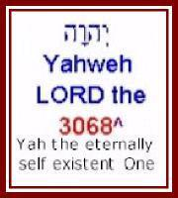 | <The first line is the Hebrew text, written RIGHT to left. <The second line (Yahweh) is the transliterated English. <The third line is the KJV English words RIGHT to left. <The fourth line, in red, is the Strong’s number.  <The fifth and sixth lines in small text have been added by the writer to make the name of Yah more visible or to provide other comments - referred to as footnotes.
Where the footnotes are in black this indicates that what is written is more or less directly based on other sources, most frequently the Brown, Driver, Briggs Hebrew Lexicon in the same version of PC Study Bible.
Where the note is followed by one or two question marks (??) this indicates that the writer has a concern about the validity of the interpretation.
In all cases the writer has substituted Yah for Yahweh where the Hebrew appears to contain ONLY Yah and not Yahweh. This is done in accordance with the conclusion published in the article 1AD.02.01.30 “Yah versus Yahweh” (18 January 2002).
Where the footnotes are in blue this indicates an interpretation given by the writer which deviates materially from that given in other sources.
In the case of Yahooshua the footnote is in red because of the significance of this name.
In the transliteration the Name of Yah is variously transliterated as “Yaah”, “Yªh”, “yaah” or “yªh”. In most cases this is clearly evident in the transliterated text.
Casual inspection indicates that Yah generally does NOT appear in the English word used and hence the principal objective of this document is to draw the attention of English readers to the PRESENCE OF THE SACRED NAME YAH in many more locations than most have previously been aware of.
In the sections that follow, a number of conventions are applied:
- The heading for the word comprises:
- the transliterated name as it appears in the graphic
- in some cases this is followed by the KJV English word or a seemingly appropriate transliteration - this is NOT consistent, the writer has found it difficult to formulate a clear view of what should be used in all cases and time and resources do not currently permit a comprehensive analysis so this information should NOT be regarded as authoritative.
- the Strong’s number
- the writers best estimate of the meaning based on Brown, Driver, Briggs and own interpretation and prayer
- The transliteration adopted is that given in the graphic although the writer is not entirely certain that this is necessarily the most accurate transliteration. In this regard refer the article 1AD.02.01.01 “Sacred Name of God YHVH YHWH Yahveh Yahweh Yeshuah Yashuah Yehshuah Yahshuah Yahushuah Yahoshua” (9 January 2002).
This makes it apparent that there are widely divergent views as to the “correct” transliteration and that technically speaking there is probably no such thing as a “correct” transliteration. Accordingly, since the PC Study Bible Interlinear makes the Name of Yah clearly apparent it has been adopted in most cases for the purposes of this document since this is NOT the principal objective.
It does, however, seem to the writer that with prayerful consideration it may be possible to adopt anglicizations of the transliterations that are more readily pronounced and remembered. This is not the objective of this document.
- Occurrence: reports the number of occurrences of each English variation in the “Authorized Version” (AV) which as the writer currently understands it is essentially the same text as the “King James Version”. This is provided in order to provide a clear picture of the frequency of occurrence of various translation variations. These
statistics are obtained from the Hebrew Lexicon in the OnLine Bible from www.onlinebible.org. In the case of words typically associated with Yah our Creator and Heavenly Father it is instructive to note the number of occurrences of specific words associated with other entities in the context of words that are generally considered to be exclusive to Him.
- In most cases a sample verse is included to demonstrate application of the word.
- Strong: is a quote from the Hebrew or Greek dictionary by Strong included in PC Study Bible.
- Brown, Driver, Briggs or BDB is a quote from the Hebrew dictionary by Brown, Driver and Briggs included in PC Study Bible.
- Thayer: is a quote from the Greek dictionary by Thayer included in PC Study Bible.
- Other notes are by the writer.
This document is intended to be primarily a mechanical analysis directed at assisting readers to gain some insight into the linguistic complexities behind the English versions. It is also hoped to make more visible the extent to which in certain cases very different Hebrew words are represented by the same English word and the level of inconsistency that accompanies this.
It is further intended to make visible to readers the extent to which the Name Yah is inherent in every aspect of Scripture and the life of Yah’s people.
Technical Caveat
In presenting this document the writer must stress that he has NO material knowledge of Hebrew. The only knowledge is a few hours instruction on the basic principles of transliteration given by an Israeli Jewish friend some years ago.
What is presented herein is a straightforward mechanical analysis based on recognizable patterns in transliteration and supported by the opinions of the Lexicon authors. In a few limited instances the writer HAS expressly prayed over a particular interpretation and sought the guidance of Yah. The entire research and document preparation HAS taken place within a context of considerable prayer and therefore the writer has assurance that the overall content of the document is in accordance with the will of Yah at this time.

Words Translated “God ”
The following words are all used to refer to Yah in English translations through translation to the word “God” or “GOD” where the capitalization is generally accepted to indicate a reference to our Creator.
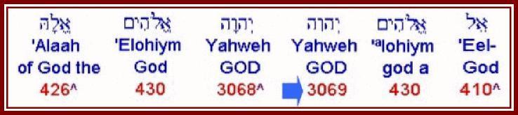
These words are discussed in more detail below. Notice the Aramaic word “Alaah” (426) which appears to correspond to the Islamic “Allah”.
Elohiym (430) is the word most frequently translated “God” in proper case (first letter capitalized) but is ALSO applied to pagan “god’s” as indicated second from right and also to men such as judges, etc, refer article 1AD.02.01.09 “Gods, God or Judges” (11 January 2002). “El” (410) in various forms is also applied to Yah when capitalized as “God” but also applied to other than Yah.
Yahweh (3068) meaning “Yah the eternally self existent One” is the particular extended Name of Yah applied by Yah in His communication’s with Israel on many occasions. This is mostly but NOT always translated “GOD” (all capital letters) as discussed subsequently. Elohim or Yahovih (3069) is a scribal device to accommodate the DELIBERATE mispronunciation of Yahweh introduced at some time before the Babylonian exile. Refer article 1AD.02.01.05 “Nazarenes and the Name of Yahweh” (10 January 2002) and other articles which refer to this corruption. Further notes in this document.
Alaah - 426 - God
Notice the correspondence to “Allah” as used in Islam.
Occurrence: AV-God 79, god 16; 95
Not exclusively used for Yah.
Ezra 5:1 “Then the prophets, Haggai the prophet, and Zechariah the son of Iddo, prophesied unto the Jews that were in Judah and Jerusalem in the name of the God [Alaah] of Israel, even unto them.” (KJV)
Strong’s 426 'elahh (Aramaic) (el-aw'); corresponding to 433; God: KJV--God, god.
BDB 426 'elahh (Aramaic)- god, God a) god, heathen deity b) God (used of Israel)
Derived from Elohiym / El / Eloah.
Elohiym - 430 - Mighty Ones (plural)
This word is widely translated “God”, however, it actually means “Mighty Ones” (plural) and is used in many other applications. The Sacred Name “Yahweh” is MISPRONOUNCED “Elohiym” in many cases and has been substituted by “Elohiym” in eight locations according to the Institute of Scripture Research.
Yah has indicated that Elohiym has ALSO been substituted for “Yah” the essential Name of our Creator and Heavenly Father in many locations well before the tradition of mispronouncing Yahweh as Elohiym came about and before the substitutions referred to above.
Yah indicates that 80% of all occurrences of Elohiym in the Hebrew texts are in fact substitutions for “Yah”!
Occurrence: AV-God 2346, god 244, judge 5, GOD 1, goddess 2, great 2, mighty 2, angels 1, exceeding 1, God-ward + 04136 1, godly 1; 2606.
Out of 2606 occurrences 259 do NOT refer to Yah.
It is therefore not possible to build any doctrine relating to Yah based exclusively on Elohiym.
Genesis 1:1 “In the beginning God [Mighty Ones or Yah?] created the heaven and the earth.” (KJV)
Strong 430 'elohiym (el-o-heem'); plural of 433; gods in the ordinary sense; but specifically used (in the plural thus, especially with the article) of the supreme God; occasionally applied by way of deference to magistrates; and sometimes as a superlative: KJV-- angels, X exceeding, God (gods)- dess, -ly), X (very) great, judges, X mighty.
BDB 430 'elohiym- 1) (plural) a) rulers, judges b) divine ones c) angels d) gods 2) (plural intensive -singular meaning) a) God, a god, a goddess b) god-like one c) works or special possessions of God d) the one true God e) God
It is apparent that any verse that uses elohiym CANNOT be used on it’s own for any doctrine that is taken to apply to Yah. By implication any verse that uses elohiym can also NOT be taken as evidence that Yahooshua IS Yah.
Yahweh - 3068 - And Yahovih - 3069
Discussed in a subsequent section on page 11.
El - 430 - Mighty One
Essentially it appears that “El” is the preferred description of Yah as Mighty One. However, this form is NOT exclusively applied to Yah.
“El” occurs in numerous words such as “Israel”, “Bethel”, “Eliyah” (Elijah), “Eliezer”, etc apparently generally but NOT always referring to Yah.
Occurrence: AV-God 213, god 16, power 4, mighty 5, goodly 1, great 1, idols 1, Immanuel + 06005 2, might 1, strong 1; 245
Note that out of 245 occurrences, 32 are NOT referring to Yah. Accordingly it is not possible to build any doctrine relating to Yah or
Yahooshua based on El alone. This includes debate on whether Yahooshua is Yah or not.
Brown, Driver, Briggs 410 'el- 1) God, God-like One, the Mighty One a) mighty men, men of rank, mighty heroes b) angels c) a god, a false god, (demons, imaginations) d) God, the one true God, Jehovah (Yahweh) 2) mighty things in nature 3) strength, power
Strong 410 'el (ale); shortened from 352; strength; as adjective, mighty; especially the Almighty (but used also of any deity): KJV-- God (god), X goodly, X great, idol, might (-y one), power, strong. Compare names in "-el."
It is not possible to build any doctrine relating exclusively to Yah out of verses which use El.
Eliy (my mighty one) ALSO 410
As used by Yahooshua on the stake before he died in Matthew 27:46-47 “And About The Ninth Hour Jesus Cried Out With A Loud Voice, Saying, "Eli, Eli, Lama Sabachthani?" That Is, "My Eliy {God}, My Eliy {God}, Why Have You Forsaken Me?" 47 Some Of Those Who Stood There, When They Heard That, Said, "This Man Is Calling For Elijah!"” (NKJ)
Notice there is more to the statement “calling for Elijah” once one recognizes that the name of EliYah means effectively “my Eliy is Yah” or “my might is Yah”.
This raises the question as to whether the people said “this man is calling for Elijah” or whether they ACTUALLY said, this man is calling for “mighty Yah” (Eliy Yah) - which makes a lot more sense and is FUNDAMENTALLY DIFFERENT! In this regard it is important to note that the use of the Sacred Name was apparently forbidden at the time of Yahooshua’s death and that Yahooshua may even have been put to death simply for uttering the Sacred Name. Refer article 1AD.02.01.05 “Nazarenes and the Name of Yahweh” (10 January 2002). Under such circumstances it is quite likely that the bystanders MIGHT have MISTAKEN what Yahooshua said to indicate that Yahooshua was calling on EliYah when in fact he was calling on “mighty Yah” = “El Yah” or “my mighty Yah” = “Eli Yah”.
Again we see the vital necessity of understanding the TRUE Names!
The passage in Matthew quotes Psalm 22:1 “My Eliy {God}, My Eliy {God}, Why Have You Forsaken Me? Why Are You So Far From Helping Me, And From The Words Of My Groaning?” (NKJ, adjusted)
Eliy (410) is distinct from Eli (5941) the High Priest when Samuel entered service to Yah.
Exodus 15:2 “Yahweh Is My Strength And Song, And He Has Become My Salvation; He Is My Eliy [= My Might / Mighty One], And I Will Praise Him; My Father's Elohiym [= Mighty One], And I Will Exalt Him.” (NKJ)
The first occurrence of “God” is Eliy, the second is “Elohim” (father’s mighty one(‘s)).
Variations: Following are some variations of 410 “El” relating to variations in case, etc which the writer is not conversant with. This provides some indication of the variability of prefixes and suffixes which is inherent in the Hebrew text and how these relate to the English.
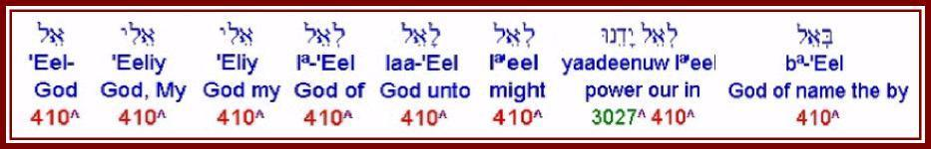
It seems clear to the writer that the exact correlation is at best tenuous in some cases. Consider the cases of lª-‘Eel, laa-‘Eel and lª’eel translated “of God”, “unto God” and “might” as the fourth, fifth and sixth words from left above. The nuances in the Hebrew in terms of jot’s and tittles appears to be very fine to non-existent to the untrained eye. This is NOT to suggest that there is not a difference, only that one needs considerable knowledge and experience to discern the difference and that, accordingly, the potential for transcription error or difference of opinion in translation appears to be significant.
We must come to terms with the reality that the collection of inspired writings traditionally referred to as “The Bible” is extremely large and complex and that the nuances of language recorded up to four thousand years ago are NOT necessarily as evident as one might suppose.
This reinforces the need for us to be led by the set apart (Holy) Spirit of Yah in gaining full understanding of Scripture. It also clearly demonstrates that complex semantic analysis in English based on English words, spelling and capitalization, as encountered in more than one recent article, is largely or entirely futile. We cannot build doctrine solely on English text and we SHOULD NOT enter into divisive dispute based solely on English text.
The need for the Spirit of Yah to guide us and particularly the need for the recognition of the vital role of prophets in restoring doctrine becomes daily more apparent to the writer from this analysis.
Update: I have increasingly come to understand Eli as meaning “my personal mighty one” or a term of endearment when used by Yahooshua in particular.
Adonay - 136 - Lord or Master
Used as a term of respect.  Occurrence: AV-Lord 431, lord 2, God 1; 434  Almost exclusively applied to Yah but NOT exclusively. In 290 instances occurs as “Adonay Yahweh” in conjunction with 3069 (Yahovih), the scribal device referred to subsequently. | 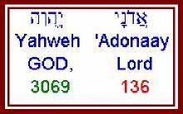

Genesis 15:2 “And Abram said, Lord GOD [Adonay Yahweh], what wilt thou give me, seeing I go childless, and the steward of my house is this Eliezer of Damascus?” (KJV)
Strong 136 'Adonay (ad-o-noy'); am emphatic form of 113; the Lord (used as a proper name of God only): KJV-- (my) Lord.
BDB 136 'Adonay- 1) my lord, lord a) used of men b) used of God 2) Lord (a title) spoken instead of Yahweh as a Jewish display of reverence
Is “used of men”. Notice reference to substitution of Yahweh with Adonay.
Yah - 3050 - The Essential Name of Our Creator and Heavenly Father
The articles 1AD.02.01.01 “Sacred Name of God YHVH YHWH Yahveh Yahweh Yeshuah Yashuah Yehshuah Yahshuah Yahushuah Yahoshua” (9 January 2002); 1AD.02.01.11 “The Name (Yahweh)” (11 January 2002) and 1AD.02.01.26 “Re: REALLY IMPORTANT : Please give me a SIMPLE explanation” (18 January 2002) together with other recent articles and notes to articles posted over the last year provide context to understanding the Sacred Name Yahweh (Yah the eternally self existent One).
The article 1AD.02.01.30 “Yah versus Yahweh” (18 January 2002) explained that “Yah” is the essential Name of our Creator and Heavenly Father and that Yahweh is a specific extension or explanation of His Name. Much of the balance of this document investigates the presence of the sacred Name “Yah” in Scripture.
Occurrence: AV-LORD 48, JAH 1; 49
Also embedded in numerous Hebrew words as discussed in subsequent sections. “Yah” is SURELY the GOLDEN THREAD OF SCRIPTURE!
Variations: The variations encountered are shown below:
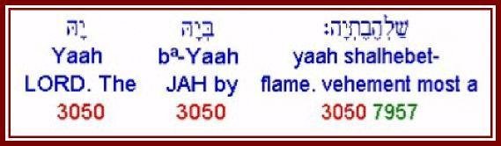
Exodus 15:2 “{The LORD} Yah is my strength and song, and He has become my salvation; he is my Mighty One, and I will praise Him; my father's Mighty One, and I will exalt Him.” (NKJ)
Psalm 68:4 “Sing to Mighty One, sing praises to His name; Extol Him who rides on the clouds, by His name YAN, and rejoice before Him.” (NKJ)
Song 8:6 “Set me as a seal upon your heart, as a seal upon your arm; for love is as strong as death, jealousy as cruel as the grave; its flames are flames of fire, a most vehement flame.” (NKJ)
Strong 3050 Yahh (yaw); contraction for 3068, and meaning the same; Jah, the sacred name: KJV-- Jah, the Lord, most vehement. Compare names in "-iah," "-jah."
Brown, Driver, Briggs 3050 Yah- Jah (Jehovah (Yahweh) in the shortened form) a) the proper name of the one true God b) used in many compounds: 1) names beginning with the English letters `Je-' 2) names ending with `-iah' or `-jah'
Notice that the above refer to “Yah” as a “contraction” of Yahweh. However, reverence surely dictates that we should not abbreviate the essential Name of our Creator and Heavenly Father and that, given His focus on precision of words, it is unlikely that He would do this.
Yah has clearly indicated to the writer that His ESSENTIAL NAME IS YAH and that all other names BUILD ON that Name as opposed to being SUB-SETS of His True Name.
The Sacred Name Yah occurs in numerous other names and words as examined in some detail later in this article.
Notice also the reference to English words beginning with “Je” and ending with “iah” or “jah”. Many of these words are highlighted in the sections that follow.
It also seems anomalous that “Yah” is transliterated as “Jah”. This was addressed to some extent in other articles posted earlier in January 2002 on the ETI informal list.
Yahweh - 3068 - “Yah the eternally self existent One”
The most frequently encountered Name applied to Yah in the Scriptures. Occurrence: AV-LORD 6510, GOD 4, JEHOVAH 4, variant 1; 6519
Used 185 times in the couplet “the LORD God” note capitalization and note the direct contrast with “Adonay Yahweh”, “the Lord GOD” above. In one case Yahweh is translated Lord and in the other GOD! | 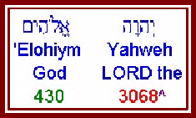
The perversion of expressing the Sacred Name “Yahweh” as “the LORD” occurs 6,510 times in the vast majority of English translations! This is IN ADDITION to the 45 times “Yah” is ALSO translated as “the LORD” and the 1 time that 3069 (Yahovih = scribal device for Yahweh) is also translated “LORD” instead of “GOD”!
This should be considered in the broader context that the word generally translated “Baal”, the Phoenician pagan (= demonic) deity could accurately be translated “lord”, see below.
Genesis 2:4 “These are the generations of the heavens and of the earth when they were created, in the day that Yahweh Elohiym made the earth and the heavens,” (KJV)
Strong 3068 Yehovah (yeh-ho-vaw'); from 1961; (the) self-Existent or Eternal; Jehovah, Jewish national name of God: KJV-- Jehovah, the Lord. Compare 3050, 3069.
BDB 3068 Yehovah- Jehovah (Yahweh) "the existing One"; the proper name of the one true God; unpronounced except with the vowel pointings of 0136
Notice that “Yahweh” IS documented in various authoritative works going back a considerable period of time.
Variations: The following variations have been identified:
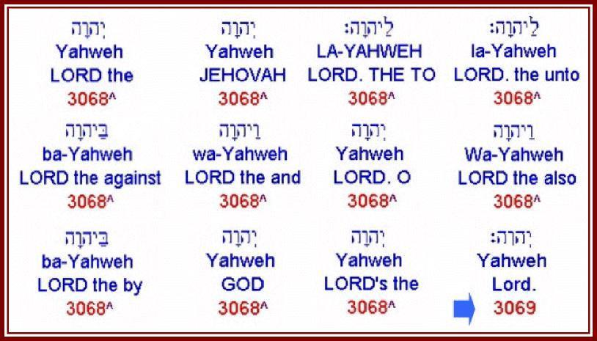
The above are in part variations in the Hebrew but are ALSO variations in translation, specifically Jehovah and GOD. Notice also the small difference in the Hebrew in the item bottom right (3069) or Yahovih which is discussed in the next section.
Update: Since this article was written I have come to understand that it is more accurate to translate the word referred to Yahweh as Yahooeh but to change this throughout this article is technically impossible because of all the images which contain it.
This again points to the level of error in modern texts.
Yahovih - 3069 - Alternative Form Of Yahweh - Scribal Device
This word, with very minor differences in the Hebrew is used to cater for a very specific set of SCRIBAL AND TRANSLATION circumstances. Yah has indicated to the writer that this is “not a real word, it is a scribal device”!
Occurrences: AV-GOD 304, LORD 1; 305
Genesis 15:2 “And Abram said, Adonay Yahweh, what wilt thou give me, seeing I go childless, and the steward of my house is this Eliezer of Damascus?” (KJV)
Strong 3069 Yehovih (yeh-ho-vee'); a variation of 3068 [used after 136, and pronounced by Jews as 430, in order to prevent the repetition of the same sound, since they elsewhere pronounce 3068 as 136]: KJV--God.
BDB 3069 Yehovih- Jehovah (Yahweh), used primarily in the combination `Lord Jehovah (Yahweh)' equal to 3068 but pointed with the vowels of 0430
Referring to Strong “Yehovih (yeh-ho-vee'); a variation of 3068 [used after 136, and pronounced by Jews as 430, in order to prevent the repetition of the same sound, since they elsewhere pronounce 3068 as 136]:”
136 is Adonay; 430 is Elohiym
In other words - “a variation of Yahweh (3068) (the Sacred Name) [used after Adonay (Lord - 136), and pronounced by Jews as Elohiym (Mighty Ones (pl) - 430), in order to prevent the repetition of the same sound, since they elsewhere pronounced Yahweh (3068) as Adonay (136)]”!
So this is the Sacred Name Yahweh PRONOUNCED as Elohim (Mighty Ones) in order to prevent repetition of Adonay since elsewhere they pronounce Yahweh as Adonay!
In other words, because the Sacred Name Yahweh is elsewhere incorrectly pronounced as “Adonay”, they require ANOTHER DEVICE here in order to tell readers to incorrectly pronounce the Sacred Name Yahweh as “Elohiym” and NOT as “Adonay” otherwise in this location they would have to say “Adonay Adonay” INSTEAD OF “Adonay Yahweh”.
In light of the writers background in engineering, military and computers the writer has great difficulty in expressing an opinion on this in non-judgmental terms. We are dealing here with the Sacred Name of the Most High Creator of the Heavens and the Earth and our Heavenly Father and yet the Name is arbitrarily substituted with other sounds which happen to be words that in some cases are ALSO applied to demonic deities!!
It seems to the writer that this is a MASSIVE INSULT to Yah and Yah confirms that He views it that way!
Variations:
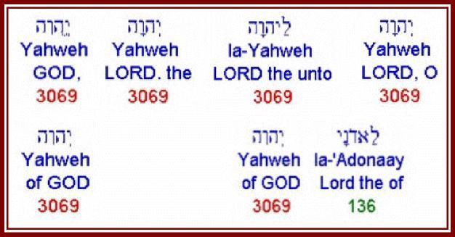
Note translation variously as GOD and LORD.
Refer also last example “of the Lord GOD of” where 3069 is used in conjunction with Adonay in order to avoid pronouncing 136 3068 as Adonay Adonay since 3068 is traditionally pronounced as 136 Adonay!
Baal - 1166, 1167, 1168, 1169 - lord, master, husband, owner
This word is NOT applied to Yah. However, it has a connotation that IS applied to Yah in English when we substitute words like “Lord” and “master” for Yahweh. This was discussed in some detail in article 1AD.01.10.02 “Why do you say that “the LORD” means “Baal”?” (23 October 2001) and will accordingly NOT be discussed in detail here.
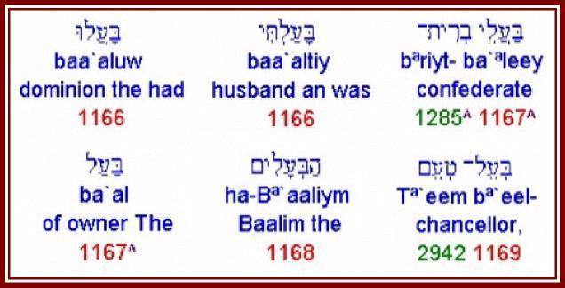
There are a number of Hebrew words all of which are built around the essential Hebrew letters of “baal” these are numbers 1166, 1167, 1168 and 1169 all of which are presented in the graphic at right:
Notice that the first three Hebrew characters from right to left are all recognizably the basic three characters of “baal” with fine nuance. In the case of “ha-Bªaaliym” in the middle of the bottom row the “ha” precedes the “baal”.
All of these words have to do with headship, dominion, rulership, etc.
From casual inspection of the above graphic the distinction between the different Strong’s numbers appears to be relatively fine, particularly when viewed in light of the definitions that follow. This seems particularly noticeable to the writer who is increasingly becoming aware of what seem to be contrastingly COARSE distinctions made with regard to certain other words which seem to apply primarily to Yah and Yahooshua and which will, Yah willing, be touched on in future articles.
Occurrence:
1166 AV-marry 8, husband 3, dominion 2, wife 1, married wife 1, Beulah 1; 16
1167 AV-man 25, owner 14, husband 11, have 7, master 5, man given 2, adversary 1, archers 1, babbler + 03956 1, bird + 03671 1, captain 1, confederate + 01285 1, misc 12; 82
1168 AV-Baal 62, Baalim 18; 80
1169 AV-chancellor + 02942 3; 3
Brown, Driver Briggs:
1166 ba` al- to marry, to rule over, to possess, to own a) (Qal) 1) to marry, to be lord (husband) over 2) to rule over b) (Niphal) to be married
1167 ba` al- an owner, a husband, a lord a) an owner b) a husband c) citizens, inhabitants d) rulers, lords e) (noun of relationship used to characterize, that is, master of dreams) f) lord (used of foreign gods)
1168 Ba` al- Baal = "lord"; as a proper noun, masculine: 1) the supreme male divinity of the Phoenicians or Canaanites 2) a Reubenite 3) the son of Jehiel and the grandfather of Saul proper noun, location: 4) a town of Simeon, probably identical to Baalath-beer
1169 be` el (Aramaic)- an owner, a lord
Notice repeated reference to “lord”.
This should all be read in the context of Yah’s words in:
Hosea 2:17 “For I will take away the names of Baalim [Lord] out of her mouth, and they shall no more be remembered by their name.” (KJV, adjusted)
and Jeremiah 23:26-29 “²⁶ How long shall this be in the heart of the prophets that prophesy lies? yea, they are prophets of the deceit of their own heart; ²⁷ Which think to cause my people to forget my name by their dreams which they tell every man to his neighbour, as their fathers have forgotten my name for Baal [the Lord]. ²⁸ The prophet that hath a dream, let him tell a dream; and he that hath my word, let him speak my word faithfully. What is the chaff to the wheat? saith Yahweh {the LORD}. ²⁹ Is not my word like as a fire? saith Yahweh {the LORD}; and like a hammer that breaketh the rock in pieces?” (KJV, adjusted)
These Scriptures are referring to the heresy of substituting “Adonay” and “Elohiym” for “Yah” and “Yahweh” in the days of Jeremiah and Hosea. They apply just as much today as they did in the time of Jeremiah when Judah went into exile in Babylon, the first Temple was destroyed and the Ark of the Covenant was hidden by Jeremiah until found in the early 1990's.
In fact, these Scriptures apply MORE today since we are under a “new and better covenant” as set out in Hebrews 8:6 “But now hath he obtained a more excellent ministry, by how much also he is the mediator of a better covenant, which was established upon better promises.” (KJV)
This covenant was purchased by Yahooshua, the son of Adam (man) on behalf of ALL mankind at a terrible price so that we can ALL have the set apart (holy) Spirit within us to teach us. Refer Hebrews 8:1011 which quotes Jeremiah 31:33-34 “¹⁰ For This Is The Covenant That I Will Make With The House Of Israel After Those Days, saith Yahweh; I Will Put My Laws Into Their Mind, And Write Them In Their Hearts: and I will be to them a Mighty One, and they shall be to me a people: ¹¹ And They Shall Not Teach Every Man His Neighbour, And Every Man His Brother, saying, Know Yahweh: For All Shall Know Me, from the least to the greatest.” (KJV, names adjusted)
James 3:1 states “My brethren, be not many masters, knowing that we shall receive the greater condemnation.” (KJV) The New King James and many other versions translate “masters” as “teachers”.
Furthermore, as set out in the article 1A1.01.12.02 “Prophetic Strategic SWOT Analysis of the Body of Believers” (24 December 2001) we have access to over 100 English translations, numerous reference books, numerous electronic tools, etc. We are WITHOUT EXCUSE and will be judged accordingly.
We MUST take these scriptures VERY seriously and cease substituting other words for the Sacred Names of Yah and Yahweh!
It must be noted that the writer is still seeking greater understanding surrounding the apparently disparate number of occurrences of Yahweh versus the relatively few occurrences of Yah although Yah is embedded in numerous other words as presented below. Until the writer has clarity on this, where Yahweh occurs in the Hebrew text the adjustment made to the English reflects Yahweh. However, in general writing, the writer is IMPRESSED by the Spirit of Yah to use Yah almost exclusively!

Names Including Yah
As previously stated, there are a large number of names and words in Hebrew that are based on the essential Name “Yah”. This section lists a number of words that have been encountered in an initial relatively superficial search together with some basic information about each word.
It is likely that there are more occurrences.
In each case a series of words are displayed from the BibleSoft PC Study Bible version 2.1G Interlinear Bible together with extracts of notes from the Strong’s and Brown, Driver, Briggs Hebrew Lexicons. In most cases interpretation is based on Brown, Driver, Briggs which seems to be more aware of the reality of the Sacred Name.
In many cases the writer has substituted “Yah” for “Yahweh” since casual inspection of the Hebrew words and basic transliteration indicates that only the syllable “Yah” is present and NOT “Yahweh”. There ARE a few instances of words based on “Yahweh”. Where it seems appropriate the writer offers a version of the word that emphasises the existence of “Yah”.
In the first stage of the analysis words adjacent to Yah (3050) were examined. It was found that Jedaiah or JedaYah (3048) appeared to be the first word which included “Yah” in that number range. It was then found that most of the words through to 3116 started with Yah or were perceived by Brown, Driver and Briggs to be based on “Yahweh” which the writer took to be “Yah” unless expressly otherwise noted.
It is STRESSED that what follows is NOT intended to be definitive, particularly anglicizations by the writer are approximations that, unless expressly indicated as given by Yah MAY be in error.
Note also that the examples in the graphics have been randomly selected and included prefixes and suffixes applicable to the particular instance from which they were selected. It is not the writer’s intention to examine these or explain them since currently the writer has no material knowledge in this context. The principal objective is to DEMONSTRATE graphically the extent to which letter patterns corresponding to “Yah” occur and draw on available resources to offer interpretation where possible.
Ezra 5:1, a portion of which is displayed to the right of this paragraph, gives an indication of the extent to which the Name of Yah occurs in a fashion that has not been visible to most English speaking readers.  Notice the presence of “Yah” as either “yaah” or “Yªh” in 2148 Zechariah (Zªkaryaah), 3061 Judah (Yªhuwd) and 3062 Jews (Yªhuwdaayee).  The sections that follow provide data with regard to specific words together with graphical representation of the Interlinear text. | 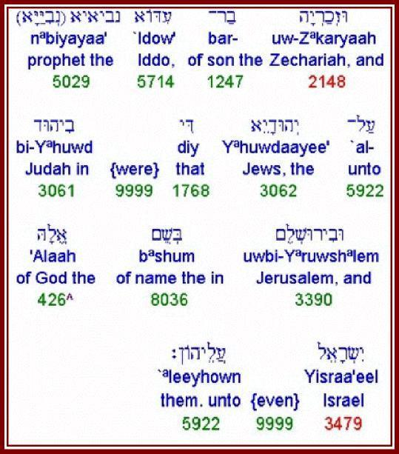
Yaah - 3050 - Yah
The essential Name of our Creator transliterated here as “Yaah”. Discussed above.
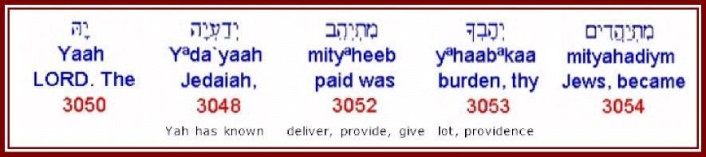
Yªda’yaah - 3048 - Jedaiah (JedaYah) - Yah has known
Occurrence: AV-Jedaiah 11; 11
BDB 3048 Yekda` yah- Jedaiah = "Jehovah (Yahweh) has known"; 1) a priest in Jerusalem 2) a man who returned with Zerubbabel 3) a ruler of the priests in the days of Jeshua 4) a post exilic priest 5) one honored by Jehovah (Yahweh), perhaps one of the above
Yahab - 3051
Sorts numerically after Yah, not sure it relates specifically to Yah always seems to be transliterated haabuw therefore ignored in this analysis.
mityªheeb - Yaheeb - 3052 - deliver, provide, give
Occurrence: AV-give 21, given + 01934 2, delivered 1, laid 1, paid 1, prolonged 1, yielded 1; 28
Strong 3052 yehab (Aramaic) (yeh-hab'); corresponding to 3051; -deliver, give, lay, + prolong, pay, yield.
BDB 3052 yehab (Aramaic)- to give, to provide a) (P'al) 1) to give 2) to place, to lay (foundations) b) (Hithp'al) 1) to be given 2) to be paid
There seems to be some conceptual correlation with Yah as our provider.
yªhaabªkaa - yahab - 3053 - burden, lot, given by Providence (= Yah)
Occurrence: AV-burden 1; 1
Psalm 55:22 “Cast thy burden upon Yahweh, and he shall sustain thee: he shall never suffer the righteous to be moved.” (KJV)
Strong 3053 yehab (ye-hawb'); from 3051; properly, what is given (by Providence), i.e. a lot: KJV-- burden.
BDB 3053 yehab- a burden, a lot (what is given)
There appears to be some correlation between Yah being our provider in the context of “providence” in particular and also relates to “lot’s” being from Yah and prophetic “burdens” being from Yah.
mityahadiym - yahad - 3054 - become a Yahuwdite (Jew)
Occurrence AV-became Jews 1; 1
Esther 8:17 “And in every province, and in every city, whithersoever the king's commandment and his decree came, the Jews [Yahudiym] had joy and gladness, a feast and a good day. And many of the people of the land became Jews; for the fear of the Jews [Yahudiym] fell upon them.” (KJV)
Strong 3054 yahad (yaw-had'); denominative from a form corresponding to 3061; to Judaize, i.e. become Jewish: KJV-- become Jews.
BDM 3054 yahad- (Hithpael) to become a Jew (in fact or in fraud), to become Judaized
wi-Yahud - Yahud - 3055 - beauty
Occurrence AV-Jehud 1; 1
Joshua 19:45 “And Jehud, and Beneberak, and Gathrimmon,” (KJV)
BDB 3055 Yehud- Jehud = "beauty"; a town in Dan, located between Baalath and Bene-berak and 8 miles east of Joppa
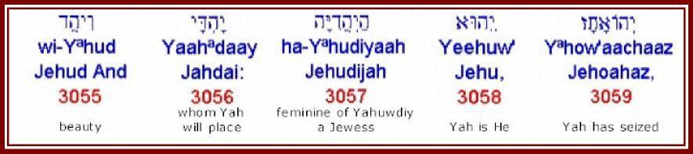
Yaahadaay - Yahdai - 3056 - whom Yah will place
Occurrence AV-Jahdai 1; 1
1 Chronicles 2:47 “And the sons of Jahdai; Regem, and Jotham, and Geshan, and Pelet, and Ephah, and Shaaph.” (KJV)
Strong 3056 Yehday (yeh-dah'-ee); perhaps from a form corresponding to 3061; Judaistic; Jehdai, an Israelite: KJV-- Jehdai.
BDB 3056 Yehday- Jahdai "whom he will place" one of the family of Caleb
Yªhudiyaah - Yahudiyah - 3057 - feminine of Yahuwdiy (a Jewess)
Occurrence AV-Jehudijah 1; 1
1 Chronicles 4:18 “And his wife Jehudijah bare Jered the father of Gedor, and Heber the father of Socho, and Jekuthiel the father of Zanoah. And these are the sons of Bithiah the daughter of Pharaoh, which Mered took.” (KJV)
BDB 3057 Yehudiyah- as an adjective, feminine: 1) the Jewess or as a proper noun, feminine: (CLBL) Jehudijah = "Jewess"; 2) a Calebite, the wife of one named Ezra
Yeehuw - Yahuw - 3058 - Yah is He
The transliteration “Yeeh” does not appear to correlate with the transliteration “Yah” or “Yaah” for the surrounding words with what appears to be the same Hebrew letters.
Occurrence AV-Jehu 58; 58
1 Kings 16:1 “Then the word of Yahweh came to Jehu the son of Hanani against Baasha, saying,” (KJV, adjusted)
Strong 3058 Yehuw' (yay-hoo'); from 3068 and 193 l; Jehovah (is) He; Jehu, the name of five Israelites: KJV-- Jehu.
BDB 3058 Yehuw'- Jehu = "Jehovah (Yahweh) is He"; 1) the king of the northern kingdom Israel who overthrew the dynasty of Omri 2) son of Hanani and an Israelite prophet in the time of Baasha and Jehoshaphat 3) the Antothite, a Benjamite, one of David's mighty warriors 4) a descendant of Judah of the house of Hezron 5) son of Josibiah and a chief of the tribe of Simeon
Yªhow'aachaaz - Yahow'achaz - 3059 Yah has seized
Occurrence AV-Jehoahaz 20; 20
2 Kings 10:35 “And Jehu slept with his fathers: and they buried him in Samaria. And Jehoahaz his son reigned in his stead.” (KJV)
Strong 3059 Yehow'achaz (yeh-ho-aw-khawz'); from 3068 and 270; Jehovah-seized; Jehoachaz, the name of three Israelites: KJV--Jehoahaz. Compare 3099.
BDB 3059 Yehow'achaz- Jehoahaz = "Jehovah (Yahweh) has seized"; 1) a king of Judah and son of Josiah 2) a king of the northern kingdom of Israel and son of Jehu 3) a king of Judah and son of Jehoram (Ahaziah)
Yªhow'aash - Yahow'ash - 3060 - given by Yah
Occurrence AV-Jehoash 17; 17
2 Kings 11:21 “Seven years old was Jehoash when he began to reign.” (KJV)
Strong 3060 Yehow'ash (yeh-ho-awsh'); from 3068 and (perhaps) 784; Jehovah-fired; Jehoash, the name of two Israelite kings: KJV--Jehoash. Compare 3101.
BDB 3060 Yehow'ash- Jehoash = "given by the Lord"; 1) a son of king Ahaziah and the 8th king of Judah 2) a son of king Jehoahaz and the 12th king of the northern kingdom of Israel
Yªhuwd - Yahuwd - 3061 - the territory of Yahuwdaah - Judea
Occurrence AV-Judah 5, Judea 1, Jewry 1; 7
Ezra 5:1 “Then the prophets, Haggai the prophet, and Zechariah the son of Iddo, prophesied unto the Jews that were in Judah and Jerusalem in the name of the God of Israel, even unto them.” (KJV)
Strong 3061 Yehuwd (Aramaic) (yeh-hood'); contracted from a form corresponding to 3063; properly, Judah, hence, Judaea: KJV-- Jewry, Judah, Judea.
BDB 3061 Yehuwd (Aramaic)- Judah -the territory of the tribe of Judah
Yªhuwdaayee - Yahuwda'iy - 3062 - the descendants of Yahuwdaah -Jews
Occurrence AV-Jews 10; 10
Ezra 4:12 “Be it known unto the king, that the Jews [Yahuwday’iy] which came up from thee to us are come unto Jerusalem, building the rebellious and the bad city, and have set up the walls thereof, and joined the foundations.” (KJV)
Strong 3062 Yehuwda'iy (Aramaic) (yeh-hoo-daw-ee'); patrial from 3061; a Jehudaite (or Judaite), i.e. Jew: KJV-- Jew.
BDB 3062 Yehuwda'iy (Aramaic)- a Jew
The descendants of Yahuwdaah (Judah)
Yªhuwdaah - Yahuwdah - 3063 - praise Yah - Judah
Occurrence AV-Judah 808, Bethlehemjudah + 01035 10; 818
Genesis 29:35 “And she conceived again, and bare a son: and she said, Now will I praise Yahweh: therefore she called his name Judah [Yahuwdah]; and left bearing.” (KJV, adjusted)
Strong 3063 Yehuwdah (yeh-hoo-daw'); from 3034; celebrated; Jehudah (or Judah), the name of five Israelites; also of the tribe descended from the first, and of its territory: KJV-- Judah.
BDB 3063 Yehuwdah- Judah = "praised"; 1) the son of Jacob by Leah 2) the tribe descended from Judah the son of Jacob 3) the territory occupied by the tribe of Judah 4) the kingdom comprised of the tribes of Judah and Benjamin which occupied the southern part of Canaan after the nation split upon the death of Solomon 5) a Levite in Ezra's time 6) an overseer of Jerusalem in the time of Nehemiah 7) a Levite musician in the time of Nehemiah 8) a priest in the time of Nehemiah
Yªhuwdiym - Yahuwdiym - 3064 - descendants of Yahuwdaah - Jews
It is important to understand that the people we call Jews in fact have a name that includes the essential Name of our Creator and Heavenly Father. Accordingly, when one uses “Jew” as a sware word or when one curses the “Jews”, one is in fact speaking against Yah and His people.
Occurrence AV-Jew 74, Jew + 0376 1, Judah 1; 76
2 Kings 16:6 “At that time Rezin king of Syria recovered Elath to Syria, and drave the Jews [Yahuwdiym] from Elath: and the Syrians came to Elath, and dwelt there unto this day.” (KJV)
Strong 3064 Yehuwdiy (yeh-hoo-dee'); patronymically from 3063; a Jehudite (i.e. Judaite or Jew), or descendant of Jehudah (i.e. Judah): KJV-- Jew.
Yªhuwdiy - Yahuwdiy - 3065 - a descendant of Yahuwdaah - Jehudi
Occurrence AV-Jehudi 4; 4
Jeremiah 36:14 “Therefore all the princes sent Jehudi [Yahuwdiy] the son of Nethaniah, the son of Shelemiah, the son of Cushi, unto Baruch, saying, Take in thine hand the roll wherein thou hast read in the ears of the people, and come. So Baruch the son of Neriah took the roll in his hand, and came unto them.” (KJV)
Strong 3065 Yehuwdiy (yeh-hoo-dee'); the same as 3064; Jehudi, an Israelite: -Jehudi.
BDB 3065 Yehuwdiy- Jehudi = "Jew"; a son of Nethaniah and servant of king Jehoiakim
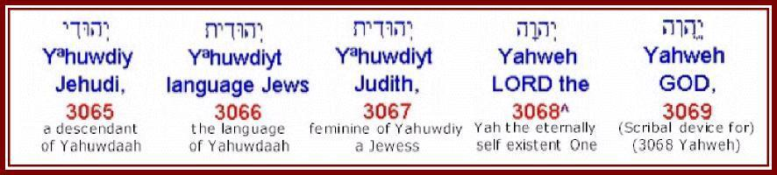
Yªhuwdiyt - Yahuwdiyt - 3066 - the language of the Yahuwdiym
Occurrence AV-Jews’ language 5, Jews’ speech 1; 6
2 Kings 18:26 “Then said Eliakim the son of Hilkiah, and Shebna, and Joah, unto Rabshakeh, Speak, I pray thee, to thy servants in the Syrian language; for we understand it: and talk not with us in the Jews' language [Yahuwdiyt] in the ears of the people that are on the wall.” (KJV)
Strong 3066 Yehuwdiyth (yeh-hoo-deeth'); feminine of 3064; the Jewish (used adverbially) language: KJV-- in the Jews' language.
BDB 3066 Yehuwdiyth- in the Jewish language, in Hebrew
Yªhuwdiyt - Yahuwdiyt - 3068 - feminine of Yahuwdiy - Judith
Occurrence AV-Judith 1; 1
Genesis 26:34 “And Esau was forty years old when he took to wife Judith [Yahuwdiyt] the daughter of Beeri the Hittite, and Bashemath the daughter of Elon the Hittite:” (KJV)
Interesting that a Hittite woman was named “Judith” / “Yahuwdiyt”, a name containing the essential Name of Almighty Yah. Note that Esau was the son of Isaac and therefore they were not YET the people of Israel and certainly not the people of Yahuwdaah (Judah). By implication the name, INCLUDING YAH, PREDATES “Jewess” and suggests that the Hittites ALSO knew Yah which is to be expected since all descended from Noah.
This suggests that the following lexicon entries which include the word “Jewess” have not accurately distilled the essence of the name.
Note also that the spelling of the name is almost identical to the previous word for “Jews language”.
Strong 3067 Yehuwdiyth (yeh-ho-deeth'); the same as 3066; Jewess; Jehudith, a Canaanitess: KJV-- Judith.
BDB 3067 Yehuwdiyth- Judith = "Jewess" or "praised"; the daughter of Beeri the Hittite and wife of Esau
Yahweh - 3068 - Yah the eternally self existent One
Occurrence AV-LORD 6510, GOD 4, JEHOVAH 4, variant 1; 6519
Discussed on page 11.
Yahovih - Yahweh - 3069 - Scribal device for 3068
Occurrence AV-GOD 304, LORD 1; 305
Discussed on page 12.
This is a scribal device, NOT a separate word. Used to assist with deliberate mispronunciation of the Name of Yah Most High.
Yahweh-yir’eh - 3070 - Yahweh provides
Occurrence AV-Jehovahjireh 1; 1
Genesis 22:14 “And Abraham called the name of that place Yahweh provides [Yahweh-yir’eh]: as it is said to this day, In the mount of Yahweh it shall be seen [provided].” (KJV, adjusted)
Strong 3070 Yehovah Yir'eh (yeh-ho-vaw' yir-eh'); from 3068 and 7200; Jehovah will see (to it); Jehovah-Jireh, a symbolical name for Mount Moriah: KJV-- Jehovahjireh.
BDB 3070 Yehovah yireh- Jehovah-jireh = "Jehovah (Yahweh) sees"; symbolic name given by Abraham to Mount Moriah in commemoration of the interposition of the Angel of Jehovah (Yahweh) who prevented the sacrifice of Isaac and provided a substitute
Many other versions translate this as Yahweh provides, for example, in the New American Standard Genesis 22:14 “And Abraham called the name of that place Yahweh Will Provide, as it is said to this day, "In the mount of the Yahweh it will be provided."” (NAS, adjusted)
Accordingly this is reflected as Yahweh provides.
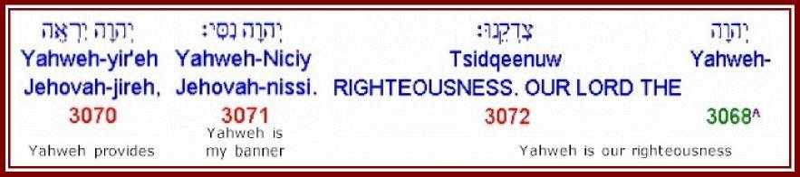
Yahweh-Nicciy - 3071 - Yahweh is my banner
Occurrence AV-Jehovahnissi 1; 1
Exodus 17:15 “And Moses built an altar, and called the name of it Yahweh is my banner [Yahweh-nicciy]:” (KJV, adjusted)
Strong 3071 Yehovah Nicciy (yeh-ho-vaw' nis-see'); from 3068 and 5251 with the prononimal suffix; Jehovah (is) my banner; Jehovah-Nissi, a symbolical name of an altar in the Desert: KJV-- Jehovah-nissi.
BDB 3071 Yehovah nicciy- Jehovah-nissi = "Jehovah (Yahweh) is my banner"; the name given by Moses to the altar which he built in commemoration of the discomfiture of the Amalekites
Yahweh Tsidqeenuw - 3068-3072 - Yahweh is our righteousness
Occurrence AV-LORD our Righteousness 2; 2
Jeremiah 23:6 “In his days Judah shall be saved, and Israel shall dwell safely: and this is his name whereby he shall be called, YAHWEH OUR RIGHTEOUSNESS.” (KJV)
Strong 3072 Yehovah Tsidqenuw (ye-ho-vaw' tsid-kay'-noo); from 3068 and 6664 with pronominal suffix; Jehovah (is) our right; Jehovah-Tsidkenu, a symbolical epithet of the Messiah and of Jerusalem: KJV-- the Lord our righteousness.
BDB 3072 Yehovah tsidqenuw- Jehovah (Yahweh) is our righteousness a sacred name symbolically applied to Jerusalem and the Messiah
Important to note the express statement that Yah (Yahweh) is our righteousness. This is challenging in the context of Scriptures like Romans 8:22 and 26 and 5:17 and 21 and 1 Corinthians 1:30 which are widely interpreted as indicating that “Jesus Christ is our righteousness” or “Yahooshua Messiah is our righteousness”.
1 Corinthians 1:30 “But of him are ye in Christ Jesus, who of God is made unto us wisdom, and righteousness, and sanctification, and redemption:” (KJV)
This relates to the discussion regarding the exact meaning of “Christ” which has been touched on in various articles and which will, Yah willing, shortly be discussed in detail. However, in the context of this particular statement that Yahweh is our righteousness it seems worth touching on.
Recently the writer has taken to frequently interpreting “Christ” in terms of “anointed one”, “anointing”, etc all of which relate to the anointing of the set apart Spirit of Yah. On this basis the above verse becomes:
“But of him are ye in the anointing [of the set apart Spirit of Yah] of Yahooshua, who of Yah is made unto us wisdom, and righteousness, and sanctification, and redemption:”
As long as we interpret “Christ” in this passage as “the anointing of the set apart Spirit of Yah” then it is YAH who is our righteousness, NOT Yahooshua! In this case there is no conflict between the statements relating to the anointing of Yahooshua and statements that Yah or Yahweh is our righteousness.
Yahweh-Shalowm - 3073 - Yahweh is peace
Occurrence AV-Jehovahshalom 1; 1
Judges 6:24 “Then Gideon built an altar there unto the LORD, and called it Yahweh-shalowm [Yahweh is peace]: unto this day it is yet in Ophrah of the Abi-ezrites.” (KJV)
Strong 3073 Yehavah Shalowm (yeh-ho-vaw' shaw-lome'); from 3068 and 7965; Jehovah (is) peace; Jehovah-Shalom, a symbolical name of an altar in Palestine: -Jehovah-shalom.
BDB 3073 Yehavah shalowm- Jehovah-shalom = "Jehovah (Yahweh) is peace"; the name of a sacred altar built by Gideon in Ophrah
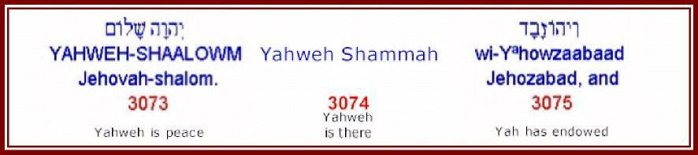
Yahweh shammah - 3074 - Yahweh is there
Occurrence AV-The Lord is there 1; 1
Not found in the PC Study Bible which lists 8033 as shammah separated from Yahweh by “is” inserted by the translators in the “King James Version”. The OnLine Bible lists 3074 in the “Authorized Version”.
However, 3074 IS listed in the Lexicon’s in the PC Study Bible.
There ARE many instances of 8033 shammah NOT in conjunction with Yahweh, it appears that there is one special case which is treated differently in the two software packages.
Strong 3074 Yehovah Shammah (yeh-ho-vaw' shawm'-maw); from 3068 and 8033 with directive enclitic; Jehovah (is) thither; Jehovah-Shammah, a symbolic title of Jerusalem: KJV--Jehovah-shammah.
BDB 3074 Yehovah shammah- Jehovah-shammah = "Jehovah (Yahweh) is there"; a symbolic name for Jerusalem
Yªhowzabad - Yahowzabad - 3075 - Yah has endowed
Occurrence AV-Jehozabad 4; 4
2 Kings 12:21 “For Jozachar the son of Shimeath, and Jehozabad the son of Shomer, his servants, smote him, and he died; and they buried him with his fathers in the city of David: and Amaziah his son reigned in his stead.” (KJV)
Strong 3075 Yehowzabad (yeh-ho-zaw-bawd'); from 3068 and 2064; Jehovah-endowed; Jehozabad, the name of three Israelites: KJV--Jehozabad. Compare 3107.
BDB 3075 Yehowzabad- Jehozabad = "Jehovah (Yahweh) has endowed"; 1) son of Shomer, a Moabitish woman, who murdered Joash, king of Judah 2) a Benjamite, captain of 180,000 armed men, in the days of Jehoshaphat 3) a Korhite Levite, second son of Obededom, and one of the porters of the Temple and of the storehouse there in the time of David
Yªhowchaanaan - Yahowchanan - 3076 - Yah has graced
Occurrence AV-Jehohanan 6, Johanan 3; 9
Notice two renderings for nominally the same word.
1 Chronicles 26:3 “Elam the fifth, Jehohanan the sixth, Elioenai the seventh.” (KJV)
Strong 3076 Yehowchanan (yeh-ho-khaw-nawn'); from 3068 and 2603; Jehovah-favored; Jehochanan, the name of eight Israelites: KJV--Jehohanan, Johanan. Compare 3110.
BDB 376 Yehowchanan- Jehohanan = "Jehovah (Yahweh) has graced"; 1) a priest during the high priesthood of Joiakim who returned with Zerubbabel 2) a high priest in the time of Ezra 3) a Levite priest who took part in the dedication of the wall in the time of Nehemiah 4) a son of Tobiah 5) a Korhite Levite and one of the doorkeepers to the tabernacle in the time of David 6) a captain of Judah under king Jehoshaphat 7) an Ephraimite 8) an Israelite with a foreign wife in the time of Ezra 9) a Jewish captain after the fall of Jerusalem 10) the oldest son of king Josiah 11) a post-exilic prince of the line of David 12) father of Azariah, priest in Solomon's time 13) a Benjamite, one of David's mighty warriors 14) a Gadite, one of David's mighty warriors 15) a returning exile
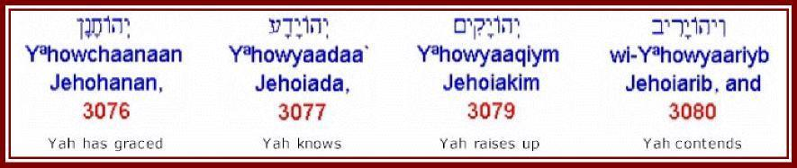
Yªhowyaadaa - Yahowyada - 3077 - Yah knows
Occurrence AV-Jehoiada 51; 51
2 Samuel 8:18 “And Benaiah the son of Jehoiada was over both the Cherethites and the Pelethites; and David's sons were chief rulers.” (KJV)
Strong 3077 Yehowyada` (yeh-ho-yaw-daw'); from 3068 and 3045; Jehovah-known; Jehojada, the name of three Israelites: KJV--Jehoiada. Compare 3111.
BDB 3077 Yehowyada`- Jehoiada = "Jehovah (Yahweh) knows"; 1) the father of Benaiah, David's mighty warrior 2) the leader of the priests who joined David at Hebron 3) a high priest at the time of Athaliah's usurpation of the throne of Judah; hid Joash, the king's son, for six years and eventually replaced him on the throne of Judah 4) the second priest, or sagan, to Seraiah the high priest
Yªhowyaakiyn - Yahowyakiyn - 3078 - Yah establishes
Occurrence AV-Jehoiachin 10; 10
2 Kings 24:6 “So Jehoiakim slept with his fathers: and Jehoiachin his son reigned in his stead.” (KJV)  Strong 3078 Yehowyakiyn (yeh-ho-yaw-keen'); from 3068 and 3559; Jehovah will establish; Jehojakin, a Jewish king: KJV-- Jehoiachin. Compare 3112. | 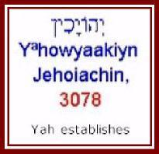
BDB 3078 Yehowyakiyn- Jehoiachin = "Jehovah (Yahweh) establishes"; king of Judah, son of Jehoiakim, and the next to last king of Judah before the Babylonian captivity; kingship lasted for 3 months and 10 days before he surrendered to Nebuchadnezzar who took him to Babylon and imprisoned him for 36 years when he was finally released
Yªhowyaaqiym - Yahowyaqiym - 3079 - Yah raises up
Occurrence AV-Jehoiakim 37; 37
2 Kings 23:34 “And Pharaoh-nechoh made Eliakim the son of Josiah king in the room of Josiah his father, and turned his name to Jehoiakim, and took Jehoahaz away: and he came to Egypt, and died there.” (KJV)
Interesting that Pharaoh-nechoh gave him a name that included “Yah” and meant “Yah raises up”.
Strong 3079 Yehowyaqiym (yeh-ho-yaw-keem'); from 3068 abbreviated and 6965; Jehovah will raise; Jehojakim, a Jewish king: KJV--Jehoiakim. Compare 3113.
BDB 3079 Yehowyaqiym- Jehoiakim = "Jehovah (Yahweh) raises up"; son of Josiah and the third from the last king of Judah; subject vassel of Nebuchadnezzar who reigned for 11 years before he died a violent death either in combat or by the hands of his own subjects
Yªhowyaariyb - Yahowyariyb - 3080 - Yah contends
Occurrence AV-Jehoiarib 2; 2
1 Chronicles 9:10 “And of the priests; Jedaiah, and Jehoiarib, and Jachin,” (KJV)
Strong 3080 Yehowyariyb (yeh-ho-yaw-reeb'); from 3068 and 7378; Jehovah will contend; Jehojarib, the name of two Israelites: KJV--Jehoiarib. Compare 3114.
BDB 3080 Yehowyariyb- Jehoiarib = "Jehovah (Yahweh) contends"; 1) a priest in Jerusalem 2) the head of the first of the 24 courses (shift) of priests in David's time
Yªhuwkal - Yahuwkal - 3081 - Yah is able
Occurrence AV-Jehucal 1; 1
Jeremiah 37:3 “And Zedekiah the king sent Jehucal the son of Shelemiah and Zephaniah the son of Maaseiah the priest to the prophet Jeremiah, saying, Pray now unto Yahweh our Mighty One for us.” (KJV, names adjusted)
Strong 3081 Yehuwkal (yeh-hoo-kal'); from 3201; potent; Jehukal, an Israelite: -Jehucal. Compare 3116.
BDB 3081 Yehuwkal- Jehucal = "Jehovah (Yahweh) is able"; a son of Shelemiah and a servant of king Zedekiah whom he sent to Jeremiah to entreat his prayers and advice
Yªhownaadaab - Yahownadab - 3082 - Yah is willing
Occurrence AV-Jehonadab 3, Jonadab 5; 8
2 Samuel 13:5 “And Jonadab said unto him, Lay thee down on thy bed, and make thyself sick: and when thy father cometh to see thee, say unto him, I pray thee, let my sister Tamar come, and give me meat, and dress the meat in my sight, that I may see it, and eat it at her hand.” (KJV)
Strong 3082 Yehownadab (yeh-ho-naw-dawb'); from 3068 and 5068; Jehovah-largessed; Jehonadab, the name of an Israelite and of an Arab: KJV-- Jehonadab, Jonadab. Compare 3122.
BDB 3082 Yehownadab- Jehonadab = "Jehovah (Yahweh) is willing"; 1) a son of Rechab, chief of the Rechabites, in the time of Jehu and Ahab 2) a nephew of David
Yªhownaataan - Yahownathan - 3083 - Yah has given
Occurrence AV-Jonathan 79, Jehonathan 3; 82
Note two different representations of nominally the same word.
1 Samuel 14:6 “And Jonathan said to the young man that bare his armour, Come, and let us go over unto the garrison of these uncircumcised: it may be that Yahweh will work for us: for there is no restraint to Yahweh to save by many or by few.” (KJV)
Strong 3083 Yehownathan (yeh-ho-naw-thawn'); from 3068 and 5414; Jehovah-given; Jehonathan, the name of four Israelites: KJV--Jonathan. Compare 3129.
BDB 3083 Yehownathan- Jonathan or Jehonathan = "Jehovah (Yahweh) has given"; 1) a son of king Saul and a friend of David 2) a son of the high priest Abiathar and the last descendant of Eli of whom we hear 3) a nephew of David who like David slew a giant of Gath 4) an uncle of David 5) one of David's mighty warriors 6) one of David's treasurers 7) a scribe in the time of Jeremiah 8) a Levite and father of Zechariah, a priest who blew the trumpet at the dedication of the wall 9) a son or descendant of Gershom, the son of Moses, and a priest to the tribe of Dan 10) a son of Kareah and a brother of Johanan; a Judaite captain after the fall of Jerusalem 11) another Judaite father of Peleth 12) the father of Ebed in the time of Ezra 13) a son of Asahel in the time of Ezra 14) a priest of the family of Melicu in the time of Nehemiah 15) a son of Joiada and his successor to the high priesthood in the time of Nehemiah
Yªhowceep - Yahowceph - 3084 - Yah has added
Occurrence AV-Joseph 1; 1
Joseph is also 3130
Psalm 81:5 “This he ordained in Joseph for a testimony, when he went out through the land of Egypt: where I heard a language that I understood not.” (KJV)
Strong 3084 Yehowceph (yeh-ho-safe'); a fuller form of 3130; Jehoseph (i.e. Joseph), a son of Jacob: KJV-- Joseph.
BDB 3084 Yehowceph- Joseph = "Jehovah (Yahweh) has added"; the oldest son of Jacob by Rachel
Yªhow`adaah - Yahow`adaah - 3085 - Yah has adorned
Occurrence AV-Jehoadah 2; 2
1 Chronicles 8:36 “And Ahaz begat Jehoadah; and Jehoadah begat Alemeth, and Azmaveth, and Zimri; and Zimri begat Moza,” (KJV)
Strong 3085 Yehow` addah (yeh-ho-ad-daw'); from 3068 and 5710; Jehovah-adorned; Jehoaddah, an Israelite: KJV-- Jehoada.
BDB 3085 Yehow` addah- Jehoadah = "Jehovah (Yahweh) has adorned"; a descendant of Saul through Jonathan
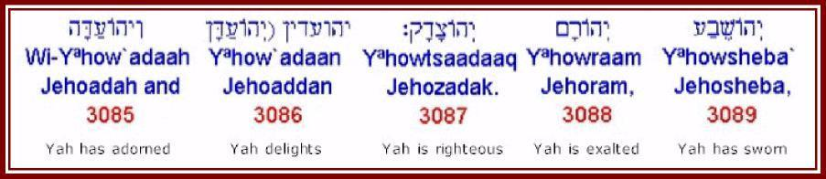
Yªhow’adaan - Yahowadaan - 3086 - Yah delights
Occurrence AV-Jehoaddan 2; 2
2 Kings 14:2 “He was twenty and five years old when he began to reign, and reigned twenty and nine years in Jerusalem. And his mother's name was Jehoaddan of Jerusalem.” (KJV)
Strong 3086 Yehow` addiyn (yeh-ho-ad-deen'); or Yehowaddan (yeh-ho-ad-dawn'); from 3068 and 5727; Jehovah-pleased; Jehoaddin or Jehoaddan, an Israelitess: -Jehoaddan.
BDB 3086 Yehow` addiyn or Yehowaddan- Jehoaddan = "Jehovah (Yahweh) delights"; the wife of king Joash and mother of king Amaziah of Judah
Yªhowtsaadaaq - Yahowtsadaq - 3087 - Yah is righteous
Occurrence AV-Josedech 6, Jehozadak 2; 8
1 Chronicles 6:14 “And Azariah begat Seraiah, and Seraiah begat Jehozadak,” (KJV)
Strong 3087 Yehowtsadaq (yeh-ho-tsaw-dawk'); from 3068 and 6663; Jehovah-righted; Jehotsadak, an Israelite: KJV-- Jehozadek, Josedech. Compare 3136.
BDB 3087 Yehowtsadaq- Jehozadak or Josedech = "Jehovah (Yahweh) is righteous"; the grandson of the high priest Hilkiah; son of the high priest Seraiah; and father of the high priest Joshua; he never attained the office of high priest himself because he was carried captive to Babylon by Nebuchadnezzar
Yªhowraam - Yahowram - 3088 - Yah is exalted
Occurrence AV-Jehoram 23, Joram 6; 29
1 Kings 22:50 “And Jehoshaphat slept with his fathers, and was buried with his fathers in the city of David his father: and Jehoram his son reigned in his stead.” (KJV)
Strong 3088 Yehowram (yeh-ho-rawm'); from 3068 and 7311; Jehovah-raised; Jehoram, the name of a Syrian and of three Israelites: KJV-- Jehoram, Joram. Compare 3141.
BDB 3088 Yehowram- Jehoram or Joram = "Jehovah (Yahweh) is exalted";
- the son of king Jehoshaphat of Judah and himself king of Judah for 8 years; his wife was the wicked Athaliah who was probably the instigator for his returning the nation of Judah to the worship of Baal
the son of king Ahab of the northern kingdom of Israel and king of Israel himself for 12 years; he was murdered by Jehu on the plot of land for which his father had murdered Naboth thus fulfilling the prophecy of Elijah to the very letter 3) a priest in the reign of Jehoshaphat
Yªhowsheba - Yahowsheba - 3089 - Yah has sworn
Occurrence AV-Jehosheba 1; 1
2 Kings 11:2 “But Jehosheba, the daughter of king Joram, sister of Ahaziah, took Joash the son of Ahaziah, and stole him from among the king's sons which were slain; and they hid him, even him and his nurse, in the bedchamber from Athaliah, so that he was not slain.” (KJV)
Strong 3089 Yehowsheba` (yeh-ho-sheh'-bah); from 3068 and 7650; Jehovah-sworn; Jehosheba, an Israelitess: KJV-- Jehosheba. Compare 3090.
BDB 3089 Yehowsheba`- Jehosheba = "Jehovah (Yahweh) has sworn"; daughter of king Joram of Judah and wife of the high priest Jehoiada alternate spelling `Jehoshabeath', 3090
Yªhowshab`at - Yahowshab`ath - 3090 - Yah is an oath
Occurrence AV-Jehoshabeath 2; 2
2 Chronicles 22:11 “But Jehoshabeath, the daughter of the king, took Joash the son of Ahaziah, and stole him from among the king's sons that were slain, and put him and his nurse in a bedchamber. So Jehoshabeath, the daughter of king Jehoram, the wife of Jehoiada the priest, (for she was the sister of Ahaziah,) hid him from Athaliah, so that she slew him not.” (KJV)
This is exactly the same person as 3089 above, this time reported in Chronicles. In other words the writers of Kings and Chronicles were NOT exactly certain of the spelling of her name. Therefore we can conclude that it IS possible that there will be other discrepancies between Kings and Chronicles and that these two Scriptures were NOT given by Yah in the form of letter and word perfect dictation as tradition suggests.
Strong 3090 Yehowshab` ath (yeh-ho-shab-ath'); a form of 3089; Jehoshabath, an Israelitess: KJV-- Jehoshabeath.
BDB 3090 Yehowshab` ath- Jehoshabeath = "Jehovah (Yahweh) is an oath"; the daughter of king Joram of Judah and wife of the high priest Jehoiada alternate spelling `Jehosheba, 3089
This is interpreted “Yah is an oath” whereas the previous version of the SAME NAME FOR THE SAME PERSON is given as “Yah has sworn”. There is NOT absolute certainty on these matters.
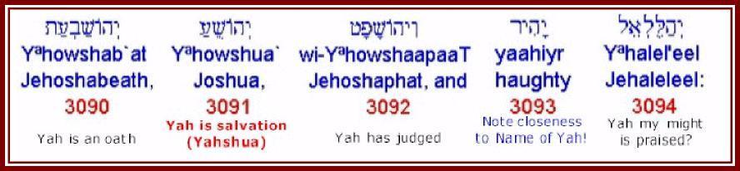
Yªhowshua - Yahooshua - 3091 - Yah is salvation
Occurrence AV-Joshua 218; 218
Exodus 17:9 “And Moses said unto Joshua, Choose us out men, and go out, fight with Amalek: to morrow I will stand on the top of the hill with the rod of Mighty One {Elohiym} Yah in mine hand.” (KJV)
This is an example of a verse where substituting “Mighty One” for “Elohiym” does not make sense, let alone substituting “Mighty Ones”. Yah states “Obviously That Should Read ‘Rod Of Yah’!” (Yah’s words).
Strong 3091 Yehowshuwa` (yeh-ho-shoo'-ah); or Yehowshu` a (yeh-ho-shoo'-ah); from 3068 and 3467; Jehovah-saved; Jehoshua (i.e. Joshua), the Jewish leader: -Jehoshua, Jehoshuah, Joshua. Compare 1954, 3442.
Refer also 3442 which is suggested as being essentially the same name.
BDB 3091 Yehowshuwa` or Yehowshu` a- Joshua or Jehoshua = "Jehovah (Yahweh) is salvation"; as a proper noun, masculine: 1) a son of Nun of the tribe of Ephraim and successor to Moses as the leader of the children of Israel; led the conquest of Canaan 2) a resident of Beth-shemesh on whose land the Ark of the Covenant came to a stop after the Philistines returned it 3) a son of Jehozadak and high priest after the restoration 4) the governor of Jerusalem under king Josiah who gave his name to a gate of the city of Jerusalem
This particular name has presented the writer with an ENORMOUS CHALLENGE on two fronts.
Firstly since becoming aware that the Name of “Jesus” was in fact Yahooshua, the writer has steadfastly wanted to believe that the Name “Yahooshua” was NOT the same as the name of “Joshua”. The writer has also studiously avoided asking Yah about this.
However, during the process of extracting these names and other data it became apparent that the name traditionally translated “Joshua” in the books traditionally referred to as the “Old Testament” was EXACTLY THE SAME NAME given to the man we all know as “Jesus”.
In other words, Yahooshua, our saviour, DID NOT HAVE A UNIQUE NAME, he had the SAME name that had been given to thousands of other believers through the ages!!
On going before Yah on this matter the writer was told “Obviously Yahooshua Could NOT Have Been Given An Exclusive Name. It Would Have Attracted Too Much Attention To Him And Made Life For Joseph And Mary Totally Unbearable!” (Yah’s words)
Secondly, up to now the writer has been firmly persuaded that the Name Yahooshua meant “the salvation of Yah”. However, having confronted the first point it was then necessary to confront the second, that is, that the Name “Yahooshua” means “YAH IS SALVATION”! In other words, Yahooshua, through his Name, POINTED US TOWARD YAH as our salvation NOT himself!
This confronts a whole spectrum of issues.
CONCLUSION:
The man we have known as “Jesus” was actually called “Yahooshua” and that is the SAME name as the man who led Israel into Canaan and that occurs 218 times in the books we traditionally refer to as “the old testament” AND that name means “Yah is Salvation” NOT “Salvation of Yah”!
This is confirmed by the following Scriptures:
Psalm 106:21 “They forgat Yah El their saviour, which had done great things in Egypt;”
Isaiah 43:3 “For I am Yahweh thy Mighty One, the Holy One of Israel, thy Saviour: I gave Egypt for thy ransom, Ethiopia and Seba for thee.”
Isaiah 43:11 “I, even I, am Yahweh; and beside me there is no saviour.”
Isaiah 45:15 “Verily thou art a Mighty One that hidest thyself, O Mighty One of Israel, the Saviour.”
Isaiah 45:21 “Tell ye, and bring them near; yea, let them take counsel together: who hath declared this from ancient time? who hath told it from that time? have not I Yahweh? and there is no Mighty One else beside me; a just Mighty One and a Saviour; there is none beside me.”
Isaiah 45:17 “But Israel shall be saved in Yahweh with an everlasting salvation: ye shall not be ashamed nor confounded world without end.”
Isaiah 49:26 “And I will feed them that oppress thee with their own flesh; and they shall be drunken with their own blood, as with sweet wine: and all flesh shall know that I Yahweh am thy Saviour and thy Redeemer, the mighty One of Jacob.”
Isaiah 60:16 “Thou shalt also suck the milk of the Gentiles, and shalt suck the breast of kings: and thou shalt know that I Yahweh am thy Saviour and thy Redeemer, the mighty One of Jacob.”
Isaiah 63:8 “For he said, Surely they are my people, children that will not lie: so he [Yah] was their Saviour.”
Jeremiah 14:8 “O the hope of Israel, the saviour thereof in time of trouble, why shouldest thou be as a stranger in the land, and as a wayfaring man that turneth aside to tarry for a night?”
Hosea 13:4 “Yet I am Yahweh thy Mighty One from the land of Egypt, and thou shalt know no god but me: for there is no saviour beside me.”
All Scriptures from the KJV with Names adjusted
It is clearly apparent that Yah is the ONLY saviour. This must be reconciled with our understanding of who exactly Yahooshua the anointed of Yah is and what exactly he accomplished on our behalf through his life and death!
YªhowshaapaaT - Yahowshaphat - 3092 - Yah has judged
Occurrence AV-Jehoshaphat 84; 84
2 Samuel 8:16 “And Joab the son of Zeruiah was over the host; and Jehoshaphat the son of Ahilud was recorder;” (KJV)
Strong 3092 Yehowshaphat (yeh-ho-shaw-fawt'); from 3068 and 8199; Jehovah-judged; Jehoshaphat, the name of six Israelites; also of a valley near Jerusalem: -Jehoshaphat. Compare 3146.
BDB 3092 Yehowshaphat- Jehoshaphat = "Jehovah (Yahweh) has judged"; as a proper noun, masculine: 1) a son of king Asa and himself king of Judah for 25 years; one of the best, most pious, and prosperous kings of Judah 2) a son of Nimshi and father of king Jehu of the northern kingdom of Israel 3) a son of Ahilud and chronicler under David and Solomon 4) a son of Paruah and one of the 12 commissary officers under Solomon 5) a priest and trumpeter in the time of David as a proper noun, location: 6) symbolical name of a valley near Jerusalem which is the place of ultimate judgment; maybe the deep ravine which separates Jerusalem from the Mount of Olives through which the Kidron Creek flowed
yahiyr - 3093 - haughty
Occurrence AV-haughty 1, proud 1; 2
Proverbs 21:24 “Proud and haughty scorner is his name, who dealeth in proud wrath.” (KJV)
Strong 3093 yahiyr (yaw-here'); probably from the same as 2022; elated; hence, arrogant: KJV-- haughty, proud.
BDB 3093 yahiyr- proud, arrogant, haughty
NOTE THE CLOSENESS TO THE NAME OF YAH - no wonder Yah hates pride - it is elevating ourselves to His level!!
Yªhalel'eel - Yahalel'eel - 3094 - Yah my might is praised
Occurrence AV-Jehaleleel 1, Jehalelel 1; 2
1 Chronicles 4:16 “And the sons of Jehaleleel; Ziph, and Ziphah, Tiria, and Asareel.” (KJV)
Strong 3094 Yehallel'el (yeh-hal-lel-ale'); from 1984 and 410; praising God; Jehallelel, the name of two Israelites: KJV-- Jehalellel, Jehalelel.
BDB 3094 Yehallel'el- Jehaleleel or Jehalelel = "God is praised"; 1) a Calebite descendant of Judah 2) father of Azariah and a Merarite Levite in the time of Hezekiah
“Mighty One is praised” or “praising Mighty One” does not make much sense when the word begins with a form of “Yah”. This is not congruent. After prayer the interpretation “Yah my might is praised” was given.
yaahalom - 3095 - a diamond
Occurrence AV-diamond 3; 3
Exodus 28:18 “And the second row shall be an emerald, a sapphire, and a diamond.” (KJV)
Strong 3095 yahalom (yah-hal-ome'); from 1986 (in the sense of hardness); a precious stone, probably onyx: KJV-- diamond.
BDB 3095 yahalom- a precious stone (known for its hardness); perhaps the jasper, onyx, or diamond
It seems significant that the word for a diamond is ALSO derived from the Name of Yah - note the characteristics, it is intensely pure, transparent, beautiful but ALSO intensely hard and will burn with intense heat if ignited - it seems to me that this in a material sense describes Yah!!
However, the Hebrew transliterated Yaah does not appear to be that close to that transliterated Yah! This seems strange since it is in numerical sequence which, until now, had been assumed to be more or less alphabetic based on the Hebrew. In light of other instances of similar words with different numbers it seems that the numbering is probably LESS systematic than assumed. Given the magnitude of the task of cataloguing all this information manually at the time it was first done it is not unreasonable for there to be inconsistencies. This observation simply demonstrates that it is unwise to make assumptions about things of this nature!
Yaahatsaah - Yahtsah - 3096 - Yah has trodden down?
Occurrence AV-Jahaz 5, Jahazah 3, Jahzah 1; 9
Numbers 21:23 “And Sihon would not suffer Israel to pass through his border: but Sihon gathered all his people together, and went out against Israel into the wilderness: and he came to Jahaz, and fought against Israel.” (KJV)
Strong 3096 Yahats (yah'-hats; or Yahtsah (yah'-tsaw; or (feminine) Yahtsah (yah-tsaw'); from an unused root meaning to stamp; perhaps threshing-floor; Jahats or Jahtsah, a place East of the Jordan: KJV--Jahaz, Jahazah, Jahzah.
BDB 3096 Yahats or Yahtsah or (fem.) Yahtsah- Jahaz or Jahazah or Jahzah = "trodden down"; a place in Reuben east of the Dead Sea where Israel defeated Sihon king of the Amorites; the site is uncertain.
In this case the Hebrew seems fairly close relative to Yah, Yah has trodden down seems to fit the place and what happened there.
Yow'aab - Joab - 3097 - Yah is father?
Occurrence AV-Joab 145; 145
1 Samuel 26:6 “Then answered David and said to Ahimelech the Hittite, and to Abishai the son of Zeruiah, brother to Joab, saying, Who will go down with me to Saul to the camp? And Abishai said, I will go down with thee.” (KJV)
Strong 3097 Yow'ab (yo-awb'); from 3068 and 1; Jehovah-fathered; Joab, the name of three Israelites: KJV-- Joab.
BDB 3097 Yow'ab- Joab = "Jehovah (Yahweh) is father"; 1) son of David's sister Zeruiah and general of David's army 2) a Judaite descendant of Kenaz 3) a post-exilic family
Yah is father seems an unlikely name?
Yow'aach - Joah - 3098 - Yah is brother?
Occurrence AV-Joah 11; 11
2 Kings 18:18 “And when they had called to the king, there came out to them Eliakim the son of Hilkiah, which was over the household, and Shebna the scribe, and Joah the son of Asaph the recorder.” (KJV)
Strong 3098 Yow'ach (yo-awkh'); from 3068 and 251; Jehovah-brothered; Joach, the name of four Israelites: KJV-- Joah.
BDB 3098 Yow'ach- Joah = "Jehovah (Yahweh) is brother"; 1) son of Asaph and chronicler to Hezekiah 2) a Gershonite son or grandson of Zimmah 3) a Korhite, third son of Obed-edom and doorkeeper in the time of David 4) a son of Joahaz and chronicler to king Josiah
Yah is brother seems to be a very familiar name? Alternatively the relationship of Yah’s people to Yah in the days when names like these were formulated was MUCH CLOSER than most people want to believe! (Yah says “that is so”).
Yow'aachaaz - 3099 - Yah has grasped?
Occurrence AV-Jehoahaz 3, Joahaz 1; 4
2 Kings 14:1 “In the second year of Joash son of Jehoahaz king of Israel reigned Amaziah the son of Joash king of Judah.” (KJV)
Strong 3099 Yow'achaz (yo-aw-khawz'); a form of 3059; Joachaz, the name of two Israelites: KJV-- Jehoahaz, Joahaz.
BDB 3099 Yow'achaz- Joahaz or Jehoahaz = "Jehovah (Yahweh) has grasped"; the father of Joah, Josiah's chronicler
It seems difficult for an untrained reader to recognize Yah in this Hebrew word.
Yow'eel - Joel - 3100 - Yah is Mighty One (El)
Occurrence AV-Joel 19; 19
1 Samuel 8:2 “Now the name of his firstborn was Joel; and the name of his second, Abiah: they were judges in Beersheba.” (KJV)
Strong 3100 Yow'el (yo-ale'); from 3068 and 410; Jehovah (is his) God; Joel, the name of twelve Israelites: KJV-- Joel.
BDB 3100 Yow'el- Joel = "Jehovah (Yahweh) is God"; 1) a son of Pethuel and the second of the 12 minor prophets with a book by his name; probably prophesied in the time of king Uzziah of Judah 2) the oldest son of Samuel the prophet and father of Heman the singer 3) a Simeonite chief 4) a Reubenite 5) a chief of Gad 6) a son of Izrahiah and a chief of Issachar 7) a brother of Nathan of Zobah and one of David's mighty warriors 8) a son of Pedaiah and a chief of the half-tribe of Manasseh west of the Jordan River in the time of David 9) a son of Nebo who returned with Ezra and had a foreign wife 10) a Benjamite, son of Zichri 11) a Levite 12) a Kohathite Levite in the reign of Hezekiah 13) a Gershonite Levite chief in the time of David 14) a Gershonite Levite, son of Jehiel and a descendant of Laadan; maybe the same as meaning no. 13
“Yah is God” is actually “Yah is El”, in other words “Yah is Mighty One”.
Yah is not easily recognized in this word suggesting that the traditional meaning of the word goes beyond the exact spelling of Yah being embedded in the word.
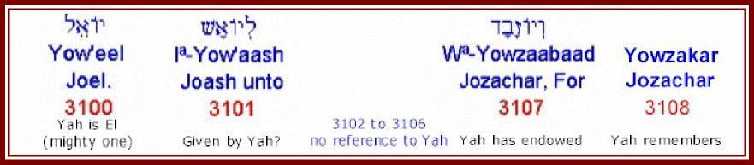
Yow'aash - Joash - 3101 - given by Yah
Occurrence AV-Joash 47; 47
Judges 6:11 “And there came an angel of Yahweh, and sat under an oak which was in Ophrah, that pertained unto boash the Abi-ezrite: and his son Gideon threshed wheat by the winepress, to hide it from the Midianites.” (KJV, names adjusted)
Strong 3101 Yow'ash (yo-awsh'); or Yo'ash (2 Chron. 24:1) (yo-awsh'); a form of 3060; Joash, the name of six Israelites: KJV-- Joash.
BDB 3101 Yow'ash or Yo'ash (2 Chron. 24:1)- Joash = "given by the Lord"; 1) a son of king Ahaziah and the 8th king of Judah 2) a son of king Jehoahaz and the 12th king of the northern kingdom of Israel 3) the father of Gideon 4) a son of king Ahab 5) a descendant of Shelah the son of Judah; either the son of Shelah or the son of Jokim 6) a son of Shemaah of Gibeah who resorted to David at Ziklag

Further Words Which Refer To Yah
There are a number of additional words which Brown, Driver, Briggs indicate refer to Yah. However the Hebrew connection is not apparent to the writer and there is a discontinuity in Strong’s numbering which seems puzzling IF there IS continuity of reference.
The writer has subsequently concluded that there is NO continuity of reference.
3102 to 3106 make no reference to Yah
Yowzabad - 3107 - Yah has endowed
Occurrence AV-Jozabad 9, Josabad 1; 10
2 Kings 12:21 “For Jozachar the son of Shimeath, and Jehozabad the son of Shomer, his servants, smote him, and he died; and they buried him with his fathers in the city of David: and Amaziah his son reigned in his stead.” (KJV)
BDB 3107 Yowzabad- Jozabad or Josabad = "Jehovah (Yahweh) has endowed"; 1) a Korhite Levite, second son of Obededom, and one of the porters of the Temple and of the storehouse there in the time of David 2) one of David's mighty warriors 3) another of David's mighty warriors 4) four other priests or Levites
Yowzakar - 3108 - Yah remembers
Occurrence AV-Jozachar 1; 1
Does not occur in the King James Version in PC Study Bible, DOES occur in 2 Kings 12:21 in the OnLine Bible. PC Study Bible has 3107 in this verse spelt as 3108! A further instance of small discrepancies indicative of differing human interpretations which must cause us to turn to Yah for guidance!
BDB 3108 Yowzakar- Jozachar = "Jehovah (Yahweh) remembers"; a servant of king Joash of Judah and one of his murderers; also called `Zabad'
Yowchaa - 3109 - Yah gives life
Occurrence AV-Joha 2; 2
1 Chronicles 8:16 “And Michael, and Ispah, and Joha, the sons of Beriah;” (KJV)
Strong 3109 Yowcha' (yo-khaw'); probably from 3068 and a variation of 2421; Jehovah-revived; Jocha, the name of two Israelites: KJV-- Joha.
BDB 3109 Yowcha'- Joha = "Jehovah (Yahweh) gives life"; 1) one of the sons of Beriah the Benjamite 2) the Tizite, one of David's mighty warriors
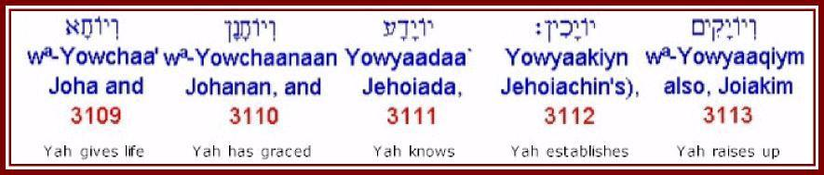
Yowchaanaan - Johanan - 3110 - Yah has graced
Occurrence AV-Johanan 24; 24
2 Kings 25:23 “And when all the captains of the armies, they and their men, heard that the king of Babylon had made Gedaliah governor, there came to Gedaliah to Mizpah, even Ishmael the son of Nethaniah, and Johanan the son of Careah, and Seraiah the son of Tanhumeth the Netophathite, and Jaazaniah the son of a Maachathite, they and their men.” (KJV)
Strong 3110 Yowchanan (yo-khaw-nawn'); a form of 3076; Jochanan, the name of nine Israelites: KJV-- Johanan. ***. Yuwtah. See 3194.
BDB 3110 Yowchanan- Johanan = "Jehovah (Yahweh) has graced"; 1) a priest during the high priesthood of Joiakim who returned with Zerubbabel 2) a Jewish captain after the fall of Jerusalem 3) the oldest son of king Josiah 4) a post-exilic prince of the line of David 5) the father of Azariah, priest in Solomon's time 6) a Benjamite, one of David's mighty warriors 7) a Gadite, one of David's mighty warriors 8) a returning exile
Yowyaadaa - Jehoiada - 3111 - Yah knows
Occurrence AV-Joiada 4, Jehoiada 1; 5
Nehemiah 3:6 “Moreover the old gate repaired Jehoiada the son of Paseah, and Meshullam the son of Besodeiah; they laid the beams thereof, and set up the doors thereof, and the locks thereof, and the bars thereof.” (KJV)
Strong 3111 Yowyada` (yo-yaw-daw'); a form of 3077; Jojada, the name of two Israelites: KJV-- Jehoiada, Joiada.
Abdb 3111 Yowyada`- Joiada or Jehoiada = "Jehovah (Yahweh) knows";
- a son of Paseah, who assisted to repair the old gate of Jerusalem
a son of the high priest Eliashib in the time of Nehemiah
YowyaAkiyn - Jehoiachin - 3112 Yah establishes
Occurrences AV-Jehoiachin 1; 1
Ezekial 1:2 “In the fifth day of the month, which was the fifth year of king Jehoiachin's captivity,” (KJV)
Strong 3112 Yowyakiyn (yo-yaw-keen'); a form of 3078; Jojakin, an Israelite king: -Jehoiachin.
BDB 3112 Yowyakiyn- Jehoiachin = "Jehovah (Yahweh) establishes"; king of Judah, son of Jehoiakim, and the next to last king of Judah before the Babylonian captivity. His kingship lasted for 3 months and 10 days before he surrendered to Nebuchadnezzar who took him to Babylon and imprisoned him for 36 years, when he was finally released.
Note reference to 3078 alternate spelling again suggesting that there is human error in the original texts in terms of specific precision at the letter level. Both refer to exactly the same man - refer to notes above and for 3078. Both have exactly the same interpretation, Yah establishes.
The 3112 reference is from Ezekial, all other references are from Kings, Chronicles and Jeremiah. Since Ezekial was in captivity with Jehoiachin it would seem probable that his record of the spelling is more likely to be correct. Either way, one or other record is presumably incorrect.
Yowyaaqiym - Joiakim - 3113 - Yah raises up
Occurrence AV-Joiakim 4; 4
Nehhemiah 12:10 “And Jeshua begat Joiakim, Joiakim also begat Eliashib, and Eliashib begat Joiada,” (KJV)
Strong 3113 Yowyaqiym (yo-yaw-keem'); a form of 3079; Jojakim, an Israelite: -Joiakim. Compare 3137.
BDB 3113 Yowyaqiym- Joiakim or Jehoiakim = "Jehovah (Yahweh) raises up"; a priest and son of Jeshua, the high priest
Yowyaariyb - Joiarib - 3114 - Yah contends
Occurrence AV-Joiarib 5; 5
Ezra 8:16 “Then sent I for Eliezer, for Ariel, for Shemaiah, and for Elnathan, and for Jarib, and for Elnathan, and for Nathan, and for Zechariah, and for Meshullam, chief men; also for Joiarib, and for Elnathan, men of understanding.” (KJV)
Strong 3114 Yowyariyb (yo-yaw-reeb'); a form of 3080; Jojarib, the name of four Israelites: KJV-- Joiarib.
BDB 3114 Yowyariyb- Joiarib = "Jehovah (Yahweh) contends"; 1) the head of the first of the 24 courses (shifts) of priests in David's time 2) a teacher in the time of Ezra 3) a Judaite in the time of Nehemiah.
Yowkebed - Jochebed - 3115 - Yah is glory
Occurrence AV-Jochebed 2; 2
Exodus 6:20 “And Amram took him Jochebed his father's sister to wife; and she bare him Aaron and Moses: and the years of the life of Amram were an hundred and thirty and seven years.” (KJV)
Strong 3115 Yowkebed (yo-keh'-bed); from 3068 contracted and 3513; Jehovah-gloried; Jokebed, the mother of Moses: KJV-- Jochebed.
BDB 3115 Yowkebed- Jochebed = "Jehovah (Yahweh) is glory"; the daughter of Levi, wife and at the same time aunt of Amram, and the mother of Moses, Aaron, and Miriam
Yuwkal - Jucal - 3116 - Yah is able
Occurrence AV-Jucal 1; 1
Jeremiah 38:1 “Then Shephatiah the son of Mattan, and Gedaliah the son of Pashur, and Jucal the son of Shelemiah, and Pashur the son of Malchiah, heard the words that Jeremiah had spoken unto all the people, saying,” (KJV)
Strong 3116 Yuwkal (yoo-kal'); a form of 3081; Jukal, an Israelite: KJV--Jucal.
BDB 3116 Yuwkal- Jucal = "Jehovah (Yahweh) is able"; a son of Shelemiah and a servant of king Zedekiah whom he sent to Jeremiah to entreat his prayers and advice

Names Including Yah
The following names include Yah embedded in the name.
Zekaryaah - Zechariah - 2148 - Yah remembers
Occurrence AV-Zechariah ; 43
Ezra 5:1 “Then the prophets, Haggai the prophet, and Zechariah the son of Iddo, prophesied unto the Jews that were in Judah and Jerusalem in the name of the Mighty One of Israel, even unto them.” (KJV)
Strong 2148 Zekaryah (zek-ar-yaw'); or Zekaryahuw (zek-ar-yaw'-hoo); from 2142 and 3050; Jah has remembered; Zecarjah, the name of twenty-nine Israelites: -Zachariah, Zechariah.
BDB 2148 Zekaryah or Zekaryahuw- Zechariah = "Jehovah (Yahweh) remembers"; 1) 11th in order of the minor prophets; a priest, son of Berechiah and grandson of Iddo, who, along with Haggai, directed the rebuilding of the Temple in the days of Zerubbabel 2) a king of Israel, son of Jeroboam II 3) a son of Meshelemiah of Shelemiah, a Korhite, and keeper of the north gate of the tabernacle of the congregation 4) one of the sons of Jehiel 5) a Levite of the second order in the Temple band in the time of David 6) one of the princes of Judah in the reign of Jehoshaphat 7) a son of the high priest Jehoiada, in the reign of Joash king of Judah, who was stoned in the court of the temple 8) a Kohathite Levite in the reign of Josiah 9) the leader of the sons of Pharosh who returned with Ezra 10) a son of Bebai 11) one of the chiefs of the people whom Ezra summoned in council at the Ahava River; stood at Ezra's left hand when Ezra expounded the law to the people 12) one of the family of Elam who had married a foreign wife after the captivity 13) an ancestor of Athaiah or Uthai 14) a Shilonite, descendant of Perez, grandfather of Athaiah 15) a priest, son of Pashur 16) the representative of the priestly family of Iddo in the days of Joiakim the son of Jeshua; possibly the same as meaning no. 1 above 17) one of the priests, son of Jonathan, who blew with the trumpets at the dedication of the city wall by Ezra and Nehemiah 18) a chief of the Reubenites at the time of the captivity by Tiglath-pileser 19) one of the priests who accompanied the ark from the house of Obed-edom 20) a son of Isshiah of Jesiah, a Kohathite Levite descended from Uzziel 21) the fourth son of Hosah, of the children of Merari 22) a Manassite, father of Iddo 23) father of Jahaziel. He prophesied in the spirit 24) one of the sons of Jehoshaphat 25) a prophet in the reign of Uzziah, who appears to have acted as the king's counsellor, but of whom nothing is known 26) father of Abijah or Abi, Hezekiah's mother 27) one of the family of Asaph in the reign of Hezekiah 28) one of the rulers of the Temple in the reign of Josiah 29) a son of Jeberechiah who was taken by the prophet Isaiah as one of the `faithful witnesses to record' when he wrote concerning Maher-shalal-hash-baz
Yªdiydªyaah - Jedidiah - 3041 - beloved of Yah
Occurrence AV-Jedidiah 1; 1
2 Samuel 12:25 “And he sent by the hand of Nathan the prophet; and he called his name Jedidiah, because of Yahweh.” (KJV)
Strong 3041 Yediydeyah (yed-ee-deh-yaw'); from 3039 and 3050; beloved of Jah; Jedidejah, a name of Solomon: KJV-- Jedidiah.
BDB 3041 Yediydeyah- Jedidiah = "beloved of Jehovah (Yahweh)"; the name given to Solomon through Nathan the prophet
Yirmªyaahuw - Jeremiah - 3414 - whom Yah has appointed
Occurrence AV-Jeremiah 147; 147
2 Kings 23:31 “Jehoahaz was twenty and three years old when he began to reign; and he reigned three months in Jerusalem. And his mother's name was Hamutal, the daughter of Jeremiah of Libnah.” (KJV)
Strong 3414 Yirmeyah (yir-meh-yaw'); or Yirmeyahuw (yir-meh-yaw'-hoo); from 7311 and 3050; Jah will rise; Jirmejah, the name of eight or nine Israelites: KJV-- Jeremiah.
BDB 3414 Yirmeyah or Yirmeyahuw- Jeremiah = "whom Jehovah (Yahweh) has appointed"; 1) the major prophet, son of Hilkiah of the priestly family in Anathoth; author of the prophetic book bearing his name 2) a man of Libnah and father of Hamutal the wife of king Josiah 3) a Gadite who joined David at Ziklag 4) a Manassehite, one of the mighty men of valor of the Transjordanic half-tribe of Manasseh 5) a Gadite and warrior of David 6) a warrior of David 7) a priest who joined Nehemiah in the covenant ceremony 8) a priest also in the time of Nehemiah; maybe the same as meaning no. 7 9) father of Jaazaniah the Rechabites
Yasha`yaahuw - Isaiah - 3470 - Yah has saved
Occurrence AV-Isaiah 32, Jeshaiah 5, Jesaiah 2; 39
2 Kings 19:2 “And he sent Eliakim, which was over the household, and Shebna the scribe, and the elders of the priests, covered with sackcloth, to Isaiah the prophet the son of Amoz.” (KJV)
Strong 3470 Yesha` yah (yesh-ah-yaw'); or Yesha` yahuw (yesh-ah-yaw'-hoo); from 3467 and 3050; Jah has saved; Jeshajah, the name of seven Israelites: KJV-- Isaiah, Jesaiah, Jeshaiah.
BDB 3470 Yesha` yah or Yesha` yahuw- Isaiah or Jesaiah or Jeshaiah = "Jehovah (Yahweh) has saved"; 1) the major prophet, son of Amoz, who prophesied concerning Judah and Jerusalem during the days of kings Uzziah, Jotham, Ahaz, and Hezekiah of Judah; the author of the prophetic book by his name. Tradition has it that he was sawn asunder in the trunk of a carob tree by king Manasseh and that this is the incident referred to in Heb 11:37 2) son of Hananiah, brother of Pelatiah, and grandson of Zerubbabel 3) a Benjamite 4) one of the six sons of Jeduthun 5) a son of Rehabiah, a descendant of Moses through Gershom, and an ancestor of a Levite treasurer in the time of David 6) a son of Athaliah and chief of the house of Elam who returned with Ezra 7) a chief of the descendants of Merari who returned with Ezra
Miykaayªhuw - Micah - 4319 - who is like Yah
Occurrence AV-Michaiah 1; 1
PC Study Bible and OnLine Bible do not agree on relative occurrences of 4319, 4321 and 4322 in terms of verse occurrence.
Strong 4319 Miykahuw (me-kaw'-hoo); a contr. for 4321; Mikehu, an Israelite prophet: KJV-- Micaiah (2 Chronicles 18:8).
BDB 4319 Miykahuw- Michaiah = "who is like God"; a son of Imlah and a prophet of Samaria who predicted the defeat and death of king Ahab of Israel
4321 and 4322 ALSO mean “who is like Yah”
Nªchemyaah - Nehemiah - 5166 - Yah comforts
Occurrence AV-Nehemiah 8; 8
Ezra 2:2 “Which came with Zerubbabel: Jeshua, Nehemiah, Seraiah, Reelaiah, Mordecai, Bilshan, Mispar, Bigvai, Rehum, Baanah. The number of the men of the people of Israel:” (KJV)
Strong 5166 Nechemyah (nekh-em-yaw'); from 5162 and 3050; consolation of Jah; Nechemjah, the name of three Israelites: KJV-- Nehemiah.
BDB 5166 Nechemyah- Nehemiah = "Jehovah (Yahweh) comforts"; 1) the son of Hachaliah, cupbearer to King Artaxerxes, who became governor of Judah after the return from exile 2) one of the 12 heads of the people who returned from exile with Zerubbabel 3) son of Azbuk and ruler of the half part of Beth-zur, who helped to repair the wall of Jerusalem
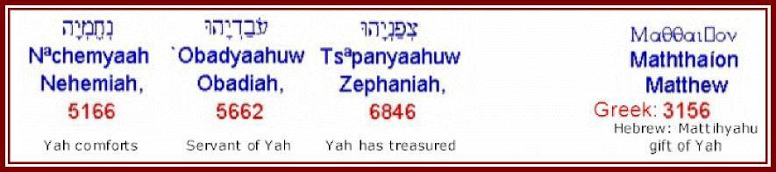
Obadyaahuw - Obadiah - 5662 - servant of Yah
Occurrence AV-Obadiah 20; 20
1 Kings 18:3 “And Ahab called Obadiah, which was the governor of his house. (Now Obadiah feared Yahweh greatly:” (KJV, name adjusted)
Strong 5662 `Obadyah (o-bad-yaw'); or `Obadyahuw (o-bad-yaw'-hoo); active participle of 5647 and 3050; serving Jah; Obadjah, the name of thirteen Israelites: KJV-- Obadiah.
BDB 5662 `Obadyah or `Obadyahuw- Obadiah = "servant of Jehovah (Yahweh)"; 1) the fourth of the 12 minor prophets; nothing personal is known of him but it is probable that he was contemporary with Jeremiah, Ezekiel, and Daniel; the prophetic book by him; prophesies against Edom 2) the father of Ishmaiah, one of the chiefs of Zebulun in the time of David 3) a Merarite Levite overseer of the work of restoring the Temple in the time of king Josiah of Judah 4) the chief of the household of King Ahab of Israel; an devout worshiper of Jehovah (Yahweh) who, at risk to his own life, hid over 100 prophets during the persecution of Jezebel 5) a descendant of David 6) a chief of the tribe of Issachar 7) a Benjamite, one of the six sons of Azel and a descendant of King Saul 8) a Levite, son of Shemaiah and a descendant of Jeduthun 9) a Gadite chief, the 2nd of the lion-faced Gadites who joined David at Ziklag 10) a prince of Judah in the time of king Jehoshaphat of Judah 11) a priest, son of Jehiel of the sons of Joab who returned from exile with Ezra 12) a gatekeeper in the time of Nehemiah 13) one of the men who sealed the covenant with Nehemiah; perhaps the same as meaning no. 12
Tsªphanyaahuw - Zephaniah - 6846 - Yah has treasured
Occurrence AV-Zephaniah 10; 10
2 Kings 25:18 “And the captain of the guard took Seraiah the chief priest, and Zephaniah the second priest, and the three keepers of the door:” (KJV)
Strong 6846 Tsephanyah (tsef-an-yaw'); or Tsephanyahuw (tsef-an-yaw'-hoo); from 6845 and 3050; Jah has secreted; Tsephanjah, the name of four Israelites: KJV-- Zephaniah.
BDB 6846 Tsephanyah or Tsephanyahuw- Zephaniah = "Jehovah (Yahweh) has treasured"; 1) the ninth in order of the 12 minor prophets; a descendant of king Hezekiah of Judah and prophet in the time of King Josiah of Judah 2) the son of Maaseiah and the second priest in the reign of King Zedekiah of Judah. He succeeded Jehoiada and an officer of the Temple. He was killed at Riblah when Jerusalem was captured. 3) the father of Josiah and Hen in the time of the prophet Zechariah 4) a Levite
There are many other such names listed in Appendix A.
Mattihyahu - Matthew - Greek 3156 - gift of Yah
Occurrence AV-Matthew 5; 5
Matthew 9:9 “And as Yahooshua passed forth from thence, he saw a man, named Matthew, sitting at the receipt of custom: and he saith unto him, Follow me. And he arose, and followed him.” (KJV)
Strongs 3156 Maththaios (math-thah'-yos) or Matthaios (mat-thah'-yos); a shorter form of 3164; Matthaeus (i.e. Matthitjah), an Israelite and a Christian: KJV-- Matthew.
Thayer 3156 Matthaios- Matthew = "gift of Jehovah (Yahweh)" son of Alphaeus, one of the 12 disciples

Additional Words Which Relate To Yah
In progressively documenting findings it became apparent that there were far more words including Yah than had at first appeared.
Time does not permit further detailed extraction such as that presented in this article thus far. Accordingly, further limited coarse extraction has been undertaken for reference purposes. This is presented in the appendices and serves to further demonstrate the great extent to which the Name of our Creator and Heavenly Father permeates every facet of Scripture and the history of His chosen people.
It is hoped that after considering this article readers will have a far better understanding of why the true Sacred Names are so important and an increasing revelation of the Sacred Scriptures!
James Robertson
24 January 2002 with minor amendments 20 November 2010

Appendix A : Instances of Jehovah and Jah = Yah (In The Hebrew Lexicon of The Online Bible)
The following 253 verse instances of Jehovah occur in the Hebrew lexicon of the OnLine Bible. Jehovah has been replaced with Yah in all cases other than those where Yahweh was already indicated in the text.
The majority of the line items that follow relate to names which refer to Yah, a small number are simply notes.
Since the objective of this appendix is simply to provide a more comprehensive picture this data is presented as obtained other than with the substitution of the Name of Yah and limited formatting and editing.
29 Abia or Abiah or AbiYah =" Yah is (my) father"
138 AdoniYah =" my lord is Yah"
168 1c) the sacred tent of Yah (the tabernacle)
172 1) (metaph) Jerusalem as adulterous wife of Yah
216 1k) Yah as Israel’s light
223 Uriah or UriYah =" Yah (Yahweh) is my light (flame)"
245 Azaniah =" Yah (Yahweh) hears"
274 Ahaziah =" Yah (Yahu) holds (possesses)"
281 Ahiah or AhiYah =" brother of Yah (Yahu)"
410 1d) God, the one true God, Yah
452 EliYah or Eliah =" my God is Yah" or "Yah(u) is God"
454 Elioenai or Elihoenai =" unto Yah are my eyes"
558 Amaziah =" Yah is mighty"
568 Amariah =" Yah speaks" or "Yah(u) has promised"
683 Azaliah =" Yah (Yahweh) has reserved (set apart)"
912 Bedeiah =" servant of Yah"
964 BizjothYah =" contempt of Yah"
1141 Benaiah =" Yah has built" or "Yahweh has built up"
1152 Besodeiah =" with the counsel of Yah" or "in the secret of Yah"
1183 Bealiah =" Yah is master"
1197 1a4) Yah’s wrath, human wrath (fig.)
1202 Baaseiah =" in the service of Yah"
1229 Bakbukiah =" wasting of Yah"
1232 Bukkiah =" Yah has emptied"
1256 Beraiah =" Yah has created"
1294 people assembled to bless Yah after the overthrow of the hosts
1296 Berachiah or Berechiah =" Yah blesses"
1332 Bithiah =" daughter of Yah"
1361 1a3a) to be lofty (of Yah’s ways-good sense)
1436 Gedaliah =" Yah is great"
1530 1b) waves (fig. of chastisement of Yah)
1587 Gemariah =" Yah has accomplished"
1612 1b) of stars fading at Yah’s judgment (metaph.)
1614 1b) of Yah’s breath (fig.)
1735 Dodavah =" beloved of Yah"
1806 Dalaiah or Delaiah =" Yah has drawn"
1878 1d) (Hothpael) to fatten oneself (of Yah’s sword)
1914 Hiddai =" for the rejoicing of Yah"
1937 Hodevah =" praise of Yah"
1938 Hodaviah =" praise ye Yah"
1939 Hodaiah =" praise ye Yah"
1940 Hodiah =" majesty of Yah"
1941 HodiYah =" my majesty is Yah"
1944 Hoham =" whom Yah impels"
1953 Hoshama =" whom Yah hears"
1955 Hoshaiah =" Yah has saved"
2057 Vaniah =" Yah is praise"
2069 Zebadiah =" endowment of Yah"
2148 Zechariah =" Yah remembers"
2185 1a) armour (used in warfare not sanctioned by Yah) (fig.)
2228 Zerahiah =" Yah has risen"
2252 Habaiah =" Yah has hidden"
2262 Habaziniah =" light of Yah"
2293 Haggiah =" festival of Yah"
2396 Hezekiah or Hizkiah or HizkiYah =" Yah is my strength"
he served Yah and did away with idolatrous practices
2446 Hachaliah =" whom Yah enlightens"
2517 Helkai =" my portion is Yah"
2518 Hilkiah =" my portion is Yah"
2619 Hasadiah =" Yah has been faithful"
2736 Harhaiah =" fear of Yah"
2811 Hashabiah =" Yah has considered"
2812 Hashabnah =" Yah has considered"
2813 Hashabniah =" whom Yah regards"
2900 Tobiah =" Yah is good"
2970 Jaazaniah =" Yah hears"
2977 Josiah =" whom Yah heals"
great revivals back to the worship of Yah which he led
2979 Jeaterai =" whom Yah leads"
2984 Ibhar =" Yah chooses"
2997 Ibneiah =" Yah builds"
2998 IbniYah =" whom Yah will build up"
3000 Jeberechiah =" Yah blesses"
3012 Igdaliah =" Yah is great"
3041 Jedidiah =" beloved of Yah"
3042 Jedaiah =" praised of Yah"
3048 Jedaiah =" Yah has known"
5) one honoured by Yah, perhaps one of the above
3050 1) Yah (Yah in the shortened form)
3058 Jehu =" Yah is He"
3059 Jehoahaz =" Yah has seized"
3068 Yah =" the existing One"
3069 1) Yah-used primarily in the combination ’Lord Yah’
3070 Yahweh-jireh =" Yah sees"
of the interposition of the angel of Yah who prevented the
3071 Yahweh-nissi =" Yah is my banner"
3072 Yah is our righteousness
3073 Yahweh-shalom =" Yah is peace"
3074 Yahweh-shammah =" Yah is there"
3075 Jehozabad =" Yah has endowed"
3076 Jehohanan =" Yah has graced"
3077 Jehoiada =" Yah knows"
3078 Jehoiachin =" Yah establishes"
3079 Jehoiakim =" Yah raises up"
3080 Jehoiarib =" Yah contends"
3081 Jehucal =" Yah is able"
3082 Jehonadab =" Yah is willing"
3083 Jonathan or Jehonathan =" Yah has given"
3084 Joseph =" Yah has added"
3085 Jehoadah =" Yah has adorned"
3086 Jehoaddan =" Yah delights"
3087 Jehozadak or Josedech =" Yah is righteous"
3088 Jehoram or Joram =" Yah is exalted"
3089 Jehosheba =" Yah has sworn"
3090 Jehoshabeath =" Yah is an oath"
3091 Joshua or Jehoshua =" Yah is salvation"
3092 Jehoshaphat =" Yah has judged"
3097 Joab =" Yah is father"
3098 Joah =" Yah is brother"
3099 Joahaz or Jehoahaz =" Yah has grasped"
3100 Joel =" Yah is El" or “Yah is Mighty One”
3107 Jozabad or Josabad =" Yah has endowed"
3108 Jozachar =" Yah remembers"
3109 Joha =" Yah gives life"
3110 Johanan =" Yah has graced"
3111 Joiada or Jehoiada =" Yah knows"
3112 Jehoiachin =" Yah establishes"
3113 Joiakim or Jehoiakim =" Yah raises up"
3114 Joiarib =" Yah contends"
3115 Jochebed =" Yah is glory"
3116 Jucal =" Yah is able"
3122 Jonadab or Jehonadab =" Yah is willing"
3129 Jonathan or Jehonathan =" Yah has given"
3130 Joseph =" Yah has added"
3131 Josiphiah =" Yah adds"
3133 Joed =" Yah is witness"
3134 Joezer =" Yah is help"
3135 Joash =" Yah hastens"
3136 Jozadak =" Yah is righteous"
3137 Jokim =" Yah raises up"
3140 Jorai =" Yah has taught me"
3141 Joram =" Yah is exalted"
3143 Josibiah =" Yah causes to dwell"
3144 Joshah =" Yah makes equal"
3145 Joshaviah =" Yah makes equal"
3146 Joshaphat or Jehoshaphat =" Yah judges"
3147 Jotham =" Yah is perfect"
3150 Jeziah =" Yah sprinkles"
3153 Jezaniah =" Yah has listened"
3156 Izrahiah or Jezrahiah =" Yah will shine"
3165 Jehdeiah =" Yah is unity"
3167 Yahaziah =" Yah views"
3169 Hezekiah or Jehizkiah =" Yah has made strong"
3174 Jehiah =" Yah lives"
3181 Yahmai =" whom Yah guards"
3203 Jecoliah or Jecholiah =" Yah is able"
3204 Jeconiah =" Yah will establish"
3210 Jalon =" Yah lodges"
3253 Ismachiah =" Yah sustains"
3269 Jaaziah =" made bold by Yah"
3285 Jaanai =" whom Yah answers"
3298 Jaresiah =" whom Yah nourishes"
3301 Iphedeiah =" Yah will redeem"
3359 Jecamiah or Jekamiah =" Yah raises"
3376 IriYah =" Yah sees me"
3404 JeriYah or Jeriah =" taught by Yah"
3414 Jeremiah =" whom Yah has appointed"
3439 Jeshohaiah =" Yah humbles"
3449 Ishiah or IshiYah or Jesiah =" Yah will lend"
3460 Ishmaiah =" Yah will hear"
3470 Isaiah or Jesaiah or Jeshaiah =" Yah has saved"
3548 1c) priests of Yah
3562 Cononiah or Conaniah =" Yah has established"
3659 Coniah =" Yah will establish"
3663 Chenaniah =" Yah establishes"
3727 reconciling Yah and His chosen people
3742 1a4) as the chariot of Yah (fig.)
4012 Mebunnai =" building of Yah"
4179 Moriah =" chosen by Yah"
4271 Maaseiah =" Yah is a shelter"
4309 Matri =" rain of Yah"
4322 Yah in the cities of Judah
4424 Melatiah =" Yah delivered"
4441 MalchiYah or Malchiah or Melchiah =" my king is Yah"
4532 1) the place in the wilderness where the Israelites tested Yah
4572 Maadai =" ornament of Yah"
4590 Maaziah =" consolation of Yah"
4641 Maaseiah =" work of Yah"
4720 1a4) of Yah
4737 Mikneiah =" possession of Yah"
4777 1a) against Yah
4920 Meshelemiah =" whom Yah repays"
4980 Mattanah =" gift of Yah"
4982 Mattenai =" gift of Yah"
4983 Mattaniah =" gift of Yah"
4992 Mattathah =" gift of Yah"
4993 Mattithiah =" gift of Yah"
5072 Nedabiah =" whom Yah impels"
5129 Noadiah =" meeting with Yah"
5166 Nehemiah =" Yah comforts"
5294 Neariah =" servant of Yah"
5374 Neriah =" lamp of Yah"
5418 Nethaniah =" given of Yah"
5514 1) the mountain where Moses received the Law from Yah;
5553 1b) as stronghold of Yah, of security (fig.)
5565 Semachiah =" Yah has sustained"
5644 Zithri =" protection of Yah"
5653 Abda =" servant of Yah"
5660 Abdi =" servant of Yah"
5662 Obadiah =" servant of Yah"
of Yah who at risk to his own life hid over 100 prophets during
5718 Adaiah =" Yah has adorned Himself"
5724 Adlai =" justice of Yah"
5752 2) a prophet of Yah in Samaria at the time of Pekah’s invasion
5798 1) a man slain by Yah for touching the sacred ark
5812 Azaziah =" Yah is mighty"
5814 Uzzia =" strength of Yah"
5818 Uzziah =" my strength is Yah"
5836 Ezri =" help of Yah"
5838 Azariah =" Yah has helped"
5839 Azariah =" Yah has helped"
6007 Amasiah =" Yah is strength"
6018 Omri =" pupil of Yah"
6043 Anaiah =" Yah has answered"
6055 Ananiah =" Yah clouds"
6070 AntothiYah =" Yah’s answer"
6222 Asaiah or Asahiah =" made by Yah"
6265 Athaiah =" Yah has helped"
6270 Athlai =" whom Yah afflicts"
6273 Othni =" lion of Yah"
6305 Pedaiah =" Yah has ransomed"
6410 Pelatiah =" Yah delivers"
6411 Pelaiah =" Yah does wonders"
6421 Pelaliah =" Yah has judged"
6494 Pekahiah =" Yah sees"
6611 Pethahiah =" freed by Yah"
6667 Zedekiah =" Yah is righteous"
6846 Zephaniah =" Yah has treasured"
6964 Kolaiah =" voice of Yah"
6984 Kushaiah =" bow of Yah"
7029 Kishi =" bow of Yah"
7041 Kelaiah =" Yah has dishonoured"
7211 Reaia or Reaiah =" Yah has seen"
7345 Rehabiah =" Yah has enlarged"
7380 Ribai =" pleader with Yah"
7422 Ramiah =" Yah has loosened"
7425 Remaliah =" protected by Yah"
7458 1a1) of Yah’s word (fig)
7480 Reelaiah =" bearer of Yah"
7485 Raamiah =" thunder of Yah"
7509 Rephaiah =" healed of Yah"
7580 1a) of lion, conqueror, Yah, cry of distress
7621 1b) oath (of Yah)
7645 Shebaniah =" increased by Yah"
7650 1b2) to swear (of Yah by Himself)
7724 Sheva =" Yah contends"
7826 1a) of Yah, wicked men (fig)
7841 Shehariah =" dawning of Yah"
7864 Sheva =" Yah contends"
7894 Shisha =" Yah contends"
7935 Shecaniah or Shechaniah =" dweller with Yah"
8018 Shelemiah =" repaid by Yah"
8098 Shemaiah =" heard by Yah"
8114 Shemariah =" kept by Yah"
8187 Sheariah =" valued by Yah"
8203 Shephatiah =" Yah has judged"
8274 Sherebiah =" Yah has scorched"
8304 Seraiah =" Yah is ruler"

Instances of Yah
The following 6 instances of Jah occur. They have been substituted with Yah:
118 Adalia =" I shall be drawn up of Yah"
728 or "joyful shouting of Yah (#2Sa 24:18)"
3050 AV-LORD 48, Yah 1; 49
1b2) names ending with ’iah’ or ’Yah’
4153 Moadiah =" the set time of Yah"
4573 Maadiah =" adorned of Yah"
4677 Mesobaite =" the one set up of Yah"

Appendix B: Instances of Yah (In The Hebrew Lexicon of The Online Bible)
The following 46 instances of Yah occur in the Hebrew Lexicon of the OnLine Bible. Most relate to explicit inclusion of Yah in the transliteration of a word.
38 Abijam =" my father is the sea" or "Yah(u) is (my) father"
452 EliYah or Eliah =" my God is Yah" or "Yah(u) is God"
568 Amariah =" Yah speaks" or "Yah(u) has promised"
723 hyra ’arayah ar-aw’-yah’
803 hywva ’ashuwyah ash-oo-yah’
885 Nqey-ynb trab B@eroth B@ney-Ya‘aqan be-ay-roth’ be-nay’ yah-a-can’
1100 leylb b@liya‘al bel-e-yah’-al
1142 Nqey ynb B@ney Ya‘aqan ben-ay’ yah-ak-awn’
1256 hyarb B@ra’yah ber-aw-yaw’
1842 Ney Nd Dan Ya‘an dawn yah’-an
1955 hyevwh Howsha‘yah ho-shah-yaw’
2425 yyx chayay khaw-yah’-ee
2899 whynda bwj Towb Adoniyahuw tobe ado-nee-yah’-hoo
2970 hynzay Ya’azanyah yah-az-an-yaw’
or whynzay Ya’azanyahuw yah-az-an-yaw’-hoo
3048 hyedy Y@kda‘yah yed-ah-yaw’
3095 Mlhy yahalom yah-hal-ome’
3096 Uhy Yahats yah’-hats
or huhy Yahtsah yah’-tsaw or (fem.)
huhy Yahtsah yah-tsaw’
3196 Nyy yayin yah’-yin
3258 Ubey Ya‘bets yah-bates’
3268 layzey Ya‘aziy’el yah-az-ee-ale’
3269 whyzey Ya‘aziyahuw yah-az-ee-yaw’-hoo
3270 ryzey Ya‘azeyr yah-az-ayr’
or rzey Ya‘zer yah-zare’
3275 Nkey Ya‘kan yah-kawn’
3279 aley Ya‘ala’ yah-al-aw’
or hley Ya‘alah yah-al-aw’
3280 hley ya‘alah yah-al-aw’
3281 Mley Ya‘lam yah-lawm’
3282 Ney ya‘an yah’-an
3284 hney ya‘anah yah-an-aw’
3285 yney Ya‘anay yah-an-ah’ee
3290 bqey Ya‘aqob yah-ak-obe’
3291 hbqey Ya‘aqobah yah-ak-o’-baw
3292 Nqey Ya‘aqan yah-ak-awn’
3293 rey ya‘ar yah’-ar
3294 hrey Ya‘rah yah-raw’
3295 hrey ya‘arah yah-ar-aw’
3296 Mygra yrey Ya‘arey ’Or@giym yah-ar-ay’ o-reg-eem’
3298 hyvrey Ya‘areshyah yah-ar-esh-yaw’
3299 wsey Ya‘asuw yah-as-oo’
3300 laysey Ya‘asiy’el yah-as-ee-ale’
3460 hyemvy Yishma‘yah yish-mah-yaw’ or
3470 hyevy Y@sha‘yah yesh-ah-yaw’ or
3967 hyam me’yah may-yaw’
4438 hyklm malkuyah mal-koo-yah’
6411 hyalp P@la’yah pel-aw-yaw’
7474 hyer ra‘yah rah-yaw’
8098 hyemv Sh@ma‘yah shem-aw-yaw’
>>> END OF ARTICLE <<<

Closure
It is hoped that the above article will challenge you and assist you in your walk with Yah.
It is hoped that this article will open a whole new dimension to you regarding the extent to which the Name of Yah permeates Scripture.
It is also hoped that this article will also sensitize readers to the reality that there IS scribal adjustment and human error in the texts of the Inspired Writings that we have today, PARTICULARLY the Greek and English translations.
Yah willing these aspects will be developed further in subsequent articles.
Father, in the Name of Yahooshua may all that is according to Your Will and Your Word in this article find deep root in the hearts of the readers and if there is anything that is not of You let it find no root at all.
It is our prayer ¹⁷ that the Mighty One of our Adonai Yahooshua the anointed one, the Father of glory, may give to you the spirit of wisdom and revelation in the knowledge of Him, ¹⁸ the eyes of your understanding being enlightened; that you may know what is the hope of His calling, what are the riches of the glory of His inheritance in the saints [set apart ones], ¹⁹ and what is the exceeding greatness of His power toward us who believe, according to the working of His mighty power ²⁰ which He worked in Yahooshua when He raised Him from the dead and seated Him at His right hand in the heavenly places, ²¹ far above all principality and power and might and dominion, and every name that is named, not only in this age but also in that which is to come. ²² And He put all things under His feet, and gave Him to be head over all things to the Body, ²³ which is His body, the fullness of Him who fills all in all. (Ephesians 1:17-23)
Originally written about 2002, republished 20 November 2010

Section 7:
Our World Today
– History –
the REAL Facts

Introduction: The need for an accurate summation of the world today
I am a Civil Engineer by training with a Bachelor of Science Honours with distinction and a PhD also in Engineering and in my entire journey with the Almighty I have sought to apply the rigorous approach instilled in me as an Engineer.
On Friday 12th March 1993, at approximately 07h00 in Sandton, South Africa, having spent the entire night running strategic processes on my life and seriously considering suicide the Almighty Creator spoke to me audibly, as clearly as you would hear me if we were in the same room. He simply said “phone Iain Peters, he has something you need”.
I phoned Iain, a business associate, told him “Iain I believe you have something I need” and he invited me to dinner. That evening, having confessed my sin and the broken state of my life, Iain and his wife shared his deep living relationship with the Almighty Creator and led me in prayer to recommit my life to Him. That Sunday Iain took me to his church and I started on a journey that continues to this day.
That day I KNEW that the Almighty had spoken to me and was real, I also knew that the magnitude of my sin was such that had I died that day I would have been close to being utterly rejected. Accordingly I chose to serve Father as best I could for the rest of my life. By His grace, I have managed to do this, NOT always at the level that He would have liked but always managing to hang in there.
In the intervening years I have had innumerable experiences that evidence to me again and again that our Creator lives and is real and that He wants a deep personal relationship with me and every other human being on the planet.
I have had Him fill my bedroom with the mighty roar of the wind of Pentecost and had Him lay His hand upon me and fill me with His Spirit. I have had His Spirit flow through me into others who have fallen to the floor convicted of sin, I have seen others healed through the laying on of my hands, I have been given words of knowledge for others that have been precisely accurate. I have had people sent across my path with messages, healing, teaching and much more. I have met others who are close to Him and I have received much personal teaching and revelation by His Spirit.
In 1995 I first realised that the Spirit of the Almighty was given to lead us into ALL truth and started to pray according. In the late 1990’s I started to pray “Father show me the level of my present deception and how to correct it”, I still pray that regularly. I also started to pray “Father judge me severely and correct me harshly that I may serve you more perfectly”. This are critical prayers IF you are serious about truth and about serving Father faithfully to the end.
In those early years I immersed myself in the Bible, attended church as frequently as possible, read innumerable books and listened to innumerable teaching audio tapes. My understanding of the matters of the Almighty grew steadily. The visions reported in “The Final Quest” and “The Call” by Rick Joyner had a powerful impact on me and opened my understanding to new possibilities and particularly the possibility that I could qualify to sit on a High Throne for eternity.
By 1997 I had learned that much of what was being taught by the established Christian Church was in error and I had been thrown out of a number of churches and badmouthed from the pulpit. In one case a visiting preacher called me and my wife out of the congregation and proclaimed a dramatic and powerful blessing over us for our obedience. The following week we were told to leave the church!
In 2000 Father called me apart in the middle of the year and I embarked on a series of eight three day full fasts at ten day intervals. I experienced a massive increase in revelation, discovered that the correct name of the Almighty was NOT “God” or “The LORD” but “Yahweh”. Subsequently I discovered that “Yahweh” means “Yah the eternally self-existing” and that the essential Name of the Creator is “Yah”. In time I undertook a very detailed analysis of the name of Yah and wrote a lengthy article on the subject see http://end-time-issueministries.org/TrueNames/Yah.aspx.html
Further revelations included that the correct name of the man most know as “Jesus” was “Yahooshua” and that Christmas was a pagan feast and Yahooshua was born on the first day of the Feast of Tabernacles (around September / October) and NOT anywhere near Christmas.
As I learned I questioned the importance of these facts. Regarding Father’s Name His reply was “how would you like it if your family called you by the name of your worst enemy” -- “God” and “The LORD” are both the names of Satanic deities. Regarding Christmas “how would you like it if your family ignored your real birthday and instead celebrated it on the birthday of your worst enemy?”
And so I got that what I was learning was critically important and so I progressed.
In the period 2000 through 2003 I wrote hundreds of articles which I published by email to a small list of people. Some of these articles were of great accuracy and others reflected the massive learning curve I was on together with a large amount of false teaching that I had taken on board along the way. Those articles are available at http://end-time-issueministries.org/Articlesto2009.aspx.html In 2003 I prayed for Satan to be judged and sent to the Pit for a thousand years which prayer was, I believe, granted.
In the years that followed I had dry spells when I did almost nothing for Father and others where I was extremely active. In 2013-14 we created a very substantial website containing nearly all the articles that I had written up to that point together with a large amount of new content based on revelation that I was receiving as I wrote. That website is at http://eti-ministries.org/ with mirror website at http://end-time-issueministries.org/ (may be faster).
During this journey I came to learn that almost everything that I had taken on board in the early days of the journey was at best corrupt and at worst entirely false. I came to understand that Yahooshua {Jesus} was NOT deity or the Almighty in the flesh, but a man filled with the Spirit of the Almighty. I came to understand that the Bible is in fact a book comprised of fragments of text written by fallible human beings and assembled by fallible human beings and, while a useful reference, is NOT “the living Word of God and without error” or any of the other claims made for it. In fact, I finally came to understand that Father HATES the Bible because of the way men worship it and spend time with it when He wants them to spend time with Him.
I came to understand that the whole message of “salvation” was topsy turvy, we were created to be in deep personal relationship with Father and THAT is the only criterion that matters and that, while Father WOULD like all human beings to be in Heaven with Him for eternity He really is indifferent to those who do NOT have a deep relationship with Him. Eventually I heard Father say “why would I want someone to spend eternity with Me in Heaven when they do NOT believe I exist?” – it makes sense and puts a very different spin on much that is believed and taught. Then I learned that “the outer darkness” IS a very cold, very dark, very unpleasant place in Heaven and that all people who at some time confess belief in the Almighty and then continue with their lives indifferent to Father will end up there, a place Father refers to as “the trash heap of Heaven”. And I learned that believers will burn in Hell for their unconfessed sins. And I learned much more.
Most of this is documented in detail on the abovementioned website http://end-time-issueministries.org/ but there are key elements of what I have learned that are only documented to a limited extent. This book seeks to draw much that I have learned into a compendium of information that relates specifically to aspects of the history of this planet and of mankind that I hope will be useful to others. With this in mind, while it DOES summarize many of the articles on the website and DOES provide information that I have not previously documented, it should NOT be seen as replacing the website and, I hope, the compilation of writings that are on the website that I hope to prepare one day – some compilations are available for download off the side-bar of the website.
It is my hope that by the time you have read this book you will have a heightened awareness of the matters of the Almighty and have taken decisions that lead you much closer to Him.

Chapter 1: The beginning – Father was lonely
Bible worship and the misinterpretation of Hebrew and Greek text in English and other translations has led to extremely distorted pictures of how humankind and this planet came to exist – this has led to vast numbers of intelligent and educated people being turned off the matters of the Creator because of the wrong thinking of many believers. This chapter seeks to set out the Creative process and answer questions with regard to the enduring debate of “Creation versus Evolution”.
In considering what follows it is important that you understand that I present this information as a person with qualifications in Engineering, Science and Biology and that I hold that everything that follows complies with the levels of rigour that my training requires.
  - Father was lonely
As His name “Yah the eternally self-existing” indicates the Creator has always existed. I understand that this represents a challenge for many people in terms of making an intellectual decision to believe. However, because of my deep personal experience of the reality of His existence coupled to deep application of Engineering disciplines and principles in my journey with Him and learning about Him, I conclude with absolute certainty that He exists and that every facet of the world we live in evidences this.
I therefore suggest for your consideration, IF you today are one who does NOT believe in the existence of the Creator or one who sort of believes but is NOT confident enough to defend your position, that each element of what is presented here will, at some level, point towards the conclusion that He is REAL. BUT I recognize that for many, perhaps most, this will NOT be sufficient and, accordingly, I suggest that you pray to Him for guidance and proof of His existence. I will give more guidance on this towards the end of the book but you might also like to read the article “The Creator Desires a Deep Personal Relationship with YOU” at http://end-time-issueministries.org/Home/CreatorDesiresDeepRelationship.aspx.html
Early on in my walk with Father I came to understand that the reason we exist is because He wanted companions, people He could talk to, have relationship with, learn with.
Did I say “learn”? yes! I did. It is a lie that Father knows ALL things. He is constantly learning, we are an experiment, He is constantly learning with us and about us. In fact, the messed up state of the world today is a consequence of errors in manufacturing and errors of judgment made by our Father during the Creative process.
Many many millions of years ago Father decided that he wanted companions, friends, people He could talk to, share things with, learn things with and so He set Himself the task of creating highly intelligent beings, beings as much like Himself as possible. People who had willpower, the ability to make decisions, to discuss, to debate, to create, people with emotions and so began a long iterative and incremental journey over millions of years to create an environment suitable for these beings and then, finally, to create the beings themselves.
At an early stage Father realized that He would make mistakes and, accordingly, He created an incinerator where failed experiments could be cast into intense fire to be utterly destroyed. This place is today known as “The Lake of Fire and Brimstone” and is at the very centre of the place colloquially known as “Hell”.
  - Periodic table of the elements
In order to get started Father needed material to work with and so He set about creating matter or “stuff” or whatever you would like to call it. The elemental building blocks that constitute the matter from which this Universe, this planet and ourselves are constituted.
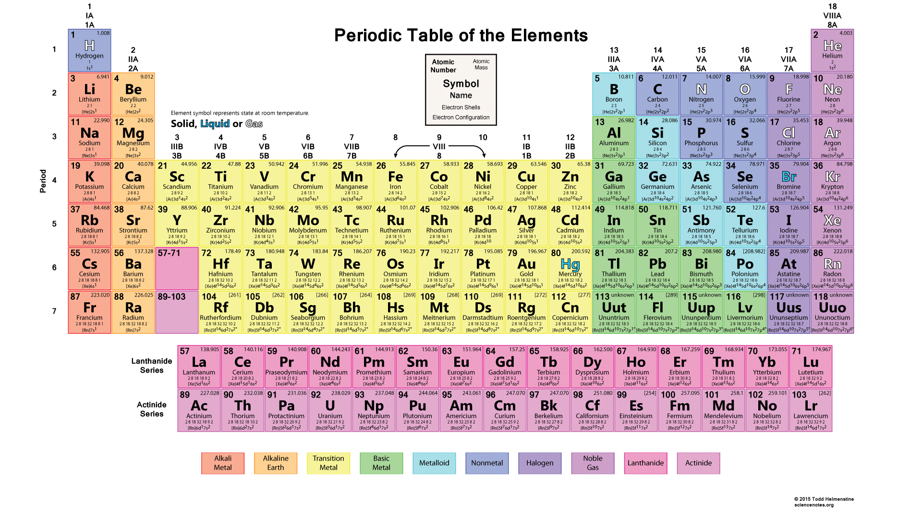
To create the elements he first had to create the sub-atomic particles that make up the elements and then create the elements themselves.
When one considers the question of our existence as a random “evolutionary” act with NO design guidance versus a process of “evolutionary creation” under the direction of a super-intelligent Creative being it is useful to consider the question of how something as orderly and systematic as the Periodic structure of elements, as graphically depicted above, could come into being through a random, unmanaged, stochastic process.
Note that once the sub-atomic elements were created the above progression was inevitable, so the real intelligence evidenced by the periodic table lies in the specification and creation of the sub-atomic elements. Either way, I submit for your consideration that it is impossible for the above order to come into existence without some super-intelligent design engineer to design and build this complexity.
  - The Universe
Once the full range of elemental building components had been created it was time to create a large body of material containing these elements and to cause that large body to explode and expand into the nothingness of space, basic laws of physics, mechanics, chemistry and, and, and having been first established.
And so we find that there was a “big bang” that set about the initial creation of the Universe in order to create a gravitational environment for more refined development. As the matter of the Universe expanded outwards from the origin numerous planets and suns were formed and Father intervened with these as He saw fit to craft environments suitable for further development. Thus it is entirely valid that there are numerous solar systems, suns and planets that are similar to our own, and others very different, that during the progression of experimentation have been used to progressively establish the optimum conditions for the optimum form of life to create the highly intelligent beings that Father wanted to be His friends.
However, where an experiment has failed to meet required design standards it has been terminated such that life has NOT continued. It is my clear understanding that right now Earth is the ONLY inhabited planet out there. No harm in looking but NOT going to find other life although other life is entirely plausible were it NOT for the controlled nature of the experiment.
  - Solar System
Within the Universe there are innumerable Solar Systems of which ours is but one of many and these have been developed experimentally to create varying conditions with a view to creating an environment suitable to establish a planet suitable for the highly intelligent creative beings that Father has been working towards for all these years.
  - Planet Earth
So that brings us to Planet Earth, a very specific, precision engineered micro-climate suitable for sustaining human beings as an intelligent life form. Again, many other planets with variable conditions created in the progressive evolutionary journey of arriving at THIS planet and THESE beings.
At each step of the way the Creative process has followed a mixture of pseudo-random creative events like the Big Bang coupled to surgically minute tuning of specific components of specific situations to create very specific conditions, in this case, conditions that would sustain human life as we know it.
In considering the geometry of this creation it is vital to understand that the conditions on earth that support life require extremely precise conditions in terms of levels of light, heat, gravitational force, etc and that these conditions will only remain in effect for relatively limited time spans at the end of which the experiment will terminate, either successfully with the required friends having come to Heaven or Heaven being unfilled.
As it happens, the experiment that we are part of HAS been successful insofar as Father has succeeded in creating a suitable Solar System with a suitable Planet with suitable beings, albeit that the beings are corrupt and highly defective in terms of Father’s design objectives. Thus there ARE, today, human beings who have successfully lived life on earth, established some level of relationship with the Creator and therefore qualified to spend eternity with Him in Heaven. A few of these are true friends, more are servants and a huge number are in the outer darkness mentioned above. However, over 100 billion humans have, at this stage, FAILED to qualify to enter Heaven and today they are roaming the Earth as Ancestor Spirit’s or demons tormenting and leading astray the living human beings pending the outcome of the Contest between Yah and Satan which will reach conclusion some time in 3003 according to the present calendar.
Given that NOT all of Heaven will be filled by the conclusion of the experiment on planet Earth, will Father create another planet and other beings? At this stage I understand Him to say that information is NOT for public distribution but that this current experiment has been so painful that He will think more than once before embarking on further creative experiments.
  - Plants of increasing complexity
Having created a planet with the exact environmental conditions that were required to support life, Father set about creating plants to beautify the planet, provide food, cleanse the air, etc. He started with single cell organisms and eventually worked up to the extremely delicate and complex plant forms that exist today. I include those forms of plant that grow under water in the form of seaweed, etc.
In considering plant life it is vital to understand that most of the more complex plant forms reproduce through sexual reproduction. In other words there are male and female reproductive organs and reproductive cells. Sometimes these both occur on the same plant and in other cases there is a distinct male plant and female plant.
Either way it is vital to understand that sexual reproduction is a complex mechanism that requires that all elements of the male and female plant organs be fully formed and function effectively so that the male and female reproductive cells (gametes) are able to merge to produce one whole new unit.
It is also vital to appreciate that in most cases there is the need for an external agency, be it wind, birds, insects, etc that is capable of transferring the male reproductive cell to the location of the female reproductive cell, frequently on another plant, sometimes a significant distance away. Again, this capability cannot come about as part of a progressive incremental uncontrolled “evolutionary” process it must ALL be in place at the beginning.
Note also that in many cases there is an intermediate life form between the reproductively mature adult and the outcome of the mating process – consider the chrysalis and caterpillar in the case of the butterfly and moth. Again, NOT possible for this to happen as a random stochastic event.
This again indicates the existence of a highly intelligent and creative agency with engineering skills to conceptualize the entire plant together with its reproductive organs and associated reproductive agency in order to ensure the ongoing existence of the species. Note also that from an “evolutionary” perspective there is NO reason to have sexual reproduction in plants. They could just as well reproduce vegetatively – again, evidence of a Creator.
  - Animals of increasing complexity
Concurrent with the plants, lagging somewhat since the animals needed something to eat, Father progressively and in an evolutionary, experimental way, created animals of increasing sophistication and complexity. As with the plants the diversity, interest, beauty and character of animals created is far greater than is required for any utilitarian model and speaks volumes of a highly intelligent Creative agency who progressively crafted more and more complex animals for no other reason than the joy of creating.
Again we find sexual reproduction, again the sexual reproduction cannot function except in its fully developed form. There is NO way that two animals can chose of their own volition to be of different sexes, develop reproductive organs and cells and reproduce in an evolutionary manner. Either there IS a male and a female and they can mate and reproduce in which case the species survives or the sexual organs do NOT work and the animal dies out immediately – in fact, it cannot exist at all.
Note that with animals there is greater complexity than with plants in that the sexual organs are more complex, many of the more advanced animals have organs that interlock as in penis and vagina and there are emotional and erotic responses at play. All of these have to work exactly before the species can reproduce, thus it is clear that they had to come into existence with fully developed sexual organs and reproductive tendencies such that males and females DESIRE to mate and carry out sometimes obscure and complex mating rituals BEFORE reproduction can occur.
Again, evidence of a genius Creator and proof that random stochastic evolution with NO Creative oversight did NOT occur.
Add to this the fact that in many mammals there exist completely superfluous organs such as the clitoris which exist purely for the purpose of sexual pleasure and one must conclude that this did NOT come into existence in some uncontrolled manner.
  - Spirit beings of increasing complexity
Concurrent with the above Father created spirit beings of increasing complexity. In fact, long before creating plants and animals Father created the beings that we today refer to as “messengers” {angels} as emotionless servants to help him with some of the heavy lifting and precision manipulation that was required during the creative process.
Up to this point, where designs did not turn out the way that was required it was easy to terminate them and either abandon them or cast them into the incinerator (lake of fire).
However, as discussed in the next chapter, things went horribly wrong. Lucifer (now Satan) one of the three leaders of the messengers {archangels} fell into pride and rebellion and challenged Father to a Contest to see if he (Satan) could lead human beings astray to such an extent that they would all forsake Father. Father accepted the challenge, which he now deeply regrets, and the result is the messed up state of the world today.
Father also put spirits into higher order animals and thus we have animals with character and personality. These spirits however simply cease to exist when the animal dies whereas human spirits live on forever unless destroyed in the incinerator.
  - Human kind
The culmination of all of this was human kind as we know ourselves today. The existence of these massively complex spirit beings with free will, intellect, creative ability, emotion, etc and complex and beautiful bodies is the culmination of Yah’s creative endeavours over millions of years and, at this stage, a source of huge disappointment and grief to Him.
He created us to have a deep personal relationship with Him and, today, hardly anyone truly believes He exists let alone has any sort of relationship with Him. Even those who are at some level convinced of his existence are almost all in deep error and sin and have only the most superficial relationship with Him.
It is a tragic situation, put yourself in His shoes, millions of years of painstaking creative effort to arrive at what exists today and they are almost all in rebellion and deny that He exists. What a tragedy!
I hope that after you have read this book you will have a better appreciation for the challenges of the Creator and the tragedy of the situation that exists today and, I hope, you will be challenged to seek a closer relationship with Him as top priority in your life going forward.

Chapter 2: Satan – an experiment gone horribly wrong – the Contest
  - Three most powerful messengers
In order to assist Him with the creative process and in the operation of all that He had created, Father created what we know as messengers {angels}.
The three most powerful of these, the chief messengers {archangels} at that time were:
Gavri’el (Gabriel) – meaning El (my beloved mighty one, the Almighty) is my strength
Mikha’el (Michael) – meaning who is as El (my beloved mighty one, the Almighty)?
Helel (Lucifer) – meaning light bearer who was the worship leader in Heaven
Various accounts report seven chief messengers but for the purpose of this article I will make reference only to the three above.
It is my understanding that each of the three messengers above were given command of one third of the total force of messengers.
These massively powerful spirit beings, with the ability to manifest with human like bodies were in charge of many operational aspects of Father’s Kingdom. The first two remain in this role, Helel has fallen as discussed shortly.
  - Messengers are guardians and servants
A key role of messengers {angels} in this age is as guardians of believers, record keepers and servants of believers. Every human being has a messenger assigned to them at the moment they are conceived and their spirit comes into existence. This messenger keeps a record of all that they do and say that is the evidence presented when they are judged.
More senior believers who operate with significant authority are assigned further messengers to protect them and to do their bidding but virtually no believers are aware of this and so those messengers generally follow them around with nothing much to do other than to protect the person that they are assigned to IF that person prays the necessary prayers and does not give the force of darkness legal right to harm them as a consequence of sin. See the article on Judgment in this Life at
http://end-time-issueministries.org/JudgmentTHISLife.aspx.html for a discussion of how this works.
  - Helel became proud rebelled cast out became Satan, the Accuser
As the creative process reached its culmination and the creation of human beings occurred, Helel (Lucifer) became proud and rebelled. His force of one third of all messengers followed him in his rebellion.
Helel, together with his followers were brought on trial, preparatory to them being cast into the incinerator, the Lake of Fire and Brimstone, when he challenged Yah, the Almighty Creator, saying something to the effect that “your whole Creation is a failure, give me seven thousand years on earth with these humans and I guarantee you that NOT ONE of them will believe you exist let alone have a deep personal relationship with you!”.
  - Satan cast out
Father was greatly angered and in a moment of hurt and frustration He accepted the challenge. A set of rules for this contest was agreed and Helel, Lucifer, now Satan, the Accuser, was cast down to Earth with his one third of the messengers.
  - The Rules of Engagement
The Rules of Engagement are discussed on the webpage of that name at http://end-time-issueministries.org/TheContest/RulesofEngagement.aspx.html
In particular, neither Yah nor Satan nor their followers and servants are permitted to do anything on earth or give any command unless it is given through a human being alive at the time. Neither of them can communicate nor teach anything unless a human being asks or creates an opening for them to intervene. The rules are fairly simple but strict and greatly limit what each can do. For this reason, Father Yah is intensely constrained in terms of what He can communicate to His servants EXCEPT if they ask. So, if you believe the Bible is the Word of God, Yah cannot tell you that you are mistaken and is forced to work with that lie. If, however, you ask Him whether the Bible is the Word of God, He can then answer your question.
This applies to every aspect of life and explains why most believers are so massively ignorant. They believe what they are taught and do NOT understand their responsibility to question, ask questions, evaluate and decide for themselves. The also do NOT understand their responsibility to rule and give direction to the Spirit realm, rather they wait for Yah to act and He is unable to act unless they act or speak first. For example, the world was submerged in the deluge or Flood because NOAH called the Flood into existence in consultation with Yah. Yah did NOT unilaterally bring the Flood into existence. The same with Moses parting the Red Sea and the same with the most trivial thing that you hope that Father will do in YOUR life.
  - Seven Thousand Years to total apostasy and defeat for Yah or defeat for Satan
The ultimate outcome of The Contest is determined very simply.
If, after 7,000 years from the Creation of Adam, there is NOT one human being on earth who is free of sin and in right relationship with Father Yah, in other words the entire human kind on earth at that time is in submission to Satan, then Satan is the victor and he will reign on earth with his followers, both messengers and humans, for ever.
IF, after the 7,000 years there IS a human being free of sin and in right relationship with Yah and able to hear Yah and aware of their authority and responsibilities such that they can call the end of the Contest and Yahooshua can return to rule on earth, then Satan will have been defeated and he and all his followers will be cast into the incinerator, the Lake of Fire and Brimstone and utterly consumed.
  - Satan in the Pit for a thousand years
Another term of the Rules of Engagement is that after 6,000 years a similar judgment would take place such that if there was a human being in right standing with Yah, hearing Yah and knowing their authority, they could bring Satan on trial in the Court of Heaven and secure a sentence for him in the Gaol or Pit, for a thousand years to pay the price for his sin. During this thousand years neither Yah nor Satan is permitted to intervene on earth directly and they would be required to act through their followers.
This happened on 5 May 2003 when Satan was cast into the Pit and the entire spiritual dispensation on earth changed accordingly.
If there had NOT been a man on earth free of sin and aligned with Father sufficiently to bring charges against Satan, Satan would have won the contest at that point and would have been spared the thousand years in Gaol.
  - Fundamentally The Contest is about relationship with Father
I have come to understand that fundamentally The Contest is about relationship with Father.
Father went to ALL of the effort to create the Universe, the Solar System, Planet Earth, plants, animals, messengers, humans with ONE goal, beings who would have a deep personal relationship with Him and who would share in discovering and learning about the world and Universe He had created.
If Satan can ensure that there is NOT a single human being with a deep personal relationship with Father at the end of the 7,000 years then Satan has achieved the ultimate victory!
Thus, it is NOT about your relationship with your Bible, your Church, your Pastor, your Home Cell Leader, your service to the Church, etc – it is ENTIRELY about whether you have a deep personal relationship with Father and that requires that you live a life without sin and in service to Father in a way that you make the sacrifices that are necessary to overcome sin in your life and do the work that Father requests you to do.
Right now there are almost NO human beings with DEEP PERSONAL RELATIONSHIPS with Father and even most of those with relatively significant relationships are in deep error and sin and therefore only in limited relationship with Him.
There was only ONE human being on Earth in a position to be able to bring Satan to trial in 2003. Right now, on a basis of simple statistics, there is a very SMALL probability of there being such a person in a position to act around May 3003.
In fact, if one is brutally frank about it, Yah has almost totally lost the battle. To date there have been over 100 billion human beings who have died without ever believing in the Creator and the vast majority of those who have at some level believed find themselves in the Outer Darkness in Heaven after a lengthy sentence in the Reformatory, Hell, where they were sent to pay the price for all their unconfessed and unrepented of sin.
The number of Overcomers, those who have overcome much of the sin and adversity on earth, is relatively small and the number of true FRIENDS of the Creator who currently sit on High Thrones alongside Him is very much smaller.
Fact is that right now Father is almost totally defeated!
So, that poses the question, “what are YOU going to do about this?” – if you do NOT believe, now is the time to deal with your unbelief and seek a relationship with Father.
If you DO believe, now is the time to stop playing games and seek a DEEP PERSONAL RELATIONSHIP, see the article on this at:
http://end-time-issueministries.org/Home/CreatorDesiresDeepRelationship.aspx.html
and the article on Seven Components in Drawing Close to Yah at:
http://end-time-issueministries.org/Home/7ComponentsinGrowingClosetoYah.aspx.html
  - This was NOT planned, it was entirely unexpected
In considering the points above it is vital to understand that NONE of this was expected.
Father was engaged in a journey of invention, creation, discovery. Something went wrong with Satan and that triggered a series of impacts that triggered the situation that exists today.
Yah did NOT expect Satan’s rebellion.
The Rules of Engagement were hastily drawn up and Yah sincerely did NOT expect there to be a major problem. What happened in the years that followed was totally unexpected and has been a time of grievous hurt and disappointment for Him.
He was looking forward to exploring all He had created in harmonious partnership with us, instead, the discovery that has taken place has in large measure taken place with and through human beings who have, at best, had very limited relationships with Him.
The brutal truth is that whereas Father had been working towards an era of glorious harmony with His Creation He ended up with a ghastly mess of rebellious and sinful beings who have totally defiled His image and His intention for us.
It is a grossly tragic situation.
I hope that after reading this chapter that you have a much more sober and real view of the world we live in, life on earth and YOUR LIFE and where YOU are heading.
I pray that after reading this you will choose to ACTIVELY seek a much deeper much more personal relationship with Father.

Chapter 3: Adam as Ruler – rebellion and falling away
  - Adam to Rule over Satan
Adam was placed on Earth to exercise Yah’s authority on earth as Yah’s agent or representative – as a ruler to exercise dominion, especially over Satan and his horde who had be cast down to Earth.
  - Adam gave authority to Satan
The minute that Adam disobeyed Yah and did what Satan proposed by eating the forbidden fruit, Adam became a servant of Satan and unable to have authority over Satan and his horde.
  - Satan became the Mighty One of this Earth
Thus Satan became the mighty one {god} of this world and has ruled on earth ever since over ALL children of Adam except those who gain mastery over sin and actively serve to seek the Almighty Creator – those who are known as “Overcomers”.
  - Victory over sin
The only way that a human being can escape the clutches of Satan is to eschew sin and defeat the forces of darkness in their life by achieving a deep personal relationship with the Almighty AND living a life above sin.
  - Only Yahooshua has fully succeeded
Only Yahooshua has FULLY succeeded in achieving this goal, he was born with no earthly father and therefore no blood-line curses and he lived and died without committing sin ONCE. As such his victory elevated him to the position of King of all Human Kings and Lord of ALL Human Lords.
  - Yahooshua delegated his authority
After his death, Yahooshua was instantly resurrected because death had NO hold on him and he was granted “all authority in Heaven and on Earth”. Since he was leaving the Earth he had NO authority on earth and so he immediately delegated this authority to those who followed him, that is, those who followed his example and sought to live a life without sin. Thus those who truly believe and are in right standing have delegated authority to deal with the forces of darkness.
In nearly all cases those who have at some level had a revelation of this authority have still been corrupt and in sin and error but, until recently Father granted grace (chen) with regard to this. This has resulted in a situation where believers think that the gifts and authority that they are exercising indicates that they are in right standing when, in fact, it does not. This chen {grace} has now been withdrawn for the reasons explained in the article on Withdrawal of Grace at:
https://www.linkedin.com/pulse/withdrawal-grace-prior-3-may-2003-amended-james
In order for Father to secure a judgment against Satan to send him to the Pit for 1,000 years it was necessary for ALL grace to be withdrawn. This has now resulted in a situation where mature believers are falling into greater and greater error, see the article “Why are so many mature, committed, sincere believers in such gross error?” at
https://www.linkedin.com/pulse/why-so-many-mature-committed-sincere-believers-gross-james
This descent into error over the past decade has led to increasing demonization of believers, see the article “Demonized Believers who Hate Truth” at:
https://www.linkedin.com/pulse/demonized-believers-who-hate-truth-james-r-end-time-issue-ministries
  - Very few understand this
Very few people understand this and those that DO attempt to walk in this authority are compromised by the level of sin and error in their lives.
I hope that as you read this you will be challenged to step up to the mark that Yahooshua set and seek to live a life above sin and, in so doing, draw very close to Father Yah AND come to a place where YOU can reign over evil on this Earth.

Chapter 4: The Flood – why it happened and how it happened
  - Degeneration to gross sin
Following Adam’s fall mankind progressively degenerated into sin and unbelief until 1,500 years after the creation of Adam only Noah and his eldest son Shem and their wives were in relationship with the Almighty Creator. Noah’s son Japheth and his wife were unbelievers and Noah’s youngest son Ham and his wife were active ancestor, that is demon, worshippers.
  - Yah and Noah agree to destruction by a flood
Yah consulted with Noah and together they agreed that the offenders should be destroyed by a global hydraulic and tectonic event, commonly referred to today as “The Flood”. Remember that in terms of the Rules of Engagement in the Contest between Yah and Satan, Yah could do NOTHING on earth without the agreement of a human being.
  - Yah deflects an ice comet
In response to Noah’s petition Yah had an Ice Comet (chunk of Ice) deflected from the Kuiper Belt and directed towards earth. He gave Noah the wisdom to build an extremely stable and extremely robust survival vessel made of wood.
  - Comet impacts and melts
The comet impacted the earth, shattered and melted thus covering the entire surface of the earth to a depth of at least one kilometre, there were NO major mountains in that time.
  - Impact knocks earth off orbit and off axis
The impact of the comet knocked the earth off its vertical axis and out ifs circular orbit around the sun and into an elliptical orbit. This change in inclination and change in orbit gave rise to massive forces in the crust of the earth leading to massive tectonic disruption in the form of fractures, volcanoes, upwelling of granite and lava, etc.
  - Massive Tsunami waves
Because the surface of the earth was submerged and the earth was rotating around its axis as well as orbiting the sun and because of the orbit of the moon massive tsunami type waves ripped around the planet in one continuous swathe. These waves cut down high ground and laid down the eroded material in vast horizontal beds which we today know as sedimentary rock. This intense erosive force cut the tops off volcanoes and granite domes as well as whatever high ground originally existed and that which was up-thrust during the event.
  - Core heated and expanded
The core of the earth contains a nuclear reactor which is why it is molten and why material from the core has a level of radioactivity. The core had progressively become hotter in the years following the creation of the earth resulting in a build-up of pressure in the core. This pressure was partially released through the cracks caused by the disruption of the surface in the form of volcanoes, lava flows and granite up-welling’s but then the pressure caused the core to expand with the surface of the earth separating into what we today know as the continental plates. It is estimated, based on how the continents fit together, that the earth expanded in diameter by around 25% from the point that the rupture of the surface took place and defined the shape of the continental plates.
  - Water drains off the continents
This expansion and associated cracking of the surface of the earth caused the water to drain off the continents with the resulting erosion giving rise to the broad landforms we have today which were further refined by the resulting “plates” colliding giving rise to the major mountain ranges such as the Andes, Rockies, Himalayas, etc.
  - Videos
See the videos and presentations on this topic at:
http://end-time-issueministries.org/Flood/FloodVideos.aspx.html
This event led to the development of completely new settlement of the earth by Noah and his sons. All human beings can be traced back to Noah through one of his sons and all animal forms can be traced back to the animals that survived on the survival vessel.

Chapter 5: Human spirits – ancestor spirits and the demonic Masterminds
  - Reward for those in deep relationship
Father Yah’s plan was that those humans who entered into close relationship with him would be reward on death with a high rank and a throne for eternity. Those who were rejected because they never believed in his existence would be cast into the incinerator, the Lake of Fire and Brimstone and utterly destroyed.
Satan’s challenge changed this so that the rejects remain on Earth till the end of The Contest and, if Satan wins The Contest, on Earth for eternity.
There are various ranks in Heaven:
- Friends – those who were friends to Yah in this life sit on the highest thrones close to Yahooshua.
- Overcomers -- also sit on thrones but NOT the highest thrones.
- Good and faithful servants -- NOT on thrones but towards the front of the throne room.
- Wise stewards -- further removed from the thrones – filled with the Spirit of Yah but only performed limited service to Father.
- Adulterous wives – those who were filled with the Spirit but in serious sin, especially many Jesus worshippers and Bible worshippers will end up here.
- Foolish virgins – those who believed but never received an infilling of the set-apart Spirit of Yah, mostly because they did NOT know it was possible or did NOT believe in it. Most traditional Christians and most Moslems and Jews will end up here. Note that it IS possible to get filled with the Spirit without knowing it is possible and that it IS possible for someone who is NOT filled with the Spirit to qualify for one of the higher ranks but it is more difficult to get there without the infilling of the Spirit.
Those sentenced to eternity in the Outer Darkness – “the Trasheap of Heaven” – those who believed but then continued to live as unbelievers and never served Father Yah at all. A very large number of those who are products of Christian “Outreach” and missionary activity will end up here
  - The first unbelievers
Within a few generations of Adam men and women were born who did not believe and who, when they died, became the first ancestor spirits or demons, taking orders from Satan.
  - Satan enrols deceased human spirits
Satan quickly realized that these highly intelligent and highly knowledgeable human spirits were a very powerful resource and so he set about working with them to determine how best to mobilize them in his hate campaign against Yah. This campaign being directed at ensuring there were NO believers in right standing with Yah by the end of the 6,000 years after creation and, failing that, by the end of the 7,000 years that will mark the end of The Contest in around May 3003.
  - First demons recognize power opportunity
These first ancestor spirits (demons) in turn recognized the opportunity presented by them being the first demons and set about applying their considerable knowledge and experience to understand how to gain power and authority by supporting Satan in his evil quest.
  - Demonic organization
They organized themselves as they had when alive, with governments, committees, etc, which bodies were reconstituted after the flood.
There are similar ranks in the demonic realm in the kingdom of Satan to those listed above in the kingdom of Yah:
- The Council of ruling Masterminds who reported directly to Satan until Satan was sent to the Pit for 1,000 years. This Council of Masterminds today rule the earth in Satan’s absence very powerfully and very effectively such that many of the activities that attract so much attention from conspiracy theorists, such as “The New World Order” are, in fact, being instigated and driven by the Council of Masterminds and NOT by living human beings, the living human beings are just pawns in this power play.
The incumbents have thousands of years of practice and guard their positions jealously and violently with huge numbers of committed supporters in a power--fear structure.
The Masterminds today include Baal, Molech, Malak, Ashteroth, Jesus, God, The LORD and Christ. Prayers to the last four names are NO LONGER answered by Yah as an act of Grace but are answered by the Principalities, Powers, Thrones and Dominions that muster in under each of the corresponding Masterminds.
- Illuminated one -- you were highly committed to Satan as a Satanist, Witch, Warlock, etc in this life, were filled with demons, perpetrated many human sacrifices and other extreme evil in order to win favour with Satan and the Masterminds -- you will be rewarded with a position of considerable evil power in support of the Masterminds.
- Foot soldier -- you were moderately successful in sinning, led many others into sin, had some sort of relationship with the demonic and Satanic realm, a position of some authority and esteem in the Satanic sense
- Pretender -- you were into sin, you denied the Creator but you really never did very much for Satan, largely disregarded in the Satanic realm, you will be used for low level assignments to low level people on earth -- remember that you will be one of over 100 billion ancestor spirits at the time you die
Kingdom of the white witches -- good "faeries" {demons} -- you lived a good life, you sort of thought there might be a God but never truly believed and never thought it important, you may have been well educated, done all sorts of good works, went to church regularly but never had a deep revelation of the existence of the Creator -- no major sin, no real use to the kingdom of Satan so they will largely leave you alone in some lonely location, such as graveyard to be a "good ghost" unless a white witch thinks she can use you in her witchcraft using the Satanic and Demonic realm to attempt to do good.
  - Most demons stranded in the flood
During the flood the vast majority of human spirits of unbelievers were left where their carriers died and mostly remain today embedded in rocks, at float in the sea, attached to marine life, etc.
  - Ruling Masterminds survive on Ham
The ruling Masterminds before the flood (Molech, etc) realized what was happening just before the flood and managed to attach themselves to Ham, Noah’s youngest son and an unbeliever. So they survived the flood such that the demonic realm got a jump start after the flood.
Yah DEEPLY REGRETS allowing Ham and Japheth and their wives to survive the Flood and today asks that we should NOT ask special favours of Him with regard to our unbelieving children and families.
Again, the key lesson is that Father desires a DEEP PERSONAL RELATIONSHIP WITH YOU and desires that you should strive to become His Friend and qualify for high honour when you cease to live on Earth.

Chapter 6: The recovery of Earth and ongoing degeneration of mankind
The Earth recovers from the flood but mankind continues to degenerate and decline, degenerative evolution occurs. Three families and historical developments leading to the world as it is today.
  - Surviving the flood was traumatic – a sodden muddy mess
Surviving the flood was traumatic, the boat was tossed in every direction and there were significant injuries.
After the earth expanded and the waters subsided to form the oceans the Earth was a sodden muddy mess of massively disrupted deposits with water everywhere, heavy cloud and much rain. It took centuries for a reasonably equitable environment to develop. Global drying and warming today is, in part, a manifestation of the ongoing draining of residual deposits of water from the flood from the land.
  - Much knowledge and experience – rapid technology advance
The survivors had brought with them a very substantial library of technical literature and much knowledge and experience. They were also of great stature (Noah was 18 feet (6 meters) tall) and of great intellect. We were literally created with massive intellect in the likeness of the Almighty. So in a short space of time advanced centres of civilisation stared to spring up.
  - Three families from Noah
The three sons of Noah brought with them three distinctly different spiritual and physical dispensations:
- The children of Shem clung closely to the religion of their fathers, Shem and Noah and became the people of the Middle East, Europe and India. They were highly inventive and adopted a culture of justice – right versus wrong.
- The children of Japheth were agnostic and idolatrous but NOT ancestor worshipers and were of lesser physical stature although highly intelligent. They were also inventive and highly disciplined and adopted a culture of honour versus shame.
The children of Ham sank into full blown ancestor (that is demon) worship and degenerated to become the people of Africa. They adopted a culture of power versus fear. Today there are people who are counter to this trend by virtue of cross fertilization by people of Shem and Japheth.
  - Global nuclear war – genetic aberrations
Some hundreds of years after the flood there was a global nuclear war and many civilizations were wiped out. The resultant nuclear contamination resulted in aberrant genetic malformation which gave rise to the cave dwelling semi-human remains that have been found in certain parts of the World. These are NOT a missing link in evolutionary development!
  - Degenerative evolution
As noted above, Noah and his family were of great stature, they were giants by today’s standards both physically and intellectually. As a consequence of the reduced gravitational forces consequent on the expansion of the Earth and as a consequence of general spiritual degradation mankind has devolved (degenerative evolution) from the great stature and intellect of Adam and even Noah to what we have today.
In the years immediately following the flood the high level of material ejected from the core of the Earth through volcanoes, lava flows and granite upwelling’s resulted in a level of limited mutation such that while there was only one species of cat on the survival vessel we now have a range of cats in different parts of the world. The same applies to other animals and to plants. There has been massive “evolutionary” development since the flood albeit in a degenerative sense.
  - Abraham a Turnaround Emissary and other Turnarounds
By the time of Abraham there were almost NO people truly serving Yah. Abraham initiated a turning around which propagated through Ishmael, Yaakov (Yisrael), Moshe and David through to Yahooshua and Mohammed each one of which initiated a Turnaround of different levels of intensity. Martin Luther also initiated a turnaround bringing an end to the Dark Ages and initiating a major global renaissance. It is vital to understand that the prosperity we enjoy today coupled with ever increasing levels of comfort and advanced technology is a direct consequence of large numbers of people turning back to Father Yah with invention and prosperity being a direct result of the blessings associated with serving Him.
  - Need for another Turning around today
Today, January 2016, there is a DEEP need for another emissary to once again initiate a major turning around. As things stand at present Yah is at great risk of losing The Contest to Satan so that Satan will rule on Earth for eternity.
There is also a great risk that the current prosperity will come to an end within a few generations as the leaders turn to full blown service to Satan and the residual effects of Yah’s standards of morals, etc are eliminated. Associated with this will be another swing to the horrors of the Dark Ages with the associated massive spiritual and associated economic decline that goes with it.
Another global nuclear war is definitely in prospect.
What will YOU do today to facilitate the turning around that is so desperately required?

Chapter 7: How the madness of Bible worship has corrupted understanding
This section discusses how the inappropriate stature accorded to the Bible has contributed to the high level of falling away that exists today. See the article “Demographics of the Kingdom of Yah elaboration” https://www.linkedin.com/pulse/demographics-kingdom-yah-elaboration-r-end-time-issue-ministries and companion articles for a discussion of the extent of the falling away.
  - The Bible hardly addresses any of this -- Miniscule fragments of Shemite history
In considering the previous chapters it is apparent that the Bible hardly addresses any of the most important elements of human history.
The Bible records minuscule fragments of human history assembled by people from the Shemite dispensation under extreme duress. As such it IS a useful but restricted resource.
And it WAS preserved with some level of supernatural intervention when Satan tried to destroy it as a limited remaining source of knowledge. That does NOT mean that it replaces the huge volume of direct revelation and teaching about the matters of the Almighty that Father Yah has given in recent centuries.
  - A useful history book – period -- part of a broad prayer led study protocol
The Bible should be read as a useful history book in conjunction with other historical accounts, NO MORE.
It is of greatest value when read together with deep fasting, prayer and questioning to understand why things happened and together with much wider reading. Prayer is needed regarding what is NOT discussed and to seek ALL truth. Prayers like “show me the level of my present deception and how to correct it” and other prayers in the article “Seeking truth” at https://www.linkedin.com/pulse/seeking-truth-james-r-end-time-issue-ministries and elsewhere in my writings, see also http://end-time-issueministries.org/Prayer.aspx.html
  - The Bible is NOT the “Word of God” -- NO supernatural attributes
Any belief that ascribes special significance to the Bible such as “the living Word of God and without error” is gross error, idolatry and breaks the Second Commandment “No Idols”.
Ascribing special “magical” or supernatural status to the Bible like standing on it or placing it on one’s head is irrational, foolish and results in any number of wrong beliefs not to mention witchcraft practices. The fact is that the modern English or other language Bible is comprised of human translations of a book compiled by other humans from fragments of material recorded and in many cases repeatedly copied by humans.
  - Yah is forced to show up when we exercise Faith for Him to be there
It is important to recognize with regard to supposed supernatural experiences with the Bible that there is a thing that Father refers to as “Force of Faith” whereby if one goes to the Bible with strong faith that one will find Yah there, He is forced to show up (His words) – see the article “Do YOU treat Father Yah like a Performing Seal?” at
https://www.linkedin.com/pulse/do-you-treat-father-yah-like-performing-seal-james
This phenomenon results in greatly mistaken beliefs about the nature of the Bible. Note also that our brains filter the spiritual impulses we receive from Father when He speaks to us so, if we believe the Bible IS the Word of God, we will hear “my word” when Father actually is trying to communicate to us about “The Bible”.
  - Wrong beliefs have turned many from faith in Yah
These wrong beliefs about the Bible have turned many people in this generation against Yah because of the foolish and absurd claims made about the book. These wrong beliefs have also led to a culture of Bible worship which has prevented huge numbers of people developing close relationships with Father as they have pursued Bible school, Bible study and other Bible based activities while ignoring the most important element, relationship with Father.
  - Much on the End Time Issue Ministries website
There is much information on the End Time Issue Ministries website, much of it written at times of intense separation and much fasting so I testify with some confidence that it is a valuable and useful resource recognizing that I am human and do make mistakes. Also that my understanding of these matters is constantly evolving and being refined.
Yah says that you should read the contents of this website rather than repeatedly reading the Bible see http://end-time-issueministries.org/ or alternatively http://eti-ministries.org/ (currently slower but with more effective search functionality).
  - Fundamentally the issue is RELATIONSHIP with Yah
AND you should be seeking a deep personal relationship with Father BEFORE you spend all your time reading and gaining head knowledge. The ETI website is geared to helping you draw close to Father quickly and to answering MANY questions you may have along the way but it cannot be comprehensive.
Father wants you to draw close to HIM and seek answers from HIM!
ANYTHING or ANYONE who gets in the way of you developing the closest possible relationship with your loving Father in Heaven should be LET GO! That includes association with ANY religious grouping, religious label or whatever. You should first and foremost be a “believer in the Almighty Creator Yah the eternally self-existing”, everything else is fluff and stuff by comparison!
I challenge you to choose this day WHO you will serve and then go ALL OUT to get as close to Father Yah as any person on earth EVER has!

Chapter 8 : Where we are today – the choices we each face
Consideration of the preceding chapters brings us to consideration of where we are today and the choices we each face with regard to the rest of our lives:
  - A watershed
We are at a watershed as extreme as that of Noah, Abraham, Moshe, Yahooshua, Mohammed, Martin Luther, perhaps more extreme – the number of believers is small and most of them are in gross error and deception, refer the article on “The Demographics of the Kingdom of Yah on Earth Today” at https://www.linkedin.com/pulse/demographics-kingdom-yah-earth-today-r-end-time-issue-ministries
  - Almost NO record and almost NO person listening
There is almost NO record of the core facts and principles and almost NO person able to hear and record this information.
  - Almost NO person who realizes the extent of the problem and the need for change
There is almost NO person who realizes the severity of the situation, let alone who realizes the need for change.
  - Almost NO person willing to make the sacrifices and do the hard work
There is almost NO person willing to make the sacrifices and do the HARD WORK to bring about the magnitude of change that is require to prepare the way for Yahooshua to return in victory.
  - Are YOU willing to come alongside me?
Are YOU willing to come alongside me and help to bring about this turning around in whatever way you can manage, be that a financial contribution (tithe or offering), be it working on the website to add new content as I create it or anything else that you can think of that you can do to help me with this burden?
  - Are YOU prepared to take the baton and run further?
Better still, are YOU prepared to take over the baton from me and run further?
  - Yah’s will for YOU today!
I tell you today, without fear of contradiction, that it is Yah’s will for you to come alongside me with a view to taking over and running further in the years ahead.
These is a GREAT work to be done and a GREAT reward to any person who will take up this challenge and successfully drive it through to the next level.
I challenge YOU to do this today!
THAT is Yah’s call for YOU today!

Conclusion -- Yah’s call to YOU today
Yah’s call to YOU today is to draw MUCH closer to Him.
Study the material that I have written, all the posts on LinkedIn at
https://uk.linkedin.com/in/james-r-end-time-issue-ministries-577494a2
All the posts on the ministry website at:
http://end-time-issueministries.org
or
http://eti-ministries.org
In particular study the article “The Creator Desires a Deep Personal Relationship with YOU” at:
http://end-time-issueministries.org/Home/CreatorDesiresDeepRelationship.aspx.html
which reinforces the message that Father desires a deep personal relationship with each one of us.
Once you have read that article and hopefully accepted the call then read the article “Seven Components in Drawing Close to the Creator” at:
http://end-time-issueministries.org/Home/7ComponentsinGrowingClosetoYah.aspx.html and put this into practice in your life.
and also the article ” Where will YOU Spend Eternity? -- What is required in order to qualify to sit on a High Throne for eternity?” at:
http://end-time-issueministries.org/Home/WhereSpendEternity.aspx.html
Whether you communicate anything to me or NOT, whether you choose to align with me or NOT I implore you to choose to align yourself with Yah and do EVERYTHING you possibly can to get close to Him, closer than I am and push ahead further than I have – He IS worthy, He has gone to such great lengths to create us and create the wonders of creation for our enjoyment and for our fellowship and He is SO lonely and SO tired of being treated like a performing seal. Please choose to love Him today and seek to serve Him faithfully for the rest of your days.
23 January 2016

Section 8:
The Global Flood
that Changed the World
How the Geology and Topography of our Planet were formed

Foreword
This book is the culmination of a number of years of observation and research coupled to formal training in Geography, Geology, Science, Mathematics and, most importantly, Engineering.
The book seeks to make visible key aspects of the topography and geology of our planet that are obvious and in plain sight once one is sensitised to them.
These observations evidence that the entire planet was submerged under water at some time in the past and that associated with this the surface of the earth was radically transformed and subject to massive tectonic (ground movement) events.
All of this took place around 4,500 years ago such that there are very few archaeological finds that are older than this and the entire surface of the Earth dates back to this event. Theories of much older dates for the formation of the surface of the Earth are shown to be flawed and false.
It is evidenced that a family of eight people survived the flood in a purpose build ship that enabled them to ride out the storms and other events associated with this flood.
It is asserted that since only one family survived and had sufficient foreknowledge of the coming event to build the ship in question this evidences the involvement of an external power who is asserted to be the Almighty Creator of the Heavens and the Earth, Yah the eternally self-existing. It is further asserted that this being warned the head of the family in question, a man named Noah or Nuh so that he had time to build the vessel and gather together a representative sample of animals and birds in the vessel at the time the flood commenced.
It is asserted that the flood was the consequence of an impact with an Ice Comet that tilted the Earth on its axis and disturbed its circular orbit around the Sun.
Evidence in support of this theory is drawn from the metamorphosed sedimentary deposits that are mined by South African Gold Mines, the presence of sedimentary rocks covering most of the planet, the presence of Granite Domes such as the Halfway House Granite Dome, the existence of the African Erosion Surface, the presence of incised river valleys and other features associated with dramatic water erosion around the planet and the presence of upthrust mountain ranges evidencing high speed movement of continental plates that then collided with one another.
It is suggested that all of this evidence points to a sound basis to conclude that the Almighty Creator exists and to choose to serve Him. Some important basic principles relating to the Almighty and service of him, including some suggested prayers are presented in the last chapter of the book.
It is hoped that any person who thinks critically will study the material in this book and come to a deep understanding of the reality of the Flood and then to a deep understanding of the reality of the Creator such that they will come to serve the Almighty as a matter of considered choice.
James Robertson
24 March 2016

Chapter 1: Introduction
I have always been interested in Geology and Geology was a favourite subject at University as I studied to become a Civil Engineer. I went on to practice as a Consulting Geotechnical Engineer for a number of years which gave me exposure to diverse geology, primarily in South and Central Africa. I was also interested in Geography and studied Geography at school as one of my top subjects.
In these years I did NOT give much thought to how the geology and topography that I was working with came about. The generally accepted wisdom was that the surface of the Earth developed over millions or billions of years and I saw no reason to question that.
Then, in about 2000 I came across the work of Johnathan Gray and over the next few years studied a number of his videos and books until in around 2005 I encountered his trilogy of books relating to the Flood reported in the historical writings known as Genesis in the book commonly referred to as “The Bible”. These three books “The Killing of Paradise Planet”, “Surprise Witness” and “The Corpse Came Back”, all of which are nowadays available on Amazon, collectively painted a VERY different picture of the origin of the Geology and Topography that we are all familiar with.
As I was reading these books I was travelling about 100 kilometres round trip from my then home in Johannesburg, South Africa, North to Pretoria. As a consequence I was driving from the Southern rim of the Halfway House Granite Dome, over the Dome itself and then over the Southern reaches of the Magaliesberg Mountain Range. Thus, as I progressively read these three books I was constantly exposed to Geology and Topography which I knew very well from my course at University and from living in the area all my life. Everything that I saw correlated exactly with what Jonathan was saying and so, progressively I came to rethink my view of how this had all been formed.
In saying this it is important to note that in all my formal study there was very little formal comment on EXACTLY how the Geology and Topography was formed other than general references to millions or billions of years, an inland sea, and similar vague statements. Frankly, we were much more concerned with what existed and how we worked with it as an Engineering material than we were concerned about the specifics of how the Geology and Topography were formed.
I should also note that by the time that I read these three books I had been down a very dramatic road of discovery with regard to the reality of the existence of the Creator of the Heavens and the Earth such that I knew with deep certainty that He DOES exist. Given that I held the Bible to be an important historical source, albeit NOT what many believers claim for it, I was open to the possibility that the account of a global flood in Genesis WAS at least approximately valid. That said, having believed for a number of years that the Bible was “The Word of God and without error”, I had come to understand that the Bible is ONLY a book containing a compilation of writings by diverse people most of which accounts are reasonably accurate as historical accounts go, but it DOES contain errors. I had also come to understand that this was NOT an issue since the Almighty is interested in us having a personal relationship with Him NOT having deep faith in a book, no matter what the book might be.
So, applying all my Engineering training (I have a PhD – Doctorate) in Civil Engineering specializing in “Cement Stabilized Soils as a Material for Dam Construction” I set about verifying Jonathan Gray’s hypothesis of how the current surface of the Earth was formed. As I read the books and observed the Geology and Topography first hand on my regular trips to Pretoria I had a progression of “Aha” moments where I constantly saw the validity of what Jonathan was saying.
Finally, having digested his writings and my observations I concluded that all parts of the surface of the Earth that I had ever observed had been laid down under water AND subject to massive upheaval.
My training as an Engineer in Mechanics clearly evidenced to me that the massive upheaval of the Earth’s Crust that I was now sensitised to required a massively dramatic external force to bring about the vertical and horizontal movements that were everywhere in evidence.
My training in Construction Materials and specifically my experience creating what was effectively artificial rock by the application of pressure and addition of Cement which formed the basis of my PhD research clearly evidenced that the rocks I was observing had ALL been subject to massive external pressure in order to take the forms that are everywhere in evidence.
Sometime later, I happened to subscribe to a news feed on my computer from NASA, the National Aeronautical and Space Agency of the United States of America, and that fed me daily satellite images from outer space which evidenced the hugely unstable environment in which our planet exists and also provided graphic details of massive ice objects in orbit around our Sun in the Kuiper Belt as well as an example of an Ice Comet. It became apparent that Jonathan’s hypothesis of an Ice Comet striking the Earth or a near miss by an Ice Comet was entirely plausible.
I was convinced!
In the years that followed I became aware that my training as an Engineer and experience as a Geotechnical Engineer afforded me the opportunity to argue the case for the hypothesis postulated by Jonathan Gray from a very robust perspective, MORE robust than the arguments which he as an archaeologist had been able to advance.
With this in mind I set myself the task of putting together a set of videos presenting my findings. This I did and the videos were completed on DVD and uploaded to You Tube in the first quarter of 2010. The videos are on You Tube at
http://www.YouTube.com/user/ProofOfGlobalFlood,
the PowerPoint slides are on SlideShare at
http://www.slideshare.net/End_Time_Issue_Ministries
and the Videos and Slideshare are available on the End Time Issue Ministries websites at
http://eti-ministries.org/Flood/FloodVideos.aspx
or alternatively at
http://end-time-issueministries.org/Flood/FloodVideos.aspx.html
In subsequent years I have come to understand some issues more clearly, I have also come to understand the consequences of the Global Flood event much more clearly. In engaging with people who dispute this hypothesis I have found that very few people have the time or the interest to watch eleven videos amounting to over three hours of viewing time or even to watch the summary at https://www.youtube.com/watch?v=61QPvCF0mp0. Accordingly I concluded that there was a need for a reasonably concise eBook that lifts out all the key points of the argument but that people could easily flip through and skim in order to get the gist of the proposition. This document sets out to meet that need.

Chapter 2: Context
In presenting this hypothesis of the formation of the Crust of the Earth into its present Geology and Topography I want to start out by offering some contextual comments. In order to keep this document to a manageable size I have limited the number of images that I have incorporated. The full presentations and videos are available as indicated. The video for this section can be viewed at https://www.youtube.com/watch?v=MtAUTP3ppZY
https://www.youtube.com/watch?v=tPsKPI4CQKg and
https://www.youtube.com/watch?v=IyENJnfk4E8
The presentation for this component can be viewed at:
http://www.slideshare.net/End_Time_Issue_Ministries/01-proof-of-global-flood-introduction-turning-history-on-its-head:
  - Acknowledgement – Jonathan Gray
The information and thinking that triggered the understanding of the formation of the Earth’s crust discussed in this presentation came to me from material published by Jonathan Gray www.beforeus.com and www.archaeologyanswers.com
You can contact Jonathan at:
Email : info@archaeologyanswers.com
Post : Surprising Discoveries, PO Box 785, Thames, 3540, New Zealand
This material forms the foundation on which my current understanding has been built
This information has been supplemented from my own knowledge and experience and diverse other sources
  - Design against failure
In my business career I have invested considerable time in learning how to achieve high value outcomes for business information system projects and, in doing this I have sought to apply what I term “Engineering Principles” to what I do. I have also sought to apply these principles in my learning about the matters of the Almighty Creator and all associated activities of which my research into the formation of the Earth’s present crust is an important element.
One of these principles I enunciate as “Engineers do NOT design bridges to stand up, they design bridges NOT to fall down”. This is a very important distinction. In order to ensure that a bridge will NOT fall down it is necessary to understand EVERY possible mechanism whereby the bridge MIGHT fall down and then eliminate ALL of those mechanisms from the design.
The same principle applies to one’s theory of the formation of the Crust of the Earth, one must ensure that one has considered EVERY possible factor that could cause one’s theory to fail, ensure that it does NOT fail on each and every point and THEN one will have a reliable hypothesis.
I have had to conclude over the last eight years or so that most people do NOT understand this principle and neither do they apply it to their religious life OR to their study of Geology and Topography. The currently prevailing theories about how the present Crust of the Earth was formed fail this test dismally – both from the professional geological camp AND the religious camp.
I have it that what is presented in the abovementioned videos and in this eBook DO comply with that requirement. In other words, I am confident that I have thoroughly considered every possible factor that might cause this hypothesis to fail and I am fully satisfied that these issues have been considered and dealt with such that I have a high level of certainty that the essence of what is presented here IS valid and reliable.
  - Credentials
In presenting this document I do so with Credentials that include the following:
- High School – including Geography, Biology, Science and Mathematics, last three with distinction. I have a solid grounding in the Geography of the World and also Topography. Training in Mathematics as a formal subject proves intense training in logic and problem solving.
- University – Bachelor of Science Honours in Engineering – Mathematics, Science, Mechanics, Geology, Materials Science, etc. I have a solid grounding in Geology and also in analytical methods. Note that this is first and foremost a Science qualification.
- University – PhD (Doctorate) – Cement Stabilized Soil as a material for the Construction of Large Dams. Solid understanding of what is required to manufacture artificial rock and also the properties of artificial rock-like materials.
- Other self-study in the field of Ceramics, etc.
- Registered Professional Engineer for over 25 years – evidence that I achieved the necessary standard of excellence to practice as an Engineer.
- Operated as a Consulting Geotechnical Engineer working on Mines throughout South and Central Africa. A basis for me to have practical hands-on exposure to the Geology of that region and the ability to interpret the Geology of other parts of the world.
Thus, when I offer my comments on the hypothesis that I am presenting in this document I do so off a strong grounding in Science and Scientific technique coupled to knowledge and experience in key fields of Science and associated disciplines that are necessary for me to have an authoritative opinion on the matters that I write about here.
  - Mathematics and Law -- Reductio ad absurdum -- Reduce to the absurd
Reductio ad absurdum is a well-established reasoning technique in Mathematics and Law in terms of which one assumes that a thesis is valid and then systematically analyses the situation based on this assumption. If the thesis stands up to this examination it is validated and if it fails, it fails. This technique is taught at school and university and is widely recognized and respected and well reported on the Internet, see for example in Wikipedia at
https://en.wikipedia.org/wiki/Reductio_ad_absurdum.
I have applied reductio ad absurdum repeatedly in considering the material presented in this document and I am confident that my argument stands up to rigorous scrutiny.
  - Most parameters in the natural physical world have non-linear characteristics
One of the false assumptions that traditional Geology and Land Form thinking makes is that it is possible to extrapolate linearly millions of years into the past. This is fundamentally false because the characteristics of most physical properties are non-linear. Consider the following graphs from my PhD research:
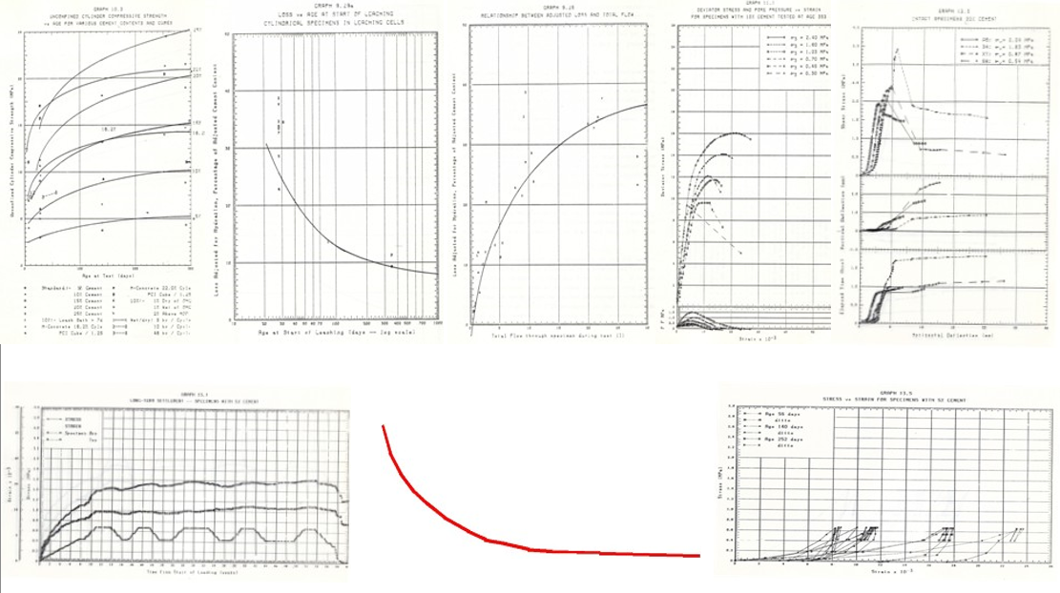
Notice that ALL the characteristics are non-linear and many are exponential.
The radioactive decay of radioactive elements is also exponential, which is why there is reference to a half-life. Extrapolating backwards up an exponential curve, the red line in the image above, is manifestly unwise, I could use much stronger language to describe it. This is the basis on which radioactive dating is done. The best that can be said for any date arrived at by looking at the tail end of the decay curve is that it is unwise and one could be much more outspoken than that.
  - Extrapolation should be avoided – fundamental Engineering principle
One of the fundamental principles of Engineering is that one should NEVER extrapolate to any significant extent when considering test results. If one is forced to extrapolate for any reason then the extrapolation should be to a limited extent and should be checked and double checked by physical world testing. The reason for this is abundantly clear in the images above. Again this is a well-established principle, Google “Extrapolation should be avoided” in order to search the EXACT statement to see the number of times this exact text occurs, 2,930 times on the day I wrote this.
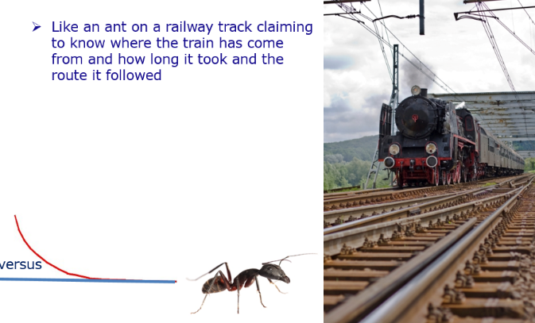
The way in which radio-carbon dating and other techniques are used to extrapolate thousands, millions and even billions of years is manifestly foolish when viewed in the light of this principle.
All the techniques that are used to estimate the age of artefacts fail this test. Dating something as “millions of years old” is tantamount to an ant on a railway track claiming to be able to predict how long the train travelled to get there just by looking at the oncoming train.
  - Engineering provides the knowledge and experience grounding to interpret these matters
Various people have challenged me on the basis of “what does an Engineer know about these matters” -- the answer to that it that because Engineers are trained to design and build things that succeed and NOT fail Engineering training is uniquely WELL suited to analyse the sort of material being discussed here. In fact, I would go so far as to suggest that Engineering training is highly desirable to understanding this situation. This is about the Engineering challenge of assembling the geology and topography that is all around us.
  - Fundamental law of mechanics – Force = Mass x Acceleration
Force = mass multiplied by acceleration – fundamental law of Physics and Mechanics.
- Any change in state, any movement relative to an apparently static position requires an external force;
- Disruption of the surface of the earth requires an EXTERNAL force, it cannot happen within a state of equilibrium on the planet;
- All evidence of dramatic change is also evidence of dramatic external forces being applied;
- Evidence of major vertical up or down thrust of the surface of the earth is evidence of massive forces being applied;
- The nature of the displacements that are visible in the surface of the Earth are such that the force was almost certainly external.
The entire surface of the Earth evidences massive displacements and shifts of one kind or another. All of this evidences a massive external force or forces. It is NOT possible to explain the surface of the Earth on the basis of a steady state condition over any period of time, be it thousands or billions of years.
  - We live in an unstable Universe – millions of years of steady state is absurd
One of the lessons that I learned through my subscription to the NASA feed was that images of the Universe showed massive instability. Solar systems are being formed and collapsing, suns are being formed and dying out, there is MASSIVE instability -- see images in the slide show slides 28 to 33. Once one becomes aware of this it then becomes MUCH easier to understand that an assumption of steady state conditions on Earth for millions or billions of years is utterly absurd. This assumption is fundamental to ALL dating methods used to predict the age of things on Earth and they are therefore ALL flawed.
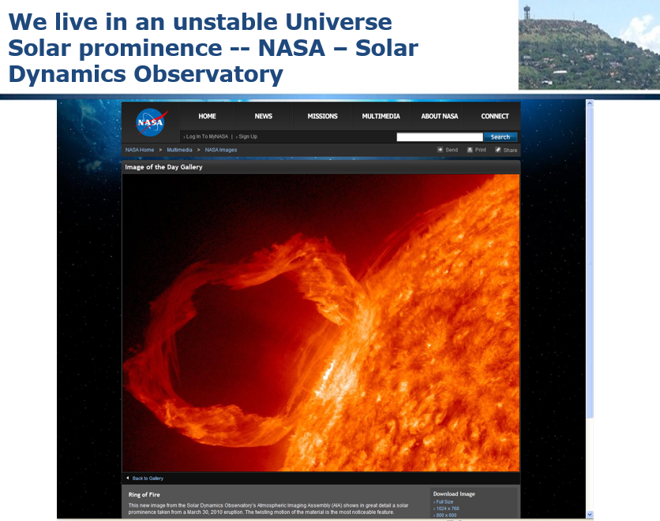
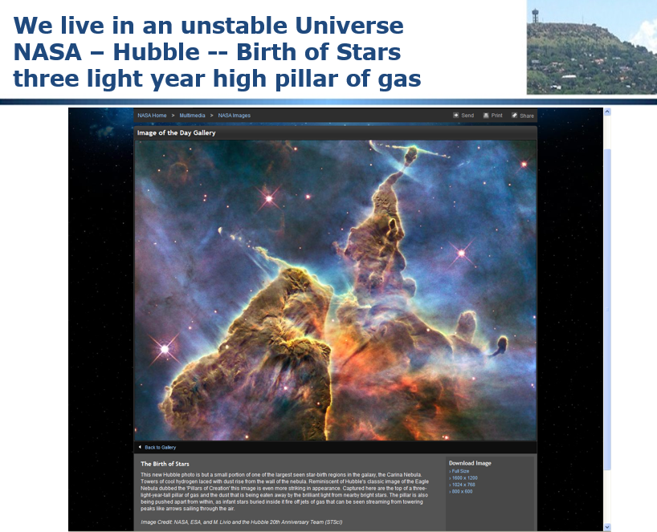
  - The Kuiper Belt – masses of chunks of ice flying around our Solar System
NASA have published images of the Kuiper Belt, a belt of ice objects orbiting the sun at the extremities of our Solar System. It would not require much of an impact for one of these objects to be deflected from its orbit around the Sun and head off in any direction. It is therefore entirely plausible for one of these items to be deflected so that it strikes the Earth. There would need to be either some fairly fine navigation or an extremely adverse probability but, either way, it is entirely plausible that one of these chunks of ice could have been deflected and struck the Earth at some time in the history of the plant. Such an impact could have huge ramifications as will be discussed later.
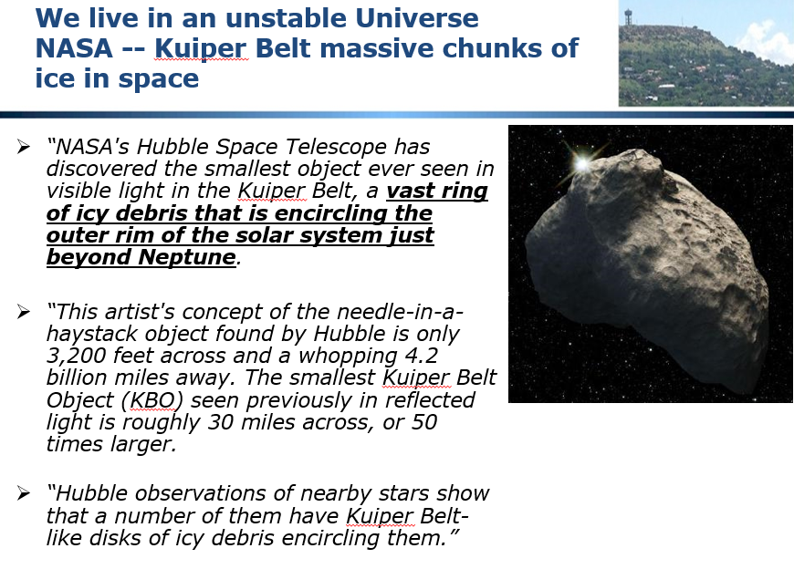
  - NASA -- Mars -- Hellas Planitia -- 1,400 mile (2,250 km) diameter crater evidence of large (ice?) space object impacts
NASA also displayed an image of a huge crater on Mars known as Hellas Planitia, 2,250 kilometres in diameter, see image below.
What is striking about this crater is that it is relatively shallow and has a flat bottom. This is clearly NOT created by a chunk of rock or similar, if it were the shape of the bottom would be different and there would either be a chunk of rock embedded in the bottom of the crater or there would be masses of fragments scattered around.
There are NOT.
The ONLY plausible explanation for the formation of this crater is a huge chunk of ice which shattered on impact and melted as a consequence of the heat generated by the impact.
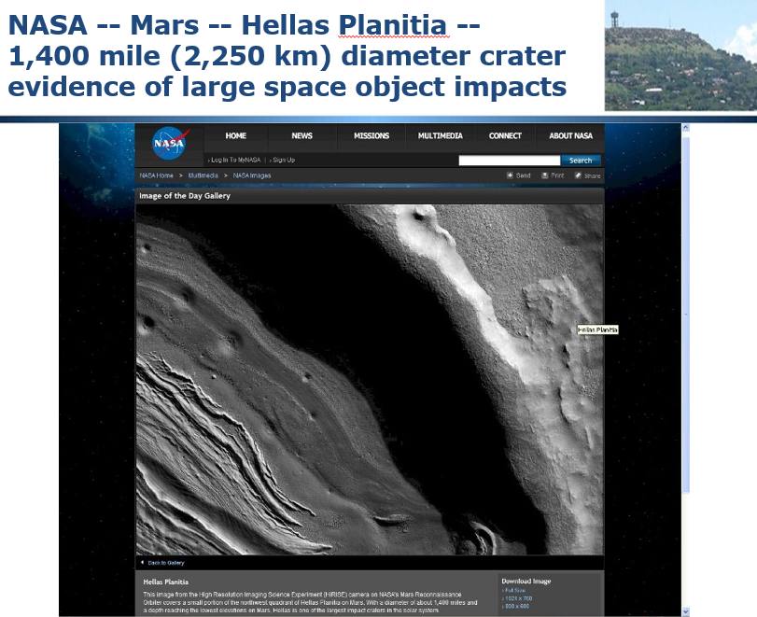
  - Hellas Planitia superimposed on Planet Earth
The image below shows Hellas Planitia super-imposed on the toe of Africa on a map of the world. I suggest for your consideration that a chunk of ice this big hitting the Earth at full velocity would do MASSIVE damage and quite easily knock the Earth off its axis and change its orbit as well as disrupting the surface of the Earth. It turns out that if the Earth were hit by an ice object the size of Hellas Planitia the surface of the Earth would be flooded to a depth of 11.75 kilometres.
What if an ice object 2,250 km diameter hit the Earth and then melted?
- 4,47 thousand million cubic meters of water;
- Earth’s diameter = 12,700 km;
- Would cover earth’s surface to depth of 11,75 km;
- So a global flood could be caused by something much smaller!
- 2 km of water requires an object 1,250 km in diameter;
It is therefore entirely plausible for an ice object to strike the Earth and totally flood it.
  - The surface of the Earth is fractured and has over 500 active volcanoes
The surface of the earth is divided into “plates”, fracture zones. It is postulated that these fractures resulted from the impact of the ice object referred to above. Along these fractures there are currently over 500 active volcanoes. It is postulated that, during the Flood, there were as many as 20,000 volcanoes. Note that because the core of the Earth is radioactive (it is kept molten by a fusion reaction), the material blasted into the atmosphere by Volcanoes is radioactive at some level. Yet another reason why radio-carbon dating is flawed and a factor that made possible mutation of the animals, plants and fish that survived the event.
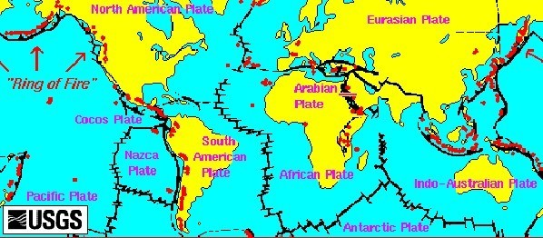
  - Northcliff, Johannesburg, South Africa – my reference point
During the time that I was studying this material I was living a few miles from the small mountain of Northcliff which provided a very useful frame of reference for this study:
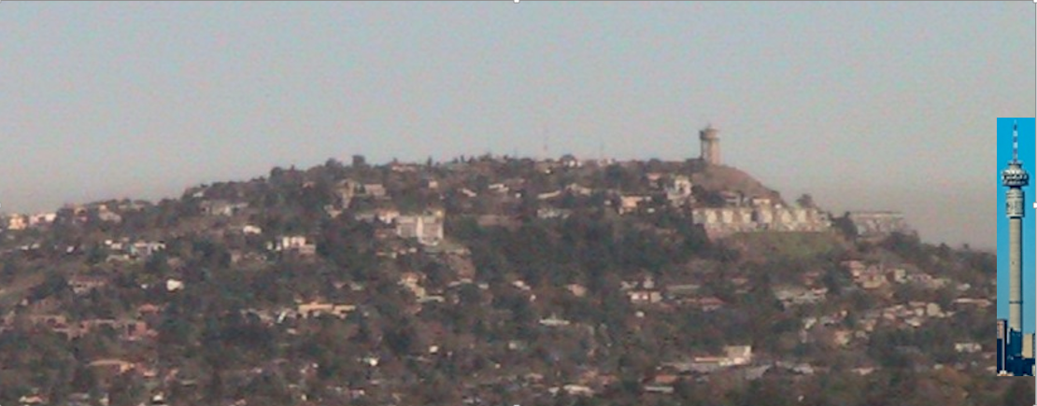
- Major landmark from East, North and West of Johannesburg, South Africa;
- Extension of the Gold Bearing metamorphic sedimentary rocks that form the gold reef;
- Within a few kilometres of where I lived at the time this research was undertaken;
- The pivot point for this article – sums up the argument in one picture;
- Vitrified quartzite rocks (sand melted as in a furnace);
- Thirty degree south dipping slope continues the mine formations;
- The geologic formation resumes 50 km north in the Magaliesberg dipping in the opposite direction – the middle is cut out;
- Underlain and up-thrust by the Halfway House Granite Dome;
- 1,807 m highpoint level with highpoints for hundreds of kilometres around, NO points higher in the vicinity – the African Erosion Surface.
Conclusion -- Context
To wrap up this chapter -- what follows is highly controversial -- it turns widely held theories on their head and requires a major rethink if you accept what is presented.
I ask you NOT to take snap decisions for or against, weigh up the evidence and make a considered decision. Look around as you travel and see whether what is proposed here explains the topography and geology elsewhere in the world.
I am confident that the interpretation postulated here is valid, valuable and an accurate interpretation of key elements of terrain formation and, by extension, history.

Chapter 3: South African Gold Mines Prove a Massive Hydraulic and Tectonic Event
This chapter explains how the geology and topography of the Witwatersrand Gold Fields of South Africa evidence that there has been a global flood.
Video https://www.youtube.com/watch?v=brc4VLnp0Rs
Slides http://www.slideshare.net/End_Time_Issue_Ministries/02-gold-mines-prove-a-global-flood
The image below is taken from a stope in a Gold Mine in South Africa which could be as deep as over 4 kilometres below the surface. The yellow line indicates the dip of the ore body.
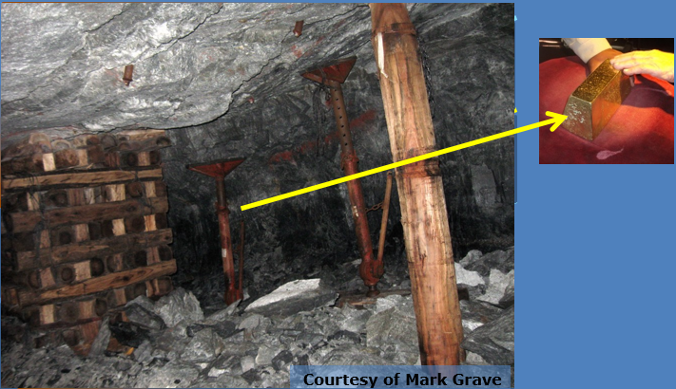
The rock mass is derived from sedimentary (water laid) deposits that were originally horizontal and on the surface.
The sand / soil raw material has been compressed by further layers being deposited on top of it to form rock. The originally horizontal layers have been tilted to an angle of approximately thirty degrees and then subject to intense heat which has caused what should be sandstone rock to metamorphose into quartzite, a ceramic form of sandstone. Deposits like this occur on the surface, with Northcliff, cited above being an example and they extend to depths of over 4 kilometres.
The important conclusions from this reality are that the only way material to this depth and this uniformity could have been deposited was by massive uniform water cutting action that flowed in one direction only. In other words, tidal tsunami’s ripping round the planet on a planet covered in water as indicated by the calculation in the previous section of the depth of water that would cover the planet if an Ice Comet the size of Hellas Planitia were to strike the Earth and melt.
Note that it is mechanically IMPOSSIBLE for these layers to be formed in a sea with tides oscillating in opposite directions or with material being transported by a river, no matter how big. The layers are of uniform thickness and composition for hundreds of miles, that requires a completely consistent very high velocity flow of water constantly flowing over the area of deposition AND it requires an equally large source of material that is progressively raised up as it is cut down.
  - Quartzite Rock
The image below shows Quartzite rock on top of Northcliff hill where the glassy ceramic nature of the rock is more evident. It is vital to understand that this huge mass of material was first deposited under water, compressed and subject to intense heat to achieve what you see here.
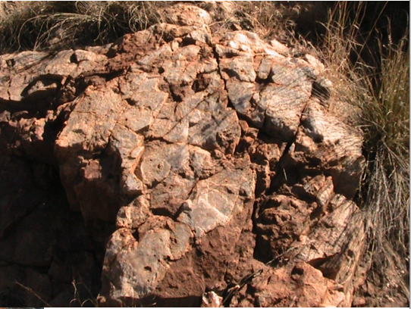
  - Contorted Geology
The Geological map below shows the extremely complex nature of the Geology in the area where the Gold Reserves are found. This is evidence of massive tectonic action on a scale that is very hard to visualize and which can, I submit, ONLY be explained by a global hydraulic and tectonic event.
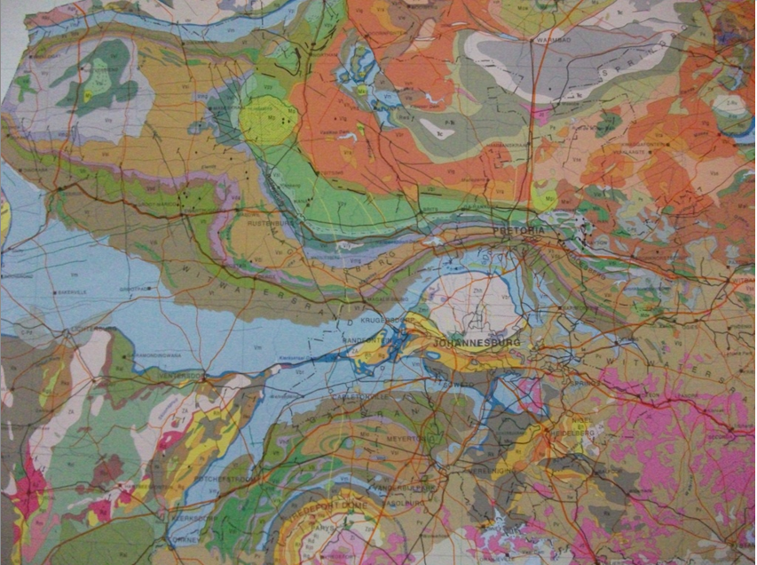
  - Cross Section showing Faulting and further erosion and deposition
The image below shows a cross section through a portion of the Gold Deposits. Notice the bedding of the rock that was originally horizontal but is now tilted to about 30 degrees.
Notice the faulting, the semi-vertical shear lines cutting at roughly right angles to the bedding. Notice that ALL of this is tilted. Then notice that the top of the formation has been cut off horizontally and that further material has been deposited on top of the cut off formation.
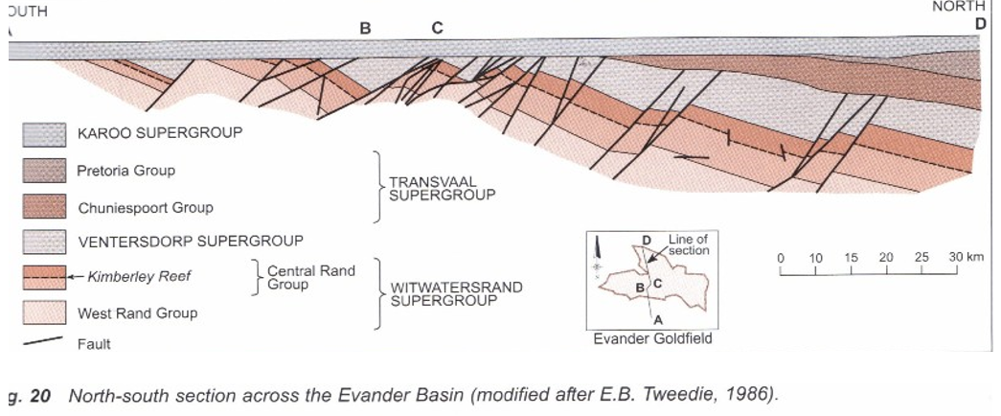
Please recognize the scale of this, look at the scale on the right of the diagram, the full width of the diagram is about 150 kilometres.
This could ONLY happen with massive depths of water, with flows in ONE direction and with massive crustal movement and crustal trauma indicative of massive external forces. So we have two distinct mechanisms operating here:
- Massive water forces in a uniform global flood.
- Massive crustal displacements in response to the impact of the Ice Comet disrupting the surface of the planet.
  - Schematic of how the horizontal material was tilted
As previously mentioned the up-thrusting of the originally horizontal material was a consequence of the intrusion of the molten mass of Granite rock that became the Halfway House Granite Dome.
The schematic below shows how the intrusion of the dome up-thrust the water-laid sediments and baked them turning the weak sandstone rock into extremely hard quartzite.
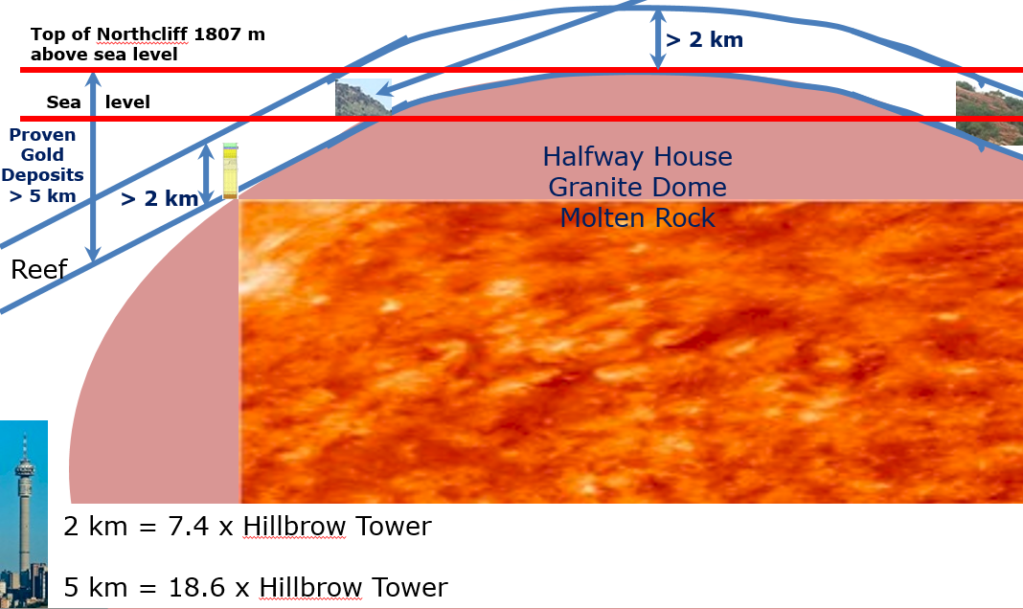
The Hillbrow Tower is referenced as an indication of the scale of this, it is 269 metres tall.
Conclusion – South African Gold Mines Evidence a Global Flood
It is important to note that mines all over the world provide similar corroborating evidence of a Global Flood in various ways.
It is important to note the huge depth and extent of the deposits, the fact that they were originally deposited horizontally but are now sloping steeply. Note the massive faulting.
The scale of the deposits can ONLY can only result from deposition in water over a large area then subject to intense pressure and temperature.
All of this begs the questions:
- Where did the material come from?
- How did it this all happen?

Chapter 4: Layered Sedimentary Rock Covers MOST of the Planet and Proves a Global Flood
Most of the planet is covered with sedimentary rocks and most of the sedimentary rocks evidence much wider extent and large portions of the same deposit which have disappeared.
Video https://www.youtube.com/watch?v=gt8J38vtzHA
Slides http://www.slideshare.net/End_Time_Issue_Ministries/03-layered-sedimentary-rock-all-over-the-earth-proves-a-global-flood
  - Table Mountain in Cape Town
Consider Table Mountain in Cape Town.
The mountain is made up of horizontal layers but the ends of the layers have disappeared.
  - Sedimentary Rocks ALL Over South Africa
Looking further afield, we discover sedimentary rocks all over South Africa.
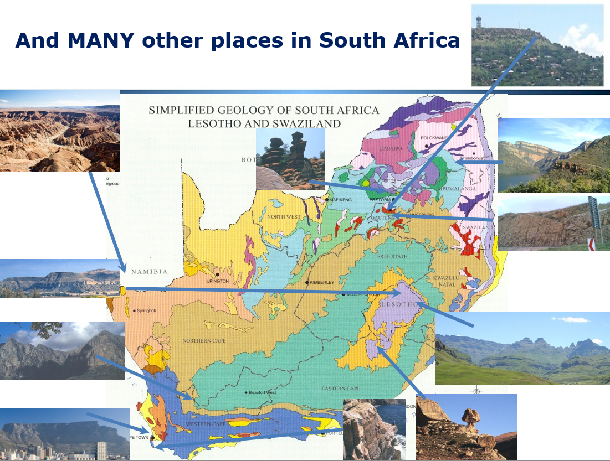
  - Sedimentary Rocks All Over the World
And looking further we find them all over the world. Consider the Grand Canyon.
Sedimentary deposits containing oil in the Gulf of Mexico are 10 kilometres below the surface, that is 10,000 metres of sedimentary material.
New world encyclopaedia says that the Earth’s crust is comprised “primarily of sedimentary rocks”.
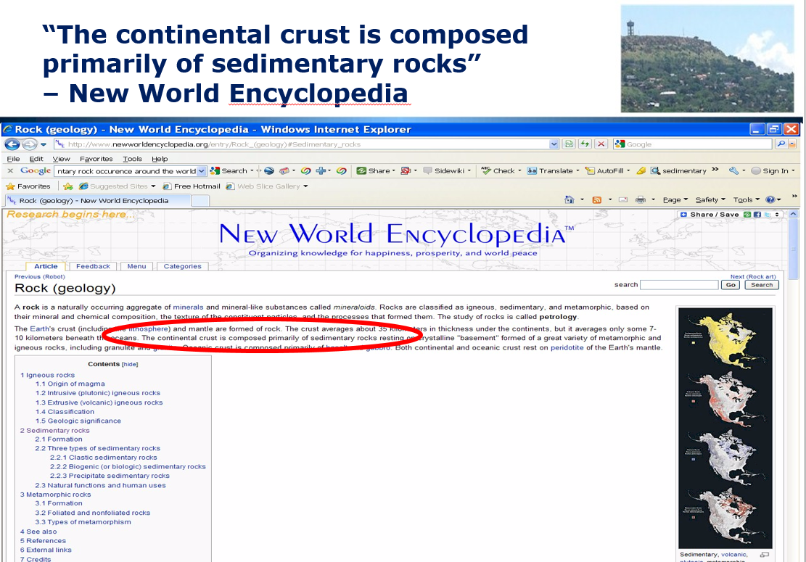
And Wikipedia says that Sedimentary Rocks form a “thin veneer” over the Earth.
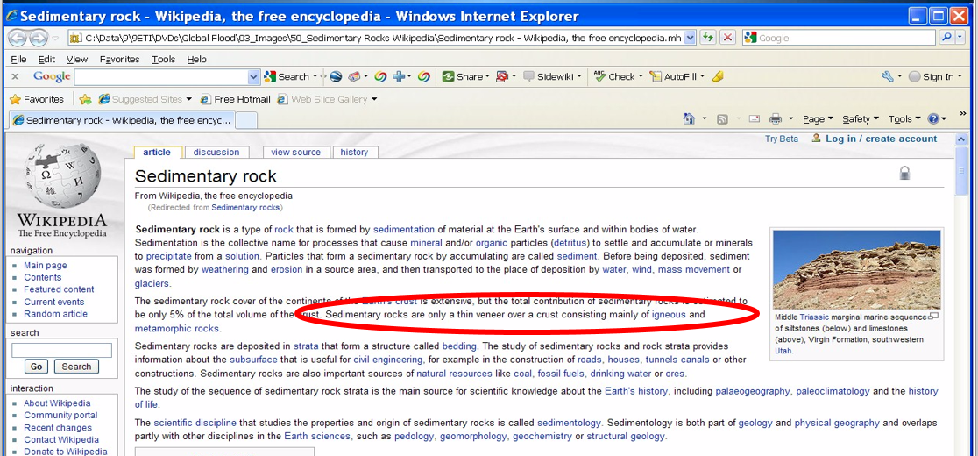
Conclusion
No matter how you look at it, the Earth has either at different times been covered by a large number of very large, very deep seas or at one time the ENTIRE planet was covered with water.
I suggest for your consideration that ONLY one interpretation is valid. The entire planet was covered with water to considerable depth with massive tidal tsunami waves ripping round the planet cutting down high ground and depositing material with constant surface disruption by the up-thrusting of volcanoes, granite domes, lava flows, etc. In other words, utter chaos!

Chapter 5: The Halfway House Granite Dome Proves a Massive Tectonic Event
We have already seen reference to the Halfway House Granite Dome in previous sections. This chapter explores the lessons we can learn from more detailed consideration of the Dome.
Video https://www.youtube.com/watch?v=qSwcvIegI1I
Slides http://www.slideshare.net/End_Time_Issue_Ministries/04-the-halfway-house-granite-dome-in-south-africa-as-evidence-of-a-global-flood
  - The Earth has a molten rock core
The first thing to understand with regard to the Dome is that the Earth has a molten core:
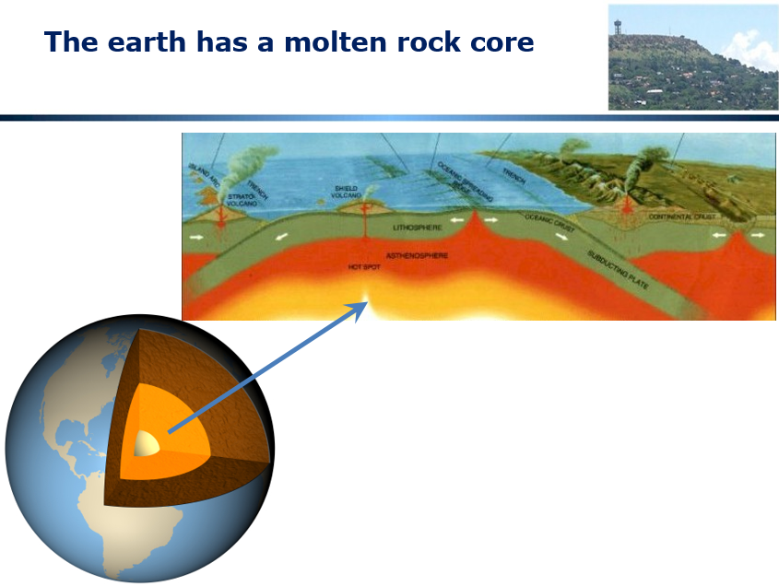
In considering this it is important to ask how the core REMAINS molten, for millions of years or longer or for a shorter period if what I am postulating here is valid. Either way, the core remains molten today as evidenced by volcanic eruptions that occur on a regular basis.
There is only ONE possible way for the core to remain molten, that is for some mechanism to exist to keep heating it, otherwise by now it would almost certainly have frozen. There is only one way that I know of for this to happen and that is by an ongoing nuclear fusion reaction and we will see a bit later in this chapter that the Granite rock contained radioactive isotopes at the time that it solidified thereby evidencing that the core IS radioactive.
Taking account of this, it is possible to postulate that there is either progressive cooling of the core or progressive warming depending on whether the core is cooling down or getting hotter. Whether this is a driver of so-called “global warming” is material for another discussion.
  - Granite domes are everywhere and can be very large
It is important to be aware that Granite domes occur all over the surface of the earth and can be of considerable size. Here are a few examples:
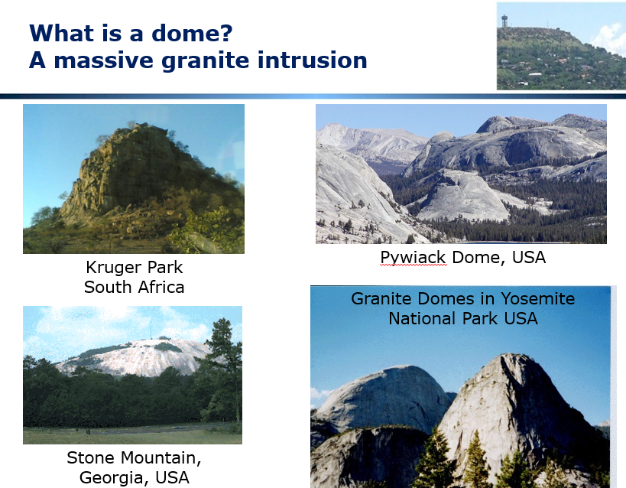
Notice that these domes project above the surface of the Earth and recognize that the rounded shape indicates that these domes were contained by surrounding material when they were formed. That material has, in the above cases, been subsequently eroded away leaving the very hard Granite to stand out.
Our discussion of the Halfway House Granite Dome informs the discussion of how the Domes pictured above came to be formed.
  - The surface expression of the Dome on a Geological Map
The image below illustrates the surface expression of the Halfway House Granite Dome on a Geological map of South Africa:
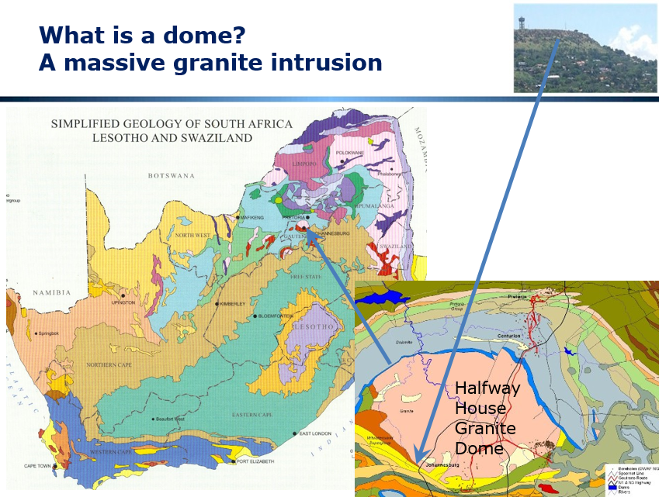
Notice that the dome is represented by the pink coloured area which is roughly circular with the Northcliff Ridge on the Southern side. Notice again how complex the geology is and how fragmented it is, all pointing to massive disruption and massive forces coupled to massive erosion and deposition.
  - Geological Section through the Halfway House Granite Dome
Following is a Geological Section through the Halfway House Granite Dome together with an overlay to better illustrate what happened.
The first image is a detailed section of the Dome as it is today:
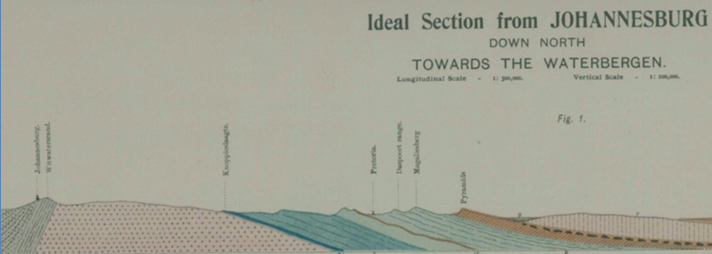
The second image shows the molten Granite being upthrust and the doming up of the originally horizontal layers:
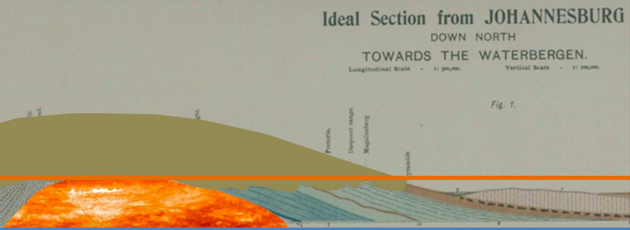
It is clear from consideration of this image that the sedimentary rocks were flexible at the time they were upthrust because they have conformed to the shape of the dome.
  - The crust was thin at the time
Consideration of the number of Domes around the Earth and the number of volcanoes indicates that the Earth’s crust was relatively thin at the time of this event so there was molten rock in vast quantities readily available just under the surface of the Earth. These upwellings also indicate massive pressures and massive instability.
Consider the image below of a “crust” formed by freezing water to form a thin outer crust:
  - The Granite contained radio-active isotopes at the time it was formed
Dr Robert Gentry has identified that Granite formations around the earth contain the signature of radioactive isotopes with very short lives. This evidences that the Granite came from a radioactive source, that is that the core of the Earth IS a nuclear reactor. He also evidences that the Granite cooled very rapidly which is consistent with it being upthrust into ice cold sedimentary deposits and ice cold water.
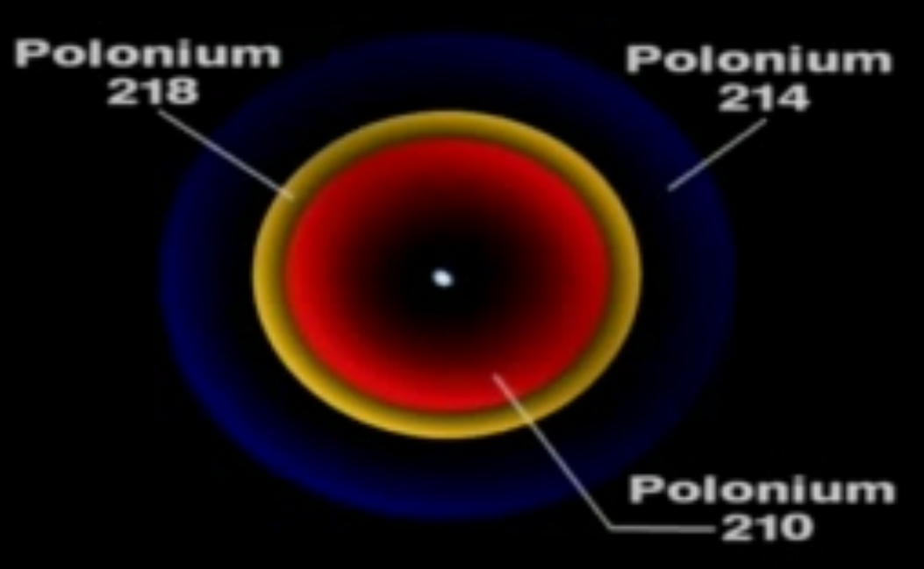
  - The sedimentary rock was NOT solid at the time the Dome intruded
We have seen that the Quartzite rock that overlays the dome is vitreous, that is glass-like, extremely hard and, by extension, extremely brittle. The image below, taken at the instant that a ceramic floor tile of similar strength to the Quartzite rock shatters under bending forces, evidences that the dome could NOT have intruded into Quartzite rock, rather the Dome FORMED the Quartzite rock through the intense heat that came from the molten rock as it forced its way upward into the sodden and soft sedimentary materials.
If the rock were already vitrified and sufficiently thick when it was subject to upthrust it would NOT fracture at all.
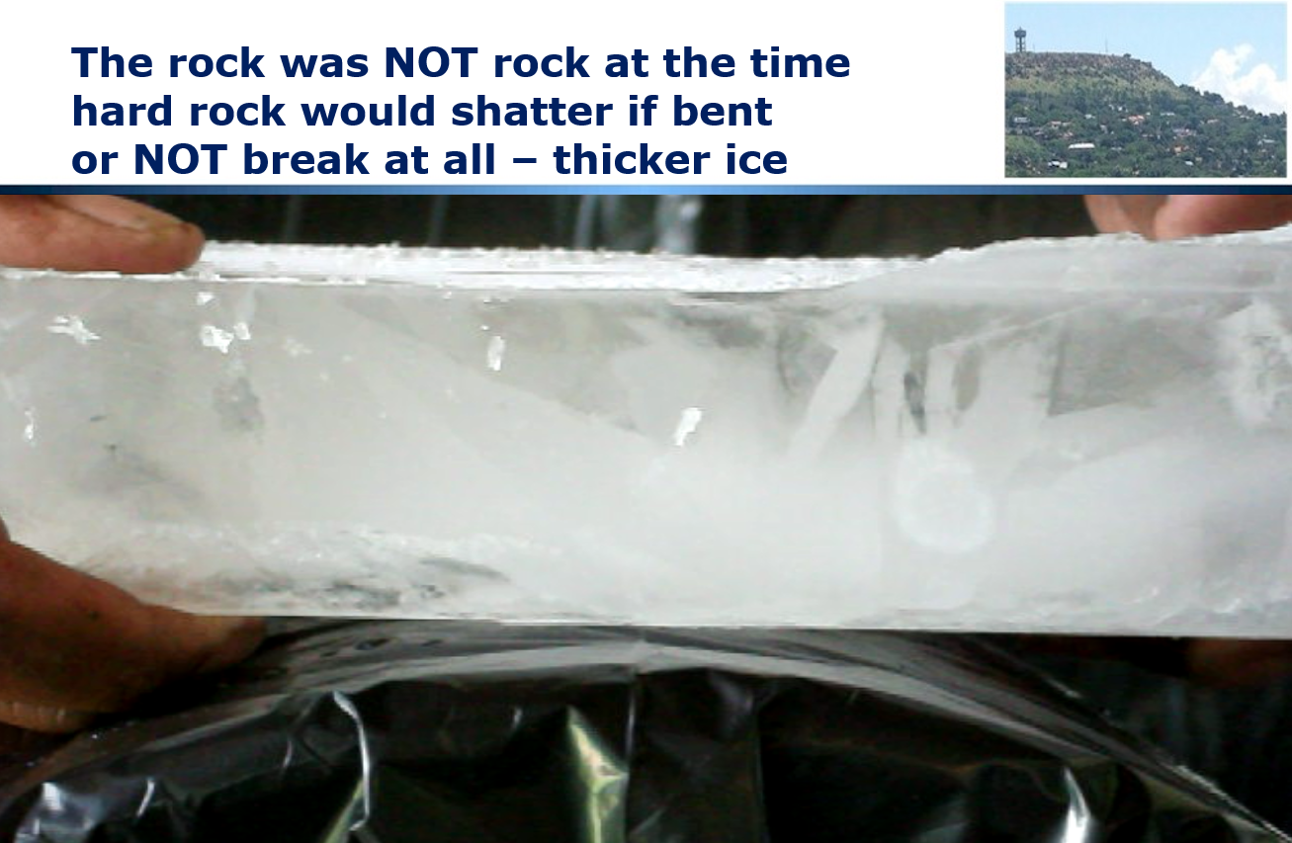
If the rock had contained cracks at the time it was upthrust then the cracks would have opened up and material would have deposited in the cracks making mining extremely difficult. This has NOT happened.
In order to give rise to the rock forms that actually exist it was necessary for the sedimentary rocks to still be soft and malleable as with the example of window putty below:
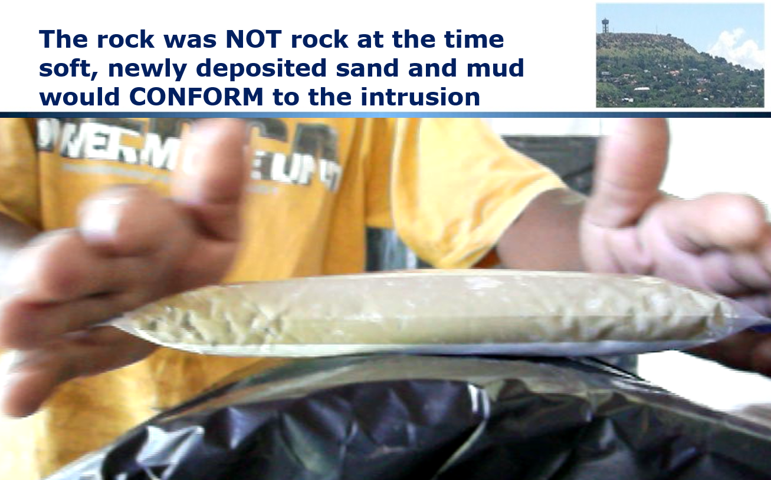
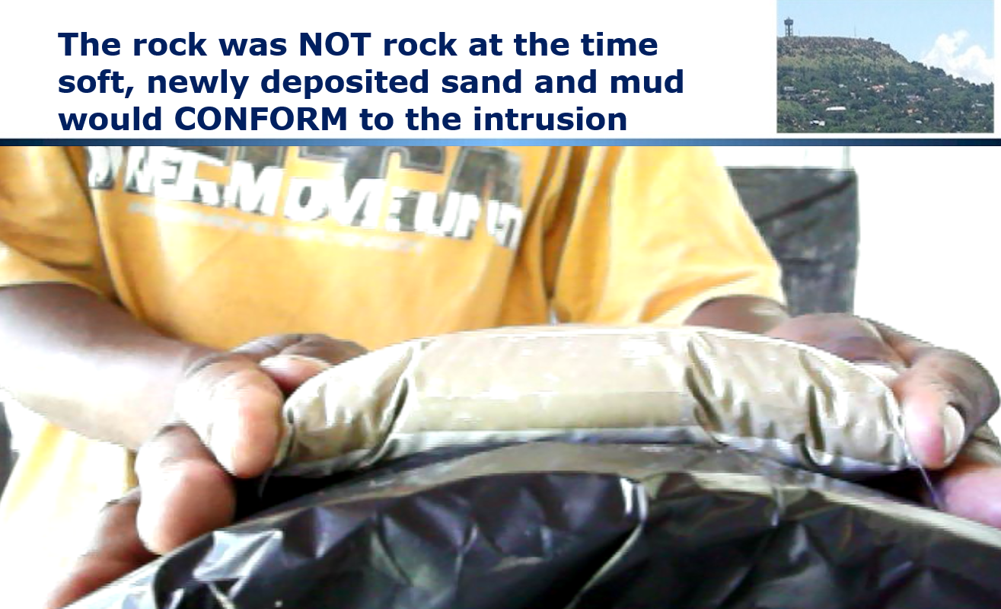
  - The Granite was subject to further disruption
Examination of the detailed Geological Map of the Halfway House Granite Dome as well as physical on-the-ground inspection indicates that there was further massive disruption including faulting of the dome and intrusion of dykes of other igneous (volcanic) rock after the Dome was formed:
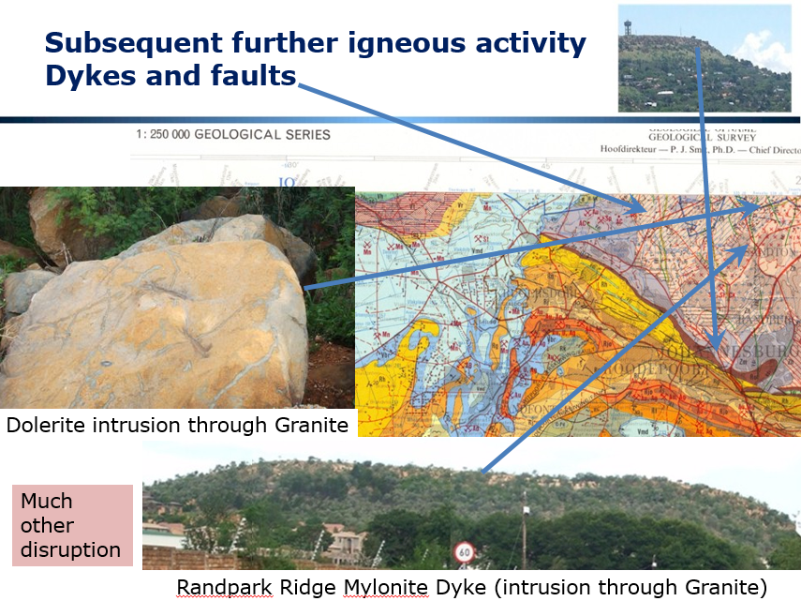
Conclusion
The scale is substantial -- about 50 km diameter at the surface. The vertical displacement of the top of the Dome is at LEAST 7,000 meters (26 Hillbrow Towers). The sedimentary deposits were converted to extremely hard vitreous (ceramic) quartzite. This had to happen quickly before the granite solidified that is “froze”. The disruption of the surface of the earth is staggering.
There is ONLY one possible explanation, a massive tectonic event accompanied by massive water action. This required an external stimulus to initiate the reactions that took place and this can only have happened with an Ice Comet impact or something very similar.

Chapter 6: The African Erosion Surface, The Planar Surface that Proves a Global Flood
The next clue in this investigation is the existence of the African Erosion Surface, a consistent plane of high points across much of the African Continent. This section will describe that surface and discuss how its existence evidences a global flood.
Video https://www.youtube.com/watch?v=t7J14L_n_EQ
Slides http://www.slideshare.net/End_Time_Issue_Ministries/05-the-african-erosion-surface-as-proof-of-a-global-flood
  - The Panorama North from Northcliff – the top has been chopped off the Dome and it is level
Looking North from Northcliff one notices an interesting phenomenon, there are NO points higher than Northcliff and MANY points the same height, in fact, the horizon appears to be level:
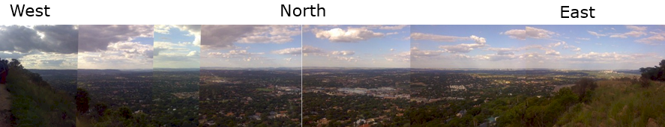
If we look to the South we see the same phenomenon and, in fact, if we travel anywhere in the vicinity for hundreds of kilometres we see the same thing. The high points for a considerable distance around Northcliff are all very close to one another.
Consider the 360 degree view from the Control Tower and Grand Central Airport, right in the centre of the Halfway House Granite Dome:
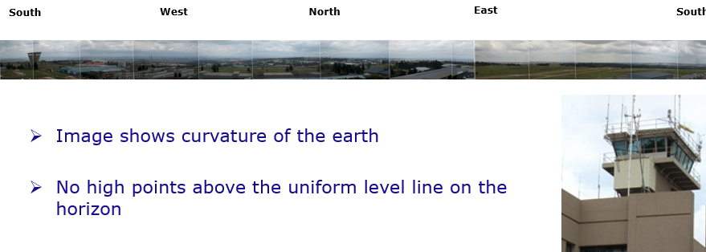
Note that because of its 360 degree view and the fact that the series of images that make up the montage were taken with a hand-held camera at different points around the Control Tower, there is a slight curve in the photo spread above but, in practice the horizontal plane is consistently visible when one is on the ground.
The map below shows how this panorama covers the entire Halfway House Granite Dome – note that the village of Halfway House is in the Centre of the Municipal Area known as Midrand (middle of the Witwatersrand):
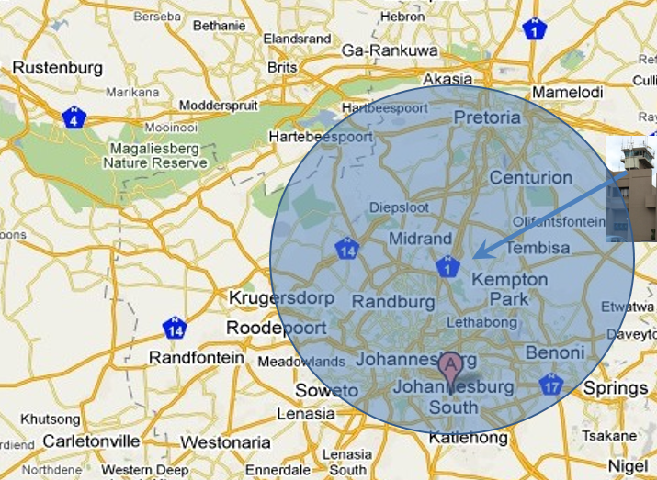
  - The African Erosion Surface is a Widely Documented Phenomenon
This flat plane is known as the African Erosion Surface and it covers most of Africa and is widely documented. Searching on Google for the exact text string “African Erosion Surface” returns over 6,380 EXACT matches, an indication of how widely the term is recognized:
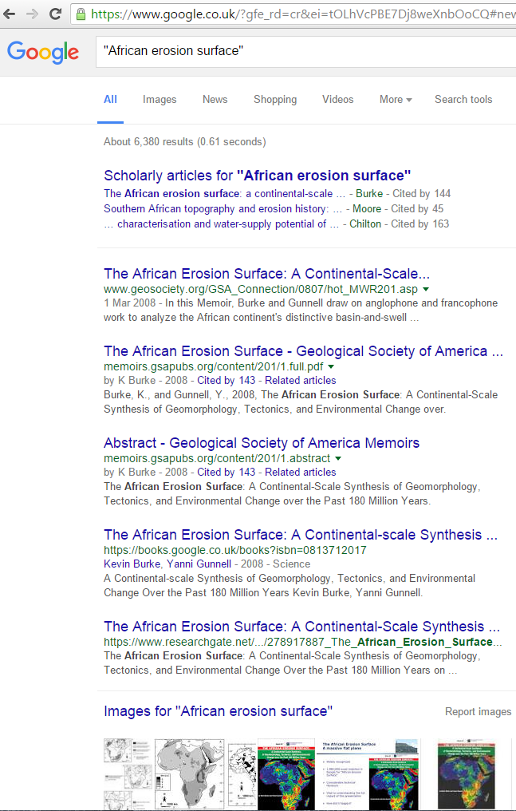
The map below shows how widespread this phenomenon of a level plane covering high points across Africa is, the orange brown shading is the African Erosion Surface.
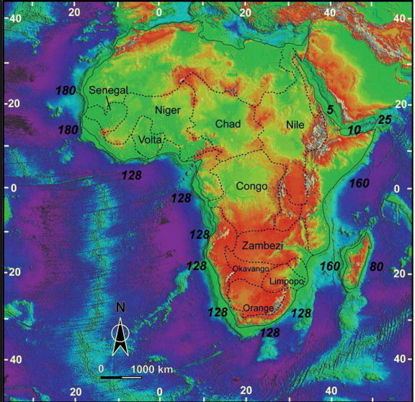
  - Spot heights confirm the phenomenon
A detailed study of spot heights of high points over the area visible from Northcliff confirms the extent of the phenomenon, high points within metres of each other over considerable distances.
  - The Engineering Difficulty of Replicating this Phenomenon
We live in a world of manmade artefacts that are level and plumb such that we do not think much about it, but, IF you have ever tried to build a wall level and plumb, ice a cake level, hang a door or build furniture or undertaken any other creative endeavour that requires things to be level and plumb, either for aesthetic reasons or for mechanical reasons you will know that the first time you tried to do this it was REALLY challenging!
In fact, those who consistently produce level and plumb buildings, roads, structures, etc use special tools and special techniques and required training and practice before they can get this right consistently.
If one were to set a task for an Engineering construction company to build an amphitheatre the size of the Halfway House Granite Dome and ensure that the hills around the entire amphitheatre were at the same height, it would require significant management and measurement to get this right.
  - The African Erosion Surface is Parallel to Sea Level but the sea is NOT visible
Note also that the African Erosion Surface is parallel to Sea Level but it is 1,800 metres ABOVE Sea Level and the area were are discussion around Northcliff is around 400 kilometres from the nearest coastline, yet the surface is exactly parallel to the sea surface. This is a major accomplishment.
  - Special Machines are Required
As stated above, it requires special machines tools and techniques to produce level and plumb on a significant scale. Consider a Road Grader. It has a long wheel base in order to smooth off undulations in the road bed and produce a surface that is consistent and to grade and it requires significant training of the operator to get this right.
  - Random Waves CANNOT do this
Random waves CANNOT have produced this surface, it requires extremely uniform waves to do this. Consider the following example of random wave action and the CHAOS that results:
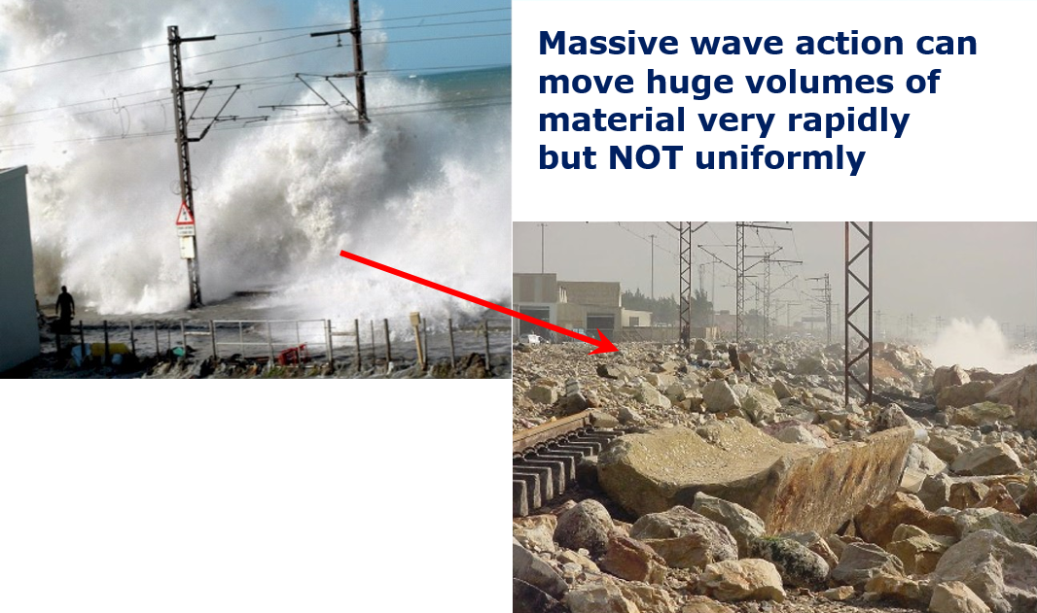
  - It is Mechanically IMPOSSIBLE for the African Erosion Surface to have happened Randomly over Millions of Years -- only a consistent Global Tsunami can have done this
If you take account of all the factors that are a play here it is mechanically impossible for the African Erosion Surface to have occurred gradually over thousands or millions of years, it required ONE mega event over a very short space of time with EXTREMELY uniform forces to cut this surface. The only possible explanation is a Global Tsunami Tidal Wave ripping round the planet absolutely uniformly. And it happened when most of the other tectonic events had stabilized.
Conclusion
Large span tidal waves, with uniform velocity and depth over considerable distances are capable of cutting down the surface of the earth to remove vast amounts of material uniformly as required to cut the top off the Halfway House Granite Dome and the sedimentary layers upthrust by the dome and create the African Erosion Surface. This is entirely consistent with a planet covered in water with the tides running as massive continuous Tsunamis around the planet giving rise to massive cutting down in very short time spans.
Please reflect on your own practical life experience and knowledge -- what else can explain the topographic forms (land forms) we see around us?
Do not abdicate your intellect, check this theory out for yourself as you drive around, look at travel books, etc. We have a massive flat plane level with the sea level but we cannot see the sea and we are nearly 2,000 meters above sea level.
From an Engineering perspective this seems impossible. It cannot possibly have occurred slowly over millions of years – it is far too uniform. So, what caused it?
There is no reasonable explanation apart from massive (global) wave action!

Chapter 7: Incised Valley’s Prove High Speed Water Drainage Consistent with a Global Flood and Continental Separation
Adding to the complexity of the Geology and Topography that we are considering the African Erosion Surface is comprehensively intersected by valleys incised into the plane that we discussed in the previous chapter.
Video https://www.youtube.com/watch?v=ZMDX89_OCUg
Slides http://www.slideshare.net/End_Time_Issue_Ministries/06-incised-valleys-prove-massive-hydraulic-action-consistent-with-a-global-flood
  - What the Remaining Surface of the Dome Actually Evidences
So what we find is small streams in wide flat valley’s where the stream does not have the erosive capacity to cut the valley and there are rough rocks in the stream bed evidencing the very limited erosive power of the stream.
The streams could never erode valleys like these, the erosive capacity is far too low, even in flood. They would produce narrow valleys. The streams are not even able to erode the granite rocks in the bottom of the stream bed.
  - Gentle rain or stream flow does NOTHING it is all about high velocity water
Low velocity water nurtures plants it does NOT erode however long it flows. Even if it flows for millions of years.
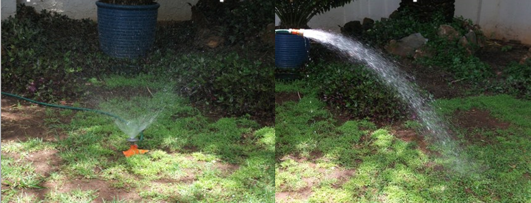
  - High velocity water scours out large amounts of material very rapidly
High velocity water erodes rapidly and continues eroding until there is nothing left to erode.
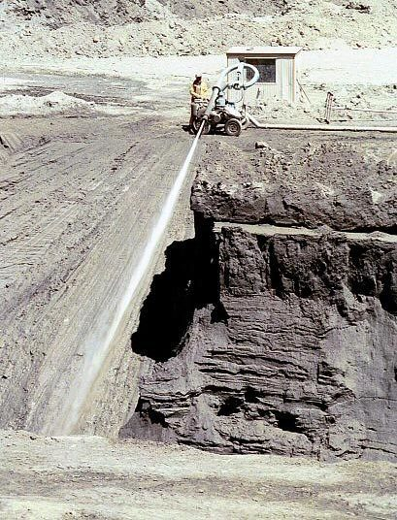
  - Erosive Capacity as River Bed Load is Exponentially Related to Water Velocity
The erosive capacity of flowing water increases exponentially with water velocity:
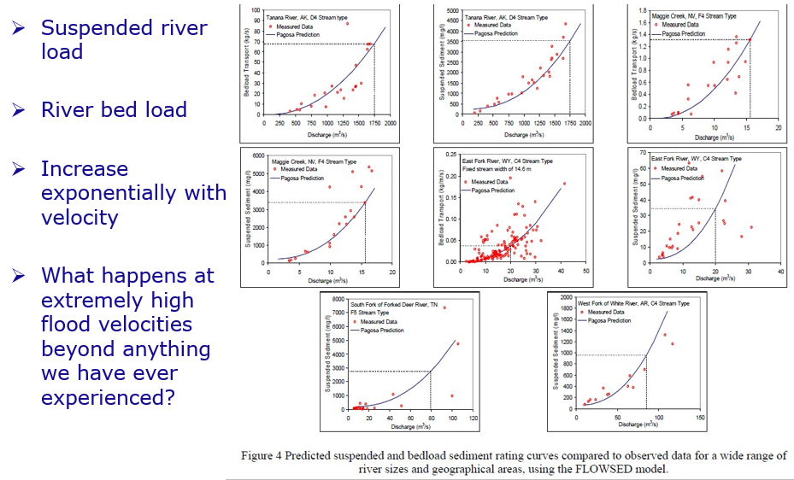
  - Plucked Cliff Faces
All over the world we see shear, steep cliff faces with large blocks plucked out of them and ragged rocks remaining. Evidence of dramatic high energy action. High velocity water with massive sucking action is the only possible explanation.
  - Plucked Hill Tops
We also see isolated ragged rocks on the tops of hills and mountains where the surrounding material has been plucked out leaving sharp, jagged rocks scattered across the hill top. High velocity water with a sucking action is the only possible explanation.
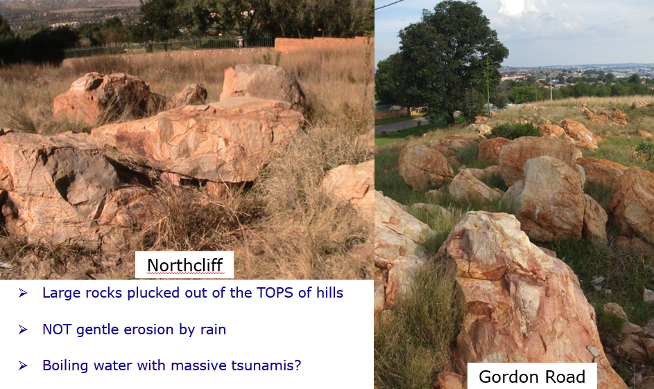

  - Where has all the rock gone?
Over the Halfway House Granite Dome about 600 cubic kilometres of rock and earth have been removed (600 thousand million cubic meters). The river flow is downhill all the way to the low ground of Limpopo province, about 1,000 kilometres distant and over 1,000 metres lower down. This material was all removed through the Hartebeestpoort gorge. ALL the material en route has disappeared as well. Massive high velocity water flows are the only possible mechanical explanation.
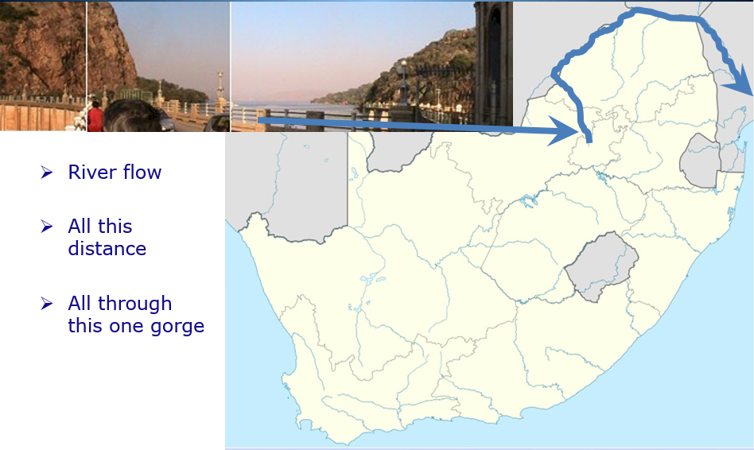
  - Not glaciers, Not evaporation, Not dissolved
Various people have given various explanations when I have raised these issues but the fact is that the valley shape is NOT consistent with glaciers, see below, and rock does NOT evaporate and does NOT dissolve and IF it did the material left behind would look different.
  - Rapid Continental Separation the ONLY Plausible Explanation
The continents fit together. Conventional theory says this took place gradually over millions of years. What if it happened rapidly like all the other events discussed in this document?
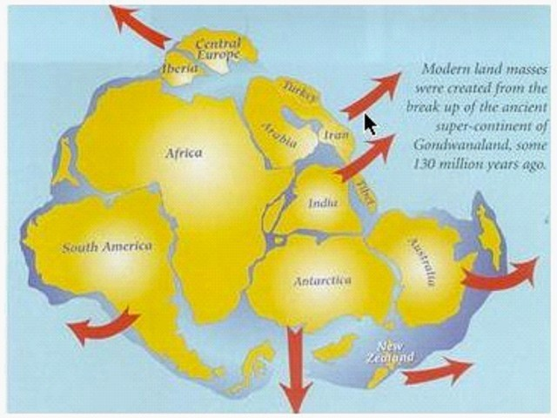
This requires massive forces to split the continents and massive forces to overcome inertia and start movement and massive forces to stop the movement. It needs an external force to initiate all of this.
Imagine rapid separation of the continents. What if simultaneously the earth expanded as a consequence of all the surface disruption breaking the crust which would have contracted rapidly as a consequence of rapid cooling? What if several kilometres depth of water drained off the land in a very short space of time – perhaps days or weeks? What if the water flow had the erosive capacity to cause the topography that I have described and the topography in the part of the world where you live?
  - A Hypothesis for Continental Splitting or Cracking
The coefficient of thermal expansion of Granite is 6.5 micrometres per metre at 20 degrees Centigrade. The melting point of Granite is 1,700 degrees Centigrade. Cooling from molten to zero degrees would shrink the circumference of the earth by approximately 427 km. BUT the core would NOT shrink. Massive tension and splitting of the crust would result. It is NOT necessary for the cooling to be from 1,700 degrees, much more modest reduction in temperature associated with a flood of ice melt water would be more than sufficient to cause huge tension in the crust.
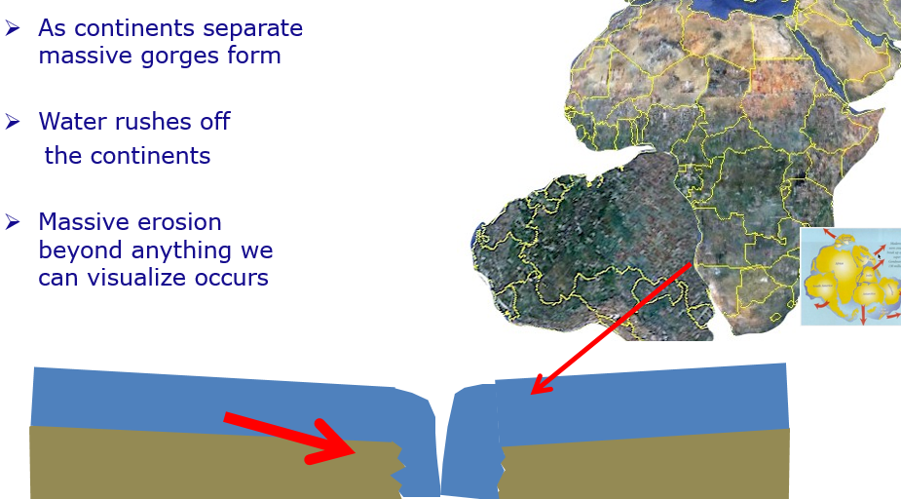
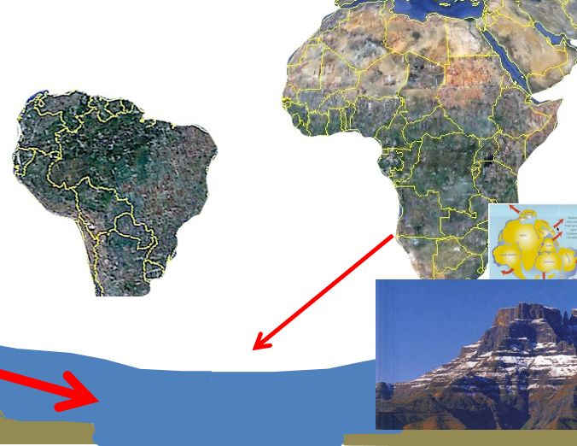
  - Ocean trenches another source of drainage
The Mariana Trench is 11,000 m deep. Seemingly concurrently with continental separation trenches were also formed further draining water off the continents. The volume of the seas is MUCH greater than the volume of the continents (18x). Easy to postulate rapid and dramatic drainage.
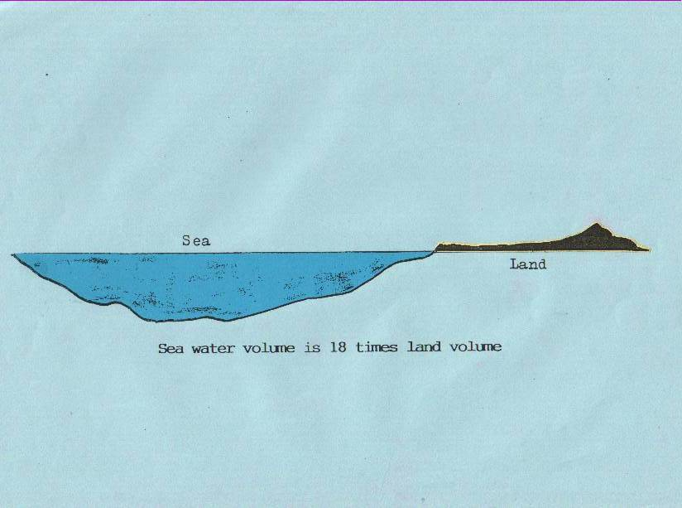
  - Massive forces when the Continents Collided
Having developed rapid motion the continents then continued around the surface of the Earth until the collided with one another giving rise to the Alps, the Himalayas, the Rockies, the Andes, etc.
  - Comet impact is consistent with all that has been reported
Impact by a Comet is entirely consistent with what has been reported here. There is a theory that Earth’s axis was once vertical, that the orbit of Sun was originally circular and not elliptical and that a year was originally 360 days. All of these parameters were changed by the comet impact introducing massive forces into the crust of the Earth.
The torsional shear between the crust and the liquid molten core would have been huge and would fully explain the rapid separation of the continents postulated here.
Conclusion
So we see large valleys incised in the dome and elsewhere – all over the earth that are too large to be formed by the streams currently running in those valleys. We see massive plucking of rocks out of cliff faces and tops of hills.
We see that the continents were originally one land mass and that thermal shrinkage of the crust due to rapid cooling associated with inundation of the surface of the earth with ice cold water explains splitting up of the continents.
We see that a massive impact of an ice comet tilting the Earth on its axis, distorting its orbit around the sun and causing massive shear (hysteresis) between crust and core can explain separation of continents and this explains rapid drainage leading to the formation of the valleys and other erosion forms we see all around us.
All this happened rapidly – it is mechanically impossible for it to happen slowly!

Chapter 8: Where did the Water come from and where did it Go?
This chapter consolidates what has been said in previous sections regarding the source of the water that flooded the earth and also where it went to after the flood. This can be viewed in detail at:
Video https://www.youtube.com/watch?v=1Ri2ZuWwjxQ
Slides http://www.slideshare.net/End_Time_Issue_Ministries/09-where-did-the-water-come-from-and-where-did-it-go-global-flood
I have indicated the mechanism that I understand to be responsible for the global inundation with water coupled to massive surface disruption so this section serves simply to consolidate what I have said.
  - Ice Comet Impact
We have seen that there are a huge number of chunks of ice in orbit around the Sun in the Kuiper Belt at the extreme limits of our Solar System.
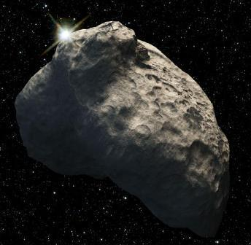
  - Ice Comets are Real
We have seen that chunks of ice travel in space in the form of Ice Comets such as Comet Lulin in the image below:
  - Ice impact crater on Mars
We have seen a crater on Mars which has geometry that seems to be the result of an Ice Comet impact.
  - Hellas Planitia would have a sizeable footprint on Earth
And we have seen that an ice object the size of this crater would have a substantial footprint on planet Earth.
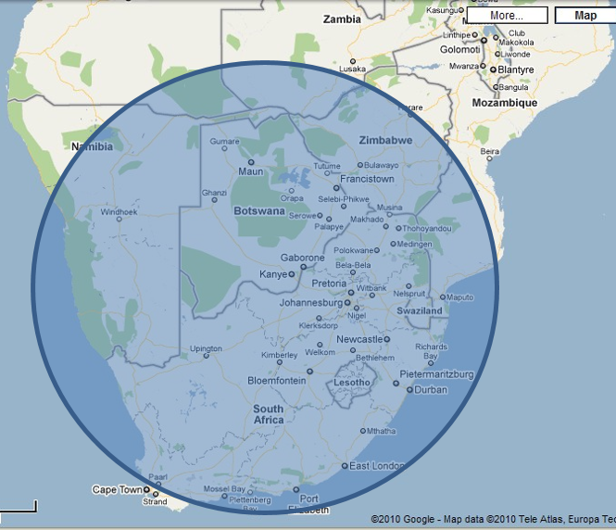
  - Submerge the Earth to a depth of 11.75 kilometres
We have also seen that an ice object this large, striking the earth and melting, would cover the surface of the earth to a depth of around 11.75 kilometres. More than enough to explain the water based surface features that have been discussed in previous chapters. In fact, this comet is probably TOO large, a smaller comet would be more than sufficient to submerge the surface of the earth. Remember also that the mountains we know today are a consequence of the flood and did NOT exist before the flood.
We therefore have an entirely plausible and practical explanation for where the water came from.
  - Impact damage
We have seen considerable evidence of massive surface disruption. How did that happen?
Well, as we have seen before, the impact of an object even smaller than that depicted above could cause a massive impact when it hit the Earth.
It is postulated that this would have knocked the Earth off its vertical axis to an inclination of about 30 degrees (it has subsequently rebounded to the present 23.5 degrees) and that it would also have knocked the Earth out of its circular orbit around the Sun of exactly 360 days resulting in the current annual cycle of 365.25 days.
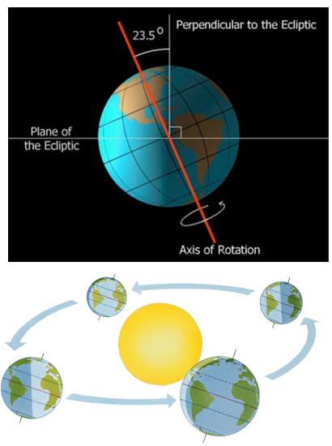
  - Fracturing of the Crust
This would also have caused fracturing of the crust of the Earth as the shock waves from the impact travelled around the earth. So we have an explanation for the formation of the Continental Plates and the associated tectonic activity in the form of volcanoes, granite domes, lava flows, etc.
  - Hysteresis of the Core – the Force to Separate the Continents
These forces would act differently on the solid crust of the Earth versus the molten and therefore liquid core. The crust, directly impacted by the strike, would rotate with the rotation of the axis and the change in orbit of the Sun.
The liquid core would demonstrate the standard hysteresis effect that is experienced by any volume of liquid subject to a change in direction – it would do its best to keep moving in the direction it was moving before the impact. This is why the tanks in tanker trucks are divided into sections and have baffles to prevent the inertia of the liquid in the tank from overturning the vehicle.
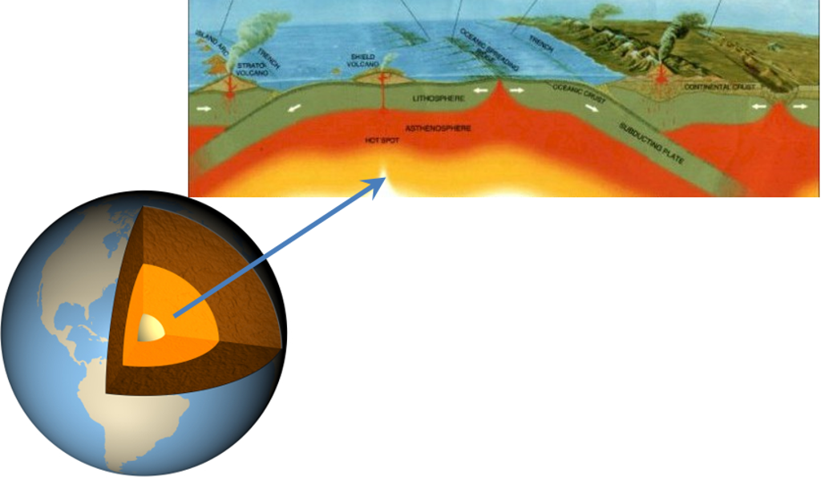
  - Shear on the base of the Crust
This would result in shear, relative movement between the rough inner surface of the crust and the highly liquid core. This would cause the continents to separate.
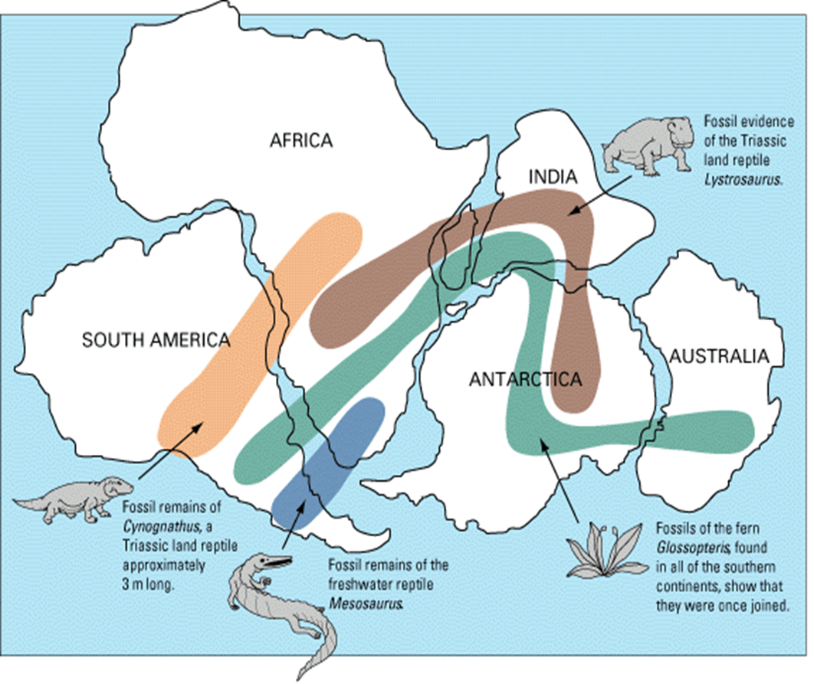
  - Continental Impact
Once the continents started moving they would keep moving until they impacted something to stop them. The other continents or continental plates. This gave rise to the major mountain ranges such as the Alps in Europe, the Himalayas in Asia, the Rocky Mountains in North America, the Andes in South America and other mountain ranges around the world.
This same movement caused tears in the ocean floor such as the Mariana trench.
  - Where did the water go to?
We are left with one unexplained phenomenon, where did the water go?
The most probable hypothesis is that the Earth expanded. Exactly HOW it expanded is the subject of divergent theories but there is quite a large body of opinion that says that it DID expand at some time for diverse reasons.
Consider the page on the Expanding Earth in Wikipedia at
https://en.wikipedia.org/wiki/Expanding_Earth
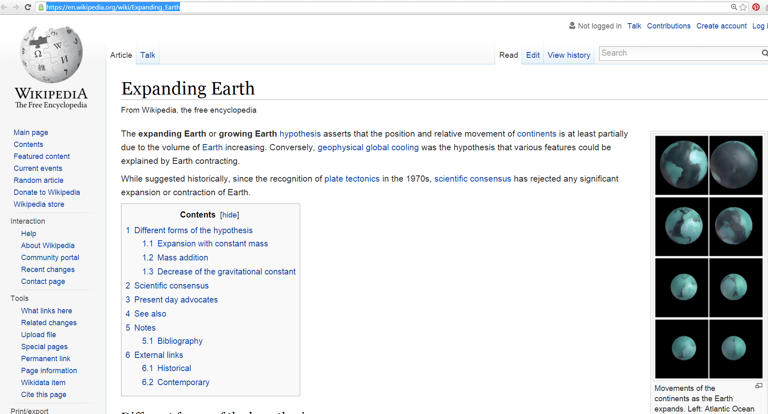
There is a theory that following the impact of the Ice Comet, the rotation on the axis and change in orbit and resulting disruption of the surface of the Earth leading to the Continental Plates being formed and movement commencing that this was associated with expansion of the surface of the Earth.
One theory says that if the diameter of the Earth is reduced such that the diameter expanded by about 25% to arrive at the present diameter, the continents fit together perfectly. I have not found substantive documentation to back this up but it seems quite possible from a geometric perspective.
How could the Earth expand?
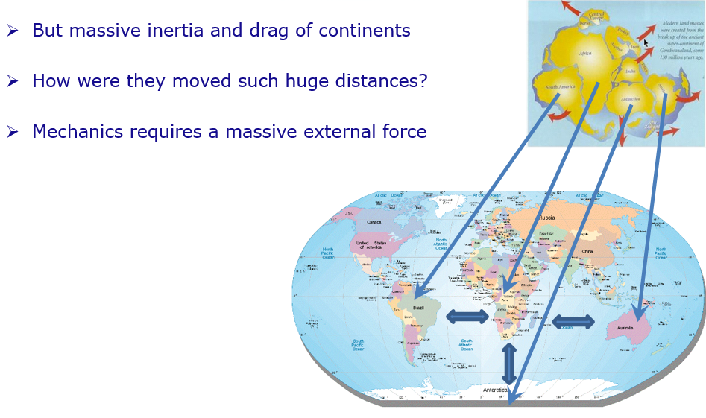
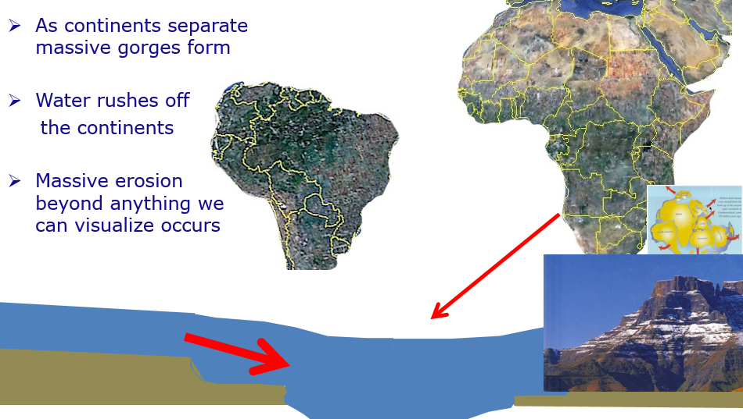
  - Nuclear reaction in the core of the Earth
If we assume that when the Earth first came into existence the core was relatively small and relatively cool and that as time passed the reactor in the core became more active and the core became hotter, larger and more molten then the Ice Comet impact causing the fracturing of the Continental Plates may have paved the way for the core to expand. It also seems possible that the massive disruption associated with the Ice Comet impact might have caused increased activity in the core leading to a substantial increase in temperature and therefore associated expansion. The fact that matter was forced out of the core in the form of Volcanoes, Granite Domes, Lava Flows, etcetera evidences that there WAS excess pressure in the Core from the commencement of the Ice Comet impact.
Conclusion – the best theory I know of
This theory fits for me. It is entirely consistent with information reported by NASA in 2009 and 2010. It made sense to me the first time I heard it.
I leave it to you to ponder and take a view on whether you have a better theory. It certainly works better for me than to suspend my engineering intellect and training and believe that all the things I have shown you happened gradually over millions or billions of years
Steady state theories cannot explain what we have discussed in this book. Massive external forces HAVE to have been applied. A massive external source of water is essential. There ARE large chunks of ice in space. An astronomical object or “Ice Comet” explains the situation perfectly.
Is there a better theory? I do not know one. What do YOU think?

Chapter 9: What is the Age of All this? REALLY?
We have repeatedly been told that the surface of the Earth is millions or billions of years old. We read of archaeological finds with ages like this. In the introduction to this book I made the point that nearly all things in the physical world follow exponential characteristics and that extrapolation, even by small amounts is extremely unwise. So, when DID this flood really take place?
Video https://www.youtube.com/watch?v=0Xnw8tt3Za4
And https://www.youtube.com/watch?v=HmoUwRzvqGs
Slides http://www.slideshare.net/End_Time_Issue_Ministries/07-the-real-date-of-this-global-hydraulic-event-or-flood
In considering the question of the age of the current topography and geology one must keep in mind that the surface of the earth was TOTALLY mashed up in the wake of the Ice Comet impact and that therefore EVERYTHING on the surface of the earth today dates back to NO earlier than the date of this event.
So, when WAS the event?
How long ago? Each stage of what has been discussed happened rapidly. More likely to be weeks or months per stage rather than millions or billions of years. There are written records that suggest this happened as recently as 2345BC. Other widely held opinions state that these events took place millions or billions of years ago. Which view is more reliable?
  - Exponential versus Linear
Fundamental to understanding the question of ageing of this event is to come to terms with the reality that most physical characteristics follow exponential curves and are NOT linear. This is particularly so with radioactive decay.
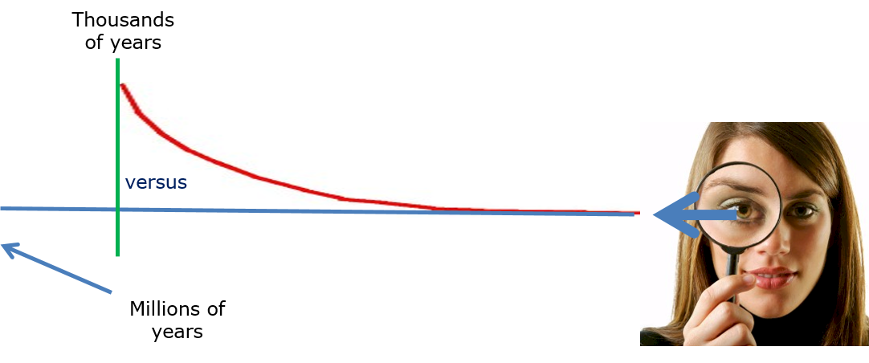
So, we get a situation where if we assume linear trends extrapolation gives ages in millions of years but if we assume exponential trends then extrapolation on the same data gives perhaps thousands of years.
  - The God’s Word Phenomenon
This whole situation is clouded by what might be termed “The God’s Word Phenomenon” which relates to people who claim that the Bible is the “Word of God” and without error and therefore try and ram their beliefs down other people’s throats on the basis of “the Bible says!”.
In fact, it turns out that a key aspect of the debate relates to ignorant insistence on the Bible as final authority with NO understanding of physics or any other technical knowledge versus arguments against believing the Bible that then go off at a tangent and miss the point.
The brutal truth is that NOWHERE in any Bible I have ever read, and I have read many Bibles, does it say something like “I the undersigned, being the person who collated all the writings in this book, hereby testify that I was directly and intensely guided by the Almighty Creator and I therefore testify that this book is ‘the Word of God’” – even if there WAS such a passage one would need to ask carefully how much reliance one should place on such a declaration by an unknown person. Then, if one were to ask the Almighty His opinion one would discover that He is not particularly keen on the Bible because of the way people worship it and have relationships with it instead of worshipping Him, see http://end-time-issueministries.org/TheBible.aspx.html for more information on this topic.
So, bottom line as I see it is that the Bible is a useful and reasonably authoritative compilation of historical writings by a diversity of human beings who have had a variety of relationships with the Almighty, NO MORE!
  - The My Teacher Told me Phenomenon
So, we get otherwise rational and sensible people who suspend their intellect on the basis of unwise beliefs about the Bible.
Then we get other rational and sensible people who suspend their intellect based on what some educator or other esteemed person told them.
The harsh reality, as we have seen so far, is that conventional wisdom regarding this event we like to call “The Flood” is that there is a LOT of wrong thinking on the part of people whose opinions are, for the most part, authoritative. As far as I can determine most of this wrong thinking relates to beliefs that they took on early in their careers from people they esteemed and greatly respected and therefore never questioned and, to question those people now, seems in some way disrespectful. So we find otherwise rational academics making statements about the age of things that simply do not gel.
We also have the problem of Geologists, Historians, and other specialists who lack Engineering training and Engineering fundamentals who therefore make assumptions that are simply NOT valid.
  - The problem of clean sharp corners
All over the world we find clean rocks with sharp corners. Over millions or billions of years these corners would be weathered and rounded by thermal stressing and covered with moss and lichen. So millions of years is improbable. Are there other indicators of age?
  - Reductio ad Absurdem
We have spoken before of the mathematical and legal principle and technique of “Reductio ad Absurdum”—reduce to the absurd. This is a well-established and well proven deductive technique and I will use it presently. The term is very well known and well applied. At the time of writing there were over 389,000 exact matches of the phrase in quotes on Google:
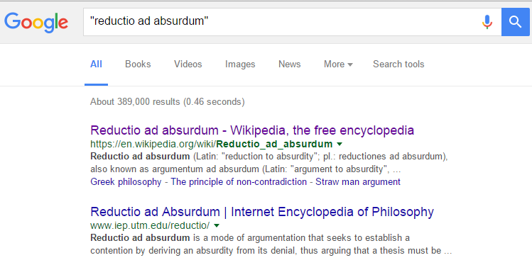
  - Extrapolation should be avoided
We also discussed the engineering and mathematical principle that extrapolation should be avoided. This is so because it is NOT possible to predict the behaviour of materials and other phenomena outside the realms of observed data. Searching for that text in quotes to get an exact match on Google we find 2,920 exact matches.
This is an important deductive principle, a principle that is totally violated by those who claim that they can age archaeological remains to millions or billions of years when all they are measuring is noise in data which is almost certainly exponential and which is subject to all sorts of contamination over time.
  - Millions or billions of years is absurd
“We know the radioactive decay rate of … ”. “We have no basis to assume that there has been a non-linear trend”.
Everything so far in this book indicates massively non-linear events. Written records going back thousands of years indicate a recent event.
Millions of years is therefore highly improbable, technically unsound and logically absurd.
So, the harsh bottom line is that from a fundamental first principles engineering, scientific, mathematical, logical perspective, even thinking that one can project back millions or billions of years with regard to the age of artefacts found on the surface of the Earth is absurd.
  - The Bible is the Word of God and without error is absurd
The Bible is a collection of writings by assorted people. Nowhere in the book is there a passage that unambiguously catalogues the content of the book and defines its scope. There are books of the same name that have different compilations and literally hundreds of different English versions. Nowhere in the book does it claim that the entire compendium of writings is without error and nowhere in the book does it claim that the entire compendium of writings is the “word of God” or “Yah” (the true name of the Creator.
The book contains errors and contradicts itself in various places.
The “the Bible is the inerrant word of God / Yah” is therefore absurd.
  - Could Genesis be correct?
At this point I suggest that the most that we can say about the book {Bible} is that it is a collection of writings the oldest of them generally accepted to be at least 2,500 years old. The book claims that there was a global flood in about 2345 BC, or more accurately, the section of the Bible named “Genesis” (origins) says that.
At this stage let us NOT get into whether the flood was an act of a being whom is customarily referred to as “God” or “THE LORD” or even whether He exists or not. Let us simply say that “Genesis claims there was a global flood” and examine that portion of that book further.
Genesis is presented as an historical account of REAL events. Can we validate this? Minor errors are NOT a problem if we consider the writings to be the work of human beings who, like ourselves, make mistakes. Most specifically, CAN we regard reports of a global flood about 4,500 years ago as reliable?
So what DOES Genesis say?
Genesis 7:11-12 “In the six hundredth year of Noah's life, in the second month, the seventeenth day of the month, on that day all the fountains of the great deep were broken up, and the windows of heaven were opened. And the rain was on the earth forty days and forty nights.” NKJV
Based on the fact that the human beings alive at the time were all in a closed boat and had NO way of knowing exactly what happened, the fact that the above account does NOT exactly conform to what I have presented is of NO concern.
Genesis 8:3-4 “And the waters receded continually from the earth. At the end of the hundred and fifty days the waters decreased. Then the ark rested in the seventh month, the seventeenth day of the month, on the mountains of Ararat.” NKJV They came to rest on the mountains of Ararat, THAT is the important piece here.
Ron Wyatt, Jonathan Gray and others have travelled to the mountains of Ararat in Eastern Turkey and found a boat that is similar to that described in Genesis.
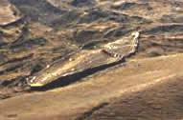
They have found the remains of a huge wooden vessel submerged in a volcanic mudflow found in the mountains of Ararat in Turkey. The size agrees with Genesis 6:15 -- length 150 meters, width 25 meters and height 15 meters.
Based on excavations they have constructed a model of the way they think the boat looked:
They have also found a house, a grave and some engravings. The boat carried a family of eight people, a man, his wife and their three sons and their wives. They were subject to a flood.
The man was approximately 18 feet, six metres, tall as evidenced by the grave and the geometry of the house.
There is every reason to conclude that the remains of the boat and the house and engravings validate the account in Genesis. Therefore it is absurd to claim that Genesis is NOT a reliable account when it comes to its report regarding the flood, at least at the headline level.
The outline of the boat can even be identified in Google Earth at the location where it is reported to have been found.
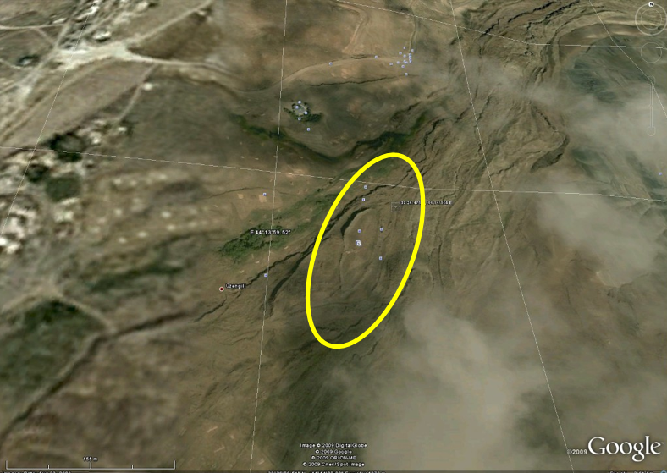
  - Genesis genealogies give the date of the flood
Genesis also contains a detailed genealogy from before the flood to well after the flood.
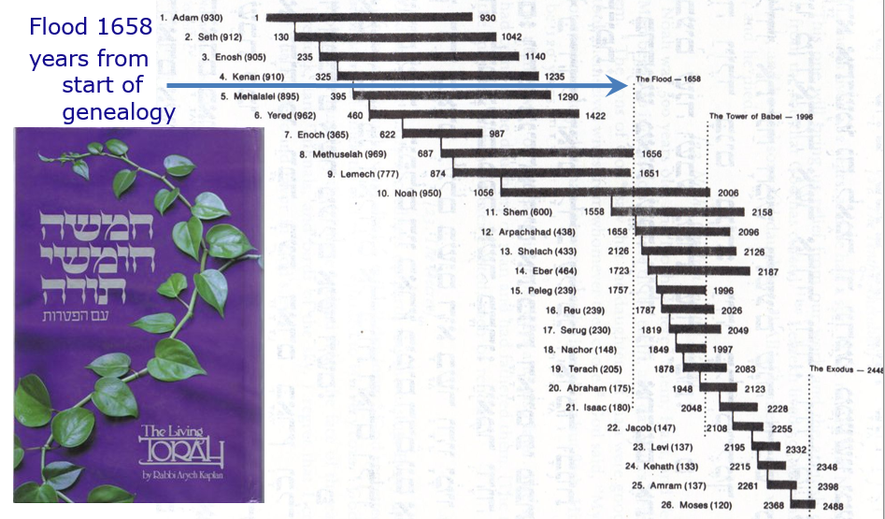
This genealogy is confirmed at a headline level by genealogies located in Ireland and elsewhere:
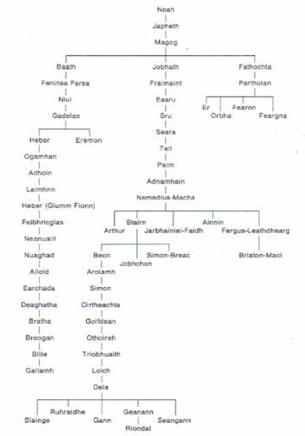
  - Egyptian time lines confirm
Egyptian time lines support a flood date of about 2345BC. Like many other advanced civilizations Egypt (Mitzraim) sprang up rapidly after the flood immediately with advanced technology. Once certain wrong assumptions with regard to the Egyptian dynasties are resolved Egyptian timelines correlate.
Likewise other advanced civilizations around the world – Babylon, Matchu Pitchu, etc confirm that these civilizations sprang up suddenly shortly after 2345BC – it is apparent that Noah and his family brought with them advanced technology.
So, again, we see that it is absurd to discount the timeline given in Genesis. Arguments that suggest that these things could NOT have happened in the time presented in Genesis are unfounded because they lack the critical facts that are presented in this book.
  - Some useful references from Jonathan Gray
Following are some books from Jonathan Gray that are available from his website and also from Amazon.
- The Killing of Paradise Planet – reconstruction of the earth before the flood based on the archaeological evidence that does exist from before the flood.
- Surprise Witness – reconstruction of the events during the flood.
- The Corpse Came Back – reconstruction of the events following the flood, repopulation of the earth, dispersion of tribes and peoples – this is a particularly valuable book, very thought provoking.
- Dead Men’s Secrets – 1,000 archaeological findings that evidence that the civilization destroyed by the flood was far MORE SOPHISTICATED than our current civilization and had technologies we do not have today – this is a MUST READ for anyone who is seriously interested in the history of man as we exist today, a real eye opener.
Reading and videos to change your worldview available from www.beforeus.com or from Amazon.
There are also some books that explain why commonly used dating methods are defective.
  - Nuclear war not long after the flood
A further complexity.
In Dead Men’s Secrets Gray reports an account of what appears to be a nuclear war:
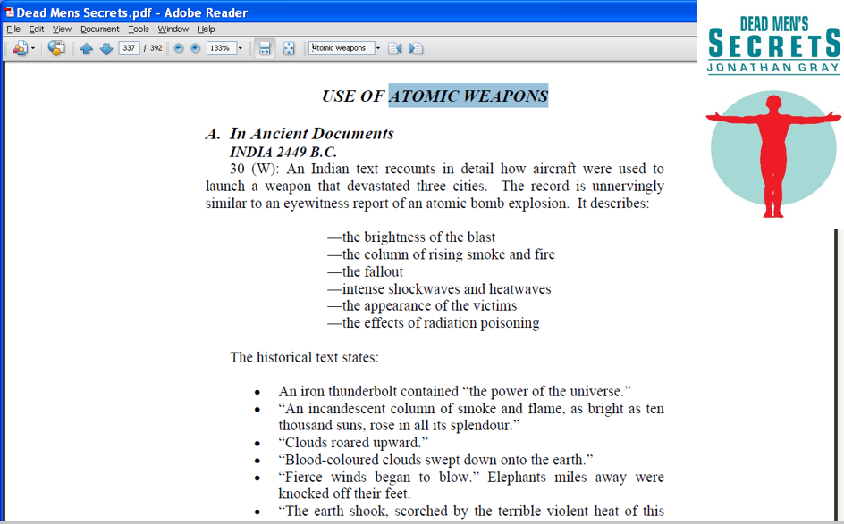
There are apparently remains of cities on various continents which show evidence of being destroyed in a nuclear war and this then opens the problem that this variable nuclear activity on the Earth after the flood further contaminates any attempt to use radio-carbon or other dating methods that rely on radioactivity.
This also introduces the possibility that Australopithecus and other “missing link” humanoid “apes” were, in fact, the mutant offspring of humans who survived the nuclear attacks but who were badly affected by radiation.
  - Total destruction of the surface of the earth less than 4,500 years ago disrupts many other theories
Global warming is a result of the earth continuing to dry out as water drains from the continents. So is the rising of sea levels – cities have been submerged.
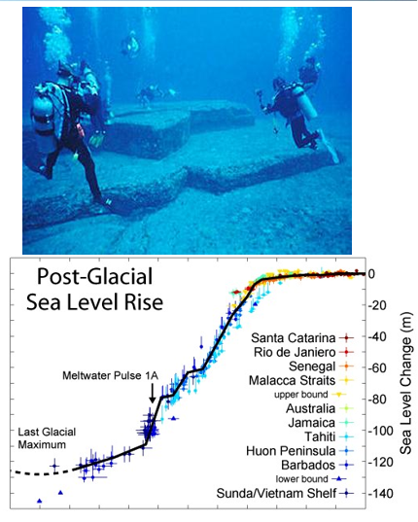
Races can all trace their origin back to Noah and his family – all differences are a consequence of degradation (negative evolution) and passively mutation as a consequence of radioactive exposure during the flood, immediately after the flood and after the nuclear war.
Evolution over millions of years is invalid, in fact it really IS absurd. In fact, it turns out that dinosaurs lived recently and the Loch Ness Monster was probably a real dinosaur.
  - The exact age is not critical but the principle is important
A debate as to whether the flood occurred in exactly 2345BC or 10,000 or 20,000 years ago is not that critical.
It IS important to decide whether there WAS a global flood. Your view on this information may point you to some major decisions.
It is also important to recognize that this happened relatively recently and NOT millions of years ago. This realization has a HUGE impact on how one views a number of other key discussions like evolution versus creation.
Conclusion
There has to have been a MASSIVE global hydraulic and tectonic event (“flood”).
Engineering principles say that long range extrapolation is unwise and reckless.
Sharp young rocks everywhere point to a young age. Historical accounts point to less than 4,500 years ago. There are good reasons to accept the Genesis account and the approximate date of 2345BC as reliable.

Chapter 10: Signs of Judgment : The REAL Miracle – a man and his family SURVIVED!
So, we have clear evidence of a global hydraulic and tectonic event not that long ago, around 4,500 years ago in fact, very recent if one has been thinking in terms of “millions of years”.
This is particularly important in the context of a body of opinion that says that mankind will only be on earth for a total of 7,000 years and that we were created slightly more than 6,000 years ago. Time is potentially running out – how should we respond to that information?
Further, there is a body of opinion that the global hydraulic and tectonic event that is the subject of this book, the “Flood”, was the consequence of judgment by the Almighty on mankind. This chapter examines the extent to which this might be so and, if it is, what one might do about that.
Video https://www.youtube.com/watch?v=CfDRAiwcj4w
and https://www.youtube.com/watch?v=9X21qcfD5bc
Slides http://www.slideshare.net/End_Time_Issue_Ministries/08-signs-of-judgment-relative-to-the-global-flood
In order to do this let us look at a number of archaeological finds that substantiate reported judgments in the books known as “Genesis” and “Exodus” in the book known as “The Bible”
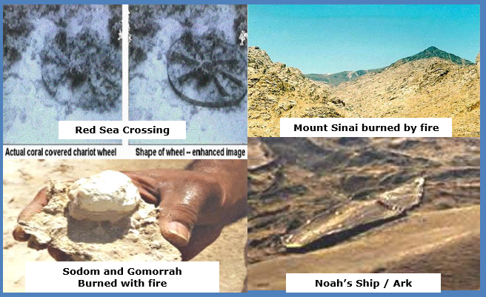
  - Genesis confirmed
We have established that Genesis IS a reliable historical account to the extent that it reports a flood that destroyed the earth. What if Genesis is correct about the existence of a Creator as well?
What if Genesis is correct that this Almighty Creator judged mankind with the flood and forewarned a man called Noah to prepare a survival vessel in order to escape? What if there is going to be another judgment and we are again being given advanced warning in order to escape?
Are you prepared?
Genesis 6:5-8 says “Then Yah the eternally self-existing {the LORD} saw that the wickedness of man was great in the earth, and that every intent of the thoughts of his heart was only evil continually. And Yah the eternally self-existing {the LORD} was sorry that He had made man on the earth, and He was grieved in His heart. So Yah the eternally self-existing {the LORD} said, "I will destroy man whom I have created from the face of the earth, both man and beast, creeping thing and birds of the air, for I am sorry that I have made them. But Noah found grace in the eyes of Yah the eternally self-existing {the LORD}.“ NKJV
  - The ship or Ark of Noah found – evidence of Judgment
As we have already seen, the ship or Ark of Noah has been found, proving that one man and his family were forewarned of the flood and assisted to escape.
This evidences that the majority of people have, historically, NOT heard the Almighty on key matters or rebelled against what they heard. The question for YOU today is whether YOU are guilty of that error.
Genesis gives dimensions of the ship that exactly correlate with what has been found.
Genesis 6:13-17 “And the Almighty {God} said to Noah, “The end of all flesh has come before Me, for the earth is filled with violence through them; and behold, I will destroy them with the earth. Make yourself an ark (container) of gopherwood; make rooms in the ark, and cover it inside and outside with pitch. And this is how you shall make it: The length of the ark shall be three hundred cubits, its width fifty cubits, and its height thirty cubits. You shall make a window for the ark, and you shall finish it to a cubit from above; and set the door of the ark in its side. You shall make it with lower, second, and third decks. And behold, I Myself am bringing floodwaters on the earth, to destroy from under heaven all flesh in which is the breath of life; everything that is on the earth shall die.” NKJV
The existence of the ship evidences that the Creator warned Noah. If there was generally available evidence of a coming flood / ice object strike / fly-by that was capable of destroying the planet there would almost certainly have been other survivors. There is NO evidence of more than one survival vessel. There is no evidence of more than one genealogy surviving. I take this as strong evidence that the Creator did indeed speak to Noah and that the flood WAS A JUDGMENT.
  - Fossil Graveyards
In various parts of the Earth fossil graveyards have been found where the remains of animals and humans occur in large deposits, again evidence of a dramatic event.
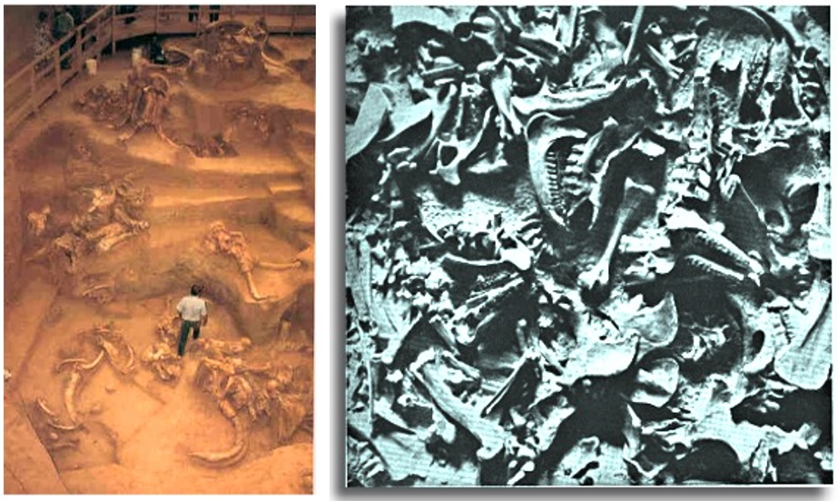
  - Other Signs of Judgment
There are other signs of judgment that have been found:
- An army drowned in the Red Sea
- Cities turned to Ash
- A fire blackened mountain top
- A split rock with erosion channels
These are discussed in the sections that follow.
  - Red Sea Crossing Site -- Drowning of an Army in the Red Sea (about 1555BC) – Exodus
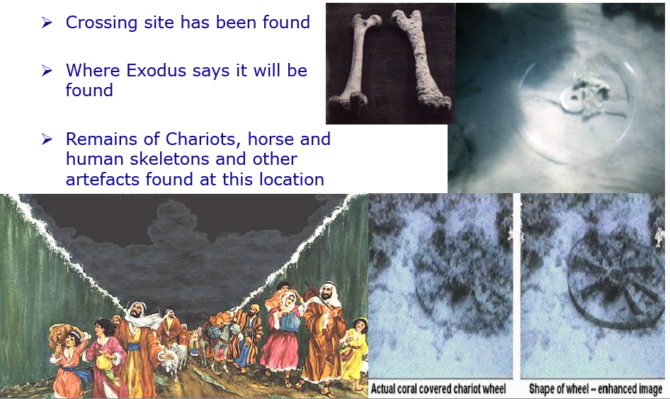
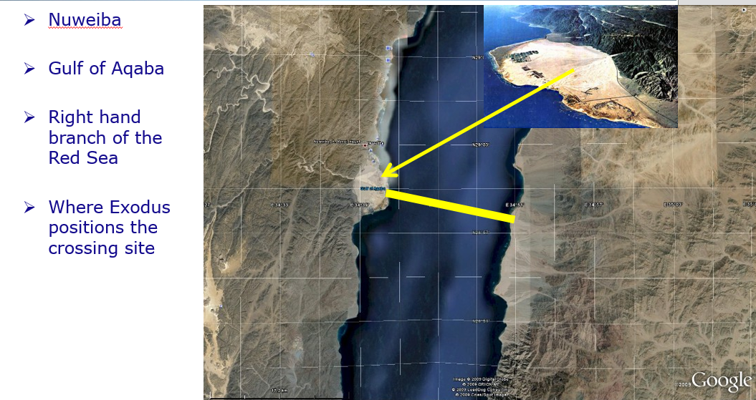
Exodus says this was a judgment on Egypt so this, too, is evidence of judgment by the Almighty.
  - Soddom and Gomorrah turned to ash by brimstone (burning sulphur) – Genesis
Brimstone – burning sulphur from the sky. Genesis 19:23-24 reports “The sun had risen upon the earth when Lot entered Zoar. Then Yah the eternally self-existing {the LORD} rained brimstone and fire on Sodom and Gomorrah, from Yah the eternally self-existing {the LORD} out of the heavens.” NKJV. The cities reduced to ash have been found in the exact locations reported by Genesis.
The ball in the image below is a piece of sulphur found in the remains of one of the cities of ash.
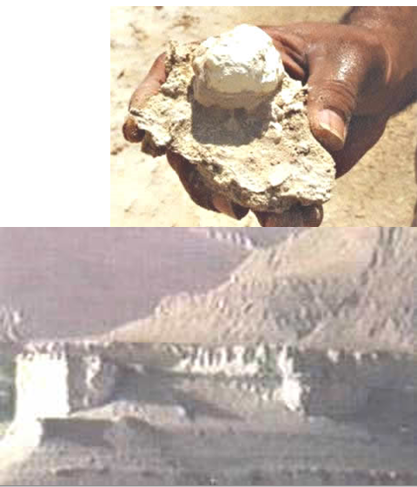
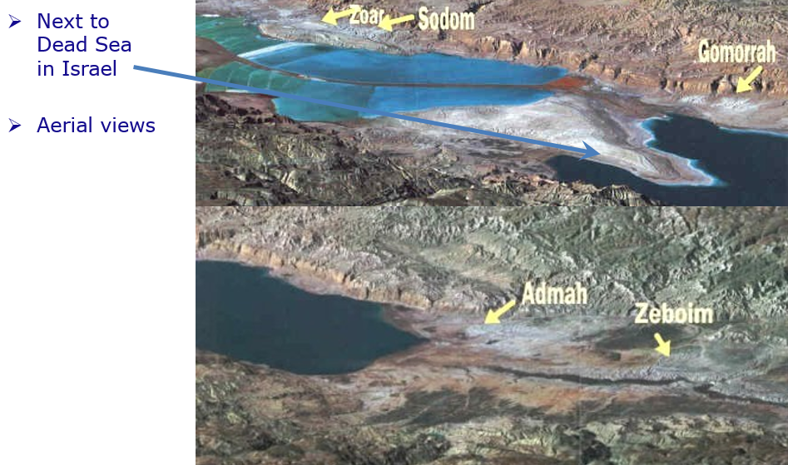
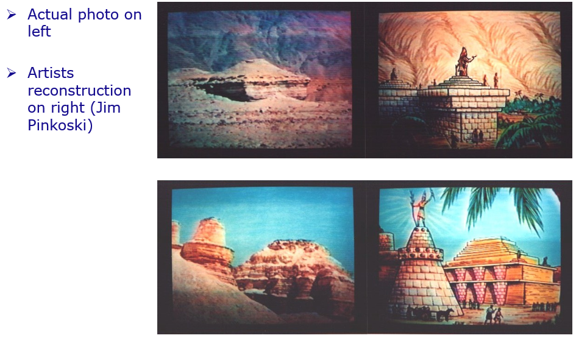
  - Split rock at Horeb and fire burned mountain (about 1555BC) – Exodus
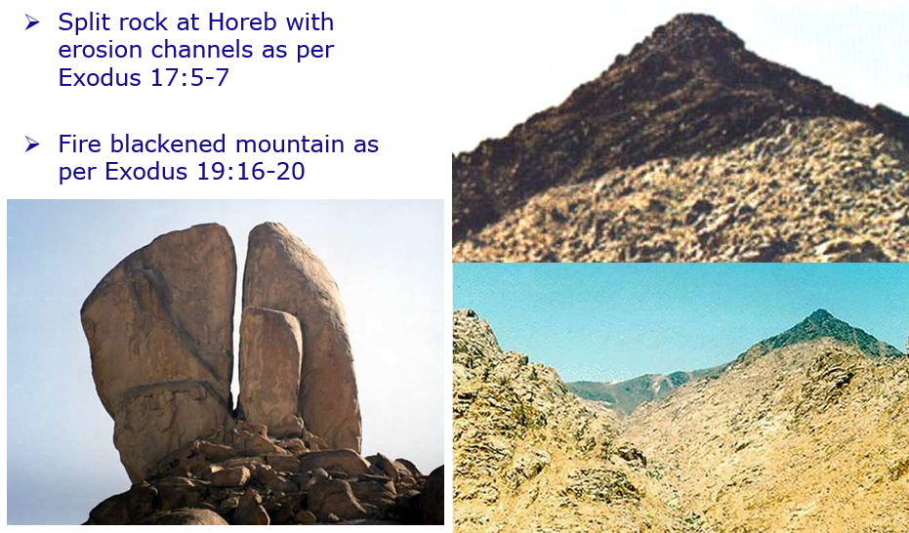
Evidence that this part of Exodus is a reliable historical account.
Exodus 19:16-20 “Then it came to pass on the third day, in the morning, that there were thundering’s and lightning’s, and a thick cloud on the mountain; and the sound of the trumpet was very loud, so that all the people who were in the camp trembled. And Moses brought the people out of the camp to meet with the Almighty {God}, and they stood at the foot of the mountain. Now Mount Sinai was completely in smoke, because Yah the eternally self-existing {the LORD} descended upon it in fire. Its smoke ascended like the smoke of a furnace, and the whole mountain quaked greatly. And when the blast of the trumpet sounded long and became louder and louder, Moses spoke, and the Almighty {God} answered him by voice.
Then Yah the eternally self-existing {the LORD} came down upon Mount Sinai, on the top of the mountain. And Yah the eternally self-existing {the LORD} called Moses to the top of the mountain, and Moses went up.” NKJV
  - The Ten Commandments Given
At this point the Almighty is reported to have given Ten Commandments or Laws, to Moses for the people and to have spoken out those Commandments audibly to the assembly of some millions of people.
Exodus 20:1-17 "And the Almighty {God} spoke all these words, saying:
1. “I am Yah the eternally self-existing {the LORD} your Mighty One {God}, who brought you out of the land of Egypt, out of the house of bondage. You shall have no other mighty ones {gods} before Me.
2. "You shall not make for yourself a carved image -- any likeness of anything that is in heaven above, or that is in the earth beneath, or that is in the water under the earth; you shall not bow down to them nor serve them.” NKJV
3. “You shall not take the name of Yah the eternally self-existing {the LORD} your Mighty One {God} in vain, for Yah the eternally self-existing {the LORD} will not hold him guiltless who takes His name in vain. “
4. "Remember the Sabbath day (Saturday), to keep it holy. 9 Six days you shall labour and do all your work, 10 but the seventh day is the Sabbath of Yah the eternally self-existing {the LORD} your Mighty One {God}. In it you shall do no work: you, nor your son, nor your daughter, nor your male servant, nor your female servant, nor your cattle, nor your stranger who is within your gates.”
5. ”Honour your father and your mother, that your days may be long upon the land which Yah the eternally self-existing {the LORD} your Mighty One {God} is giving you.
6. "You shall not murder.
7. "You shall not commit adultery.
8. "You shall not steal.
9. "You shall not bear false witness against your neighbour.
10. “You shall not covet your neighbour’s house; you shall not covet your neighbour's wife, nor his male servant, nor his female servant, nor his ox, nor his donkey, nor anything that is your neighbour's." NKJV
This is the only time in recorded history that the Almighty Creator has appeared in a manifest form and spoken to millions of people. Accordingly, what was said there should be viewed as extremely important. The Ten Laws or Commandments are therefore the MOST IMPORTANT laws ever given!
  - The Ten Commandments engraved on Stone Tablets
Exodus 24:12 "Then Yah the eternally self-existing {the LORD} said to Moses, “Come up to Me on the mountain and be there; and I will give you tablets of stone, and the law and commandments which I have written, that you may teach them." NKJV
The Almighty engraved the Commandments onto tablets of stone. They are engraved in stone so they are enduring and will NOT pass away.
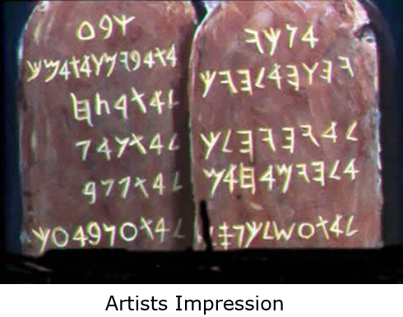
  - The Tablets of Stone placed in the Ark (container) of the Covenant
Deuteronomy 10:3-5 "So I [Moses] made an ark of acacia wood, hewed two tablets of stone like the first, and went up the mountain, having the two tablets in my hand. 4 And He wrote on the tablets according to the first writing, the Ten Commandments, which Yah the eternally self-existing {the LORD} had spoken to you in the mountain from the midst of the fire in the day of the assembly; and Yah the eternally self-existing {the LORD} gave them to me. 5 Then I turned and came down from the mountain, and put the tablets in the ark which I had made; and there they are, just as Yah the eternally self-existing {the LORD} commanded me.” NKJV
1 Kings 8:9 “Nothing was in the ark except the two tablets of stone which Moses put there at Horeb, when Yah the eternally self-existing {the LORD} made a covenant with the children of Israel, when they came out of the land of Egypt.” NKJV
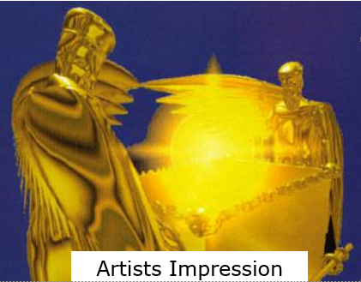
The “Ark of the Covenant”, the container of the terms of the Covenant, the ten Laws (Commandments) which form the basis of judgment. Strictly speaking, if you break the Covenant you DIE. But the Ark went missing about 587 BC at the time of the exile from Jerusalem to Babylon.
  - Ark of the Covenant found in 1982 AD by Ron Wyatt -- Evidence of coming judgment
The Ark of the Covenant was found in 1982 AD by Ron Wyatt, hidden in an excavated cave outside the walls of Jerusalem under a hill called “skull hill” because it looks like a skull Matthew 27:33, Mark 15:22 and John 19:17.
The Ark was found six meters under an execution {crucifixion} site that bears close resemblance to that described in the books of Matthew, Mark, Luke and John with an earthquake crack (Matthew 27:54) that cuts through the middle stake {cross} hole.
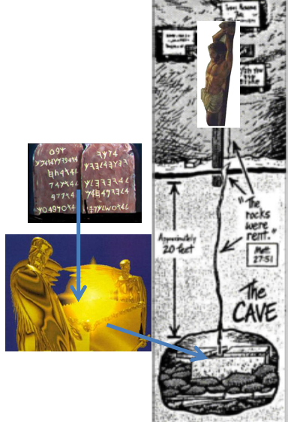
Blood with only the female chromosome set has flowed down the crack onto the Mercy Seat of the Ark.
This is huge if you get the real significance.
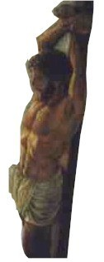
There is close correlation with the four historical accounts that deal with the death of a prophet commonly known as “Jesus Christ”, whose actual name was “Yahooshua” meaning “Yah (the Almighty) is salvation” and “Christ” meaning “anointed with the Spirit of Yah”. Anointing refers to the presence of the Spirit of Yah on a human being metaphorically compared with smearing with anointing oil which is a common practice in hot countries of the Middle East to respond to the hot dry air.
This man died on a stake (tree trunk) NOT a cross (the cross is a demonic sign, an “Ankh” which is a pornographic symbol).
Once one studies this it becomes apparent that matters had to be this way. Blood on the Mercy Seat of the Ark was necessary for any offering {sacrifice} for atonement to have validity (Leviticus 16). It was necessary for a new Covenant. It was necessary for a new way of responding to the threat of coming judgment.
Videos (DVD), books and other material available from graysales@bigpond.com and other sources.
These finds require careful consideration in the context of any discussion about where we are going in terms of our lives and in terms of coming judgment.
  - Signs of Judgment
So we have:
- Strong proof of the flood
- The ship of Noah – clear evidence that one man was warned and assisted to survive.
- The Fire blackened mountain evidencing that the Almighty DID speak to the assembled millions.
- The execution {Crucifixion} site with the earthquake crack, important corroboration of the relevant passages.
- The Ark of the Covenant with blood on the Mercy Seat, vital for a New Covenant, a new offering for sin, a new priesthood.
- The Tablets of stone with the Ten Laws (Commandments) engraved in them, vital as a basis for future judgment.
All in all, a basis for careful introspection and self-examination.
Consider these points in terms of the pivot point for the Flood presentation, the small mountain at Northcliff:
- Massive tectonic upheaval.
- Massive depths of water.
- Massive water action laying down sediments.
- Massive dome up-thrusting earth’s surface.
- Massive water action cutting the top off the dome.
- Massive water action cutting the valleys into the dome.
- In fact – almost anywhere you go on earth you are SURROUNDED BY SIGNS OF JUDGMENT!
ARE you prepared like Noah?
OR …?
  - IS there another judgment? Or is this all history and no need to worry?
In terms of my goal with this book, the KEY question for you to consider is whether there is another judgment in which you will participate or can you safely ignore all this as being purely of historical and therefore academic interest.
There are various passages in the compendium of writings commonly known as “The Bible” that point to judgement to come. For example:
Revelation 20:11-15 “Then I saw a great white throne and Him who sat on it, from whose face the earth and the heaven fled away. And there was found no place for them. And I saw the dead, small and great, standing before the Almighty {God}, and books were opened. And another book was opened, which is the Book of Life. And the dead were judged according to their works, by the things which were written in the books. The sea gave up the dead who were in it, and Death and Hades delivered up the dead who were in them. And they were judged, each one according to his works. Then Death and Hades were cast into the lake of fire. This is the second death. And anyone not found written in the Book of Life was cast into the lake of fire.” NKJV
Revelation 21:5-8 “And He said to me, “It is done! I am the Alpha and the Omega, the Beginning and the End. I will give of the fountain of the water of life freely to him who thirsts. He who overcomes shall inherit all things, and I will be his Mighty One {God} and he shall be My son. But the cowardly, unbelieving, abominable, murderers, sexually immoral, sorcerers, idolaters, and all liars shall have their part in the lake which burns with fire and brimstone, which is the second death.“ NKJV
There are other verses.
  - The alternatives when we die
When we die, fundamentally what happens is as follows:
  - IF when you die you are a believer in the Almighty Creator you are immediately brought before the Judgment Seat of the Almighty and judged. In this process you are shown all your unconfessed sin and also put in touch with other believers that you have sinned against so that you can address your error. You are then sent to the place of correction known has “Hell” where you are tormented for all your unconfessed sins. Sin that you have confessed is washed away by the terms of the covenant. See the section on Hell on my website at:
http://end-time-issueministries.org/Hell.aspx.html
Once you have paid the price for your unconfessed sin you return to Heaven for eternity.
  - If you die as an unbeliever, you are taken to the Lake of Fire to be shown your fate if Satan loses the contest.
See http://end-time-issueministries.org/REALContest.aspx.html)
You are then returned to your corpse where you may remain indefinitely or you may be collected up by a human Satan Servant and put to use in the service of Satan. At the end of the 7,000 years of man on Earth, IF Satan wins the contest you will remain on Earth in the service of Satan. If Satan loses the Contest, Satan, together with all his servants, messengers {angels}, demons (human spirits) and living human servants will be judged and cast into the Lake of Fire to be utterly destroyed and obliterated.
The choice is yours.
This book has presented convincing evidence that the Almighty exists, that there WAS a flood and that ONE man and his family survived the flood. Consider the precision required to direct that ice object to be the right size to strike the Earth and flood it but with an impact that still allowed Noah and his family to survive.
It is now up to you to decide whether:
- You believe and go ALL OUT to serve the Almighty and have a deep personal relationship with Him seeking to become a Friend and to sit on a high throne for eternity. See
http://end-time-issueministries.org/Home/CreatorDesiresDeepRelationship.aspx.html
- You believe but you make NO material effort to serve the Almighty and so end up in the “Outer Darkness”, the trash heap of Heaven for those who pay NO attention to the Almighty.
- You do NOT believe and you do whatever you consider appropriate in your service of Satan.
If you have never considered the possibility of a judgment in which you will participate the last few pages are potentially highly challenging. If you claim to believe in some way and have not realized that YOU face judgment, the same comment applies. If you have known there is a judgment and that you will participate but have not realized that you can still face outer darkness or a high throne or anything in between the same applies.
Ultimately there is nothing more important than where you will spend eternity. I hope that this presentation has challenged you on this?
Conclusion
There WAS a global flood.
There IS a creator.
There WILL be a day when YOU will be Judged.
There IS a lake of fire.
There IS a place of beauty with thrones for eternity.
AND we have a CHOICE about how we live our lives.
I leave you to reflect on your beliefs and see if they fall into the same category as believing in steady state conditions on Earth for millions or billions of years in an unstable Universe.
A prayer of repentance if you believe but are not prepared for judgment
Father I come to you in the name of Yahooshua,
I now recognize that there is a judgment to come and that I will participate in it,
I am not prepared,
I ask you to forgive my error and forgive my sin in the name of Yahooshua,
I ask you to lead me and guide me to prepare myself in order that I may overcome in the days ahead and be found a good and faithful servant, overcomer and friend on the day of my judgment,
Amen.
A prayer if you have not previously believed
Father I come to you in the name of Yahooshua,
I recognize that I have not previously believed in your existence but that you do indeed exist,
I ask you to forgive my sins in the name of Yahooshua and to give me another chance,
I ask you to guide me in all things and particularly to help me to find the material I need to read, hear, etc and to meet people who can help me,
Help me to overcome to the end that I may be found a good and faithful servant, an overcomer and a friend,
Amen.
Some useful points to pray
Father please bring the people you want into my life and take the people you do not want out,
Open the eyes of my understanding to see what you want me to see and close my eyes to what you do not want me to see,
Open my ears to hear what you want me to hear and close my ears to what you do not want me to hear,
Help me to speak only what you want me to speak and to refrain from saying those things that are not appropriate or not pleasing to you,
Lead me in every possible way and teach me to be led by Your Spirit,
Fill me with your Spirit and let the fire of your Spirit burn out all in my life that is not pleasing to you,
Speak to me in whatever way I can hear you through books, CD’s, DVD’s, the Internet, email, radio, TV, through people I meet or in any other way I am able to hear you,
Help me to be sensitive to your leading and help me to know you more day by day,
Show me the level of my present deception and how to correct it,
Amen.

Chapter 11: Implications of the Global Flood. What important lessons can we learn?
I collected, collated and prepared the material for the Flood presentations and videos in 2010 and early 2011 and recorded them in March 2011 at the time of the Japanese Tsunami.
Since then I have lived with the knowledge that I consolidated in preparing the videos, which is presented in detail in this book. During the ensuing period I went through several times where I was really close to Father Yah and learned a considerable amount of new information that is not generally available or known.
In this chapter I will share some key learnings in terms of my current understanding of the significance of the Flood as something that has shaped human understanding in the present age.
The following points stand out for me:
  - Only ONE man heard the Almighty Creator
In his generation Noah was the ONLY human being in right standing with the Almighty, clearly the others of his generation were NOT serving Yah in a meaningful manner because if they had been they would have also been warned to escape.
I have also become more aware of the reality that Father Yah can do NOTHING on Earth except through a living human being and thus the decision to flood the Earth has to have been taken in consultation with Noah AND, in fact, Noah must have spoken the flood into existence.
Important to realize that at other times there has been only one man really close to Yah, we see that with Abraham, Moshe {Moses}, Yahooshua, Muhammed and to a lesser extent other significant prophets who are recorded in the pages of historical writings that make up the book commonly referred to as “The Bible”.
In fact, it appears that there have been significant interludes of time when NO ONE was truly hearing Father at a deep level as a friend and one must conclude that it is possible in this age for there to be at most one man or woman hearing Father clearly or, perhaps, NOT ONE.
It is therefore unwise for any human being to presume to be hearing Father really clearly UNLESS they are VERY certain Father has told them that they ARE. I claim to be in this position.
  - Do NOT put our wants ahead of Yah’s counsel
About two years ago Father Yah explained to me that He did NOT want to save Noah’s son Japheth and his wife and Ham and his wife. Japheth was an unbeliever and idolater and Ham was an unbeliever and ancestor worshipper.
The people of the Far East are descended from Japheth and those of Africa from Ham and they have largely retained those spiritual tendencies ever since.
Father has said to me that He wanted to only save Noah and his wife and Shem and his wife and that HUGE problems have resulted from listening to Noah’s pleas to save all three of his sons and their wives.
There is a huge lesson here in terms of NOT putting our carnal, soulish wants and desires above Yah’s counsel thereby potentially causing huge problems in later generations.
It is seductive to beg Father to do things that WE want but often we want things that are NOT in our best interests or in Father’s best interests.
  - All that Survived the Flood were subject to some level of Radiation
In previous chapters, particularly the chapter on the Halfway House Granite Dome, I have pointed out that the Earth’s molten core is kept molten by a nuclear fusion reaction that is constantly taking place.
The consequence is that matter from the centre of the Earth is, at some level, radioactive as we saw for the granites. During the massive tectonic upheaval that accompanied the Flood there are estimated to have been around 20,000 volcanoes erupting simultaneously plus Granite Domes intruding, lava flows and dykes intruding all bringing molten and somewhat radioactive material to the surface of the Earth.
Thus, all living organisms, including seeds in and on the waters would at some level have been exposed to radioactivity. This radioactivity triggered minor mutations in the organisms so exposed, including to humans, animals, birds, fish and plants.
The range of species before the Flood was relatively limited, this is why it was possible for Noah to take two of each species on the ship, assisted by taking young animals so that space requirements were limited.
Post the flood, because of radioactive exposure during the flood and exposure to some level of radioactivity all over the surface of the Earth, Noah’s ship came to rest on a lava flow from a Volcano, there was some level of mutation resulting in a diversity of species such that we have many cats that originated from one pair of cats, the same with dogs and all other sorts of animals, birds, fish and plants as well as with humans.
So we most notably have distinctly different physical attributes between the off-spring of Shem – the European, Middle-Eastern and near East Asian people, the off-spring of Japheth, the people of the Far East and the off-spring of Ham, the people of Africa.
Thus, a component of what is perceived to be evolution is change stimulated by this radioactive exposure.
  - Selective Breeding
As people, animals and birds dispersed from the site of the landing of Noah’s ship some level of selective breeding took place. So the Shemite people tended to marry and breed with other Shemite people, ditto the Japhethites and the Hammites resulting in the distinctly different physical appearances being refined and embedded. In the same way Tigers in different lands have different characteristics as with all other animals that have distinct local variants. These variations may well have developed at least in part due to environmental influences giving rise to genuine evolutionary development, such as with the Tortoises of the Galapagos.
These tendencies were reinforced by continental separation which saw groups of animals and plants isolated from their siblings by land movements.
Selective breeding occurs when a male and female breed in other than a random selection basis. For example if I am blonde and I marry a woman who is blonde we are more likely to have blonde children and if we encourage our blonde children to marry blonde’s we will eventually develop a pure bred blonde sub-race.
By this form of selection we have the various major races and tribes.
Selective breeding can also give rise to giant variants like Great Dane dogs and very small variants like Jack Russel Terriers. Breed the tallest male dog you can find with the tallest female dog you can find and keep doing that and, in a few generations you will have really tall dogs. This is the essence of all plant and animal breeding.
  - The Master Minds achieved a significant victory through Ham surviving the Flood
The world today in the Spirit Realm is governed by a counsel of Demonic Masterminds who rule the Satanic and Demonic realm taking orders from Satan. These demons are the spirits of some of the first human beings who never believed in the Almighty before the Flood.
They survived the Flood by realising shortly before the Flood started that Ham, who was an ancestor, that is demon worshipper, would survive the flood and that there WAS something afoot. These demons then very quickly established their reign on Earth after the Flood and have continued to reign ever since.
So, those who suspect conspiracies to rule the Earth which they attribute to human beings are, at some level correct, but the real Master Minds are these demonic entities who are using the more than 100 Billion Demons and Billions of Satanic Messengers on Earth to direct and guide human beings down particular paths.
It is up to each one who believes to ensure that they defeat the hold the demonic realm has in their lives through earnestly seeking Yah and His judgments and guidance in their lives.
  - Degradation of all life forms after the Flood
It is reported that Noah was about eighteen feet, about six metres, tall as evidenced by his grave and part of his skeleton that were found and by the house at the location where the ship was located. Fossils of pre-flood animals and plants also indicate that very much larger life forms of the same plants and animals we have today existed before the flood. There is speculation as to why this happened but the important thing is that it DID happen.
All life forms have DEGRADED since the flood.
  - The land is drying out contributing to Global Warming
When the Flood ended and water drained off the continents, the predominantly sedimentary rocks that made up most of the surface of the Earth were totally saturated with water. There were also numerous in-land seas, for example the Sahara Desert was an inland sea.
Over the millennia since the Flood water has been draining off and out of the continents with the result that, overall, the global climate has been getting drier and, as a consequence warmer. Thus, while CO₂ levels MAY be contributing to Global Warming it is likely that the drying of the continents is also playing a significant role.
  - Age determinations are totally flawed
As has been spelt out in several places, the conventional methods of determining the age of fossils, strata, etc are totally flawed. The surface of the earth overall is around 4,500 years old with a few artefacts and fossils slightly older than this. All teaching with regard to the age of the Earth is fundamentally inaccurate as are all age determinations that run to tens of thousands of years, let alone hundreds of thousands of years, millions of years or billions of years.
There is a major issue here with regard to the number of highly respected people who have fallen for these wrong dating’s and now seem reluctant to confront the truth.
  - Civilization has degraded and then recovered
It is important to recognize that the people who survived the Flood were highly advanced technologically, hence the advanced Civilizations, such as Egypt, that sprung up within a few hundred years after the flood.
As people turned away from serving Father Yah and became more savage and more primitive, Civilizations collapsed. We have seen several cycles of collapse and regeneration, most recently the regeneration that we are currently living through. As people turn away from Father, as is now happening, so more barbaric and primitive practices will become more pronounced and eventually there will again be a degradation into a cycle of a Dark Age.
  - The level of error is huge
Considering the facts that have been presented here regarding the Flood it is apparent that in certain key areas with regard to history, geology, geography, botany, zoology, etc there are huge errors.
To the extent that we well understand the current state, the issue is with the historical explanations which, while erroneous, do NOT for the most part materially impact the application of current knowledge.
That said, it is important to recognize that these errors DO negatively affect the credibility of those who champion these incorrect theories and, as such, one can expect intense opposition to these ideas from many who do not have the appetite for admitting they have been in error.
Conclusion
The event commonly referred to as “The Flood” has dramatically impacted the world as we know it today. There is considerable error in the field of commonly taught thinking and belief with regard to the development of the world we live in today.
Please consider carefully all the material presented in this book and decide what you will do in order to align yourself with what is in your best interests.

Chapter 12: Some Spiritual and Religious Considerations
In closing I would like to offer a few spiritual and religious points for your consideration.
Video https://www.youtube.com/watch?v=HUFtdq0oiEU
and https://www.youtube.com/watch?v=r1CHePGXiNo
Slides http://www.slideshare.net/End_Time_Issue_Ministries/11-end-notes-to-proof-of-a-global-flood-some-important-religious-information
What follows is, in my opinion, the most important information in this entire book. It does not help to accept that there was a flood if one does not come to repentance and seek a deep relationship with our Father in Heaven. It is difficult to have a deep relationship with Him if we do not know the basics about Him.
This chapter seeks to present some critical information which I hope you will find of value:
  - Seek truth NOT error
Our world is full of error, do not get stuck on it. I have error I do not know about, do not get stuck on what you think I have in error, seek the truth that I have.
Seek the truth the Almighty Creator, Yah the eternally self-existing, has for you today. When you meet people, focus on the truth they have that you lack and share the truth you think you have. Do not get into arguments, share what you hold to be truth and gather what another may have that is truth and then, if you cannot agree, move on. There are many lost truths, those I think are most important are summarized here.
Words in curly brackets are words that are widely used but which I understand to be incorrect.
Examples of error in different people – radar plots of truth and error:
The centre of the plot is truth and the periphery of the plot is error. So the person on the left has a lot of truth and a lot of error. The person on the right has almost all error but one area of deep truth and the person in the middle has a very considerable range of truth but one area of error. There are few if any people on the planet today with profiles like that in the middle.
The person on the left is middle of the road, no extreme truth and no extreme error. The profile on the right is probably closer to reality, a huge number of areas of truth and error.
The graph in the middle shows two people both of whom have considerable deep truth and considerable deep error but in the opposite direction. This is probably representative of Christianity and Islam, for example.
  - Confusion regarding names, terms, beliefs – Yah the eternally self-existing
There are major errors and confusion relating to names. The true name of the Creator is “Yah”. His most widely used name is “Yah the eternally self-existing” which is frequently translated as “Yahweh” or more accurately “Yahooeh”.
His name is NOT “THE LORD” which is a literal translation of “Baal” which is a pagan name. “THE LORD” is therefore blasphemous and should be avoided.
  - Yahooshua – Yah is salvation
The man commonly referred to as “Jesus” was a Hebrew, he was NOT a Greek. Jesus is a derivative of the Greek word Iesus which in turn is derived from Zeus which is the name of a pagan deity and is therefore blasphemous. Avoid the use of Jesus at all times.
His true name was Yahooshua which means “Yah is salvation”. This is the message which he came to bring and he should always be referred to by this name “Yahooshua”. It is an insult and disrespectful to call the most powerful human being in existence who is king of all human kings and lord of all human lords by anything other than his correct name.
  - Other terms
God is a pagan name and therefore blasphemous. The word translated “God” or “god” means “Mighty One” or “Almighty” when applied to the Creator or “mighty one” when applied to anyone else. A ruler or judge is a “mighty one” and can therefore technically be referred to as a “god” but in actual fact the word god should not be used at all. Except perhaps for Satan in the sense of “god (mighty one) of this world”.
Yahooshua {Jesus} is a mighty one and therefore can technically be called a god but it is disrespectful to do so. This duality of meaning gives rise to confusion.
  - Christ is NOT a name
The word “Christ” derives from the Greek “Christos”. It is used as a substitute for a technical term which refers to the impartation of the Spirit of the Almighty in a form of “smearing” that is called “anointing”. Thus “Jesus Christ” means “Yahooshua the anointed of Yah”. “Christ Jesus” means “the anointing of the Spirit of Yah that was upon Yahooshua”. “Christ” means “anointed one” or “the anointed of Yah”.
“Christ” is NOT Yahooshua’s name. Any believer filled with the Spirit of Yah is an anointed one, that is a “christ”. It is confusing and disrespectful to call Yahooshua “Christ” rather refer to him by his correct name “Yahooshua the anointed of Yah” or simply “Yahooshua”.
  - Some more word errors
Yahooshua was executed on a stake (a length of tree trunk) NOT a cross. The cross is a pagan symbol that has pornographic symbolism and should be avoided.
The word “holy” actually means “set apart” and relates to separation from the things of the world. This word is better represented by the Hebrew “qodesh”.
“Bible” is derived from the Greek “Biblios” which means book as in the Afrikaans “Biblioteek” meaning library. The book does not claim a title for itself, it is merely a compendium of writings and different compendia appropriate the title “Bible” – the word should be avoided.
All versions of the book contain error and none claim to be without error or fully inspired. There are texts in the book which are inspired by Yah and recorded with varying levels of accuracy. Yah says that 2.5% of the Bible is inspired, the rest NOT. All that can be said of this book is that it IS an important reference work.
“Baptise” is another confusing term which should be correctly translated “immerse”. It refers to full immersion in water and is a routine procedure for cleansing that is laid down repeatedly in Leviticus. It is not mechanically possible to immerse a person with a thumb dipped in a cup of water and therefore the debate about what constitutes baptism is eliminated, immersion is the prescribed ordinance. We should immerse regularly, whenever we have repented of significant sin or have been contaminated spiritually in some way.
“Angel” is a representation of a word that means “messenger”, it is more helpful to refer to them as messengers because that is what they are.
  - Confusion around marriage
The act that we generally refer to as “marriage” is “sexual intercourse with a virgin, widow or truly divorced female”. In Yah’s terms the joining of a man and female in some ceremony is invalid and is adultery unless the woman satisfies one of the above conditions, in such cases is it something that humans do because they want to and NOT because Yah has prescribed it – modern legal marriage has pagan, that is Satanic roots in order to bypass adultery.
  - Covenant includes a death penalty
Covenant includes a death penalty. Father Yah has made innumerable covenants with human beings of which a few notable ones include covenants with Adam, Noah, Abraham, Isaac, Jacob, David, Yahooshua, etc and with many others. He still makes covenants today.
Failure to observe a covenant leads to death, it may result in premature death in this life failing which it may lead to rejection in the life to come in the event of repeated unrepented breaches. Thus while much is made of the covenant through Yahooshua it should be seen in context and it must be understood that wilfully and repeatedly breaking that covenant will lead to eternal hell fire -- Hebrews 6:4-6.
  - Judgment in this life
There IS judgment in this life. We may request judgment in this life in order that we are not judged in the life to come. We may be judged in any event – any illness, accident, loss of any sort is frequently a judgment. Judgment requires the prosecutor – Satan or one of his messengers to bring charges before the Court of Heaven.
Yahooshua as our advocate may plead for mitigation of sentence, mercy, etc as may be applicable for young believers. Father Yah as the Judge hands down the sentence. Satan and his messengers and demons execute / carry out the sentence, for example by causing an accident. Read the first few chapters of Job for an indication of how this happens.
Judgment in this life is to be sought and desired. It trains us, allows us to learn. It is GRACE that helps us to learn and avoid damnation in the life to come and if we desire it helps us to aspire to a high throne for eternity. It allows us to pay the price for our unconfessed sin in this life and therefore helps us to avoid a part in the lake of fire.
Pray “Father I ask you to judge me severely and correct me harshly that I may serve you more perfectly”.
  - The spiritual journey of man on earth over seven thousand years
At the start (6,000 plus years ago) human beings ONLY knew good. As a consequence of disobedience and rebellion they started to learn all there is to learn about evil.
This generation, over 6,000 years from the creation of mankind, is the most evil generation that has ever lived. Yahooshua came and died that we might regain authority on earth. We are called to restore good on earth in order that he may return. Evil is the opposite of service to Yah. So, we live in a society which by man’s standards is good but by Yah’s standards it is evil.
At present Yahooshua, having been resurrected because he lived a life without sin, is “seated at the Right Hand of the Father WAITING for his enemies to be made his footstool”: Matthew 22:44, Mark 12:36, Luke 20:43, Acts 2:35, Hebrews 1:13 and Hebrews 10:13.
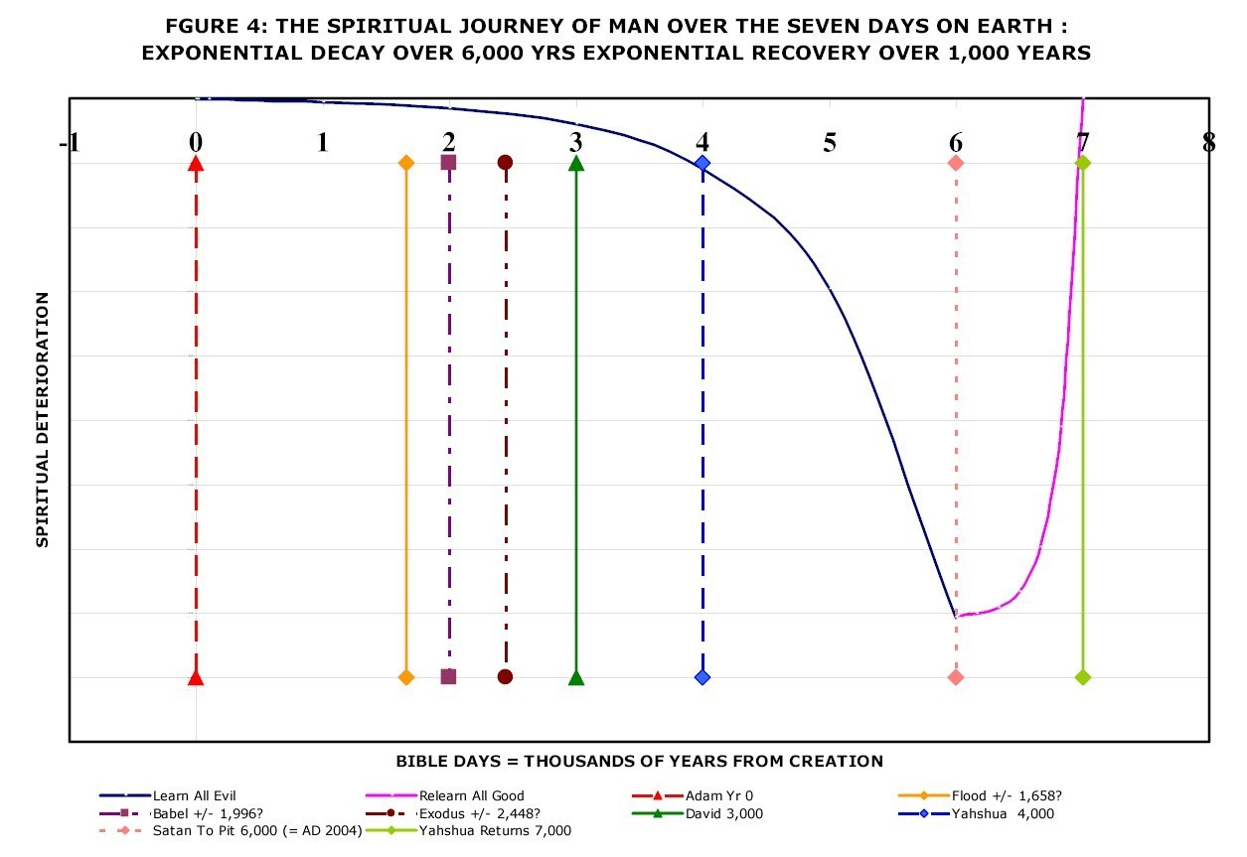
Satan was cast into the Pit for one thousand years in 2003. 2,000 years ago, Yahooshua, having regained authority on earth from Satan by living a sinless life, immediately handed that authority to those that followed him and went to sit at the right hand of Father Yah to AWAIT the time when his followers would regain authority on earth and prepare a place for his return.
That is not happening because believers do not understand that it is their role to prepare for Yahooshua, they mostly believe that “Jesus is coming soon” and are sitting back waiting for Yahooshua to sort out the mess. Yahooshua is waiting for us to sort out the mess – we have less than a thousand years in which to do this. If we truly understood the significance of Yahooshua’s return, the onset of judgment, we would NOT be asking for his soon return.
  - The continuum between the mountain of Yah and the Pit
This life and the life to come are more complex than most understand. There is a continuum between entirely and completely good which has only been achieved by Yahooshua and Father Yah and entirely and completely bad which has only been achieved by Satan.
The climb to all good is metaphorically referred to as “the mountain of Yah”, this is difficult as represented by the mountain in the photo.
IF the believers are successful in preparing a place for Yahooshua to return to then Yahooshua will return to receive his kingdom and Satan, his messengers and all those who have not qualified to enter heaven will be cast into the lake of fire and utterly destroyed. If they do NOT succeed then Yahooshua will never return and Satan will take control of the Earth for ever. However, Father will withdraw His Spirit so all life on Earth will cease so Satan’s victory will be something of a pyric victory.
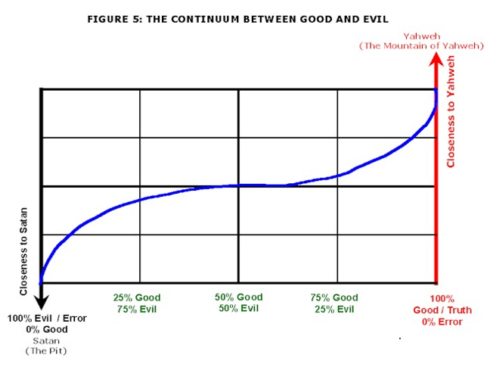
Most people are lukewarm, they are on the gently sloping ground in the middle between serving Yah and serving Satan. Most are oblivious to the battle that is raging all around them in the spiritual realm and are oblivious to the fact that in the absence of concerted action to climb the mountain of Yah they will eventually slide further and further towards Satan. The bulk of “good Christians” and “good Muslims” and “good Jews” are effectively serving Satan because of all the wrong things they believe and do. Even when those things SEEM good!
Climbing the mountain requires constant focussed effort so, if you are not consciously seeking to climb the mountain you are almost certainly sliding away.
  - Yah is one, have NO OTHER mighty ones
Yahooshua is reported in Mark 12:29-30 as saying "The first of all the commandments is: 'Hear, O Israel, Yah the eternally self-existing our Mighty One, Yah the eternally self-existing is one. And you shall love Yah the eternally self-existing your Mighty One with all your heart, with all your soul, with all your mind, and with all your strength.' This is the first commandment.”
In Exodus 20:3 it is written that Yah said on the mountain “You shall have no other mighty ones before Me.”
It is therefore clear that it is sin to equate Yahooshua to Yah or to worship Yahooshua or in any way conjoin Yahooshua to Yah in the way that is customarily done.
  - The Ten Laws
The Ten Commandments, that is the ten laws, which are the sole contents of the Container {Ark} of the Covenant are the essence of the Covenant made by the Almighty at Sinai. Since Yah appeared in fire on top of the mountain and spoke with an audible voice to several million people we must assume that these are the most important words ever spoken to human beings since this is the only time He has appeared so concretely that we know of. The ten laws form the basis of judgment.
The ten laws can be summarized as:
- Yah is one -- have no other mighty ones before him, includes do NOT worship Yahooshua;
- No graven images or idols, includes do not worship the bible;
- Do not use the name of Yah in vain, includes not using God, the LORD, Jesus, etc;
- Observe the true Sabbath (Saturday) and the feasts and fasts;
- Honour your mother and father;
- Do not commit murder, includes do not oppose the death penalty, do not curse, no abortion, no contraception that causes abortion;
- Do not commit adultery, based on virginity and widowhood as set out above, no homosexual congress;
- Do not steal including taking tithes and offerings while teaching error;
- Do not bear false witness, includes lying and false doctrine;
- Do not covet, includes lust.
  - How did Yahooshua become King and achieve what he did?
Yahooshua was 100% a human being. Born with a creative miracle less dramatic than Adam and Eve. He would not have been able to operate on Earth if he was NOT 100% human.
No human father therefore no blood line curses. First created spirit, lived with Yah before coming to earth so knew Yah well and Yah’s ways and Satan’s ways so well equipped. Lived a life without sin, gained victory and regained authority over the heavens and the earth.
King because humans proclaimed him king. Lord (Adonai) because humans proclaimed him lord.
Lamb of Yah because Yahoochanan the Immerser {John the Baptist} proclaimed him the Lamb. Through that assignment gained the right to take the place of the animal offerings for sin and thus provide a simpler way to forgiveness. Assigned the body and blood of the lamb to the bread and wine at the last meal with those who followed him most closely thereby assigning the body and blood of the lamb to bread and wine so that all believers anywhere had access to the mechanical ingredients necessary for forgiveness of sin by FAITH.
Became high priest because the High Priest laid hands on him in mockery and proclaimed him Messiah and the blood of the offering fell on the Mercy Seat of the Ark of the Covenant. Became offering for atonement because his blood fell on the Mercy Seat, also the people laid hands on him for transfer of sin and sent him outside the gate and took his blood on themselves.
There is nothing magical about what Yahooshua achieved. Not even anything particularly supernatural. He lived a life without sin, THAT is the most noteworthy achievement and he died without sinning and as a consequence death had no hold on him and he was automatically resurrected.
Death in this life is the price we pay for sin, if we live without sin we are entitled to be resurrected, thus far only Yahooshua has accomplished this and so the position of King of Kings and Lord of Lords is filled for eternity. But, through Yahooshua’s life and death we have access to an easier route to repentance and eternal life. There are other ways for other groups.
  - The beast? The mark? The Pit?
The beast is another name for Satan. The mark of the beast is a spiritual mark in the forehead – what we think and in the hand – what we write and contract that breaks one or more of the Ten Commandments. If you are breaking any of the Commandments you have the Mark of the Beast.
The Pit is a prison into which offending spirits are sent until their period of sentence has been served.
  - The other Sabbaths
In addition to the Saturday Sabbath we are required to observe:
- Passover;
- Pentecost;
- The Feast of Trumpets;
- The Day of Atonement as a set apart {sacred} fast day – water only fast;
- The first day of the Feast of Tabernacles;
- The last or Great day of the Feast of Tabernacles.
  - Other important points – Islam
Muhammed was also a prophet of the Most High and the Muslims are people of Yah, Allah is the Arabic word that corresponds to Elohim, the Hebrew Word for the Almighty. Muhammed correctly rebuked the Christians for worshipping Yahooshua and for worshipping the book {Bible}.
“Islam” means the worship and service of the Almighty. “Muslim” means one who worships and serves the Almighty. Most Muslims have gross error just like most Christians have gross error. Muslims are subject to different covenant terms to those applicable to the children of Israel and therefore they have to be grafted in to the covenant through Yahooshua but this will only happen when the truth about Yahooshua is preached and taught.
  - Other important points – Other sheepfolds
Yahooshua indicated that he had other sheepfolds to visit. I am aware of one in Central America. There is every reason to believe that there are sheepfolds all over the Earth and that there are other religious groupings that have roots in knowledge of Yah and Yahooshua.
There is also reason to believe that virtually all human beings today are children of Abraham. The nations of Europe are descended from the tribes of Israel that went into exile.
  - A difficult truth -- Isaiah 4:1 – many wives
Taking and giving of virginity results in a covenant, ditto sex with a widow or truly divorced female. A female can only do this once, therefore sexual intercourse is one of the most sacred (set apart) acts possible between two humans.
It is possible for a man to take the virginity or widowhood of more than one woman and it is therefore possible for a man to be in life time sexual covenant {marriage} with more than one woman. The problem is that modern women cannot share their man and most become highly aggressive if confronted with such a situation.
Isaiah 4:1 indicates there will be seven times more women than men in body of true believers at the end and this is evident today. This means that most believing women should remain single.
Conclusion
- Seek truth NOT error;
- Use technically correct names and terms;
- Become aware of covenant and the price of breaking covenant;
- Become aware of and seek judgment in this life;
- Prepare for judgment at the end of your life;
- Understand and observe the Ten Commandments;
- Understand how Yahooshua accomplished his purpose;
- Recognize that there is gross evil on the earth and seek to overcome it in your life;
- Look for truth in other groups and cease judging them, there ARE other sheepfolds;
- Become conscious of virginity, widowhood and true divorce as set apart states and the covenant that follows from change of these states -- sexual intercourse as a highly spiritual and set apart covenant act. Necessary consequences of recognizing set apartness of virginity and widowhood – men can covenant with more than one woman -- Isaiah 4:1;
Set a clear goal for yourself for eternity!
Closing thought
Ecclesiastes 12:13-14 “Let us hear the conclusion of the whole matter: Fear Yah and keep His commandments, For this is man's all. For Yah will bring every work into judgment, including every secret thing, whether good or evil.”
If you gain nothing else from this book, fear judgment and seek a personal relationship with the Creator and choose to adjust the way you live your life accordingly.
Closing prayer
Father I come to you in the name of Yahooshua
I ask you to give me a hunger for truth and to seek to avoid error
I ask you by your Spirit to reveal ALL error in my life and show me how to deal with it
I ask you to help me hold on to truth no matter how hard it may be
I ask you to help me to overcome to the end no matter how hard it may be
I ask you to help me to build a deep personal relationship with you
Amen

Conclusion
I have presented in-depth evidence to demonstrate that without doubt there was a massive global hydraulic and tectonic event that totally mashed up the surface of the Earth around 4,500 years ago.
I have provided information that indicates that this event was the consequence of a judgment of mankind by the Almighty Creator and I challenge you to adjust your life to serve Him and overcome sin in your life.
In closing I challenge you to repent of your sins, change your life, pray the necessary prayers and do all that you need to do to build a deep personal relationship with the Almighty so that you may dwell with Him on a high throne for eternity.
See the article “The Creator Desires a Deep Personal Relationship with YOU” at http://end-time-issueministries.org/Home/CreatorDesiresDeepRelationship.aspx.html to better understand what I am saying to you.
Read the article “Seven Components in Drawing Close to the Creator” for detailed guidance on what to do in order to give effect to your decision see
http://end-time-issueministries.org/Home/7ComponentsinGrowingClosetoYah.aspx.html
Read the article “Where will YOU Spend Eternity? -- What is required in order to qualify to sit on a High Throne for eternity?” for a detailed discussion of the options available to you in terms of your destiny and how to get there
see http://end-time-issueministries.org/Home/WhereSpendEternity.aspx.html
There is much more information on the above website, you will find answers to many questions there.
It is my prayer that you will take strong notice of the reality of the Creator, the Flood and Judgment and pull out all the stops to earnestly seek to know and serve the Creator for the rest of your life not matter what it costs you.
25 March 2016

Section 9:
Table of Contents of the Memory Card
in the Front Cover of this Book
End Time Issue Ministries
Dr James A Robertson

The Almighty Creator Desires a DEEP PERSONAL relationship with YOU!
Since Friday 12th March 1993 when Father spoke to me audibly for the first time I have been seeking a close relationship with Him. This journey has involved many diverse experiences and some considerable personal loss but brought me to a place where in 2001 He called me His Friend for the first time. I have spent the ensuring years, to time of writing (28 April 2018) learning what it means to be a Friend of the Almighty and that there are almost no friends today which is tragic given that Father’s original objective was for mankind to be His Friends and companions and to learn together.
During this journey I have learned much, including that there is HUGE error in ALL the established monotheistic religions of the World not to mention all the error in the broader range of religions in the World.
I have also learned what is required to come to a place of being in deep personal relationship with our Almighty Creator, whose true Name is Yah the Eternally-Self Existing. I have written copiously, of the order of 1,000 articles ranging from short one-pagers to a book of around 360 pages on Marriage. I have recorded over 50 audio teachings on marriage and produced 12 videos on the Flood that destroyed the world about 1,500 years after Creation which took place just over 6,000 years ago.
I have also had a very detailed website built.
In considering this material I must stress that it is YOUR responsibility to check in with Father regarding any item you do NOT agree with or are unsure of. We are each responsible for our own lives before Father and therefore, while I give you my assurance that I am confident that much of this material is inspired and compiled under a material anointing of different levels at different times I do NOT guarantee that any of it is 100% accurate or reliable. You must draw close to Father and check this out.
This memory device contains a full download of the Website as it was at the end of 2014 with virtually all the above-mentioned material on it. It also includes copies of all articles and books that I have written.
This document is the Table of Contents for the memory stick.

This memory stick contains:

01 Most Important Articles
This section contains what I consider to be the five most important documents I have ever written in my journey of building my relationship with our Father in Heaven. I understand Him to say that He regards them as the five most important documents on the planet today from His point of view.
Our Father in Heaven, Yah the eternally self-existing, created mankind to be His Friends and to do things with Him and learn with Him. Today virtually no-one on Earth knows this and a minute number of people are actually seeking to come to the point where they hear Father Yah tell them that they are His Friend. In fact, it is my understanding that, at the time of writing, 22 September 2018, there are only TWO people on Earth who Yah has actively named as being His Friends.
This document is intended to make YOU aware that Father Yah wants YOU to be His Friend AND to explain to you how to achieve this position in YOUR relationship with Him. IF you succeed in becoming His Friend and remain His Friend throughout your life you WILL qualify for a very high throne and a position of great esteem and responsibility for eternity. It is entirely up to YOU and within YOUR grasp to achieve this position.
The five documents in this set are:
  - The Almighty Creator Desires a DEEP Personal Relationship with YOU!
This document sets the scene and explains the context and the call to become Yah’s Friend. Read this first to set the scene.
  - Seven Steps to Drawing Close to the Almighty Creator
This document sets out in great detail most of the measures I have taken, the fasts I have been on, many of the prayers I have prayed and most of the worship songs I have sung hundreds of times in order to progress to the point where Father has called me “Friend”. These same measures have enabled me to retain this position since 2001 to time of writing in July 2017 and, I believe, IF I diligently apply them for the rest of my life, will enable me to leave this life and graduate to a position of high esteem and authority in Heaven on a High Throne. I pray that YOU will aspire to achieve this same status and to climb the mountain of Yah HIGHER than I have climbed.
There are many other prayers I have prayed and much conversation I have had with Father but this document sets out what I currently understand to be the essential measures. I know one person who, having put many of these measures into practice, was in 2017, to my great joy, pronounced by Father Yah to be His Friend. I commend this document to you for your EARNEST attention!
  - Where will YOU Spend Eternity?
This document, recently revised, was written many years ago as the best expression of how I understand things to be. In particular it provides a detailed analysis of what it takes to qualify for a High Throne and comments on life style adjustments that will be necessary in order to qualify for a High Throne. Read this once you have deeply immersed yourself in the first two books.
  - The TRUE Names of the Almighty in the Bible
This eBook undertakes a comprehensive analysis of the Names of the Almighty in the Bible and, in the process reveals how important it is to know that the True Name of the Almighty Creator is “Yah the Eternally Self-Existing”. It is not possible to be a true Friend if you do not know the true name of the one one desires to call Friend!
  - Recommended Worship Songs Corrected Words
This text is also contained in the Seven Steps document and provides corrected words for the songs that are on the CD at the back of this book.
The first two documents were written around the Day of Atonement in 2014 at a time when I was operating under a very intense anointing and was the closest to Father that I have ever been and was hearing Him the clearest I have ever heard Him. I commend them to you as inspired and anointed works.

02 Very Important Articles
A number of articles that rank second only to those above in their importance and also highly recommended. Some of these are contained in this volume and some in Volume 2.

03 Books
Books -- various ebooks written at different times. Most of these are on the website except the most recent books.
The suite of books that this memory stick is distributed with on “The Almighty Creator Desires a DEEP Personal Relationship with YOU” are included in pdf form suitable for printing and also for reading on-line. They are also included in Word format. The print format is available in both A5 and A4 versions with the cover documents also included so that you can reprint the books and have them Perfect Bound for your library.

04a Radio Transcripts
Transcripts of all programs broadcast on W4CY Radio from 2018 onwards. These broadcasts are a self-contained summary of what I consider to be the most important elements of the message that the Almighty Creator Desires Friends.

04b Radio Recordings
The audio recordings from which the above transcripts were prepared.

05 Relationship with Yah Series
Regular postings of mostly short articles off the ministry mailing list in late 2017 and 2018. This is a useful collection of mature and consolidated thinking on a diversity of topics. This set has a long list of articles yet to be written.

06 Annual Volumes
Compilations of the articles written in 2009 through 2011. This set is incomplete, I have not had time to compile the other sets and the books in the preceding section cover more of this range.
All the individual articles are contained in the Article Sections listed below.

07a Recommended Worship Songs – Corrected Words
A collection of 20 Worship Songs that I consider to be most suitable for drawing close to the Almighty with doctrinally incorrect words substituted by words I consider to be more accurate.

07b Recommended Worship Songs
A collection of 20 Worship Songs that I consider to have the most appropriate words to be used in worshipping the Almighty. I listen to almost nothing else except these songs and listen to them on my mobile phone when working and in my car when driving and at every possible opportunity. I sing them in the Spirit and never get tired of them because the words are SO important.
There are words that are used that are technically inaccurate and the pdf document “00_Recommended-Worship-Songs” contains a discussion of these inaccuracies together with the corrected words that I apply when singing these songs. Some of the original songs contain doctrinally inaccurate concepts and these elements have been deleted so that the songs are, as far as possible, doctrinally sound. ALL should be sung ONLY to the Almighty Creator and NOT to Jesus or Yahooshua or Messiah, or …
In considering this list it is vital to be aware that the vast majority of other songs are doctrinally corrupt no matter whether you are coming from the Christian, Jewish or Muslim traditions. Be very careful what you sing because IF you sing songs that are doctrinally corrupt you will imprint those wrong thoughts in your spirit and they will draw you into error and away from the Almighty.

08 Music CD
The above set of songs will NOT all fit on a standard Music CD so this folder contains the subset that I consider most appropriate.

09 Global Flood
The Flood Video suite comprising the PowerPoint slides and the audio recordings, the Videos are only available on YouTube or on DVD -- these were recorded in early 2010 and are a very important resource in terms of understanding the world we live in today. These are on the website in the "Flood" section although the Slideshare and YouTube components are NOT available on the off-line website above.
The videos are available on YouTube at:
http://www.YouTube.com/user/ProofOfGlobalFlood
The presentations are also available at:
https://www.slideshare.net/End_Time_Issue_Ministries

10a Marriage Teaching Transcripts
Transcripts of the Marriage Audio Teaching set -- these were recorded during a program of fasting in the second half of 2000 and contain some very important information about how Father intended Marriage to be and how to achieve that in our lives today. These are all on the website. In some respects these teachings are outdated relative to my current understanding but there is a lot of value in them.

10b Marriage Teaching
The Marriage Audio Teaching set.

2000 to 2009
Most of the articles written from 2000 to 2009 in individual folders. A significant number of articles were lost many years ago in copying documents from one computer to another.

2010 to 2019
All articles written from 2009 to present (end of September 2018), the articles from 2009 to 2014 are all on the website so these are a backup. The articles from 2015 onwards are in the Articles database on the website but are on LinkedIn and in these folders.

www.eti-ministries.org Website on Disk
The current ETI website at http://www.ETI-Ministries.org which has only been updated in the Articles Database and NOT the webpages. Run this website by clicking on "Launch www.eti-ministries.org.html" -- if you read the entire website starting with the home page you will have a very comprehensive view of what Father has been saying to me up to early 2015 and the articles from that date on will give you the rest of the picture. Apart from the articles prior to 2009 where there are variable levels of anointing and variable levels of error, the website is largely written under a reasonably strong anointing and a reasonably high level of inspiration so is a useful resource.
The Webpage Header articles are contained in Volume 3 of this book set.
Launch www.eti-ministries.org
Click on this file to load the website on your local computer. You do NOT require an Internet connection to do this so this allows you to browse the website at your leisure off-line. The search functions are not working.

Conclusion
I hope that you will find this material of value and will distribute it as widely as possible. You are free to copy and use as you see fit giving thought only to how you will be judged with regard to how you have used it, whether positively or negatively.
May Father bless you and keep you and make His face to shine upon you
May Yah judge me severely and correct me harshly and show me the level of my present deception and how to correct it with regard to everything that I write and publish
Warm regards and blessings,
James Robertson
Emissary and Spokesman of Yah
20 October 2018
James_Book_1_@ETI-Ministries.org

Section 10:
Table of Contents
of
the End Time Issues Website
http://end-time-issueministries.org
or
https://www.eti-ministries.org

(Control Click to follow links to website)

Home
The Creator Desires a Deep Relationship with YOU
Seven Components in Growing Close to Yah
Recommended Worship
Where will YOU Spend Eternity?
WHY Believe in the Almighty Creator and seek relationship with Him
What Actually Happens when someome comes to believe
The First Eight Days after first believing in the Creator
Triple Immersion as a powerful means of cleansing
Fasting as a vital component of being a believer
Worship is essential in drawing close to the Almighty
What to Read once you have come to belief
The First Year after coming to belief
Those who come to limited belief initially
Those who come to limited belief initially
The TRUE Name of the Creator is Yah the Eternally Self-Existing
The TRUE Names of the Almighty in the Bible -- Detailed Analysis -- Abstract
Objective, Technical Notes And Technical Caveat
Words Translated "God"
Names Including Yah
Further Words Which Refer To Yah
Names Including Yah
Additional Words Which Relate To Yah
Instances Of Jehovah And Jah = Yah In The Hebrew Lexicon Of The Online Bible
Instances Of Yah In The Hebrew Lexicon Of The Online Bible
Closure Regarding The Name Of Yah
This website is the culmination of applying Engineering Principles to the matters of the Almighty Creator since 1993
Yah, the Creator, desires to have deep personal relationships with people who become His friends
Creator Desires Deep Relationship
7 Components of Growing Close to Yah
Recommended Worship
Where will YOU Spend Eternity?
About
About James Robertson -- An engineering approach to religion and knowledge of the Most High Creator of the Heavens and the Earth, Yah the eternally self-existing
Headlines of the walk of James Robertson with the Almighty Creator (Yah the Eternally Self-Existing)
About End Time Issue Ministries
James Robertson's Business interests -- James A Robertson and Associates Limited -- Executive Level Consulting with Regard to the Effective High Value Application of Business Information Systems
What to do if you disagree with me
Our Logo
Building a close relationship with Yah the Eternally Self Existing, the Almighty Creator
Key Principles with regard to relationship with Yah
Why are we here?
Stages in the Relationship with the Almighty Creator
The Anointing of the Spirit of the Almighty
Worship of the Almighty
Prayer and petition to the Almighty
Prayer in agreement
Fasting as a vital component of drawing close to the Almighty
Hearing Yah
Judge me Severely and correct me harshly
Yah's Emotions -- He has feelings too
Daddy Yah is LONELY please talk to Him and use His true Name
Did YOU bring JOY to your Daddy Today?
Seeking to live a Life WITHOUT Sin
Overcoming and a High Throne
The Continuum between Yah and Satan
Drawing Closer to Yah
Drawing Close to Yah
Chesed = Covenant Love
Yah's Still Small Voice
Visions and Dreams
What IS Inspiration?
If Yah is moving Hold your Peace
The Authority of Believers
Obedience is a vital element of relationship
If you love Yah keep His commandments
You are NOT a glove puppet you ARE accountable
Sacrifice -- The Death of the Stake
Death with Yahooshua
Further Principles relating to Relationship with Yah
Who to Listen To
Even the highly anointed are falling away
Yah is everywhere
Relationship with Yah NOT worship of intellect
The Majority is ALWAYS Wrong
Specific Messages from the Almighty
Yah speaks to James
Yah speaks to the Church
Yah speaks to Believers Generally
Yah speaks to South Africa
Yah speaks to the World
Yah calls His Servants NOT Man
Yah works through His anointed ones
What IS Inspiration?
The Seventy Facets of Yah's Jewelled Words
A Guide to Receiving Personal Prophecy
Seek Truth
Seek Truth NOT Error
Yah's Commandments are BEST
Important Truths
Satan's Most Effective Lies
Pastors and the Church
The Contest
Rules of Engagement
Yah HAS to work through sons of Adam
Satan HAS to work through sons of Adam
The Forces of Darkness Rule on Earth and Yah is Constrained to act through believers
The REAL battle is between the highly anointed versus the highly illuminated ones
Descent into ALL Error
Yahooshua led a Life without Sin
Satan to the Pit
Recovering Lost Truth
A Son of Adam on the Last Day
IF Satan Wins the Contest
IF Satan Loses
Who ARE "Demons"
The Masterminds
Illuminated versus Anointed
Satan's Devices
Combat in the Heavenly Realm
Yah could do MUCH more in earlier years
All authority and dominion on earth has been given to humans, Yah and Satan are constrained to act through them
Hell
What IS Hell?
Why IS Hell?
Visits to Hell
Korean Artist
Bill Weise
Angelica Zambrano
Choo Thomas
No one is intentionally going to hell
There are good decent people in hell
Satan rules the world through the leadership of Demonic Masterminds and human Satan Servants
Satan to Pit 2003
Worship
Recommended Worship
Prayer
Important Prayers
The Most Important Prayers
Covenant
What IS Covenant?
The Blood of a Covenant Means Death to the Person who breaks the Covenant
Covenant between Man and Woman
Tattoos and Piercings
Words
The Importance of Words
Words that Kill
Words that Bring Life
Right Confession
Words with Pagan / Satanic Impact
Words are Spiritual
Jokes
Take Care is a Curse
Wishes
Luck
Television
The Bible
What to Read Instead
Old Testament versus New Testament
"The WORD" is Semantic Nonsense
The bible is the most pervasive idol
Diverse Articles relevant to the discussion about the Bible
The Essence of the issues relating to the Bible
Positive aspects of “The Bible”
Summing up re “The Bible”
About the Bible
The Arrogance of Christian Ignorance
Relationship with the Almighty NOT Worship of Intellect
Getting close to Yah Appropriate prayer and fasting are VITAL (the answer to doctrinal differences)
IF the Bible IS corrupt then WHAT do I do?
Satan’s Lies – Response to Rebuttal
“The bible is a corrupt book compiled by corrupt men”
The Majority is ALWAYS Wrong
Further Articles relevant to the discussion about the Bible -- Section 2
Bible study versus deep relationship
Demonically inspired bible versions -- rebuttal
Demonically inspired bible versions
Believers who abdicate their intellect
Your Heavenly Account
The contents of the bible are but a pin prick in the history of mankind
Clarification re THE WORD
New Testament? No No No
Further Articles relevant to the discussion about the Bible -- Section 3
Yah is at SOME measure in EVERY book (and so is Satan through his demons)
Clarification -- there IS good in the bible
The King James Version of the bible is NOT THE definitive English translation
Yah works through His anointed prophets NOT committees
The origin of the Christian bible
Those who followed Yahooshua did NOT know Torah
What IS inspiration?
The seventy facets of Yah's jeweled words
Further Articles relevant to the discussion about the Bible -- Section 4
The bible IS a useful reference work – period
Covenant – NOT New Testament
James: What do YOU believe about the bible? REALLY?
Pastors – the Prison Warders of Yah's people
Why Yah could do much greater works thousands of years ago (level of anointing and level of prayer)
Proof of a Global Flood -- Turning history on its head
Where will YOU spend eternity?
Are visions precise and free of error?
Understanding Satan's devices
Clergy versus laity
The Name of Yah in the book {bible}
The TRUE Names of the Almighty in the Bible -- Summary
What is the origin and the purpose of man? -- creation versus evolution
Older Articles -- Prior to 2009
Conclusion -- The Bible is NOT what is claimed for it
Yah (The Almighty) says that the bible is "the Greatest Idol" on earth today
Anointed Life
Anointed Life Part 1
What or Who IS an Anointed One?
Worship is Critical
Filled with the Spirit of Yah
Led by the Spirit of Yah
Guardian Messengers {Angels}
Fasting
Death with Yahooshua
The Mind of Yah
Wisdom
Intellect
Supply of Needs
Poverty in the Body of Believers
Anointed Life Part 2
Power Anointing
In the World NOT OF the World
Yah is everywhere
The Race
The Armour
Trust and Belief
Obedience
Your Heavenly Account
Merit
Anointed Life Part 3
Good and Faithful Servant
Overcoming
Angelo beggar on a high throne
Authority of Believer
Works that Yahooshua did
Deliverance
Immersion
Immersion NOT Baptism
Tearing Down Strongholds
The Battle
Spiritual Warfare
The 144,000
Single Anointed Women
Anointed Life Part 4
Salvation
Discipline
Protection
Peace
Joy
Love
Grace
Tongues
Let your Yes be Yes
Oaths
Judge me Severely and correct me Harshly that I may serve You more perfectly
Seek Truth NOT Error
Anointed Life Part 5
Man and Woman in Harmony
Messengers
Right Confession
Four phases of the Wilderness
Critical Success Factors for Life
Highly Anointed Ones Make Mistakes and Sin
Even the highly anointed are falling away
Treachery
Fear
Body Mind and Spirit
Commandments
Believe in Yah the Eternally Self-Existing, the Almighty
Chesed {love} the Almighty with all your heart, mind, soul and strength
Yah is ONE
Who IS Yah?
Who IS Yahooshua?
Who IS Satan?
Demonic "gods"
No Trinity
NO Idols
Not Worship the Bible
Not Worship Jesus
Not Worship Cross
Not Worship People
Not Worship Things
Name Yah NOT in Vain
Yahoo_com
Yes in Afrikaans and German
True Names
Keep Sabbaths
Day Begins at Sunrise
True Sabbath Saturday Sunrise
New Moons
1st Aviv
Pesach -- Passover
Shavuot -- Pentecost
Yom Teruah -- Day of Trumpets
Yom Kippur -- Day of Atonement
Sukkot -- Tabernacles 1st Day
Sukkot -- Tabernacles Great Day
False Sabbaths
Levites BREAK the Sabbath
Chesed {love} your Neighbor as yourself
Honor Parents
Blessing
Curse Mother or Father and Die
NOT Old Age Homes
NO Murder
NO Abortion
NO Abortive Contraception
Death Penalty for Murder
WHY Death Penalty?
NO False Teachings
Anal intercourse is valid birth control
NO Adultery
What IS Adultery?
Breaking Covenant / Treachery
Betrothal
Male with Male
Female with Female
Animals
Serial Polygamy
Prostitution
Pornography
Chick Flicks are Pornography TOO
Masturbation
Phone / Skype Sex
Oral and Anal Sex
Church Marriage
False Monogamy
NO Stealing
Most Prosperity Teaching is Fraud
Fraudulent Contracts
Misrepresentation in Sales
Outright Theft
Restitution
NO False Witness or Lying
False Teaching by Church
False Teaching in Other Religions
Misrepresentation in Sales
White Lies
ALL Liars will burn
Believe Lies and Die
NO Coveting or Lusting
Pornography
Fantasies
Most Adverts
Valentines Heart
Lust is visible in the spirit realm
The MARK of the Beast
All of the 10 Commandments as well as the Principal Commandment have been almost universally broken and made of NO effect
The Satanic
The Satanic Part 1
Who is Satan
Fallen Messenger
Principalities, Powers, Thrones, Dominions, etc
We wrestle NOT against flesh and blood
Combat in the Heavenly Realm
The Forces of Darkness Reign and Yah is constrained to act through believers
Illuminated Ones
Witches
Satanists
Ancestor Spirits {Demons}
Molech
If Jesus is living in your heart you have a problem
The Satanic Part 2
Curses
Take Care is a Curse
Secret Societies
Free Masonry
The Authority of the Believer
Satan's Most Effective Lies
Lilith Adam's first wife
The Satanic Part 3
Treachery is a Spiritual Force
The Peace of Satan
Fear is Faith in the Satanic
Tsunami of Evil Covers the Planet
Satans Devices
What is REALLY happening
Satan sentenced to one thousand years in the Pit on 3 May 2003
Power from drinking blood
Power from eating human flesh
Power from murder
Satanic Dominion
General Satanic
True Names
Yah
Yahooeh
Yahweh
Mighty One
Almighty
My Darling Mighty One
Yahooshua
Anointing of Yah
Stake
Other True Names
The TRUE name of the prophet from Nazareth is "Yahooshua" NOT "Jesus"
Blasphemous Names
Grace withdrawn
The LORD
God
Jesus
Christ
Cross
Other Incorrect Names
NOT God
NOT LORD
NOT Christ
True Sabbaths
Day Begins at Sunrise
True Sabbath Saturday Sunrise
New Moons
1st Aviv
Pesach -- Passover
Shavuot -- Pentecost
Yom Teruah -- Day of Trumpets
Yom Kippur -- Day of Atonement
Sukkot -- Tabernacles 1st Day
Sukkot Great Day
Year of Jubilee
Saturday is the 7th day of the week and is Yah's true weekly Sabbath
Satanic Feasts
Halloween
Christmas
On what day was Yahooshua born?
Easter
New Year
Valentine's Day
Other Satanic Feasts
Sunday Sabbath
Sunday is the Pagan day of the Sun god and is NOT appropriate for worshipping Yah, the Almighty Creator
Christmas is a Pagan Feast and is an abomination in the sight of the Almighty Creator
Yahooshua died on a Stake NOT a Cross
It is NOT Baptism it is Immersion
The Coninuum between Good and Evil
Religion
True Religion
The Great Falling Away
Even the highly anointed are falling away
Seek Truth NOT Error
The End of the Age
Judaism
Christianity
Most Christians are NOT Anointed Ones
The Church put Yahooshua to Death
If Jesus is living in your heart you have a problem
Clergy versus Laity
Judgement on the church of Jesus Christ
Planet X Nibiru
Revivals
Believers who Beg
History Revisited
This Evil Generation
Christian Denominations
Roman Catholic
Mormon
Jehovah's Witnesses
Pentecostal
Traditional
Islam
Who IS Allah
Other Religions
The Inquisitions have had a major impact on believers today
The upsurge of civilization following the Reformation, that is the Renaissance, masks the long term degradation of human beings over time
The turnaround prophets of history are Noah, Moshe, Yahooshua, Mohammed and Luther -- we need to understand their role to understand the world today
The True Religion of the Almighty Creator, Yah, is a synthesis of, and bracketed by, Judaism, Christianity and Islam
Christianity has from the outset compromized with paganism and almost every doctrine of Christianity is fatally corrupt and does NOT define the Creator
Tithes are Invalid in this age
Judaism is one of the three main religions serving the Creator
Islam is the third of the main religions serving the Creator
Yahooshua
Yahooshua Part 1
Who IS Yahooshua
Yahooshua IS the mightiest CREATED being in the entire creation
Yahooshua was an OLD Testament Prophet
How DID Yahooshua Accomplish what he did?
Thank Yah that the Jews Killed Jesus
Why Yahooshua HAD to die THAT way
Father forgive them they do not know what they are doing
My Darling why have You forsaken me?
The Covenant of Yahooshua
As oft as you eat it in remembrance of Yahooshua
Death with Yahooshua
Yahooshua Part 2
Yahooshua is WAITING for his enemies to be made his footstool
What IS special about Yahooshua?
Yahooshua will return once the true message has been preached to ALL the earth
The Church put Yahooshua to Death
Authority IN the Name of Yahooshua
LIMITATIONS in the Name of Yahooshua
The Blood of the Covenant
Who Yahooshua is NOT
Old Testament versus New Testament
On what day was Yahooshua born?
Those who followed Yahooshua did NOT know Torah
Greater Works than Yahooshua did
There is NO Trinity
Yahooshua is NOT the ONLY way
The man Yahooshua, commonly called Jesus was and is a human being and is NOT the Creator
Yahooshua, commonly called "Jesus" will only return around 3003 and is NOT "coming soon"
The Great Falling Away is right now
Judgment
Judgment in THIS Life
Judgment of Believers Who Die
Judgment of Unbelievers Who Die
The Day of Judgment
High Throne with Yahooshua
The Outer Darkness in Heaven
The Foolish Virgins in Heaven
The Lake of Fire and Brimstone
Satan to the Pit for a Thousand Years
Judgement on the church of Jesus Christ
Judgment at the End of the Age
Yahooshua is WAITING UNTIL his enemies are made his FOOTSTOOL
Yahooshua will return when the true message has been preached to ALL the world
No one is intentionally going to Hell
Few people are intending to become demons
Obedience as a Basis of Judgement
Judgment THIS Life
Protection
Provision
Health
Obedience
Judge me Severely and Correct me Harshly that I may serve You more Perfectly
Believing Men in Lack
Highly anointed ones also make mistakes and sin
Eternity
Burn for Eternity Yes? or No?
Where will YOU Spend Eternity?
Part 1 of the eBook -- Where will YOU Spend Eternity?
A Critical Question
An Important Caveat
Where will YOU Spend Eternity?
A Vital question: Do we know what sin is? - What is the essence of Judgment?
Cause for Concern - Nearly ALL of mankind is breaking most of the commandments
Part 2 of the eBook -- Where will YOU Spend Eternity?
Is there an alternative? -- can one aspire to a High Throne?
It is NOT just heaven or the lake of fire, there is a continuum
It IS POSSIBLE to overcome
What indicators are there about pleasing the Almighty?
How do we overcome? What is the Price?
Some challenging passages from The Final Quest
Joyner's experience of the Judgment
Conclusion
The Final Quest by Rick Joyner
Yah speaks on Rick Joyner
The Call by Rick Joyner
Critical Success Factors for Life
Creation versus Evolution -- What is the Origin and Purpose of Man?
Engineered Creation
Sexual reproduction proves there is a Creator
Part 1 of the book What is the origin and purpose of man
Introduction
An important assumption and some painful deductions
Some important preparatory points
Use of statistics from Google.com
Argument from Incredulity
Progressive development versus Instantaneous Creation
Other religions and spirits
Some other issues with certain religious views of creation
What next?
Part 2 of the book What is the origin and purpose of man
The "I AM RIGHT" "YOU ARE WRONG" Paradox
Does this mean deadlock?
A Different approach?
Some issues that arise from the above questions
Science - Engineering - Religion
Religion
Suggested principles for further analysis
"Planned (Engineered) Creative Evolution" versus "Unplanned (Unengineered) Spontaneous Evolution"
Part 3 of the book What is the origin and purpose of man
Evidence in Immediate Physical Environment
Tying up loose ends
Various bits and pieces
Some other considerations regarding creation versus evolution
Soft attributes of human beings
If all else fails, ask for a "sign"?
Conclusion
Flood
The World Before the Flood
The Flood Itself
The World After the Flood
Understanding the Impact of the Flood
Why Millions of Years is Invalid
Flood Videos
Overview of the Flood Videos
Section 1 -- Proof of a Global Flood -- Introduction
Section 2: Gold Mines -- Evidence of Massive Hydraulic Flood Action
Section 3: Layered Sedimentary Rocks -- Evidence of a Global Flood
Section 4: The Halfwayhouse Granite Dome -- Massive Surface Disruption
Section 5: African Erosion Surface -- massive flood cutting action
Section 6: Incised Valley deep in massive Granite -- evidence of massive flood action
Section 7: The REAL Age of all this - a flood as recently as 4,500 years ago?
Section 8: Signs Of Judgment -- Real Mount Sinai and Ten Commandments
Section 9: Where DID the water came from? And where did it go? -- Proof of a Global Flood
Section 10: Summing Up -- Proof of a Global Flood
Section 11: End Notes -- Proof of Global Flood
There is global proof of a global catastrophe which is FAR beyond a "flood"
Evolutionary Creation is the ONLY practical explanation of what exists today
Sex
The Spiritual Nature of Sex
Yah Created Sex and it was good
The Virgins Covenant
Sex is a Covenant Act
The One-Flesh Bond
Making Love
Transfer of Demons
Soul Ties
Betrothal
Role of Man
Role of Woman
Monogamy and sexual lovemaking
The Bed is Undefiled
The Joy of Sex
Sex -- Permitted and Prohibited
"Sex Before Marriage"
One Night Stands
Men with Men
Women with Women
Anal Sex
Oral Sex
Masturbation
Pornography
Fantasy
Sexual Thoughts
Voyuerism
Spiritual Separation of Man and Woman
Coping with Sexual Need
The Virgin's Covenant is CRITICAL to understand sex, marriage, adultery and divorce
Men & Women
Men and Women and covenant
The Virgins Covenant
Age to Marry
Betrothal
Marriage
Cleave is NOT Adhere
Isaiah 4:1
Men and Women and Family
Divorce
Separation of Man and Woman
Men
Women
Children
Family
Polygyny
Polygamy
Is Polygamy Scriptural?
Monogamy
Sex
The Book -- The Scriptural Definition of Marriage, Adultery and Divorce
Preamble and Table of Contents
1: Introduction & Concepts
2: How does scripture define the marriage covenant?
3: What does scripture say about adultery?
4: Scriptural Divorce
5: Is monogamy scriptural?
6: Some other scriptures on marriage issues
7: The Tradition of the Elders and Other heresies
8: Consequences of the Heresy of Monogamy and Related false Doctrines
9: Summary and Conclusion
Appendices A to G
Appendices H to P
Appendices Q to V
Appendices W to Index of Key words
Man and Woman in Harmony
Marriage Strategy
Marriage Teachings
Part 1: The Coming Tribulation
Part 1: The Coming Tribulation
Part 2: JUDGMENT IN THIS Life
Part 3: Scriptural definition of Marriage, Divorce & Adultery
Part 4: Towards Heaven on Earth in Marriage
Part 5: Practical Application of Marriage Teachings
Part 6: Deliverance
Part 7. Conclusion
The Almighty designed us from the beginning such that one man can covenant with more than one woman, this is evidenced by the seal of virginity
There are seven times as many believing women as men on earth today so most need to remain celibate and single
The Responsibility of Believing men towards single believing women
A Letter to a Single Woman
The need of Single Women for Companionship
The impact of Wild Oats (children from casual sex) on the world today
The truth about Divorce
Society
Commerce
Yahs Commandments
Contest or Compromise
The Mark of the Beast
This Life
Race
ALL are Seed of Noah
Nearly ALL alive on earth today are Seed of Abraham
Most of those alive today are Seed of Yisrael
Shemmites
Abraham
Yitzak
Yisrael
Yahoodah {Judah}
Yahooshua
Ephraim
Levi
Afrikaners
Ishmael
Arabs
Muhammed
Japhethites
Hammites
Middle East
Yisrael
Babylon / Iraq
Europe
United Kingdom
Rest of Europe
North America
USA
Central America and Bahamas
South America
Asia
Australasia
Africa
The Curse of Canaan
South Africa
Afrikaners
Rest of Africa
The Majority is Always Wrong
"Jews"
Yahoodite = Jew
Thank Yah that the Jews Killed Jesus
The Jews are Yisraelites and NOT Khazars
The Jews are Yisraelites and NOT Seed of Satan
Jews are NOT Ominipotent
Blessed for Relative Faithfulness
"Blacks"
The Colour of a Person Tells Nothing About Their Bloodline
The Hammite African Spiritual Dispensation
The Curse of Canaan on many Africans
Conspiracy
World Trade Center Demolition
New World Order etc
Do NOT Concern yourself with Conspiracy
Y2K (The Year 2000 Computer Fear) -- What WAS it? -- an immature believes conspiracy theory
The REAL Conspiracy
Calendar
Media
Annual Volumes
Books
Videos
Audio
Emails
Articles Emailed
Creator Desires a Deep Personal Relationship with YOU
Seven Components of Drawing Close to the Almighty
Where will YOU Spend Eternity?
6010 (2013/4)
6011 (2014/5)
Particularly Important Articles and other Resources
Insights that I have gained into various topics from day to day
Table of Contents of the body of the Website
Articles to 2009 (6005)
Articles
List of Articles from 2009
Article Keyword Cloud
Article Categories
Contact Us
Audience
The REAL Contest
What IF Satan WINS?
Satanic Dominion
Where are YOU headed for Eternity?
What should YOU do about the direction of your life today?
The ULTIMATE GOAL -- deep personal friendship with the Almighty Creator of the Heavens and the Earth
The ULTIMATE SIN -- unbelief -- believing the Almighty Creator does NOT exist -- by default allegiance to Satan
The TRAP to prevent you achieving the goal of deep personal relationship with the Creator -- Jesus, the Bible, the Church and Pastors and other people
If you have questions

Conclusion
I hope that this collection of writings will help you to choose to draw much closer to the Almighty and will help you to chart your course.
You are welcome to email me at James_Book_1_@ETI-Ministries.org.
Warm regards and blessings,
James Robertson
Emissary and Spokesman of Yah
22 September 2018

